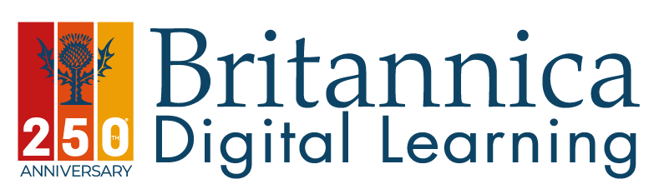

Dear Student,

Your homework just got a lot easier!

At Britannica we understand how challenging getting homework started and finished on time can be.

Britannica School is a resource that lets you search, just like using Google, where you will find exactly what you are looking for!

Get straight to the point, no searching for ages and ages trying to find the right article or image. Everything you need to make your life easier at school is one click away.

Britannica is updated regularly buy our team of over 60 editors, our articles are all relevant to the UK curriculum, with different reading levels to support you. Translated into over 120 languages. Making reading or language no longer a barrier.
Explore the world without the risk of fake news!
https://school.eb.co.uk/levels
Username – essex
Password – virtual

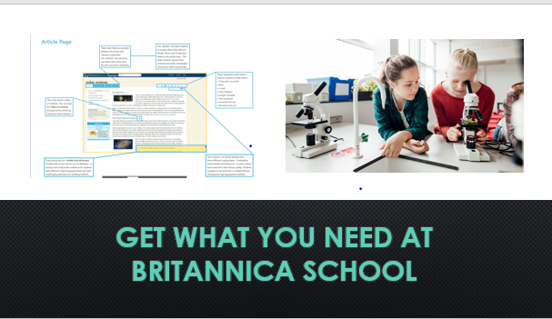

Best Regards
Emma Cork
Britannica Digital Learning

