SEND in Essex

Scheme of delegation in respect of decisions relating to Education, Health & Care (EHC) Needs Assessments and Plans

Version details
- Version: 1.2
- Last updated: 7th Feb 24
- Updated by: Alex Abercrombie, SEND Transformation Lead
- Date for review: To be reviewed every two years, with next review in February 2026
- Responsibility to review: Ralph Holloway, Head of SEND Strategy & Innovation

Introduction and principles

The purpose of this document
The scheme of delegation sets out the delegated powers related to SEND and/or allocation of additional resources. It empowers officers of the Council to take decisions on behalf of the Director of Children Services to ensure that the Council meets its obligations under the Children and Families Act 2014, SEND Code of Practice 2015 and relevant financial regulations.
All decisions should be well informed, transparent and must have regard to the views and wishes of parents/carers, young people and professional advice. Reasons for decisions must be clearly recorded and communicated, they must ensure fair and transparent distribution of resources. Decisions are subject to routine audits and council corporate procedure.

Principles
Our vision for SEND in Essex can be found in the SEND Strategy 2022:
Our vision for children and young people with special educational needs and disabilities (SEND) and the whole SEND system is based on the fundamental rights of all children and young people as defined in the United Nations Convention on the Rights of the Child (UNCRC).
- Every child and young person is safe and feels safe
- Every child and young person’s views, feelings and wishes are always considered and taken seriously in all matters that affect them
- Every child and young person has the best possible health and wellbeing
- Every child and young person’s education and training should develop their personality, talents and abilities to the full
- Every child and young person is connected to, and plays an active part, in their local community
- Every child and young person has the education, care and support they need to lead a full and purposeful life with dignity and independence
This vision is for all children and young people and will be applied with ambition.

Ensuring that decision-making, planning and support for children and young people with SEND in Essex is the individual and collective responsibility of all professionals, managers and leaders across education, health and care services.

Key documents
All officers making decisions about EHC needs assessments and plans in Essex must have regard to the following national guidance and legislation –
- Children and Families Act 2014 and its associated regulations
- SEND Code of Practice 2014 (subsequent changes and amendments January 2015)
- Children's Act 1989
- Chronically Sick and Disabled Persons Act 1970
- Working Together to Safeguard Children and Keeping Children Safe in Education
- School Admissions Code of Practice
- Equality Act 2010
- Supporting pupils at school with medical conditions
- Mental Capacity Act 2005
- Care Act 2014
- The School and Early Years Finance (England) Regulations
All officers making decisions about EHC needs assessments and plans in Essex must also have regard to the following local guidance, which sets out the practices and processes that must be consistent across the SEND system in Essex –
- Terms of reference for SEND statutory panels
- Essex SEND strategy;
- Essex ordinarily-available framework
- EHC needs assessment guidance
- Essex banding framework
- Essex EHCP quality-assurance framework
- Essex EHCP annual review guidance
- EHCNA Checklist

A summary of where authority for making decisions about aspects of the EHC system sits within Essex

Summary
This scheme of delegation was developed through consultation with a working group of senior leaders responsible for SEND in the local authority and engagement with a wider core group of representatives from Education, Social Care and Health throughout 2021. In planning where decision-making authority should sit within Essex, we followed a series of eight steps in the EHC process. This is summarised in the graphic below.
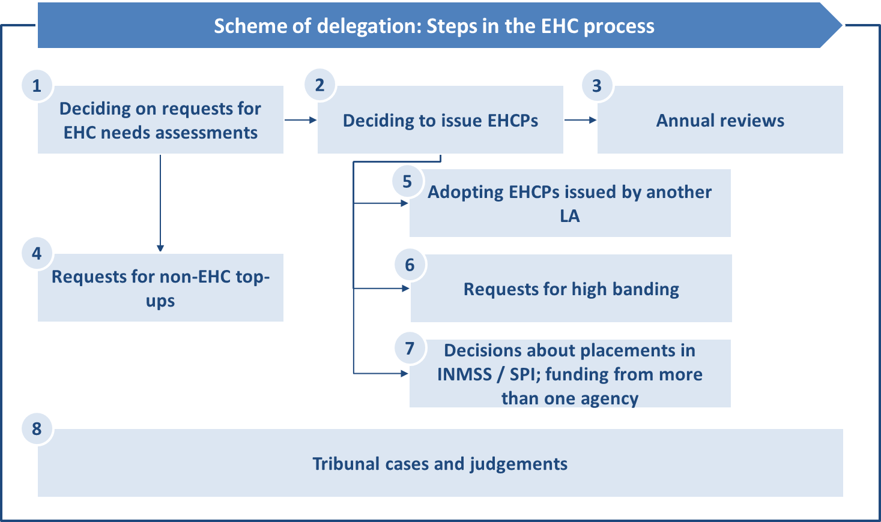

The table below presents an “at-a-glance” summary of where responsibilities for each of these stages sit within the Essex system.
Stage of EHC process | SEND Operations Co-ordinator | Annual Review Co-ordinator | SEND Operations Partner | SEND Operations Lead/ Deputy | Initiation Panel | Resourcing Panel | Complex Case Forum
- Request for EHCNA |  |  | X | X | X
- Decision to issue EHCP |  |  |  | X |  | X
- Annual Review  … initial triage, no change | X* first Annual Review | X
… band change +/- 1 band, same placement type |  |  | X
… Band change +/- 2 or more bands, change of placement type, cease EHCP |  |  |  | X |  | X
- Non-EHCP top-ups  Medical needs |  |  |  | X |  | X
… transition top ups |  |  |  | X |  | X
…post 16 top-ups | To be confirmed see Head of SEND Strategy & Innovation
- Adopting EHCPs from other areas  Straightforward/ direct equivalent |  |  | X
… no direct equivalent in Essex |  |  |  | X |  | X
- Requests for high bands of funding  5+ mainstream, 8+ special |  |  |  |  |  |  | X
- Requests for independent sector placements |  |  |  |  |  |  | X
- Tribunal decision | Responsibility for representing the local authority in tribunal cases, reses with the Tribunal Officers

Delegation of decision-making responsibilities

In detail
Officer (and Panel where decisions taken through a Panel chaired by the Officer) | Frequency of decision-making | Level of decision-making | Recording and communication of decisions | Escalation, review or QA of decision-making
Annual Review  Co-Ordinator | Ongoing (to meet statutory timescales) | Existing EHCPs  To consider annual review reports and updated advice from the education setting, family, health and care professionals.  Where there is “no change” recommended, to decide whether to agree with that recommendation.  To agree to amendments that would not require any changes in the allocation of resources – for example, updating the EHCP so that it accurately reflects the young person’s assessed needs, required provision, targets and outcomes.  Where the recommendation from the setting / school or the judgement of the SEND Operations Co-ordinator themselves is that a more significant change to the EHCP is required or the EHCP may need to be ceased, to refer those cases to the chair of the Quadrant Resource Panel (a SEND Operations Lead). | To maintain up-to-date case notes and records of decisions reached and reasons for decisions.  To communicate decisions taken regarding annual reviews to parents / carers, young people, and settings / schools / colleges as appropriate, in writing and in a timely manner.  To alert senior officers to potential risks of placement breakdown, escalation of costs, appeals against decisions. | Requests to review decisions should be escalated to the SEND Operations Partner for supervision and oversight.
SEND Operations Co-ordinator | Ongoing (to meet statutory timescales) | Requests for statutory assessment  To co-ordinate the EHC needs assessments.  New EHCPs  To prepare Needs Assessment Reports.  To prepare draft EHCPs.  Existing EHCPs – First Annual Review  To consider annual review reports and updated advice from the education setting, family, health and care professionals.  Where there is “no change” recommended, to decide whether to agree with that recommendation.  To agree to amendments that would not require any changes in the allocation of resources – for example, updating the EHCP so that it accurately reflects the young person’s assessed needs, required provision, targets and outcomes.  Where the recommendation from the setting / school or the judgement of the SEND Operations Co-ordinator themselves is that a more significant change to the EHCP is required or the EHCP may need to be ceased, to refer those cases to the chair of the Quadrant Resource Panel (a SEND Operations Lead). | To maintain up-to-date case notes and records of decisions reached and reasons for decisions.  To communicate decisions taken regarding requests for assessments, issuing new EHCPs, and annual reviews to parents / carers, young people, and settings / schools / colleges as appropriate, in writing and in a timely manner.  To alert senior officers to potential risks of placement breakdown, escalation of costs, appeals against decisions. | Requests to review decisions should be escalated to the SEND Operations Partner for supervision and oversight.
SEND Operations Partner | As required | Existing EHCPs  To consider requests for changes to EHCPs through the annual review process where the changes requested are (a) of one band (increase or decrease), and/or (b) of a change of placement within the same type of placement (e.g., a change from one mainstream school to another).  To consider the content of EHCPs of young people who have moved from another local area, which previously maintained the EHCP, and to agree to the provision if there is a straightforward or direct equivalent in Essex. (In instances where there is not a straightforward or direct equivalent in Essex, these cases should be referred to the SEND Operations Lead and considered through the Quadrant Resourcing Panel.) | To ensure that records of decisions reached and reasons for decisions are recorded accurately, appropriately and in a timely manner. | Requests to review decisions should be escalated to the SEND Operations Lead for supervision and oversight.
SEND Operations Lead/ Deputy | Weekly (Panel meetings)  Other decisions as required | Requests for statutory assessments  To review any decisions taken or being considered by the SEND Operations Co-ordinators that have been raised through the escalation process.  As chair of a Quadrant Initiation Panel, to agree to or refuse requests for EHC needs assessments or re-assessments, in line with the Code of Practice and the Essex EHCNA Guidance document.  Although the panel is quadrant the list of requests for EHC needs  New EHCPs  As chair of the Quadrant Resourcing Panel, to consider (a) whether or not to issue an EHCP, and (b) the content and resourcing (top-up banding) of proposed new EHCPs.  Requests for bands 5+ (mainstream) or 8+ (special), or for placements in independent provision must be referred to the Head of SEND Strategy & Innovation, and considered through the Complex Case Forum.  To attend joint-agency panels on a rota, alongside Head of SEND Strategy, to contribute to consideration of joint provision and funding for placements for children with EHCPs requiring input from education, health and care.  Requests for non-EHC top-up funding  As chair of the Quadrant Resourcing Panel, to consider and decide whether or not to agree to requests for top-ups to support (a) medical needs (in consultation with the Designated Clinical Officer from the relevant Clinical Commissioning Group), or (b) with transition between phases of education.  To review existing non-EHC top-up funding for medical needs or to support transition.  Existing EHCPs  To consider requests for changes to EHCPs through the annual review process where the changes requested are (a) of two or more bands (increase or decrease), and/or (b) of a change of placement type (e.g., a change from a mainstream school to a special school). Requests for bands 5+ (mainstream) or 8+ (special), or for placements in independent provision must be referred to the Head of SEND Strategy & Innovation, and considered through the Complex Case Forum.  To consider the content of EHCPs of young people who have moved from another local area, which previously maintained the EHCP, and to agree to the most appropriate provision, or further assessment, if there is not a straightforward or direct equivalent in Essex. | To ensure that records of decisions reached and reasons for decisions are recorded accurately, appropriately and in a timely manner.  To alert senior officers to potential risks of placement breakdown, escalation of costs, appeals against decisions. | Requests to review decisions should be escalated to the Quadrant Manager or the Head of SEND Strategy & Operations for supervision and oversight.
SEND strategy Lead Compliance  (Complex Case Forum) | Monthly (panel) | New and existing EHCPs  As chair of the Complex Case Forum, to consider requests for bands 5+ (mainstream) or 8+ (special), or for placements in independent provision.  To act as the representative of SEND at joint-agency panels considering joint provision and funding for placements for children with EHCPs requiring input from education, health and care. | To ensure that records of decisions reached and reasons for decisions are recorded accurately, appropriately and in a timely manner.  To alert senior officers to potential risks of placement breakdown, escalation of costs, appeals against decisions. | Requests to review decisions should be escalated to the Director of Education for supervision and oversight.
Tribunal Officer | As required. | To take decisions in Tribunal hearings or in implementing Tribunal judgements, when decisions are required at that time and cannot be deferred to Panel discussions. |  | Final Tribunal judgements must be implemented by the local authority

Arrangements and responsibility for reviewing the scheme of delegation
This scheme of delegation will be reviewed and, if necessary, updated every two years. Feedback will be gathered from the relevant officers and leaders , through the Quality of Plans COG, panel meetings, and through the operation of the Essex EHCP Quality-Assurance Framework. Responsibility for the review of the scheme of delegation and enacting decisions by the Director of Children’s Services and the Director of Education regarding any changes made to the scheme of delegation will sit with the Head of SEND Strategy & Innovation.

