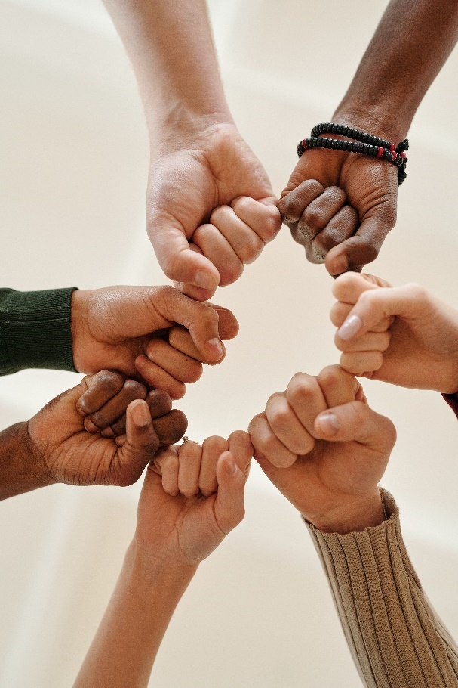
Let’s Talk: Healthy relationships
Secondary

This resource is part of our self-care suite of resources and has been co-produced, with children and young people living in Essex, for children and young people. They have also been developed and quality assured by the following stakeholders:
- Essex Educational Psychology Service
- Essex Health Watch
- Essex Mental Health Support Teams (MHSTs) NELFT NHS Foundation Trust
- Essex Multi-schools Council
- Essex Social, Emotional and Mental Health (SEMH) strategy team
- HCRG care group Child and Family Wellbeing Service
- NELFT NHS Trust Southend, Essex, and Thurrock (SET) Child, Adolescent and Mental Health Service (CAMHS)
- Professionals in schools and settings can access all these resources via the Essex info link SEMH portal. Children and young people (CYP), parents/carers and professionals can also access these resources via the SET CAMHS website. Our self-care content can also be accessed via SET CAMHS Instagram account:

The resources are intended to be accessed by CYP independently or trusted adults use these resources with CYP through 1:1 conversation, whole school/group discussion and assemblies.
Please note: some of the content within our self-care resources may be emotive for CYP. We recommend that you make use of the ‘signposting to support’ section of this document should any of the content be triggering.
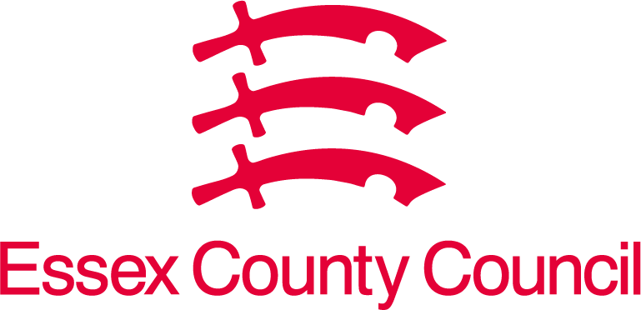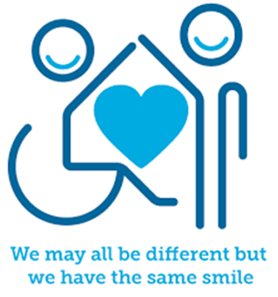
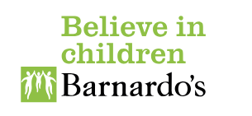

Introduction
Healthy relationships/friendships involve trust, honesty, respect, and open communication between people. In a healthy relationship/friendship each person should be able to have fun and enjoy each other’s company, feeling comfortable together. Relationships, including the one you have with yourself, are vital to our mental wellbeing. People with healthy, positive, and supportive relationships are more likely to be happier and healthier.
Creating and maintaining good connections with others can also help to combat loneliness and improve mental health issues, such as stress and anxiety.

Facts
- We need to work at build and keep good relationships going
- Relationships can change
- Key ingredients to healthy relationships include respecting and supporting others and having open and honest conversations.
- Being able to speak openly about the way you are feeling and, in turn, listening to your partner/friend or family member can strengthen relationships, reduce relationship anxiety, and help to protect your mental wellbeing.
- Disagreements are normal, but it can affect your mental wellbeing if an argument is not resolved.
- Disrespectful behaviour is hurtful to others and the opposite of respectful behaviour.
- Respectful behaviours include being polite, noticing personal space, asking for consent/permission, considering other people’s feelings.

Myth Buster
- Fighting doesn’t happen in healthy relationships
- Jealously means that they love you
- Relationships are easy
- A relationship is about putting another person’s needs above your own
- A healthy relationship means another person has control over what you wear, say and do
- If someone is a friend/partner it’s okay for them to ask you to do things you feel uncomfortable about or don’t want to do
- You should do things that are uncomfortable or that you don’t want to do to keep a friendship/relationship going

Video clips
- Losing Control: When Someone Cares | Childline - YouTube
ChildLine’s video about unhealthy relationships to help you start a conversation.

- What is a healthy relationship? - BBC Bitesize
A video clip and information to help you discuss what healthy relationships look like.

- Teen Voices: Friendships and Boundaries - YouTube
A video sharing the voices of other young people about friendships and boundaries.

- Working out Relationships? The Shackleton Relationships Project. - YouTube
A video for children and young people exploring the ingredients of managing relationships.

- What makes a healthy relationship – YouTube
A video to start a conversation about healthy relationships.

Resources
We have indicated whether the resources are accessible for Ks3, Ks4 or Ks5+. However, some of the content may be able to be differentiated to suit other age groups of children and young people using these resources.

- Relationships: Can bring joy & challenges to our lives – Brook
Get help and support with relationships.

- Relationships | Childline
Being in a relationship can be exciting, but sometimes it can be confusing too. Read our advice on what to do if you’re not sure about a relationship.

- Sex & Relationships Education Hub | Contraception, STIs & More | The Mix
The mix offer support & information on sex & relationships. Sharing information about having better relationships, coping with break ups, and choosing the right contraception to falling in love and exploring sex and sexuality.

- TEENS & YOUNG PEOPLE | Act on It Now
Act on it now provide information, resources, ideas, and quizzes to help them reflect and think about their relationships and supporting a friend.

Reflective questions
(Try exploring these reflective questions with a CYP)
- What are the different types of relationships you have?
- How do you manage disagreements and conflicts in relationships?
- What are the important qualities in the relationships you have?
- How should relationships make you feel?

Quiz of 5 questions per theme
Once you’ve gone through this resource with a CYP try this quiz questions with them:

- What steps can people take to keep online friendships positive and safe?
- What is the difference between communicating with someone online to communicating with someone face to face?
- What should a healthy relationship feel like?
- What are some of the qualities of a positive relationship?
- What early warning signs would you see in unhealthy relationships?

Additional ideas
Other things to try:
- Boundary.Circles.pdf (nbcgutah.com)
You get to decide which circle a person belongs in when it comes to your life. Use the diagram below to outline who is in what circle in your life.

- Top Tips - Healthy Relationships PEERS (Postcard) (mentalhealth.org.uk)
Mental Health Foundation have created a top tips healthy relationships with our peers. For young people created for young people.

- Asking For a Friend – Need to know more about sexual health
Essex sexual health offer a go-to for free confidential advice and support for young people.

Signposting to Support
For additional support we recommend that trusted adults use these resources to support children and young people access support when required:
- CEOP Safety Centre
- Get Support | Childline
- Contact Us | Samaritans
- Papyrus Hopeline247
- Home | Terrence Higgins Trust (tht.org.uk)
- Welcome to Essex Sexual Health Service
- Anna Freud Centre – On My Mind
- Kooth.com
- Explore counselling/therapy
- Childline 0800 1111 when contacting ChildLine what to expect?
- Hopeline 0800 068 41 41 offering confidential support and practical advice
- Text ‘SHOUT’ to 85258 for free, confidential, anonymous text support service.
- Share any concerns about your mental health with your GP and Understanding Confidentiality
- NHS 111
- Southend, Essex & Thurrock Children and Adolescent Mental Health Service (SET CAMHS)
- Where to get urgent mental health support from: Advice from NHS

- SET CAMHS Instagram account

How to help a friend
- Share this resource with them
- Tell them about the SET CAMHS Instagram account
- Information for 11–18-year-olds on supporting friends or partner(s) - Mind
Information for young people aged 11-18 about how to support a friend or partner with how they're feeling.
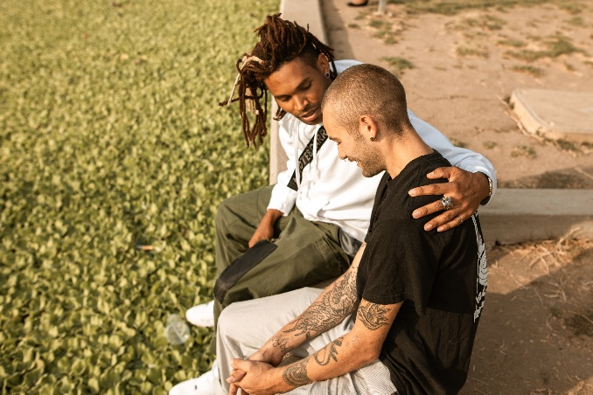

The adult box (for professionals and parent/carers to read)
- Teaching Your Child about Internet & Online Safety | NSPCC
Talking to your child about online safety. Advice on how to start the conversation and get support if you're worried.

- Parents and carers | CEOP Education (thinkuknow.co.uk)
Help your children get the most out of the internet.
- How do I talk to my teenager about healthy relationships and consent? - Support for Parents from Action for Children
Action for happiness offer parents/carers advice on how to talk to young people about healthy relationships and consent.

- Talk Relationships: resources to deliver sex and relationships education | NSPCC Learning
NSPCC learning provide teachers with information about delivering sex and relationships education.

- Modern Families | Network on Family Regulation and Society | University of Exeter
University of Exeter have created resources for teachers to teach about Modern Families during PSHE lessons.

- Key Stage 3 resources for teachers | BBFC
Our secondary PSHE resource, Making Choices: Sex, Relationships and BBFC Age Ratings, is aimed at Key Stage 3 learners. This resource will help your class develop strategies for coping with peer pressure and enable them to recognise the differences between real life and on-screen relationships.

- Commitment - what does it mean? (pshe-association.org.uk)
PSHE lesson on commitment and exploring the development and maintenance of healthy and reliable relationships, across a range of different relationship types
- Disrespect NoBody: preventing teenage relationship abuse (pshe-association.org.uk)
These discussion guides and lesson plans support the Home Office Disrespect NoBody campaign, aimed at preventing abuse in teenage relationships. They're designed to help pupils understand and maintain healthy relationships, learn about consent and how to deal with controlling behaviour, violence, and abuse.

- Respecting me, you, us - RSE lessons (thinkuknow.co.uk)
Respecting me, you, us is a CEOP Education resource developed in association with clinical psychologist, Dr. Elly Hanson. Designed for young people aged 12-14, Respecting me, you, us is a set of eight lesson plans and five short situational films.

- PSHE lessons: KS3 Curious about conflict | CRESST
This series of six lessons introduces students to the essential skills and valuable understanding needed to effectively de-escalate and resolve conflicts. The concepts, attributes and skills addressed by the lessons are relevant to many aspects of the PSHE curriculum and can be returned to throughout KS3 and KS4 when teaching about health and wellbeing, relationships and living in the wider world.

- University of Bristol: EDUCATE (pshe-association.org.uk)
The EDUCATE lesson will be most useful if it is delivered to Year 8 students before they are offered the HPV vaccine. However, other young people may also benefit from having the opportunity to find out more about the process.

- Working out Relationships | Network on Family Regulation and Society | University of Exeter
Working out Relationships? is a fun and interactive two-part lesson plan for use in PSHE classes for Key Stage 4 pupils. The lesson plans and accompanying video use a gym theme to normalise that, like a gym membership, relationships are fun but require work.

- Tips for talking to your kids about LGBTQ+ families - BBC Tiny Happy People
BBC provide parents and carers with tips for talking to your kids about LGBTQ+ families.

- CEOP Education (thinkuknow.co.uk)
The National Crime Agency's CEOP Education team aim to help protect children and young people from online child sexual abuse. We do this through our education programme, providing training, resources and information to professionals working with children, young people, and their families.

