Let’s Talk: Physical Activity and Exercise
Secondary
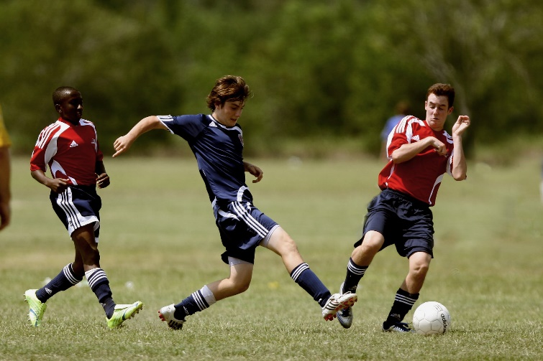

This resource is part of our self-care suite of resources and has been co-produced with children and young people living in Essex, for children and young people. They have also been developed and quality assured by the following stakeholders:
- Essex Educational Psychology Service
- Essex Health Watch
- Essex Mental Health Support Teams (MHSTs) NELFT NHS Foundation Trust
- Essex Multi-schools Council
- Essex Social, Emotional and Mental Health (SEMH) strategy team
- HCRG care group Child and Family Wellbeing Service
- NELFT NHS Trust Southend, Essex, and Thurrock (SET) Child, Adolescent and Mental Health Service (CAMHS)
- Professionals in schools and settings can access all these resources via the Essex info link SEMH portal. Children and young people (CYP), parents/carers and professionals can also access these resources via the SET CAMHS website. Our self-care content can also be accessed via SET CAMHS Instagram account:

The resources are intended to be accessed by CYP independently or trusted adults use these resources with CYP through 1:1 conversation, whole school/group discussion and assemblies.
Please note: some of the content within our self-care resources may be emotive for CYP. We recommend that you make use of the ‘signposting to support’ section of this document should any of the content be triggering.
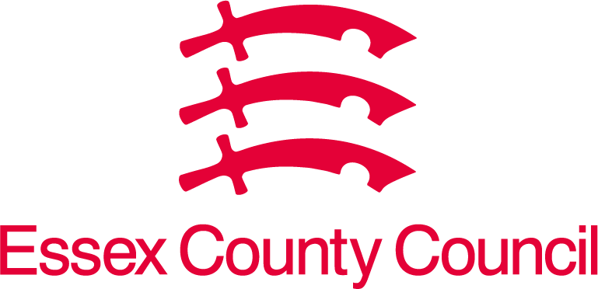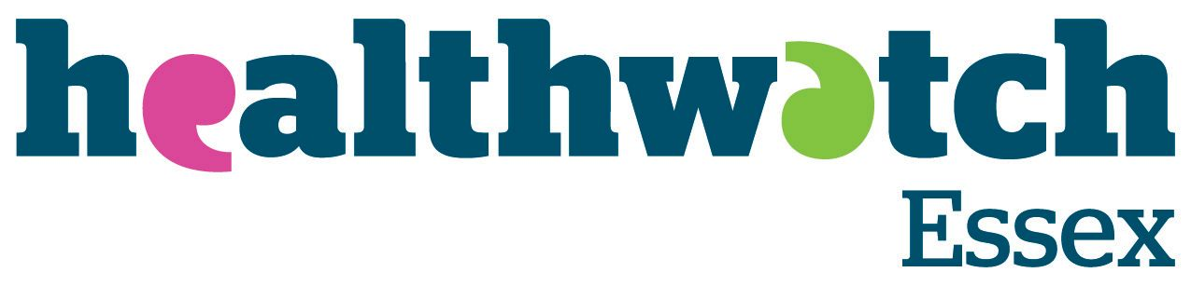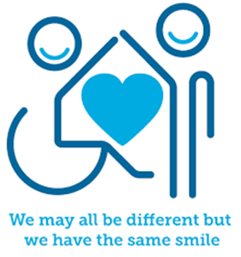
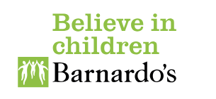

Introduction
Physical activity and/or exercise is important for a variety of reasons including helping us to manage our own physical, emotional, and mental health. Physical activity and/or exercise comes in variety of forms, and this might be from playing team or individual sport activities to just being able to move our body from one place to the next like walking.

Facts
- Physical activity / exercise supports our brain performance and sharpens your memory
- Physical activity / exercise prevents signs of ageing
- Physical activity / exercise makes us better at keeping away germs
- Physical activity / exercise is a good way to make friends
- Physical activity / exercise makes you feel better about yourself
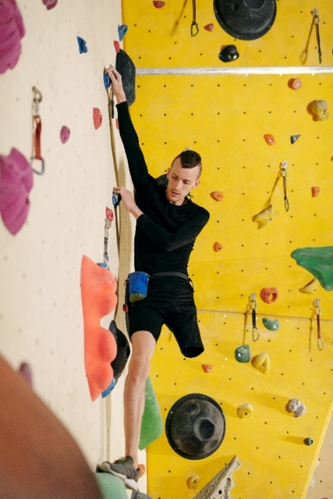

Myth Buster
- You should feel pain during or after a physical activity / exercise X
- You should eat more protein and avoid fat and carbohydrates X
- Lifting weights makes you bulky X
- More sweat means more calories burned X

Video clips
Check out these videos about Physical activity and exercise:
- Total Body Teen Workout
Total body work out for teenagers that can be done at home with no equipment and led by teenagers.

- Physical Activity benefits to your body and brain
A video to explain how taking part in exercise, sport or taking part in physical activity benefits your body and brain.

- Deep breathing exercise
Deep breathing exercise for teenagers to support physical activity and exercise.

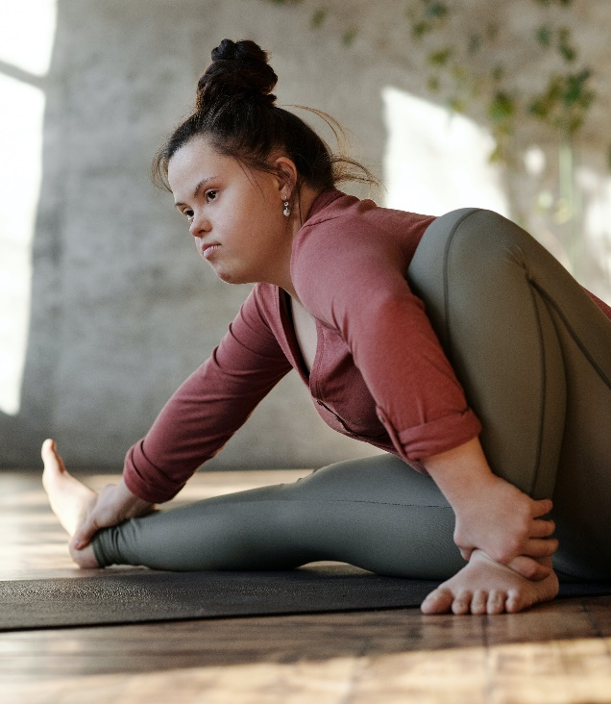

Resources
We have indicated whether the resources are accessible for Ks3, Ks4 or Ks5+. However, some of the content may be able to be differentiated to suit other age groups of children and young people using these resources.

- About physical activity - Mind
Information about how physical activity can help your mental health and wellbeing, and tips for choosing an activity that works for you, and how to overcome anything that might stop you from becoming more active.

- Anna Freud – Physical Exercise
Describes how physical exercise is part of our self-care.

- Royal College of Psychiatrists – Physical activity, exercise, and mental health
This information is for children and young people and looks at the link between physical activity and mental health. It covers the benefits of physical activity and exercise, how exercise can support good mental health, and how active you need to be to feel better.

Reflective questions
(Try exploring these reflective questions with a CYP)
- Which type of physical activity or exercise do you most enjoy?
- What do you notice about you heart rate when you are doing physical activity or exercise?
- Why do you think you perspire (sweat) when you are doing physical activity or exercise – what do you think your body is trying to do?

Quiz of 5 questions per theme
Once you have gone through this resource with a CYP try this quiz questions with them:
- What is the recommended amount of physical activity or exercise per week for young people?
- Can you be physically active at home?
- Why do you think being physically activity or taking part in exercise is good for your mental health?
- Can you list 5 exercises that you are able to be physically active?
- Can you list 5 exercises that you can do with other people? (Hint – think of team sports).

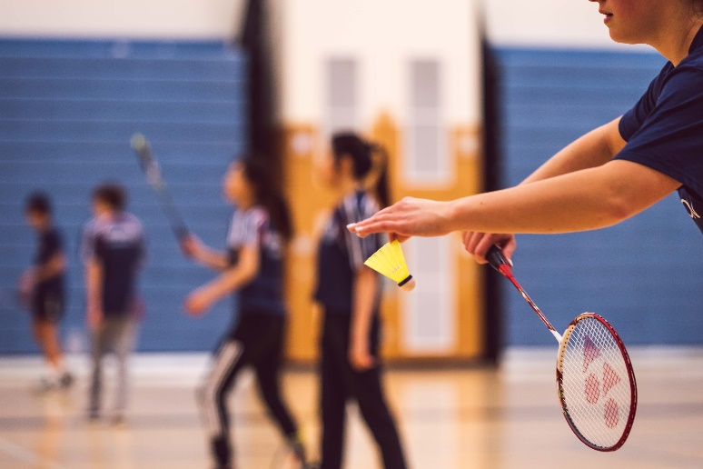

Additional resources, websites, and apps that you might find helpful
Websites
- Health fitness and wellbeing, physical benefits of physical activity – YouTube
- workout for Teenagers – YouTube
- 8-minute workout for teens – YouTube
- 5 minutes brain break workout for teens – YouTube
- Study Break Routine – YouTube
- 20 minutes beginners’ cardio HIIT for Teens – YouTube
- 30-minute home workout for beginners – YouTube
- 15 min dance party workout – YouTube

Websites
- Six online workout classes for Teenagers with YouTube clips
- Better Health Get Active Apps

Signposting to Support
For additional support we recommend that trusted adults use these resources to support children and young people access support when required:
- Anna Freud Centre – On My Mind
- Kooth.com
- Explore counselling/therapy
- Childline 0800 1111 when contacting ChildLine what to expect?
- Hopeline 0800 068 41 41 offering confidential support and practical advice
- Text ‘SHOUT’ to 85258 for free, confidential, anonymous text support service
- Share any concerns about your mental health with your GP and Understanding Confidentiality
- NHS 111
- Southend, Essex & Thurrock Children and Adolescent Mental Health Service (SET CAMHS)
- Where to get urgent mental health support from: Advice from NHS

- SET CAMHS Instagram account

How to help a friend
- Invite them to do something active with you e.g., go for a walk, kick a ball about etc.
- Think with them about what activities you enjoy doing with promote you being active or exercise.
- Talk about the impact being active and exercise has on your physical and mental health.
- Find out what they do to be active and exercise.
- Talk about what other things you could do to be active and exercise.
- Suggest they look at this resource for ideas and support.
- Recommend that they follow the SET CAMHS Instagram account: set_camhs_nhs

The adult box (for professionals and parent/carers to read)

- Physical activity guidelines for children and young people - NHS
NHS Physical activity guidelines for children and young people.

- Help your kids get more physical activity - Move Your Way | health.gov
Help your kids to get more physically activity.
- Exercises for Adults & Adults NHS Inform
Information about great ways of both you and your child achieving your recommended level of physical activity is to do things to together that involves physical activity.

- PSHE Education teaching resources
PSHE association for schools and teachers in relation to specific resources focusing on physical activity and exercise to support curriculum planning and lesson delivery.

- Active Essex
Active Essex is the Physical Activity and Sport Partnership for Essex, Southend, and Thurrock, and are one of 43 Active Partnerships in England who collaborate with local partners to ensure the power of physical activity and sport can transform lives. Providing children with the motivation, confidence, physical competence, knowledge, and understanding to value and take responsibility for engagement in physical activities for life will much more likely result in an active adulthood. Ensuring children and young people begin an active start to life, does go further than just what they participate in and can access at school and on this page you will find a range of activities which can be enjoyed by the whole family!

