Let’s Talk: getting males to talk about mental health
Secondary +

This resource is part of our self-care suite of resources and has been co-produced with children and young people living in Essex, for children and young people. They have also been developed and quality assured by the following stakeholders:
- Essex Educational Psychology Service
- Essex Health Watch
- Essex Mental Health Support Teams (MHSTs) NELFT NHS Foundation Trust
- Essex Multi-schools Council
- Essex Social, Emotional and Mental Health (SEMH) strategy team
- HCRG care group Child and Family Wellbeing Service
- NELFT NHS Trust Southend, Essex, and Thurrock (SET) Child, Adolescent and Mental Health Service (CAMHS)
- Professionals in schools and settings can access all these resources via the Essex info link SEMH portal. Children and young people (CYP), parents/carers and professionals can also access these resources via the SET CAMHS website. Our self-care content can also be accessed via SET CAMHS Instagram account:

The resources are intended to be accessed by CYP independently or trusted adults use these resources with CYP through 1:1 conversation, whole school/group discussion and assemblies.
Please note: some of the content within our self-care resources may be emotive for CYP. We recommend that you make use of the ‘signposting to support’ section of this document should any of the content be triggering.
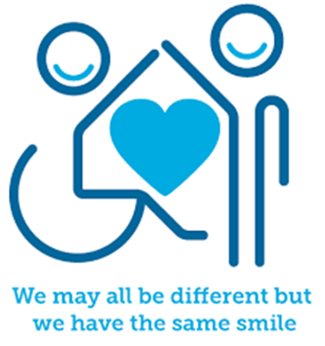

Introduction
“Be proud. Be hopeful. Be assertive. Be respectful.

Enjoy the things that make YOU a man, and do not tolerate any suggestion that we must all behave in a certain way to fit the male stereotype.”

(Henry Bullock - Youth Advisor, Boys in Mind, May 2020)

We all have mental health. Research shows that males commonly avoid seeking help for their mental health and often try to manage them on their own. Unfortunately, if left unsupported this can lead to unhealthy coping strategies, anxiety, depression, loneliness, and suicide.
The Priory reported that:
- 77% of men polled have suffered with common mental health symptoms like anxiety, stress, or depression.
- 40% of men have never spoken to anyone about their mental health.
- 29% of those who haven't done so say they are "too embarrassed" to speak about it, while 20% say there is a "negative stigma" on the issue.
- 74% of all suicides in the UK involve men.
- Suicide is the second biggest cause of death in young males (1-19 years old).
(Priory 2023)
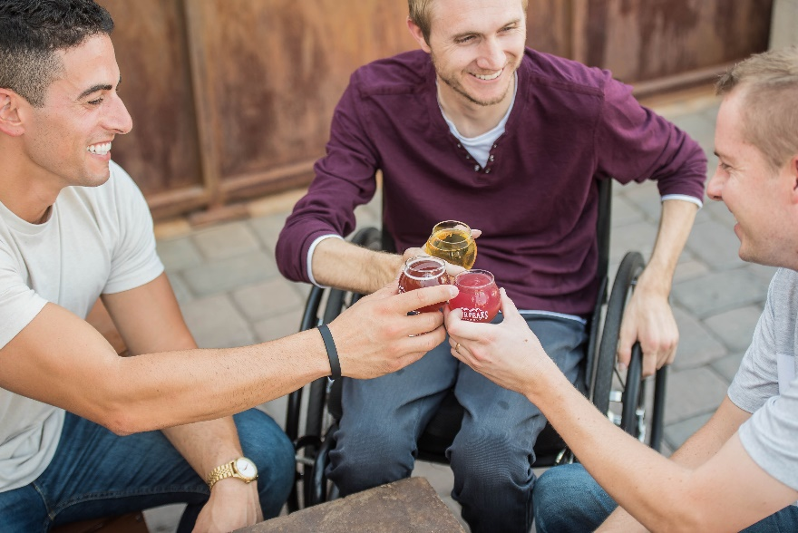

Facts
Mental Health:
- We all have mental health, and it is as important as our physical health.
- We all need to look after our mental health.
- Mental health refers to anyone's state of mental and emotional well-being, whilst mental illnesses are diagnosable conditions that affect the way we think, feel communicate, behave, and interact with others.
- Males can find it hard to talk about their emotional wellbeing and mental health for a range of reasons. This includes societal views and pressures, and cultural influences from family, religion, peer group, community groups and schools etc. This can lead to loneliness and isolation and affect their confidence, self-esteem, resilience, levels of anxiety and mood.

Myth Buster
- Talking about your mental health won’t help and
just make it worse X
- Males don’t talk about their mental health X
- Males don’t have emotions X
- Males just must get on with it X
- Other males won’t understand what I’m going through X
- People will laugh or take the mickey if I share
how I’m feeling X
- If males share their feelings they are ‘weak’ X
- Males need to be ‘strong’ X
- It’s bad to seek support and health for my mental health X
- Experiencing mental health difficulties is something
To be ashamed of X

Video clips
Check out these videos about self-care:
- A message to young men - video
Boys in Mind (BIM) have made a message for young men.

- School-Link: Caring for mental health
A video clip for Ks2 pupils about caring for mental health needs for children and young people.

- Hear my voice
Young minds hear my voice poetic unity poem by Aaron.

- Sinking feeling
Papyrus prevention of young suicide
*Warning: this video may be triggering as it refers to suicide*

- A new way to tackle male depression
BBC – Prince William breaks down a new way to tackle male depression.

- Masculinity is not what you see on TV
The Guardians Modern Masculinity Series.

- Premiership football stars and Prince William discuss mental health
BBC

- Heads Together and the FA
Heads together and FA partnering up to promote talking about mental health.

- Loose Men Richard, Jordan, Rob, and Martin open up about mental health
Talking about the quality of conversation about mental health and writing down what you really need to talk about. *Warning: This video contains content around suicide which may be triggering. Please take care of yourself and seek support. Please see some of suggested support below.

- Is there pressure to be ‘manly’ in today’s society?
Loose Men Vernon, Tommy, Paul, and Martin talk about the rise in more lads feeling 'inadequate' or 'not good enough'.

- What does masculinity mean to modern men?
BBC Sport have produced a Man up: part 1.

- How do men battle against depression and suicidal thoughts?
BBC Sport have produced a Man up: part 2.
*Warning: This video contains content around suicide which may be triggering. Please take care of yourself and seek support. Please see some of suggested support below.

- How do men battle with body image?
BBC Sport have produced a Man up: part 3.

Resources
- Britain Gets Talking
Downloadable printable PDF self-help activities.

- A self-care action plan
Video clip talking about making a self-care plan

- Young Minds self-care
A guide for young people about self-care

- Self-care strategies
Explore a library of self-care activities examples to try

- Making a self-care plan
Create a self-care plan for young people in secondary school and College

- Every Mind Matters & Heads Up Campaign & Mind Plan
Get your every mind matters mind plan

Reflective questions
(Try exploring these reflective questions with a CYP)
- How are you feeling?
- List/think of 4 different ways you can look after your emotional wellbeing and mental health?
- Who would make up your support network if you wanted/needed to speak to someone about your mental health?
- Which organisations could you go to if you needed support around your mental health? (See the support section in this resource for examples)
- How often do you check in with your friends and talk about their mental health and how they are feeling?

Quiz of 5 questions per theme
Once you’ve gone through this resource with a CYP try this quiz questions with them:
- In the priory research what are the percentage of males that have experiences challenges with their mental health e.g., anxiety, stress, and depression?
- In the priory research what was the percentage of men that have never talk about their mental health?
- Can you recall 5 myths about myths around males’ mental health that we need to bust?
- Name three well known males in the public eye who advocate the importance of talking about males mental health?
- Name 5 different self-care strategies?

Additional ideas
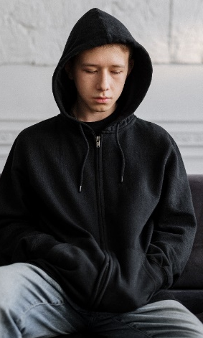
Other things to try:
- Self-care Toolkit
Tools and ideas to support children and young people to explore and start creating their own self-care toolkit

- Mood Journal
Describing the use of a mood journal
- Mindfulness Calendar
Offering a range of daily 5-minute mindfulness activities to try

- Headspace for Kids
A series of video clips that teach self-regulation skills for
children and young people.

Signposting to Support
For additional support we recommend you:
- Mental health short story
Man up – mental health short documentary.
*Warning: This video contains content around suicide which may be triggering. Please take care of yourself and seek support. Please see some of suggested support below.
- Anna Freud Centre – On My Mind
- Kooth.com
- Explore counselling/therapy
- Childline 0800 1111 when contacting ChildLine what to expect?
- Text ‘SHOUT’ to 85258 for access to their 24/7 textline
- Hopeline 0800 068 41 41
- MINDJAM Mentoring and Counselling services through gaming.
- Share any concerns about your mental health with your GP and Understanding Confidentiality
- NHS 111
- Southend, Essex & Thurrock Children and Adolescent Mental Health Service (SET CAMHS)
- Where to get urgent mental health support from: Advice from NHS

How to help a friend
- Start a conversation with your friend about how they are feeling.
- Start a conversation about self-care.
- Talk to your friend about the things you do to support your self-care.
- Ask what your friends does to support their self-care.
- Suggest they look at this resource for ideas and support.
- Recommend that they follow the SET CAMHS Instagram account: set_camhs_nhs
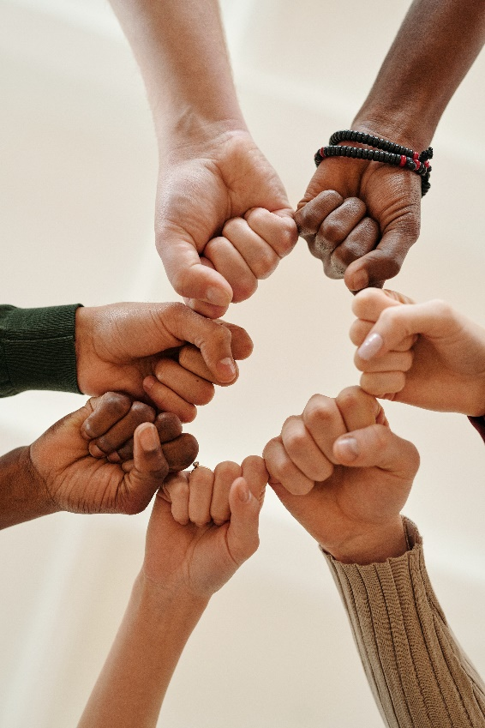
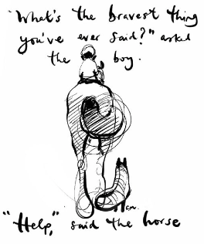

The adult box (for professionals and parent/carers to read)
- How to talk to your teens about self-care
Blog that shares top tips about talking to teens about self-care.
- Worried about your teenager?
The NHS provide some advice and guidance about how to notice early warning signs and signposting to support.

- Talking to your child about feelings
The NHS provide some advice on talking to your child about their feelings.

- Stem4 Supporting Teenage Mental Health
Advice on how to support boys and young men’s mental health.

- Brightline talking to kids and teens about mental health
9 tips for talking to kids & teens about mental health.

- Looking after yourself as a parent/carer
Young minds offer advice about supporting yourself whilst support a child/young person’s mental health. This link includes parents A-Z mental health guide, how to talk to your child about mental health, getting help for your child, how to set up a parent support group, parent helpline and webchat and a parent blog.

- Gaming courses and qualifications for young people
Enemy of Boredom are offering a unique opportunity to support people that think differently using video game design to build futures. They have small cohorts and support students with both accredited education and social opportunities with likeminded peers.

- Teaching about emotional wellbeing and mental health
PSHE association have lesson plans from Ks3 – 4 to support schools and settings teach about mental health to their pupils.

