Let’s Talk: getting boys to talk about mental health
Primary

This resource is part of our self-care suite of resources and has been co-produced with children and young people living in Essex, for children and young people. They have also been developed and quality assured by the following stakeholders:
- Essex Educational Psychology Service
- Essex Health Watch
- Essex Mental Health Support Teams (MHSTs) NELFT NHS Foundation Trust
- Essex Multi-schools Council
- Essex Social, Emotional and Mental Health (SEMH) strategy team
- HCRG care group Child and Family Wellbeing Service
- NELFT NHS Trust Southend, Essex, and Thurrock (SET) Child, Adolescent and Mental Health Service (CAMHS)
- Professionals in schools and settings can access all these resources via the Essex info link SEMH portal. Children and young people (CYP), parents/carers and professionals can also access these resources via the SET CAMHS website. Our self-care content can also be accessed via SET CAMHS Instagram account:

The resources are intended to be accessed by CYP independently or trusted adults use these resources with CYP through 1:1 conversation, whole school/group discussion and assemblies.
Please note: some of the content within our self-care resources may be emotive for CYP. We recommend that you make use of the ‘signposting to support’ section of this document should any of the content be triggering.
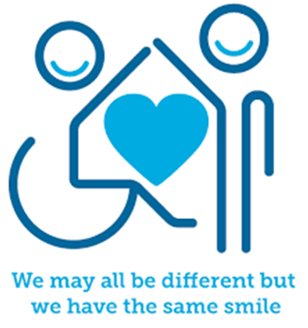
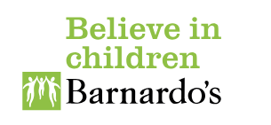

Introduction
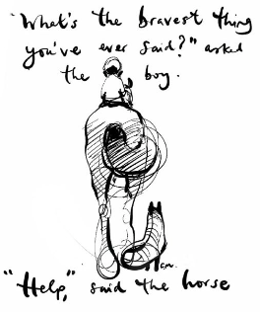

(By Charlie Mackey)

We all have mental health. Research shows that males/boys commonly avoid asking for help when they need it. Unfortunately, if left unsupported this can lead to feeling sad, lonely, stressed, overwhelmed, left out, and anxious.
Facts
Mental Health:
- We all have mental health, and it is as important as our physical health.
- We all need to look after our mental health.
- Mental health describes the health of our mind.
- Boys can find it hard to talk about their mental health for a range of reasons. This could come from the way our family and friends talk about mental health as well as the way our school and clubs talk about and support our mental health. Negative views about mental health can stop boys talking about their feelings and this can lead to them feeling lonely and isolated. It can also affect their confidence, self-esteem, resilience, levels of anxiety and develop feelings of sadness and low mood.

Myth Buster
- Talking about your mental health won’t help and just make it worse X
- Boys shouldn’t talk about how they are feeling X
- Boys don’t have emotions X
- Boys should just get on with it X
- If you cry you’re a ‘cry baby’ X
- ‘Big boys don’t cry’ X
- People will laugh or take the mickey if I tell them how I’m feeling X
Video clips
Check out these videos about self-care:
Kids Academy What mental health is (KS1 & KS2)
What mental health is and why it’s important to take care of it

- School-Link: Caring for mental health (KS2)
A video clip for Ks2 pupils about caring for mental health needs for children and young people.

- Bridge the Gap (KS1 & KS2)
Video clip describing mental health and offers some ideas on ways to support your mental health. For age 5+
- Kids want to know (KS2)
Video clip that explains why we lose control of our emotions
- Anna Freud: Talking about Mental Health (KS2)
A video describing what mental health is and how to get help.

Resources
- Self-care strategies (KS2)
Explore a library of self-care activities examples to try

- Making a self-care plan (KS2)
Create a self-care plan for young people in primary school

- Childline Toolbox (KS2)
However, you're feeling, we’re here to help. Take your mind off things with games, use our tools to find ways to cope or get creative and let your feelings out. It’s all in your handy toolbox.

- The way I feel (KS1)
Mrs S, narration of the book ‘The way I feel’ by Janan Cain.

- The Colour Monster (KS1)
Mrs colour monster narrated by Mr Joshua Brooks.

- Twinkl mental health resources (KS1)
What is mental health PowerPoint presentation

Reflective questions
(Try exploring these reflective questions with a CYP)
- How are you feeling?
- Can you think of a time when you felt sad? What helped you to feel better?
- Can you think of a time you felt worried? What helped you to feel better?
- Can you think of a time when you felt angry? What helped you to feel better?
- Name 5 people you could go to if you needed help?

Quiz of 5 questions per theme
Once you’ve gone through this resource with a CYP try this quiz questions with them:
- What is mental health as important as?
- Can you think of a myth about mental health?
- Why might boys not talk about their mental health?
- What activities can you do to support your mental health?
- Which service has a toolbox designed to support children and young people’s mental health?

Additional ideas
Other things to try:
BBC Teacher’s health and wellbeing videos for ages 5 to 7
Four series of videos, suitable for use in health and wellbeing education lessons with primary school children at Key Stage 1 in England, Wales, and Northern Ireland, and at 1st Level in Scotland.

- Headspace for Kids
A series of video clips that teach self-regulation skills for children and young people.

Signposting to Support
For additional support we recommend you:
- Getting help for your child: where to start
- Childline 0800 1111 when contacting ChildLine what to expect?
- Hopeline 0800 068 41 41 offering confidential support and practical advice
- Text ‘SHOUT’ to 85258 for free, confidential, anonymous text support service
- NHS 111
- Southend, Essex & Thurrock Children and Adolescent Mental Health Service (SET CAMHS)
- Explore counselling/therapy
- Where to get urgent mental health support from: Advice from NHS

- SET CAMHS Instagram account

How to help a friend
- Start a conversation with your friend about how they and/or you are feeling
- Talk to your friend about the things they enjoy doing to make themselves feel good/better
- Share with them the things you enjoy doing that make you feel good/better
- Give some friends some advice about speaking to someone they trust if they are feeling sad, unhappy, scared, frightened, lonely, stressed or overwhelmed.

The adult box (for professionals and parent/carers to read)
- Talking to your child about feelings
The NHS provide some advice on talking to your child about their feelings.

- Looking after yourself as a parent/carer
Young minds offer some advice about supporting yourself whilst support a child/young person’s mental health. This link includes parents A-Z mental health guide, how to talk to your child about mental health, getting help for your child, how to set up a parent support group, parent helpline and webchat and a parent blog.

Teaching about emotional wellbeing and mental health
PSHE association have lesson plans from Ks1 – 4 to support schools and settings teach about mental health to their pupils.

