Quality Assurance Framework
January 2023
  - Summary document of the Essex SEND Quality Assurance Framework

Introduction
A revised process and framework for the quality assurance of EHCPs was implemented across the Essex SEND system in October 2021. The process, criteria and responsibilities are subject to regular review to ensure the model is effective, learning is disseminated, and improvements made as a result. This document sets out the agreed quality assurance process and framework following the review in Autumn term 2022.

Principles
The Essex quality-assurance framework provides a structure through which managers, leaders, partners and stakeholders can analyse the quality of planning, support and compliance with statutory responsibilities, local and national guidance, so that children and young people with SEND in Essex can achieve positive outcomes and pursue their aspirations successfully.

Our approach to quality-assurance is informed by five core principles.
- Participation: we will listen to and engage co-productively with children and young people and parents / carers.
- Responsibility and accountability: all professionals take responsibility and are accountable for the quality of their work, including being prepared to explain their judgements and actions to people who use Essex services, to senior leaders, and to the public.
- A culture of shared learning and understanding through the process of QA: we will engage pro-actively in the process of quality-assurance, take on board feedback and development opportunities, and promote a learning organisational culture.
- Dynamic collaborative feedback and review: we will pro-actively seek out and welcome regular collaborative feedback and review from those using Essex services.
- Consistently high-quality and impactful: we seek to improve our support continuously to ensure a consistently high-quality offer across the county. Our work around quality-assurance is designed to have a direct impact on improving experiences and outcomes for children and young people and their families.

Process of Quality Assurance
Regular scrutiny of the quality of EHC plans and planning is done at three levels, shown below:

Figure 1: The three levels of QA activity in the Essex SEND system

The quality-assurance activity that takes place at each level is set out in the table below. At each level, leaders and managers will come together to consider a sample of EHCPs using a standard framework (Annex A).

Level | Process | Outcome | Frequency | Who is involved
Level 1:  Individual SEND service level | Light-touch quality-assurance of all new EHCPs.  - Colleagues responsible for reading and signing off draft EHCPs allocate a single, overall score for each draft EHCP.  - 1 outstanding | 2 good | 3 requires improvement | 4 inadequate).  - Consistent criteria are used to determine the 1-4 score.  - This is recorded by each quadrant and collated centrally.  - Draft EHCPs judged less than ‘Good’ are not issued. Amendments are made to raise the quality to at least ‘Good’. | No EHCPs judged to be inadequate or requires improvement are issued.  Managers and leaders can track the proportion of draft EHCPs of each grade, that are drafted and issued. | Routine  Reported monthly | The resourcing panel (in line with the Essex scheme of delegation)  SEND Operations Lead minimum.
 | Light touch quality assurance of written advice.  - Leaders and Team Managers quality assure a 10% sample of reports provided by their service.  - This is a light-touch exercise, providing an overall score (outstanding | good | requires improvement | inadequate. | No inadequate reports are issued or provided to the SEND Operations Team as part of the EHCNA process. | Routine | Team managers of services providing reports, plus:  Social Care – SEND Development Officer  Health – Designated Clinical Officer  Educational Psychology Service – peer review and Principal Educational Psychologist.
SEND Strategy | SEND Strategy: Full QA of one plan (specific area of need)  - Each area of SEND Strategy (SEMH, SLCN, Autism, Participation, Sensory, PfA, and Cognition and Learning) undertakes a full QA exercise of at least one new plan, or one recently amended plan  - Plan chosen by SEND Strategy Delivery Partner, to include age ranges and localities  - Considering the EHCP and written advice / reports  - Using the template in Annex A | Continuous improvement cycle is embedded across partners.  Local intelligence has a direct impact on the quality of plans, training and development. | Termly | SEND Strategy Leads  Senior Specialist Educational Psychologist  SEND Strategy Delivery Partner
Level 2: Multi-agency level | Quadrant: Full QA of one plan  - Each quadrant SEND Joint Working Group undertakes a full QA exercise of one new plan, or one recently amended plan  - Considering the EHCP and written advice / reports  - Using the template in Annex A  - Plans chosen will be either random, or selected based on local improvement priorities | Continuous improvement cycle is embedded across partners.  Local intelligence has a direct impact on the quality of plans, training and development. | Termly | SEND Joint Working Group  Each quadrant has a SEND Joint Working Group, who’s terms of reference includes QA of plans.  Quadrant Manager lead.
 | Countywide: Full QA of four plans  - A full quality-assurance exercise of one new plan, or one recently amended plan from each quadrant  - considering the EHCP and written advice / reports  - using the template in Annex A  - Plans chosen will be either random, or selected based on countywide improvement priorities  - The group will collaboratively QA the EHCPs as well as identify areas for improvement.  - The SEND Strategy and Innovation representatives are responsible for logging the QA and improvement proposals, initiating and driving improvement activities and monitoring impact via the Co-ordination and Oversight Groups. | Continuous improvement cycle is embedded.  Improvement priorities are informed by the ongoing improvement in quality of plans.  Consistency is reviewed and learning is shared across the county. | Termly | Dedicated countywide multi-agency quality-assurance meeting.  - Head of SEND Strategy & Innovation  - SEND Transformation Lead  - 1x Assistant Director  - 1x Quadrant Manager  - 1 x SEND Operations Lead  - 1 x Quadrant Senior Educational Psychologist (or IPL);  - 1x Children’s Social Care Manager  - 1x Designed Clinical Officer  - 1 x Health Provider representative  - 1x Essex Family Forum representative  - 1x SENDIASS representative  - School, Setting representative  - SEND Delivery Partner  There will be a rota of attendance for roles duplicated across the county.
Level 3: Strategic governance level | COG and SEND Partnership Board  - A data report of the outputs of the level 1 QA of all draft plans is shared with the Quality of Plans COG  - Learning from the sample of advice at service level is shared with the Quality of Plans COG, via health and social care  - Learning from Quality Assurance Activity sessions are held termly, with the qualitative and quantitative information from level 1 and 2 quality assurance activity.  - The above are both used to inform ongoing improvement priorities, training and development needs at a whole system level.  - Escalations are made to the SEND Partnership board, to inform them of the current level of quality of new EHCPs being issued across Essex. | The COG monitors the overall quality of new plans across the county on an ongoing basis.  Leaders are well informed of the quality of planning and support, as well as compliance with statutory responsibilities. These can shape future improvement priorities as a result. | Monthly report  Bi-monthly COG meetings  Bi-monthly SEND Partnership Board Meeting | SEND Strategy & Innovation  SEND Quadrant Managers  SEND Operations Leads  SEND Inclusion & Psychology Leads  Designated Clinical Officers – health  SEND Development Officer – Social Care  Service Manager – Social Care  Members of the SEND Partnership Board.

Recording and Reporting
Level of QA | Description | Recorded | Report frequency | Reports sent too
Level 1 | Weekly QA on every Needs Assessment Report (NAR) | Special School funding - NAR new banding spreadsheet | Monthly | SEND Management Team, Quality of Plans COG and escalation to SEND Partnership Board
Level 2 | QA at SEND Working Group | Special School funding - QA recording for Vanessa | Termly | Quality of Plans COG and SEND Partnership Board
Level 2 | Multi-Agency QA | Multi-Agency QA of EHCPs Team | Termly | Quality of Plans COG and SEND Partnership Board

Feedback from children, young people and families
Feedback from children, young people and their families on their experience of EHC plans and planning is under development.
Communications about the EHC needs assessment, engagement in co-producing their EHCPs and their experience of annual reviews is currently gathered through routine mechanisms, including, but not limited to the following:
- Feedback survey included with each new EHCP
- Essex Family Forum Graffiti Wall – with information fed into the Communications & Intelligence COG
- Direct discussion with families to capture their feedback, via the quadrant team and the SEND Navigator team

Feedback received through compliments and complaints
Senior leaders of SEND in Essex will routinely analyse compliments and complaints made directly to the local authority or partner agencies, or through the relevant ombudsman, as well as cases that have gone to mediation and appeals to the Tribunal, and the decisions reached in those cases. These will be analysed through team and leadership meetings, and themes escalated to the bi-monthly meetings of the SEND Partnership Board as needed.

Framework for Quality Assurance (Annex A)
This document sets out the consistent criteria to be used for the different levels of QA set out above.

Light touch QA of all draft plans:
SEND Operations Leads record a single judgement, whether the draft plan is inadequate, requires improvement, good or outstanding.
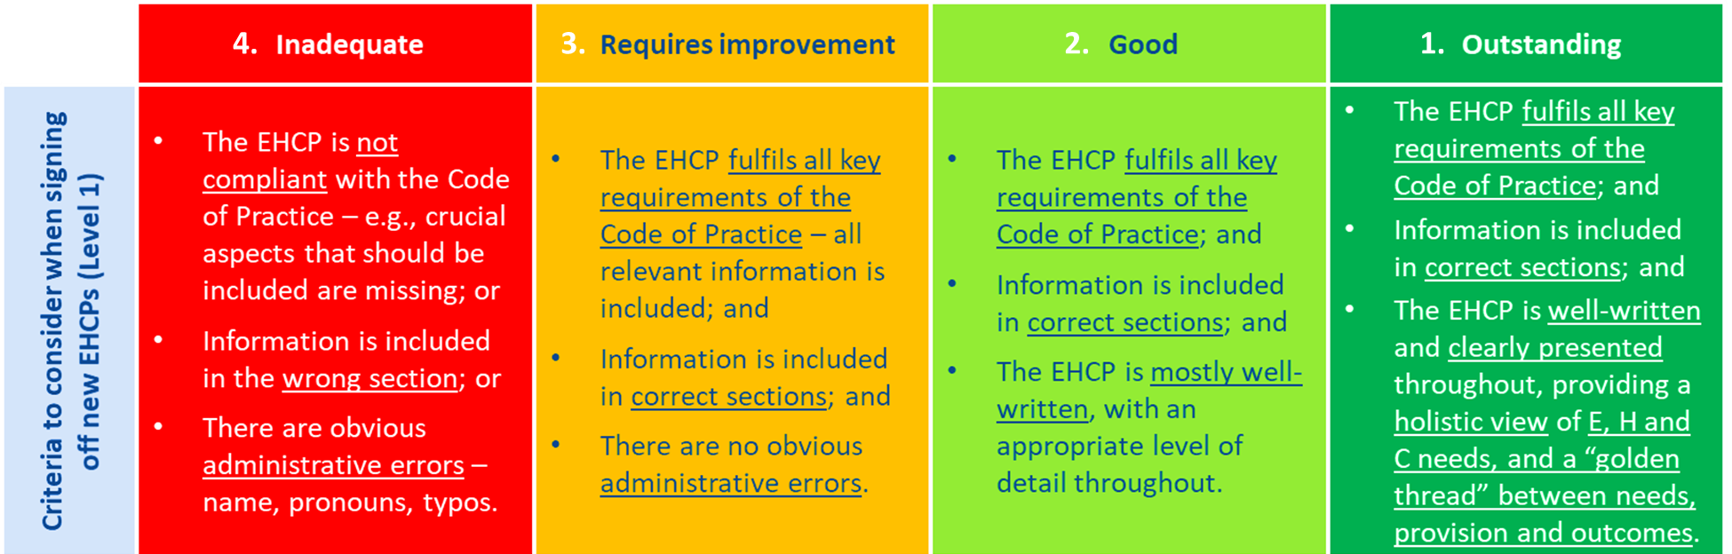
Figure 2: Criteria for light-touch QA of all draft EHCPs

Full Quality Assurance (QA2)
Full QA (QA2) is structured around the 11 sections of the EHCP. Each section contains a small number of descriptors of good practice, derived from the SEND COP. For each section the QA team will be asked to record:
- Quality score for each section:
  - using the scale below and the descriptors for each section, enter a score (1-4) for each section.
- Commentary:
  - record key strengths, areas for improvement and rationale for the score

- Quality score for the overall plan
  - Considering the above, a score for the plan, as a whole

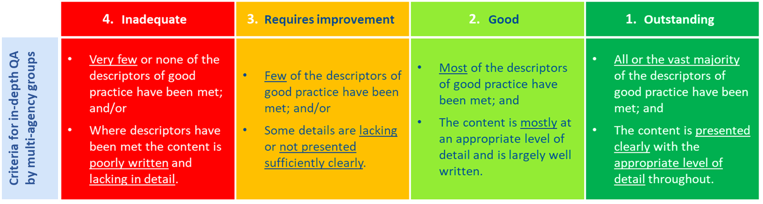Figure 3: Criteria for the full QA of plans by multi-agency groups

EHCP quality-assurance framework: Descriptors
Section of the EHCP | Descriptor of good practice | Quality score  1 Outstanding | 2 Good | 3 Requires improvement | 4 Inadequate | Commentary  Strengths | Areas for improvement
Section A: Views, interests and aspirations | - This section captures the child / young person as a person, rather than as a set of needs. It captures the child’s / young person’s views, interests, and strengths in depth, as well as their hopes, aspirations and goals for the future (for example, securing paid employment, independent living, full participation in community activities).  - Captures the child’s / young person’s history succinctly and accurately – including family background, educational history (placements, current academic levels), involvement of health and care services. The EHCP describes the people who support the family. This may include a one-page profile, or equivalent, making clear when the one-page profile was produced.  - This section specifies how child / young person has been engaged, how their views were gathered, and how they have contributed to the EHCP. It is clearly indicated when the child / young person is being quoted directly, or when their views are being reflected. Throughout the section, it is made clear whose voices is being reflected – where it is the child / young person and where it is the parent / carer.  - This section includes summary of how to communicate with the CPY and include them in decision-making.  - Captures the parents’ / carers’ views and aspirations.
Section E: Outcomes | - Outcomes reflect the child’s / young person’s hopes, aspirations and goals (section A) and needs (sections B, C and D), as opposed to reflecting the perspective of a specific service.  - Outcomes are set out clearly and in a SMART format, with a clear link between outcomes and the provision needed for them to be achieved.  - Outcomes are age-appropriate (as a minimum, distinct preparation for adulthood outcomes for young people aged 17 and over, while, as good practice, lifelong outcomes should be included in the EHCPs of young people of all ages, and certainly from Year 9 onwards).  - This section includes long-term outcomes, including education, health and care outcomes over the course of a key stage or equivalent. Arrangements for setting short-term targets at setting / school / college level or equivalent are specified.  - Clear monitoring and review arrangements for long-term outcomes, including key review dates, are included.
Section B: Special educational needs | - All areas of SEN / difficulties identified in the professional advice received, listed in Section K, are captured in the plan. Any conflicting advice about a child’s or young person’s SEN are addressed, indicating which professional report listed in section K advises of what, with the local authority’s position on this issue set out clearly.  - All areas of SEN / difficulties are set out clearly (e.g., numbered sub-sections, with titles that reflect the child / young person) and described in sufficient detail (type and severity). The description of the child’s / young person’s needs is linked clearly to established categories of SEN.  - As a minimum, for a child / young person in Year 9 and above, needs are identified relating to preparation for adulthood. (As good practice, needs relating to preparation for adulthood should be included in EHCPs for children and young people of all ages.)
Section C: Health needs relating to SEND | - The child’s / young person’s health needs, identified through the EHCNA, that relate to their SEN are set out clearly and in accessible language. If the child / young person has no health needs related to their SEN, this is made clear.  - Any health needs not directly related to the child’s / young person’s SEN, and their implications, are identified as such.
Section D: Social care needs related to SEND | - The child’s / young person’s social care needs, identified through the EHCNA, that relate to their SEN or require provision for a child under 18 (section 2, Chronically Sick and Disabled Person’s Act 1970) are set out clearly. If the child / young person has no care needs related to their SEN, this is made clear.  - Any care needs not directly related to the child’s / young person’s SEN are identified as such.
Section F: Special educational provision | - Provision is specified for every type of need identified in section B, and is proportionate to assessed severity of need, grounded in professional advice. Preparation for adulthood support specified, as a minimum for a child / young person in Year 9 and above.  - There should be a “golden thread” that connects each need to each type of provision, and how the overall provision will support the achievement of the outcomes specified in section E.  - Provision is detailed, specific and quantified (where applicable), presented in a clear and accessible way so that professionals in a setting / school / college would know how to implement it. The type of provision (Facilities, staffing, equipment), hours, frequency of support, level of expertise required, departure from national curriculum / study programmes, chronological age should be specified. Vague terms (e.g., “opportunities to …”) and non-specific language is avoided.  - The provision specified could be given to a setting / school / college for staff to put into place without substantial extra work to interpret Section F being required.
Section G: Health provision | - Provision matches each specific health need identified in section C.  - It is made clear how the provision specified will support the achievement of the outcomes specified in section E.  - Provision is clear, detailed, specific and quantified (type of support and who will provide it).  - From Year 9 onwards, the health care provision clearly specifies what is required to assist in the preparation for adulthood and independent living (where appropriate).
Section H1: Social care provision for a child or young person under 18, relating to the Chronically Sick and Disabled Persons Act 1970 | - Provision matches each specific care need identified in section D, specifically those relating to section 2 of the Chronically Sick and Disabled Persons Act 1970.  - All provision assessed as being required for a disabled child or young person under 18, under section 2 of the Chronically Sick and Disabled Persons Act 1970, is included in section H1. This could include practical assistance at home, relating to meals. relating to educational or recreational facilities, relating to travel, relating to holidays, as well adaptations to the home, or non-residential short breaks. Support for the parents / carers of a disabled child or young person is included if appropriate.  - It is made clear how the provision specified will support the achievement of the outcomes specified in section E.  - Provision is clear, detailed, specific and quantified (type of support and who will provide it).
Section H2: Social care provision | - Children’s social care provision identified through early help, children in need or safeguarding assessments for children under 18, or adult social care provision for young people aged 18 and over, are included in section H2.  - It is made clear how the provision specified will support the achievement of the outcomes specified in section E.  - Provision is clear, detailed, specific and quantified (type of support and who will provide it).
Section I: Placement | - The name and type of setting / school / college is clearly recorded (only on final EHCP). (If a parent / carer has decided to home educate, this is recorded clearly.)  - The EHCP makes clear if the placement is the preference of the parents / carers.  - It is unlikely that home-to-school transport would need to be mentioned in this section. The only reason for home-to-school transport to be mentioned would be if the parent or carer had chosen a mainstream school that is not the nearest suitable school. If the latter is the case, Section I should include the following exact wording: ‘Child X shall attend school A which is the parent’s preferred school. This is not the nearest suitable school, which is B school. The parent has accepted full responsibility for transport to their school of preference (school A). If, for any reason, the parent is unable to transport Child X to school A, arrangements will be made for Child X to transfer to the nearest suitable school.’
Section J: Personal budget | - The EHCP specifies whether a personal budget has been requested and agreed to deliver part of the provision.  - (If applicable) The EHCP specifies the provision, needs and outcomes that the personal budget is to help meet.  - (If applicable) The EHCP specifies the type of personal budget, the amount covered by the personal budget, arrangements / regulations relating to direct payments.
Section K: Advice and information | - Advice and information that has informed the EHCNA and EHCP is set out clearly – titles and dates of relevant reports.  - The final EHCP has been signed off by the relevant officer(s).  - All parties involved in the development of the EHCP are listed, including family advisory services if relevant.
Overall quality of the EHCP | - The EHCP will help secure the best outcomes across education, health and social care for the child/young person.  - Clear and accessible language is used throughout.  - There is a clear “golden thread” that runs between aspirations (section A), needs (sections B, C and D), advice (section K), provision (sections F, G and H), and outcomes (section E).  - There is clear evidence that the plan is the result of co-production with the child / young person, parents / carers and professionals, and that decisions about the content of the plan have been made openly and collaboratively.  - The EHCP will help prepare the child/young person for adulthood

Actions
After each quality-assurance discussion, key themes / areas for development will be collated and strategic actions agreed.
No. | Main areas for development identified | Improvement actions required
1.
2.
3.

Annex B: Framework for quality-assuring written advice
Introduction
A similar framework to the main EHCP quality-assurance framework can also be used to quality-assure individual pieces of written advice and reports. This allows for a more in-depth focus on individual items of written advice and reports, not only to inform the overall score for section K of the EHCP, but also to be able to identify any themes around the quality of advice from specific services that can then be addressed directly. Again, in quality-assuring written advice and reports, colleagues will be asked to provide (1) a quality score (using the scale below), and (2) commentary on key strengths and areas for development.

About the written advice / report
Case
Date
Service providing the report | - School / education setting  - Educational Psychologist  - Therapist  - Early help  - Children’s social care  - Hearing Impairment Service  - Visual Impairment Service  - Other (please provide details below)

Quality scoring grid
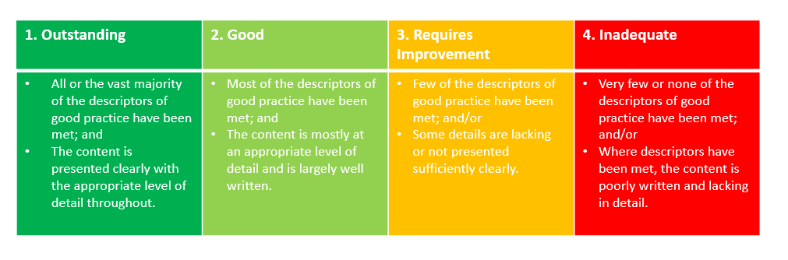
Figure 4: Quality scoring grid for QA of advice

Quality-assurance framework for written advice and reports
Aspect of the written advice / report | Descriptor of good practice | Quality score  1 Outstanding | 2 Good | 3 Requires improvement | 4 Inadequate | Commentary  Strengths | Areas for improvement
Presentation and accessibility of the advice | - Reasons for advice are clearly stated.  - Report is signed and dated.  - Advice is timely and reflects current need (in some cases historical information may inform advice).  - Advice is presented clearly and is easy to read. Complex terms or test results are explained.  - Advice is limited to the area of professional expertise.  - There is evidence of person-centred planning (how the assessment was conducted, focused on needs and outcomes not availability of provision).  - There is evidence of a golden thread – Aspiration, needs, outcomes, provision.
Aspirations, views and wishes of children, young people and their families | - The young person’s views are clearly captured and reflected in the report.  - The views of the parent / carer are clearly captured and reflected in the report.  - There is evidence about the young person and the parent / carer have informed the assessment.
Needs of the child or young person | - The type of need(s) of the child or young person is described clearly.  - The severity of need (for each type of need identified) is described clearly. The report makes clear if the severity of need is constant across the week and different settings, or whether it changes (e.g. at home or at school).  - The impact of the young person’s needs on learning and social interaction is described clearly.  - Detail about how professional judgements have been reached about the nature and severity of the young person’s needs (e.g. tests, one-off visit, regular observation, in a classroom and/or home setting).
Outcomes | - Outcomes should be set out clearly and in a SMART format.  - The outcomes should reflect the young person’s long-term aspirations.  - The report describes what needs to change and how changes in support / provision will benefit the young person.
Strategies and provision | - Provision should typically describe the type of support a child/young person needs, above what would be ordinarily available, is needed (e.g., “More of …”, “Different to …”) including the frequency, duration, the methods and the professionals who need to be involved in delivering it should be specific about all of the above without naming a particular school, nursery or other setting.  - Provision should identify what any additional adult time would be doing rather than just that more adult time is needed.  - Details are included about who is going to be responsible for providing this support / provision, and how this will be done (including if any specific training is required).  - Details are included about how this support / provision and its impact on outcomes will be monitored and reviewed, by whom, and when / how often.

Actions
After each quality-assurance discussion, key themes / areas for development will be collated and strategic actions agreed.
No. | Main areas for development identified | Improvement actions required
1.
2.
3.

Annex C: Process for Plans QA’d as less than ‘Good’
The below process is followed in each quadrant where a draft EHCP is rated as ‘inadequate’ or ‘requires improvement’, through the QA process.
- Draft EHCP is quality assured by SEND Operations Lead according to high level framework
- Feedback provided to plan writer (SEND Operations Co-ordinator)
  - If minimal changes required: SOL makes suggested amendments and provides feedback by way of ‘tracked changes’ and ‘comments’ to the plan writer as learning for the future
  - If more substantial work is required: SOL provides feedback to the plan writer and plan writer makes amendments, which may include gathering more evidence or clarifying information from the evidence already provided. Draft plan is QA’d again and graded separately.
- Plan is issued when graded at least ‘Good’
- Report provided by SEND S&I shows the number of plans which have been re-graded through the QA process

This information is issued by:
Essex County Council
Contact us:
SENStrategy@essex.gov.uk
www.essex.gov.uk
The information contained in this document can be translated, and/or made available in alternative formats, on request
Published November 2022.

