Let’s Talk: Sleep
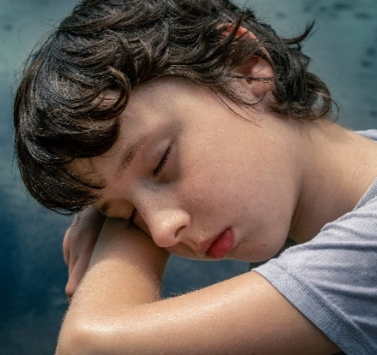
Primary

This resource is part of our self-care suite of resources and has been co-produced with children and young people living in Essex, for children and young people. They have also been developed and quality assured by the following stakeholders:
- Essex Educational Psychology Service
- Essex Health Watch
- Essex Mental Health Support Teams (MHSTs) NELFT NHS Foundation Trust
- Essex Multi-schools Council
- Essex Social, Emotional and Mental Health (SEMH) strategy team
- HCRG care group Child and Family Wellbeing Service
- NELFT NHS Trust Southend, Essex, and Thurrock (SET) Child, Adolescent and Mental Health Service (CAMHS)
- Professionals in schools and settings can access all these resources via the Essex info link SEMH portal. Children and young people (CYP), parents/carers and professionals can also access these resources via the SET CAMHS website. Our self-care content can also be accessed via SET CAMHS Instagram account:

The resources are intended to be accessed by CYP independently or trusted adults use these resources with CYP through 1:1 conversation, whole school/group discussion and assemblies.
Please note: some of the content within our self-care resources may be emotive for CYP. We recommend that you make use of the ‘signposting to support’ section of this document should any of the content be triggering.
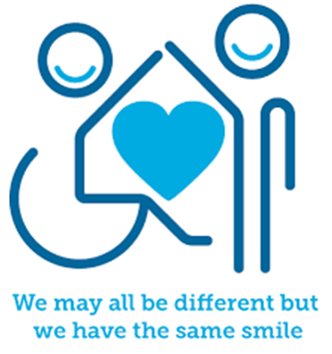

Introduction
Every living thing sleeps, from the smallest insect to the largest whale. Some animals spend as many as 20 hours a day sleeping! Sleep helps our body and brain develop and grow. Your brain needs sleep so you can process what you have learnt, pay attention, concentrate, solve problems, and think of new ideas. Your body also needs sleep to help your muscles, bones and skin grow, as well as mend if you are injured. Sleep also helps you to stay healthy and fight if you are sick. It is particularly important to create a good sleep routine.
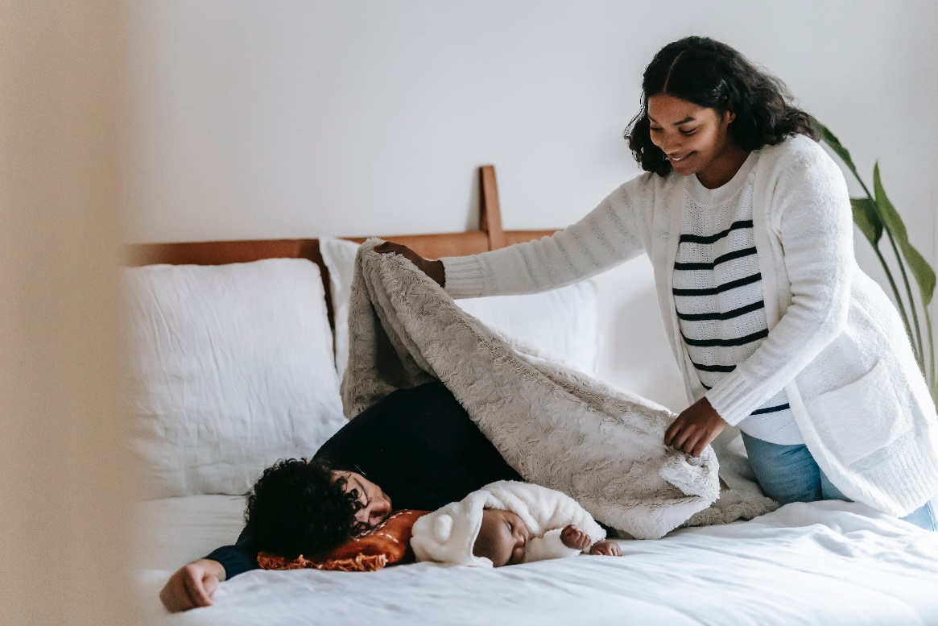

Facts
- Sleep is a need that everyone has
- Humans sleep for a third of their lives – approximately 20-30 years
- All species on our planet sleep
- Lack of sleep can affect concentration, your mood and memory
- The National Sleep Foundation tell us that on average children aged 3-5 years of age need 8-14 hours of sleep a night and children aged 6-12 years need between 7-12 hours’ sleep a night
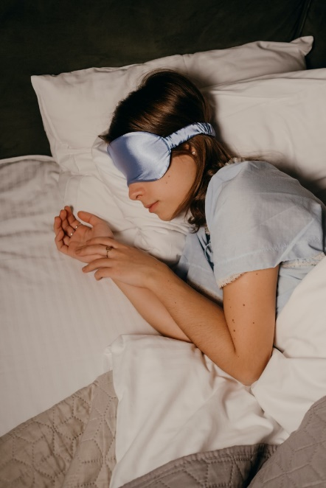
Myth Buster
Here are some myths about sleep:
- Your body gets used to lack of sleep X
- How long you sleep is all that matters X
- If you are having trouble falling asleep, stay in bed until you can X
- A warm bedroom temperature is best for sleeping X
- Sleeping with the light on is harmless X
- Napping makes up for a lack of night-time sleep X
- You can catch up on your sleep over the weekend X

Video clips
Check out these videos about sleep:
- Importance and Benefits of Sleep
A video to explain the importance of sleep and some of the common sleep disorders.

- The Importance of Sleep: 8 Scientific Health Benefits of Sleep + Sleeping Tips
A video to explain some key health benefits of sleep and sleeping tips

- Good Sleep Hygiene
A video to explain some tips for getting a good night’s sleep.
- Why is sleep important?
An NHS video for primary aged children about the importance of sleep

Resources
We have indicated whether the resources are accessible for Ks1 or Ks2. Please note that some of the ks2 content could be adapted and differentiated to support pupils in Ks1.
- The Sleep Charity Childrens Sleep Diary.pdf
A printable resource to help children establish sleep patterns. (KS2)

- Children’s Sleep eBook - The Sleep Charity
An eBook providing information, advice, hints, and tips to improve sleep. (KS2)

- Getting_a_good_nights_sleep_
An easy-to-read checklist to remind children about what to do and avoid before bedtime. (KS1 & KS2)

- The Sleep Charity editable bedtime routine checklist
A checklist for bedtime routines (KS1 & KS2)
- Sleep Meditation for Kids | THE SLEEPY RAINBOW | Bedtime Sleep Story for Children
A guided sleep meditation video for children (KS1 & KS2)

Reflective questions
(Try exploring these reflective questions with a CYP)
- What are the some of the benefits of sleep?
- What does sleep hygiene mean?
- What advice or tips would you give to a friend about getting a good night’s sleep?
- How can you improve your own bedtime routine?

Quiz of 5 questions per theme
Once you have gone through this resource with a CYP try this quiz questions with them:

- Why is sleep important/what are some of the benefits of sleep?
- How much sleep should we be having?
- What would be included in a good bedtime routine?
- What things are not recommended for a good night’s sleep?
- How long should you try to fall asleep for before getting up?

Additional ideas
Other things to try:
Sleep - Headspace
Learn how to create conditions for a more restful night’s sleep with this sleep music

Stop, Breathe & Think Kids: Focus, Calm & Sleep App Review | Common Sense Media
An app that offers guided meditation videos

Calm - The #1 App for Meditation and Sleep
An app that offers meditation, calming music and gentle stretching videos
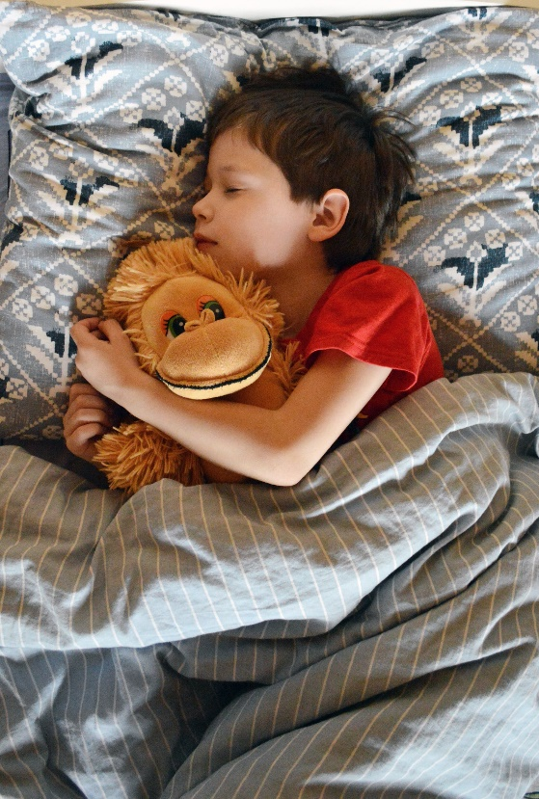
The Sleep Charity: Relaxation at bedtime
Advice that may help with relaxation at bedtime
Sleep for Kids
Teaching children the importance of sleep (KS1)

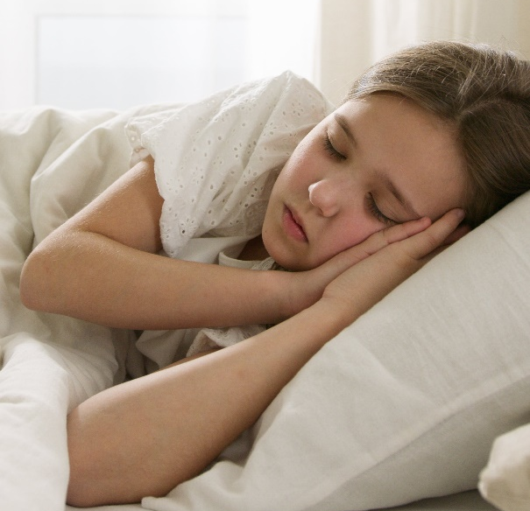

Signposting to Support
For additional support we recommend that trusted adults use these resources to support children and young people access support when required:
- NHS Every Mind Matters Sleep Advice and Tips
Top tips and videos about falling asleep faster and sleep better

- Advice Sheets - The Sleep Charity
Offering useful information for children, young people, and adults

- Save the children – Relaxation activities for children
Downloadable PDF of relaxation activities for children

- How to sleep better | Mental Health Foundation
This guide offers tips on how to sleep better - looking at improving the quality of your sleep, what causes sleep disorders and possible solutions, top tips from a sleep doctor, and a sleep diary template to help you keep track of your sleep and the possible reasons it happened.

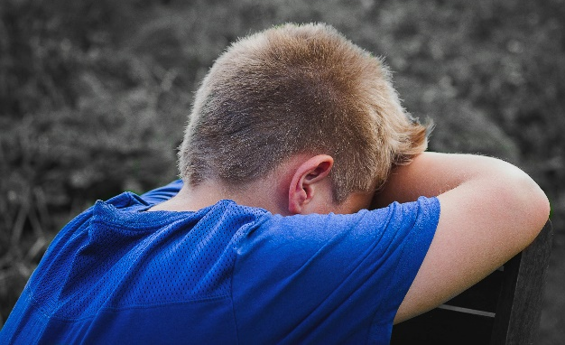

How to help a friend
• Ask how your friend(s) sleep.
• Have a conversation about the importance of sleep.
• Share with each other what your bedtime routine looks like.
• Talk about what you both/all do if you cannot sleep or want to get back to sleep if
you have been woken up.
• Describe how you feel if you have had a good night sleep and when you have had a bad
night sleep.

The adult box (for professionals and parent/carers to read)
- Children and Sleep | Sleep Foundation
Information and advice on the importance of sleep and tips to make sure your child gets a full night’s sleep

- Children – The Sleep Charity
Information on sleep problems, bedtime routines, bedroom environment, relaxation tips, diet and sleep, night terrors and support services.

- Sleep - Support for Parents from Action for Children
Sleep advice covering a range of topics

- Healthy Sleep: Healthier Together
Sleep advice for different age ranges

- Sleep problems in young children
Advice for parents on supporting children’s sleep

Sleep advice for children with SEND
- The Sleep Charity – Children with SEND
Advice that may help if your child is struggling to drop off or stay asleep

- The Sleep Charity – Diet and sleep
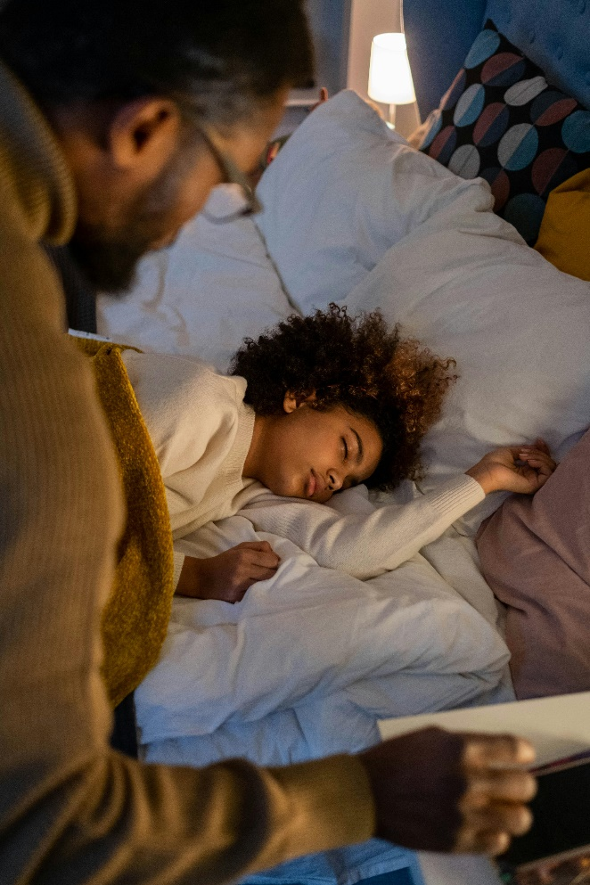
Advice on diet and how some foo ds can affect sleep.

