‘With a Little Kindness’
Soundtrack for Essex Emotional Wellbeing & Mental Health
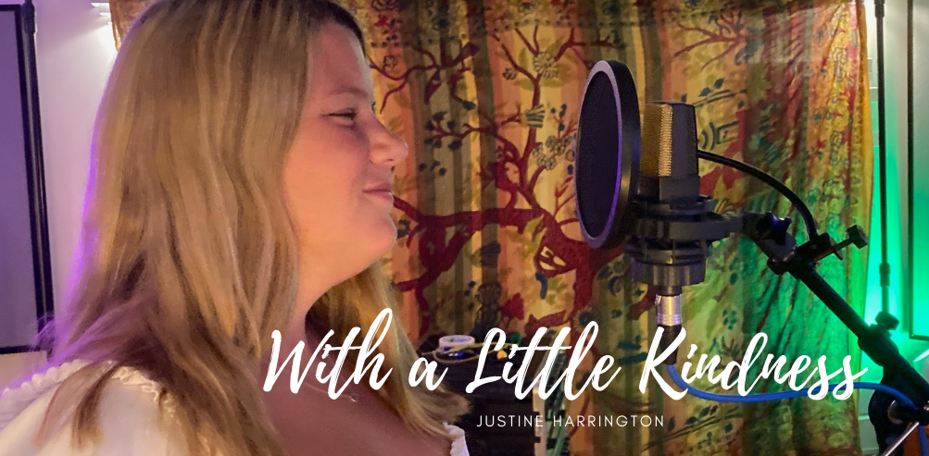
Released on Monday 6th September 2021
Written and produced by Multi-schools Council ambassador Justine Harrington and supported by Michael from Studio 6 in Witham. The track features some fantastic young people from across Essex and is aimed at promoting children’s mental health.
The song, which is backed by Essex County Council’s Social, Emotional and Mental Health Strategy Team, will be used as the official soundtrack for the Trauma Perceptive Practice (TPP) approach being rolled out across Essex schools/settings.
Download for free from any streaming site - search for ‘With a little Kindness’.
We want all educational settings to learn the song – for a copy of the lyrics please sign up to the Multi-schools Council by emailing mschoolscouncil@gmail.com
Look out for the album due for release on Tuesday 28th September 2021.

