Let’s Talk: Anxiety
Primary

This resource is part of our self-care suite of resources and has been co-produced with children and young people living in Essex, for children and young people. They have also been developed and quality assured by the following stakeholders:
- Essex Educational Psychology Service
- Essex Health Watch
- Essex Mental Health Support Teams (MHSTs) NELFT NHS Foundation Trust
- Essex Multi-schools Council
- Essex Social, Emotional and Mental Health (SEMH) strategy team
- HCRG care group Child and Family Wellbeing Service
- NELFT NHS Trust Southend, Essex, and Thurrock (SET) Child, Adolescent and Mental Health Service (CAMHS)
- Professionals in schools and settings can access all these resources via the Essex info link SEMH portal. Children and young people (CYP), parents/carers and professionals can also access these resources via the SET CAMHS website. Our self-care content can also be accessed via SET CAMHS Instagram account:

The resources are intended to be accessed by CYP independently or trusted adults use these resources with CYP through 1:1 conversation, whole school/group discussion and assemblies.
Please note: some of the content within our self-care resources may be emotive for CYP. We recommend that you make use of the ‘signposting to support’ section of this document should any of the content be triggering.
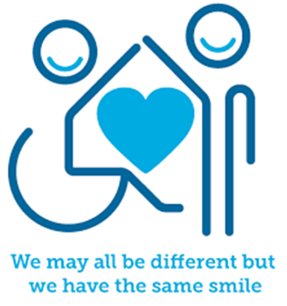

Introduction
Anxiety or worry is something that a lot of young people will experience at times, to differing degrees and for a range of reasons. A certain level of anxiety is normal, and it helps us to get things done or focus on something that needs our attention. Anxiety can, however, become more overwhelming sometimes with feelings of fear or panic. If the problem resulting in anxiety has gone but the feeling of fear or panic stays, or even gets stronger, that’s when anxiety can become a problem. How we address and manage anxiety can make a significant difference to our emotional and mental wellbeing, and the first steps to managing anxiety is to recognise we are anxious, know how it affects us and why.

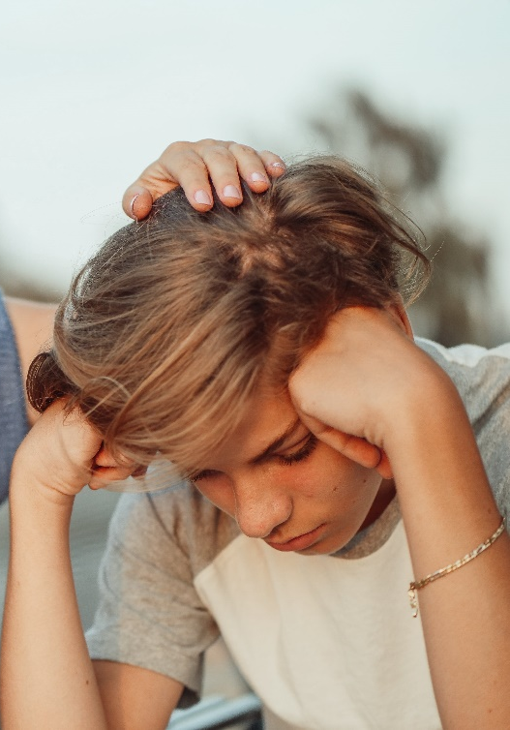
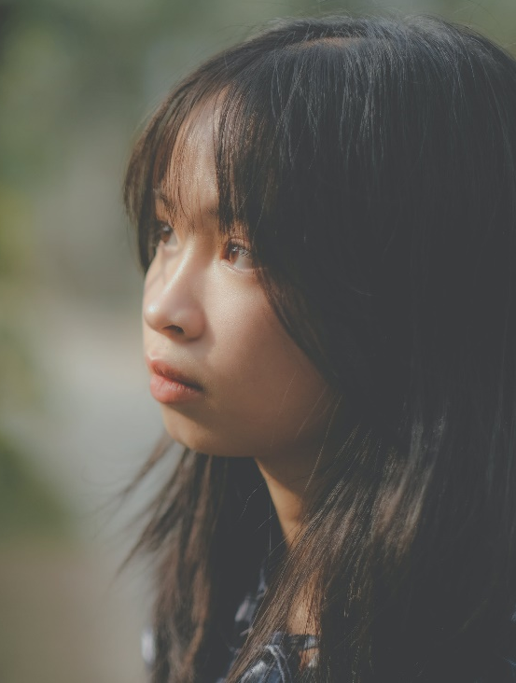

Facts
- Anxiety is a hormonal response from the body to get us ready to respond in different ways including ‘fight, flight and freeze’
- When we experience anxiety, our body releases a hormone called adrenaline. Anxiety can make us have physical symptoms such as headaches, tummy cramps, not wanting to eat and our heart beating faster
- Anxiety impacts on our thoughts, feelings, and actions and this can be helpful or unhelpful depending on the levels of anxiety
- Relaxation, Imagery and Distraction (RID) can help to manage anxiety

Myths
- Anxiety difficulties are not common X
- Anxiety always goes away on its own X
- People with anxiety should avoid stressful situations X
- Everybody experiences and responds the same way to anxiety X
- Anxiety only affects your mind X

Video clips - Check out these videos about anxiety:
- Let’s Talk about anxiety animation (KS2)
Anna Freud’s video to introduce anxiety and how to look after yourself

- BBC Teaches health and wellbeing videos for ages 8-11 years (KS2)
A series of videos which includes anxiety and panic attacks.

- Flipping your lid video – You Tube Clip: The Hand Model (KS2)
A model to show what happens to your brain when you experience stress and anxiety

- Calming your amygdala (KS2)
A strategy to support you calm your amygdala down using your hands

- Practical tips for dealing with anxiety (KS2)
Anxiety UK video offering practical tips to deal with anxiety

- How to cope with anxiety (KS2)
Childline’s video offering advice about how to cope with anxiety

Resources
We have indicated whether the resources are accessible for KS1 or KS2. Please note that some of the KS2 content could be adapted and differentiated to support pupils in KS1.

- Poster pupils WMHD (mentallyhealthyschools.org.uk) (KS1 & KS2)
How are you feeling chart and 6 things that can help you feel good.

- Talking mental health: animation & teacher toolkit | Anna Freud (KS1 & KS2)
An animation about mental health, including managing big and small feelings.
- How to Make a Self-Soothe Box | Young Person Blog | Young Minds (KS1 & KS2)
This self-soothe box for Ks2 children can be adapted for Ks1.
- Stress and anxiety | The Children's Society (childrenssociety.org.uk) (KS2)
Explains what stress is, what causes it and how to manage it.
- Wellbeing activities: managing stress | British Red Cross (KS2)
Learning how to manage wellbeing can help us cope with change and challenges.
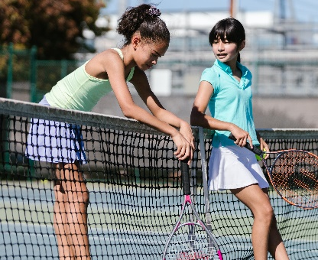

Reflective questions - Try exploring these reflective questions with a CYP
- What is anxiety and how might we know when we are feeling anxious?
- How does the adrenalin in our bodies prepare us?
- How might anxiety affect us emotionally?
- Can you think of an example of a time when your avoided doing something and what you might have been thinking?
- How might you help a friend who may be dealing with anxiety?

Quiz of 5 questions per theme
Once you’ve gone through this resource with a CYP try these quiz questions with them:
- What hormone is released in the body when you feel anxious?
- How can anxiety affect us physically?
- What does RID stand for?
- Name 3 things which you can help us to cope with stress?
- Name some breathing or relaxation techniques that you are aware of

Additional ideas
Other things to try:
- ‘Mind in a Jar’ practical activities for KS1 and KS2

- Mindfulness exercises for Children (KS1 and KS2) – inspired by ‘Sitting Still Like a Frog’ by Eline Snel

- Mindfulness colouring/doodling (KS1 and KS2)

- Making a sensory box (KS1 and KS2)

- Books/stories (KS1 and KS2) – For example, ‘Willy and the Wobbly House’ (Margaret Sunderland); ‘I’m Worried’ (Brian Moses); ‘The Huge Bag of Worries’ (Virginia Ironside and Frank Rodgers)

- ‘Think Good, Feel Good’ (Paul Stallard) (KS2)

- Headspace for Kids meditation (KS2)
Managing anxious thoughts and stress with mindfulness

- The Partnership in Education (KS2)
The 5-4-3-2-1 method: A grounding exercise to manage anxiety

Signposting to Support
For additional support we recommend that trusted adults use these resources to support children and young people access support when required:
- Childline 0800 1111 when contacting ChildLine what to expect?
- Share any concerns about your mental health with your GP and Understanding Confidentiality
- NHS 111
- Southend, Essex & Thurrock Children and Adolescent Mental Health Service (SET CAMHS)
- www.Kooth.com
- www.youngminds.org.uk
- www.relaxkids.com

How to help a friend
- Share this resource with them.
- Help them to relax, for example by spending time with them, making them laugh, chatting, listen to music, encouraging them to do an activity/exercise.
- Listen to them and offer reassurance.
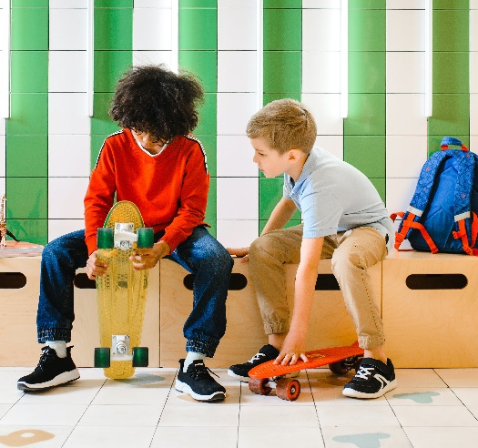

The adult box (for professionals and parents/carers to read)
- Managing stress and building resilience - tips - Mind
Managing your own levels of stress and building resilience as the adults.

- Talking to your child about feelings - NHS (www.nhs.uk)
NHS advice about different ways of talking to your child about feelings.

- What is wellbeing? - KS1 and KS2 assembly | PHE School Zone
What is wellbeing assembly resource for primary schools.

- Stress - Every Mind Matters - NHS (www.nhs.uk)
Dealing with stress as the adult.

