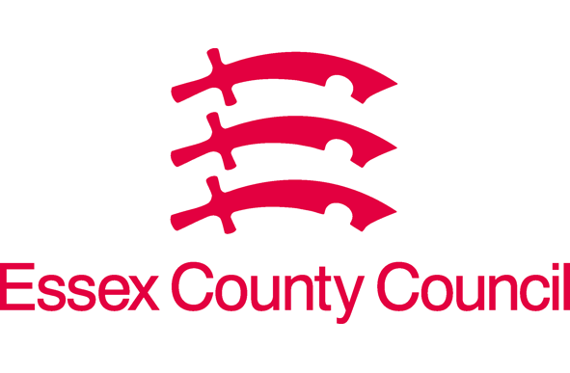
Bobby Testchild
Test School
Social Worker:
Designated Teacher:
Essex
Essex Virtual School
T: 03330321200
E: virtual.school@essex.gov.uk
https://schools.essex.gov.uk/pupils/Essex_Virtual_School/Pages/default.aspx
Date of PEP Meeting: 20-Mar-2020
Date of PEP Document: 01-Jun-2020
EDUCATION PLAN
Date of Birth 13-Jul-2004
OFFICIAL-SENSITIVE
PERSONAL

Pupil Voice
Please choose which Child Voice Form you wish to use
Pupils Voice KS4

I have completed this form on my own/ I had help from: | Date
If no form has been completed, how has the pupil's voice been captured?
MY FEELINGS ABOUT SCHOOL AND MY EDUCATION - KEY STAGE 4
Things that are going well in my education: | I am doing well at school in:
Things that I would like to change in my education or where I would like some help: | The person in school who really helps me with my education is:
My favourite sports or hobbies at school or anywhere else: | I would like to take part in an activity or club at school or elsewhere - Such as football, basketball, dance, drama club, gym club
I would like to learn something new - Such as learn a musical instrument, gymnastics | In the future I think I would like to:
I am wondering about a particular course, career or job. It is... | These are my current hopes, dreams and ambitions for further or higher education and training?
I have / have not had a careers interview? | I have / have not had work experience (paid or unpaid). It was at...  I did / did not enjoy it and want to know more:
What do we need to do to help you work towards your career aspirations?
For Virtual School use only:
Pupil Voice

