Trauma Perceptive Practice (TPP) Briefing

Alignment of TPP values to Headship
We all need a holistic approach to looking after our own emotional and mental wellbeing. Essex County Council has committed to an approach named Trauma Perceptive Practice (TPP), to support schools to understand behaviour and support emotional wellbeing. This is fundamentally grounded in the following values:

- Compassion and Kindness
- Hope
- Connection and Belonging

These values are vitally important for us all and equally apply to the adults in school and to the wider school community. Becoming Trauma Perceptive encourages us all to think and act more boldly, through our values, policies and practice. This is vital in helping us to understand how to effectively support children and young people in our schools and beyond, whilst enabling us to create safe places where all can flourish, become resilient and learn.

Checklist for protecting mental wellbeing aligned to HT role
Research shows there are five simple things we can do as part of daily work or home life to build resilience, boost our wellbeing and lower the risk of developing mental health problems. These simple actions are known internationally as the Five Ways to Wellbeing (these were developed by the New Economics Foundation (NEF) on behalf of the Foresight Commission in the UK). They have subsequently become the NHS 5 steps to mental wellbeing

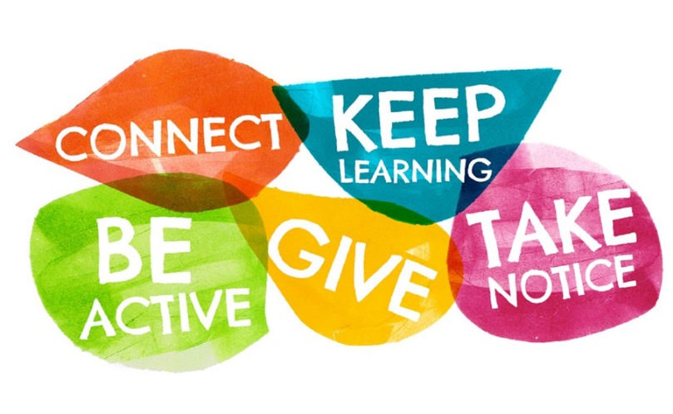

Why the Five Steps work: summary

- Connect: strong relationships with others are an essential part of building resilience and boosting wellbeing
Evidence shows that connecting with others including colleagues, friends, and the wider community promotes wellbeing, and helps build a support network for when times get tough. We all need to feel close to and valued by other people. At work, having good relationships with colleagues helps us stay motivated and engaged. Connecting is about being there for others, talking and listening, and feeling a sense of belonging.

Checklist examples:
- Talk to someone – and really listen
- Organise a shared lunch
- Eat lunch with colleagues
- Find ways to collaborate
- Plan a social event at work
- Join in with the children and young people in your school
- Talk or phone instead of emailing

- Keep Learning: being curious and seeking out new experiences positively stimulates the brain
Setting goals, being open to new ideas and continuing to learn throughout life helps boost wellbeing and build resilience. Learning improves our self-esteem, keeps us connected and involved and helps us adapt to change and find meaning in our lives. It has also been shown to help prevent depression in later years. Learning is more than just formal education – it’s about exploring new ideas, seeing opportunities, embracing new experiences and sharpening our skills. It means being curious and having an enquiring mind, in all areas of life.

Checklist examples:
- Participate in a course
- Add to your work knowledge
- Organise lunchtime workshops
- Set a goal and work towards achieving it
- Take on a new task or help someone
- Get to know your colleagues more

- Be Active: being physically active every day is great for our bodies and minds.
As well as improving physical health and fitness, being active can also improve our mood and overall mental wellbeing, and decrease stress, depression and anxiety. These benefits are increased when we get outside. Being active with others can help us feel more connected and motivates us to build new habits. Being active does not have to mean going for a run. Do what you can to move your mood. Any form of physical movement can be beneficial – find something that you enjoy and that suits your level of mobility and fitness.

Checklist examples:
- move or stand more at work – build habits to bring more active movement into workday
- Go for a gentle stroll at lunchtime
- Break up long periods of sitting
- Have walking meetings
- Use the stairs instead of the lift
- Try some stretches

- Give: giving makes us feel good. Carrying out acts of kindness, whether small or large, can increase happiness, life satisfaction and general sense of wellbeing.
Giving is more than just sharing material things with others. It’s about cultivating a spirit of generosity and actively supporting others. The acts of giving, receiving and being aware of acts of kindness, even indirectly, give us a sense of purpose and self-worth. Giving also builds connection with others. At work, a culture of giving helps to build a positive emotional environment and promotes connection, empathy and teamwork.

Checklist examples:
- Compliment someone
- Help a colleague with their work
- Share your ideas or feedback
- Express gratitude - thank someone
- Make someone a cup of tea
- Perform a random act of kindness for a colleague, friend or even a stranger

- Take Notice: paying more attention to the present moment, to thoughts and feelings and to the world around us can boost our wellbeing.
Using attention to increase awareness, concentration, and focus on the current moment and the task at hand, has been shown to improve wellbeing and mood. These are skills that can give us greater creativity, accuracy, and productivity. Becoming more aware of the present moment means noticing the sights, smells, sounds and tastes we’re experiencing, as well as the thoughts and feelings that occur from one moment to the next. It’s about reconnecting with the world around us, appreciating the little things and savouring the moment.

Checklist examples:
- Keep a beautiful object near your desk
- Practise gratitude
- Try mindfulness meditation
- Sit quietly somewhere
- Listen to your favourite music
- Take a break from digital devices
- Single-task – do one thing at a time

Checklist for managing our own stress, looking after ourselves; personal responsibility*

- Take time out to get sufficient sleep and rest, relax and eat regularly and healthily

- Talk to people you trust and allow yourself to be comforted. You don’t have to tell everyone everything, but not saying anything to anyone is often unhelpful

- Reduce outside demands and avoid taking on additional responsibilities

- Spend time in a place where you feel safe and calm to go over what’s happened over the course of the day/week. Don’t force yourself to do this if the feelings are too strong or intense at the time

- Try to reduce your access to the constant stream of news from media outlets and social media. Try scheduling ‘digital power off’ times

- Use relaxation strategies – for example: slow breathing, progressive muscle relaxation, self-talk

- Build in opportunities for recognising hope and positive strength

- Allow yourself experiences of sadness and grief.

Try to avoid:

- Bottling up feelings. Consider whether it would be helpful to talk about them with someone you trust.

- Feeling embarrassed by your thoughts, feelings or those of others. These are normal reactions to a stressful event and period of time.

- Isolating yourself from those you trust and feel safe around.

Reference:
*Adapted from Advice from NHS Guidance for Coping with Stress Following a Major Incident
https://assets.publishing.service.gov.uk/government/uploads/system/uploads/attachment_data/file/617321/nhs_trauma_leaflet.pdf

Activity – ‘walking the talk’ of TPP values in day-to-day work

Two seminal pieces of research
- Leadership commitment and engagement is the most important factor to achieve healthy workplaces. (World Health Organization (2017). Five keys to healthy workplaces)

- If those communicating the messages, e.g. leaders and managers, also model the behaviours, it makes the message more attainable or ‘real’ for people. (Mental Health Foundation of New Zealand (2017). Working Well. A workplace guide to mental health.)

Championing the values:

- Compassion and Kindness
- Hope
- Connection and Belonging

- 3 groups each taking one of the values – using the stick of rock analogy

How does our practice reflect these values – where does it not?

- How do we champion the 3 values- How does it fit with everything we do

- How can we:

- create a shared sense of purpose — clearly communicating the vision for a mentally healthy team or workplace and take people along for the journey.

- really listen — ask your team what they think about the values ing and really take notice and take onboard what they say.

- set clear expectations — managers actively promote and support their people and teams to

- set the tone — champion the values through emails, notice boards, social media groups, finding an opportunity to speak about it and participating in activities.

- lead by example — be a role model for others and introduce the values being the best leaders we can be

