Self-Care & the Impact of Social Media on Mental Health

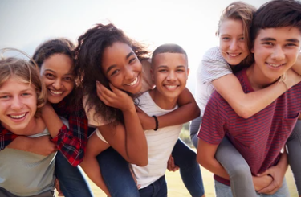

Questionnaire for Essex Children & Young People 2023

Content

- Context Page 2

- The results
i: Self-selecting CYP Page 4
ii: Self-selecting Group Page 7

- Summary Page 10

- Conclusion Page 11

Context
The Emotional Wellbeing and Mental Health Strategic Board has identified self-care as a priority and key focus for this year to support children and young people’s (CYP) emotional wellbeing and mental health.
The Social, Emotional and Mental Health Strategy Team put together a questionnaire to send out to children and young people inviting them to share their views about self-care and the impact CYP feel social media has upon their mental health.
The result of the questionnaire will be used as a starting point to inform and shape current and future projects, resources and interventions for CYP.
In addition, the multi-agency working party developing the self-care resources for CYP, will continue to work with both CYP and families to enable co-production throughout the process.
The questionnaire was sent out to several participation groups. These were The Multi-Schools Council and other Essex Youth Service participation groups, SET CAMHS Participation Groups and Healthwatch Youth Mental Health Ambassadors. The questionnaire was also advertised to our Trauma Perceptive Practice community inviting TPP trainers to self-select the pupils in their schools/settings to contribute their views also.
To participate, CYP had to be aged eight years or older, and they could either complete the questionnaire by themselves, or with the support of a trusted adult. The questionnaire was made up of two sections. The first section explored self-care. The second section ask those participants who had at least one social media account, their views about the impact that social media has upon mental health.

Participation
There were 239 self-selecting CYP who completed the questionnaire. 233 were individual contributions, whilst 6 young people provided a group response via the Multi-schools Council. 172 responses were made from a school or setting, 14 were via the Essex Youth Service, 7 participants were via Healthwatch and 32 stated they had heard about the questionnaire through another source.

Age
The age range of participants who completed the questionnaire were aged between 8 – 25 years. 149 responses were from children and young people aged 8-11, 65 responses were aged 11-15, 10 responses were aged 16-18 and 5 responses were aged 19-25 years. Although we do not have the specific ages for the Multi-Schools Council group contribution, we do know the participants range from primary to secondary school age.

Gender Orientation
Out of the 239 CYP who took part in the questionnaire, 112 participants identified as female, 95 identified as male, 3 participants identified as transgender and 4 identified as gender fluid. In addition, 2 participants identified as non-binary, 8 participants preferred not to say, 5 answered ‘other’ and 6 of the participants who provided a group response were unknown.

Location
135 participants reported living in Mid-Essex, 29 live in North-East Essex, 16 live in South Essex, and 37 live in West Essex. Although the specific locality of the 6 participants who provided the group response are unknown, it was reported that they live across Essex.

Education/Vocation
The participants Education/Vocation status was also sought. 168 CYP attend Primary School, whilst 47 attend Secondary School. 7 participants attend sixth form in a Secondary School, 1 participant attends Sixth Form College, whilst 2 attend University, 2 have a full-time job, 5 have part-time jobs and 5 specified ‘other’. The vocation of the group of six participants is unknown, however they are all part of the Multi-Schools Council, so will be on a school roll.

Results

Section 1: Self-Care

The following data provides a range of self-care activities that the participating CYP said they enjoyed doing. We have listed the number of times each of the themes/activities were mentioned in the feedback we received. Please note however, CYP who mentioned a number of activities under the same theme e.g. electronic device activities, craft and physical exercise activities, were only assigned one mention for the purposes of these results. Themes where this occurred have been highlighted with a *.

Self-care Activities | Number of times this activity was mentioned by CYP
Clubs* (Majorettes, Cubs, netball, Brownies, academy arts, drama, cheer leading, language school, youth club) | 16*
Rest | 9
Sleeping (naps, going to bed early, health sleep routine) | 24
Art/drawing* (Digital or traditional methods, drawing, colouring, sculptures, painting) | 59*
Writing* (including stories, lists, journaling, poetry) | 20*
Looking after physical self (body care- personal hygiene / appearance / pampering* (skin care, hair, make-up, face masks, shower, wash, brush my teeth, bath, deodorant, hand sanitiser, washing hands) | 22*
Crafts/Creative* (macrame, Jewellery making, crochet, knitting, making, sewing) | 18*
Journaling (gratitude and emotional) | 4
Spending time with my pet (Hamster, dog, cat) | 24
Watching TV/TV series/Films | 48
Physical exercise* (walking, football, karate, swimming, dancing, cricket, horse riding, rugby, netball, golf, gymnastics, tennis, yoga, gym, running, walking dog, skipping, trampoline, basketball, Parkour, Kung Fu ) | 115*
Shopping (clothes, tattoo artist) | 3
Socialising/play/talking with peers (friends, romantic partners – in person and online) | 67
Socialising/talking with my family (Parent(s), sibling(s) ) | 39
Reading (paperback & audio books) | 64
Electronic Device Activities* - (Games Consoles, phone, tablet, Laptop, PC etc including playing games and looking on social media platforms including YouTube) | 88*
Singing | 9
Playing music (Piano, guitar, drums) | 11
Hugs | 2
School | 1
Time on my own | 11
Playing/going to the park | 3
Board games / Lego | 5
Listening to music | 52
Revising/studying | 2
Tidying & organising (my belongings) | 1
Talking about how I feel | 1
Worship (praying, attending a place of worship) | 2
Practicing positive thinking | 1
School (PSHE, learning that I enjoy, revise) | 6
Podcasts | 3
Talking to a trusted adults (keyworker, counsellor, therapist, mentor) | 2
Using tools and techniques (breathing exercises, meditation, mindfulness, thinking exercises, mindset, counting) | 9
Food (eating fruit, vegetables healthy eating, vegan dishes) | 26
Learning / Developing skill (Magic, money, making edits, coding, Optical Illusions, baking, cooking) | 6
Resisting self-harm/injury | 1
Nothing | 5
Treating myself (food, activity) | 4
Drinking (Water) | 6
Not listening to negative comments | 1
Thinking | 2
Researching about the natural world (animals, plants) | 2

The most popular self-care activities that CYP identified and described using were:
- physical exercise,
- electronic device activities,
- socialising with peers (either in person or online),
- reading,
- art/drawing,
- listening to music,
- watching TV/TV series/films.

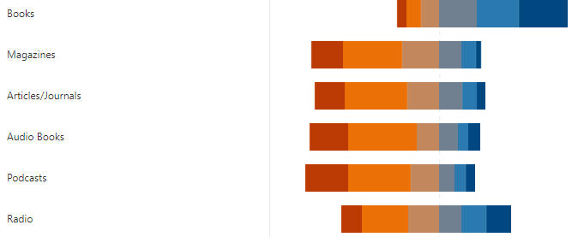
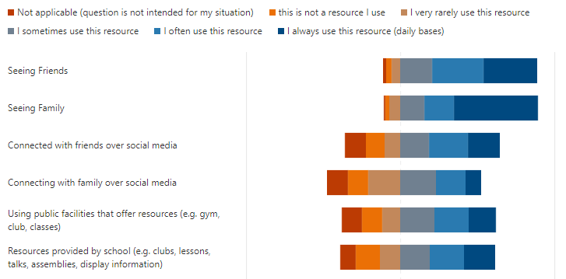
Participants were asked which of the following resources they use to support access their self-care activities. The results showed that the CYP reported using the following resources most often:
- seeing family and friends,
- TV apps,
- Apps for SMART, phone/laptop/tablets,
- video clips,
- gaming,
- books.

The least popular resources included:
- magazines,
- articles/journals,
- audio books,
- podcasts,
- radio,
- resources in the workplace (for those that this was applicable to).

67% of participants agreed that they would be interested in being able to find helpful information to learn more about self-care activities, to support their emotional wellbeing, mental health.
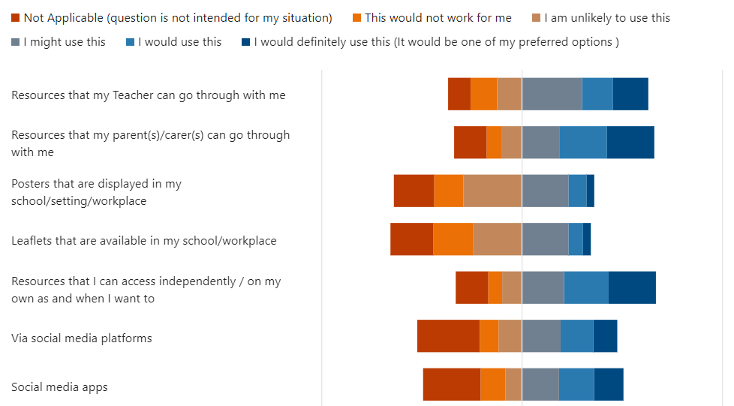
When asked how CYP would like self-care information to be made available to them, the most popular answers were:
- via family,
- via teachers,
- resources that they can access independently.

The most popular ways of presenting information about self-care were via:
- video clips,
- websites,
- via social media.

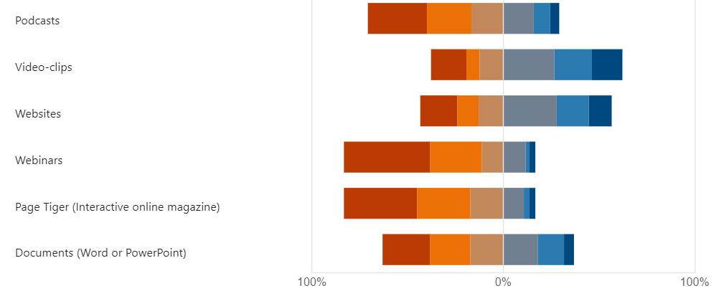
The least popular were:
- posters,
- leaflets,
- webinars,
- page tiger,
- documents.

Although Podcasts were not a popular medium for accessing information about self-care overall, it was one of the most popular choices for the group of 6 participants from the Multi-Schools Council. This is important to keep in mind to ensure a variety of mediums are used to ensure the self-care resources promote inclusion and are accessible to all CYP, with all types of abilities.
When asked if there were any other ways CYP would like the self-care information to be shared, further examples included via assembly, books, adverts, mental health related learning in school, meetings with people e.g. therapist.
Out of 239 responses, 91% participants said that they would want CYP to support Essex services to create resources for CYP.
73% of the 239 participants shared that they had at least one social media account. These participants continued onto Section B, to share their views about the impact of social media on mental health.

Section 2: The impact of social media on Emotional Wellbeing and Mental Health

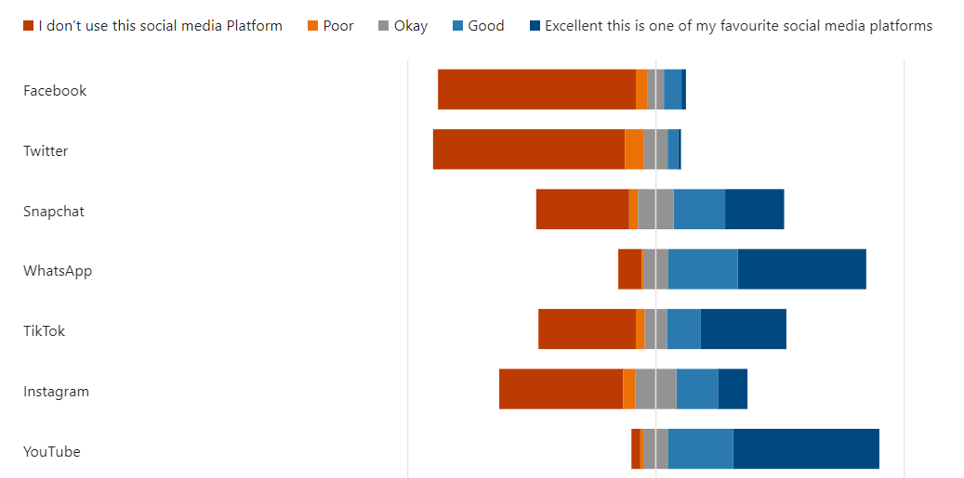
We asked these 174 participants to rate a range of social media platforms. Participants results showed that the most popular social media platforms used by participants are:
- Online gaming,
- YouTube,
- WhatsApp,
- TikTok,
- Snapchat,
- Pinterest.
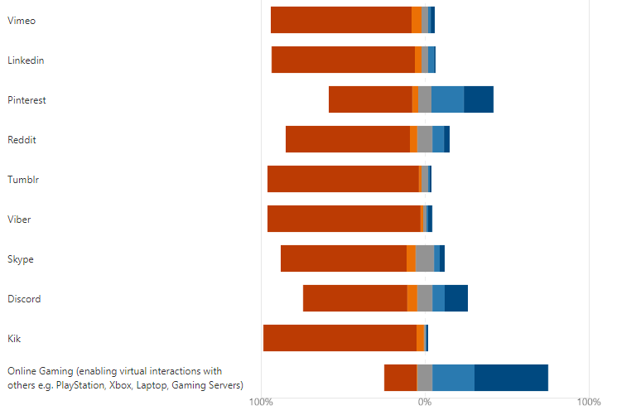
The least popular social media platforms appear to be:
- Facebook,
- Twitter,
- Instagram,
- Vimeo,
- LinkedIn,
- Reddit,
- Tumblr,
- Viber,
- Skype,
- Discord,
- Kik.

The participants were then asked how much time, on average, do they spend in total each day on one or more social media platform(s). Out of 174 participants, 12% reported using social media between 0-1hr per day. 48% of CYP reported watching social media between 1-4hrs per day and 22 % use social media between 4-7hrs a day. In addition, 13% report watching social media between 7-15 hours and 4% reported watching 15 hours or more of social media a day.
We also invited participants to share the type(s) of social media content they look at. Please note, CYP that mentioned a number of activities under the same theme e.g. topics of interest and gaming, were only assigned one mention for the purposes of these results. Themes where this occurred have been highlighted with a *.

Social Media Content CYP Search For | Number of CYP
Make-up Tutorials/skin care | 8
Funny Videos e.g. animal videos & People who do funny videos * | 41*
Comedians | 1
Influencers | 12
TikTok | 5
Digital Art | 6
Mental Health | 2
Disability | 1
Neurodiversity | 1
Chronic Illness | 1
Animation | 1
Memes related to my interests | 2
Tattoo designs | 1
Gaming / gaming videos e.g funny gaming commentary* | 40*
Email | 1
Diversity e.g. LGBTQ+, racism, autism, | 1
Topics of particular interest* including music (videos and tutorials), mythical creatures, crochet, wildlife, baking, dancing, rugby, exercise, Minecraft, hobbies, dance, food, football, singing, money, animals, basketball, chess, combat action, acting, technology | 36
TV shows / films / documentaries | 9
Look at my friends social media posts | 1
YouTube channels /clips /shows | 24
Art/Crafts/Textiles | 1
Education based e.g. GCSE Revision, subject specific, study tips | 4
Debates & Politics | 2
Football | 1
Religious content | 2
Stories | 2
Vlogs | 4
Podcasts | 1
Pinterest content | 1
Edits | 4
Following favourite celebrities | 5
Scrolling on social media / nothing in particular / general content | 6
Music | 3
Inspirational/motivational speakers | 6
Reading/book reviews | 2
Conversations online / speaking with my friends /looking at what friends are posting* | 8*
Lifestyle | 1
Writing | 1
Law & Politics | 1
Memes | 2

The most popular social media content that young people looked at included:
- Funny videos,
- Gaming / gaming Videos e.g funny gaming commentary,
- Topics of particular interest,
- YouTube clips/channels/shows.

When asked how much of the social media content that they look at supports their self-care, 20% of CYP reported that they felt it either ‘did not’ or ‘almost never’ supported their self-care. 43% of participants felt that their social media content supported their self-care ‘sometimes’, whilst 23% felt it ‘often’ supported and a further 12% reported social media ‘almost always’ supported their self-care.

Out of 174 participants, 65% of CYP feel that social media can have both positive and negative affects upon mental health. Whilst 26% of young people felt that it only has a positive effect upon mental health, and 9% of participants felt that social media only has as negative affect on mental health.
We also obtained the following views that participants shared about the positive and negative impact of social media upon mental health and wellbeing:
Positives:
- helping you to understand the world and how other people think
- connect with others / like-minded people
- relate to other people’s experiences
- see content that makes you laugh and smile
- learn about different / new perspectives
- helps to switch off / relax / chill
- encourages you to try new things and develop confidence
- helps develop confidence in trying new things and learning new skills
- helps you avoid getting bored
- a resource to support self-regulation and manage emotions
- it can inspire to help you achieve your goals

Negatives:
- exposure to cyber bullying
- creating unrealistic expectations because of fake and misleading content
- edited content can build a false idea of ‘perfection’ which you can compare yourself to
- it can make young people feel left out
- leads to overthinking
- it makes young people feel bad about themselves and doubt themselves
- romanticises severe mental health issues and becomes very addictive and difficult to stop using
- exposes CYP to inappropriate content that you don’t want to see
- it can be a contributor to depression and affect CYP’s mood
- content may be emotionally triggering
- it can make CYP feel lazy and lethargic
- it can create conflict within relationships
- can give your headaches

Summary
From the 239 responses we had to this questionnaire, the information we obtained show us that the CYP of Essex use a broad range of self-care activities to support their emotional wellbeing and mental health. The most popular self-care activities reported were physical exercise, electronic device related activities, socialising with peers (either in person or online), reading, art/drawing, listening to music and watching tv/Tv series/films.
CYP have told us that the preferred resources they use to access or support their self-care currently are via family and friends, TV apps, Apps for Android/Smart Phones, laptops/Tablets, video clips, gaming and books.
The results show us that CYP would like to access self-care information either via a trusted adults within their family and/or their school/setting, as well as independently via video clips, websites, and social media.
67% of CYP would be interested in being able to find more helpful information about self-care activities, and 91% of responses reported that they would also like CYP to support Essex services create these resources.
When exploring the impact of social media upon a CYP’s emotional wellbeing and mental health, 73% of all participants completing the questionnaire told us that, they had at least one social media account.
The most popular social media platforms being used by Essex CYP currently appear to be online gaming, YouTube, WhatsApp, TikTok, Snapchat and Pinterest.
When we investigated the usage of social media, 12 % of CYP reported using 0-1 hour of social media per day, whilst 48% of CYP reported watching social media between 1-4hrs and 22 % use social media between 4-7hrs a day. In addition, 13% report watching social media between 7-15 hours and 4% reported watching 15 hours or more of social media a day.
We also asked participants about the type(s) of social media content they search for. The most popular content CYP reported search for included: funny videos, gaming / gaming videos e.g. funny gaming commentary, topics of particular interest*, YouTube clips/channels/shows
CYP’s views varied in relation to how much they felt their social media supported their self-care. 20% of CYP reported that they felt it either ‘did not’ or ‘almost never’ supported their self-care. 43% of participants felt that their social media content supported their self-care ‘sometimes’, whilst 23% felt it ‘often’ supported and a further 12% reported social media ‘almost always’ supported their self-care.
Finally, 65% of CYP feel that social media can have both positive and negative affects upon mental health. Whilst 26% of young people felt that it only has a positive effect upon mental health, and 9% of participants felt that social media only has as negative affect on mental health.

Conclusion
In conclusion, the data within this report provides an array of helpful information to support the multi-agency working party develop the self-care resources for CYP.
The data clearly shows us that CYP in Essex use a diverse range of self-care activities to support their emotional wellbeing and mental health, personalised to their individual preferences. The results provided us with a range of commonalities in CYP’s preferred self-care practices, which will inform and support us to shape the content of the resources, to ensure that they are relevant and meaningful to the CYP of Essex.
It is clear, that the resources created need to be multi-functional, so that CYP can access the information independently and / or with the support of trusted adults. It is also evident that it would be helpful to diversify away from some of the more traditional formats to share content, that have been used previously with CYP, to more relevant, popular and accessible formats e.g. via a range of appropriate social media platforms and digital platforms/mediums etc. This would be particularly helpful, when we know that CYP can feel that social media can have a negative impact upon their emotional wellbeing and mental health.
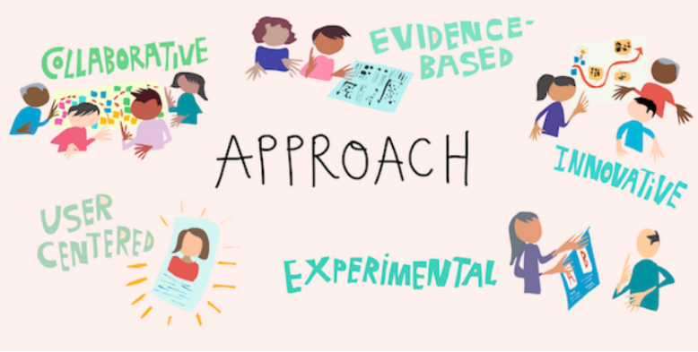
We are encouraged to hear that 91% of participants would be interested in supporting the co-production of these self-care resources to support the CYP of Essex. This provides us with an opportunity to work with several CYP forums and participation groups, who will be invited to support at each stage of this project’s development and co-produce the final products.

