Let’s Talk: Everyday Stress
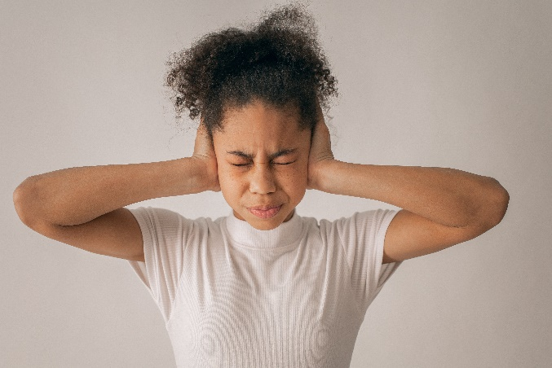
Primary

This resource is part of our self-care suite of resources and has been co-produced with children and young people living in Essex, for children and young people. They have also been developed and quality assured by the following stakeholders:
- Essex Educational Psychology Service
- Essex Health Watch
- Essex Mental Health Support Teams (MHSTs) NELFT NHS Foundation Trust
- Essex Multi-schools Council
- Essex Social, Emotional and Mental Health (SEMH) strategy team
- HCRG care group Child and Family Wellbeing Service
- NELFT NHS Trust Southend, Essex, and Thurrock (SET) Child, Adolescent and Mental Health Service (CAMHS)
- Professionals in schools and settings can access all these resources via the Essex info link SEMH portal. Children and young people (CYP), parents/carers and professionals can also access these resources via the SET CAMHS website. Our self-care content can also be accessed via SET CAMHS Instagram account:

The resources are intended to be accessed by CYP independently or trusted adults use these resources with CYP through 1:1 conversation, whole school/group discussion and assemblies.
Please note: some of the content within our self-care resources may be emotive for CYP. We recommend that you make use of the ‘signposting to support’ section of this document should any of the content be triggering.
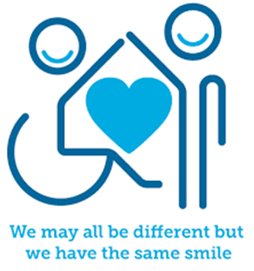

Introduction
Stress is something everyone feels at times, especially when dealing with change or life challenges, such as money worries, work issues or relationship problems. A little stress can be a good thing, as it helps us to get things done or focus on something that needs our attention. How we manage stress can make a significant difference to our mental wellbeing, and the first step to managing it is to know how it affects us and why.
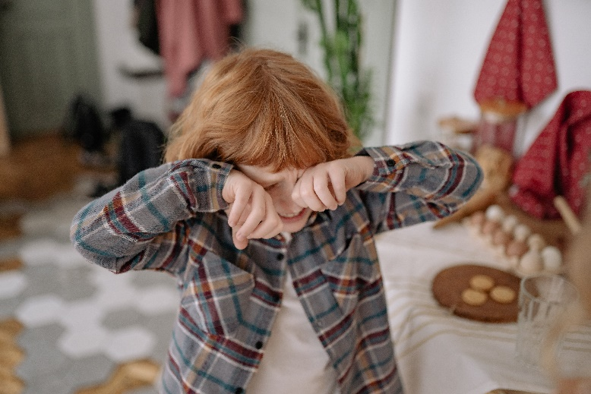

Facts
- Stress is a hormonal response from the body
- When we experience stress our body releases a hormone called adrenaline
- Stress is the body’s reaction to feeling threatened or under pressure
- Too much stress can affect our mood, our body, and our relationships
- Stress can affect our emotions and sometimes we may experience physical symptoms

Myth Buster
- Stress is purely negative X
- Everybody experiences and responds the same way to stress X
- Only adults experience stress X
- Stress cannot be controlled X
- Stress is a serious mental health condition X

Video clips
Check out these videos about everyday stress:
- 5 Steps to Wellbeing Animation - YouTube (KS2)
A guide to keeping your mind healthy
- Stress Management Tips for Kids and Teens! - YouTube (KS2)
Tips on how to manage stress
- Wellbeing activities: managing stress | British Red Cross (KS2)
How to understand stress

Resources
We have indicated whether these resources are accessible for Ks1 or Ks2. Please note that some of the ks2 content could be adapted and differentiated to support pupils in Ks1.

- Poster pupils WMHD (mentallyhealthyschools.org.uk) (KS1&2)
How are you feeling chart and 6 things that can help you feel good.

- Talking mental health: animation & teacher toolkit | Anna Freud (KS1 & KS2)
An animation about mental health, including managing big and small feelings.
- How to Make a Self-Soothe Box | Young Person Blog | YoungMinds (KS1 & KS2)
This self-soothe box for Ks2 children can be adapted for Ks1.
- Stress | The Children's Society (childrenssociety.org.uk) (KS2)
Explains what stress is, what causes it and how to manage it.
- Wellbeing activities: managing stress | British Red Cross (KS2)
Learning how to manage wellbeing can help us cope with change and challenges.

Reflective questions
(Try exploring these reflective questions with a CYP)
- What is stress?
- Give 2 examples of things that can help us to cope stress
- How might stress affect us emotionally?
- How might stress affect us physically?
- How might you help a friend who may be dealing with stress?
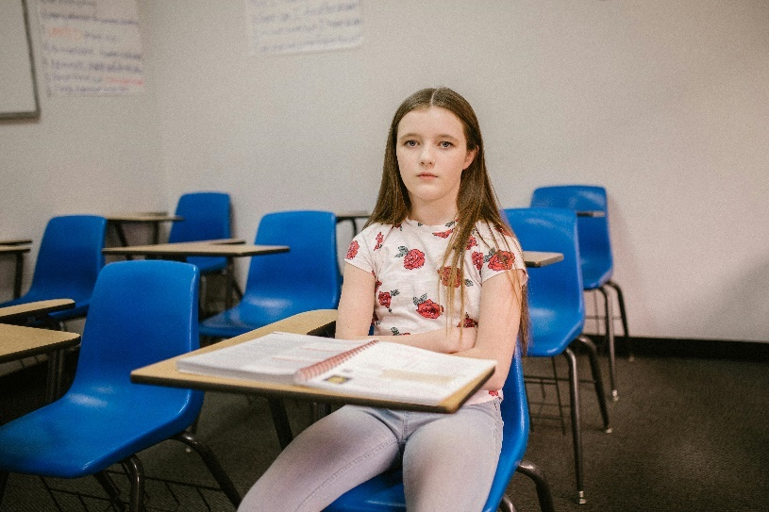

Quiz of 5 questions per theme
Once you’ve gone through this resource with a CYP try this quiz questions with them:
- What are the 5 steps to wellbeing?
- Name 3 things which you can help us to cope with stress?
- Name some breathing or relaxation techniques that you are aware of
- What hormone is released in the body when you feel stressed?
- What is a self-soothe box?

Additional ideas
Other things to try:
- Headspace for Kids meditation (KS2)
Managing anxious thoughts and stress with mindfulness

- The Partnership in Education (KS2)
The 5-4-3-2-1 method: A grounding exercise to manage anxiety

- Mindful Minute Mindful Eyes (KS1 & KS2)
Taking a moment to become mindful

- The Mindfulness Teacher (KS1 & KS2)
30 second triangle breathing exercise

- Pure Star Kids (KS1)
Candle and flower breathing

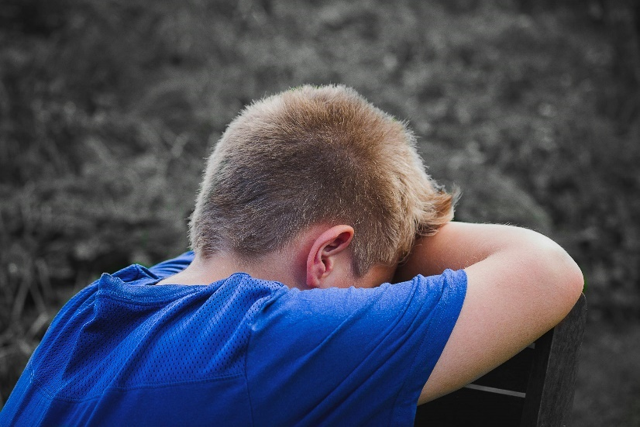

Signposting to Support
For additional support we recommend that trusted adults use these resources to support children and young people access support when required:
- Getting help for your child: where to start
- Childline 0800 1111 when contacting ChildLine what to expect?
- Hopeline 0800 068 41 41 offering confidential support and practical advice
- Text ‘SHOUT’ to 85258 for free, confidential, anonymous text support service
- NHS 111
- Southend, Essex & Thurrock Children and Adolescent Mental Health Service (SET CAMHS)
- Where to get urgent mental health support from: Advice from NHS

How to help a friend
- Share this resource with them
- Help them to relax by making them laugh and spending time with them
- Listen to them and offer reassurance

The adult box (for professionals and parent/carers to read)
- Childhood Stress: How Parents Can Help (for Parents) - Nemours KidsHealth
How parent/carers can help with stress.
- Beano for Schools: Lesson 4 understanding stress
A lesson for both KS1 and KS2 teaching about stress to children.

- Wellbeing activities: managing stress | British Red Cross
PSHE lesson ideas for ages 7-18 to support children and young people manage stress.

- Boiling point: Talking to children about stress | The Children's Society (childrenssociety.org.uk)
Talking to children and young people about stress.

- Managing stress and building resilience - tips - Mind
Managing your own levels of stress and building resilience as the adults.

- Talking to your child about feelings - NHS (www.nhs.uk)
NHS advice promoting different ways to talk to your child about feelings.

- What is wellbeing? - KS1 and KS2 assembly | PHE School Zone
What is wellbeing assembly resource for primary schools.

- Stress - Every Mind Matters - NHS (www.nhs.uk)
Dealing with stress as the adult.

