Let’s Talk: Screen time and social media
Primary

This resource is part of our self-care suite of resources and has been co-produced with children and young people living in Essex, for children and young people. They have also been developed and quality assured by the following stakeholders:
- Essex Educational Psychology Service
- Essex Health Watch
- Essex Mental Health Support Teams (MHSTs) NELFT NHS Foundation Trust
- Essex Multi-schools Council
- Essex Social, Emotional and Mental Health (SEMH) strategy team
- HCRG care group Child and Family Wellbeing Service
- NELFT NHS Trust Southend, Essex, and Thurrock (SET) Child, Adolescent and Mental Health Service (CAMHS)
- Professionals in schools and settings can access all these resources via the Essex info link SEMH portal. Children and young people (CYP), parents/carers and professionals can also access these resources via the SET CAMHS website. Our self-care content can also be accessed via SET CAMHS Instagram account:

The resources are intended to be accessed by CYP independently or trusted adults use these resources with CYP through 1:1 conversation, whole school/group discussion and assemblies.
Please note: some of the content within our self-care resources may be emotive for CYP. We recommend that you make use of the ‘signposting to support’ section of this document should any of the content be triggering.
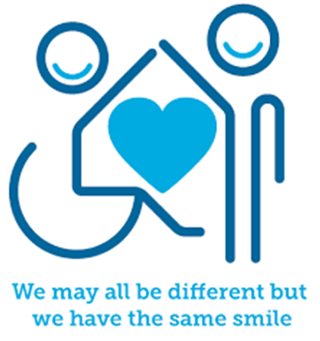

Introduction
Screen time plays an important role in our lives and how we view and see the world. Screen time is the amount of time that someone spends using a device or computer, watching television, or playing on a games console. Social media refers to the different media platforms (apps and websites) and can include YouTube, TikTok and Snapchat. There are lots of benefits to social networking and can allow users to connected with friends and family. They can also learn many different things, from make-up or gaming tutorials to making slime, or how to create your own videos.

Facts
Screen time and social media:
- One in three internet users online worldwide is under 18 years old.
- Just under 50% of parents find it hard to control their children’s screen time.
- 20,000 parents of children aged between 2- and 5-years old think that screen time limits may have nothing to do with a young child’s ability to thrive.

It helps:
- Enhance teamwork and creativity
- Helps builds knowledge and understanding of the world
- Takes away physical barriers to social connections
- Supports academic development

Myth Buster
Here are some of the myths about screen time and social media.
Screen time and social media:
- Everything you watch or see on social media is true X
- All information that you watch on your screen or see on social media can be trusted X
- Everyone on this game is a child as well X
- You can’t get hurt online because it’s not real X
- Big news stories must be true X
- Opinions can’t hurt people X

Video clips
Check out these videos about screen time and social media:
Place2Be: Parenting Smart: Safe social media for primary aged children (KS2)
Video for safe social media for primary aged children.

- Staying Safe Online - BBC Newsround (KS2)
Staying safe online tips.

- Online Safety and Safer Internet Day - Teaching Resources - BBC Teach (KS2)
Online safety website with videos and resources to support children with staying safe online.

- KS2 Computing - BBC Bitesize (KS2)
Bitesize resources and video clips for children’s screen time and social media.
- UK safety Internet Centre (KS1 & KS2)
Children and young people resources age 3-11
- Twinkl Online safety (KS1)
Resources for computing: online safety

Resources
- Social media | NSPCC
NSPCC information website for the use of social media. Useful information surrounding the different social apps/websites that children may use.
- Place2Be: Parenting Smart: Safe social media for primary aged children
Place 2Be social media website and safety tips.

- How Are Primary Schools Using social media? - Twinkl
Information about how schools are using social media and screen time.
- Social media and online safety | NSPCC Learning
Social media and online safety information.

Social media and self-care (annafreud.org)
Information regarding social media from the Anna Freud website.

Reflective questions
(Try exploring these reflective questions with a CYP)
- What is difference between screen time and social media?
- What social media apps or websites do you know?
- What social media apps or websites do your friends go on?
- How much screen time do you think is healthy for you?

Quiz of 5 questions per theme
Once you’ve gone through this resource with a CYP try this quiz questions with them:
- How can you stay safe online?
- What are the benefits of screen time and social media?
- Is everything on the social media true?
- What might you do if you see something on social media that has made you feel worried?

Additional ideas
Other things to try:
- Resources for 3-11s - UK Safer Internet Centre
UK Safer Internet Centre resources for children and families.

- BBC Teaches health and wellbeing videos for ages 8 to 11: Mentally Healthy Schools
Information on tech for children and families on the Anna Freud.

- Screen time tips for 7-11 yrs. - KS2 | Resources- Internet Matters
Information for children and parents to support the amount of screen time as well as a short video to help understand more about this area.

Signposting to Support
For additional support we recommend you:
- Getting help for your child: where to start
- Childline 0800 1111
- NHS 111
- Southend, Essex & Thurrock Children and Adolescent Mental Health Service (SET CAMHS)
- Explore counselling/therapy
- Where to get urgent mental health support from: Advice from NHS
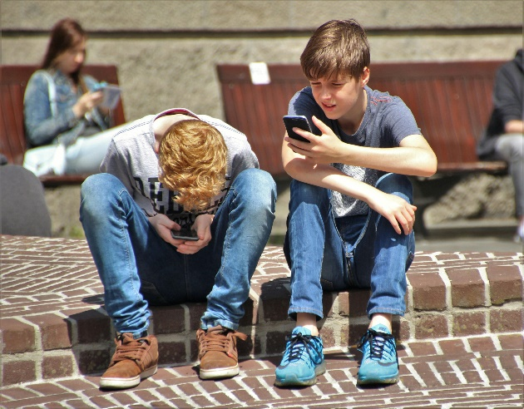

The adult box (for professionals and parent/carers to read)
- How to start a conversation about mental health
This resource provides some guidance and advice about how to talk to children and young people about mental health and introduce the importance of self-care.

- Talking to parent/carers about a child/young person’s mental health
This resource provides some guidance and advice about how to start conversations about children and young people’s mental health. Talking about self-care can be a supportive as part of this conversation.

- Modelling self-care as a supporting adult
It’s important to model self-care to young people to support your mental health. This resource is for teaching staff exploring the building blocks of good mental health and wellbeing.

