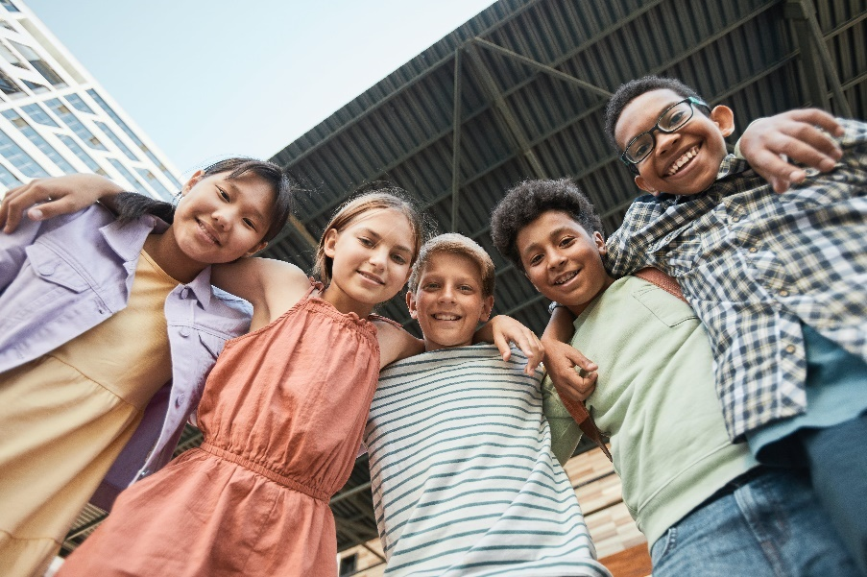
Let’s Talk: Healthy Relationships
Primary

This resource is part of our self-care suite of resources and has been co-produced, with children and young people living in Essex, for children and young people. They have also been developed and quality assured by the following stakeholders:
- Essex Educational Psychology Service
- Essex Health Watch
- Essex Mental Health Support Teams (MHSTs) NELFT NHS Foundation Trust
- Essex Multi-schools Council
- Essex Social, Emotional and Mental Health (SEMH) strategy team
- HCRG care group Child and Family Wellbeing Service
- NELFT NHS Trust Southend, Essex, and Thurrock (SET) Child, Adolescent and Mental Health Service (CAMHS)
- Professionals in schools and settings can access all these resources via the Essex info link SEMH portal. Children and young people (CYP), parents/carers and professionals can also access these resources via the SET CAMHS website. Our self-care content can also be accessed via SET CAMHS Instagram account:

The resources are intended to be accessed by CYP independently or trusted adults use these resources with CYP through 1:1 conversation, whole school/group discussion and assemblies.
Please note: some of the content within our self-care resources may be emotive for CYP. We recommend that you make use of the ‘signposting to support’ section of this document should any of the content be triggering.
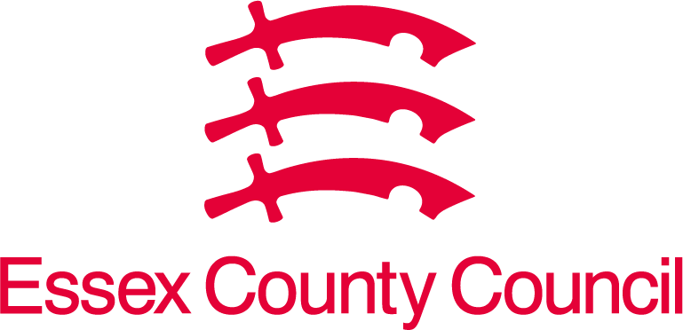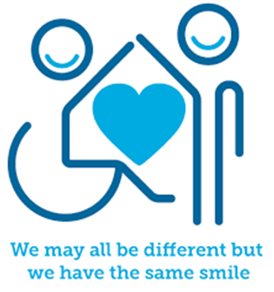
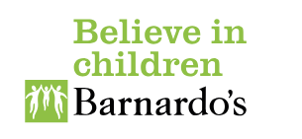

Introduction
Healthy relationships/friendships involve trust, honesty, respect, and open communication between people. In a healthy relationship/friendship each person should be able to have fun and enjoy each other’s company, feeling comfortable together. Relationships, including the one you have with yourself, are vital to our mental wellbeing. People with healthy, positive, and supportive relationships are more likely to be happier and healthier.
Creating and maintaining good connections with others can also help to combat loneliness and improve mental health issues, such as stress and anxiety.
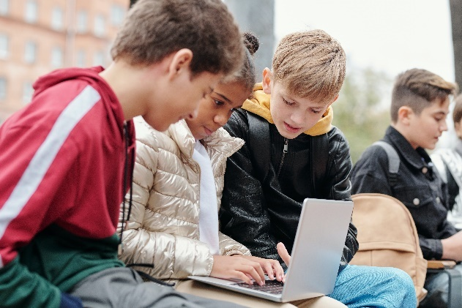

Facts
- We need to work at build and keep good relationships going
- Relationships can change
- Key ingredients to healthy relationships include respecting and supporting others and having open, trusting, and honest conversations.
- Being able to speak openly about the way you are feeling and, in turn, listening to your partner/friend or family member can strengthen relationships.
- Disagreements are normal, but it can affect your mental wellbeing if an argument is not resolved.
- Apologising for you part of a disagreement is helpful in repairing the relationships.

Myth Buster
- Disagreements and arguments do not happen in relationships X
- Jealously is an important part of a relationship? X
- Friendships are always easy and don’t take effort X
- Relationships mean I put someone else’s needs before mine all the time X
- A healthy relationship means another person has control over what you wear, say, and do X

Video clips
Check out these videos about healthy relationships:
- Samsung Kids the Personal Space Song - YouTube (KS1)
Personal space song with animation.

- The Boundaries Song - "That's a Boundary." - YouTube (KS2)
An animation and song to teach younger children about boundaries.

- What Makes a Relationship Healthy? - YouTube (KS2)
A video describing what a healthy relationship looks like.

Resources
- We have indicated whether the resources are accessible for Ks1 or Ks2. Please note that some of the ks2 content could be adapted and differentiated to support pupils in Ks1.

- Relationship Circles (KS1 & KS2)
An activity to encourage children and young people to think about different relationships they have.

- Friends | Childline (KS2)
Talking about friendships including talking, falling out, being bullied, fancying a friend, coping when you miss your friend and difficult friendships.

Reflective questions
(Try exploring these reflective questions with a CYP)
- Can you think of the different types of relationships you have?
- How do you manage disagreements in your relationships?
- What are the important qualities in the relationships you have?
- How should relationships make you feel?
- How should a relationship not make you feel?

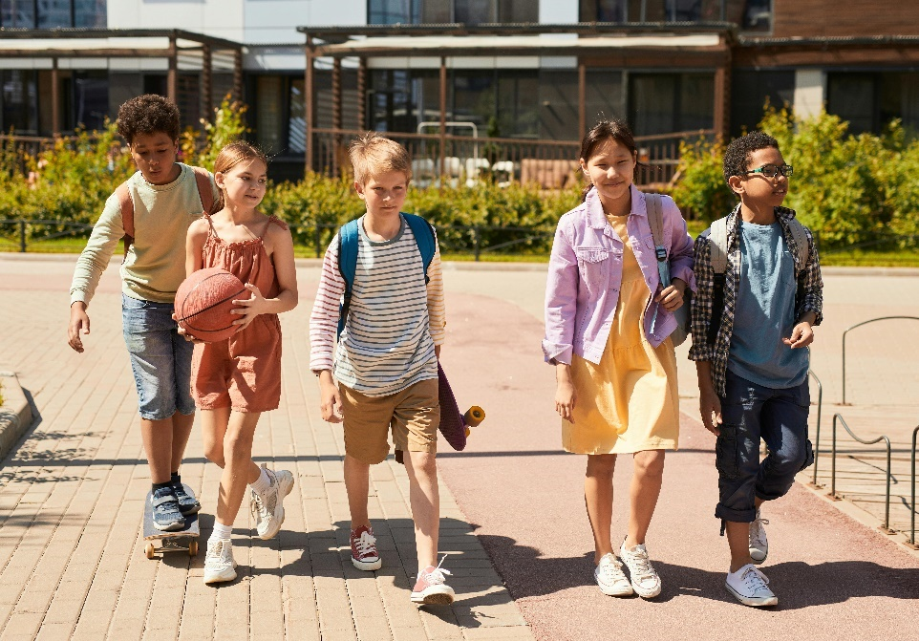

Quiz of 5 questions per theme
Once you’ve gone through this resource with a CYP try this quiz questions with them:
- Why is friendship important?
- What are some of the qualities of a good friend?
- What things may impact a friendship and make it change?
- What are the qualities of a good and healthy relationship?
- What are the qualities of a negative and unhealthy relationship?

Additional ideas
Other things to try:
- Consent lesson pack (pshe-association.org.uk) KS1&2
*Please note: this is a member only resource

- Building connections: Year 6 lesson plan: Mentally Healthy Schools (KS2)
This lesson from Public Health England supports Year 6 pupils to understand that it's normal to feel lonely, and that there are strategies they can use to safely build connections with family, friends, and their community.

- Our Class | Educational resources about children's friendships (northampton.ac.uk) KS2
‘Our Class’ is a series of educational resources to help teach primary school children about friendships and peer relationships.

- Understanding consent: Gloucestershire Healthy Living and Learning (ghll.org.uk) upper KS2
A lesson on understanding consent.
- Disrespect NoBody: preventing teenage relationship abuse (pshe-association.org.uk) KS2-5
Lesson plans on disrespecting Nobody: preventing teenage relationship abuse.

- PANTS resources for schools and teachers | NSPCC Learning (KS1 & KS2)
Download our free Talk PANTS resources, teaching children the Underwear Rule to help keep them safe from abuse.

- Rosie's story | Network on Family Regulation and Society | University of Exeter
Rosie’s Story is a fun and interactive two-part lesson plan for use in PSHE teaching for Upper Key Stage 2 pupils. It deals with the difficult subject of parental separation.

- NCA-CEOP: Jessie & Friends (pshe-association.org.uk) KS1
The resource aims to equip 4–7-year-olds with the knowledge, skills, and confidence to help keep them safe from sexual abuse and other risks they may encounter online as they grow up.

- ks1-worksheet-getting-to-know-me.pdf (mentallyhealthyschools.org.uk) (KS2)
Heads together have made a KS1 worksheet aimed at supporting children get to know each other.

- Play Like Share (thinkuknow.co.uk) KS2
Play Like Share is a three-episode animated series (c. 6-7 minutes each) and accompanying resource pack which aims to help 8–10-year-olds learn how to stay safe from sexual abuse, exploitation, and other risks they might encounter online.

- CEOP Education (thinkuknow.co.uk)
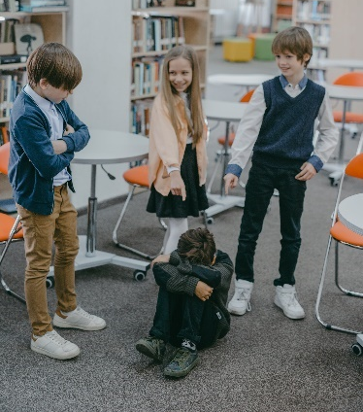
The National Crime Agency's CEOP Education team aim to help protect children and young people from online child sexual abuse. They do this through education programmes, providing training, resources and information to professionals working with children, young people, and their families. Resources for professionals working with children and young people; parents and carers; 4–7-year-olds; 8–10-year-olds and 11–18-year-olds.

Signposting to Support
For additional support we recommend that trusted adults use these resources to support children and young people access support when required:
- Childline 0800 1111 when contacting ChildLine what to expect?
- Hopeline 0800 068 41 41 offering confidential support and practical advice
- Text ‘SHOUT’ to 85258 for free, confidential, anonymous text support service.
- Share any concerns about your mental health with your GP and Understanding Confidentiality
- NHS 111
- Southend, Essex & Thurrock Children and Adolescent Mental Health Service (SET CAMHS)
- Where to get urgent mental health support from: Advice from NHS

How to help a friend
- If a friend is having difficulties with a relationship encourage them to tell a trusted adult, so that they can get some help.
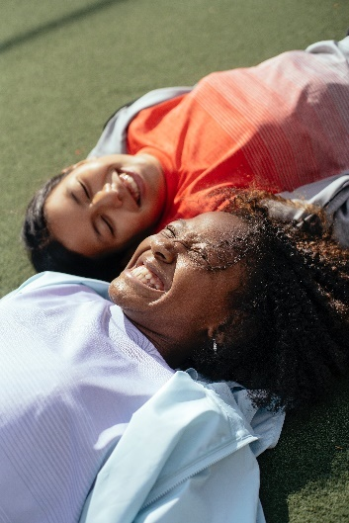
- Spend time with your friends.
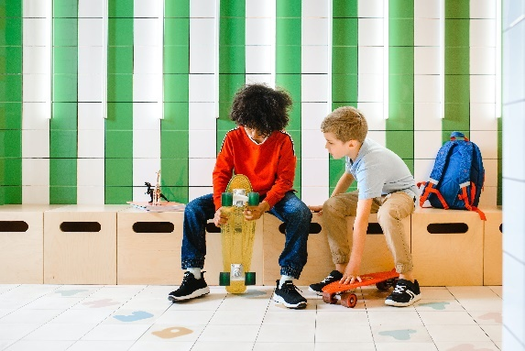
- Ask your friend if they are okay.

The adult box (for professionals and parent/carers to read)
- Healthy relationships | NSPCC
Advice for parents and carers on how to talk to their child about relationships, sex, and consent.

- Teaching healthy relationships: 6 resources to help (thinkuknow.co.uk)
Primary and secondary resources that support teach children and young people about healthy relationships.

- NCPCC Bullying and Cyber Bullying
Advice for parents and carers to help keep children safe from bullying, wherever it happens.

- Teaching Your Child about Internet & Online Safety | NSPCC
Advice on how to start the conversation and get support if you're worried.
- Tips for talking to your kids about LGBTQ+ families - BBC Tiny Happy People
How to talk to your child about LGBTQ+ and different family units.

