Let’s Talk: Sleep
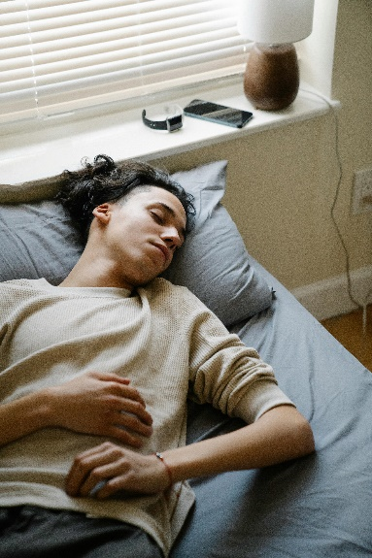
Secondary

This resource is part of our self-care suite of resources and has been co-produced with children and young people living in Essex, for children and young people. They have also been developed and quality assured by the following stakeholders:
- Essex Educational Psychology Service
- Essex Health Watch
- Essex Mental Health Support Teams (MHSTs) NELFT NHS Foundation Trust
- Essex Multi-schools Council
- Essex Social, Emotional and Mental Health (SEMH) strategy team
- HCRG care group Child and Family Wellbeing Service
- NELFT NHS Trust Southend, Essex, and Thurrock (SET) Child, Adolescent and Mental Health Service (CAMHS)
- Professionals in schools and settings can access all these resources via the Essex info link SEMH portal. Children and young people (CYP), parents/carers and professionals can also access these resources via the SET CAMHS website. Our self-care content can also be accessed via SET CAMHS Instagram account:

The resources are intended to be accessed by CYP independently or trusted adults use these resources with CYP through 1:1 conversation, whole school/group discussion and assemblies.
Please note: some of the content within our self-care resources may be emotive for CYP. We recommend that you make use of the ‘signposting to support’ section of this document should any of the content be triggering.
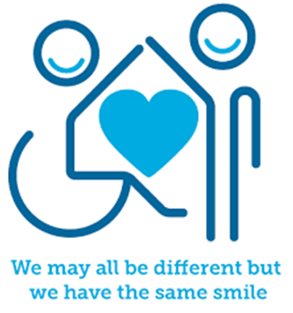

Introduction
The NHS tell us that sleep is important because it enables us to rest and repair our mind and body. It's vital for good physical and mental health and wellbeing. Longer stretches of bad sleep can do the opposite and have a negative impact on our physical and mental health or wellbeing. The health benefits of good quality sleep include:
- Get sick less often.
- Stay at a healthy weight.
- Lower your risk for serious health problems, like diabetes and heart disease.
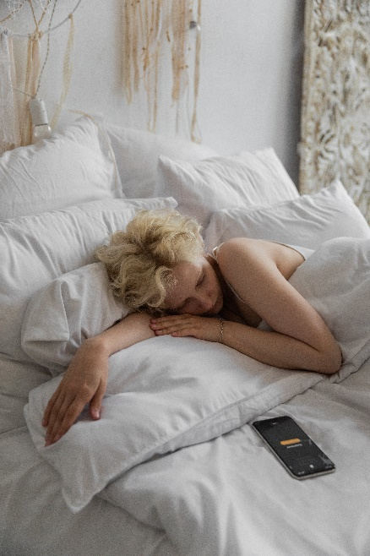
- Reduce stress and improve your mood.
- Think more clearly and do better in school and at work.
- Get along better with people.

Facts
- Sleep is a need that everyone has.
- Humans sleep for a third of their lives – approximately 20-30 years.
- All species on our planet sleep.
- Lack of sleep can affect concentration, your mood and memory.
- The National Sleep Foundation tell us that on average children aged 6-12 years need between 7-12 hours sleep a night, and young people aged 13-17 require between 7-11 hours of sleep a night.

Myth Buster
Self-care:
- Your body gets used to lack of sleep X
- How long you sleep is all that matters X
- If you are having trouble falling asleep, stay in bed until you can X
- A warm bedroom temperature is best for sleeping X
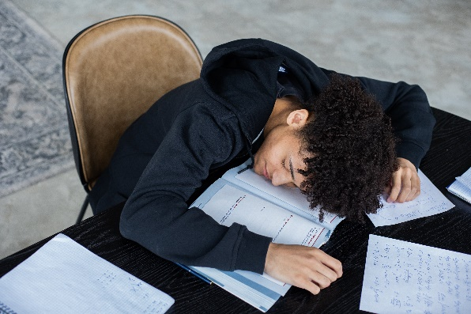
- Sleeping with the light on is harmless X
- Napping makes up for a lack of night-time sleep X
- You can catch up on your sleep over the weekend X

Video clips
Check out these videos about self-care:
- Importance and Benefits of Sleep
A video to explain the importance of sleep and some of the common sleep disorders.

- The Importance of Sleep: 8 Scientific Health Benefits of Sleep + Sleeping Tips
A video to explain some key health benefits of sleep and sleeping tips

- Good Sleep Hygiene
A video to explain some tips for getting a good nights sleep.

- How Can Sleep Affect A Teenagers Education? | Matthew Walker
A video to explain sleep and its impact on memory/learning.

- Teens & Young People - Teen Sleep Hub
A selection of videos covering topics such as social media, peer pressure, screen time, anxiety, exercise and routines.
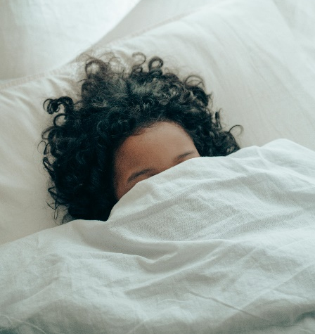
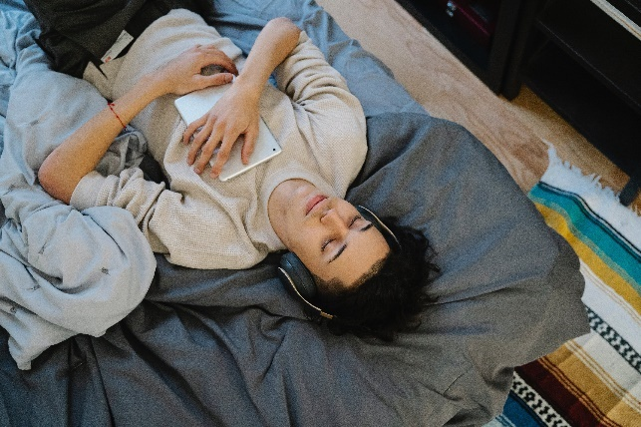

Resources
- Teens & Young People - Teen Sleep Hub
Quiz and book with advice and information to empower and help you feel more confident in making the right changes to your sleep.

- The Sleep Charity: Teen Sleep Diary
A free printable sleep diary that helps identify sleep patterns.

- Sleep Foundation: Sleep Diary
A free printable sleep diary to track sleep habits and achieve a better nights sleep

- PositivePsychology.com: Sleep Quiz
Helps you assess whether you are giving sleep sufficient priority in your life and
identify what actions you may need to take to get optimal sleep.
- PositivePsychology.com: Sleep hygiene checklist and actions
Worksheet that helps you consider and adjust features of a bedroom (and how it is used) that may affect a child’s quality of sleep.

Reflective questions
(Try exploring these reflective questions with a CYP)
- What are the some of the benefits of sleep?
- What does sleep hygiene mean?
- What advice or tips would you give to a friend about getting a good night’s sleep?
- How can you improve your own sleep routine?

Quiz of 5 questions per theme
Once you’ve gone through this resource with a CYP try this quiz questions with them:
- Why is sleep important/what are some of the benefits of sleep?
- How much sleep should we be having?
- What would be included in a good sleep routine?
- What things are not recommended for a good night’s sleep?
- How long should you try to fall asleep for before getting up?

Additional ideas
Other things to try:
- Sleep - Headspace
Learn how to create conditions for a more restful nights sleep with this sleep music

- Calm - The #1 App for Meditation and Sleep
An app that offers meditation, calming music and gentle stretching videos

- Young Minds: A guide for young people sleep problems
This resources shares information about the causes of sleep problems, tips and support, sleep disorders and treatments and where to get further help.

Signposting to Support
For additional support we recommend you:
- Young Minds - Sleep problems
A guide for young people experiencing sleep problems.

- Home – Teen Sleep Hub
Getting the support you need to achieve a good night’s sleep

- Guy’s & St Thomas NHS Foundation Trust - How to sleep well for teenagers | Evelina London
Everything you need to know about teenage sleep.

- Teen Sleep Tips Poster
Teen sleep tips offering strategies to avoid and strategies to try.

- National Sleep Helpline - The Sleep Charity
National sleep helpline – speak to a trained sleep advisor.

- The Sleep Charity – Exams & Sleep
Tips on helping you manage the exam season and make sure you get enough sleep

- SET CAMHS Instagram account

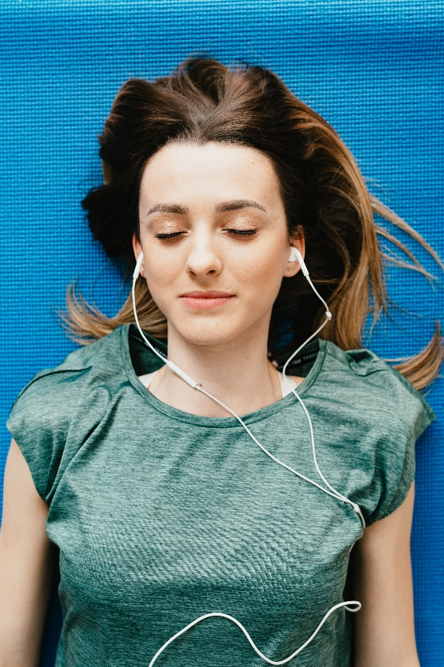

How to help a friend
- Ask your friend(s) about their sleep.
- Have a conversation about the importance of sleep.
- Suggest they look at this resource for ideas and support.
- Share with each other what your bedtime routine looks like and if there is anything you could try to make it better.
- Talk about what you both/all do if you can’t sleep or want to get back to sleep if you’ve been woken up.
- Describe how you feel if you’ve had a good night sleep and when you’ve had a bad night sleep.
- Recommend that they follow the SET CAMHS Instagram account: set_camhs_nhs

The adult box (for professionals and parent/carers to read)
- Parents & Carers - Teen Sleep Hub
Top tips to help you understand your teens sleep and how you can help.

- Teenagers - A good night's sleep - BBC Bitesize
Advice and support for getting your teen to bed at night.

- Teen Sleep Hub – Teen sleep matter: Information for Parents
Parent information on young people’s sleep.

- Public Health England sleep resources
Ks3 and Ks4 lesson plans exploring the benefits of good quality sleep and learn strategies for better quality sleep. This resource also includes videos.
- PHSE Association: The Sleep Factor
Lesson plans, classroom ready PowerPoints, teacher guidance and statutory RSHE content for KS3-4.

