School Guidance

Implementing Physiotherapy Programmes in School

There are many children and young people (CYP) who, for a particular reason, need a physiotherapy programme to help develop or maintain their physical skills. This could be because they have a long-term physical disability or a short-term injury for which they have a rehabilitation programme.
CYP who have a physiotherapy programme are assessed and monitored by a physiotherapist, often referred to as the PT. It is their role to oversee the implementation of the programme which may include daily exercises or stretches and the use of specific equipment.
When considering how the CYP will carry out the physiotherapy programme it is important to ask; if the child was at home, when would be the optimum time for undertaking the exercises/stretches or using equipment? The physiotherapist and parents would agree that this is usually once the CYP is fully awake, not fatigued, and some time after eating a meal. School staff can ask the same question and pin- point when is the optimum time to carry out the programme and discuss this with parents, as it will often coincide with school hours.
The majority of physiotherapy programmes are made up of several individual exercises or stretches and sometimes the use of postural management equipment such as; a standing frame, therapy bench, wedge cushion or walking frame (this is just as sample of commonly, prescribed, physiotherapy equipment).
Some examples of equipment;

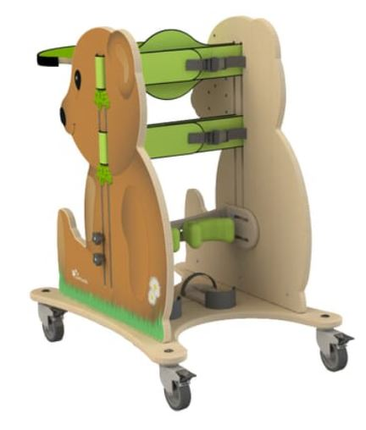
A picture containing a Buddy upright standing frame: a wooden frame and table on locking wheels which allows a child to be supported in an upright position to stand.
www.nrshealthcare.co.uk

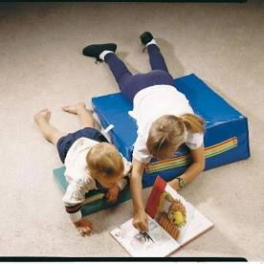
A picture containing two wedge shaped cushions on the floor. Both cushions have a child lying on their tummy, while sharing a picture book.

www.smirthwaite.com
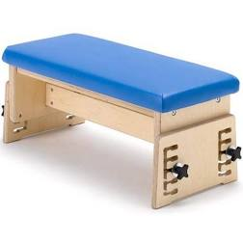
Therapy bench; small, height adjustable, wooden bench with blue cushioned seat
www.smirthwaite.com

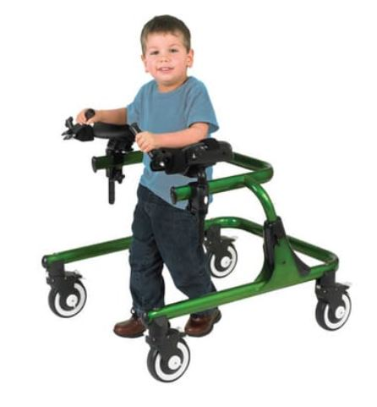
A picture containing a young boy standing with a walking frame

www.nrshealthcare.co.uk

(images sourced from google images www.google.com each image has had permission granted from the company.)

Excerise and Stretch programmes
The CYP will usually visit their NHS physiotherapist at the local clinc where a programme of exercises or stretches will be assessed and finalised. Once the phsyio has establised which exercises or stretches are appropriate to the CYP they will demonstrate these to parents and provide a written copy of the programme. The physiotherapist will explain that the programme should be carried out daily, depending on the level of phsyical activity the CYP will engage with. If the CYP has a PE lesson or sporting club to attend, then it is recommeded to ask if the phsyiotherapy programme is needed to be carried out on the same day. Parents and the physiotherapist should be consulted and an agreement made. Programmes often include pictures and have a written explanation of the moves to be carried out, here are some examples;
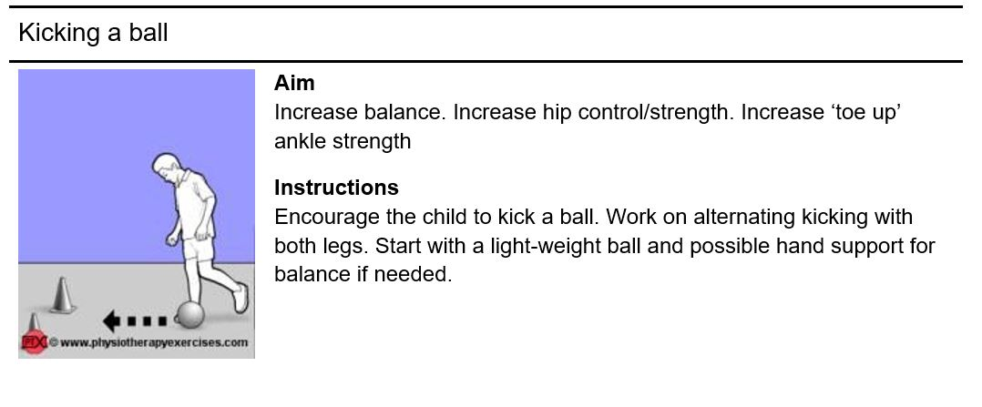
Cartoon style image of a child attempting to kick a football through two cones set as a goal.
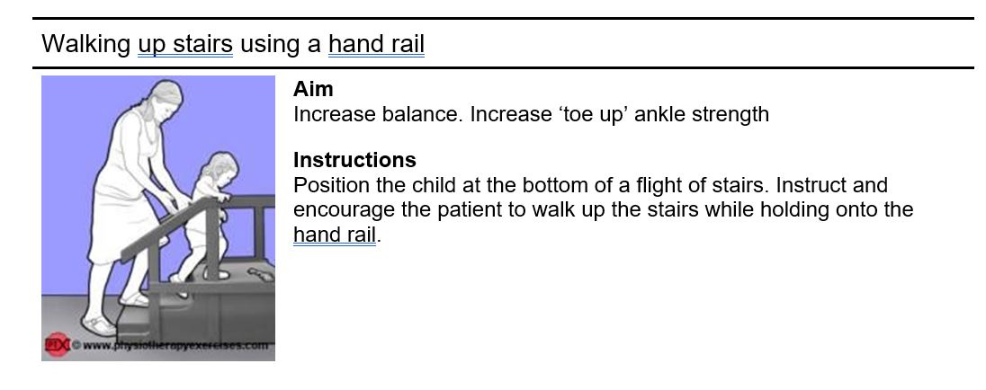
Side view image of a small child walking infront of an adult up a short flight of steps holding a handrail. Adult has their hands outstretched towards the child’s trunk for support if needed.
Images taken from www.phsyiotherapyexercises.com which is a free to use tool

Carrying out Physiotherapy at school
After discussion with parents, CYP and the phsyiotherapist, it is highly likely that there will be aspects of the phsyiotherapy programme that may need to be carried out at school. This may include the exercise/stretch programme and or use of postural equipment. If specialist equipment is being recommended then the NHS physiotherapist can arrange for this to be provided at school and they will demonstrate to staff how it is used. The physiotherapist will adjust the equipment for the CYP, school staff should never adjust equipment rather they should report any concerns to the physiotherapist and stop using the equipment. Before you start;
- You will need to consider where to carry out the programme. It would be useful to have a PE mat if you need to use the floor.
- Agree with parents what aspects of the programme you can accomplish each day and make a chart to record this.
- Take exercises/stretches individually and look to work on them in small chunks, visiting the programme several times a day, rather than all at once.
- Avoid using break and lunch time for physiotherapy as this reduces social time with peers.
- Negotiate with the CYP and class teachers which lessons specialist, postural equipment can be used for – add these to the time table so the CYP is prepared at the beginning of the day.
- Liaise with parents and the physiotherapist if the CYP is finding any of the programme uncomfortable.
- Report to parents when there have been unexpected changes – the class had a more intense PE lesson so the programme was reduced to reflect this.

