Let’s Talk: Self-care
Secondary

This resource is part of our self-care suite of resources and has been co-produced, with children and young people living in Essex, for children and young people. They have also been developed and quality assured by the following stakeholders:
- Essex Educational Psychology Service
- Essex Health Watch
- Essex Mental Health Support Teams (MHSTs) NELFT NHS Foundation Trust
- Essex Multi-schools Council
- Essex Social, Emotional and Mental Health (SEMH) strategy team
- HCRG care group Child and Family Wellbeing Service
- NELFT NHS Trust Southend, Essex, and Thurrock (SET) Child, Adolescent and Mental Health Service (CAMHS)
- Professionals in schools and settings can access all these resources via the Essex info link SEMH portal. Children and young people (CYP), parents/carers and professionals can also access these resources via the SET CAMHS website. Our self-care content can also be accessed via SET CAMHS Instagram account:

The resources are intended to be accessed by CYP independently or trusted adults use these resources with CYP through 1:1 conversation, whole school/group discussion and assemblies.
Please note: some of the content within our self-care resources may be emotive for CYP. We recommend that you make use of the ‘signposting to support’ section of this document should any of the content be triggering.
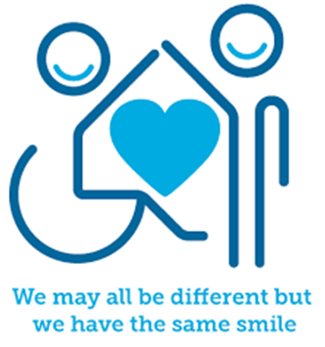
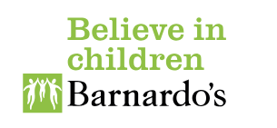

Introduction
self-care is about the little things we choose to do to look after our own physical, emotional, and mental health. Self-care is personal to us and will vary from person to person. It includes trying to listen to how we are feeling and understanding what we need, even if it’s difficult, so we can take actions that support us to care for ourselves.
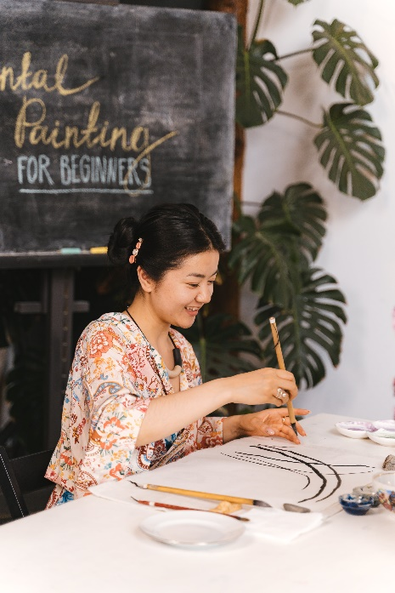

Facts
Self-care is:
- a basic human need​
- personal to you​
- about making time​ for yourself
- a way of looking after yourself and getting your own needs met

Self-care includes activities and strategies that support:
- your physically healthy — including hygiene, nutrition, and seeking medical care when needed.
- your emotional needs (including a range of feelings)
- manage stressors that occur in your life.
- promote health.
- prevent illness.

Myth Buster
Self-care:
- is optional X
- is selfish and indulgent X
- doing yoga and meditation X
- is the same for everyone X
- the effects of self-care are only temporary X
- just for females X
- it takes too much time X
- is too expensive X
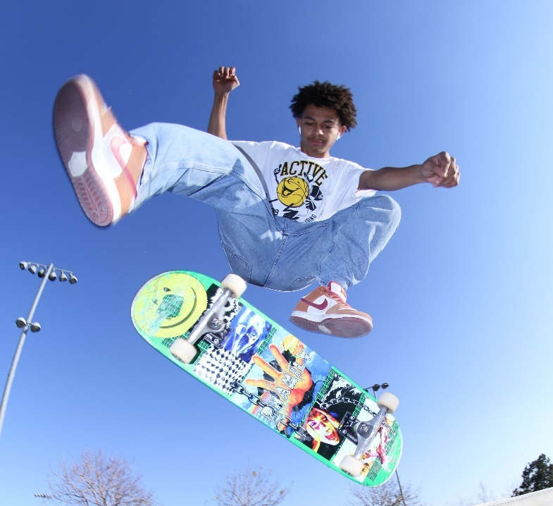
- it must be earned X
- is all or nothing X
- requires resources you do not have X
- others always must come first X
- it must involve others X
- it cannot involve others X

Video clips
Check out these videos about self-care:
- What is self-care?
Video of young people describing self-care

- Self-care explained
Video animation describing self-care

- What does self-care really mean?
Video of young people describing self-care

- Self-Care: What Teens Think - YouTube
Video of young people describe what they think about self-care

- How self-care supports you recover from Stress & Trauma
Video animation describing self-care

- Self-care in school
Video of young people describing self-care in school

- Self-care in College
Video of young people describing self-care in college

- Healthy coping strategies for young people
Video describing healthy coping strategies for young people

- Self-care in nature support your mental health
This video discusses ways that nature improves mental health

Resources
- Every Mind Matters Free Plan
& Free Mind Plan
Every mind matters advert and a free mind plan
- Making a self-care plan
Create a self-care plan for young people in secondary school and College

- Self-care strategies
Explore a library of self-care activities examples to try

- A self-care action plan
Video clip talking about making a self-care plan

- Young Minds self-care
A guide for young people about self-care
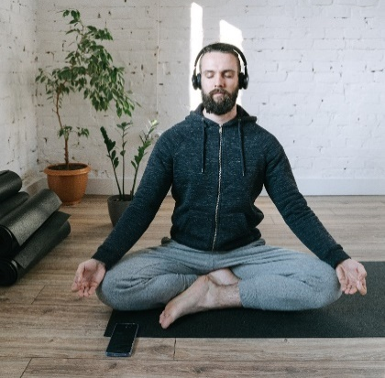
Reflective questions
(Try exploring these reflective questions with a CYP)
- How much self-care do you feel you fit in during your week?
- What self-care activities do you do?
- What self-care activities would you like to do more of?
- What advice would you give a friend about self-care?

Quiz of 5 questions per theme
Once you have gone through this resource with a CYP try this quiz questions with them:
- Can you describe what self-care is?
- Can you describe what self-care is not?
- Can you list 5 self-care activities?
- What can self-care activities support?
- What is every mind matters?

Additional ideas
Other things to try:
- Self-care Toolkit
Tools and ideas to support children and young people to explore and start creating their own self-care toolkit

- Mood Journal
Describing the use of a mood journal
- Mindfulness Calendar
Offering a range of daily 5-minute mindfulness activities to try

Signposting to Support
For additional support we recommend you:
- Anna Freud Centre – On My Mind
- Kooth.com
- Explore counselling/therapy
- Childline 0800 1111 when contacting ChildLine what to expect?
- Hopeline 0800 068 41 41 offering confidential support and practical advice
- Text ‘SHOUT’ to 85258 for free, confidential, anonymous text support service.
- Share any concerns about your mental health with your GP and Understanding Confidentiality
- NHS 111
- Southend, Essex & Thurrock Children and Adolescent Mental Health Service (SET CAMHS)
- Where to get urgent mental health support from: Advice from NHS

- SET CAMHS Instagram account

How to help a friend
- Start a conversation about self-care. Describe to them what it is and why it is important for your mental health.
- Talk to your friend about the things you do to support your self-care.
- Ask what your friends do to support their self-care
- Suggest they look at this resource for ideas and support.
- Recommend that they follow the SET CAMHS Instagram account: set_camhs_nhs
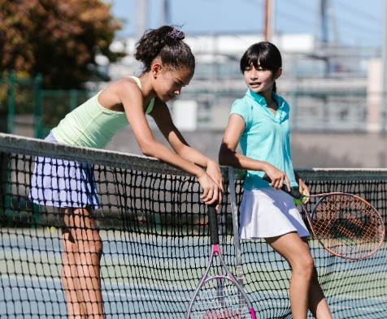

The adult box (for professionals and parent/carers to read)
- How to talk to your teens about self-care
Blog that shares top tips about talking to teens about self-care.
- Modelling self-care as a supporting adult
It is important to model self-care to young people. This resource is for teaching staff exploring the building blocks of good mental health and wellbeing.

- Secondary student self-care booklet
A range of self-care activities which are printable to use with young people.

- Self-care form time activities
A series of activities for Key Stage 3 and 4, introducing them to a range of self-care techniques.

- Bank of self-care ideas for students
250 self-care ideas that you can add to your routine

- Looking after yourself as a parent/carer
Young minds offer advice about supporting yourself whilst support a child/young person’s mental health. This link includes parents A-Z mental health guide, how to talk to your child about mental health, getting help for your child, how to set up a parent support group, parent helpline and webchat and a parent blog.

