ESSEX VIRTUAL SCHOOL
Self-Evaluation 2023

“Education is the most powerful weapon which you can use to change the world.”
Nelson Mandela
Our mission is to place our children and young people at the very heart of everything we do. Championing their interests, celebrating their successes, and constantly striving to ensure that all those working around them share the highest aspirations for their achievements. We want our children and young people to feel happy, safe, and secure in settings where they receive an outstanding educational experience that enables them to grow into confident, resilient citizens.
Essex Virtual School 2021

Introduction
This report summarises the educational outcomes of Essex Virtual School’s children and young people in care 2021-23. It also highlights the work of the Virtual School since November 2021 to develop its systems processes and practices to promote the educational needs of children in care and previously looked after children and develop its strategic leadership role in promoting the educational outcomes of the cohort of children with a social worker.
The Headteacher Essex Virtual School is responsible for ensuring that the local authority effectively discharges its statutory duty, under 22(3A) of the Children Act 1989, to promote the education of children in the care of the local authority (DfE 2014)1. The key priority of Essex Virtual School is to further ‘close the gap’ in attainment and achievement that exists between its children and others by working with partners to address their specific and distinctive educational needs.
This report aims to clarify the ways in which the Virtual School works, the range of support we provide and the challenge we bring to raise expectations, aspirations and improve the educational outcomes of our children and young people.
Integral to our success is the partnership we have with those who support our children including carers, schools, and social care. Designated Teachers for children in care - a statutory role in every school, play a key role in supporting our children and young people in schools and colleges.
The Virtual School sits within ‘Essex Specialist Education Services’ and is therefore ideally placed to be able to work with social workers, carers, and the many teams and services who all contribute in different ways to ensuring that children enjoy and achieve in their education and beyond.
Essex Virtual School are fully committed to being ‘educational advocates’ for our children and young people. We aim to deliver this not only with determination and energy, but also with care and compassion.
- Structure and Organisation

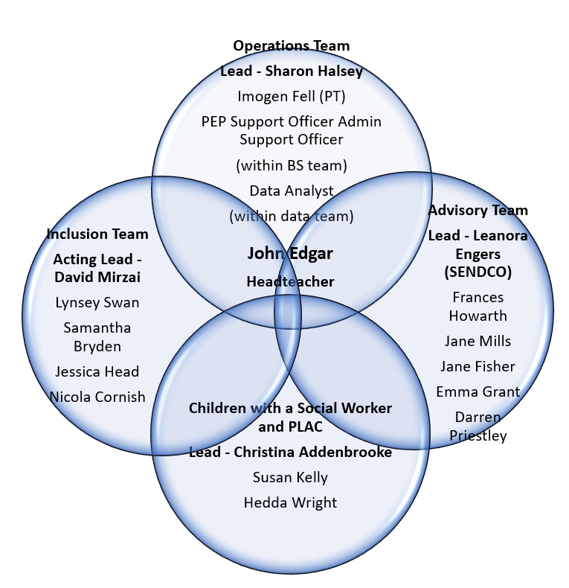
Following the appointment of a new Headteacher and Lead Education Adviser in the past 15 months, Essex Virtual School has developed new ways of working and increased its number of staff to reflect this. These changes are ongoing and reflect the challenges faced post covid, the increase in numbers of children in care (CiC) including separated migrant children, the growing demand for support and guidance from parents and schools in relation to Previously Looked After Children (PLAC), and the Virtual School’s new duties for children with a social worker ever six (CWSW).
We are committed to distributing leadership widely across our teams and have developed a structure that facilitates this and is designed to promote ‘joined up’ working. The structure adopted reflects this, as does the provision of ongoing CPD for all staff.
Each of the teams has a Lead Professional who is responsible for their team’s operational delivery and for supporting members of their team through regular supervision. The Lead Professionals work in partnership with the Headteacher Virtual School to determine strategic priorities and monitor this through the lens of the school’s improvement priorities.
Our priorities for are:
- Consulting students about their learning and wider education.
- Evidence based working.
- The PEP Process.
- Working with partners to develop a distinctive Post 16 offer.
- Collaboration within and beyond the Virtual School.
- A dynamic training & CPD offer.

How do the Operations Team collect information about quality of provision and work strategically to shape the quality of that provision?
They coordinate the VS training offer that assists schools understand the specific educational needs of CiC and how to incorporate this understanding into their curriculum, behaviour/relationships policies, teaching, and pastoral care systems. They cross reference this with schools engaged with the Essex Trauma Perspective Practice (TPP). They provide training for DTs and social workers to support the PEP process.
Training Offer
Audience | Training
Social Workers | New Starters introduction to Education
Social Workers | PEP Process
Social Workers | Enhanced Multi Agency Working
Social Workers | PEP Meetings setting the education agenda
Social Workers | Education and aspiration
Carers | Carer Level 1
Carers | Carer Level 2
Carers | Make it Happen
Carers | Drop in with VSH
DTs | DT Level 1
DTs | DT Level 2
DTs | Attachment Awareness Accreditation Network
DTs | PEP Training
DTs | PEP Meetings setting the education agenda
DTs | Enhancing Multi Agency Working
DTs | Network Meetings
Schools/DTs | Behaviour & Relationships
Schools | CSS Training project  - Training offered includes the following:  - Mental Health  - Positive Behaviour Management  - Attachment Theory into Practice  - Effective Communication  - Identify and responding to behaviour  - Coaching Pupils  - Stress Analysis  - Co-regulation Self-Regulation
All | Academic Resilience (see attached slides)
They also oversee our Projects for Children:
- Laptops for CiC.
- Maths Whizz
- Reading Plus
- Britannica online.
- School Led Tutoring (15 hours)
- Music Service
Activity | LAC | PLAC/CiN | SEND | Disadvantaged | Total children
Workshops | 24 | 36 | 127 | 303 | 1323
Whole Class Tuition | 1 | 0 | 2 | 6 | 30
Songwriting for Wellbeing | 12 | 7 | 47 | 48 | 179
Nurture Groups | 15 | 10 | 90 | 102 | 130
Interventions | 2 | 0 | 0 | 2 | 2
Summer Holidays | 0 | 12 | 0 | 0
Cultural Diversity Programme | 7 | 0 | 0 | 0 | 270
TOTAL | 61 | 65 | 266 | 461 | 1934

- Mental health and well-being workshops with Ignition Arts.
- Essex Virtual School, Essex Year of Reading Projects - Cliff McNish Workshops, Lucy Strange Workshops, Michael Rosen Workshops.
- Dermot O’Leary Books, Dollywood Foundation & Letterbox.
- Learn how to Vehicle wrap- years 10,11 and 12
- SPEC Holiday program – Sports and Wellbeing project
How do the Operations Team collect information about children’s individual educational needs and work operationally to ensure school’s plan to meet those needs and evaluate the impact of those plans on children’s outcomes?
They have oversight of and conduct the Quality Assurance of Personal Education Plans (PEPs). This is the statutory process for ensuring the specific needs of CiC are addressed. They also administer Pupil Premium Plus (PP+) funding to support specific interventions identified in PEPs that are additional to core provision or are funded by an EHCP or other funding source (e.g. Inclusion Framework).
How do the Inclusion Team collect information about quality of provision and work strategically to shape the quality of that provision?
They provide guidance to social workers, carers and schools regarding admissions, (see attached documents), attendance and exclusion/suspension. The quality of provision in schools in England is judged by Ofsted. Children in Care (CiC) can only be admitted to schools that have an Ofsted rating of ‘Outstanding’ or ‘Good’. The Inclusion Team provide support and guidance to assist social workers, as the professionals with parental responsibility for CiC, meet their statutory duty to complete admissions requests to appropriate schools (that meet need) and consult with the Virtual School. They monitor the number of children in RI schools and Inadequate schools. This is used by the Advisor Team to plan the work they do with these schools to ensure the quality of provision for CiC.
Where a child has an Education Health Care Plan (EHCP) the SEND department in the Authority where the child resides are responsible for conducting a search and naming an appropriate school (that meets need) on the Plan. The Inclusion Team consults with SEND team in the Authority in which the child resides, to ensure statutory timeframes are adhered to and the most appropriate schools are named on Plans. They ensure a VS SEND Advisor is consulted where necessary.

The Inclusion Team provide advice and guidance to schools regarding attendance, exclusion (PEX), suspension (SUS), part time timetables (PTT), and Alternative Provision (AP). They closely monitor this through Welfare Call and challenge schools to ensure they comply with statutory guidance. They ensure a VS Advisor is consulted if there are concerns with PTT or AP provision.

The Inclusion Team, work with FE Colleges to commission provision for Y11 Separated Migrant Children (SMC) and monitor courses to ensure safeguarding requirements are adhered to.
How do the Inclusion Team collect information about children’s individual educational needs and work operationally to ensure school’s plan to meet those needs and evaluate the impact of those plans on children’s outcomes?
The Inclusion Team monitors the collection of attendance data by Welfare Call and responds to SUS and PEX immediately.
Where attendance is poor an Inclusion Officer will work with a school to ensure strategies for improving attendance are included in the child’s PEP.
The use of PPT and AP are closely monitored, and schools are required to consult with an Inclusion Officer when this is part of the PEP to ensure provision meets the needs of the child.
The inclusion Team monitors and are responsible for provision of CiC who are deemed to be Children Missing Education (CME). They ensure temporary provision is put in place, commission and monitor the quality of this and conduct PEP Review Meetings for these children.
How do the Advisor Team collect information about quality of provision and work strategically to shape the quality of that provision?
From September 2022 – Advisers complete a Virtual School Support Plan for all Essex schools with CiC students on roll, to identify areas of need / concern. The focus is on being evidence based incorporating PEP evidence, Ofsted Reports, Information from Education, Social Care and other relevant professionals.

Where a school is highlighted as needing support advisers will either attend the PEP (depending on if the issues are student based) or complete a strategic review of provision for CiC students in the school or setting. Priority for support is based on Ofsted category, number on roll, student progress in last term / academic year.

Depending upon the outcome of the PEP / Strategic review this will result in action from advisers which may be to review the Virtual School Support Plan / Signpost to training / professionals / organisations to address need, bespoke training for school / MAT staff / escalation via SEND quadrants / SEP / VS Head as appropriate following escalation protocols for advisers. Raising profile of CiC and statutory guidance with SEND colleagues and social care to ensure there is high quality provision for SEND.

Lead Adviser / Advisors now sit on Complex Case Forum and JAAP for CiC students to ensure appropriate educational provision where a student has complex SEND needs and is CiC. Advisers also currently invited to attend West Complex Case panels and raise the importance of educational provision for cases that are deemed complex by social workers

Training for social workers, carers, DTs and schools updated with SEND guidance. Also being invited to deliver workshops at partners’ conferences including TPP conference in October 2022 and CiC Council Love and Relationships conference.

Out of county offer around trauma and attachment for non-Essex schools.
Three advisers are TPP trainers and working with central SEMH team to develop additional training to meet CiC and wider cohort’s learning needs e.g. Trauma, Lead Adviser and PLAC / CHwSW Lead to meet with DoD and AD to discuss issues specific to each quadrant

New Systems in place to analyse outcomes of public examinations and statutory assessments to be completed Autumn 2022 – comparing with Essex, Statistical Neighbours and National outcomes. New Data Analyst supporting role to be completed end of Autumn Term.

How do the Advisor Team collect information about children’s individual educational needs and work operationally to ensure school’s plan to meet those needs and evaluate the impact of those plans on children’s outcomes?
New PEP template gives more accurate information regarding SEND need / status. Advisers will look at assessment data from PEPs each term and this will inform the Virtual School Action plan for a school – particularly in terms of progress.

Third team of advisers created ‘SEND and PRU specialist advisers’ who work in partnership with Primary / EYFS and Secondary / Post 16 teams to work strategically with schools and teams around a student where there are concerns about student’s progress to address education provision.

Working Memory and maths and literacy interventions. Student Voice and the PEP process. Academic resilience and the educational conversation.
Piloting specialist consultation with Senior EP where there are concerns about complex needs in relation to developmental trauma and its impact on learning.

New PEP template changing the ways schools report on progress so advisers can be more responsive when there are concerns about student progress and particularly for KS3 progress and attainment can be universally understood for CiC students particularly in terms of the unique ways schools report on progress for this Key Stage.

Advisers to check all PEPs for allocated schools that have been identified as needing additional support from the VS and any concerns for attainment / progress would trigger a review / intervention from a VS adviser.

How do VS systems and processes:
- Collect information about quality of provision and work strategically to shape the quality of that provision?
- Collect information about children’s individual educational needs and work operationally to ensure school’s plan to meet those needs and evaluate the impact of those plans on children’s outcomes?
Student Profiles
A student profile can be completed by any professional, carer or child where there are concerns about the progress, attainment or wellbeing of any CiC or PLAC. These are shared with professionals and placed in the child’s ePEP record.
The purpose of the Student Profile is to provide additional information not available in the PEP. Information is discussed at a VS Panel sitting weekly during term time. The panel considers each one and decides what VS resources are allocated.
For urgent matters the Leads for Inclusion and the Advisor team can be contacted directly. For urgent PLAC matters the Lead for CHWSW can be contacted directly.

- Current Cohort information Spring Term 2023

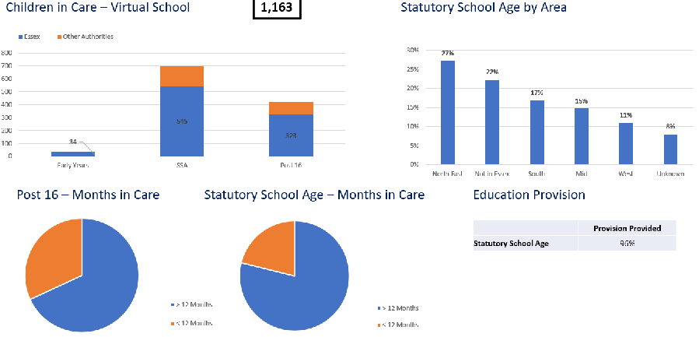

- School Ofsted ratings

Statutory guidance states that Children and Young People in Care should attend schools that are rated as either or Good or Outstanding by Ofsted. Virtual School provides detailed guidance for social workers in regard to the admissions of children in care.
Ofsted School Rating | Number of pupils | Percentage of Cohort | In County | Out of County
Outstanding | 53 | 8.5 | 44 | 9
Good | 400 | 64.3 | 317 | 83
Requires Improvement | 52 | 8.4 | 39 | 13
Serious Weaknesses | 14 | 2.3 | 14 | 0
No data available | 77 | 12.4 | 61 | 16

72.8% of Essex LAC attend schools graded Outstanding/Good. A further 12.4% are in schools that do not yet have an Ofsted rating, these are schools transferring to academy status. 10.7% of students attending RI/Inadequate schools are placed in Special Schools. LAC are not placed in RI schools, but students coming into care who attend a RI school will usually remain in that school as will students attending a school that changes category. Rigorous processes and procedures for monitoring and intervening where CiC attend a category school are in place. Details are included in this report under section 1, the work of the Advisor Team.

- Supporting learning and achievement

The Essex Virtual School team are committed to improving educational outcomes for children and young people in care, and previously in care and children with a social worker. We achieve this through a combination of direct, advisory, and strategic work with children, schools, social workers, carers and other key partners.
These include:
- Regular meetings with Designated Teachers.
- Supporting and improving the Personal Educational Planning process
- Tracking attendance, exclusions, attainment, and progress
- Providing direct learning support to pupils.
- Providing advice and training, together with robust challenge and support to schools and social care
- Interventions and wider activities to promote learning, raise aspirations and celebrate achievements

Further details regarding the specific systems and practices developed this year are included in Section 1.
Spring Term Progress:
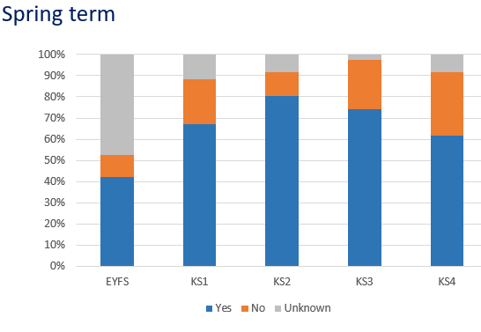
- Pupil Premium Plus (PP+)
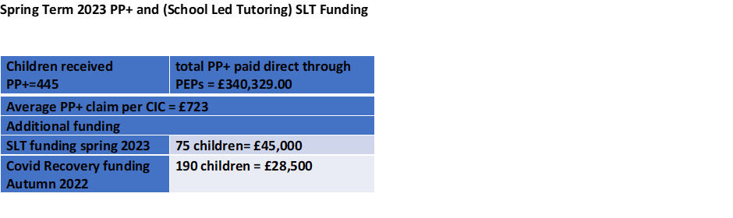
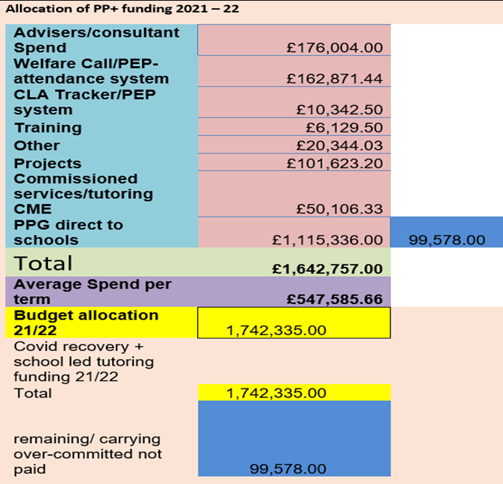

PP+ funding is provided by the Department for Education (DfE) to diminish the difference and realise the potential for all Essex children in care, wherever they live. The PP+ Policy is reviewed annually to reflect changes in practice and provision from the DfE.

Currently Essex Virtual School receives the EYFS PP+ grant and PP+ for children of Statutory School Age. There is currently no funding received to support work with Post 16 CiC.

Essex Virtual School currently top slice 20% of PP+ to fund the teams of Advisors and Inclusion Officers who provide:
- Training and support for Designated Teachers, carers, and social workers.
- Support, guidance, and monitoring for schools in category schools attended by our children.
- Interventions to avoid exclusion, support admissions, tackle underperformance, and improve attendance.
- Support and guidance for Designated Teachers.
- A response to enquiries from carers, social workers, and schools.

This year we have used PP+ funding to ensure all CiC have access to a laptop or suitable device to enable access to learning and the learning platforms funded by the Virtual School:
- Maths Whizz - KS1 and KS2
- Reading Plus - KS2-4
- Britannica - All ages

It also funds projects such as:
- Vehicle wrap- years 10,11 and 12
- SPEC Holiday program – Sports and Wellbeing project
- Music Services – All ages
- Mental health and well-being workshops with Ignition Arts.
- Author reading workshops in schools.

Some PP+ funds training to promote the education of our children, this includes:
- Attachment Aware Training delivered by the EP Service.
- PEP/role of DT/DT Network meetings.
- TPP Foster carers.
- Education Matters/Made/Make it Happen – Foster Carers
CSS Training project for schools – Mental Health, Positive Behaviour & Relationships, Attachment in the classroom, coaching, co and self-regulation.

In addition to PP+

Covid Recovery LAC funding-Autumn 21 and Spring 22
Total Received
£53,867.75
Total provided for covid recovery support
Additional SEMH support/ catch up groups/SEMH projects and training
£69,495.50
(Virtual school added an additional £15,627.75 from PP+ grant)
145 students direct claim for above + 55 schools projects and training.
School Led Tutoring LAC funding -Autumn 21 and Spring 22
Total Received
£52,683.75
Total provided
£65,854.50
(Virtual School added a contribution of £13,170.75, 25% to meet the conditions of the grant)
Breakdown of funding
4380 hours= LAC 292 students
250 students = English/2000 hours
250 students = Maths/1750 hours
- tudents=Science /630 hours

- Personal Education Plans
From January 2022 a single PEP process for Essex CiC has been introduced. Information to inform the learning discussion at the termly review meetings will be collected and held on Welfare Call ePEP.
Training for social workers, carers and DTs is already underway to support them in the use of the system and develop the quality of the learning discussion.
In preparation for this change the Essex ePEP has been completely overhauled to ensure it is fit for purpose. The key changes are:
- Identifies Essex Quadrant.
- PTT and AP provision mandatory with details of provision and monitoring
- Curriculum preconisation
- Internal and external suspension and associated provision
- Detailed attendance record
- Transition planning.
- SDQ – SEMH Assessment
- SEND status and funding, including assessment.
- Live Progress & Attainment Section – Records Engagement with Learning, progress towards end KS target and from starting points, attainment.
- Reading and Spelling age.
- Wishes and aspirations section completely renewed and greater flexibility.
- Meetings & SMART Targets – record of who attended, meeting notes, review of previous targets, new SMART targets, interventions & support. Use of PP+.
- QA section with quality judgements by VS

Current PEP completion data following move to a single PEP:
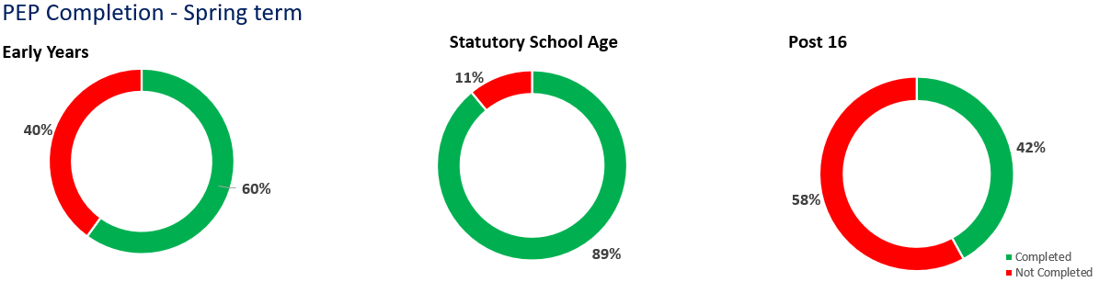
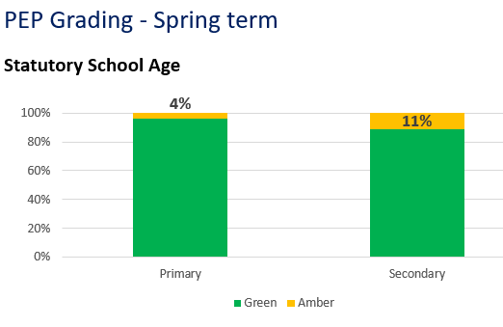
- Attendance, FTE and Exclusion

The Virtual School Inclusion team monitors the school attendance of all of Essex’s children and young people in care continually using Welfare Call. Further details regarding the work of the Inclusion Team is included in Section 1 of this report.
We have seen an increase in PEX so far this year, having 0 PEX last year. One PEX followed VS and the school working closely to avoid exclusion. In the other two cases VS has taken the decision to IRP.
VS has successfully avoided in excess of 15 PEX for CiC this year through negotiation with schools.
Spring Term Attendance Data:
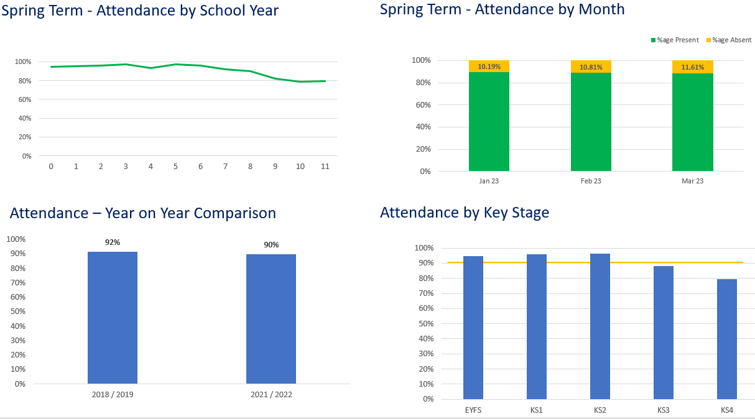

Spring Term Suspension and PEX
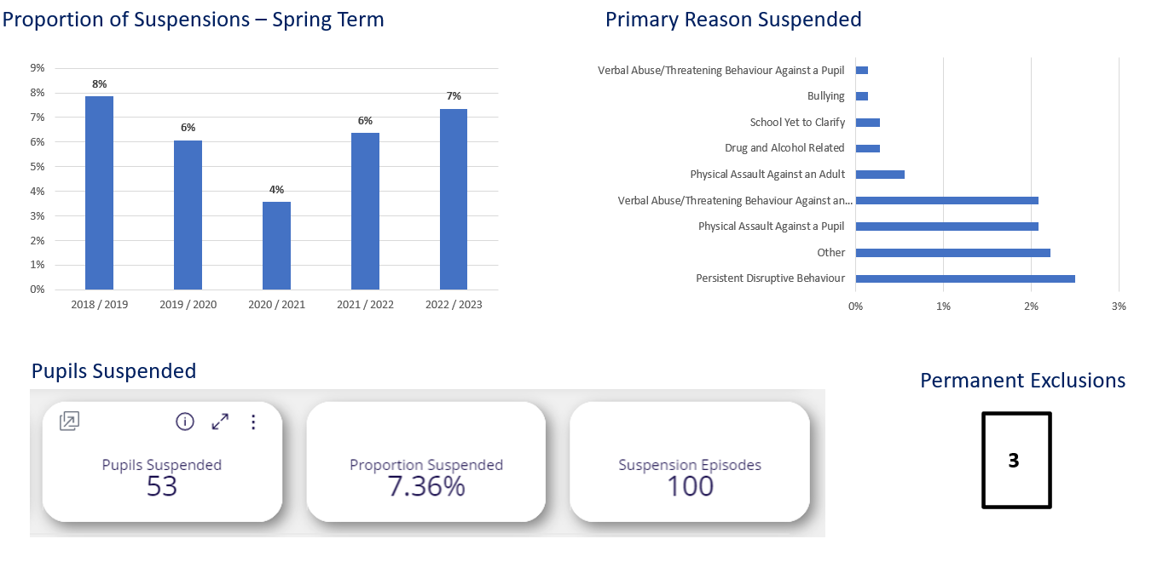

- Post-16 Education, Employment and Training

Whilst VS has explored a number of projects and pilots this year these have had mixed success. The focus in 2023 has been on developing our support for SSA CiC, see section 1. Post 16 will be our key priority for the next academic year, but much is dependant on funding and on the school’s staffing.
been 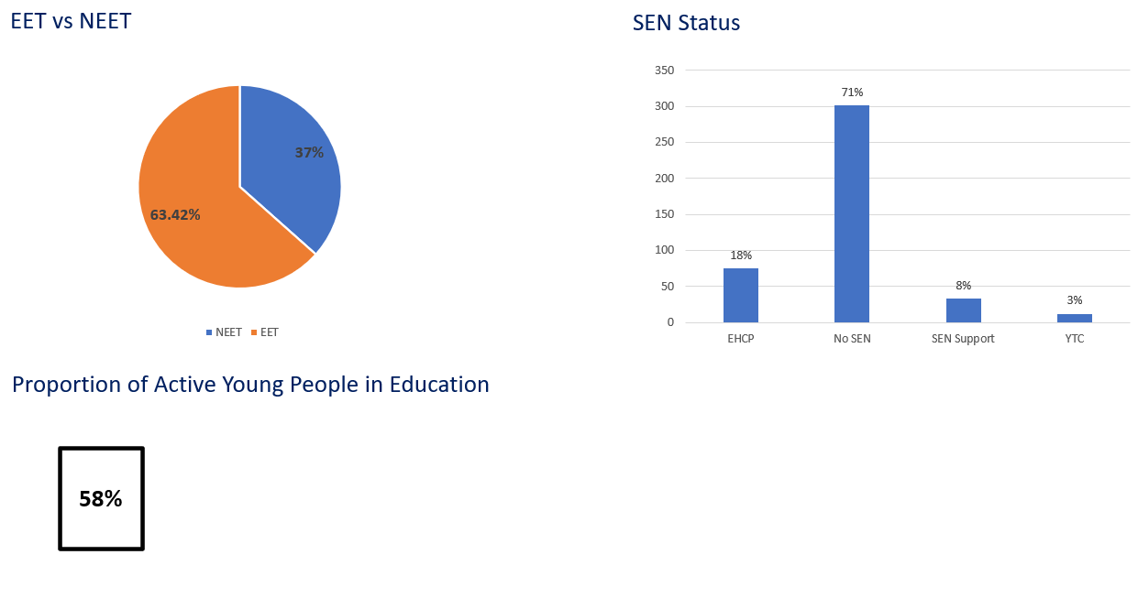
- Governance and Accountability

This year has seen a renewed focus to ensure that the VS keeps the Corporate Parenting Panel up to date with key education outcomes of CiC and the work of the VS. This year CPP held an extraordinary meeting to enable VS to share its work and Education Outcomes are now presented termly to the Board.
Virtual School has its own Governing Body that sits termly and includes members from Social Care, Virtual School, schools and colleges.

- Extension Role

In September 2021 Virtual School Heads become strategic leaders for improving education outcomes for the cohort of children who have been assessed as being in need under Section 17 of the Children Act 1989 and currently have a social worker and those who have previously had a social worker.

This cohort has been identified as a group of children who face significant barriers to education as a result of experiences of adversity and trauma, most commonly abuse and neglect.

Virtual Schools role is to be the strategic lead to champion the educational attendance, attainment and progress of children with a social worker. This means that they will help to:
• make visible the disadvantages that children with a social worker can experience, enhancing partnerships between education settings and local authorities to help all agencies hold high aspirations for these children.
• promote practice that supports children’s engagement in education, recognising that attending an education setting can be an important factor in helping to keep children safe from harm.
• level up children’s outcomes and narrow the attainment gap so every child can reach their potential. This will include helping to make sure that children with a social worker benefit from support to recover from the impact of COVID-19.
In January 2022 an appointment to lead on the new duty and PLAC made. Several initiatives including pilots with groups of schools and research commissioned by the Virtual School have been organised to scope out the barriers to achievement that exist within Essex. In addition, training and collaborative events have been organised to promote Multi agency working and create data sets that can be used to evaluate this cohort and evaluate the impact of future work.

- Next Steps

Whilst a great deal has been accomplished this year there remains much to be done to ensure that we can successfully close the gap between the achievements of our cohorts of children and their peers. We will continue to focus on our improvement priorities:
Improving outcomes through:
Consulting students about their learning and wider education.
- Evidence based working.
- The PEP Process.
- Working with partners to develop a distinctive Post 16 offer.
- Collaboration within and beyond the Virtual School.
- A dynamic training & CPD offer.

Our aim will be to ensure that our PEP for statutory school age children and the support our teams provide for them and the professionals who work with them will be well progressed by the end of this academic year. This will enable us to focus on re designing our teams to meet the challenge of effectively supporting our Post 16 cohort and developing our offer for care leavers. In particular, building capacity and partnerships to address the high level of young people who are NEET by listening and responding to their views in order to build successful strategies that bridge KS4 and Post 16.

