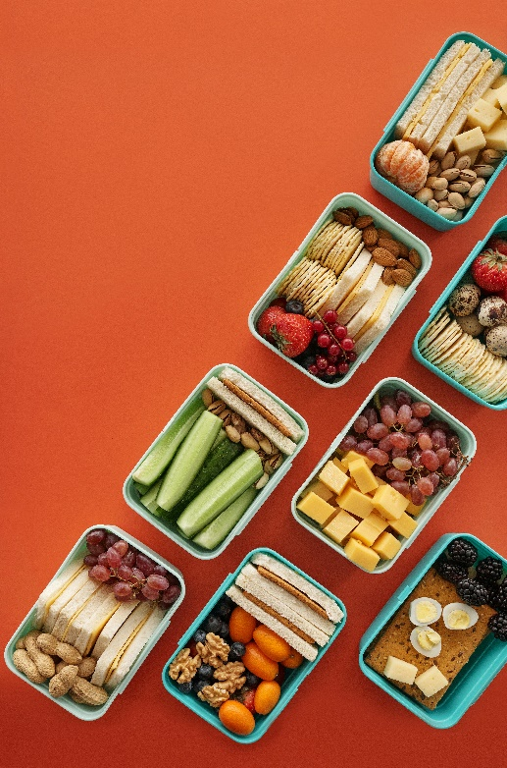
Let’s Talk: Healthy Eating
Primary

This resource is part of our self-care suite of resources and has been co-produced with children and young people living in Essex, for children and young people. They have also been developed and quality assured by the following stakeholders:
- Essex Educational Psychology Service
- Essex Health Watch
- Essex Mental Health Support Teams (MHSTs) NELFT NHS Foundation Trust
- Essex Multi-schools Council
- Essex Social, Emotional and Mental Health (SEMH) strategy team
- HCRG care group Child and Family Wellbeing Service
- NELFT NHS Trust Southend, Essex, and Thurrock (SET) Child, Adolescent and Mental Health Service (CAMHS)
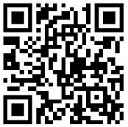
- Professionals in schools and settings can access all these resources via the Essex info link SEMH portal. Children and young people (CYP), parents/carers and professionals can also access these resources via the SET CAMHS website. Our self-care content can also be accessed via SET CAMHS Instagram account:

The resources are intended to be accessed by CYP independently or trusted adults use these resources with CYP through 1:1 conversation, whole school/group discussion and assemblies.
Please note: some of the content within our self-care resources may be emotive for CYP. We recommend that you make use of the ‘signposting to support’ section of this document should any of the content be triggering.
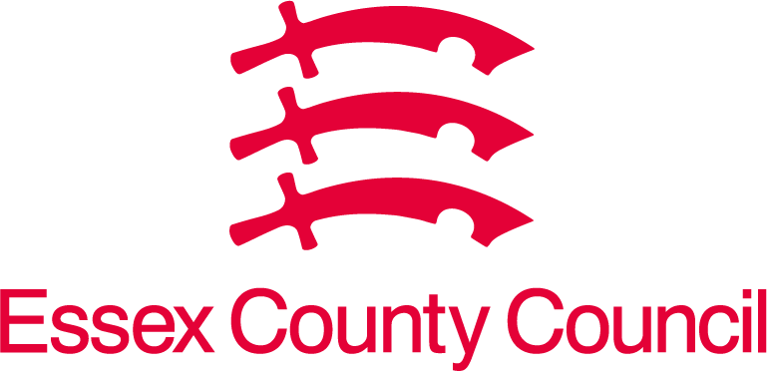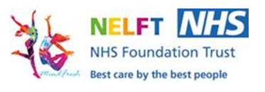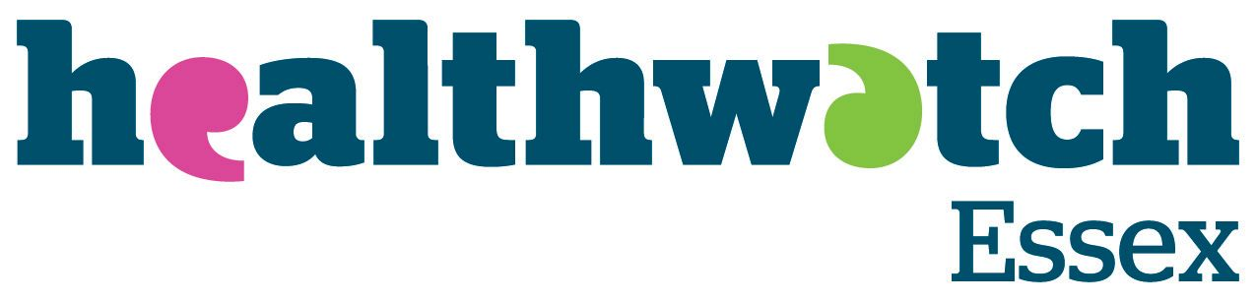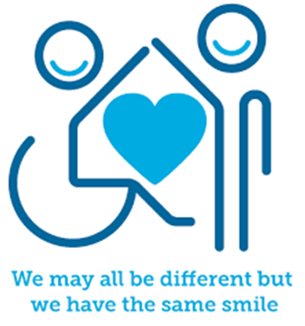
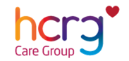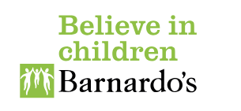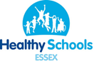

Introduction
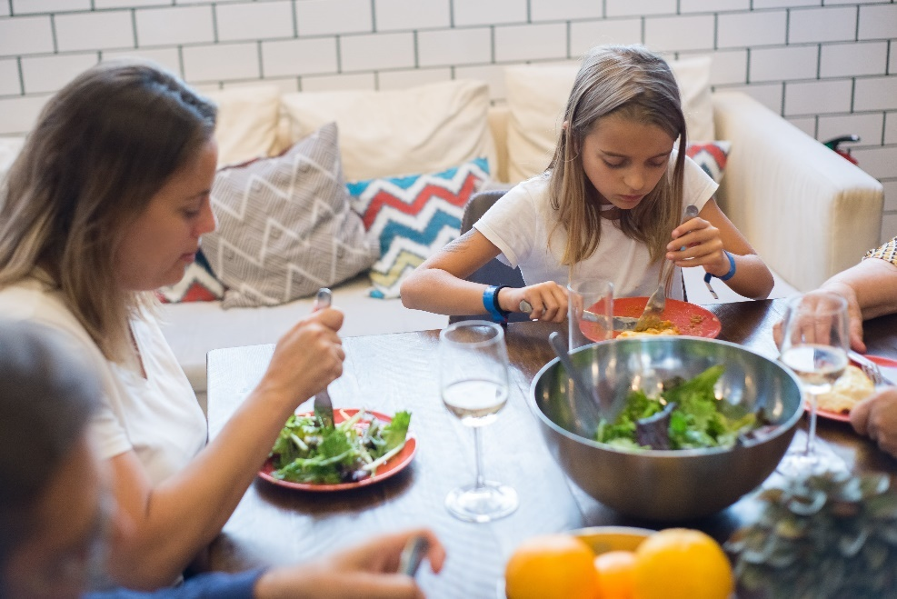
The NHS tell us that a well-balanced diet provides a range of benefits. It provides the energy you need to keep active, learn and interact with others throughout the day. It also provides you with the essential nutrients you need for growth and repair, helping you to stay strong and healthy and help to prevent diet-related illness. This means eating a wide variety of foods in the right proportions and consuming the right amount of food and drink to achieve and maintain a healthy body weight.

Facts
- A healthy diet requires a balance of different foods. These different foods help your body in different ways.
- Proteins (meat, fish, nuts, and eggs) help your muscles to grow.
- Vitamins and minerals (fruits and vegetables) help keep your skin strong and grow as you grow. They also help to keep your organs going.
- Dairy (milk and cheese) helps you as you grow and helps give you strong teeth, bones, and nails.
- Sugar (chocolate, sweets, and cakes) give you energy quickly, but you only need a small amount of it.
- Carbohydrates (bread, pasta, and potatoes) give you energy but release more slowly than sugar, keeping your energy levels going throughout the day.
- Fats (butter and oil) keep you warm but you do not need to eat a lot of these.
- You should drink about 6 cups of water everyday too, not sugary fizzy drinks.
- Everyone should have 5 fruit and vegetables a day.

Myth Buster
Here are some myths about Healthy eating:
- Raw carrots are more nutritious than cooked X
- Frozen and canned fruits and vegetables are not healthy X
- Eating carrots will improve your eyesight and help you see in the dark X
- Eating the crusts of bread gives you curly hair X
Video clips
Check out these videos about healthy eating:
- Keeping my body healthy - BBC Teach
This animation explains the importance of eating well, drinking water, and getting enough exercise and sleep. It explores the different food groups from the ‘Eat Well Plate’ and explains what each food group does to help the body to work correctly.

- Balanced Diet
A video to explain the important nutrients and their benefits for our body.

- What do humans need to stay healthy? - BBC Bitesize
A video that explores the benefits of good health and ways to be healthy.

- Staying healthy and eating well - KS1 - Science - Home Learning with Bitesize - BBC Bitesize
A video to explain that we need to eat well and exercise to stay healthy.

- Harvest - Live Lesson - BBC Teach
This harvest-themed Live Lesson looks at where food comes from and how it reaches our tables. We explore seasonality, distribution and how family traditions are passed down on our plates.

- Eat yourself healthy - BBC Bitesize
A video that explains food that keep you healthy.
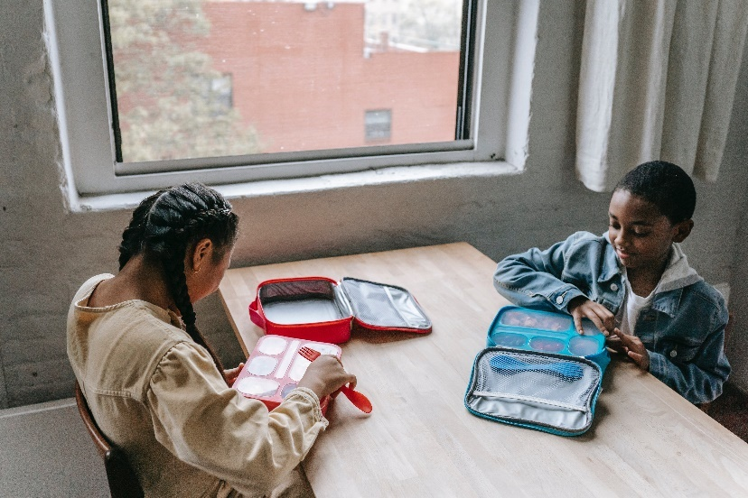

Resources
We have indicated whether the resources are accessible for Ks1 or Ks2. Please note that some of the ks2 content could be adapted and differentiated to support pupils in Ks1.
- Harvest - Live Lesson - BBC Teach (Ks1 & Ks2)
This harvest-themed Live Lesson looks at where food comes from and how it reaches our tables. We explore seasonality, distribution and how family traditions are passed down on our plates.

- Healthy eating (7-11 Years) - Food A Fact of Life (Ks2)
This section provides activity ideas and resources to help consolidate learning of diets, eating well, energy, nutrients, digestion, and activity.

- Food facts - Healthier Families - NHS (www.nhs.uk) (Ks2)
Information on healthy snacks, sugar, salt, 5 a day, healthier food swaps and fat.

- Twinkl - Primary Recipe Resources (Ks2)
A range of food recipes for key stage 2 pupils.
Reflective questions
(Try exploring these reflective questions with a CYP)
- Why is it important to have a healthy diet?
- How much water is recommended for children per day?
- Which foods should you not eat too much of?
- What foods help make your teeth, bones, and nails stronger?

Quiz of 5 questions per theme
Once you have gone through this resource with a CYP try this quiz questions with them:

- Why do you need to have a healthy balanced diet?
- How many portions of fruit and vegetables should we be eating a day?
- What foods give you vitamins and minerals?
- Do carbohydrates give you quick or slow bursts of energy?
- Which foods should you only have a little bit of?
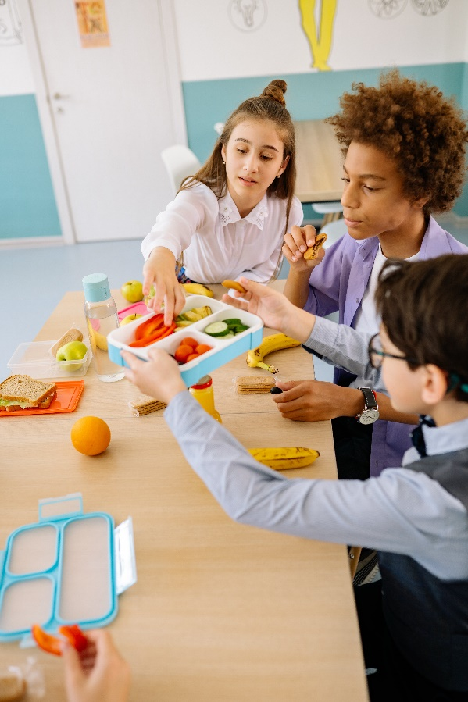

Additional ideas
Other things to try:
- Eatwell Guide – Balance diet guide
Balanced diet food wheel poster

- Childline – How are you feeling?
Need to talk, get support, or use their toolbox of games aimed to help you feel better.

Signposting to Support
For additional support we recommend that trusted adults use these resources to support children and young people access support when required:
- Eating a balanced diet
Anna Freud Centre talk about a balanced diet.

How to help a friend
- Talk with your friends about your favourite meals (breakfast, lunch, and dinner)
- Have a conversation about what a healthy diet is and why we need to eat a balanced diet.
- Talk about what your favourite snacks are. How healthy do you think they are?
- Have a conversation about how much water and other drinks you have a day to keep your body hydrated.

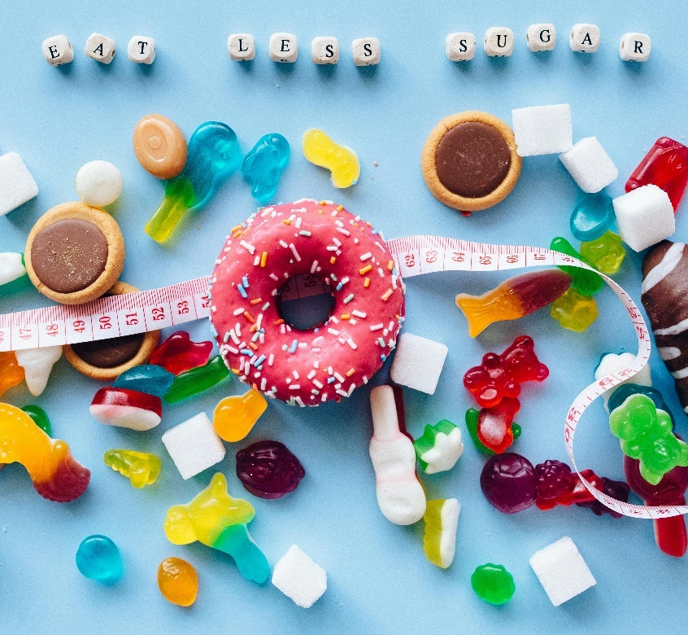

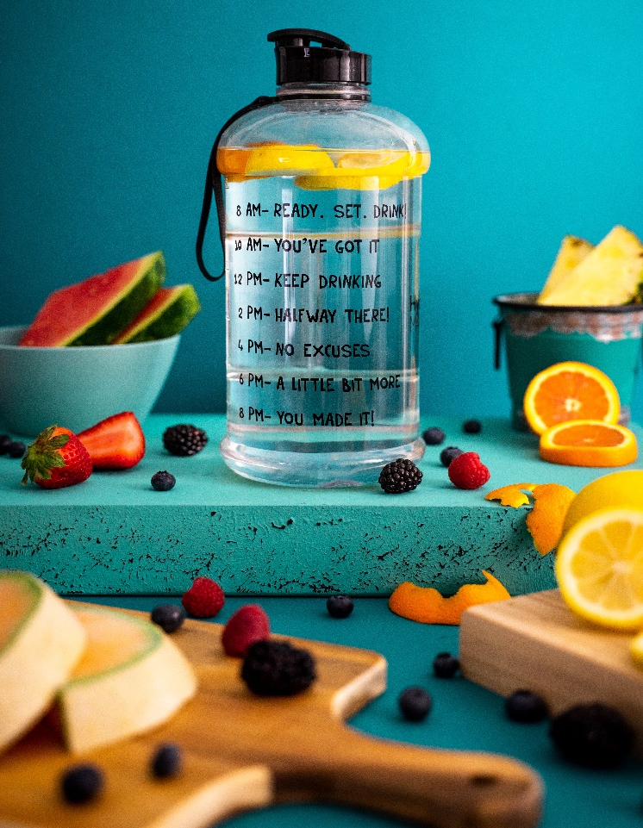

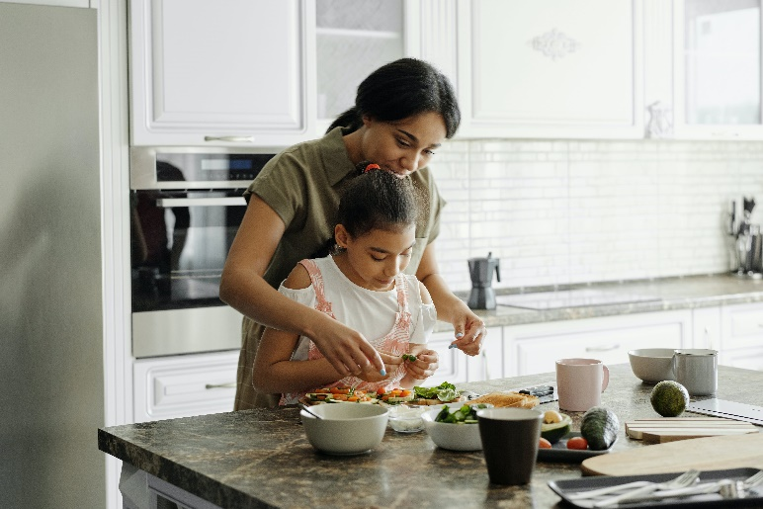

The adult box (for professionals and parent/carers to read)
- Healthy eating for children | British Dietetic Association (BDA)
A fact sheet for parents to help you ensure your child is eating the right food

- Public Health – Protecting and improving the nation’s health
The Eatwell guide: helping you eat a healthy, balanced diet.

- Recipes - British Nutrition Foundation
A selection of healthy recipes to try.

- Recipes - Healthier Families - NHS (www.nhs.uk)
A selection of recipes for all mealtimes.

- Mentally Well Schools posters
Claim your free sleep, exercise, and healthy balanced diet tips poster.

- The Eatwell Guide and Resources | Food Standards Agency
The Eatwell guide and resources

- Beat – POD for parents and carers
POD is an e-learning platform and community for carers that provides you with online modules, resources, and spaces to talk with peers to help you better support your loved one.

- Beat – SPOT for schools and professionals
SPOT is an Online training for school professionals, aiming to increase understanding of eating disorders, including how to spot the early signs in children of primary school age.

- Eating Disorders and Problems | Parent Guide | YoungMinds
A guide for parents about eating disorders.

