Supporting Young people in Care in Schools and Colleges Post 16.

Contents.
- Legislative compliance.
- The PEP and the Pathway plan.
- The Local Authority Leaving Care team.
- The Personal Adviser and the Pathway Plan.
- Advocacy and support Post 16. The Key worker role.
- Barriers to learning and realising aspirations.
- Asylum Seekers.
- Difficulties surrounding applying for University.
- Practical help the school and college can give to support applications for Apprenticeships, UCAS and Further education.
- Wider support available.
- Contact details.
- Examples of PEP targets.

What is a personal education plan and why are they so important?
It is a Statutory requirement that every young person in care up to the age of 18 should have an individual Personal education plan. It forms part of their Care plan and must be a live, monitored and updated record of actions for the young person to reach their full potential.
The PEP is designed with the view of improving joint working relationships between professionals, whilst providing a platform for the young person to have their wishes and feelings heard, their future aspirations listened too, and their support needs catered for.
PEPs should celebrate success, heighten expectations and lead to aspirational target setting, as well as highlighting areas of challenge and learning needs.
They should include personalised curriculum-based targets and detail the wider provision and support that will be put in place to address the CICs additional needs, in particular their barriers to learning, and their personal, social and emotional development.

Post 16 PEPs
Post 16 PEPs must be completed to provide consistency and support to young people, as they progress along their education, or training pathways.
- For those young people entering their first year of post 16 (education and training Year 12) PEP meetings should take place at the start of the Autumn, Spring and Summer terms
- Those in Year 13 should have a PEP at the start of the Autumn and Spring term and where possible in the Summer term too, depending upon when their courses finish.
Post 16 PEPs should be completed online through the e-PEP platform.

The PEP and the Pathway plan

When a looked after young person is about to turn 16, the local authority has to prepare a Pathway plan to assist them with their transition to adulthood and leaving care.

The Pathway plan will build upon the young person’s existing Care and support plan, which will be subsumed within the Pathway plan.

It will capture the actions which will be necessary from the local authority, the young person’s carer, young person, parent and other identified parties to assist the young person to make a successful transition from care.

The Pathway plan will continue once the young person turns 18. The Pathway assessment and planning process should also determine and record what information, advice and assistance should be provided for the young person as they prepare for, and once they have left care.

One aspect the Pathway plan must address is education, training and employment.
This is why the PEP must be maintained while the young person continues to receive full or part-time education.

Information within the PEP will feed directly into the Pathway plan and it should be developed further as part of the Pathway planning process when the young person turns 16.

Pathway plans must also have an explicit focus on career planning, taking into account the young person’s aspirations, skills, and educational potential.
The young person must also be provided with access to high quality information, advice and assistance, to help them plan any move to continuing education, training or employment. How this will be met should be included in the Pathway plan.

Further information regarding this can be found below.

This career planning support should help young people recognise the relevance of their studies to their future career and life chances and should encourage them to reflect regularly on their skills, strengths and aspirations.

The Post 16 PEP should continue to be reviewed and updated as part of the Pathway plan.

Local authority Leaving care team

Around this time the young person may move out of care and into the remit of the local authority’s Leaving care team who have a duty to adequately prepare them to live independently.
Care leavers who are aged 16 or 17 are entitled to accommodation and maintenance, financial support to meet education, training and employment needs. They also have access to a Personal adviser.

Personal adviser and the Pathway Plan

Every looked after child should be assigned a Personal adviser who will act as a mentor during their transition to adulthood.
The Personal adviser and social worker will use the PEP as a basis for drawing up a Pathway plan that builds on the Care Plan.

The Personal adviser will ensure that the plan is realistic and deliverable and arrange review meetings, taking responsibility for communicating the outcomes to other agencies and individuals as necessary, including schools and post-16 providers.

It is essential that the plan captures the young person’s intentions to go on to further learning, to ensure they get the support and funding required.

Advocacy and support post-16 The Key Worker role

The importance of having someone who takes an active interest in championing the needs of Post 16 Looked after young people is critically important.

Each young person needs to be linked to a key worker who they relate well to. Someone who makes it their priority to know them and to build strong relationships.

They need to
- Positively engage them in learning outside the classroom, creating opportunities for them to develop and demonstrate leadership, resilience, good organisation and communication skills, through taking on roles at school/college and beyond, such as volunteering, work shadowing/ work experience. This will help the student build up a good CV for when they apply for Apprenticeships and University courses.
- Ensure their views are taken seriously and intervene promptly if a problem emerges with their care placement, behaviour, work or attendance.
- Proactively support them in the selection of and application for transitions to future and higher education, based on their skills and educational potential.
- Balance effective levels of support with real challenge, ensuring aspirations are high for the young person.
- Develop strong relationships with carers and specialist agencies where appropriate.
- Encourage and support the young person in care to discuss their progress, be involved in setting their own targets and take responsibility for their learning.
- Ensure that they are accessing the 16-19 Bursary fund and the money is targeted to enable them to fully participate in their post 16 education/ training.

Barriers to Learning Post 16 and realising aspirations.

Difficulties faced by Young people in Care, who may have had a chequered educational history, trauma and attachment issues, include placement moves and breakdowns which can cause massive disruption and can impact on their engagement, motivation and attendance.

- They may lack self-esteem, self-confidence and find competitive situations difficult.
- Some may fear failure.
- For a number there may be anxiety about leaving their care placement. They may grieve the loss of relationships at home and at school/college.
- In relation to contact with birth parents, especially where they are emotionally involved, they may feel let down if visits don’t happen. They may worry about their family.
- A number will have difficulty dealing with and managing their emotions. This can impact on learning and how they embrace their next steps.

Asylum Seekers

- They may have a more secure base, but they may have experienced trauma in camps for years, been trafficked, assaulted on their journey and lived with constant uncertainty.
- Where there is a delay from the Home Office re their leave to remain, this can impact on their motivation and attendance. Social workers can’t directly help. Schools can pursue their application on their behalf.
- Some hear sooner and this can lead to conflict if they want to live with an older sibling.
- There may be requests from their home country for other family members to come. They cannot action this and worry about not being able to support them. This can impact on their learning and again on how they access their next steps.

Difficulties surrounding University applications.

- They may lack confidence or be able to deal with the approach at University which is more self-study led with the onus on them accessing support available.
- They may not have the skills to manage money and be vulnerable to lending money to fit in and be accepted.
- There may be an issue of finding their own way to Campus with all their belongings.
- Accommodation in the summer holidays in hall, could lead to them having to change location while redecoration is in progress. This can be unsettling.
- Their wider skills may have slipped through the net in terms of personal management, washing, cooking etc.

Practical help the school can give to support applications for Apprenticeships, UCAS and further education.

- Pursue EHCP plans as early as possible as they can trigger additional support when they move to University/College and Independent living /semi Independent accommodation. For the latter 10 hours per week, help with life skills and loose adult supervision becomes available
- They may not have family connections/networks to facilitate work experience or have had access to extracurricular experiences so useful for CV/ UCAS applications. The school needs to encourage engagement in voluntary work, work shadowing and create opportunities for them to develop and demonstrate a wider skill set.
- Recruitment /Assessment centres can be an ordeal for them. They may be anxious, lack resilience and fear failure. Its important that they are given lots of practice re Skype calls, telephone interviews and ensure they are aware of the mix of skills they should be demonstrating. They need to be aware that they are being assessed constantly, they should engage with others and not withdraw and be on their phone.
- They will need assistance re CV construction and their UCAS statement. It is important to get a member of staff who knows them well and a friend to draw out all their attributes. They may not have had the breadth of experience but with support can turn their situation into something very positive. They need to focus on what their experience has enabled them to bring to the workplace and what employers and admissions tutors would value such as resilience, determination, problem solving etc.
- The school needs to flag up their status as far more Companies and Universities are tuned into their Corporate social responsibility and the need for them to be recruiting a diverse work force. Young people in Care may not have had the experiences of others but can still deliver a very powerful message.
- They need to be aware of their presence on Social media and that companies will check their profiles.
- The school needs to ensure they get bespoke Careers advice very early on, so they are fully aware of what is available.
- The school also needs to ensure as much support is secured for them if they have special requirements eg: Youth advisers see contact details below.

Wider support available.

- The Social worker will generate the Pathway plan which will cover Education, Training, Employment and Independent living.
- This plan is worked on with the Carers and its very helpful if the school can support it too.
- Their Social worker meets with the young person in care every 6 weeks. They have their Looked After Children Review every 6 months. The school, Social Care and Foster carers attend.
- The After-Care team as mentioned above give support in helping with the transition into Independent living.

Contact details

- Leaving and After Care team manager Suzzanne Hester 03330138094
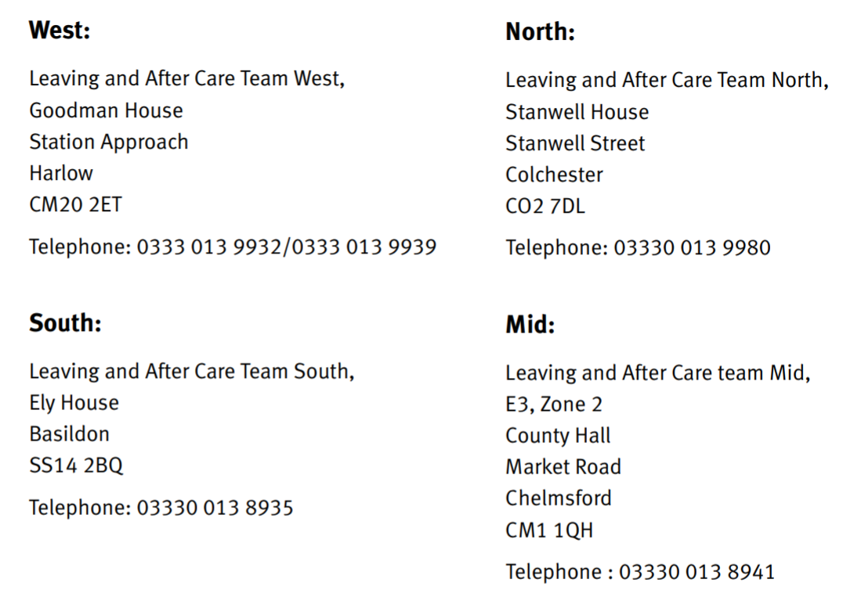
Team Leader for West.

- Pathway, Careers, Mentoring and Matching Service for yr11 leavers will support re securing apprenticeships and help re the barriers CICs face. 03330131501 07717814461

- Goodman House West. Susanna Moorhouse susanna.moorhouse@essex.gov.uk and Tracy Mount After Care/ Fostering. 03330137236 07788303630
Children in Care Manager Jill Hartwell and Melissa Jiggens.
Unaccompanied Asylum-Seeking Children UASC Team manager Sharon Turner.

- Employment Advisers can be accessed via the Social worker.

- Youth Advisers.
West: Paul Lovin
T: 033301 39350
E: Paul.lovin@essex.gov.uk

Mid: Glen Cameron
T: 03330 139727
M: 07775 407970
E: Glen.Cameron@essex.gov.uk

South: Lisa McKinlay
T: 03330 138732
M: 07920 825748
E: lisa.mckinlay@essex.gov.uk

North: Stephanie Doherty
T: 03330 322015
M: 07809 105108
E: stephanie.doherty@essex.gov.uk

- University of East Anglia Lead support for Children in Care living Independently. Debbie Barker 01245 684288

- Apprenticeship hub lead who will support re securing Apprenticeships. Fiona Marriage 03330131501 07717 814461

- Aim Apprenticeships Rebecca Rayner 075111 56232 free support, she will visit schools and give support re CV construction, mock interviews, workshops, presentations for carers and parents individual support and what to expect from Assessment centres.
They can give support re Budgeting guidance.

- All Universities have someone assigned to CICs a key person the Care Leavers need to be aware of.

- Some will operate a Buddy scheme pairing them up with another Care Leaver in yr 2 or 3. They will have an understanding of issues and how to support. Universities are very experienced in knowing the sorts of situations they might face and the extra help they may need settling in.

Examples of PEP Targets that could be used, covering aspects of the above.

X will have become more independent in his/her learning and will have developed a number of strategies and skills to support him/her in this process.

- X will have identified the correct resources/ information needed for the task set.
- X will be organised in his/her approach.
- X will have developed good research skills where needed to complete the work set.
- X will have developed the self-discipline necessary to focus on their work.
- X will have been able to check, review and reflect on their work making amendments where required.

Success Criteria:

- X will have become more independent in his/her learning and will have developed a number of strategies and skills to support him/her in this process.
- A number of pieces of work completed and submitted will reflect these higher order skills.

X will be in a good position to take up his/her A level subjects/Vocational course in September.

- X will be familiar with the syllabus for each of his/her chosen courses and will have done some background reading on a topic in each that interests him/her.
- X will have completed any preparatory tasks set by his /her teachers over the Summer term.
- X will have researched online recommended study practices for successful Post 16 study, including such topics as managing workload, how to be organised, best practice re keeping files, planning, meeting deadlines etc.
- X to ensure he/she has all the resources and equipment needed to start the course eg: files, calculator, recommended texts/books etc.

Success Criteria.

- X will feel confident and enthusiastic about starting his/her Vocational course/ A level subjects in September.
- All preparatory tasks set over the summer will have been completed and submitted.
- X will be in a good position to become more independent in his/her learning and will have a number of strategies to support him/ her in this process.
- X will have all the necessary resources and equipment needed for the course/A levels.

Apprenticeships.

Learning Objective

X will be in a good position to start his /her apprenticeship in September.

- X will be familiar with the Apprenticeship programme he/she has applied for, the areas covered and the assessments in place. He/she will have done some background reading on an area that interests him/her.
- X will have researched fully the company/organisation he/she will be training with and will be aware of further opportunities that will be available if he /she does well.
- X will have researched online, what companies/ organisations are looking for in a successful Apprentice so he/she is fully aware of what they need to be doing and how they should be behaving if they want to succeed and do well on the programme.

Success Criteria.

- X will feel confident, familiar and enthusiastic about starting his/her apprenticeship programme in September.
- X will be familiar with further progression routes following successful completion of his/her initial training and will have goals that will provide focus over the coming months/years.
- X will be aware of his/her approach, how to conduct him/herself and the sorts of attributes and qualities the company/organisation will be looking for.

For students who do not have options in place for September.

Depending on need, the Social worker would make a referral for a targeted Youth Adviser to work with the CIC on the following, including where possible CV construction and interview skills.

Learning Objective

X will be in a good position to apply for a Course /Apprenticeship starting in September.

- X will have identified the things he/she enjoys doing and is good at in terms of skills, interests etc.
- X will be in a good position to apply for a Course /Apprenticeship starting in September.
- X will have explored online related careers/types of employment that match the above and the sorts of courses /qualifications/apprenticeships that are needed.
- X will have researched locally, college offers/apprenticeships and identified a number they would be interested in.
- X will have completed online applications to those, that are of particular interest.
- X with support will have created a CV and had some interview practice.

Success Criteria.

- X will have applied for and secured a course appropriate to his/her interests, ability and needs.

Wider involvement and opportunities to enhance future applications for jobs, higher level Vocational courses and University.

- X understands that they need to be proactive in generating evidence that will be included in a CV/UCAS application.
- Directly linked to their chosen course or Career aspiration, X will have researched online/local work shadowing/placement opportunities that would demonstrate a commitment to their chosen area of study/career pathway and stand them in good stead in advance of future applications.
- X will have identified from the School/Colleges prospectuses the activities they wish to be involved in that will enhance, develop and demonstrate a range of qualities such as; commitment, leadership, resilience, reliability, initiative, confidence and community spirit that they can include in any future application.

Success Criteria.

- X will have a number of ideas for possible Work placements/shadowing throughout the duration of their course to discuss with a member of the Sixth form/college team.

- X will have identified a range of activities, opportunities and projects he/she wishes to become involved in, which will positively enhance his/her CVUCAS application for example The Duke of Edinburgh Award scheme, World Challenge, Camp America, Prefect status, Peer mentoring, Being a Children in Care Buddy, Sixth form/College Council, Charity Representative, Sports Leader, Extra-Curricular involvement in Sport, Music/Drama productions/ concerts, Young Enterprise, Public Speaking and Debating.

