School Forum Decisions – 12th July 2023

Agenda Item 2 – High Needs Block Surplus

Recommendations:

2.1 Schools Forum noted the accumulative forecast balance and the medium term forecast for the high needs block.
 | 2018/19  £’000 | 2019/20  £’000 | 2020/21  £’000 | 2021/22  £’000 | 2022/23  £’000
Opening Balance | 2,840 | 2,810 | 10,132 | 5,950 | (3,019)
Outturn | 139,075 | 152,533 | 157,861 | 171,996 | 192,397
Funding | (139,105) | (140,932) | (162,043) | (180,965) | (202,853)
In-Year deficit / (surplus) | (30) | 11,601 | (4,182) | (8,969) | (10,456)
Transfer from SB | 0 | (4,279) | 0 | 0 | 0
Closing Balance | 2,810 | 10,132 | 5,950 | (3,019) | (13,475)

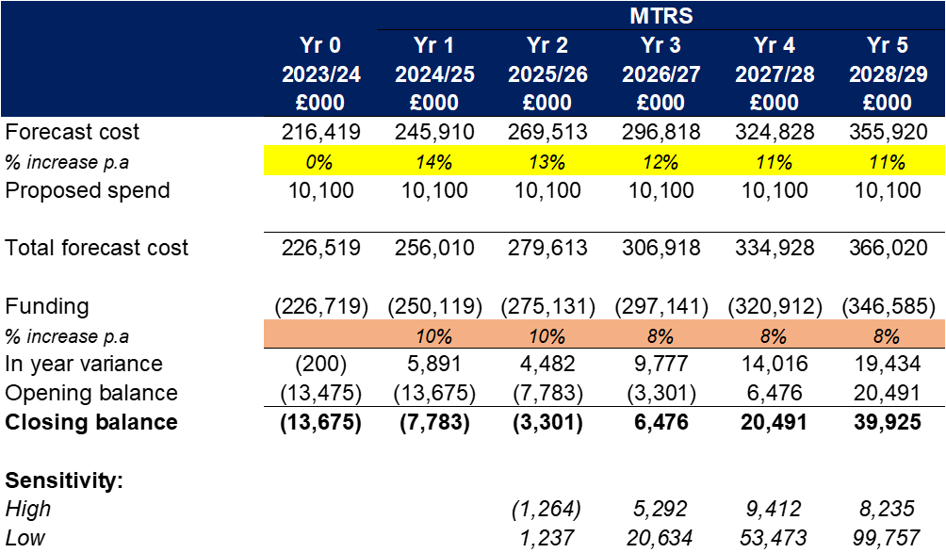

2.2 Schools Forum approved the one-off allocations from the surplus balance at 4.10 to 4.14.

 | 2023/24  £’000 | 2024/25  £’000
5% increase to top-up funding | 3,100 | 3,100
Up to £500 per pupil for settings in receipt of place funding. | 716 | 716
Inclusion Framework | 0 | 2,000
Outreach | 1,000 | 2,000
Training | 0 | 600
Total | 4,816 | 8,416

Agenda Item 3 – Schools Contribution to Capital Maintenance

Recommendations

2.1 Maintained school members agreed to increase school contributions from £40 per pupil up to £50 per pupil, using the tiered approach at 4.5 from 1st April 2024.

4.5 It is proposed to use the DfE recommended level of revenue balances, as used in the balances criteria within the Falling Rolls Fund, to determine the contributions each school should make. The proposed tier approach is detailed below.

- Small primary schools with 210 pupils or fewer with revenue balances of £60,000 or up to 8%, whichever is the higher, will continue to contribute £40 per pupil.
- Primary schools with 211 pupils or more with revenue balances below 8% and secondary schools with revenue balances below 5%, will continue to contribute £40 per pupil.
- Schools with revenue balances above 8% (above 5% for secondary schools) but less than 20% will contribute £45 per pupil.
- Schools with revenue balances of 20% or higher will contribute £50 per pupil.

Agenda Item 4 – Early Years Funding 2023/24

Recommendations

2.1 Schools Forum agreed to distribute the former teachers pay and pension grants via a Quality Supplement to all eligible schools.

2.2 Schools Forum noted the details of the additional funding from September 2023.

2.3 Schools Forum approved to delegate the decision to increase funding rates for 2023/24 to the Chair and Vice-Chair of Schools Forum in consultation with the two early years representatives.

Agenda Item 5 – Falling Rolls Fund

Recommendations

2.1 Schools Forum agreed that Finchingfield Academy receives Falling Rolls funding for 2023/24.

2.2 Schools Forum approved the Falling Rolls Fund is increased by £58,000 to be funded from the Schools Block underspend in 2022/23.
.

Funding for 2024/25 will be based on balances at 31/03/24 for maintained schools and 31/08/23 for academies.

