Let’s Talk: Physical Activity and Exercise
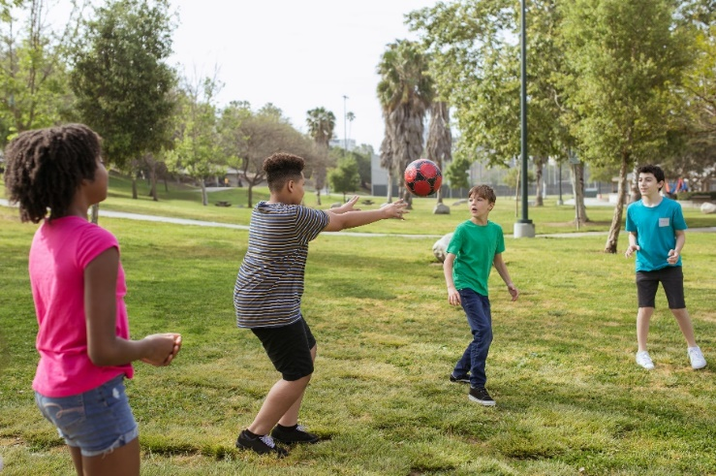
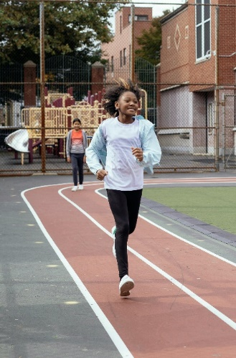
Primary

This resource is part of our self-care suite of resources and has been co-produced with children and young people living in Essex, for children and young people. They have also been developed and quality assured by the following stakeholders:
- Essex Educational Psychology Service
- Essex Health Watch
- Essex Mental Health Support Teams (MHSTs) NELFT NHS Foundation Trust
- Essex Multi-schools Council
- Essex Social, Emotional and Mental Health (SEMH) strategy team
- HCRG care group Child and Family Wellbeing Service
- NELFT NHS Trust Southend, Essex, and Thurrock (SET) Child, Adolescent and Mental Health Service (CAMHS)
- Professionals in schools and settings can access all these resources via the Essex info link SEMH portal. Children and young people (CYP), parents/carers and professionals can also access these resources via the SET CAMHS website. Our self-care content can also be accessed via SET CAMHS Instagram account:

The resources are intended to be accessed by CYP independently or trusted adults use these resources with CYP through 1:1 conversation, whole school/group discussion and assemblies.
Please note: some of the content within our self-care resources may be emotive for CYP. We recommend that you make use of the ‘signposting to support’ section of this document should any of the content be triggering.
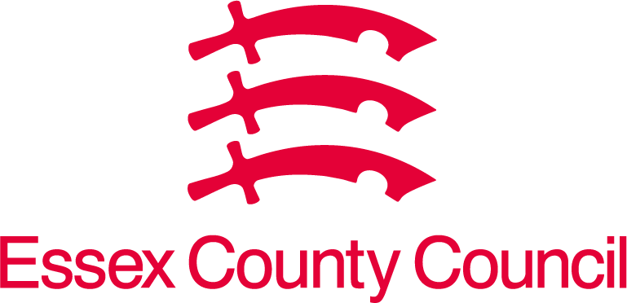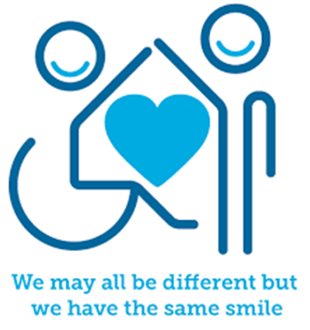

Introduction
Physical activity and/or exercise is important for a variety of reasons including helping us to manage our own physical, emotional, and mental health. Physical activity and/or exercise comes in variety of forms, and this might be from playing team or individual sport activities to just being able to move our body from one place to the next.

Facts
- Physical activity / exercise helps our brain.
- Physical activity / exercise helps us to remember things.
- Physical activity / exercise can support us keep away germs.
- Physical activity / exercise is a good way to make friends.
- Physical activity / exercise makes you feel better about yourself.

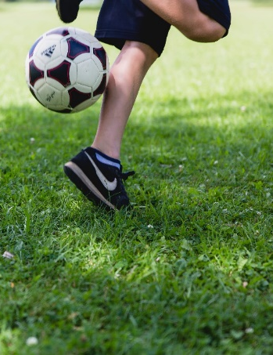
Myth Buster
- Physical activity / exercise does not have to mean just playing sport. X
- Physical activity / exercise does not have to be hard. X
- Physical activity / exercise is not the same for everyone. X

Video clips
Check out these videos about self-care:
- Dinosaur Exercise for Kids | Learn About 8 Different Dinosaurs | Indoor Workout for Children - YouTube
Dinosaur exercise for children. Learn about 8 different dinosaurs – indoor physical activity / exercise

- Super Mario Epic Video game workout
Listen to the instructions and join in this Mario workout game.

- 10 – minute family fun cardio exercise workout
A workout that adults and children/young people can do together.

  - Yoyo kids exercise videos
Workout videos that can be done in the classroom or at home.

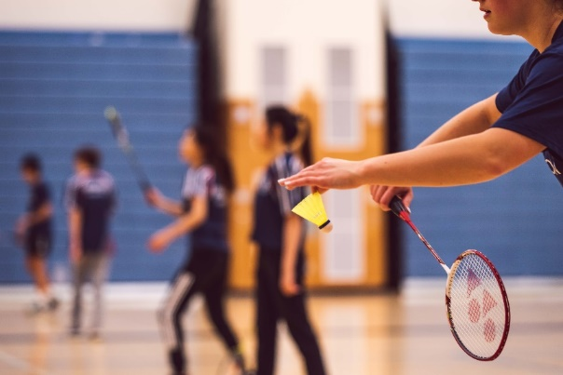
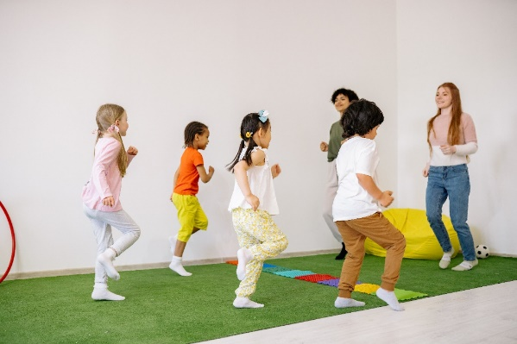

Resources
We have indicated whether the resources are accessible for Ks1 or Ks2. Please note that some of the ks2 content could be adapted and differentiated to support pupils in Ks1.

  - A Complete List Of The Best Exercises For Kids - With Video Instruction (bestkidssolutions.com)
List of the ways in which to support your children becoming physically active.
  - Healthier Families NHS
Great and easy ways to eat well and improve physical activity as a family.

  - 10 Easy Exercises for Kids
Ten easy ways to help children develop their attitude to physical activity and exercise through fun games.

Reflective questions
(Try exploring these reflective questions with a CYP)
- Which type of exercise or physical activity do you most enjoy and why?
- What do you notice about your body when you are doing physical activity or exercise?
- Who else does physical activity or exercise in your class?

Quiz of 5 questions per theme
Once you have gone through this resource with a CYP try this quiz questions with them:

What do you think is happening inside your body when you are doing physical activity or exercise?
- Do you think the game of ‘Twister’ is exercise? (Yes, you are moving your body!)
- Can you tell me why physical activity is good for you?
- If you are walking does that count as physical activity or exercise?
- What are the other benefits of being physically active or taking part in exercise?

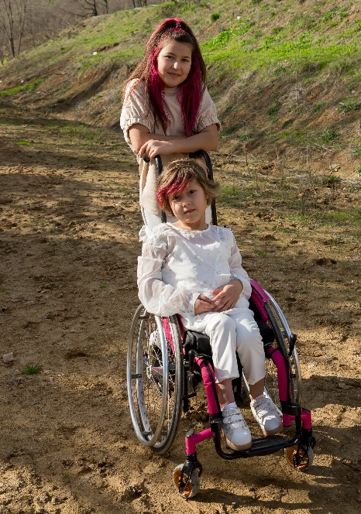
Additional websites and apps that you might find helpful.

Websites:
  - 5-minute moves kids’ workout – YouTube

  - 9 Minutes Exercise for Kids – YouTube

  - Family Fun Cardio Workout – YouTube

  - How exercise Affects Your Body – YouTube

  - PE Makes you happier, healthier, and smarter – YouTube

  - Balance and coordination exercises – YouTube

Information
- ABCDee learning 20 awesome exercises for kids – Blog

- 12 Fun Exercises for Kids – Blog

- 8 easy and fun exercises to get your kid moving, according to paediatricians – Blog

Apps
- Best Health and Fitness Apps for kids - Apps

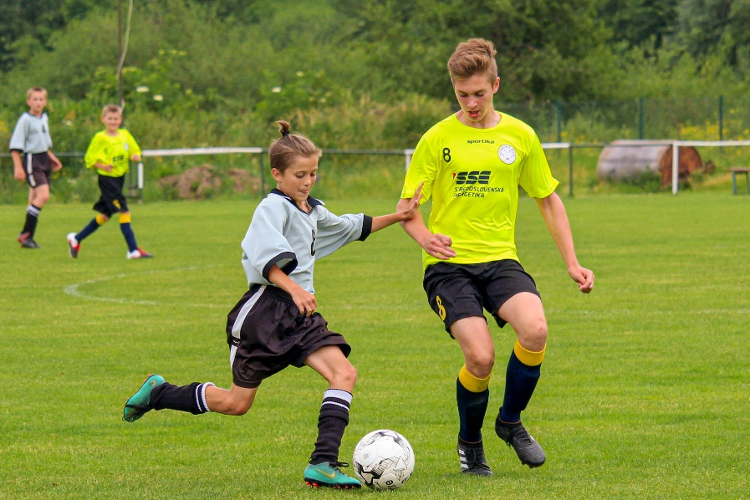
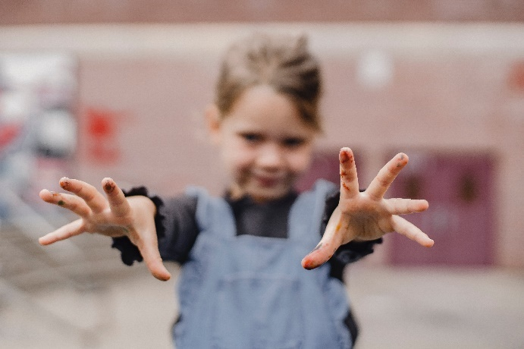

Signposting to Support
For additional support we recommend that trusted adults use these resources to support children and young people access support when required:
- Getting help for your child: where to start
- Childline 0800 1111 when contacting ChildLine what to expect?
- NHS 111
- Southend, Essex & Thurrock Children and Adolescent Mental Health Service (SET CAMHS)
- Explore counselling/therapy
- Where to get urgent mental health support from: Advice from NHS

- SET CAMHS Instagram account
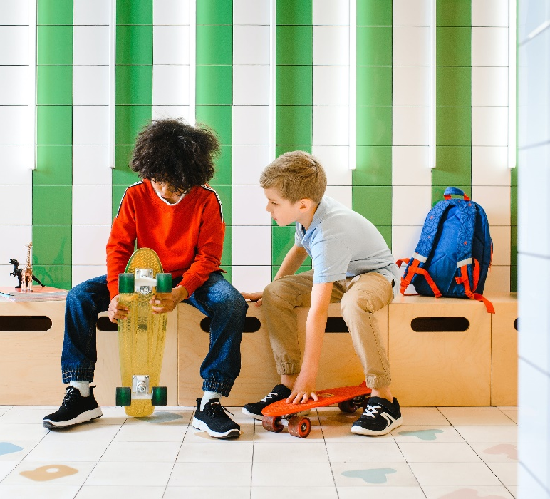

How to help a friend
- Invite them to do something active with you e.g., go for a walk, kick a ball about.
- Think of the different things you enjoy doing and work out how many of them require you to be active or exercise.
- Talk about what other things you could do to be active and exercise.
- Talk about the different ways that being active and exercising can help your physical and mental health.

The adult box (for professionals and parent/carers to read)
- Physical activity guidelines for children and young people - NHS
NHS Physical activity guidelines for children and young people.

- Help your kids get more physical activity - Move Your Way | health.gov
Help your kids to get more physically activity.
- Exercises for Adults & Adults NHS Inform
Information about great ways of both you and your child achieving your recommended level of physical activity is to do things to together that involves physical activity.

- PSHE Education teaching resources
PSHE association for schools and teachers in relation to specific resources focusing on physical activity and exercise to support curriculum planning and lesson delivery.

- Active Essex
Active Essex is the Physical Activity and Sport Partnership for Essex, Southend, and Thurrock, and are one of 43 Active Partnerships in England who collaborate with local partners to ensure the power of physical activity and sport can transform lives. Providing children with the motivation, confidence, physical competence, knowledge, and understanding to value and take responsibility for engagement in physical activities for life will much more likely result in an active adulthood. Ensuring children and young people begin an active start to life, does go further than just what they participate in and can access at school and on this page you will find a range of activities which can be enjoyed by the whole family!

