Let’s Talk: Anxiety
Secondary

This resource is part of our self-care suite of resources and has been co-produced with children and young people living in Essex, for children and young people. They have also been developed and quality assured by the following stakeholders:
- Essex Educational Psychology Service
- Essex Health Watch
- Essex Mental Health Support Teams (MHSTs) NELFT NHS Foundation Trust
- Essex Multi-schools Council
- Essex Social, Emotional and Mental Health (SEMH) strategy team
- HCRG care group Child and Family Wellbeing Service
- NELFT NHS Trust Southend, Essex, and Thurrock (SET) Child, Adolescent and Mental Health Service (CAMHS)
- Professionals in schools and settings can access all these resources via the Essex info link SEMH portal. Children and young people (CYP), parents/carers and professionals can also access these resources via the SET CAMHS website. Our self-care content can also be accessed via SET CAMHS Instagram account:

The resources are intended to be accessed by CYP independently or trusted adults use these resources with CYP through 1:1 conversation, whole school/group discussion and assemblies.
Please note: some of the content within our self-care resources may be emotive for CYP. We recommend that you make use of the ‘signposting to support’ section of this document should any of the content be triggering.
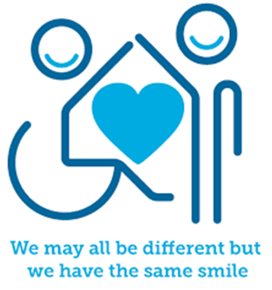

Introduction
Anxiety or worry is something that a lot of young people will experience at times, to differing degrees and for a range of reasons. A certain level of anxiety is normal, and it helps us to get things done or focus on something that needs our attention. Anxiety can, however, become more overwhelming sometimes with feelings of fear or panic. If the problem resulting in anxiety has gone but the feeling of fear or panic stays, or even gets stronger, that’s when anxiety can become a problem. How we address and manage anxiety can make a significant difference to our emotional and mental wellbeing, and the first steps to managing anxiety is to recognise we are anxious, know how it affects us and why.

Facts
- Anxiety is a hormonal response from the body to get us ready to respond in different ways including ‘fight, flight, freeze and flap.’
- When we experience anxiety, our body releases a hormone called adrenaline. Anxiety can make us have physical symptoms such as headaches, tummy cramps, not wanting to eat and our heart beating faster.
- Heightened anxiety can affect our mood, our body, and our relationships. Anxiety impacts on our thoughts, feelings and actions and we can experience helpful or unhelpful thought cycles.
- Acute anxiety happens within a few minutes to a few hours of an event. It can last for a short period of time and is very intense. Chronic stress and anxiety lasts for a longer period of time or keeps coming back. You might experience this if you are under lots of pressure a lot of the time.
- Relaxation, Imagery and Distraction (RID) and other key interventions outlined below can help to manage anxiety.

Myths
- Anxiety difficulties are not common X
- Anxiety always goes away on its own X
- People with anxiety should avoid stressful situations X
- Everybody experiences and responds the same way to anxiety X
- Anxiety only affects your mind X

Video clips - Check out these videos about anxiety:
- Beaconhouse.org.uk
A series of videos which includes anxiety and panic attacks.

- Flipping your lid video – You Tube Clip: The Hand Model

- Wellbeing activities: managing anxiety - British Red Cross
A series of videos which includes anxiety and panic attacks.

- Calming your amygdala
A strategy to support you calm your amygdala down using your hands

- Practical tips for dealing with anxiety
Anxiety UK video offering practical tips to deal with anxiety

- How to cope with anxiety
Childline’s video offering advice about how to cope with anxiety

- Practical tips for dealing with anxiety
Anxiety UK video offering practical tips to deal with anxiety

- How to cope with anxiety
Childline’s video offering advice about how to cope with anxiety

- BBC Overcoming Anxiety
Incredible animation on battling and overcoming anxiety
Warning: This video contains emotive content related to suicide. If you are feeling vulnerable, we recommend you skip this video or come back to it later. If you require support, please go out the signposting section in this resource.

- What is anxiety?
Why anxiety is different to stress and the problem with self-diagnosing an anxiety disorder

Resources
The resources below are accessible for KS3 and KS4 and can be adapted and differentiated.

- Beaconhouse.org.uk
Including ‘bottom-up brain development,’ work by Bruce Perry related to anxiety and ‘what survival looks like in secondary school.’

- The Window of Tolerance Animation by Beacon House - YouTube
Includes information about the window of tolerance and our emotional pot.

- YoungMinds.org.uk
Resources and signposting related to stress and anxiety and other mental health needs.

- Mind.co.uk
Relevant information and resources related to anxiety and panic attacks.

- Talking mental health: animation & teacher toolkit | Anna Freud
Resources and animations about mental health, including anxiety.
- Wellbeing activities and information related to anxiety | British Red Cross
A range of activities to help understand and learn to cope with feelings of anxiety.

Reflective questions - Try exploring these reflective questions with a YP.
- What is anxiety and how might we know when we are feeling anxious?
- How does the adrenalin in our bodies prepare us and how have you noticed it affects you?
- How might anxiety affect us emotionally and physiologically?
- Can you think of an example of a time when your avoided doing something and what you might have been thinking and feeling?
- How might you help a friend who may be dealing with anxiety?

Quiz of 5 questions per theme
Once you’ve gone through this resource with a YP try these quiz questions with them:
- What hormone is released in the body when you feel anxious?
- How can anxiety affect us physically?
- What does RID stand for?
- Name 3 things which can help us to cope with anxiety?
- Name some strategies or relaxation techniques that you are aware of.

Additional ideas
Other things to try/consider:
- Relevant Apps such as DARE - this app guides you out of stressful moments through calming advice and breathing techniques. The user can select an audio based on how they are feeling, e.g., an audio related to having a panic attack. CALM – this is a great app for meditation beginners but also provides more advanced sessions for experienced users. Use at bedtime can be extremely helpful. CATCH IT – learning how to manage thoughts and feelings related to anxiety and low mood. Includes problem solving and challenging unhelpful thinking. HEADSPACE – relates to meditation, lower stress levels and greater resilience.

- Books/stories/resources (KS3 and KS4), for example, ‘Think Good, Feel Good’ (Paul Stallard); ‘Breathe Out – A Creative Guide to Happiness for Teen Minds’; Feeling Better: CBT Workbook by Rachel Hutt (2019); CBT Toolbox for Children and Adolescents: Over 220 Worksheets & Exercises for areas including Anxiety (Phifer, 2017). Also, stories such as ‘The Goldfish Boy’ by Lisa Thompson.

Signposting to Support
For additional support we recommend that trusted adults use these resources to support children and young people access support when required:
- Getting help for your child: where to start
- Childline 0800 1111 when contacting ChildLine what to expect?
- Hopeline 0800 068 41 41 offering confidential support and practical advice
- Text ‘SHOUT’ to 85258 for free, confidential, anonymous text support service
- NHS 111
- www.youngminds.org.uk
- www.Beaconhouse.org.uk
- www.mind.org.uk
- Southend, Essex & Thurrock Children and Adolescent Mental Health Service (SET CAMHS)
- Explore counselling/therapy
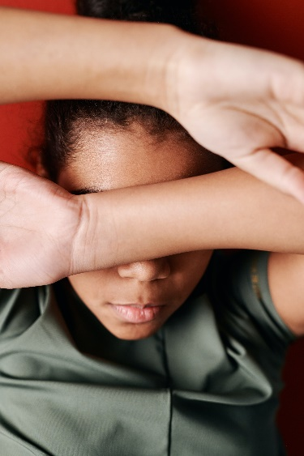
- Where to get urgent mental health support from: Advice from NHS

- SET CAMHS Instagram account

How to help a friend
- Share this resource with them and signpost them to specific support if needed
- Help them to relax, for example by spending time with them, making them laugh, chatting, listen to music, encouraging them to do an activity/exercise that they enjoy.
- Listen to them, offer reassurance, guidance, and supportive ways forward.
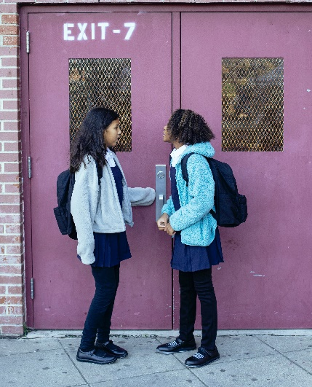

The adult box (for professionals and parents/carers to read)
- Managing stress and building resilience - tips - Mind
Managing your own levels of stress and building resilience as the adults.

- The Window of Tolerance Animation by Beacon House - YouTube
Includes information about the window of tolerance and our emotional pot.

- www.annafreud.org
Advice for parents and carers: talking mental health with children at secondary school.

- Stress - Every Mind Matters - NHS (www.nhs.uk)
Dealing with stress as the adult.

- Mind.co.uk
Relevant information and resources related to anxiety and panic attacks and
how to support young people.

