**Phonics Screening Check**

**Data Collection Summer 2023**

**Guidance Notes for Schools**

**Data to be submitted:**

**from Friday 23 June 2023**

**to Friday 21 July 2023**

**Enquiries to: Data Collections Team**

**Telephone: 0333 013 9856**

**Email:** [**schooldata@essex.gov.uk**](mailto:schooldata@essex.gov.uk)

Reporting phonics screening check results to the LA

The phonics screening check takes place during week beginning Monday 12 June. If a child is absent that week, schools have until Friday 23 June to administer the check.

Schools may submit their data to the LA from Friday 23 June 2023.

Schools should record the check result for each pupil on their assessment software (e.g. Target Tracker, SIMS Assessment Manager, etc). The software will allow you to create a results file which should be sent to the LA via the s2s secure website not later than Friday 21 July.

Please note we cannot accept results as paper returns.

Any queries regarding the *creation* of the export file should be referred to your software provider, but please contact us if you require assistance in using s2s to send your data.

The following data items should be submitted for all Year 1 pupils, plus any Year 2 pupils who did not meet the expected standard at the Summer 2022 Phonics check:

* surname, forename, gender, date of birth, UPN, NC Year Group.
* a ‘phonics mark’ between 0-40
* one of the following outcome codes:

|  |  |
| --- | --- |
| Description | Phonics outcome code |
| Pupil took the check and met the expected standard | Wa |
| Pupil took the check and did not meet the required standard | Wt |
| Pupil was absent | A |
| Headteacher decided it was not appropriate for pupil to take the check | D |
| Pupil left the school | L |
| Check subject to maladministration | Q |

As the DfE will announce the threshold mark on Monday 26 June (i.e. after the testing period ends), your software may not show the correct outcome (e.g. this may default to Wt for any pupil whose score is below 40, or be based on an earlier year’s threshold mark). However, this field will show the correct value for each child when we submit your data to the DfE.

**Using s2s to return data to the LA**

Schools should use the **school to school (s2s)** data transfer website to send their phonics data to the LA. Schools are reminded that s2s is now via DFE Sign-in.

Log in to **DfE Sign-in**

The **DfE Sign-in** screen looks like this:

**Screen 1**

Enter your email address and password and click **‘Sign in’.** The My Services (like Screen 2 below) will now appear.

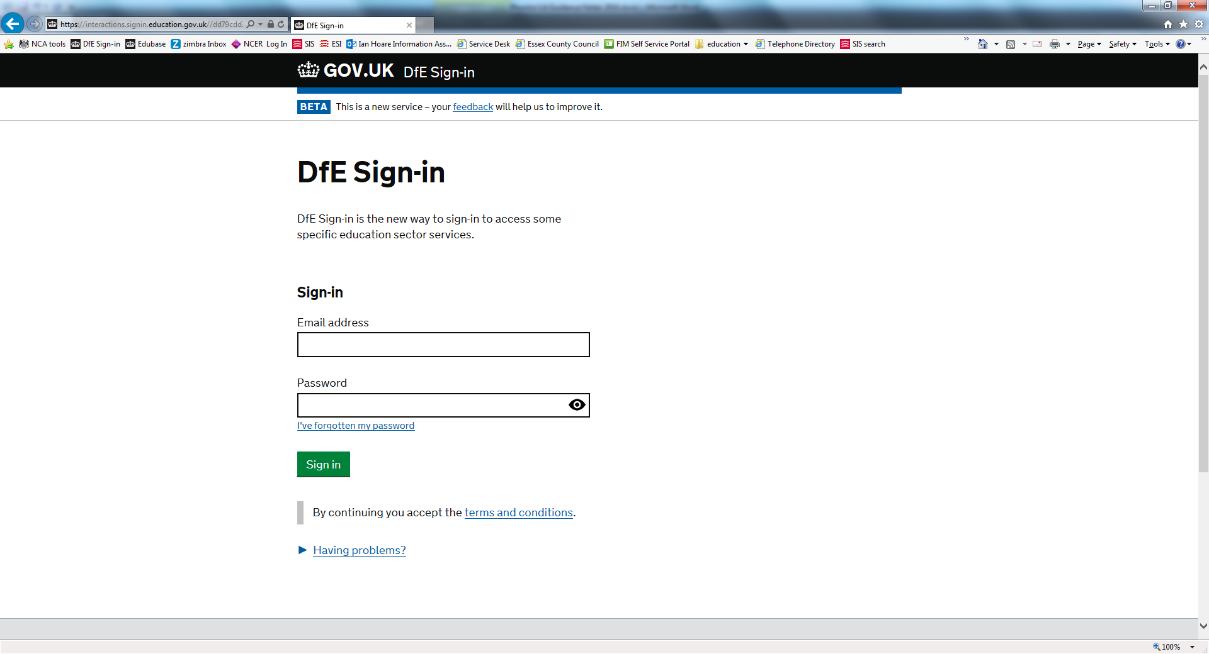

**Screen 2**

Select **‘School to School’** to access the school to school (s2s) data transfer website. (other services such as Collect may be on this screen if your approver has selected them for you. If School to School is not showing, click the My Approvers link and find your approver and request access to s2s).

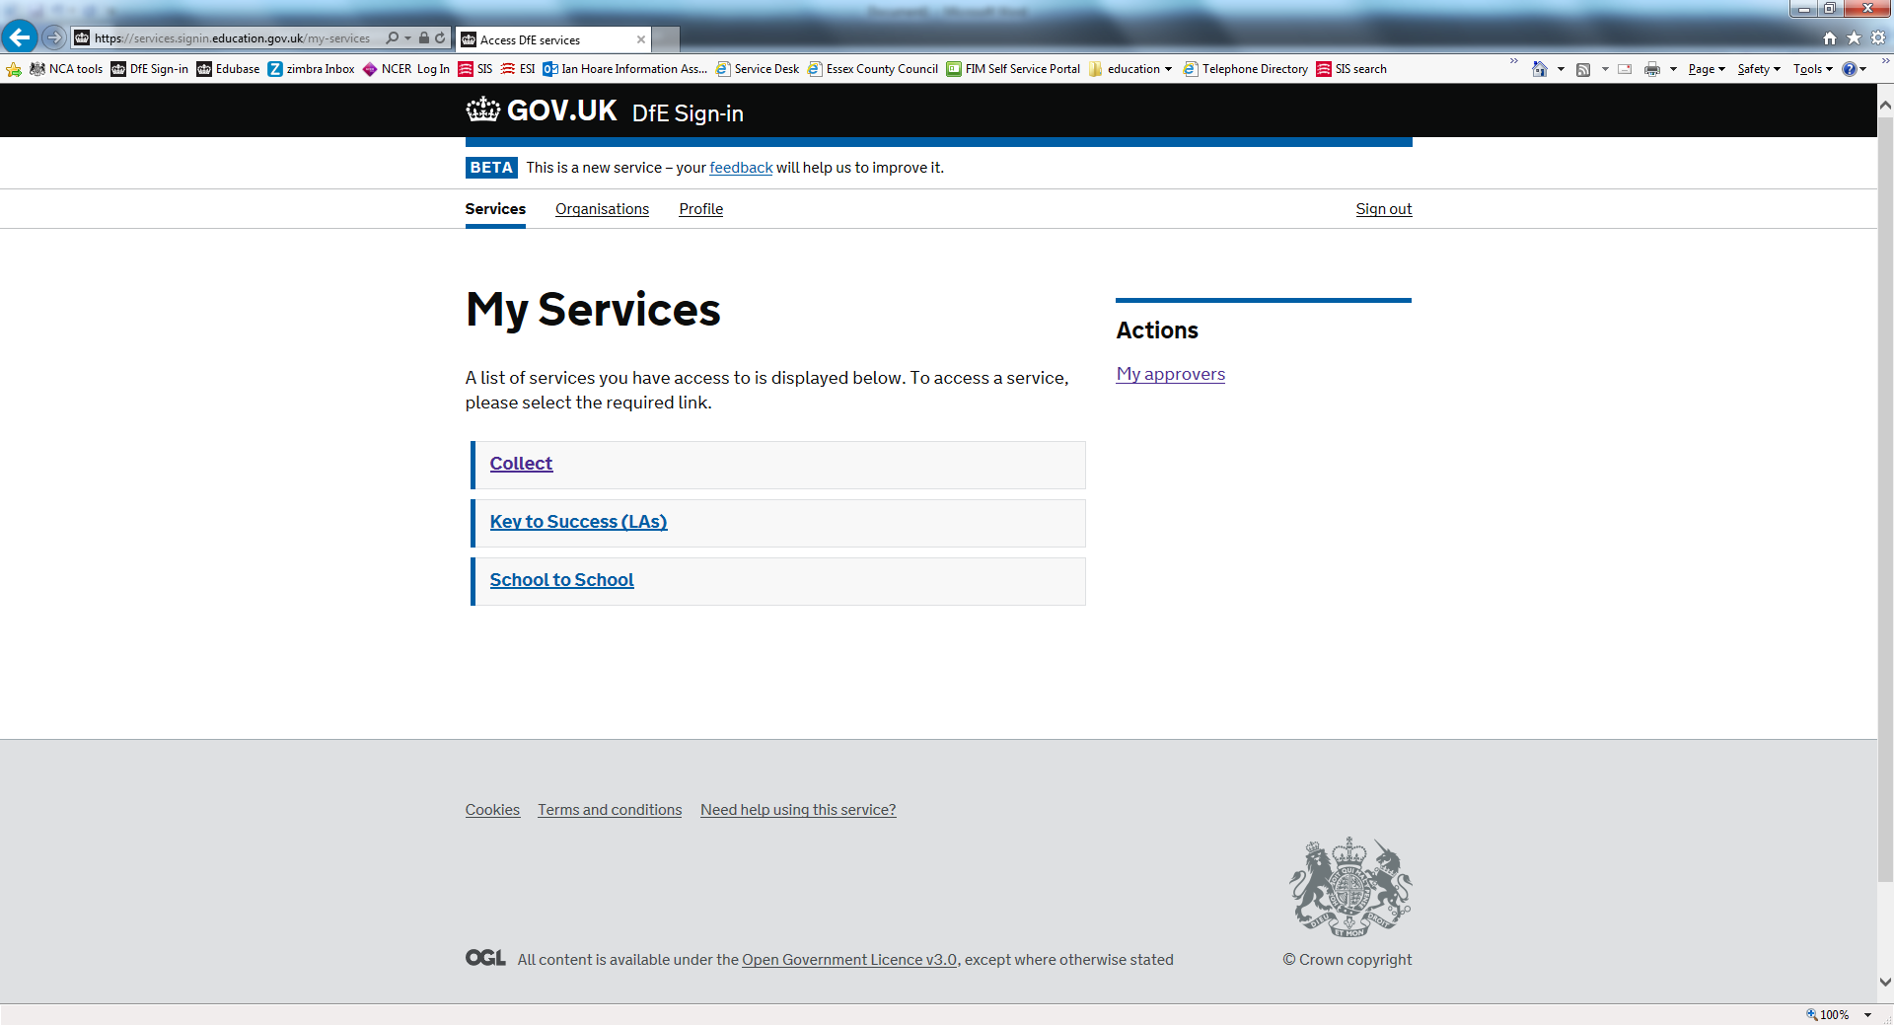

Screen 3 should now appear. (Other DFE Sign-in screens may intervene.)

**Screen 3**

From the Upload menu on the left-hand side of the screen, select **‘Upload CTF File’.** Screen 4 will now appear:

s2s upload choices screen

**Screen 4**

Schools must use the **‘Browse’** function to find their file. If you type in the file path this results in an empty file being returned.

s2s file upload page

Use the Browse function to find the phonics XML file stored on your computer in your chosen location. The file name will be in one of the following formats:

**881SSSS_PHO_881LLLL_NUM.XML or**

**881SSSS_CTF_881LLLL_NUM.XML**

where:  
**SSSS** is the school DfE number.  
**NUM** is a file extension number (such as 001, 002 or 100, 101), which increases each time a phonics file is created.

To check that you have located the most recent version, hover over the file name with your cursor to see ‘date modified’.

Once the file has been located, double click on the file name and the box **Select Folder & File Name** will be populated with the file. Screen 5 will now appear.

**Screen 5**

Click ‘**Upload file’**. A warning box will appear to say this could take up to five minutes to upload. Click **‘OK’**.

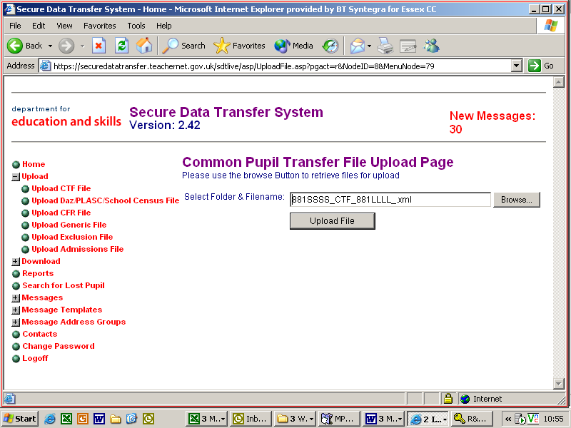

Once the upload is complete a message similar to the one in Screen 6 will appear to say that the file has been transferred to the web site. It is important that you wait for this message, because if you exit the screen before it appears no data will be transferred.

**Screen 6**

**PLEASE NOTE:** The wording will vary slightly depending on the type of file transferred.

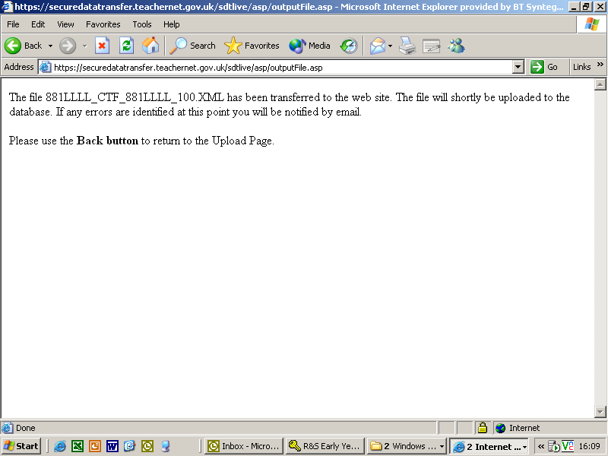

When the file has been successfully transferred to the website, use the ‘Back’ button on your toolbar to return to the previous page and choose logoff from the s2s menu on the left and then click the ‘Sign Out’ button to exit DFE Sign-in.