**Schools Forum Agenda**

Wednesday 17th May 2023, **Chelmsford City Racecourse CM3 1QP**

From 8am for an **8.30am start**; breakfast **10am** finish by **12 noon**.

|  |  |  |  |  |
| --- | --- | --- | --- | --- |
|  |  | Author | Voting / Relevance | Page |
| 1 | Apologies for Absence (and substitute notices) | Chair |  |  |

**Decision Papers**

|  |  |  |  |  |
| --- | --- | --- | --- | --- |
| 2 | Early Years Update | Carolyn Terry | All schools | 2 |
| 3 | Falling Rolls Fund | Yannick Stupples-Whyley | All schools | 11 |
| 4 | School and Academy Balances | Yannick Stupples-Whyley | All schools | 23 |
| 5 | Constitution and Membership of Schools Forum | Yannick Stupples-Whyley | All schools | 29 |

**Forum Business**

|  |  |  |  |  |
| --- | --- | --- | --- | --- |
| 6 | Any other business, feedback from schools through Associations and from Schools Forum representatives on other Bodies | Chair | All schools | 38 |
| 7 | Minutes of 11th January 2023 | Chair | All schools | 39 |
| 8 | Minutes Action Log | Yannick Stupples-Whyley | All schools | 55 |

**Information Papers for Discussion**

|  |  |  |  |  |
| --- | --- | --- | --- | --- |
| 9 | High Needs Review | Ralph Holloway | All schools | 56 |
| 10 | Schools Budget & Education Functions Draft Outturn Report 2022/23 | Yannick Stupples-Whyley | All schools | 59 |
| 11 | Implementing the Direct National Funding Formula – Consultation Response | Yannick Stupples-Whyley | All schools | 64 |
| 12 | Afghanistan Resettlement (Education) Grant 2022/23 | Yannick Stupples-Whyley | All schools | 75 |
| 13 | Forward Plan | Yannick Stupples-Whyley | All schools | 77 |

**Closing Comments**

|  |  |  |  |  |
| --- | --- | --- | --- | --- |
| 14 | Closing Comments | Chair |  |  |

|  |  |
| --- | --- |
| Schools Forum | **Agenda Item 2** |
| Date: 17 May 2023 |  |

**REPORT TITLE:** Early Years Update

Report by: Early Years & Childcare Sufficiency & Sustainability

Contact details: [carolyn.terry@essex.gov.uk](mailto:carolyn.terry@essex.gov.uk)

1. **Purpose of report** 
   1. To update Forum on the forecast budget requirement for 2023/24 of the two, three & four year old Free Early Education Entitlement (FEEE), including the Early Years Pupil Premium (EYPP)

1.2 To update Forum on the proposals to allocate **£1.9 million** of the **£7.4 million** Early Years Block surplus balance.

1.3 To request consent to undertake a consultation on how to apply the Teachers Pay and Pension Grants (TPG and TPECG).

1. **Recommendations**

2.1 That Forum notes the draft outturn for 2022/23 at 5.1.

2.2 That Forum agrees the proposal to allocate **£1.9 million** of the Early Years Block surplus balance set out at 5.4.

2.3 That Forum agrees to undertake a consultation on how to apply the former teacher’s pay and pension grants set out at 5.5.

1. **Relevant Schools Forum Power and Responsibility**

3.1 Table 1 shows the relevant responsibilities in relation to Early Years which is taken from the Education and Skills Funding Agency’s Schools forum powers and responsibilities published in September 2018.

|  |  |  |
| --- | --- | --- |
| Local Authority | Schools Forum | DfE |
| Early Years Funding Formula – Proposes and Decides | Must be consulted | Checks compliance with regulations. |
| Retained Expenditure - Proposes | Decides | Adjudicates where Schools Forum does not agree local authority proposal. |

1. **Background**

4.1 FEEE funding supports the statutory universal offer to all three- and four-year-olds and up to 40% of the least advantaged two-year-olds; these are children who meet predetermined eligibility criteria.

4.2 At the end of the Spring 2023 term report: -

* Across Essex, currently 20.6% of all two-year-olds are eligible to access the FEEE funding.
* The take-up of the two-year-old FEEE during the Spring 2023 term was 3,011, which was 87% of the 3,461 eligible two-year-olds in the county. This take-up figure remains significantly higher than the national take up level for the Spring 2023 term of 71.9%.
  1. The take-up of the universal three- and four-year-old FEEE at the Spring term 2023 headcount was 33,586, which is 97.3% of the eligible three- and four-year-olds. This remains above the national take up % of 92.3%

1. **Financial Implications**

5.1 Table 2 shows the draft outturn for 2022/23.

|  |  |  |  |
| --- | --- | --- | --- |
|  | Budget  £’000 | Draft Outturn  £’000 | Variance  £’000 |
| 2 Year Olds | 9,825 | 9,511 | (314) |
| 3 & 4 Year Olds | 79,346 | 77,502 | (1,844) |
| Early Years SENCOs | 1,300 | 1,300 | 0 |
| EY Quadrant Teams | 766 | 722 | (44) |
| Quality & Improvement | 550 | 550 | 0 |
| Contingency | 0 | (2,653) | (2,653) |
| Education Service Recharge | 151 | 151 | 0 |
| Corporate Overheads | 401 | 401 | 0 |
| Total | **92,339** | **87,484** | **(4,855)** |

5.2 The reason for the underspend as shown in Agenda Item 10 is a lower take-up of the free entitlement for 3- and 4-year-olds (**£1.8 million**) and 2-year-old funding (**£314,000**). The remaining **£2.7 million** underspend is the additional funding for 2021/22 announced in July 2022.

5.3 Table 3 shows the Early Years Block surplus is **£7.4 million**. This paper sets out proposals to allocate a further **£1.9 million** of the surplus. In addition, **£1.6 million** is earmarked for proposals previously approved by Forum. If the proposals in 5.4 are approved the remaining surplus balance will be **£3.9 million**. This will be held until the Authority knows the outcome of the final adjustment to the 2022/23 allocation which is due in July.

|  |  |
| --- | --- |
| Early Years Block | £m |
| Opening balance 1st April 2022 | (2.5) |
| 2022/23 Outturn | (4.9) |
| Balance at 31 March 2023 | **(7.4)** |
| Agreed Contingency | 1.0 |
| 4 Early Years Early Intervention Partners | 0.6 |
| Proposals in 5.4 | 1.9 |
| Revised Surplus Balance | **(3.9)** |

**5.4 Early Years Block underspend proposals**

The table below sets out a number of proposals to implement from the Early Years Block underspend, these are all intended to bring additional resources / capacity to support the early years sector to help mitigate the pressures the early years sector is facing in ensuring that early years education entitlement funded places continue to be available for eligible children.

|  |  |  |
| --- | --- | --- |
| **Proposal** | **Purpose** | **Total Cost**  **£** |
| 1. 1fte of temporary increased staffing levels to Early Years Sufficiency and Sustainability team | To provide additional business management consultancy and childcare sufficiency staffing support to early years sector for 2 years  £60,000 x 2 years | 120,000 |
| 1. Year of Reading | Contribution to project to cover early years activity | 100,000 |
| 1. Year of Numbers | Contribution to project to cover early years activity | 100,000 |
| 1. Speech and Language Club | On-line resource by SALT specialists in the 6 levelling up areas.  42 settings and 500 children and their families supported through the setting, along with up to 10 additional direct support for parents  Supplier: Essex Speech Club. | 94,500 |
| 1. Continuation of Speech and Language Club following a 1-year review | Should the project show success, a further 2–3-year funding, continuation and expansion of the Speech and Language Club. Potential for collaboration with Health colleagues and/or the High Needs Block. | 350,000 |
| 1. Help for sufficiency of disadvantaged EY settings | Funding for Early Years settings in levelling up and disadvantaged areas to help provide sufficiency and longevity in tough times. The settings would be distinguished through location, and if the setting is the only option for families in the area to access their funded place. | 750,000 |
| 1. Talk, Listen & Cuddle improvement and expansion | Talk listen and cuddle is a platform for parents that provide information, advice and guidance. Potential to offer improvement and expansion of this platform and to allow access to more parents. | 50,000 |
| 1. Recruitment and retention support | Work underway to put together a package to support the early years sector | 300,000 |
| **Total** |  | **1,864,500** |

* 1. **Request to undertake consultation on changes to the Early Years Block Teachers Pay and Pension Grants (TPG and TPECG) implemented from April 2023**
     1. A summary paper on the above was taken to the Schools Forum Financial Review Group on 25 April. The background to this issue is set out below: -
     2. As a result of the recent consultation on the Early Years Single National Funding Formula, the DfE have taken the decision to mainstream the Teachers’ Pay and Pensions Grants from April 2023.

The funding that was previously distributed through the teachers’ pay and pensions grants (TPPG) has now been rolled into funding that local authorities receive for the 3&4 year old entitlement. This has been allocated at a rate of 4p for every hour / full time place that funding has been paid for. For Essex, this equates to £650,574.24.

From analysis of the funding distributed from last year’s TPPG where £654,167 was paid to 96 schools, this is a reduction of £3,592.76.

Last financial year, the 96 schools were paid between: -

* £755 and £24,279, an average of £6,815.00 / school for the financial year
* £129.76 and £185.36 per child, an average of £181.82 / child

4p per every funded hour was applied equates to an allocation of £22.80 per full time place for the financial year.

Please note that for the Maintained Nursery School (MNS) supplement has already had the TPPG added to the MNS Supplement base rate, and so Tanglewood and Woodcroft are not affected by this decision, and they have not been included in the figures above.

No element of this funding is ring-fenced, and the DfE has said it is for local authorities to determine the approach to implementing the change locally, depending on their provider make-up and local circumstances, so long as it is in line with regulations. The DfE are encouraging local authorities to consider using this funding to support some of the costs for which the grants were originally introduced, for example, the need to pay employer contributions to the teachers’ pension scheme. This could therefore include cost pressures faced by PVIs in relation to Qualified teaching staff, as well as school-based nurseries, and LAs are being encouraged to use a quality supplement to do this.

As with all supplements, local authorities have the discretion to determine the appropriate metrics for the quality supplement, so long as their approach is in line with the principles set out in guidance, which includes consulting with the early years sector on the options.

The DfE are not recommending any one solution but have shared planned approaches from some LAs. These include: -

* consulting on a quality supplement, paid at the hourly rate received for settings with a qualified teacher and in the Teachers’ Pension Scheme (TPS)
* consulting on allocating the TPPG into funding the Base Rate so all early years’ settings benefit.

A consultation needs to be undertaken with the whole early years sector - PVI and Maintained - on how the TPPG should be distributed, to enable Schools Forum to make a decision on which proposal will be implemented from this financial year onwards.

* + 1. The recommendation of the Schools Forum Finance Review Group recommendation was to undertake a consultation proposing to ringfence the TPPG to continue to pay this grant to the schools who this was originally intended to be paid to. The outcome of this consultation will be brought to the July Schools Forum meeting for a final decision

5.6 **Update on the new SEN Inclusion Funding proposals progress**

An update on the progress of the work to implement a new SEN Inclusion Funding (SENIF) was taken to the SF High Needs Block in April 2023 to seek consent for the work to continue. This update covered the following areas: -

* Plans to align the currently separate SEN Premium and Early Years Inclusion funding processes into one single SENIF process, with a single front door, application process, decision-making and payments making it more straightforward for settings to access and at the same time creating a more responsive system that is not dependent on diagnosis / section 23 notifications from health professionals but based on evidence of need collected by early years settings.
* Implementing a new banding methodology – with clear criteria, specific descriptors for early years children but that is clearly linked to and aligned to the all-age descriptors. This will ensure EY settings and schools speak the same language and supports transition. Consistency to ensure same bands cover children supported with SENIF or with EHCPs to ensure consistent, needs-based, transparent, and fair decision-making. Top-up funding rates to be consistent across the PVI and maintained sections of the sector, and clearly identified support offer for children with needs below top-up level.
* Fairer, more sustainable system, with strong moderation, consistent decision-making, and robust financial oversight to ensure early years settings can be confident that requests for funding for children with similar needs in different settings will be considered and treated in the same way across the county.
* Maintain an offer in Essex that remains more generous than the statutory minimum to provide support for children with additional needs to access an early learning funded place, whilst supporting parents to work. These proposals were being developed prior the recent Childcare Reforms announcements but remain in line with the expectations from these reforms.
* Implementation of a Transition funding process to support the transition from an early years setting into a reception class, with a new process to encourage early planning between EY settings, schools and parents.

1. **Budget Childcare Reforms Update**

6.1 In the March 2023 budget, a package of measures was announced with the intended aim of reforming the childcare system and supporting more parents, specifically women, to enter or re-enter the workplace.

In summary, these were:

* 30 hours of free childcare for all children over 9 months from September 2025 – this will be introduced in phases from April 2024
* An uplift in the funding paid to early years providers, including nurseries, pre-schools, childminders and school run early years provision, for the existing funded hour provision from September 2023 – in Essex rates for 3-and 4-years olds are expected to increase from £4.73 to £4.88 (3.17% rise / 15p per funded hour) and for 2-year-olds from £5.89 to £7.68 (30.39% rise / £1.79 per funded hour)
* Funding for primary schools and local authorities to be used to establish wrap around childcare at the beginning and end of the school day for all schools by September 2026
* Revision to Universal Credit childcare payments so that these are paid upfront and not in arrears, and an uplift to the maximum claims that can be made
* Piloting of a scheme to provide incentive payments to encourage people to sign up as childminders (£600 per childminder or £1,200 if signing up via a childminder agency)

**6.2 Benefits of the reforms**

* Parents able to access funded hours from the end of maternity / parental leave, rather than only from the term after the child turns 3 (for the majority as per the current system)
* Additional funded hours are intended to bring the costs of childcare down meaning cost will be less of a barrier to accessing childcare, working, or working more hours
* Some financial concerns of settings will be addressed through the uplift of funding for 2-year-olds, which brings this more in line with the costs of actually providing care (although the same level of uplift has not been applied for 3-and 4-year-olds)
* Expansion of both childminding and before and after school provision which are known areas of under supply, increasing options for parents
* A barrier to accessing work for those in receipt of Universal Credit, namely that costs are paid in arrears, will be removed and uplifts in funding mean claimants can access more care resulting in more hours worked
* Changes in ratios (meaning staffing can be reduced, reducing costs) may result in cheaper care being available to parents and increased diversity of provision as it enables greater flexibility in how settings are run
* More children accessing high quality childcare should result in improved outcomes and school readiness and provides greater opportunity to identify and provide additional support to those in need; evidence also shows that better outcomes are linked to higher levels of maternal employment

**6.3 Concerns of the Childcare Reforms**

* **Financial:** The early years sector is already facing significant financial difficulties primarily driven by the differential in the rate paid for funded hours and the cost of providing these hours. A strategy used by many settings is to offset the losses made on the funded 3-and 4-year-old provision with the fees charged for children 2 and under.

Feedback from the sector has indicated that due to the financial impact of this, many settings will be unable to continue in business and across Essex we are already seeing more settings closing due to their financial unsustainability, than we have seen before. For others, many are considering not providing these funded hours as it is unaffordable. Settings that do offer funded hours may decide to prioritise places for younger children where funding rates are higher, which will lead to a lack of provision for older children. Taken together these factors may mean that contrary to the policy aims the result is actually less available childcare and that the level of ‘free’ childcare is significantly under what was desired.

* **Capacity** It is very hard to predict the take up of this new provision however it is likely to result in increased demand, as more parents feel able to afford care, people make the switch from informal to formal care, and there are potential increases in the birth rate as cost barriers to having a child or second child may be perceived to be removed. Demand is particularly likely to become higher for 2 and under places. There is not currently capacity in the system to meet this expanded demand, especially for babies, and to meet it there will need to be expansion in all setting types but particularly childminders and day care provisions. This will include expanding existing provisions and establishing new settings. In addition to meeting new demand, new capacity will also be required to make up for capacity lost as a result of existing providers leaving the market.
* **Parental expectation** There is clear positive messaging around these reforms for parents focused on ‘free childcare’. There is however a significant disconnect between the promise of free childcare and the experience of parents seeking to access this and finding there is still a cost to access a ‘free place’. This is already an issue with the current system and is likely to be exacerbated when bringing more parents in, particularly those who have not been involved before.
* **Childminders** the Government is committed to expanding childminder provision; this is welcome as childminders are a key component of the current early years system but one where there are considerable financial and recruitment and retention difficulties. Reforms to funded hours and wrap around provision have however the potential to further destabilise the market and push more current childminders out of business. An incentive payment scheme may encourage new entrants, however the levels of new entrants required to expand capacity to meet demand will be considerable, the incentives would need to be sustained over the longer term and significant input will be needed from the LA to ensure quality.
* **Wrap around care** Many schools already have wrap around provision however this still remains an issue for some parents and so attempts to address this are welcome. There is however concern about the capacity of schools to effectively respond to this requirement in the context of existing significant pressure on staffing and budgets. There are also concerns that setting up new school-based provision may further destabilise the childminder market within local areas and threaten the business of existing third-party providers. There have in the past been centralised programmes for extended services for schools which were successful in encouraging the development of provision however this was not sustainable once centralised revenue resource was withdrawn and there is concern the same issue could also occur here. This reform also does not address childcare to cover school holidays, which is a further significant issue for working parents, and in fact the potential impact on third party providers could threaten their sustainability when they are in the main the principal providers of holiday schemes. There is no indication that this care is expected to be free or funded so cost may continue to present a barrier.
* **Ratios** Reforms around ratios are concerning. The Government is proceeding with these changes, despite an overall negative response to its own consultation on the matter. There are concerns about safety and quality of care and it is thought unlikely that changes in ratios within existing provision will result in any significant level of cost reduction to parents. What may result is new provision setting up with reduced ratios, this would increase the options for parents but may result in a possible two-tier market of lower cost but lower quality provision vs higher cost, higher quality options. Meeting the needs of SEND children within reduced ratios will be significantly more difficult and may increase draws on inclusion funding or limit available places. There is also a particular risk to the quality of staff and child interaction, which is vital to the development of communication skills, where there are current known deficits across the system.
* **Recruitment and Retention** of early years professionals is likely to be a significant limiting factor on these reforms. The early years sector is already experiencing a staffing crisis with a sustained loss of childminders and nursery staff since the pandemic. The sector is low paid and, while rewarding, the work is challenging, and higher paid opportunities are easily available in other, often unskilled industries such as factories and supermarkets. These reforms place additional pressures on the workforce such as the need to upskill in respect of the care of babies and the potential requirement to manage the needs of an increasing diversity of children within reduced ratios. There are concerns that further promised reforms to childminding are potentially positioning childminders as a ‘lesser’ form care which is not helpful messaging when trying to retain the commitment of current minders or encourage new ones into the industry.
* **Children with SEND** No specific consideration is given to the needs of children with SEND in these reforms, even though the lack of suitable childcare for children with SEND is a particular limiting factor on their parents being able to work. Ensuring that all new settings are appropriately equipped to meet needs is important. ECC is already experiencing significant increases in requests for Inclusion Funding to meet suspected SEND need in the early years, it is anticipated that this will be exacerbated by these changes as more children are brought into settings, ratios potentially change, and there is increasing pressure on staffing and training budgets. The announcements have not made any reference to the potential impact on Councils’ statutory duties in the SEN Code of Practice re providing support to children with SEN to access a funded place, or whether the funding levels for the Dedicated Schools Grant High Needs Block will be increased to cover the need to provide SEN Inclusion Funding for more children accessing more funded hours.
  1. Work is underway on further analysis of the Childcare Reforms to develop an action plan for each of the sections above

1. **Schools Forum Early Years and Childcare Reference Group**

7.1 The Schools Forum Early Years and Childcare Reference Group has continued to meet, with ongoing representation from all early years’ sector types and each district.

The key areas of discussion have continued to be around the following areas: -

* increasing number of early years children with emerging additional needs that need more support
* the funding levels being paid not meeting the actual cost of providing a funded place for eligible 2 year olds and 3 and 4 year olds which is further impacting the financial pressures on the economy such as increases to the national minimum wage, NI contributions, utility, and food costs, which are causing sustainability concerns for the early years sector.
* the recruitment and retention of qualified staff is becoming an increasing issue with settings either needing to limit the number of childcare places being offered, impacting on parents ability to work and in some cases leading to childcare settings taking the decision to close.

7.2 Future meetings continue to be scheduled to coincide with reporting to Schools Forum

|  |  |
| --- | --- |
| Schools Forum | **Agenda Item 3** |
| Date: 17 May 2023 |  |

**REPORT TITLE: FALLING ROLLS FUND**

Report by Yannick Stupples-Whyley

Contact details: Telephone (03330 138464); e-mail: yannick.stupples-whyley@essex.gov.uk

**1. Purpose of report**

1.1 To present to the Schools Forum the proposed balance criteria to add to the existing Falling Rolls criteria and the recommended schools to be funded from the falling rolls fund.

**2. Recommendations**

2.1 To approve the balances criteria at 4.2 as recommended by the Finance Review Group (FRG).

2.2 To approve the recommendation of FRG to fund the schools listed at 4.6 to be funded by the Falling Rolls Fund for the amounts shown at 5.2 for 2023/24.

2.3 To approve using **£76,000** of the Schools Block surplus balance to increase the budget for the Falling Rolls Fund at 5.3.

###### 3. Relevant Schools Forum Power and Responsibility

3.1 **Table 1** is an extract from the Schools Forum Operational and Good Practice Guide (September 2018), which sets out the role of the Authority, Schools Forum and the Secretary of State for the Falling Rolls Fund.

|  |  |  |  |
| --- | --- | --- | --- |
| Function | Local authority | Schools forum | DfE role |
| Central spend on and the criteria for allocating funding from:   * funding for good or outstanding schools with falling rolls where growth in pupil numbers is expected within three years | Proposes | Decides | Adjudicates where schools forum does not agree local authority proposal |

###### 4. Background

4.1 Schools Forum approved the revised criteria for the Falling Rolls Fund at the meeting on 11 January 2023.

4.2 Schools Forum requested, at the January meeting, a further criteria to prevent schools with large balances benefitting from the falling rolls fund. Table 2 shows the proposed criteria:

|  |  |
| --- | --- |
|  | Balance Criteria |
| Primary schools 210 pupils or fewer. | The balance should be less than or equal to £60,000 or 8% of the relevant budget share, whichever is the greater. |
| Primary schools with 211 pupils or greater. | The balance should be less than or equal to 8% of the relevant budget share. |
| Secondary schools | The balance should be less than or equal to 5% of the relevant budget share. |

4.3 The criteria above are in line with the DfE recommended level of balances. The variation for schools with 210 pupils or fewer is that the smallest schools could have a balance in excess of 8% which is low value, especially in the current economic climate. £60,000[1] is 8% of the average budget share for the schools with 210 or fewer pupils.

4.4 The Authority contacted all schools that met the mandatory Ofsted rating and the falling rolls criteria. Each school was sent a proforma to complete and details of the falling rolls fund. Table 3 shows the schools that were contacted and those that have made a subsequent application.

|  |  |
| --- | --- |
| School Contacted | Application Submitted |
| Cherry Tree Academy | No |
| Clavering Primary | Yes |
| Doddinghurst Junior | Yes |
| Felsted Primary | No |
| Finchingfield Primary | No |
| Holt Farm Infant | Yes |
| Monkwick Infant | No |
| Prettygate Infant | Yes |
| St Andrew’s CE Primary, Marks Tey | Yes |
| St Margaret’s CE Primary, Bowers Gifford | No |
| St Mary’s CE Primary, Hatfield Broad Oak | Yes |
| The Alderton Junior School | Yes |
| Wethersfield CE Primary | Yes |
| Wimbish Primary | Yes |

4.5 Annex A shows a breakdown of each application.

4.6 FRG has reviewed the data in Annex A and recommend the following schools are funded from the falling rolls fund.

* Prettygate Infant School
* St Mary’s Primary, Hatfield Broad Oak
* Clavering Primary
* Holt Farm Infant School
* Wethersfield Primary
* The Alderton Junior School

4.7 Two schools, Doddinghurst Infant and Wimbish Primary meet all criteria except the proposed balances criteria.

4.8 The applications have also been reviewed by the School Organisation and Place Planning Team who agree with the recommendations shown in Annex A.

**5. Financial Implications**

5.1 Schools Forum approved a budget of £466,000 for 2023/24.

5.2 Table 5 shows the funding that will be paid to the schools proposed for approval.

|  |  |  |  |  |  |
| --- | --- | --- | --- | --- | --- |
| School | 2023/24  £ | 2024/25  £ | 2025/26  £ | 2026/27  £ | 2027/28  £ |
| Prettygate Infant | 121,878 | 138,806 | 94,794 | 0 | 0 |
| St Mary’s Primary HBO | 60,939 | 81,252 | 101,565 | 121,878 | 142,191 |
| Clavering Primary | 91,409 | 108,336 | 108,336 | 108,336 | 108,336 |
| Holt Farm Infant | 179,432 | 274,226 | 223,444 | 0 | 0 |
| Wethersfield Primary | 20,313 | 37,241 | 44,012 | 50,783 | 50,783 |
| The Alderton Junior | 67,710 | 115,107 | 115,107 | 121,878 | 0 |
| Total | **541,682** | **754,969** | **687,259** | **402,876** | **301,310** |

5.3 The budget is insufficient for the applications recommended for approval. It can be seen within Agenda Item 10 that there is a surplus balance in the Schools Block. It is proposed to use **£76,000** of the Schools Block surplus to increase the budget for the Fallings Roll Fund. The funding for future years is indicative based on the pupil forecast by each school. Actual allocations will be determined by each October census.

**6. Background / Supporting papers.**

6.1 Annex A – School applications.

**Falling Rolls Fund – Annex A**

**Prettygate Infant School**



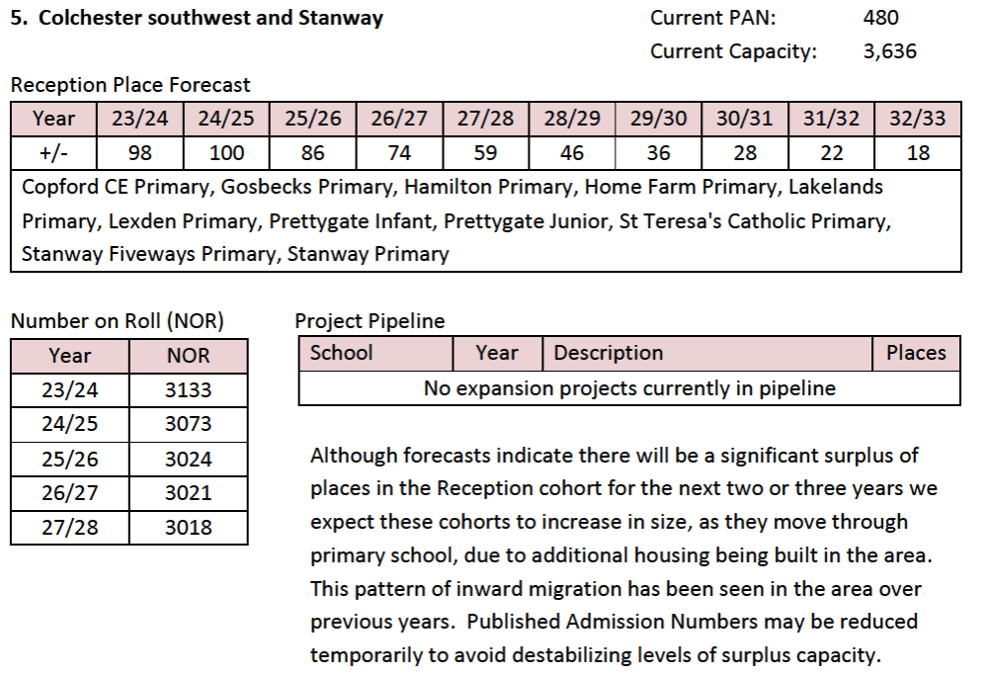

Funding based on pupil forecasts:

|  |  |  |
| --- | --- | --- |
|  | Total Pupils Funded | £ |
| 2023/24 | 36 | 121,878 |
| 2024/25 | 41 | 138,806 |
| 2025/26 | 28 | 94,794 |

The school is rated Good by Ofsted with the last inspection in December 2022. The school has closed 2022/23 with a surplus balance of £33,051, which is 4.6% of its 2022/23 budget share. The school’s pupil forecast shows that the NOR will fall again in October 2023 which is allowable under the criteria of the scheme and then as required increases in October 2024. As the school is an infant school 2025/26 is the final year the school will receive funding.

It can be seen in the LA’s 10 Year Plan the number of surplus places in the planning group are expected to reduce as new housing is being built.

The school meets all the criteria of the falling rolls fund and the Authority recommends the application is approved.

**St Mary’s CE Primary, Hatfield Broad Oak**



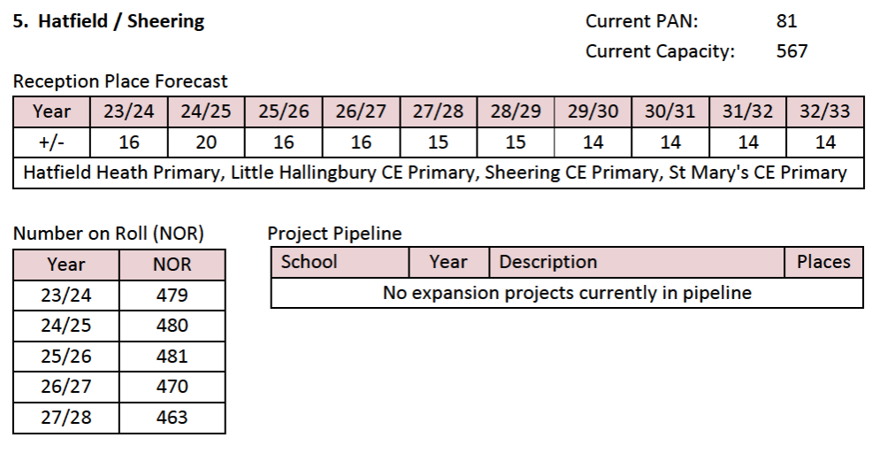

Funding based on pupil forecasts:

|  |  |  |
| --- | --- | --- |
|  | Total Pupils Funded | £ |
| 2023/24 | 18 | 60,939 |
| 2024/25 | 24 | 81,252 |
| 2025/26 | 30 | 101,565 |
| 2026/27 | 36 | 121,878 |
| 2027/28 | 42 | 142,191 |

The school is rated Good by Ofsted with the last inspection in April 2018. The school closed 2022/23 with a surplus balance of £21,820, which is 5.2% of its 2022/23 budget share. The NOR is forecast to increase in October 2024 and to continue to increase each subsequent October.

The 10 Year Plan for the local planning group shows no significant change in the number of surplus places. The increases forecast by the school are not significant and therefore do not contradict the 10 Year Plan.

The school meets all the criteria of the falling rolls fund and the Authority recommends the application is approved.

**Doddinghurst Infant**



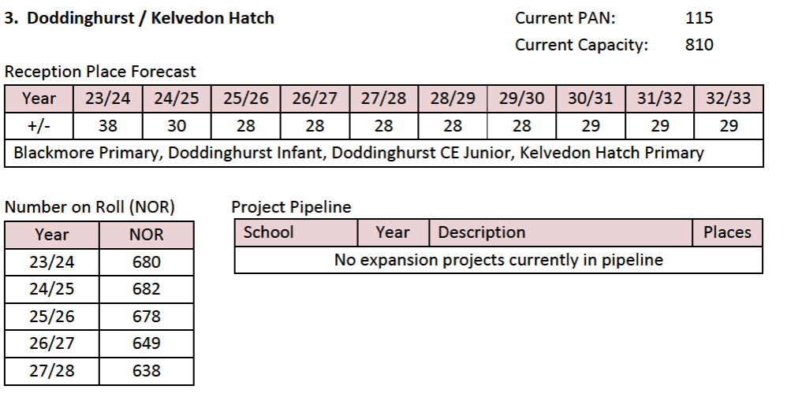

Funding based on pupil forecasts:

|  |  |  |
| --- | --- | --- |
|  | Total Pupils Funded | £ |
| 2023/24 | 33 | 111,722 |
| 2024/25 | 49 | 165,890 |
| 2025/26 | 48 | 162,504 |

The school is rated Good by Ofsted with the last inspection in January 2023. The school closed 2022/23 with a surplus balance of £94,836, which is 14.3% of its 2022/23 budget share. The NOR is forecast to increase in October 2024 which would be the last year of funding for an infant school.

The 10 Year Plan for the local planning group shows no significant change in the number of surplus places. The increases forecast by the school are not significant and therefore do not contradict the 10 Year Plan.

The school fails the proposed balance criteria of the falling rolls fund and the Authority recommends the application is not approved.

**Wimbish Primary**



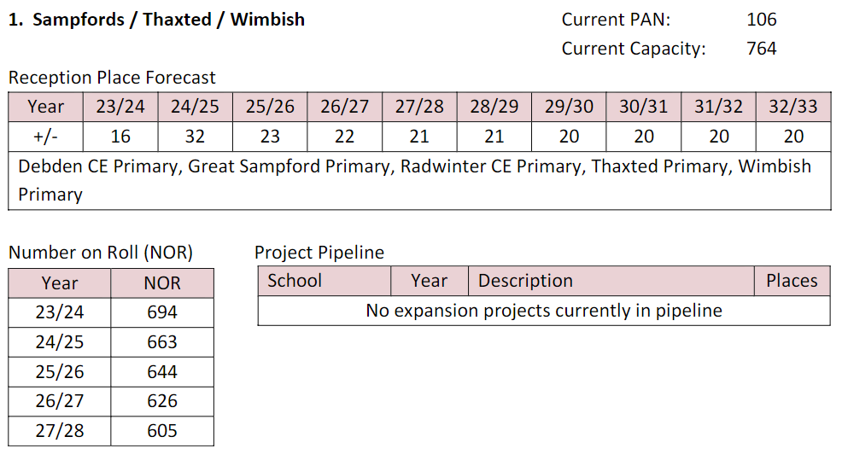

Funding based on pupil forecasts:

|  |  |  |
| --- | --- | --- |
|  | Total Pupils Funded | £ |
| 2023/24 | 10 | 33,855 |
| 2024/25 | 17 | 57,554 |
| 2025/26 | 17 | 57,554 |
| 2026/27 | 17 | 57,554 |
| 2027/28 | 17 | 57,554 |

The school is rated Good by Ofsted with the last inspection in May 2022. The school closed 2022/23 with a surplus balance of £109,026, which is 22.1% of its 2022/23 budget share. The NOR is forecast to increase in October 2024 and in subsequent years

The 10 Year Plan for the local planning group shows the number of surplus places fall in 2025/26 and then remain consistent.

The school does not meet the proposed balances criteria, so subject to that being approved the school is not eligible for the falling rolls fund.

**Clavering Primary**



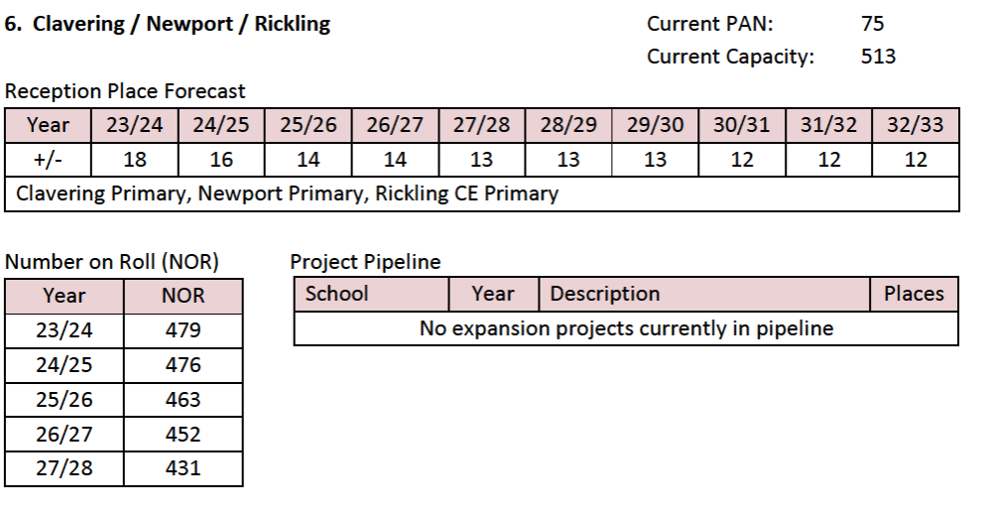

Funding based on pupil forecasts:

|  |  |  |
| --- | --- | --- |
|  | Total Pupils Funded | £ |
| 2023/24 | 27 | 91,409 |
| 2024/25 | 32 | 108,336 |
| 2025/26 | 32 | 108,336 |
| 2026/27 | 32 | 108,336 |
| 2027/28 | 32 | 108,336 |

The school is rated Good by Ofsted with the last inspection in May 2022. The school closed 2022/23 with a surplus balance of £14,224, which is 1.8% of its 2022/23 budget share. The NOR is forecast to increase in October 2024 and in subsequent years

The 10 Year Plan for the local planning group shows the number of surplus places remaining consistent across the 10 year period, however housing is being built in the area and the school is confident its NOR will increase.

The school meets all the criteria of the falling rolls fund and the Authority recommends the application is approved.

**Holt Farm Infant**



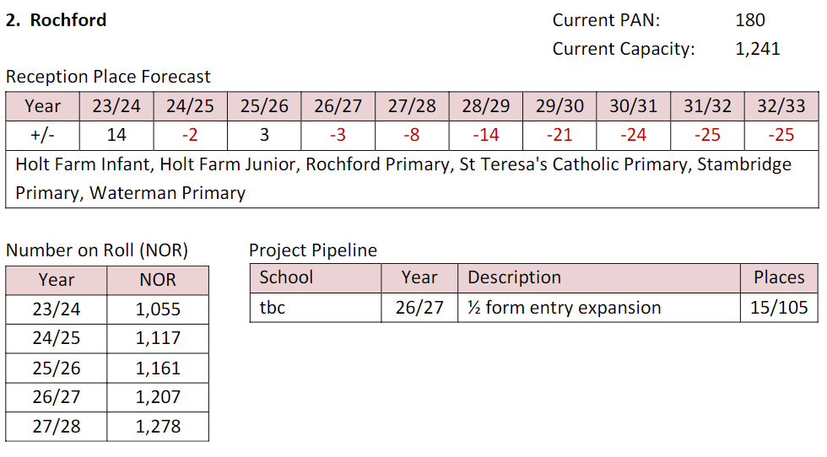

Funding based on pupil forecasts:

|  |  |  |
| --- | --- | --- |
|  | Total Pupils Funded | £ |
| 2023/24 | 53 | 179,432 |
| 2024/25 | 81 | 274,226 |
| 2025/26 | 66 | 223,444 |

The school is rated Good by Ofsted with the last recorded inspection in January 2013. The Head has indicated the school has been rated Good at a recent inspection. The school closed 2022/23 with a surplus balance of £5,336, which is 0.6% of its 2022/23 budget share. The NOR is forecast to increase in October 2024 and in subsequent years

The 10 Year Plan for the local planning group shows an imminent deficit of places across the 10 year period. Housing is being built in the area and the 10 year plan shows a half form entry expansion is expected in the area in 2026/27. The school is confident its NOR will increase.

The school meets all the criteria of the falling rolls fund and the Authority recommends the application is approved.

**St Andrew’s Primary, Marks Tey**



The forecast NOR falls in October 2024 and continues to fall. The school has been invited to review its forecasts but has not resubmitted its application.

The growth criteria are not achieved and the school is therefore not eligible for funding.

**Wethersfield Primary**



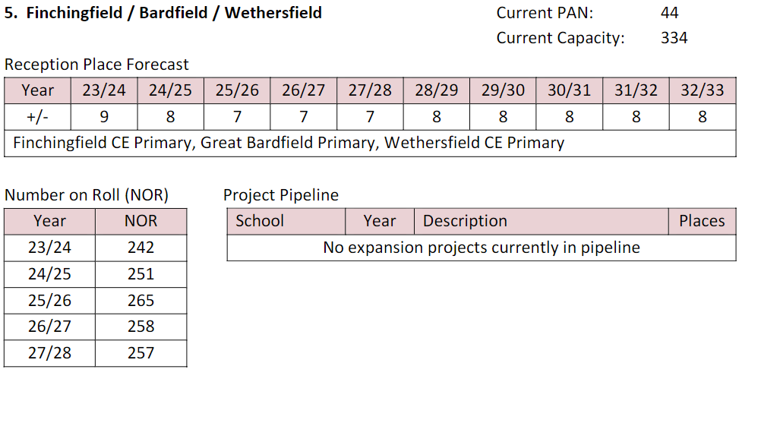

Funding based on pupil forecasts:

|  |  |  |
| --- | --- | --- |
|  | Total Pupils Funded | £ |
| 2023/24 | 6 | 20,313 |
| 2024/25 | 11 | 37,241 |
| 2025/26 | 13 | 44,012 |
| 2026/27 | 15 | 50,783 |
| 2027/28 | 15 | 50,783 |

The school is rated Good by Ofsted with the last recorded inspection in February 2018. The school closed 2022/23 with a surplus balance of £46,162, which is 11.7% of its 2022/23 budget share. The NOR is forecast to increase in October 2024 and in subsequent years

The school has recently joined a Federation and is confident that this will have a positive impact on pupil numbers. There are also 2 housing developments within a 10 minute drive of the school and other local schools are full.

The surplus percentage of surplus balance held will be impacted by the balances proposal. Subject to the proposal being approved it is recommended that the application is approved.

**The Alderton Junior School**

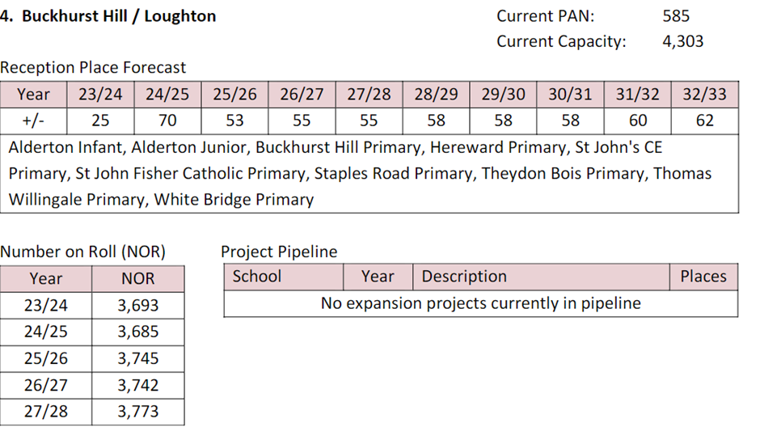



Funding based on pupil forecasts:

|  |  |  |
| --- | --- | --- |
|  | Total Pupils Funded | £ |
| 2023/24 | 80 | 270,841 |
| 2024/25 | 94 | 318,238 |
| 2025/26 | 94 | 318,238 |
| 2026/27 | 96 | 325,009 |

The school is rated Good by Ofsted with the last recorded inspection in January 2023. The school is an academy closed 2021/22 with a surplus balance of £77,361, which is 6.1% of its 2022/23 budget share. The NOR is forecast to increase in October 2024 and in subsequent years.

The school is reducing its Year 3 PAN to 60 from September 2023 and it is appropriate to fund the school on a PAN of 60 rather than a PAN of 90, otherwise excess pupils will be funded.

|  |  |  |
| --- | --- | --- |
|  | Total Pupils Funded | £ |
| 2023/24 | 20 | 67,710 |
| 2024/25 | 34 | 115,107 |
| 2025/26 | 34 | 115,107 |
| 2026/27 | 36 | 121,878 |

The recommendation is to approve the application using a PAN of 60 to generate the funding allocation.

|  |  |
| --- | --- |
| Schools Forum | **Agenda Item 4** |
| Date: 17 May 2023 |  |

**REPORT TITLE: SCHOOL and ACADEMY BALANCES**

Report by Yannick Stupples-Whyley

Contact details: Telephone (03330 138464); e-mail: yannick.stupples-whyley@essex.gov.uk

**1. Purpose of report**

1.1 To update Schools Forum on the level of balances held across all Essex schools and to seek agreement to recommence the review of schools with high balances.

**2. Recommendations**

2.1 To note the report.

2.2 To agree the recommendation of the Finance Review Group (FRG) to reconvene the review of schools with balances of 30% or higher.

###### 3. Relevant Schools Forum Power and Responsibility

3.1 There are no specific school forum powers or responsibilities in connection to school balances.

###### 4. Background

4.1 The combined balances for maintained schools and academies are **£176.9 million**, which is an increase of **£12.5 million** compared to last year. Table 1 shows the total balances on 31st March 2023 for maintained schools and 31st August 2022 for academies.

|  |  |  |  |  |
| --- | --- | --- | --- | --- |
| Phase | No. of Schools | Maintained School Balances  31st March 2023  £’000 | Academy Balances  31st August 2022  £’000 | Total  Balances  £’000 |
| Nursery | 2 | 194 | 0 | 194 |
| Primary | 447 | 35,453 | 50,918 | 86,371 |
| Secondary | 79 | 2,617 | 67,094 | 69,711 |
| All-Through | 2 | 0 | 1,682 | 1,682 |
| Special | 21 | 3,701 | 9,048 | 12,749 |
| PRU | 6 | 1,695 | 4,463 | 6,158 |
| Total | **557** | **43,660** | **133,205** | **176,865** |

4.2 Table 2 shows the movement in balances for maintained schools between 2022/23 and 2021/22.

|  |  |  |  |  |
| --- | --- | --- | --- | --- |
|  | 2021/22  £’000 | 2022/23  £’000 | Movement  £’000 | %  Change |
| Nursery | 212 | 194 | (18) | (8.5) |
| Primary | 39,788 | 35,453 | (4,335) | (10.9) |
| Secondary | 2,906 | 2,617 | (289) | (9.9) |
| Special | 4,227 | 3,701 | (526) | (12.4) |
| PRU | 1,664 | 1,695 | 31 | 1.8 |
| Total | **48,797** | **43,660** | **(5,137)** | **(10.5)** |

4.3 Balances for maintained schools have decreased by **£5.1 million**, which is broken down as follows:

* £833,000 relates to the 3 schools that converted to academy status in 2022/23.
* The remaining £4.3 million decrease relates to the schools that were maintained on 31st March 2023.

4.4 Table 3 shows that not all maintained schools had reducing balances in 2022/23.

|  |  |  |  |  |
| --- | --- | --- | --- | --- |
|  | No. of Schools with in-year Surplus | £’000 | No. of Schools with in-year Deficit | £’000 |
| Nursery | 0 | 0 | 2 | (18) |
| Primary | 75 | 2,609 | 145 | (6,945) |
| Secondary | 1 | 58 | 3 | (347) |
| Special | 2 | 171 | 4 | (697) |
| PRU | 2 | 209 | 1 | (178) |
| TOTAL | **80** | **3,047** | **155** | **(8,185)** |

4.5 Table 4 shows the movement in balances for academies between 2020/21 and 2021/22.

|  |  |  |  |  |
| --- | --- | --- | --- | --- |
|  | 2020/21  £’000 | 2021/22  £’000 | Movement  £’000 | %  Change |
| Primary | 47,537 | 50,918 | 3,380 | 7.1 |
| Secondary | 55,994 | 67,094 | 11,099 | 19.8 |
| All-Through | 1,164 | 1,682 | 518 | 44.4 |
| Special | 7,202 | 9,048 | 1,846 | 25.6 |
| PRU | 3,699 | 4,463 | 764 | 20.7 |
| Total | **115,597** | **133,205** | **17,608** | **15.2** |

4.6 Table 5 shows the same analysis as Table 3 for academies including trust’s central services balances.

|  |  |  |  |  |  |
| --- | --- | --- | --- | --- | --- |
|  | No. of Schools with in-year Surplus | £’000 | No. of Schools with no change in balances | No. of Schools with in-year Deficit | £’000 |
| Primary | 107 | 8,985 | 35 | 83 | (5,605) |
| Secondary | 41 | 22,239 | 16 | 18 | (11,140) |
| All-Through | 1 | 570 | 0 | 1 | (52) |
| Special | 7 | 4,338 | 0 | 7 | (2,492) |
| PRU | 3 | 764 | 0 | 0 | 0 |
| TOTAL | **159** | **36,896** | **51** | **109** | **(19,289)** |

4.7 Table 6 shows for maintained schools the number of schools in surplus or deficit. For the schools in surplus the number of schools above the DfE thresholds is also shown.

|  |  |  |  |
| --- | --- | --- | --- |
| Phase | Surplus | Deficit | Surplus above DfE Threshold |
| Nursery | 2 | 0 | 1 |
| Primary | 209 | 11 | 153 |
| Secondary | 4 | 0 | 4 |
| Special | 5 | 1 | 4 |
| PRU | 3 | 0 | 3 |
| Total | **223** | **12** | **165** |

4.8 Table 6 shows there are 12 maintained schools in deficit at 31st March 2023, which is an increase of 9 schools compared to 2021/22. Whilst maintained school balances have decreased there are still a significant number of schools with balances above the DfE thresholds of 5% for secondary and 8% for all other schools.

4.9 Table 7 shows for academies the number of schools in surplus or deficit. For the schools in surplus the number of schools above the DfE thresholds is also shown.

|  |  |  |  |  |
| --- | --- | --- | --- | --- |
|  | Surplus | No Change / Pooled | Deficit | Surplus above DfE Threshold |
| Primary | 171 | 38 | 16 | 135 |
| Secondary | 56 | 16 | 2 | 50 |
| All-Through | 2 | 0 | 0 | 1 |
| Special | 10 | 4 | 0 | 7 |
| PRU | 3 | 0 | 0 | 3 |
| TOTAL | **242** | **62** | **18** | **196** |

4.10 Table 7 shows there are 18 schools in deficit, which is an increase of 2 schools since 2020/21. Similarly, to maintained schools there are a significant number of schools with balances above the DfE thresholds.

4.11 Chart 1 shows the movement in balances over the last 5 years.

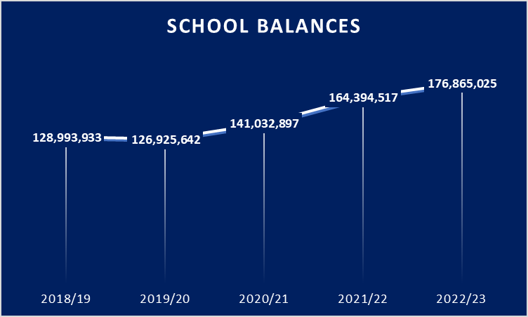

4.12 Between 2018/19 and 2022/23 balances have increased by **£47.9 million** (37.1%).

**5. Schools Forum Review of Balances**

5.1 Schools Forum agreed in May 2022 a deep dive into schools with balances in excess of 30% of their funding. In September 2022 this review was postponed due to the increased energy costs schools were facing.

5.2 Table 8 shows for primary schools a breakdown of the percentage of balances held with a comparison to the previous year.

|  |  |  |
| --- | --- | --- |
|  | 2021/22  No. of Schools | 2022/23  No of Schools |
| 60% and above | 3 | 3 |
| Between 50% & 59.9% | 4 | 3 |
| Between 40% & 49.9% | 14 | 9 |
| Between 30% & 39.9% | 27 | 41 |
| Between 20% & 29.9% | 67 | 78 |
| Between 8.1% & 19.9% | 176 | 157 |
| Between 0% & 8.0% | 140 | 126 |
| Deficit | 16 | 27 |
| Total Schools | **447** | **444** |

5.3 The number of primary schools with balances above 30% has increased from 48 schools to 56 schools (12.6%).

5.4 Table 9 shows for secondary schools a breakdown of the percentage of balances held with a comparison to the previous year.

|  |  |  |
| --- | --- | --- |
|  | 2021/22  No. of Schools | 2022/23  No of Schools |
| 60% and above | 2 | 2 |
| Between 50% & 59.9% | 1 | 0 |
| Between 40% & 49.9% | 2 | 1 |
| Between 30% & 39.9% | 5 | 3 |
| Between 20% & 29.9% | 5 | 11 |
| Between 10% & 19.9% | 25 | 26 |
| Between 5.1% & 9.9% | 10 | 11 |
| Between 0% & 5.0% | 25 | 23 |
| Deficit | 3 | 2 |
| Total Schools | **78** | **79** |

5.5 The number of secondary schools with balances above 30% has decreased from 10 schools to 6 schools (7.6%).

5.6 Table 10 shows for special schools a breakdown of the percentage of balances held with a comparison to the previous year.

|  |  |  |
| --- | --- | --- |
|  | 2021/22  No. of Schools | 2022/23  No of Schools |
| 60% and above | 0 | 0 |
| Between 50% & 59.9% | 1 | 1 |
| Between 40% & 49.9% | 0 | 0 |
| Between 30% & 39.9% | 3 | 2 |
| Between 20% & 29.9% | 2 | 2 |
| Between 8.1% & 19.9% | 10 | 6 |
| Between 0% & 8.0% | 3 | 8 |
| Deficit | 0 | 1 |
| Total Schools | **19** | **20** |

5.7 The number of special schools with balances above 30% has decreased from 4 schools to 3 schools (15%).

5.8 For PRUs, 4 have balances in excess of 30% (66.7%). One of the all-through schools has a balance in excess of 30%.

5.9 Whilst maintained school balances have gone down and academy balances have yet to reflect winter fuel costs there will still be a significant number of schools with high balances.

5.10 FRG recommends that the review of high school balances is reconvened.

**Financial Implications**

5.1 The financial implications are embedded in the report.

**6. Other Resource Implications**

**7. Consultation with stakeholders**

**8. Background / Supporting papers.**

8.1 Annex A – Maintained School Balances

8.2 Annex B – Academy Balances

|  |  |
| --- | --- |
| Schools Forum | **Agenda Item 5** |
| Date: 17 May 2023 |  |

**REPORT TITLE: CONSTITUTION AND MEMBERSHIP OF SCHOOLS FORUM**

Report by Yannick Stupples-Whyley

Contact details: Telephone (03330) 138464; e-mail:

[yannick.stupples-whyley@essex.gov.uk](mailto:yannick.stupples-whyley@essex.gov.uk)

**1. Purpose of report**

* 1. To consider the current membership of the Schools Forum in the light of the continuing transfer of maintained schools to the Academy sector and the change in pupil numbers.

**2. Recommendations**

* 1. To approve to change the meeting arrangements switching the in person meeting from January to May at 3.2.
  2. To note that no changes are required to the constitution of Schools Forum at 3.6 and 3.8.
  3. To note Membership at Annex A and Attendance at Annex B.

**3. Background**

3.1 Schools Forum approved a mix of both in person and remote meetings at the May 2021 meeting following the change to the Schools Forum Regulations allowing the use of remote meetings on a permanent basis.

3.2 Following the switching of the January 2023 meeting to remote and today’s meeting to in person. It is proposed to make this switch on a permanent basis.

* May – in person
* July – remote
* September – in person
* November – remote
* January – remote

3.3 All sub-group meetings will be held remotely.

3.4 Table 1 shows the agreed structure Forum approved in December 2020:

|  |  |  |  |
| --- | --- | --- | --- |
|  | Maintained Schools | Academies | Total |
| Primary | 5 | 5 | 10 |
| Secondary | 1 | 6 | 7 |
| Special | 1 | 1 | 2 |
| PRUs | 1 | 1 | 2 |
| Nursery | 1 | - | 1 |
| Non School Members |  |  | 6 |
| Total | **9** | **13** | **28** |

3.5 T able 2 shows the ratio of pupils between primary and secondary schools as at the January Census 2023.

|  |  |  |
| --- | --- | --- |
|  | Pupils | Ratio |
| Primary | 119,563 | 1.44 |
| Secondary | 82,755 | 1.00 |

3.6 The ratio between primary and secondary pupils is 1.44:1 which requires no change to the number of primary and secondary representatives.

3.7 Table 3 shows a breakdown of pupils for primary and secondary between maintained schools and academies as at the January Census 2023.

|  |  |  |  |
| --- | --- | --- | --- |
|  | No. of Schools | Pupils | % Split |
| Primary  Maintained  Academies  Total Primary | 220  227  **447** | 54,890  64,673  **119,563** | 45.9%  54.1%  **100%** |
| Secondary  Maintained  Academies  Total Secondary | 4  77  **81** | 3,834  78,921  **82,755** | 4.6%  95.4%  **100%** |

3.8 The above primary pupil split in Table 3 between maintained schools and academies still requires 5 maintained members and 5 academy members.

3.9 A full list of members is shown at Annex A.

3.10 Table 4 shows the members who are coming to the end of their current term of office.

|  |  |
| --- | --- |
| Name | Last Meeting |
| Simon Wall | 17 May 2023 |
| John Hunter | 27 September 2023 |
| Philomena Cozens | 12 July 2023 |

3.11 Details of attendance are shown at Annex B for Schools Forum, the High Needs Review Group, the Finance Review Group and the Early Years Sub-Group. It can be seen in Annex B one member has breached the terms and conditions where they must attend at least one of three consecutive meetings. The Authority will write to the Diocesan Board to seek a different representative.

**4. Financial Implications**

4.1 There are no financial implications.

**5. Other Resource Implications**

**6. Consultation with stakeholders**

**7. Background / Supporting papers.**

7.1 Annex A – School Forum Membership

7.2 Annex B – Schools Forum Attendance

**Annex A**

**School Forum Members (November 2022)**

**Maintained Schools:**

**Primary School Headteachers**

|  |  |  |
| --- | --- | --- |
| **Name** | **School** | **Term of Membership** |
| Sue Bardetti | Holland Haven Primary School | November 2021 to November 2025 |
| Luke Bulpett | Brightside Primary School | July 2020 to July 2024 |
| Jinnie Nichols | The Chorus School Federation | September 2021 to September 2025 |

**Primary School Governors**

|  |  |  |
| --- | --- | --- |
| **Name** | **School** | **Term of Membership** |
| Nigel Hill | John Bunyan Primary | November 2022 to November 2026 |
| Claire Styles | Trinity Road Primary | September 2021 to September 2025 |

**Secondary School Governors**

|  |  |  |
| --- | --- | --- |
| **Name** | **School** | **Term of Membership** |
| Sean Moriarty | St Benedict’s Catholic College | November 2022 to November 2026 |

**Special School Headteachers**

|  |  |  |
| --- | --- | --- |
| **Name** | **School** | **Term of Membership** |
| Simon Wall | Lexden Springs | May 2019 to May 2023 |

**Pupil Referral Units**

|  |  |  |
| --- | --- | --- |
| **Name** | **School** | **Term of Membership** |
| Jo Barak | CSS South | September 2021 to September 2025 |

**Maintained Nursery Schools**

|  |  |  |
| --- | --- | --- |
| **Name** | **School** | **Term of Membership** |
| Debs Watson | Tanglewood Nursery School | November 2020 to November 2024 |

**Academies / Free Schools:**

**Primary**

|  |  |  |
| --- | --- | --- |
| **Name** | **School / MAT** | **Term of Membership** |
| Robin Taverner | St Mary’s Primary, Woodham | July 2022 to July 2026 |
| Rod Lane (Chair) | Lakelands Primary School | January 2023 to January 2027 |
| Harriet Phelps-Knights | Janet Duke Primary School | May 2022 to May 2026 |
| Richard Potter | Home Farm Primary School | May 2023 to May 2027 |
| John Hunter | Felmore Primary | September 2019 to September 2023 |

**Secondary**

|  |  |  |
| --- | --- | --- |
| **Name** | **School / MAT** | **Term of Membership** |
| Ruth Bird | The Chelmsford Learning Partnership | January 2023 to January 2027 |
| Sarah Speller | Tabor Academy | November 2022 to November 2026 |
| Stuart Roberts | Shenfield High School | July 2022 to July 2026 |
| James Saunders | Honywood School | November 2022 to November 2026 |
| Lyn Wright | Sigma Trust | November 2020 to November 2024 |
| Jody Gee | Anglo European School | November 2022 to November 2026 |

**Special**

|  |  |  |
| --- | --- | --- |
| **Name** | **School / MAT** | **Term of Membership** |
| Ruth Sturdy | SEAX Trust | November 2020 to November 2024 |

**Pupil Referral Units**

|  |  |  |
| --- | --- | --- |
| **Name** | **School / MAT** | **Term of Membership** |
| Philomena Cozens | Keys Co-operative Academy Trust | July 2019 to July 2023 |

**Non-School Members**

|  |  |  |
| --- | --- | --- |
| **Name** | **Representation** | **Term of Membership** |
| Jeff Fair (Vice-Chair) | Teaching Unions Rep | January 2022 to January 2026 |
| Scott Bowak | 16-19 teaching institutions | May 2023 to May 2027 |
| Suthan Santhaguru | Anglican Church Rep | November 2020 to November 2024 |
| Jo Santinelli | Roman Catholic Church Rep | November 2020 to November 2024 |
| Chanel Lassman | PVI | May 2022 to May 2026 |
| Marilyn Smith | Support Staff Unions Rep | September 2021 to September 2025 |

**Annex B**

**School Forum Attendance**

|  |  |  |  |  |  |  |
| --- | --- | --- | --- | --- | --- | --- |
|  | **13th**  **Jul**  **2022** | **28th**  **Sept**  **2022** | **30th**  **Nov**  **2022** | **11th**  **Jan**  **2023** | **% Attendance** | **% Attendance incl. Sub** |
| Rod Lane (Chair) | Yes | Yes | Yes | Yes | 100 | 100 |
| Jeff Fair (Vice – Chair) | Yes | Yes | Yes | Yes | 100 | 100 |
| Sue Bardetti | Yes | Yes | Yes | Yes | 100 | 100 |
| Luke Bulpett | Yes | Yes | Sub | Yes | 75 | 100 |
| Jinnie Nichols | Yes | Yes | Yes | Yes | 100 | 100 |
| Nigel Hill | Yes | Yes | Yes | Yes | 100 | 100 |
| Claire Styles | Yes | Yes | Yes | No | 75 | 75 |
| Sean Moriarty | Yes | Yes | Yes | Yes | 100 | 100 |
| Simon Wall | Sub | Sub | Yes | No | 25 | 75 |
| Jo Barak | Yes | Yes | Yes | Yes | 100 | 100 |
| Debs Watson | Sub | Yes | Sub | Yes | 50 | 100 |
| Harriet Phelps-Knights | Yes | Yes | Yes | Yes | 100 | 100 |
| Richard Green | Yes | Sub | Yes | Sub | 50 | 100 |
| John Hunter | Yes | Yes | Yes | Yes | 100 | 100 |
| Robin Taverner | Yes | Yes | Yes | Yes | 100 | 100 |
| Ruth Bird | Yes | No | Yes | Yes | 75 | 75 |
| Lyn Wright | Yes | Yes | Yes | Yes | 100 | 100 |
| Sarah Spellman |  |  | No | Yes | 50 | 50 |
| Ruth Sturdy | Yes | No | Yes | Yes | 75 | 75 |
| Jody Gee |  |  | Yes | Yes | 100 | 100 |
| James Saunders |  |  | Yes | Sub | 50 | 100 |
| Stuart Roberts | Yes | Yes | Yes | Yes | 100 | 100 |
| Philomena Cozens | Yes | No | Yes | Yes | 75 | 75 |
| Chanel Lassman | Yes | Yes | Yes | Yes | 100 | 100 |
| Marilyn Smith | No | Yes | Yes | Yes | 75 | 75 |
| Suthan Santhaguru | No | No | No | No | 0 | 0 |
| Jo Santinelli | No | No | Yes | Yes | 50 | 50 |

**High Needs Review Group Attendance**

|  |  |  |  |  |  |
| --- | --- | --- | --- | --- | --- |
|  | **21st Jun 2022** | **7th Sept 2022** | **2nd Nov 2022** | **2nd Nov 2022** | **% Attendance** |
| Jeff Fair (Chair) | Yes | Yes | No | Yes | 75 |
| Rod Lane | Yes | Yes | Yes | Yes | 100 |
| Sue Bardetti | Yes | Yes | Yes | No | 75 |
| Luke Bulpett | Yes | Yes | Yes | Yes | 100 |
| Harriet Phelps-Knights | No | Yes | Yes | Yes | 75 |
| John Hunter | Yes | Yes | Yes | Yes | 100 |
| Pam Langmead | Yes | Yes | Yes | Yes | 100 |
| Ruth Bird | Yes | Yes | No | Yes | 75 |
| Carole Herman |  | Yes | Yes | No | 67 |
| Ruth Sturdy | Yes | No | Yes | Yes | 75 |
| Simon Wall | Yes | Yes | No | Yes | 75 |
| Emily Welton | Yes | Yes | Yes | No | 75 |
| Philomena Cozens | No | Yes | Yes | Yes | 75 |
| Jo Barak | Yes | Yes | Yes | Yes | 100 |
| Scott Bowak / Amanda Thurston |  | Yes | No | Yes | 67 |

**Finance Review Group Attendance**

|  |  |  |  |  |  |
| --- | --- | --- | --- | --- | --- |
|  | **7th Sept 2022** | **2nd Nov 2022** | **10th March 2023** | **25th April 2023** | **% Attendance** |
| Jeff Fair (Chair) | Yes | No | Yes | Yes | 75 |
| Rod Lane | Yes | No | Yes | Yes | 75 |
| Sue Bardetti | Yes | Yes | No | Yes | 75 |
| Richard Green | Yes | Yes | No |  | 67 |
| Harriet Phelps-Knights | Yes | Yes | Yes | Yes | 100 |
| John Hunter | Yes | Yes | Yes | Yes | 100 |
| Nigel Hill | Yes | Yes | Yes | Yes | 100 |
| Pam Langmead | Yes | Yes | Yes | No | 75 |
| Ruth Bird | Yes | No | Yes | No | 50 |
| Sean Moriarty | Yes | Yes | No | Yes | 75 |
| Carole Herman | Yes | Yes | No | Yes | 75 |

**Early Years Sub-Group Attendance**

|  |  |  |  |  |  |
| --- | --- | --- | --- | --- | --- |
|  | **16th June 2022** | **8th Sept 2022** | **3rd Nov 2021** | **8th December 2022** | **% Attendance** |
| Chanel Lassman (Chair) | Yes | No | Yes | No | 50 |
| Rod Lane | Yes | Yes | Yes | Yes | 100 |
| Samantha Cottrill | No | Yes | Yes | No | 50 |
| Maggie Catmull | Yes | Yes | Yes | No | 75 |
| Helen Taylor (Vice-Chair) | Yes | Yes | Yes | Yes | 100 |
| Jennie Heath | Yes | Yes | Yes | No | 75 |
| Terri Ewer | Yes | Yes | Yes | No | 75 |
| Jo Gridley | Yes | Yes | No | Yes | 75 |
| Sarah Lyne | No | Yes | No | No | 25 |
| Annalei Smith | Yes | No | Yes | Yes | 75 |
| Lisa Rozee | Yes | No | Yes | Yes | 75 |
| Linda Reynolds | No | No | Yes | Yes | 50 |
| Helen Hill | No | Yes | No | No | 25 |
| Beverley Middleton | No | Yes | Yes | No | 50 |
| Jennie Gregory | Yes | No | Yes | No | 50 |
| Katherine Waite | Yes | No | Yes | No | 50 |
| Kelly Stallwood | No | No | Yes | Yes | 50 |
| Zoe Orr | Yes | No | No | No | 25 |
| Tina Carnegie- Dielhenn | Yes | Yes | No | Yes | 75 |
| Ferliene Willis | Yes | Yes | Yes | No | 75 |
| Catherine Hamilton | Yes | No | No | Yes | 50 |
| Claire Owers | Yes | Yes | Yes | No | 75 |
| Claire Wall | Yes | No | No | No | 25 |
| Sharlin Paul | Yes | No | No | No | 25 |
| Sarah Drummond | Yes | No | No | No | 25 |
| Sharon Woodrow | Yes | No | No | No | 25 |
| Michelle Wisbey | Yes | No | No | Yes | 50 |
| Vicky Wellen | No | Yes | No | No | 25 |
| Dawn Saunders | No | No | Yes | No | 25 |
| Antonia Fasae | No | No | Yes | No | 25 |
| Michelle Boreham | No | No | Yes | No | 25 |
| Claire Macklin | No | No | Yes | Yes | 50 |
| Dawn Saunders | No | No | Yes | Yes | 50 |
| Gaynor Baker | No | No | No | Yes | 25 |
| Angie Owen | No | No | No | Yes | 25 |

|  |  |
| --- | --- |
| Schools Forum | **Agenda Item 6** |
| Date: 17 May 2023 |  |

Any Other Business and Feedback from Associations and Other Forum Members

|  |  |
| --- | --- |
| Schools Forum | **Agenda Item 7** |
| Date: 17 May 2023 |  |

**Schools Forum Meeting Minutes of 11th January 2023**

**held via Microsoft Teams**

**8.30 – 10.22**

*(subject to forum approval)*

In Attendance

|  |  |  |
| --- | --- | --- |
| Rod Lane (RL) – Chair | Jo Barak (JB) | Luke Bulpett (LB) |
| Jeff Fair (JF) | Carole Herman (CH) | Marilyn Smith (MS) |
| Sean Moriarty (SM) | Debs Watson (DW) | Chanel Lassman (CL) |
| John Hunter (JH) | Sue Bardetti (SB) | Stuart Roberts (SR) |
| Ruth Bird (RB) | Harriet Phelps-Knights (HP-K) | Robin Taverner (RT) |
| Nigel Hill (NH) | Pam Langmead (PL) | Lyn Wright (LW) |
| Nicola Woolf (NW) | Jinnie Nichols (JN) | Jody Gee (JG) |
| Ruth Sturdy (RS) | Philomena Cozens (PC) | Jo Santinelli (JS) |
| Sarah Speller (SS) |  |  |
| **LA Officers** |  |  |
| Yannick Stupples-Whyley (YSW) | Andrew Page (AP) | Clare Kershaw (CK) |
| Cllr Tony Ball (TB) | Cllr Andrew Sheldon (AS) - observer | Val Cleare (VC) - Minutes |

|  |  |
| --- | --- |
| **1** | **Apologies for Absence and substitute notices**  Jeff Fair opened the meeting and welcomed everyone as Rod Lane was delayed in attending.  Richard Green has decided after serving the last 8 years on Schools Forum it is time to step back and let another primary colleague to take his place. On behalf of Schools Forum, I would like to thank Richard for his commitment and contribution to Schools Forum and I wish him well for the future.  Apologies had been received from Claire Styles, James Saunders, Emily Welton, Scott Bowak and Clare Kershaw.  Pam Langmead will substitute for the vacant role in primary and Carole Herman will substitute for James Saunders.  Nicola Woolf is attending on behalf of Clare Kershaw.  JF welcomed Cllr Tony Ball. Cllr Ball introduced Cllr Andrew Sheldon as an observer. Cllr Sheldon was welcomed.  Rod Lane arrived at 8.35 am to join the meeting. |
| **2** | **Falling Rolls Fund -Yannick Stupples-Whyley**  YSW brought the report to seek Schools Forum approval to change the criteria within the Falling Rolls Fund and to establish a falling rolls fund budget for primary schools for 2023/24  The current criteria which schools need to meet to be eligible for the falling  rolls fund are:   * The school must have been judged as good or outstanding by OFSTED (mandatory) * The school must have had a falling roll for a minimum of 2 years based on the October Census; * The number on roll (NOR) must have fallen by 10% in both previous years; * The forecast pupil data must show the school is expected to have an increase in pupil numbers by the end of 3 years and should continue to grow in years 4 and 5. * Pupil numbers will be compared with the Authority’s pupil forecast   Table 2 showed Local Authority websites where Falling Rolls Funds are operated. We are finding that we have a number of primary schools with 210 pupils or less where it does not meet the 10% reduction. For smaller schools it is more significant. The purpose is to help schools retain staffing rather than having to go down the redundancy route and maybe recruit in 1-2 years.  The Authority therefore proposed to amend the criteria for measuring falling  rolls. It is proposed to change the criteria that the number on roll must have  fallen by 10% in both previous years to:   * The NOR must have fallen by 4% in both previous years for primary schools with 210 or fewer pupils; or * The NOR must have fallen by 7% in both previous years for primary schools with greater than 211 pupils up to 420 pupils; or * The NOR must have fallen by 10% in both previous years for primary schools with more than 420 pupils and secondary schools.   Table 3 demonstrated how it would work with a Pan of 40 in a primary school using the October census.  For junior schools the funding will be based on Year 3 and for secondary  schools will be based on Year 7.  For each year a school is within the funding rolls fund a further year group  will be added and schools will be funded the difference between PAN and  NOR for the relevant year group. Table 4 shows an example based on  Table 3.  The maximum number of years a school can be in the Falling Rolls Fund is  as follows:   * Infant – 3 years * Junior – 4 years * Secondary – 5 years * Primary – 7 years   For the October 2022 Census we can calculate which schools meet the criteria. 17 primary schools meet the criteria at 4.8. It was noted no secondary schools currently meet the falling rolls criteria.  The estimated cost of the falling rolls fund is **£932,000** however it is not  expected that all schools will meet the criteria that the NOR increases. The Finance Review Group recommends to set a budget of **£466,000**, noting that if there is a shortfall in funding in 2023/24 there will be a retrospect top-slice in 2024/25.  **Questions**  RT felt it was outrageous to confine this to good and outstanding schools. There are no criteria on how much money schools have unallocated surplus funds in the budget.  YSW stated if a school applied and had a surplus, we would need to consider that.  JG commented about the Birmingham criteria, should it be published and looked at, and whether or not there is an issue if that school is a Multi Academy Trust. They would have the potential support of the MAT and be less vulnerable if there was a surplus budget in the MAT, rather than the school.  YSW indicated it would be on an individual school basis. Some MATs in Essex do pool their balances, therefore we do not get an individual balance against some of the schools.  CH was referring to JG’s comments and thinking of an example of where money was applied for to the detriment of another school that was already receiving money from the Falling Rolls Fund, and there was a considerable surplus which was a matter of public record, and that did not seem to be taken into account. CH wondered whether YSW had any information about when that consultation will take place? CH was really interested in the criteria and was drawing on her own personal experience.  YSW’s thoughts were that we would have expected the consultation to have been responded to by now. It was noted the White Paper had been dropped. It was the White Paper that was going to introduce the legislation. Therefore, that has not been put through.  CH went back to JG’s comments about public funds, and if a MAT has accrued a significant amount of money and instead applying for the Falling Rolls Fund, there is an inherent unfairness in that. It is an issue in terms of the way that funding is being deployed.  YSW said if Schools Forum is happy, we can add a balances criteria.  JF agreed with everything that had been said. However, he recommended we should be looking to introduce that criteria as soon as we can  LW believed it would be better to step away from looking at balances as it is very complex. YSW had talked about identifying the number of schools this would fall to. Should we not look at which schools they would be and bottom out whether Local Authority schools or MATs? LW stated none of the sigma primary schools would request this because we would use our resources to support those schools as we do now.  JN agreed with the points raised. JN is Chair of the small Headteachers Group in Essex and JN’s concern was that Heads do not know that this is available to support them. JN stated she is Head of three small schools and in the third school staff have already been trimmed back and classes amalgamated. JN believes that balances should be explored, but how headteachers of small schools are able to access and understand this sort of support. JN would like consideration around communication once this is agreed.  YSW stated when we have schools for the first two criteria, we write to them telling them they meet those two criteria, and if they feel they meet the remaining criteria, we ask them to put in an application. One of the four schools we wrote to them 2/3 years ago and they never did make an application.  JN pointed out being in small schools that letters can go adrift. Office staff are not there on a permanent basis. If a school as to make the application, school Heads are often teaching and something like this can easily be overlooked. JN felt the onus is on the Local Authority to be providing that funding rather than be reliant on a small school to be under pressure and make sense of that and someone to put the application together.  YSW said we will take this on board, but the school needs to say that it is expecting an increase in numbers.  JN did not see how that is possible to see in the future like 3 years’ time. In her experience it is about changing the perception locally in the community about that school. It has often been in decline for a period of time. It is about changing the reputation and the image of that school which does take time, particularly in a rural setting. 98% of my pupils are out of the catchment area and it is difficult to get a picture in a rural setting and therefore is quite a complex picture for those small schools.  RL asked if there were any more comments, points to consider.  SM quoted the example given in 4.14 and looking at this, should we expect there to be a rolling growth in the requirement for schools, for the Falling Rolls Fund, if over a period of 3-4 years, if we go with this proposal? Members need to be aware of that issue before making a decision.  YSW responded in the past once a school makes an application, we knew what’s the likely requirement over a number of years the school will be in the fund, but at the moment it is difficult. Potentially, you would expect an increase but as a rule your numbers start coming into reception for primary schools would be higher.  SM commented there is a likelihood it will increase in initial years and then it will plateau.  YSW indicated Yes.  SS is Headteacher at Tabor Academy, and queried it is a two-year criteria that you need to have a falling roll. How does that work for secondary schools? SS added because we had a very low roll initially, and it took quite a long time and obviously we have lagged funding. How are we protecting schools and if they are under budget, staffing may be an issue? Also, how are schools supported then?  SS clarified this is schools that may have met the criteria. SS described the process: you get the funding for that year; the following year you are not going to get the full potential until the following year because of lag funding. You are not going to get your budget until the following year. That will still be low, but you might by then have had your roll go up but for that year there will be a decrease in funding still.  YSW responded this does not quite work on the same lag basis. It could for an Academy, but we are relating it to 2023/24 budgets. If you have an Academy the Falling Rolls Fund is based on the October 2022 Census and it would start to receive funding ahead of September 2023.  Voting was unanimous.  **Recommendations:**   * The Forum agreed the recommendation of the Finance Review Group to amend the falling rolls criteria at 4.8. * The Forum agreed an additional criteria be added to exclude schools with a bulge class qualifying for the falling rolls fund when the bulge year exits the school at 4.9 * The Forum agreed the variation to the growth criteria to reflect the primary sector at 4.10. * The Forum agreed the proposed changes to the funding methodology to fund the difference between the published admission number and the number on roll for reception, year 3 and year 7 at 4.11. * The Forum agreed to set a falling rolls budget for primary schools of **£466,000** for 2023/24 at 5.3.   **Question**  PL’s point raised, what can we do about change from good and outstanding schools to schools requiring improvement?  YSW stated if the DfE comes back and it is not a mandatory requirement, it can be removed. |
| **3.** | **Dedicated Schools Grant Budget 2023/24 – Yannick Stupples-Whyley**  YSW updated Schools Forum of the updated School Funding Settlement and the assumptions built into the budget. YSW also sought the Forum’s agreement of the relevant elements of the Dedicated Schools Grant budget for 2023/24.  YSW went through Table 1 under 3.1 which showed the formal change. Consultation was held in September. De-delegation was agreed in November.  Table 2 showed the funding settlement for each block. It can be seen the increase in the settlement from 2022/23 is an increase of **£100.2 million** (7.3%).  The DSG allocation remains provisional as the Early Years Block is funded  5/12ths on the January 2023 Census and 7/12ths on the January 2024  Census. The High Needs Block allocation is also provisional as it is subject  to any changes to the Import / Export adjustment which is based on the  January 2023 Census.  Figure 1 showed how the Schools Block allocation is calculated.  Figure 2 showed how the Central School Services Block (CSSB) is calculated. There is an ongoing responsibility per pupil, and this includes the Central Schools Services element of the former Education Services Grant. Funding increased by £164,000 due to the increase in pupil numbers.  The historic commitments element is the annual £3.8 million contribution for the SEND & PRU capital project. The DfE are trying to wind down historic commitments and reduced our allocation by **£761,000**. The Authority has applied for the **£3.8 million** to be protected in 2023/24 and this has been approved.  Figure 3 showed how the High Needs Block is calculated.  Figure 4 showed how the Early Years Block is calculated.  **Mainstream Schools Additional Grant**  The DfE announced on 6th December that the additional **£2 billion**  announced in the Autumn Statement would be split **£1.6 billion** to  mainstream schools and **£400 million** to the High Needs Block.  As the national funding formula had been run for 2023/24 the additional  funding will be paid through a Mainstream Schools Additional Grant.  Disability Access Fund – **£828**.  **Pupil Premium**  The pupil premium funding rates for 2023/24 have increased by 5%. Table 3  showed the rates for eligible pupils.  The Growth Fund is known as explicit growth and provides funding for basic  need growth where schools are expanding. It also provides funding for  bulge classes where temporary growth is required, for furniture and  equipment for new and expanding schools, for the infant class size  contingency and funding for schools where growth is required due to Afghan  or asylum seeking children.  The funding rates for 2023/24 have increased with primary growth being  funded **£1,520** per pupil, an increase of **£35** per pupil and secondary growth  is funded at **£2,275** per pupil, an increase of **£75** per pupil. For any new  schools that appear for the first time on the October 2021 census, local  authorities receive an allocation of **£74,700**, an increase of **£3,900** per new  school. An area cost adjustment is applied.  For each local authority schools are allocated into middle super output  areas (MSOAs). For each school the October 2021 census is deducted from  the October 2022 census. A total is calculated for each MSOA for primary  and secondary and where the total is positive growth funding is allocated.  Table 4 showed an example of how this works at MSOA level.  The allocation for Essex for 2023/24 is **£7.3 million**, which is an increase of  **£368,000** from 2022/23.  Table 5 showed the planned growth fund requirement for 2023/24.  The growth fund request for 2023/24 is **£6.8 million**, including setting a  contingency of **£0.8** million for any unexpected in-year growth or against a  future shortfall in funding. As discussed in Agenda Item 2 it is proposed to  use the remaining **£466,000** to fund the Falling Rolls Fund.  **Varying Pupil Numbers**  Table 6 showed the number of growth places funded by varying pupil  numbers.  **PFI Affordability Gap**  Indicative school contributions for facilities management costs for 2023/24  are shown in Table 7.  Table 8 showed the affordability gap for each scheme.  **Delegated Budgets**  The Authority must submit the Authority Proforma Tool, which sets out how schools will be funded in 2023/24, to the Education and Skills Funding Agency (ESFA) by Friday 20thJanuary 2023. Once it has been submitted it can only be changed at the request of the ESFA. There is a small risk that the figures in Table 11 could change but overall delegation will remain the same.  In 2023/24 the Essex Formula has fully transitioned to the Schools National  Funding Formula and Essex will now be classed as ‘mirroring’ NFF. Essex is not fully on NFF as the basic entitlement values for primary, key stage 3 and key stage 4 differs, as do the primary / secondary funding differential and the basic entitlement weighting between key stage 3 and key stage 4.  Table 9 showed the funding to be delegated to primary and secondary  schools in 2023/24.  **Essex Formula for Funding Schools**  Table 10 showed the proposed hourly rates that will be funded in 2023/24.  The indicative two-year old funding is funded on 1,708,763 hours. The  Authority is forecasting to fund 1,720,990 hours so the initial rate of £5.89  will result in a forecast overspend of **£37,800**.  The indicative allocation for 3- and 4-year-olds is funded on 16,982,358  hours. The Authority is expecting to fund 16,264,356 hours which at the  proposed rate of £4.77 will result in a **£3.4 million** underspend. The hourly  rate funded cannot be increased as it is expected that the DfE will clawback  **£3.4 million** based on the expected take-up of 3- and 4-year-old provision.  Table 11 showed how the funding is distributed across each factor using the  NFF 2023/24 values inflated by the non-fringe area cost adjustment.  The Authority is required by legislation to fund the Early Years Pupil  Premium at 60 pence per hour. Funding is based on 949,210 hours but the  Authority is forecasting to fund 1,206,500 hours. This will result in an  overspend of **£154,000**. It is expected that the increasing number of children  entitled for the early years’ pupil premium will be reflected in the January  Census.  It can be seen in Table 11 that now the Essex Formula has transitioned to  NFF the largest funding increase is within the basic entitlement. Table 12  showed the increase schools will receive per pupil in 2023/24.  Table 14 showed the number of schools in 2023/24 that require additional  funding through the minimum per pupil level.  **Central Expenditure**  Table 15 showed the proposed central expenditure for the Early Years Block and the Central School Services Block for 2023/24.  **High Needs Block**  Table 16 showed the proposed allocation of the High Needs Block (HNB) for  2023/24.  Place funding increases **£2.4 million** due to the following:   * An additional 146 special school places * An additional 20 places in enhanced provisions * An additional 82 PRU places, due to an increase of 40 places in Moundwood, 35 medical places and 7 places in North East.   Top-up funding increases **£15.6 million** due to:   * Forecast increase of 260 EHCPs in mainstream schools. * Impact of the increase of 146 places in special schools. * Increased places in PRUs plus the full year effect of the new funding arrangements that were implemented in September 2022. * Forecast increase of 77 Post 16 FE places * There is a forecast increase of an additional 55 independent school places from April 2023. * Increase of 20 places in enhanced provisions. * The number of pupils in other local authority schools is forecast to increase by 61 pupils   SEN Support Services increases **£1.9 million** due to an additional  **£1million** one-off contribution to SEND transport, transferring the Early  Years Inclusion Fund to the High Needs Block **£600,000**, a new Early Years  high needs intervention strategy **£251,000** and an increase in equipment  costs **£140,000**.  Support for Inclusion increases **£1.6 million** due to **£1 million** allocated to  The Inclusion Framework and an increase in non-statutory education  psychology costs **£500,000**.  The High Needs Contingent budget increases **£1.5 million** due to the  increase in funding being higher than the increased demand. The Authority  is required to ensure that special schools and PRUs receive a 3.4%  increase in funding for 2023/24. The estimated increase in funding is **£2.6**  **million** for special schools and **£0.5 million** for PRUs. The additional  funding for special schools will be different as it will incorporate the new  funding rates from September 2023. The figures in Table 16 do not reflect  this so the increase will be funded by the high needs contingent budget. The  Authority will continue to develop early intervention strategies but will also  retain a contingency to offset future demand.  **Risks**  The budget is built on known assumptions and pressures identified so far.  There are risks from the continuing effect of Covid, complexity, volatility and  energy are all unquantified pressures that will be monitored throughout the  year and reported back on a quarterly basis. Inflation is currently 10.7% and  is forecast by the Bank of England to start to fall from the middle of 2023.  **Questions**  RS was disappointed we have got a 3.4% increase in funding. We have yet  to hear what changes might happen in terms of top up funding. RS was not  happy with the funding for special schools.  SM had a question around the allocations of delegation in Table 11. At 9.4  which was just before Table 11, YSW explained the delegation increases  from **£1.017 billion** to **£1.082 billion**. Then there is a further **£37 million**  from the Mainstream Schools Additional Grant. I can see how the totals for  primary and secondary come to the **£1.082 billion** that you referred to.  Then the next Table 12 shows how that works. It is a table which shows the  Basic figures for primary key stage 3 and key stage 4. I am struggling to  see where the **£37 million** comes in from the Mainstream Schools  Additional Grant which was announced in November so that everything has  been run for next year. Can you explain that?  YSW stated that will be paid on top of the figure. The figures shown in  Tables 11 and 12 sit outside of these. We will calculate and go out to  schools and then formulate section A, Part 1 of the statement and the  additional grant will be paid on top of that. For Academies they will be paid  directly by the ESFA and will come via the Local Authority for maintained  schools.  SM spoke about the additional special grant of 3.4% of the delegated  funding of the **£1.082 billion**. SM referred to Table 12 which he felt was the  core of this. That shows increases of anything between 6.71 for primary  and 3.26 for secondary for key stage 4. Are you saying that because of this  that Mainstream Schools Additional Grant, the monies received when  everything is worked through will be slightly higher.  YSW confirmed “Yes”. It will be how it will be allocated. Schools will be  able to take their October census to apply that to give them indicative  allocation to give the additional guide to what they will receive. YSW would  expect the funding would be mainstreamed into DSG for 2425.  JF commented usually it is good news. However, JF felt disappointed it  does not touch the side of the increasing costs that schools are facing for  this year. It is good news, it has gone up, but it is not really sufficient to do  the business. It has been based on a premise that is not really reasonable.  Voting – majority agreed.  **Recommendations:**  The Forum noted the School Funding Settlement for 2023/24, including the allocation for each DSG Block at 4.5;  The Forum noted the funding for the PFI Affordability Gap at 8.1;  The Forum noted the total delegation for primary and secondary schools at 9.3;  The Forum noted the proposed allocation of the High Needs Block at 12.1;  The Forum noted the risks and opportunities at 13.1;  The Forum agreed the funding for the Growth Fund at 5.9;  The Forum agreed the funding for the Falling Rolls Fund at 7.3;  The Forum agreed the funding rates for early years providers at 9.8; and  The Forum agreed the central expenditure for the Central School Services  Block and Early Years Block at 11.1. |
| **4.** | **Any other business, feedback from schools through Associations and from Schools Forum representatives on other Bodies.**  **ASHE**  CH reported concerns for secondary schools. There will be concerns about the budgets going forward. In addition to that the recent announcement for energy support, for 12 months for further support but the level of help will be reduced which is a concern particularly for special schools. There is concern with current industrial unrest with various other professional associations including secondary headteachers which will create turbulence going forward. Also concerned about the announcement from the Prime Minister about Maths going to the age of 18 years. Recruiting decent Maths teachers is a most challenging issue for all schools. There are also a lot of issues aimed at students who do not get a standard pass and required to take their GCSE again between the age of 16 and 18. That is actually a percentage of young people take A level, so it begs so many education, financial and recruitment questions.  There are other ongoing post pandemic concerns for secondary schools such as behaviour growing issues and financial implications. Attendance is still an issue for most schools, and also an increase in elective home education and protocols around that.  JG agreed with CH. SS was also in agreement. SS stated it is a shame with all this funding with combining the pandemic, attendance and mental health and everything else, that there is not an allocated fund that can come from S62 support. In the bigger picture that would support schools greatly and reduce the costs that we have for all those home visits.  **EPHA**  HPK highlighted mainstream financial pressures and particularly energy price increases. In small schools our staff are suffering as well as everyone else. We do not know where we will be with unfunded pay awards and has an impact on schools’ budgets. Also, other cost of living, inflationary pressures, price of food, consumables, transport. In the primary sector recruitment and support staff, better pay and hours elsewhere. There is more pressure in primary schools in particular supporting SEN children, SEMH attendance is putting added pressures. We are keen to see the development and funding of the ESSET outreach proposal. We think that will help capacity and support within primary schools as well as developing provision in mainstream schools.  We are still coping with anxiety of parents and pupils around Covid and what that means. We know it has not gone away and there are lots of people still testing positive. Then we have that pressure that they are not in school ,and we have to cover their duties.  **ESSET**  RS agreed with all of the above and all our special schools are suffering from being small schools. We do not see how budgets will balance in the coming year. There are issues around funding and huge concerns. We are awaiting outcome on banding. We have all done our banding moderation.  RS ended on a positive note about the Hawthorn free school that was first proposed in 2015. Finally, it has opened in temporary accommodation. We have 15 children with another 10 joining soon. The new build is planned to be finished by 2024.  **PRUs**  PC added some good news on our behalf at Colchester. Our new buildings should be open just after half-term. There is an increase in demand with 7 pupils in North-East Essex. Despite the need we are not being funded enough. A group of us are going to be working on outreach support in the short-term.  JB reported in the South there has not been an increase in number. There has been an increase of 2 in places, so schools are not benefitting from any expansion which limits our ability to offer any outreach support.  There has been a high rate of staff absence due to general illness and Covid and various strains, along with mental health issues.  **Early Years – Nurseries**  DW had spoken outside of the meeting with YSW about maintained nursery schools and the supplementary funding has been welcomed. Like everyone else we face the same challenges. DW welcomed that money was put aside for Early Years High Needs intervention strategy.  **ESGA**  JH mentioned wellbeing of staff and there is still a lot of sickness. Attendance has been hit as well. Some children have not settled back into school because they had been isolated so much. There are relationship problems among youngsters. Hoping next year that it will improve, and children will catch up a lot more.  **Unions**  JF had nothing further to say other than mentioned at the last meeting. The position remains the same, budget and financial proposals are not indicative, and Government is not listening to what is going on.  **Unison**  MS had the same comments as last time. The funding from the Government is not coming through for schools to deliver the education that is needed.  **Church Rep**  No report. JS had to leave to teach.  **High Needs Sub-Group** -  This group had not met.  **Finance Review Group**  This group had not met.  **Early Years Sub-Group**  The group had met and the minutes were attached to the agenda.  **Any Other Business**  None. |
| **5.** | **Minutes of 30th November 2022**  Corrections on Page 36 - Robin Taverner had left the meeting. He requested the school referred to should be St Mary’s, Woodham Ferrers, not St. Mary’s, Witham.  With that correction members were happy to accept the minutes as a true record. |
| **6.** | **Minutes Action Log –**  Early Years surplus funding – ongoing.  YSW informed we have now had **£2.6 million** agreed by Schools Forum to be allocated for additional posts agreed at the last Forum. Proposals to be brought to the next Schools Forum in May 2023. |
| **7.** | **Third Quarter Budget Update 2022/23 – Yannick Stupples-Whyley**  YSW updated Schools Forum on the outturn position for the year-ended  31st March 2023 for both the Schools Budget and Education Functions.  Based on the Quarter 3 (November 2022) the Schools Budget is forecast to  underspend by **£8.5 million**, an adverse movement of **£1.3 million** from the  Half-Year outturn forecast. The significant variations (above £100,000)  contributing to the 2022/23 forecast outturn position are described below.  This is set out in Annex A.  **Central School Services Block - £163,000 overspend**  There is current pressure where expenditure has not reduced in line with  academy conversions. Going forward the pressure has been mitigated that  we are not expecting any pressure in 2023/24.  **High Need Block - £7.6 million underspend**  Forecasting **£1.1 million** overspend for maintained schools and academies.  This is due to an increase in EHCP’s of **£656,000,** and also an increase in  the number of pay 16 learners which is **£407,000**. There is an increase in  the number and complexity of people in independent special schools and  that is forecast at **£1.6 million** overspend. This is currently showing them at  **£11.8 million** underspend. There is also **£919,000** overspent on individual  people resulting in agreements due to medical need to **£141,000** increase in  volume of **£95,000**, and some funding for inclusion framework projects of  **£583,000** of alternative provision is for cut involved and **£43,000** overspend.  This is due to an increase of 46 pupils above the budgeted people forecast.  Both inclusion is for capital **£169,000** underspend under **£50,000** for  therapies and other health services is forecasting an overspend of  **£633,000**.  There are three new contracts. There is also an increased demand and  complexity of people going into therapy related services.  **Early Years Block - £1.2 million underspend**  Early Years underspend forecasting lower take up of 3 and 4-year old  Places and work only being funded for. This is being held as a contingency  as it is likely to be clawed back in July 2023.  **Risk and Opportunities**  Table 2 showed a number of risks and opportunities that are not included in the outturn forecast. There is insufficient certainty to quantify the risks.  HNB – There is a change in methodology in calculating special equipment. This will increase the overall cost and calculated at the year end and do not have a forecast what the increased costs will be.  **Forecast DSG Balance**  Table 3 showed the forecast DSG position on 31st March 2023 and expecting to end 31st March 2023 with a **£15.3 million** surplus.  **Education Functions**  At the meeting of 6th October 2021 Schools Forum approved the authority’s  proposals for services provided to all schools, as shown in Table 4.  Also, at the meeting of 6th October 2021, maintained members of Schools  Forum agreed to de-delegate from maintained school **£40.67**.  The Secretary of State approved further de-delegation for School  Improvement following the 50% reduction to the School Improvement,  Monitoring and Brokering Grant for 2022/23. Table 5 showed the total  funding de-delegated from maintained schools in 2022/23.  The budgets in Table 5 are subject to recoupment each time a school  converts to an academy. To date there have been three academy  conversions which are reflected in Table 6.  Table 7 showed the forecast outturn at Period 8 (November 2022) which is a **£44,000** overspend.  **Recommendation:**  That Forum noted the forecast outturn position for the year ended  31st March 2023. |
| **8.** | **Forward Plan – Yannick Stupples-Whyley**  YSW read this out and confirmed the dates of future meetings.  **Recommendation:**  The Forum noted the dates of future meetings and that additional items as proposed by Schools Forum are included in the Forward Plan. |
|  | **Chair’s Closing Comments**  JF informed Forum how long RL has been on the forum.  JF read out a message received from Clare Kershaw for RL.  “I am sorry that I am not here today to deliver this on your last day as Chair of the Schools Forum. Whilst you are remaining on the Forum, I thought it would be good to remind you.  The first meeting was on 14th January 2003 with yourself, CK and JF attending.  At the meeting on 3rd December 2008, you were nominated as Chair and a lot has happened. To date there have been:   * 12 Secretaries of State, your first being Ed Balls. * 6 Prime Ministers * 4 Directors of Education * The introduction of Academies and the DSG has increased to £1.3 billion in 2022/23 from £761.9 million in 2008/09.   As Chair you have overseen:   * The SEND and approved Capital Programme * Countless School Funding consultations, even more Budget Monitoring reports, on-going transition to direct National Funding Formula * Kept Schools Forum going during Covid.   You have also overseen the transition of Schools Forum into an effective decision-making body and effective development of sub groups to become consultative groups, guiding the Forum to making decisions.  On behalf of ECC and the Schools Forum I want to thank you for your commitment to Schools Forum and the Sub Groups over the last 20 years. Also, for your guidance to the Local Authority and Schools Forum, and for both being an effective Chair and also your commitment to developing the Forum.  I know you will still remain a member of the Forum, but we will deeply miss your leadership going forward. You leave it with large shoes to fill and so there is no pressure on Ruth going forward and a legacy that has impacted on the quality of education for children and young people across Essex. You have much to be proud of.” With kindness, Regards, Clare.  JF said “I would like to add my thanks to your as Vice Chair. You have been a real pleasure to serve under and I am looking forward to doing the same for Ruth.”  RL said he was very humbled by the views, and he wanted to thank JF for his support and felt we had worked very well together. RL wanted to thank everyone for attending the meetings and developing a good relationship with the Local Authorities.  RL concluded the meeting and looked forward to seeing everyone on 29th March 2023 virtually.  **Date of next meeting – Exceptional Schools Forum meeting will be held on 29th March 2023 at 8.30 a.m. virtually.** |
|  | **DATES OF FUTURE MEETINGS:**  **17th May 2023 – in person**  **12th July 2023 – virtual**  **27th September 2023 – in person**  **29th November 2023 - virtual**  **10th January 2024 - virtual** |

|  |  |
| --- | --- |
| Schools Forum | **Agenda Item 8** |
| Date: 17 May 2023 |  |

**REPORT TITLE: Minute Action Log**

Report by Yannick Stupples-Whyley

Contact details: Telephone (03330 138464); e-mail: [yannick.stupples-whyley@essex.gov.uk](mailto:yannick.stupples-whyley@essex.gov.uk)

|  |  |  |  |  |  |
| --- | --- | --- | --- | --- | --- |
| Date of Meeting | Report | Action Owner | Action | Response | Status |
| 18 May 2022 | Agenda Item 9 – Early Years Update | Carolyn Terry | To bring proposals for allocating £1.5 million of the surplus balance to the July / September meeting. | Schools Forum has agreed proposals totalling £2.6m of the surplus balance to be allocated. Further proposals are outlined in Agenda Item 2. | In progress |

|  |  |
| --- | --- |
| Schools Forum | **Agenda Item 9** |
| Date: 17 May 2023 |  |

**REPORT TITLE: Update on implementation of the new SEN top-up funding system**

Report by Ralph Holloway

Contact details: Telephone (03330 322691); e-mail: ralph.holloway@essex.gov.uk

**1. Purpose of report**

* 1. To update Schools Forum on the progress made towards the implementation of the new SEN top-up funding system for Essex.
  2. To update Schools Forum on the amended timeline for the introduction of the financial element of the new banding system for colleges and special schools.
  3. To update Schools Forum on the strategic direction and underlying principles required for the implementation of the new banding system for early years providers.
  4. To update Schools Forum on the methodology and timeline for moderation of the banding returns from mainstream schools and enhanced provisions.

**2. Recommendations**

2.1 To note the progress made towards the implementation of the new SEN top-up funding system for Essex (3.1 to 3.4).

2.2 To note the amended timeline for the introduction of the financial element of the new banding system for colleges and special schools (3.5 to 3.7).

2.3 To note the strategic direction and principles required for the implementation of the new banding system for early years providers (4.1 to 4.4)

2.4 To note the methodology and timeline for the moderation of banding returns from mainstream schools and enhanced provisions (5.1).

###### 3. Colleges and special schools

3.1 The rationale, principles and methodology for the review is set out in appendix one.

3.2 The progress made towards the implantation of the new banding system for colleges, special schools and mainstream schools is set out in appendix two - Update on implementation of new SEN top-up funding system for Year 1 (special schools and colleges).

3.3 All Essex post-16 colleges and special schools have completed the banding of all Essex children and young people with an EHCP. Two rounds of moderation have been completed for all settings and some indicative financial modelling has been undertaken to assess affordability and to test the outcomes against the principles established to guide the review – that the new system is effective, coherent, fair and transparent.

3.4 Following the completion of the two rounds of moderation there remain significant concerns about the overall level of “accuracy” of banding, and thus whether we can yet move to a new system confident that it is fair, evidence-led, and sustainable.

3.5 Further work needs to be completed before the new system can “go live”:

* Take action to address the “accuracy” of the banding and agree an overall profile of bands that we are confident are fair and underpinned by the evidence – this will involve pro-active support with some schools / colleges where the moderation revealed evidence of inaccurate banding.
* Financial modelling – taking the agreed banding profile and iteratively modelling and refining the financial values of each band in order to set the final financial band values so that they are affordable within the overall financial envelope. This will also involve agreeing any form of transitional protection for institutions that may lose out financially from the move from old to new systems.
* Communications – confirming with schools / colleges the final agreed bands and their budgets for the next financial year(s).

3.6 The three options for a timeline to complete the additional work are set out on pages 4-7 of appendix two.

3.7 The recommended option for completion of the work required is option two: – go live with the new band names in September 2023, but only introduce the new band values from April 2024.

**4. Early years providers**

4.1 A separate working group has focussed on the new system to be implemented for early years providers. The progress made towards a new system is set out in Appendix three.

* 1. The focus of the work has been to: -

4.2.1 Create an effective, fair and coherent system that complements the wider work being undertaken with schools, special schools and colleges, whilst simplifying the current three separate processes currently in place for early years providers

* + 1. develop an early years version of the banding descriptors framework, that included: -
* the funding rates and the level at which funding could be applied for
* eligibility criteria and proposals on a transition funding process for children moving from their early years setting into a reception class
  1. The proposals are to implement:-
     1. a new early years banding descriptor that aligns the current three funding source processes
     2. a fairer, more sustainable system that apply the funding at an equitable level across the private, voluntary, independent (PVI) and maintained early years provider types
     3. a revised offer that remains more generous than the statutory minimum to provide the best support for children but is affordable within the financial resource
     4. a new transition funding model to support children moving from their early years setting into a reception class
  2. These proposals are a significant change in the current offer, but represent a coherent package of support for enhancing support for early years children with SEN in early years settings, the detail of which is set out on page 14 of Appendix 3 and the proposed timeline for implementation on page 15

**5. Mainstream schools and enhanced provisions**

5.1 The methodology and timeline for the moderation of bands for mainstream schools and enhanced provisions is set out on page 8 of appendix two.

|  |  |
| --- | --- |
| Schools Forum | **Agenda Item 10** |
| Date: 17 May 2023 |  |

**REPORT TITLE: SCHOOLS BUDGET DRAFT OUTTURN REPORT 2022/23**

Report by Yannick Stupples-Whyley

Contact details: Telephone (03330 138464); e-mail: yannick.stupples-whyley@essex.gov.uk

**1. Purpose of report**

1.1 To update Schools Forum on the draft outturn position for the year-ended 31st March 2023 for both the Schools Budget and Education Functions.

**2. Recommendations**

2.1 That Forum notes the draft outturn position for the year ended 31st March 2023.

###### 3. Relevant Schools Forum Power and Responsibility

3.1 Table 1 shows the relevant responsibilities that Forum has in relation to the Schools Budget, which are taken from the Education and Skills Funding Agency’s **Schools forum powers and responsibilities** published in September 2018.

|  |  |  |
| --- | --- | --- |
| Local Authority | Schools Forum | DfE |
| De-delegation – proposes | Decides | Adjudicates where Forum disagrees with the Authority’s proposals |
| General Duties for maintained schools – proposes | Decides | Adjudicates where Forum disagrees with the Authority’s proposals |
| Growth Fund and Falling Rolls Fund – proposes | Decides | Adjudicates where Forum disagrees with the Authority’s proposals |
| Central Spend on Early Years and Central School Services – proposes | Decides | Adjudicates where Forum disagrees with the Authority’s proposals |
| Central Spend on High Needs – Decides | None, but good practice to consult. | None |

###### 4. Background

4.1 The draft outturn for 2022/23 is set out at Annex A.

4.2 The total Dedicated Schools Grant (DSG) received for 2022/23 after academy recoupment is **£557.1 million**.

4.3 The DSG draft underspend for 2022/23 is **£17.6 million**. Table 2 shows the movement in the overall DSG balance between 1st April 2022 and 31st March 2023.

|  |  |  |  |  |  |
| --- | --- | --- | --- | --- | --- |
|  | Schools  Block  £m | Central  Schools  Block  £m | High  Needs  Block  £m | Early  Years  Block  £m | Total  £m |
| Opening Balance 2022/23 | 0.0 | (1.2) | (3.1) | (2.5) | (6.7) |
| 2022/23 Draft Outturn | (1.4) | (0.9) | (10.5) | (4.9) | (17.6) |
| Closing Balance 2022/23 | **(1.4)** | **(2.1)** | **(13.5)** | **(7.4)** | **(24.3)** |

4.4 The significant variations contributing to the outturn position are:  
  
**Schools Block - £1.4 million underspend**

4.5 Forum are aware the Authority held a contingency within the Growth Fund for funding for schools who admit a significant number of refugee or asylum seeking children. The contingency was set at **£1 million** of which **£355,000** has been allocated to schools. The remaining **£645,000** will be carried forward to 2023/24. The DfE has recalculated the growth fund allocation and funded an additional **£685,000**. The remaining underspend reflects an underspend in Key Stage One Class Size funding.

**Central School Services Block - £900,000 underspend**

4.6 The underspend reflects a reduction in the recharge for School Improvement due predominantly to one-off funding in 2022/23 where an historic balance on the former Initial Teacher Grant was determined that repayment was not required (**£508,000**). The recharge was also reduced as expenditure was charged to the final allocation of the School Improvement Monitoring and Brokerage Grant (**£404,000**). This has been slightly offset by an overspend within the Virtual School (**£12,000**).

**High Needs Block - £10.5 million underspend**

4.7 Top-up funding for maintained schools and academies overspent (**£276,000**). This is due to the continued increase in the number of Education, Health and Care Plans (EHCPs) (**£416,000**), which has partially been offset by an underspend in Post 16 FE due to a reduction in learners (**£140,000**).

4.8 Independent special schools overspent (**£507,000**) due to an increase in numbers and an increase in the complexity of pupils.

4.9 SEN Services underspent (**£12.0 million**). Forum will recall the Authority held a High Needs Contingent budget due to the increased funding for 2022/23. At year-end the HN Contingent budget underspent by **£11.9 million**. Underspends also occurred within Pre-School SEN (**£317,000**), HNB management (**£251,000**) and Early Intervention Strategies (**£273,000**)The underspend is partially offset by a **£758,000** overspend on Individual Pupil Resourcing Agreements due to increased medical needs (£241,000 overspend), an increase in volume (£95,000 overspend) and inclusion framework projects (£422,000 overspend).

4.10 Other alternative provision services overspent **£154,000**. SENAlternative Provision overspent (**£841,000**)due to an increase of 112 pupils above the budgeted pupil forecast. This is offset by an underspend (**£609,000**) for Excluded Pupils due to a reduction in the expected cost of pupils placed through the IPES framework. There was also an underspend on the Hard to Place Dowry (**£78,000**).

4.11 Support for inclusion underspent **£271,000** underspend due to staffing vacancies.

4.12 Therapies and other health related services overspent **£507,000** due to three new contracts exceeding the price of the old contract due to increased demand.

4.13 Plans on spending the contingent budget will be brought to Schools Forum later this year.

**Early Years Block - £4.9 million underspend**

4.14 The underspend is due to a lower take up of the free entitlement for 3 and 4 year olds (**£1.8 million**) and 2 year old funding (**£314,000**). The remaining **£2.7 million** underspend is the additional funding for 2021/22. Options to allocate this funding are presented in Agenda Item 2.

**Education Functions**

4.15 At the meeting of 6th October 2021 Schools Forum approved the authority’s proposals for services provided to all schools, as shown in Table 3.

|  |  |
| --- | --- |
| Education Functions – All Schools | £’000 |
| Education Welfare | 1,170 |
| Strategic Management | 1,577 |
| Asset Management | 333 |
|  | **3,080** |

4.16 Also at the meeting of 6th October 2021, maintained members of Schools Forum agreed to de-delegate from maintained school £40.67.

4.17 The Secretary of State approved further de-delegation for School Improvement following the 50% reduction to the School Improvement, Monitoring and Brokering Grant for 2022/23. Table 4 shows the total funding de-delegated from maintained schools in 2022/23.

|  |  |
| --- | --- |
| Education Functions – Maintained Schools | £’000 |
| Asset Management | 281 |
| Statutory & Regulatory Duties | 2,115 |
| School Improvement | 440 |
|  | **2,835** |

4.18 The budgets in Table 5 are subject to recoupment each time a school converts to an academy. To date there have been three academy conversions which are reflected in Table 5.

|  |  |  |  |
| --- | --- | --- | --- |
|  | Asset Management  £ | Statutory & Regulatory  £ | School Improvement  £ |
| Original Budget | 280,968 | 2,114,621 | 439,669 |
| Recoupment | (1,756) | (13,217) | (2,408) |
| Revised Budget | **279,212** | **2,101,404** | **437,261** |

4.19 Table 6 shows the draft outturn, which is a **£14,000** overspend.

|  |  |  |  |
| --- | --- | --- | --- |
| Education Functions | Budget  £’000 | Draft  Outturn  £’000 | Variance  £’000 |
| Education Welfare | 1,170 | 1,180 | 10 |
| Strategic Management | 1,577 | 1,611 | 34 |
| Asset Management – all schools | 333 | 333 | 0 |
| Asset Management – maintained schools | 279 | 281 | 0 |
| Statutory & Regulatory Duties | 2,101 | 1,991 | (110) |
| School Improvement | 437 | 489 | 52 |
| Total | **5,898** | **5,885** | **(14)** |

4.20 The significant variations, above £75,000 are described below.

4.21 Statutory & Regulatory Duties underspent (**£110,000**) due to staffing costs being lower than forecasted.

**5. Other Resource Implications**

**6. Consultation with stakeholders**

**7. Background / Supporting papers.**

7.1 Annex A – Schools Budget Draft Outturn 2022/23

**Agenda Item 10 – Annex A**



|  |  |
| --- | --- |
| Schools Forum | **Agenda Item 11** |
| Date: 17 May 2023 |  |

**REPORT TITLE: IMPLEMENTING THE DIRECT NATIONAL FUNDING FORMULA – CONSULTATION RESPONSE**

Report by Yannick Stupples-Whyley

Contact details: Telephone (03330 138464); e-mail: yannick.stupples-whyley@essex.gov.uk

**1. Purpose of report**

1.1 To update School Forum on the Government’s response to the consultation on implementing the direct national funding formula (NFF).

**2. Recommendations**

2.1 To note the report.

###### 3. Relevant Schools Forum Power and Responsibility

3.1 There are no Schools Forum powers or responsibilities in relation to DfE consultations

###### 4. Background

4.1 The consultation opened on 7th June 2022 and forms the DfE’s next stage in moving to the direct NFF. The consultation closed on 9th September 2022.

4.2 The DfE published their response to the consultation on Wednesday 26th April 2023.

**Interaction between High Needs and Schools Funding**

4.3 The consultation sought views on continued flexibility to transfer funding from the schools block to the high needs block once the direct NFF is implemented. Following an 82% favourable response the Government confirm local authorities will be allowed to requests transfers to the high needs block and will select their proposed funding adjustment from a short menu of options. For example, this could be all schools or a particular sector.

4.4 The consultation also sought views on should the direct NFF include an indicative SEND budget set nationally. Again, there was a favourable response to this proposal (70%). The Government will identify for each school an indicative budget as a guide to the resources that may be needed by a school in supporting its pupils with SEN.

**Growth and Falling Rolls Fund**

4.5 The consultation proposed requirements on how local authorities can operate their growth and falling rolls funding. The majority of responses favoured the development of national criteria or minimum standards. The Government is committed to change but will introduce gradual change to reflect many LAs will have agreed a multi-year growth fund allocation with schools.

4.6 The next question sought responses on whether the restriction on only providing falling rolls funding to schools judged Good or Outstanding by Ofsted should be removed. There was an 86% favourable response. The Government will remove the mandatory Ofsted criteria in 2024/25 and local authorities will be required to use SCAP data in taking decisions and only provide funding where the data shows that school places will be required in the subsequent three to five years.

4.7 The consultation sought views on how growth and falling rolls funding should be allocated to local authorities. There was less support for the proposals with only 33% generally supportive. The Government will revise the current growth allocation methodology to allocate funding for both growth and falling rolls in 2024/25.

4.8 The consultation also sought views on expanding the use of growth and falling rolls funding to support local authorities in repurposing and removing spaces. The consultations responses supported this with 78% of respondents in favour. The Government will expand the use of growth and falling rolls funding to allow local authorities to fund the revenue costs with repurposing or reducing school places in 2024/25. Such funding could support repurposing surplus places to create SEND units or resource bases in mainstream schools.

4.9 The consultation sought views on a local flexible approach over the national standardised system. The majority of respondents (82%) supported this approach. The Government will retain some flexibility in the allocation of growth funding rather than moving to a fully standardised system.

4.10 The consultation also sought views on popular growth which is currently allowed for academies but not for maintained schools. There was a significant favourable response (88%) that maintained schools should also be able to access popular growth funding. The Government recognises the need for consistency and will ensure funding is accessible for all schools.

**Split Sites**

4.11 The consultation put forward proposals to introduce a national formula for split site funding. Views were sought on funding split sites on both a school’s ‘basic eligibility’ and ‘distance eligibility’. There was a majority favourable response (77%). The Government has decided to allocate split site funding on this basis from 2024/25 rather than further consultation as indicated.

4.12 The consultation sought views on the criteria for ‘basic eligibility’. The majority of respondents (75%) agreed with the criteria. The Government will allocate funding to schools in 2024/25 that meet the basic split sites eligibility criteria.

4.13 The consultation also sought views on the criteria for the ‘distance eligibility’. There was a split response with only 38% respondents agreeing that 500 metres distance criteria is about right. The Government will use 500 metres as the distance criteria.

4.14 The consultation sought views as to the maximum split site funding for a school being 60% of the NFF lump sum value. Again, the response was split with the highest response (38%) agreeing that the funding is about right. The Government thinks that 60% of the 2024/25 lump sum is right but will keep this under review.

4.15 The consultation sought views as to whether the distance eligibility should be funded at twice the rate of basic eligibility. Again, the response was evenly split across the options with 33% of responders saying it should be the other way round with the basic eligibility receiving more funding. The Government has listened to the feedback and will allocate two-thirds of the available funding through the basic eligibility and one-third through the distance eligibility.

4.16 The consultation sought views on the proposal to collect data on split sites. The majority of respondents (69%) agreed it should be collected through the Authority Proforma Tool (APT). The Government will collect the data annually through the APT until the direct NFF is implemented.

4.17 The consultation sought comments on the proposed approach to split site funding. The most frequent point raised was protection for schools from changes to split site funding. The Government confirmed that schools that lose funding or are no longer eligible for funding will be protected by the minimum funding guarantee. Once the direct NFF is implemented schools will not be protected from losses if they cease to be a split site school.  
  
**Exceptional Circumstances**

4.18 The consultation sought views on the proposed approach to exceptional circumstance in terms of standardising what is funded through exceptional circumstances, restrict funding to historic agreements already made and to increase the funding threshold from 1% to 2.5%. The response was split with the highest response agreeing the proposals (41%). The Government will continue to progress plans to reform exceptional circumstances. They will restrict the circumstances that are eligible for funding to a small number of categories. The threshold will remain at 1% for the time-being.

**The Minimum Funding Guarantee (MFG) under the Direct NFF**

4.19 The consultation sought views on using local formulae baselines for maintained schools and actual GAG allocations for academies for MFG in the year of transition to the Direct NFF. There was a majority favourable (83%) response. The Government will continue with the proposal as outlined in the consultation.

4.20 The consultation sought views on using a simplified pupil-led funding protection for MFG under the direct NFF. There was a majority (84%) favourable response. The Government will move to a simplified pupil-led funding protection.

**The Funding Cycle**

4.21 The consultation sought views on what will be most useful to schools to plan their budgets before they receive their final allocations. The majority of respondents (65%) supported a calculator tool rather than notional allocations. The Government will aim to develop a product that schools can use to estimate their funding.

4.22 The consultation sought views on data collection with regards to school reorganisation, pupil numbers and de-delegation. The most favourable responses were a prepopulated data collection in December for school reorganisation (38%) and one single data collection for de-delegation (64%). The Government will adopt a December collection for school reorganisation and a single data collection in March for de-delegation.

**Changes for 2024/25**

* Continued move to NFF through minimum and maximum values
* Place further requirements on how local authorities can operate their growth and falling rolls fund
* Introduce a national split site factor

**Next Steps**

* The 2024/25 NFF for schools and high needs will be announced in July. This will also confirm the requirements on local authorities to bring their local funding formulae closer to NFF.
* The DfE plan to engage with the sector on funding for PFI schools and the determination of indicative SEND budgets.

**5. Financial Implications**

5.1 Table 1 shows the implication for each school based on the 2023/24 lump sum value. The split site national formula will have a negative impact on Essex Schools in receipt of split site funding. The reduction in funding for each school will be protected by the minimum funding guarantee.

|  |  |  |  |  |  |
| --- | --- | --- | --- | --- | --- |
| School | Basic  £ | Distance  £ | Total  £ | Current  £ | Shortfall  £ |
| Plume School | 51,200 | 25,600 | 76,800 | 207,666 | (130,866) |
| Wickford Primary School | 51,200 | 0 | 51,200 | 65,650 | (14,450) |
| St. George's School | 51,200 | 12,800 | 64,000 | 76,830 | (12,830) |
| Clacton Coastal Academy | 51,200 | 0 | 51,200 | 178,615 | (127,415) |
| Tendring Technology College | 51,200 | 25,600 | 76,800 | 262,626 | (185,826) |
| St John's Green Primary School | 51,200 | 25,600 | 76,800 | 81,510 | (4,710) |
| William de Ferrers School | 0 | 0 | 0 | 56,156 | (56,156) |

**6. Other Resource Implications**

**7. Consultation with stakeholders**

**8. Background / Supporting papers.**

8.1 Full consultation response [Implementing the Direct National Funding Formula Government consultation response (publishing.service.gov.uk)](https://assets.publishing.service.gov.uk/government/uploads/system/uploads/attachment_data/file/1153128/_Implementing_the_direct_national_funding_formula_government_consultation_response.pdf)

8.2 Annex A – Schools Forum response to the consultation.

**Agenda Item 11 – Annex A**

**Question 1**

Do you agree that local authorities’ applications for transfers from mainstream schools to local education budgets should identify their preferred form of adjustment to NFF allocations, from a standard short menu of options? Do you have any other comments on the proposals for the operation of transfers of funding from mainstream schools to high needs?

Yes

|  |
| --- |
| The ideal position is that there is sufficient high needs funding to enable local authorities to sufficiently fund their high needs provision.  However, if this is not the case then yes there needs to be the ability to transfer funding from the Schools NFF to the High Needs Block.  Yes, it will be helpful for local authorities to identify their preferred form of adjustment to NFF allocations when applying for transfers to the high needs block. Local authorities will know the causes of the overspend on their high needs block and this flexibility to identify the preferred form of adjustment will allow local authorities to address local issues.  In terms of specifying which schools should be affected by the reductions there should be an option to exclude small schools as they are often adversely impacted more than other schools as they do not have the economies of scale of larger schools to mitigate reductions in funding without impacting on standards. |

**Question 2**

Do you agree that the direct NFF should include an indicative SEND budget, set nationally rather than locally?

Yes

|  |
| --- |
| It will ensure consistency across all schools. The calculation of the indicative SEND budget should be restricted to pupil-led factors so that it is responsive to changes in pupil numbers and pupil characteristics.  In determining the amount schools should contribute towards the cost of EHCPs any changes should not have a negative impact upon the high needs block. Should the current £6,000 reduce there should be an increase in funding for the High Needs Block to prevent a financial burden for local authorities. |

**Question 3**

Do you have any comments on the proposals to place further requirements on how local authorities can operate their growth and falling rolls funding?

|  |
| --- |
| A standard set of criteria for allocating growth funding will ensure consistency but in determining the criteria the impact on schools currently receiving growth fund must be considered to ensure no schools are significantly impacted.  In setting minimum expectations funding needs to be sufficient to enable local authorities to fund the thresholds set without causing a financial burden. In addition, the allocation needs to be sufficient to fund the expanded use of the growth fund in repurposing or removing surplus places.  As local authorities will be required to hold funding for the growth fund and falling rolls fund, it would be more appropriate for the funding to be transferred to the CSSB. |

**Question 4**

Do you believe that the restriction that falling rolls funding can only be provided to schools judged “Good” or “Outstanding” by Ofsted should be removed?

Yes

**Question 5**

Do you have any comments on how we propose to allocate growth and falling rolls funding to local authorities?

|  |
| --- |
| The current methodology of funding growth is fine but the funding allocated per pupil is insufficient for authorities that fund growth at the basic entitlement rate. The funding allocated needs to ensure there is enough to fund the thresholds set in terms of amount and number of pupils per class, but also needs to allow for in-year allocations plus the proposed increase in scope to manage surplus places.  More information is needed on how funding will be generated for the falling rolls fund. What are the parameters for significant decreases? |

**Question 6**

Do you agree that we should explicitly expand the use of growth and falling rolls funding to supporting local authorities in repurposing and removing space?

Yes

**Question 7**

Do you agree that the Government should favour a local, flexible approach over the national, standardised system for allocating growth and falling rolls funding; and that we should implement the changes for 2024-25?

Yes

**Question 8**

Do you have any comments on the proposed approach to popular growth?

|  |
| --- |
| Some maintained schools are popular and grow as a result. If the schools NFF is to be equitable to all schools then maintained schools must be able to apply for popular growth. |

**Question 9**

Do you agree we should allocate funding on the basis both a schools’ basic eligibility and distance eligibility?

Yes

**Question 10**

Do you agree with our proposed criteria for split site basic eligibility?

Yes

**Question 11**

Do you agree with our proposed approach split site distance criterion of 500m?

That is about the right distance

**Question 12**

Do you agree with the total available split sites funding being 60% of the NFF lump sum factor?

The funding should be higher

**Question 13**

Do you agree that the distance eligibility should be funded at twice the rate of basic eligibility?

The distance eligibility should be given a higher weighting.

**Question 14**

Do you agree with our proposed approach to data collection on split sites?

Yes

**Question 15**

Do you have any comments on our proposed approach to split site funding?

|  |
| --- |
| The funding needs to reflect the size of school. For example, you could have a small school and large school qualify for the same funding, yet the large school is likely to have more costs as more staff or a greater number of pupils will move between sites.  Distance eligibility should weight higher than basic eligibility as the further two sites are apart, the cost of operating a split site school will increase. However, a lump sum approach is not appropriate. |

**Question 16**

Do you agree with our proposed approach to the exceptional circumstances factor?

Unsure

**Question 17**

Do you have any comments on the proposed approach to exceptional circumstances?

|  |
| --- |
| Increasing the threshold to 2.5% of total budget will result in the one academy that currently receives funding for joint use facilities not being eligible and it will lose £101,000. The move from 1% to 2.5% is significant so should be introduced gradually moving from 1% to 1.5% then to 2% and finally to 2.5%.  It is not clear from the consultation the proposal for one of our exceptional circumstances for recovering the costs of buying out the Tendring PPP contract, which the Department has provisionally agreed the exceptional factor can continue through to 2028-29. |

**Question 18**

Do you agree that we should use local formulae baselines (actual GAG allocations for academies) for the minimum funding guarantee (MFG) in the year we transition to NFF?

No

**Question 19**

Do you agree that we should move to using a simplified pupil-led funding protection for the MFG under a direct NFF?

Yes

**Question 20**

Do you have any comments on our proposals for the operation of MFG under the direct NFF?

|  |
| --- |
| As academies are funded through local funding formulae, the APT baseline should be used for maintained schools and academies. |

**Question 21**

What do you think would be most useful to schools to plan their budgets before they receive confirmation of their final allocations (i) notional allocations or (ii) a calculator tool?

Calculator tool

**Question 22**

Do you have any comments on our proposal for the funding cycle in the direct NFF including how we could provide early information to schools to help their budget planning?

|  |
| --- |
| Using a calculator tool, schools can input their October Census data to estimate their funding subject to de-delegation for maintained schools, transfers to the high needs block, exceptional circumstances and growth funding. We currently seek de-delegation decisions in September based on provisional data, so maintained schools in Essex will have earlier certainty on the amount to be de-delegated. |

**Question 23**

Do you have any comments on the two options presented for data collections in regard to school reorganisations and pupil numbers? When would this information be available to local authorities to submit to the DfE?

|  |
| --- |
| The second option is more favourable where the DfE will issue a pre-populated form in December for completion by early January. |

**Question 24**

Regarding de-delegation, would you prefer the Department to undertake one single data collection in March covering all local authorities or several smaller bespoke data collections for mid-year convertors?

One single data collection

**Question 25**

Do you have any other comments on our proposals regarding the timing and nature of data collections to be carried out under a direct NFF?

|  |
| --- |
| De-delegation decisions are transparent as they are shown on local authority school forum websites. Therefore, you will only need to gain data from authorities where schools are converting to academies. This would only need to be one request as local authorities can provide the amount per pupil which you can retain for any further conversions in that authority. |

Response ID ANON-VMYX-T5BB-1

Submitted to Implementing the direct national funding formula

Submitted on 2022-09-08 16:39:33

|  |  |
| --- | --- |
| Schools Forum | **Agenda Item 12** |
| Date: 17 May 2023 |  |

**REPORT TITLE: AFGHANISTAN RESETTLEMENT (EDUCATION) GRANT 2022/23**

Report by Yannick Stupples-Whyley

Contact details: Telephone (03330 138464); e-mail: yannick.stupples-whyley@essex.gov.uk

**1. Purpose of report**

1.1 To update Schools Forum on the Afghanistan Resettlement (Education) Grant 2022/23.

**2. Recommendations**

2.1 To note the report.

###### 3. Relevant Schools Forum Power and Responsibility

3.1 There are no School Forum powers or responsibilities in relation to other grants funded by the Department for Education.

###### 4. Background

4.1 The DfE announced in late March details of the Afghanistan Resettlement (Education) Grant for 2022/23.

4.2 Funding for 2022/23 will be based on the same rates as the funding for Ukrainian children:

* Early Years - £3,000
* Primary - £6,580
* Secondary - £8,755

4.3 The total allocation for 2022/23 is £1,020,755 which is considerably higher than the funding received in 2021/22 (£125,715).

4.4 In 2021/22 schools received £1,000 per child based on the available funding.

4.5 The Authority proposes the following for the 2022/23 funding.

* Schools will receive £1,000 per child for the summer term in line with the funding received in 2021/22.
* The Authority will retain the costs of home to school transport (£225,000).
* The balance will be held until the autumn term once the Government has concluded its rehoming programme for all families currently in bridging hotels, as we will not know which schools the children are attending.

**5. Financial Implications**

5.1 The financial implications are embodied in the report.

**6. Other Resource Implications**

**7. Consultation with stakeholders**

**8. Background / Supporting papers.**

|  |  |
| --- | --- |
| Schools Forum | **Agenda Item 13** |
| Date: 17 May 2023 |  |

**REPORT TITLE: Forward Plan**

Report by Yannick Stupples-Whyley

Contact details: Telephone (03330 138464); e-mail: [yannick.stupples-whyley@essex.gov.uk](mailto:yannick.stupples-whyley@essex.gov.uk)

**1. Purpose of report**

1.1 To bring the Schools Forum Forward Plan and confirm the dates of future meetings.

**2. Recommendations**

2.1That the Forum notes the dates of future meetings.

2.2 That additional items as proposed by Schools Forum are included in the Forward Plan

###### 3. Background

3.1Following a review of School Forum Agendas a Forward Plan has been created. The items included are as follows:

|  |
| --- |
| **Regular and Administrative items** |
| Apologies |
| Any other business and feedback from schools through Associations |
| Feedback from Schools Forum representatives on other bodies |
| Minutes from previous meetings |
| Forward Plan and dates of next meetings |
| Sub Group updates (HNRG, Early Years, FRG) |

|  |  |
| --- | --- |
| **Date of Schools Forum** | **Agenda Items** |
| Wednesday 12th July 2023 | Falling Rolls Fund (D) |
|  | Schools Budget and Education Functions Q1 Update 2023/24 (I) |
|  | High Needs Funding Banding Review -(D/I) |
|  | High Needs Block Surplus (D/I) |
|  |  |
| Wednesday 27th September 2023 | Half Year Budget & Education Functions Update 2023/24 (I) |
|  | Scheme for Financing Schools (D) |
|  | High Needs Funding 2024/25 (D/I) |
|  | School Funding 2024/25 (D) |
|  | High Needs Funding Review (I) |
|  | De-Delegation 2024/25 (D) |
|  |  |
| Wednesday 29th November 2023 | Early Years and Childcare Update (I) |
|  | School Funding Consultation Final Proposal (D) |
|  | Scheme for Financing Schools (D/I) |
|  | High Needs Funding Review (D/I) |
|  | SEND and PRU Capital Investment Project (D/I) |
|  | Constitution and Membership of Schools Forum (D / I) |
|  |  |
| Wednesday 10th January 2024 | DSG Budget 2024/25 (D) |
|  | Third Quarter Budget Update 2023/24 (I) |
|  | High Needs Funding Review (D/I) |
|  |  |
| Wednesday 15th May 2024 | Falling Rolls Fund (D/I) |
|  | Schools Budget & Education Functions Draft Outturn Report 2022/23 (I) |
|  | High Needs Funding Review (D/I) |
|  | Constitution and Membership of Schools Forum (D /I) |
|  | Early Years and Childcare Update (I) |
|  | Review of School Balances (I) |

1. This will be reviewed on an annual basis.