The Resilience Project

A Programme for Schools and Settings
Created by staff and students from the Multi-Schools Council

September 2022

Contents

- Foreword Pg 3
- Introduction to The Resilience Project Pg 4
- Session 1 – What is resilience? Pg 6
- Session 2 – What worries you? Pg 11
- Session 3 – What can you do to increase your resilience? Pg 15
- Session 4 – What is mental health? Pg 18
- Session 5 – What is self-esteem? Pg 22
- Session 6 – How can resilience help me achieve my goals? Pg 25

Appendices:

Appendix 1 - CYP’s Resilience Questionnaire for sessions 1 & 6 Pg 28
Appendix 2 – Meditation Scripts for Session 3 Pg 29
Appendix 3 - Further Reading and helpful links Pg 30

Foreword

“No one escapes pain, fear, and suffering. Yet from pain can come wisdom, from fear can come courage, from suffering can come strength – if we have the virtue of resilience.”
― Eric Greitens, Resilience

The truth is that we will all have unpleasant experiences in our lives, we will all make mistakes, we won’t always get what we want. This is all part of being human. Setbacks, disappointments and suffering are inevitable and universal. How we respond is what makes the difference.

Here lies the start of the problem; when the misguided belief that discomfort, mistakes and disappointment signal something about our self-worth. For example, the belief that the unpleasant things in our lives are all we deserve.

But there is hope. It is also the beginnings of the solution as during our childhood; we learn to manage how we feel and we develop more optimistic ways of thinking and believing. With this comes the development of coping strategies, which we call self-regulation. These strategies and beliefs can be helpful or unhelpful and they are frequently stored in our memory and often become very habitual.

This Resilience Programme is one that methodically and systematically guides the children and young people through a set of themes to guide and coach them to reframe their thoughts and feelings so that the stressors become more tolerable. There are tools that will be covered to help their understanding of the behaviour that follows so that children and young people learn to take better care of themselves and to discover that they have the skills to cope with their stressors.

I would like to thank Kierran Pearce for his resolute passion for creating this in his work with the Multi Schools Council, and Deb Garfield for her support and commitment in developing this resource.

As a group leader, bring to these sessions the values of Trauma Perceptive Practice when working with your children and young people; Compassion and Kindness, Hope, Connection and Belonging; for these will help provide the necessary nurturing environment during the sessions. I leave you with the words of Nelson Mandela:
“Do not judge me by my success, judge me by how many times I fell down and got back up again.”
Best wishes

Stephen Whitfield
Senior Educational Psychologist and SEMH Strategy Lead for Essex County Council

Introduction

How ‘The Resilience Project’ came into being (by Kierran Pearce):

The programme was put together with staff and students from the Multi-Schools Council, Essex. This was in response to young people identifying a low level of resilience amongst their peers and themselves. The programme was first piloted within a SEN school to understand it’s strengths and weaknesses. We are keen that any resources that support young people, support all young people.

The programme was then delivered across North Essex initially, working with both primary and secondary aged pupils. This was funded through the North-East Essex Clinical Commissioning Group (NEE CCG) and was underpinned by what young people told us would make a difference to their overall wellbeing. As the programme developed, we worked with the new mental health in school’s teams to help improve the programme but also train their practitioners to deliver the programme themselves as part of their school offer. The impact of this programme was highlighted within a report I wrote for the NEE CCG which can be shared with interested partners on request.

What is resilience, and why is it so important?

“The ability to deal with difficult situations.” This is just one definition of resilience. Life doesn’t always go the way we expect it to, and there will be difficult situations in everyone’s lives. The ability to ‘bounce back’ from challenges helps to build resilience for the future. The has an important positive impact on long term mental health into adulthood.

A research paper commissioned by the Essex Education Task Force (published in September 2022) into the wellbeing of young people in Essex found:

“Most pupils in Essex report wellbeing scores broadly in line with results observed in the most similar survey of pupils in the UK, the Good Childhood Report. However, pupils in Essex have lower wellbeing relating to their appearance (26.7 per cent report low wellbeing for this item in Essex, 11.7 per cent nationally), and feel less happy about how they use their time (16.7 per cent report low wellbeing for this item in Essex, 6.1 per cent nationally). In line with national trends, older pupils report lower rates of wellbeing than younger pupils. 10.6 per cent of pupils in year 6 report low wellbeing, compared with 21.1 per cent of year 11 pupils.”

In addition, children and young people have found it challenging to return to school and studies following the pandemic, and the period of lockdown itself brought its own challenges in terms of the impact on mental health of many.

Who is ‘The Resilience Project’ for?

The Resilience Project is aimed at all young people from 8-18 years of age.

How do I deliver ‘The Resilience Project’ in schools and settings?

The project is designed to be delivered over six hour-long sessions in whole classes of 30 or smaller groups of around 8 students as intervention. It is important to be mindful of student groupings in order to ensure it is a safe space where pupils are able to share their experiences and talk openly if they wish.

Any resources that are required are listed in the manual at the start of each session. There are delivery notes on the PowerPoint presentation itself, but these notes have also been replicated here in the manual for ease.

What about pupils with SEND?

The key ingredient in the making of The Resilience Project is that it was designed by and for students with all needs and abilities. Therefore, it is user-friendly for all. Where we have differentiation suggestions, these are clearly marked in the manual.

Feedback from children and young people who have completed the project:

“To me, resilience means if something goes wrong it goes pear-shaped. So you try to bring the wrong shape back into a perfect circle, even if it goes wrong in the middle. Persevere – things will get better.”

“We learned about meditation and it helped me to de-stress.”

“I benefitted from the sheet in which the people on my table wrote positive things about me.”

“I would love to do the self-esteem activity to check whether, as I grow up, my comments have changed.”

“Before I started The Resilience Project I didn’t know anything about resilience, but now I know lots.”

“I learned not to beat myself up as I’m good as I am.”

“I learned I can forgive people and not let worries and problems get in the way.”

“I would like to do all the activities again as they really helped.”

“Resilience means to persevere and stay strong. Now I can persevere more from doing the activities.”

“I have learned that resilience is important to have as it will help you to feel good about yourself.”

Session One – What is resilience?

The aim of this session is to ensure that the children and young people (CYP) have a good understanding of what resilience is, how it can help them, their relationships with friends and the importance of recognising diversity.

You will need:
- Dry-wipe board/flip chart for collating CYP views
- Post-it notes (optional)
- Copies of the scoring chart for all pupils
- Rope/skipping rope (you may wish to watch this video to prepare for this activity: Autism - the brain and the rope (teacher guide)
- Paper with body shape printed on (or large sheet of paper so they can draw round themselves) – one per pair
- Connection to YouTube

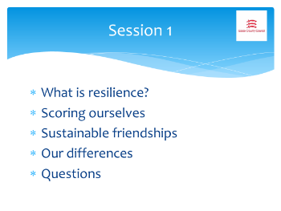 | This programme was put together with staff and students from the Multi-Schools Council, Essex. This is a group of children and young people (CYP) from a variety of schools who come together regularly to have a voice in education.  Today we’re going to be looking at the following:  - What resilience is and how it can help us.  - How to score ourselves to find out how resilient we are already (at the end of the 6th session we’ll do this again to see if we’ve become more resilient).  - We’ll explore friendships both in and outside of school.  - We’ll look at differences between people in terms of individual needs.  - Finally, there’s a chance at the end to ask any questions that you have.
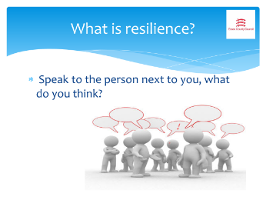 | Firstly, what is resilience?  Spend five minutes with a partner (or in a small group) to see what you can come up with. Once you’ve finished, each group will get chance to feedback and we’re going to see if there’s any similarity in the answers. If there is, then we’ll put together our own definition of resilience.  After the five minutes talk, create a group definition of resilience and keep this on display throughout the six sessions.
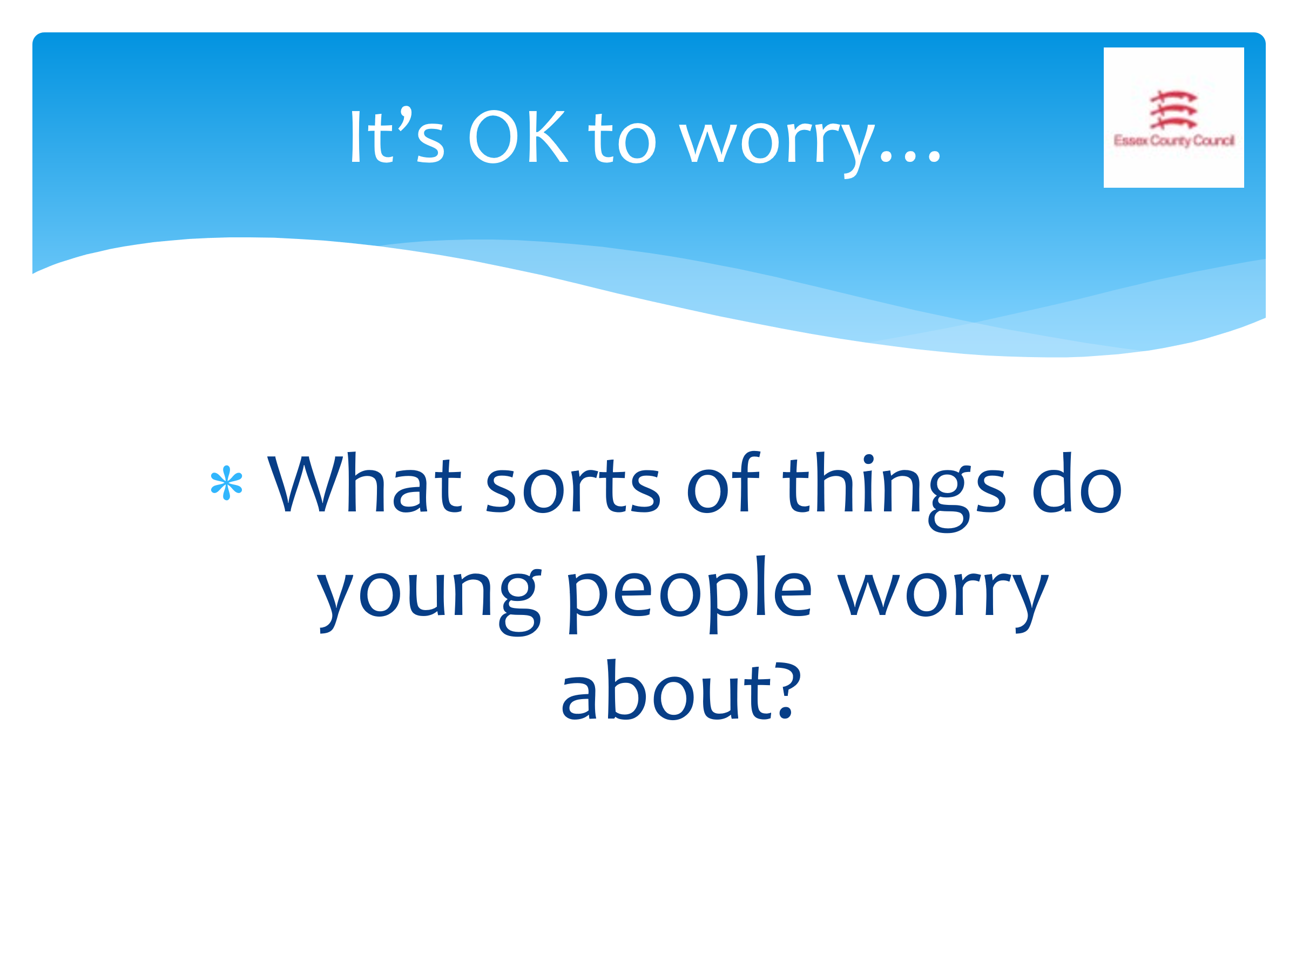 | This can be a pair/group exercise with feedback, or CYP could respond individually with adult collating the answers. CYP could also be given post-it notes to write words on and add to spare wall or board to be feedback by adult. Decide on the best course of action for the group.  So now we’re going to look at worries, and the kind of things we can all worry about. The first thing to make clear is that it is OK to worry. It’s perfectly natural to worry about things: interviews, exams, driving tests, when someone is ill etc.  I’ve named a few common worries here, but what do CYP in particular worry about? You don’t have to share your own worries if you don’t want to, but you can suggest things that you know CYP worry about.  If they’re struggling, there are ideas on the next slide that you can discuss with them to see which are more relevant, and if there are any others they think should be in there.
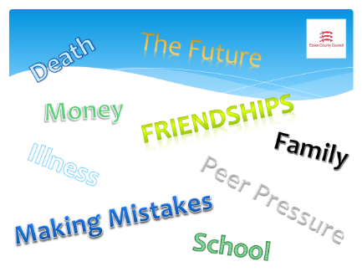 | You’ve all come up with lots of great ideas. Let’s see how many of our ideas are on here.  - Did you have these?  - Are there any we’ve come up with that aren’t on the list?  - Are there certain worries that come up at certain times? (Exams from January, money worries at Xmas, the pandemic which was a huge worry in 2020 but less so now).  Of all the worries we have listed, add up in your head (you don’t need to share this!) how many of those you feel personally. You’ll probably find that we all carry worries with us.
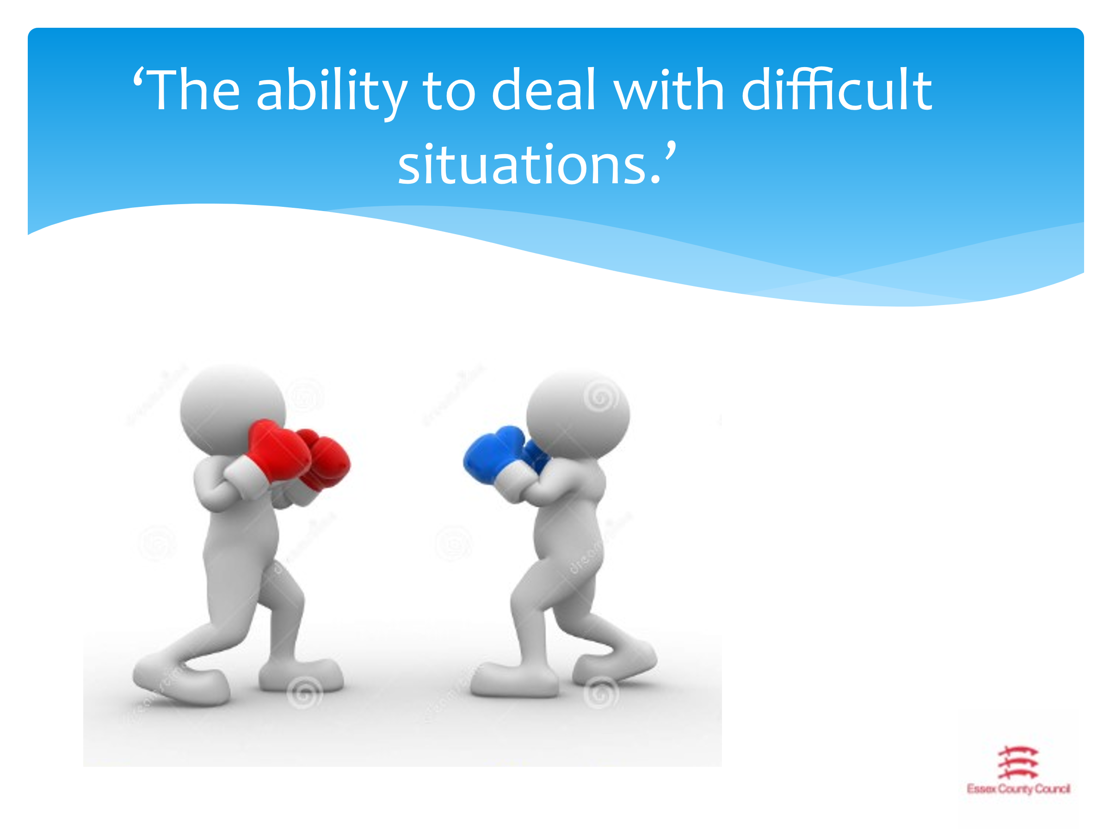 | This quote is one definition of resilience. Life doesn’t always go well, and there WILL be difficult situations which occur throughout our lives.  As an example, let’s think about what we can learn from boxing and boxers.  This slide can be made active by asking them to get into boxing stances.  Boxers have the ability and resilience to get knocked down and get back up again. They have to eat well, sleep well and train hard in order to achieve their goals. The key here is that resilience relies on other areas of wellbeing, and not just the issue at hand.  Getting knocked down and getting back up, training harder to come back stronger, is all about resilience.
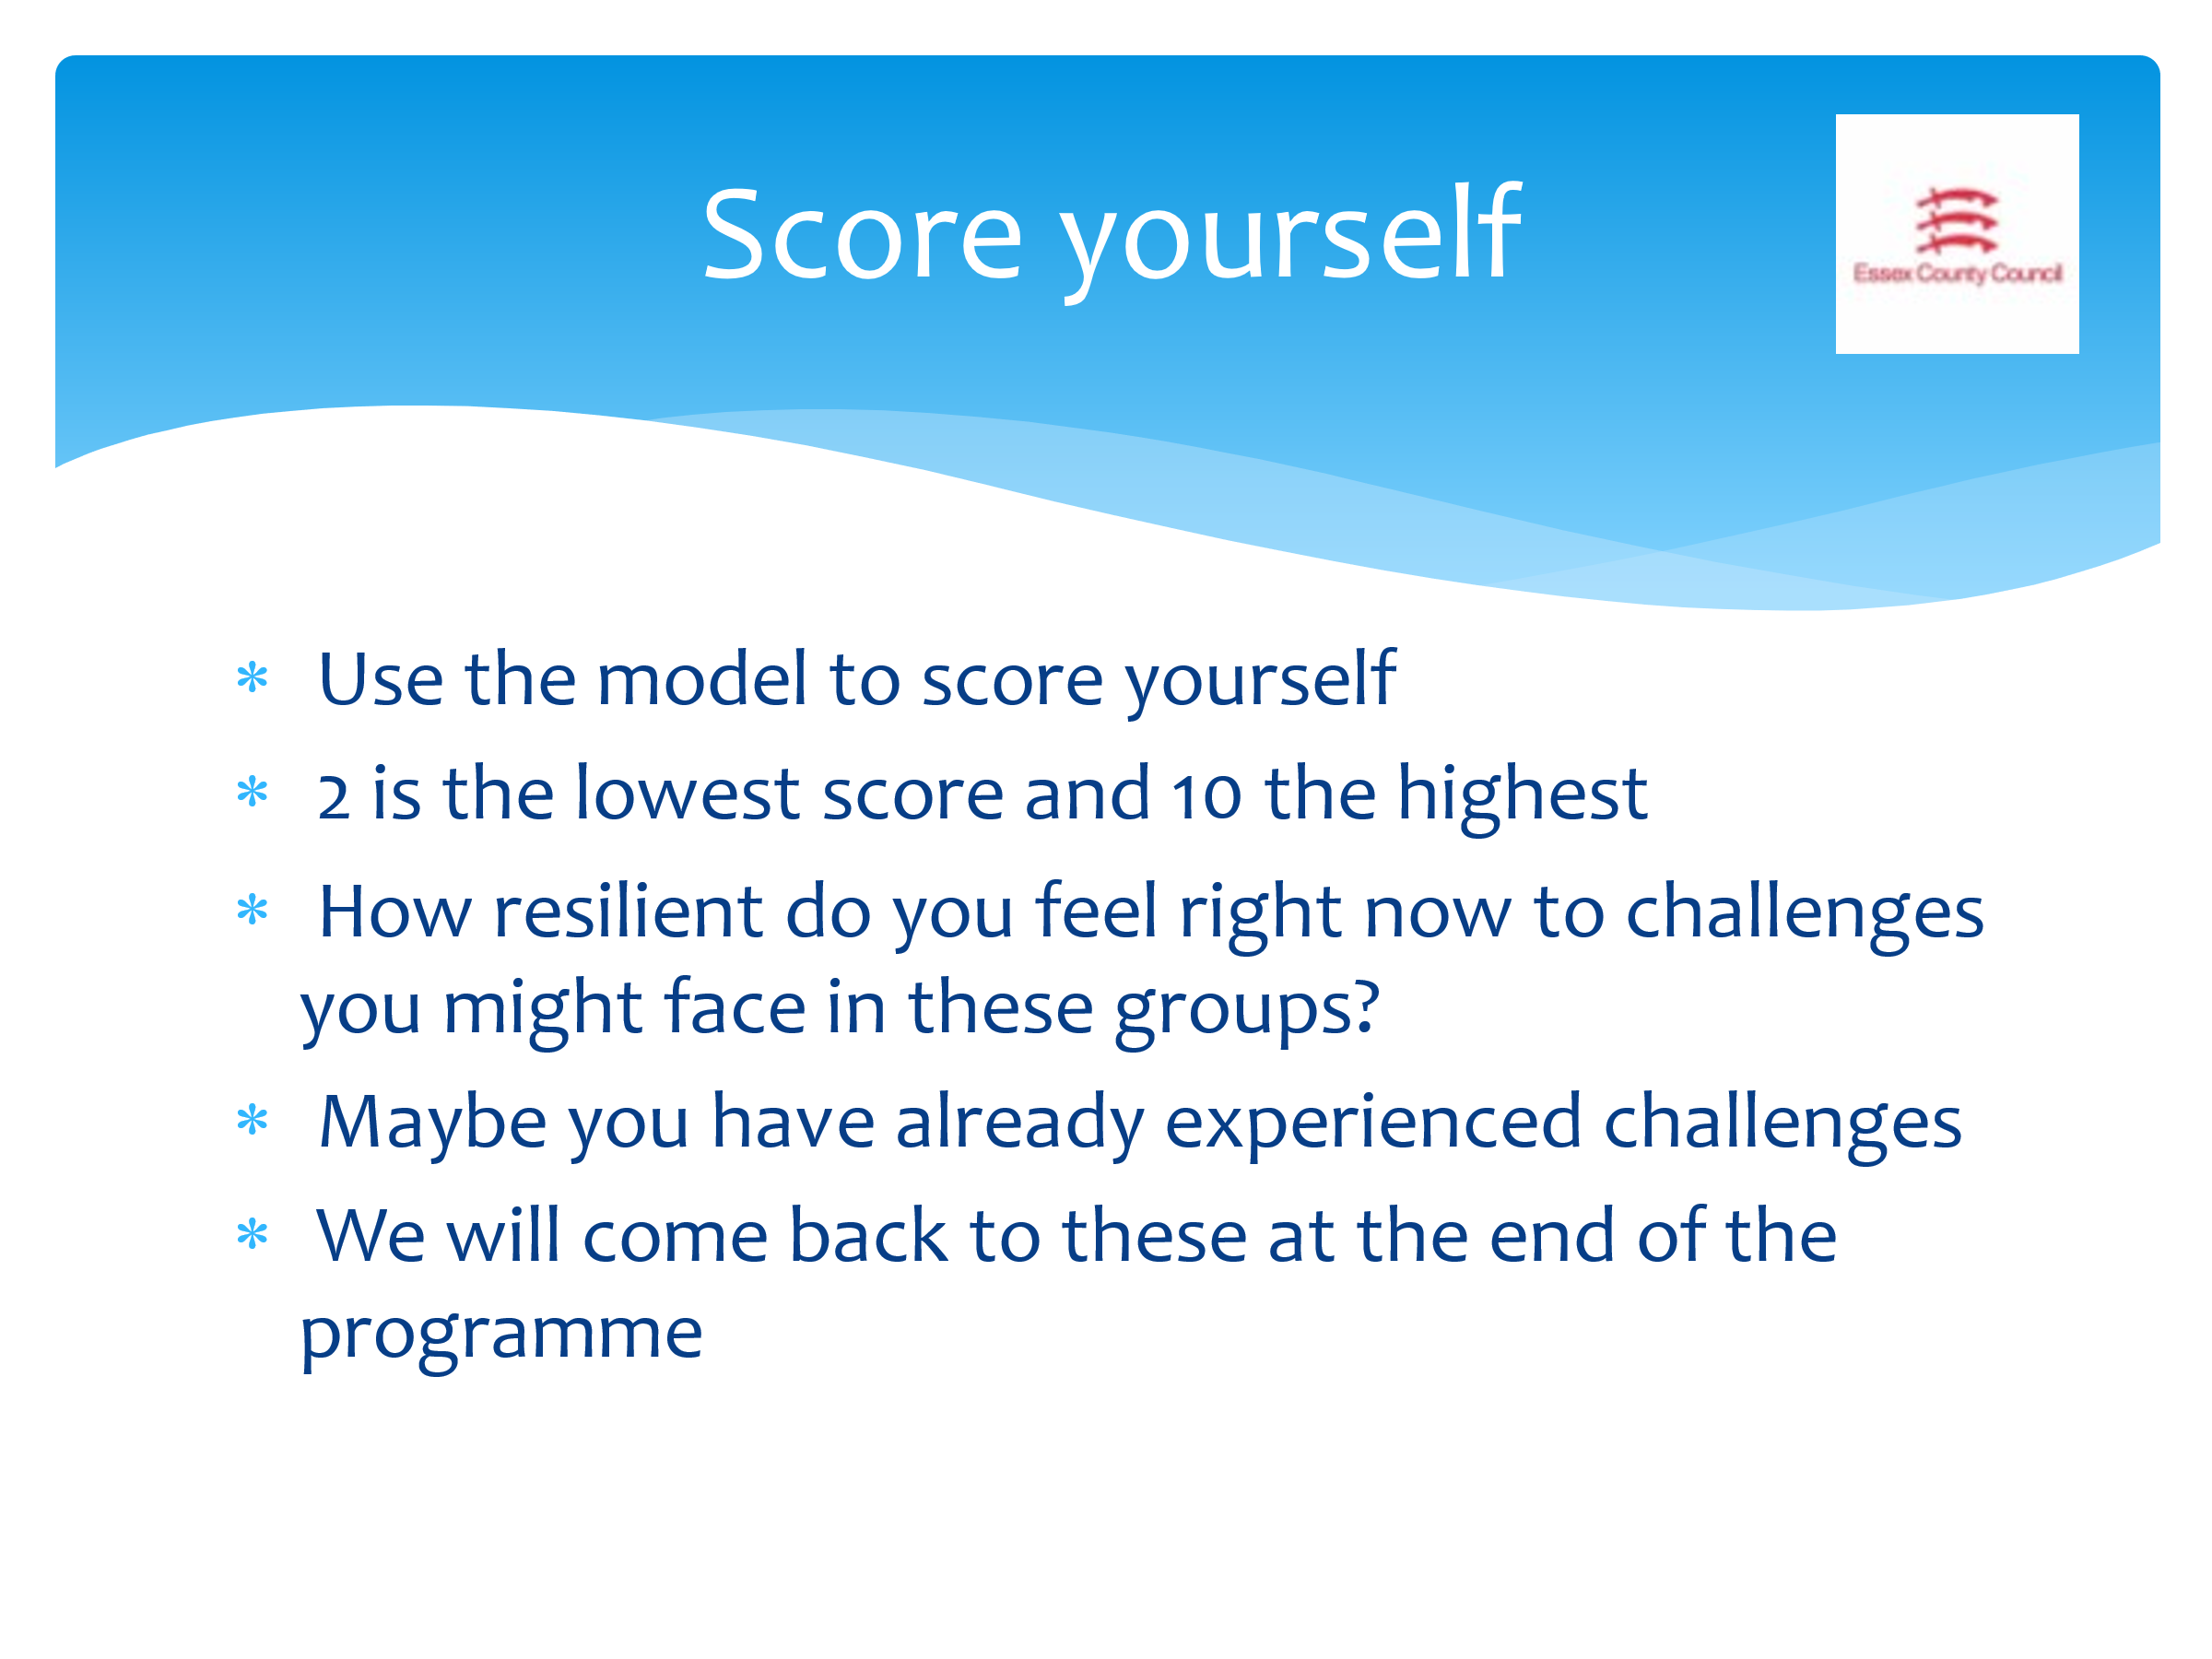 | Handout score sheets – one per CYP.  Now we’re going to look at how resilient we are. We’ll repeat this same score sheet at the end of session 6 to see if we’ve managed to increase our resilience.  This form was designed and created by CYP in order to monitor how they improved their own resilience over time. You’ll need to use the scoring chart to score yourselves – be as honest as you can. You need to score yourself in every area of the chart.  - 2 is the lowest score and 10 the highest  - Think about how resilient you feel right now. You can think about the challenges you’ll face in these sessions.  - It might be that you have already face, and even overcome a number of challenges.  Ensure these are kept safely in order to compare with the score sheet at the end of session six.
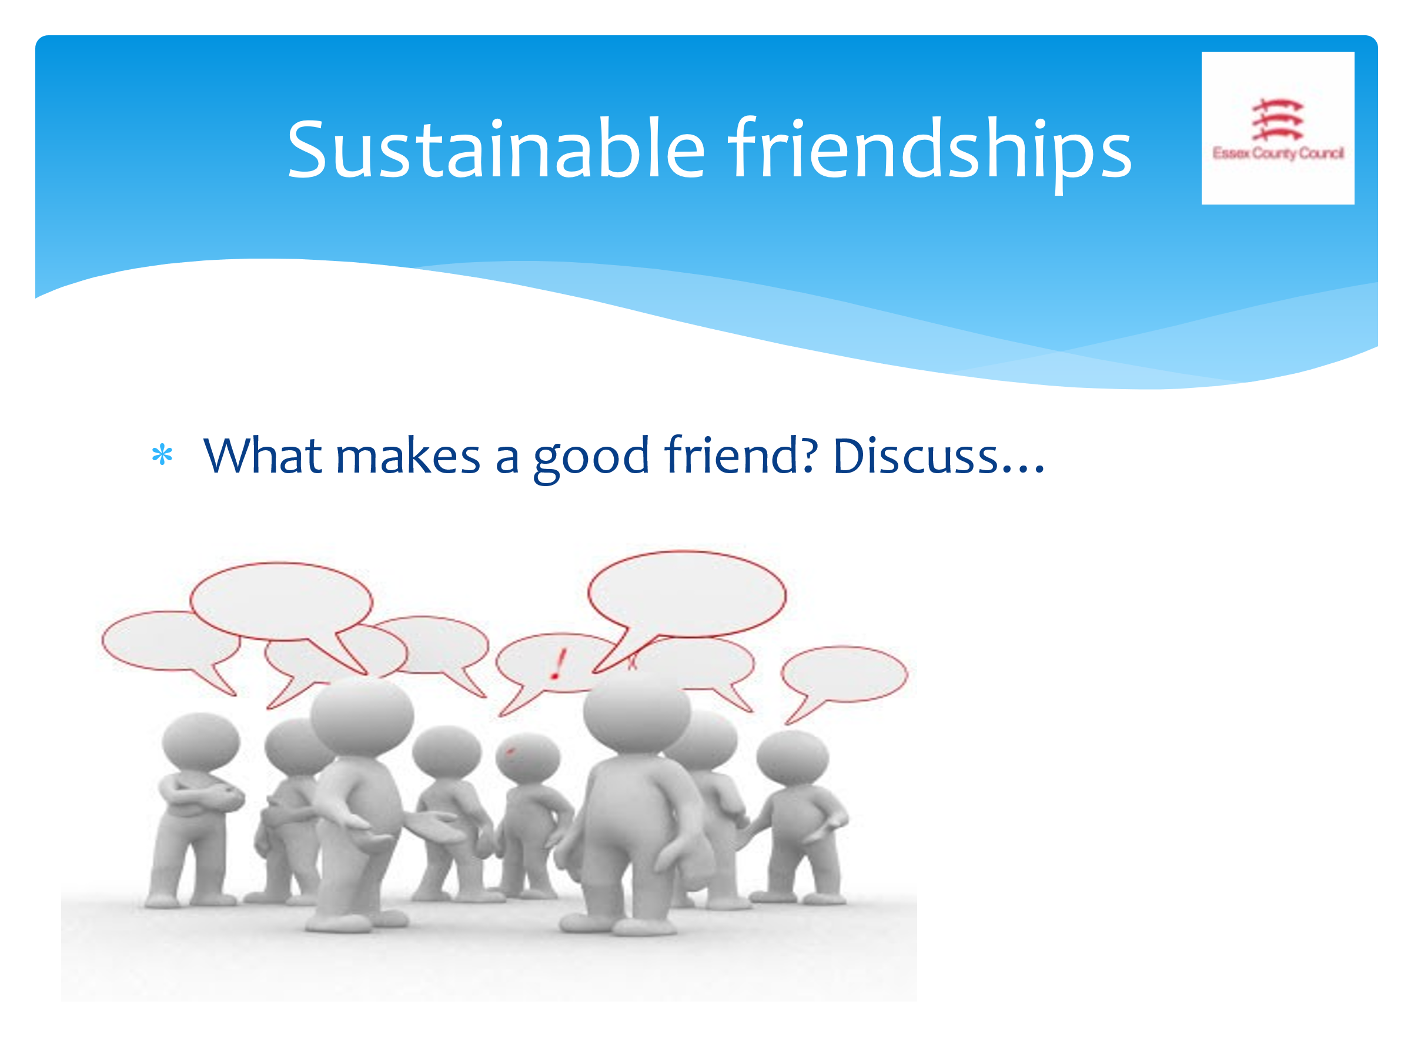 | This next section focuses on friendships. Work in pairs or small groups to discuss what makes a good friend? Make a list of all the things you think are important in your friendships and we’ll feedback to the group in 5 minutes.  From the feedback draw out key themes and ideas. There is no need to write these down.
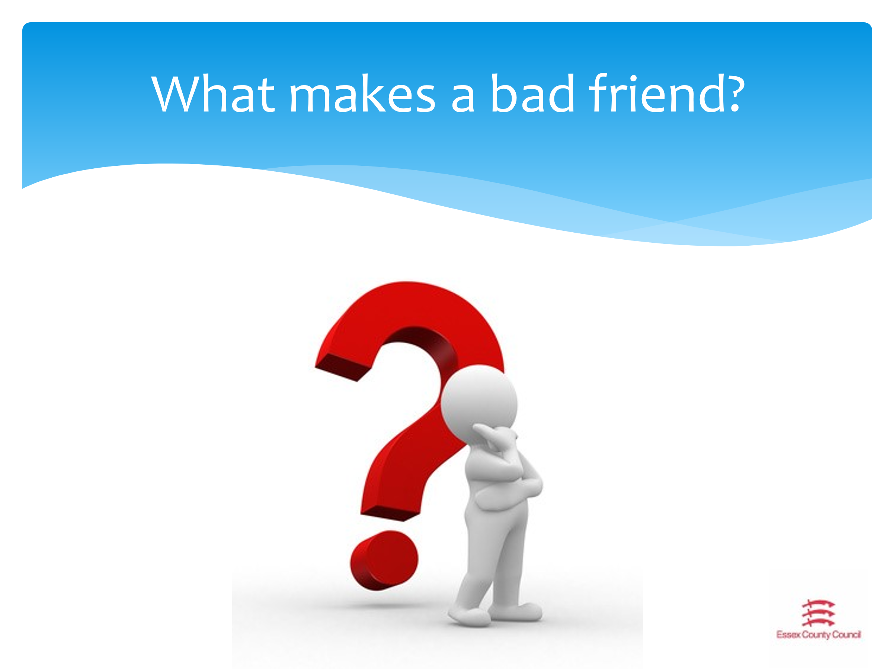 | Now we’re going to consider what makes a BAD friend. You may find this easier than the last exercise as it’s often quicker to list the things you don’t like than the things you so! Same again, discuss in your pairs/groups and we’ll feedback in 5 minutes.  From the feedback draw out key themes and ideas. There is no need to write these down.  What’s important to note here is that we can’t always see what is going on inside a person, or what the state of their mental health is. People may be expressing themselves poorly due to how they’re feeling inside, so it’s important to bear this in mind.  It’s easy to be friends with someone when everything is going well, but it’s harder to be there when things are difficult. Having a good team of people around us contributes to our resilience.
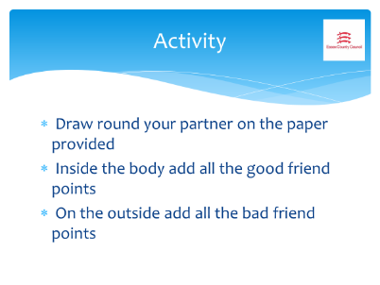 | Pairs or small groups. You will need either the sheets with a body shape drawn on, or a large piece of paper and markers so pupils can draw around their own shape. If necessary, they can have a plain piece of paper and draw around their own hand.  In your pair or small group, you will have/need to create a body or hand shape. We will be writing things inside and outside of the drawing, so leave space!  On the INSIDE of the hand/body you need to write all the things that YOUR GROUP think makes a GOOD friend, and on the outside of the shape, all the things you think makes a BAD friend.  Remember, these are YOUR views, not the views of the entire group. Some things that are important to one, may not be important to the other.  Pin the sheets to the wall/place on desks  Now you need to walk round the room look at each other’s ideas. Are there common agreement in certain areas? Are there certain things that we ALL agreed are bad/good?
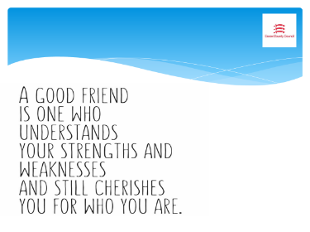 | This is one definition of what a good friend is. Do we agree? What would we add from our discussion from the last activity?
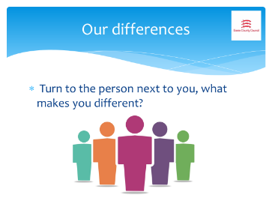 | We’ve had a really good look at friendships, and now we’re going to look at the differences between people. Now you need to turn to the person next to you and discuss what is different about each other. This can be physical, but also include character traits, personality, likes and dislikes etc.  You’ll have three minutes to discuss then feedback to the group one difference you found in your pair.
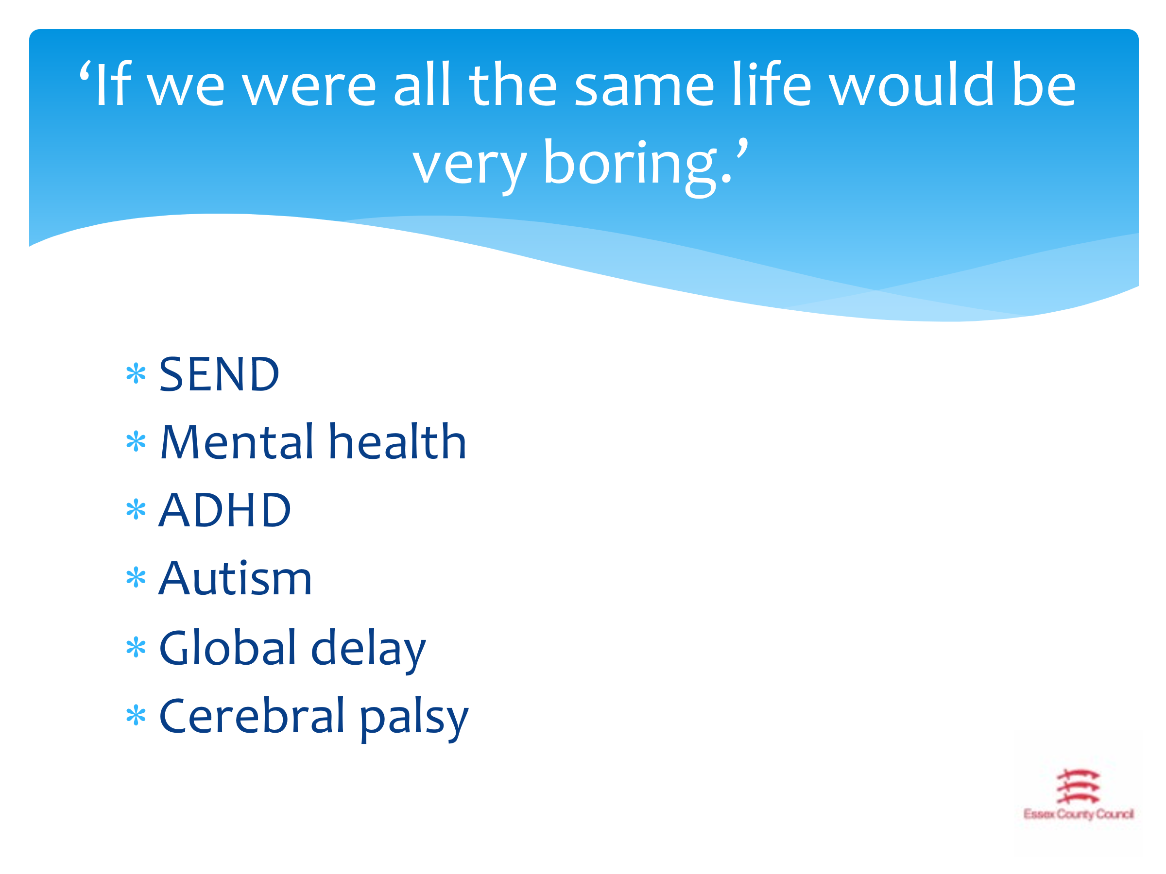 | Lots of things make us different. We can have different hair colour, height, interests, personalities etc and there are some differences that which can play a part in our daily life and our resilience. We have to remember that many of our differences are internal, and many can’t be changed.  All of these on the slide (and many more) can have a real impact on our daily life, learning and resilience. It’s true to say that if we were all the same, life WOULD be very boring, so please always remember to respect and embrace each other’s differences!
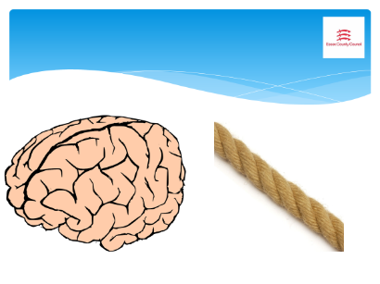 | It is helpful to have watched this video BEFORE delivering this session: Autism - the brain and the rope (teacher guide)  Now I’m going to use these two items - a plastic brain and skipping rope to show that all brains work in different ways! Everyone has a talent, even if you don’t know what it is yet. But one thing we know is that we can’t ALL be good at EVERYTHING because our brains are different. Resilience is about understanding that.  Think about a rope lying on the floor (use an actual rope if you have one). On the left of the rope there are brains that work without using words to communicate. They are resilient because can communicate in other ways (signs/photos/drawings etc).  On right of the line there are verbal communicators. They might use ear defenders at times so they can concentrate, or perhaps they need to work on their own or in very small groups.  None of this means anyone is better or worse than anyone else, we’re just different, and if we’re resilient we can come to terms to that and find out our own talents.
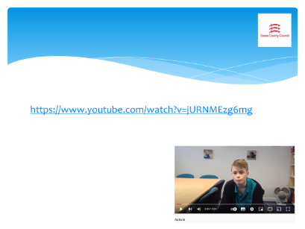 | Listen to this short video of one of the Multi-Schools Council members talk so positively about autism.  On this channel there are further videos made by CYP about their differences such as mental health, ADHD etc). Tailor this to your group.
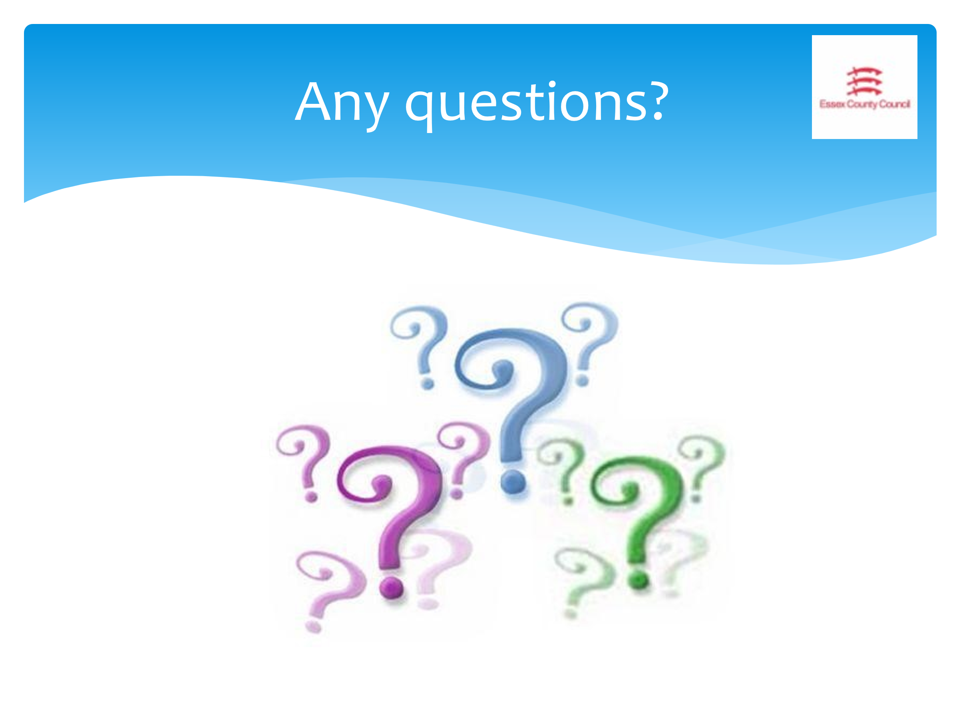 | Are there any questions that have arisen today as a result of this session? Anything you’d like to know more about or discuss in more detail?

Session Two – What worries you?

The aim of this session is to look more in depth at the worries CYP have, how to look at them in terms of those they have control over and those they don’t, and how to be a good listener.

You will need:
- Dry-wipe board/flip chart for collating CYP views
- Post-it notes
- Large paper (A3/flip chart)
- Highlighters/bright markers

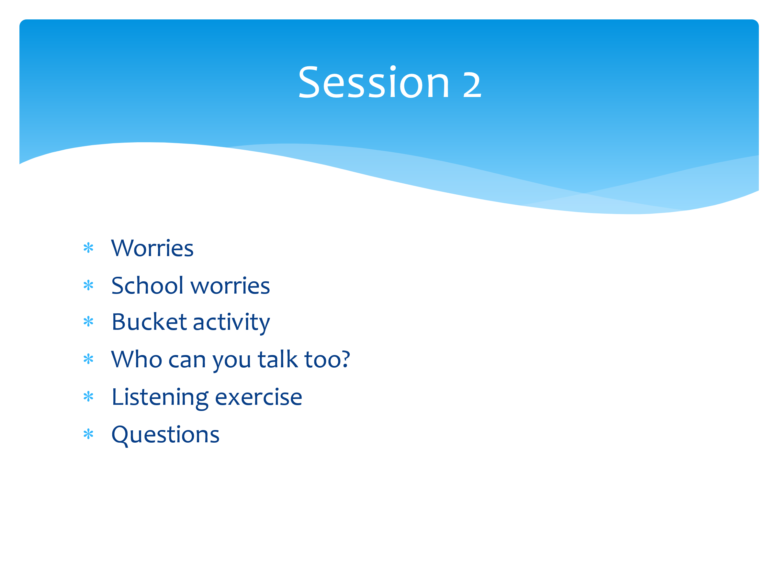 | Last week we introduced the concept of resilience, looked at definitions (ensure the group definition is displayed somewhere in the room) and started to look at the role of our worries and also our friendships in terms of resilience.  In today’s session we’re going to move that forward and try to find ways to increase our resilience by identifying our worries and finding solutions.  Last session we discussed some of the worries we have relating to school, home, ourselves and our lives. Today we’ll look specifically at worries relating to school and school life as these are often things we will all have in common or can relate to.  We’re then going to look at these worries and differentiate between those that we can control, and those that we can’t (bucket activity).  We’ll move on then to identifying people that we can talk to, or who can help us, and end up by learning the power of active listening.
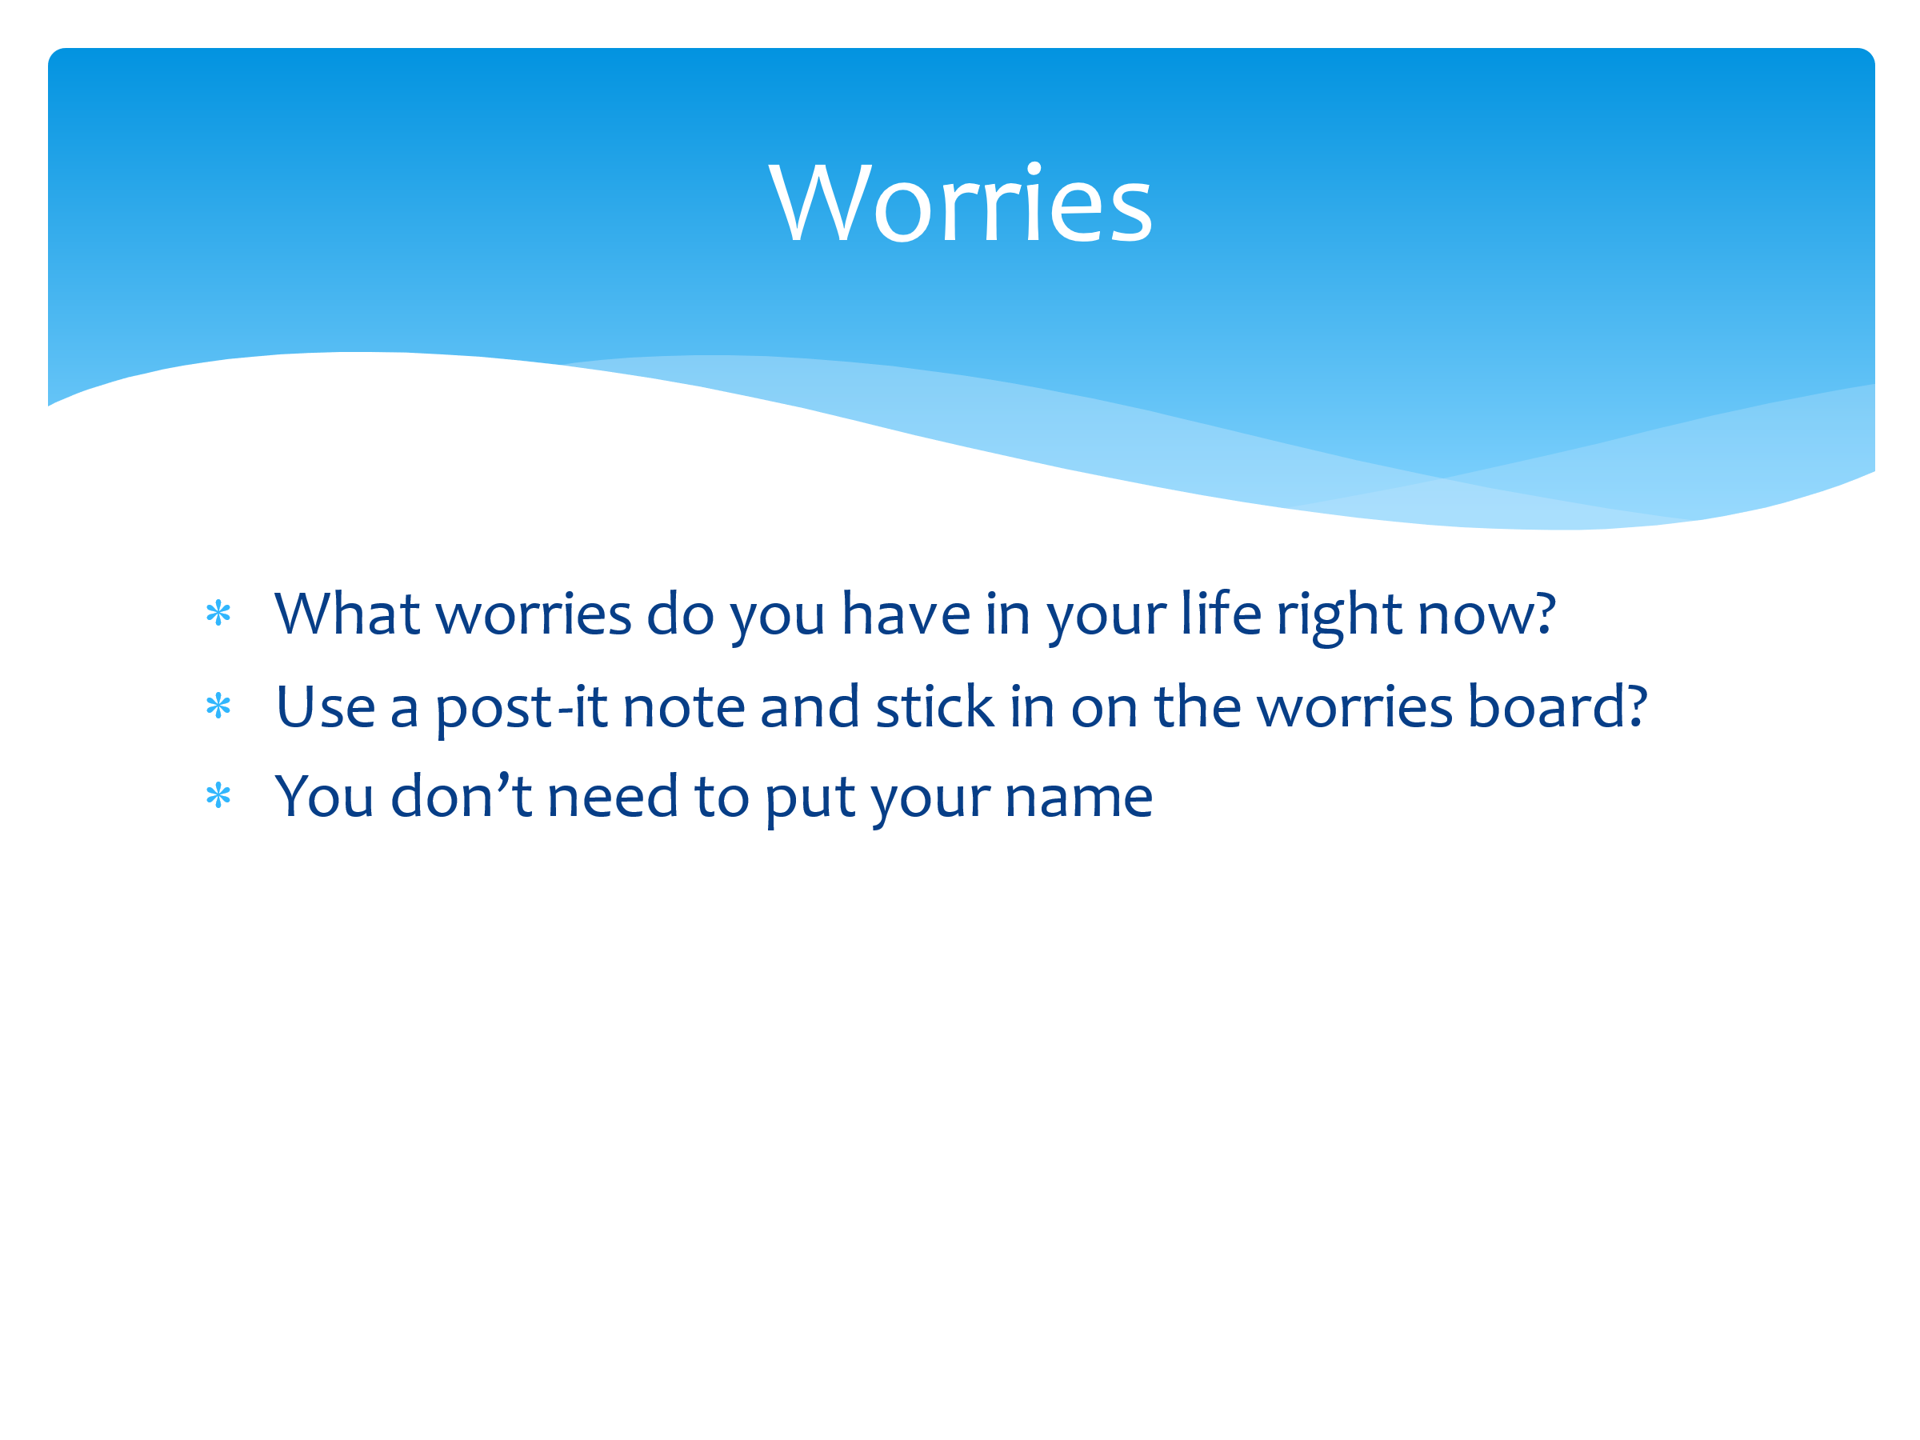 | Give each pair/table post-it notes.  On your post-it notes I want you to write down (one per post-it) any worries that you, or someone you know, has about your/their life right now NOT related to school. There are big ones (money/death/illness) and smaller ones. If you don’t feel comfortable sharing your own worries, then think about CYP in general and the worries they may be having right now about. Once you’ve done that, stick them to the wall/board.  Adults can role-model by sharing some of their own worries. Adult then reads out and collates into similar themes by moving the post-its.
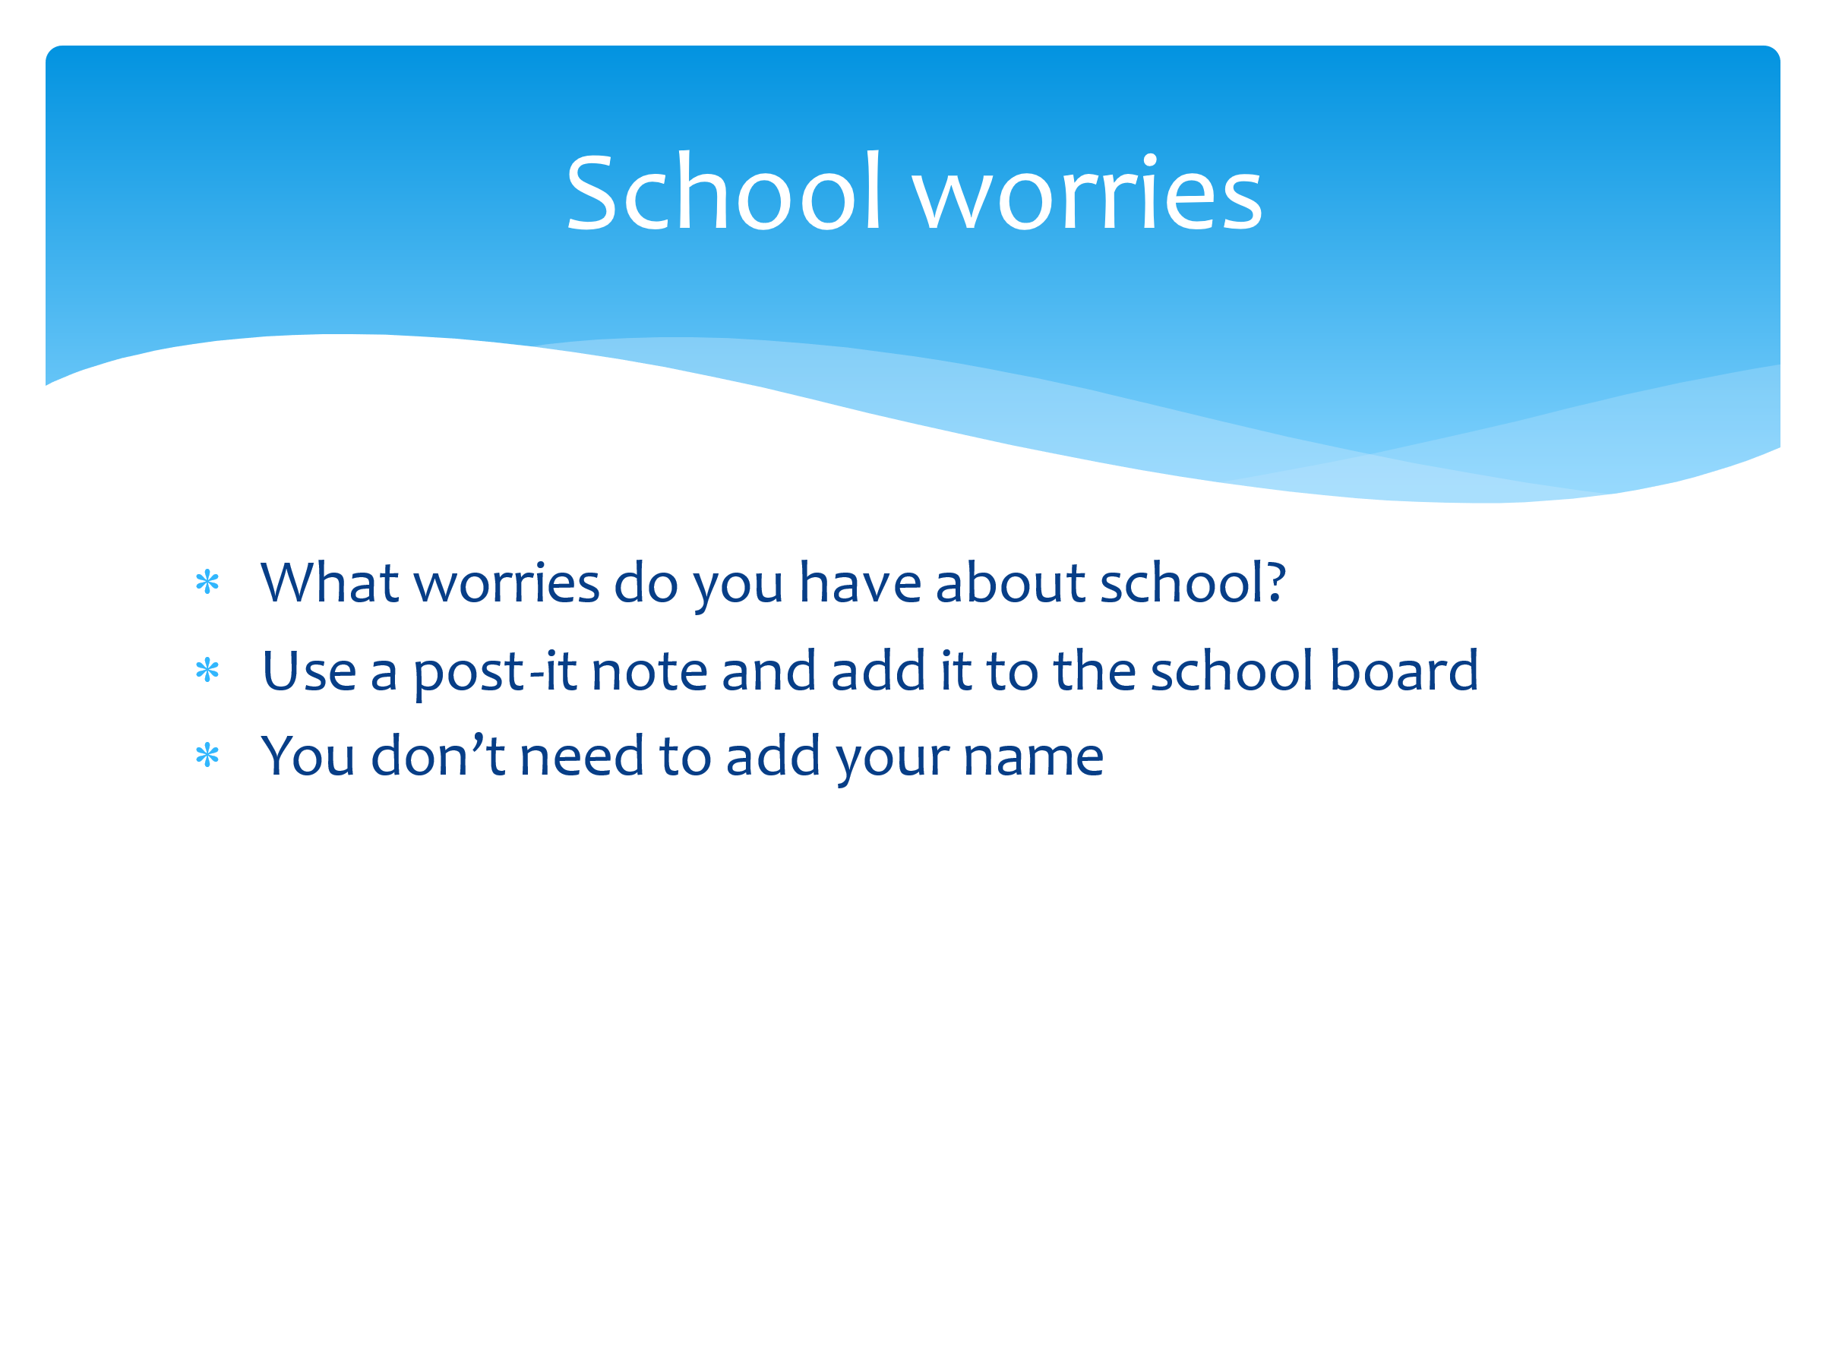 | Now I want you to think about school. What worries do you have specifically related to school and education? These can include things like your friendships in school, groups, specific subjects etc.  Again, pop them on the board and we’ll see where the common themes lie.  Adult then reads out and collates into similar themes by moving the post-its. Draw out any crossovers such as friendship worries can relate to in school and out of school.
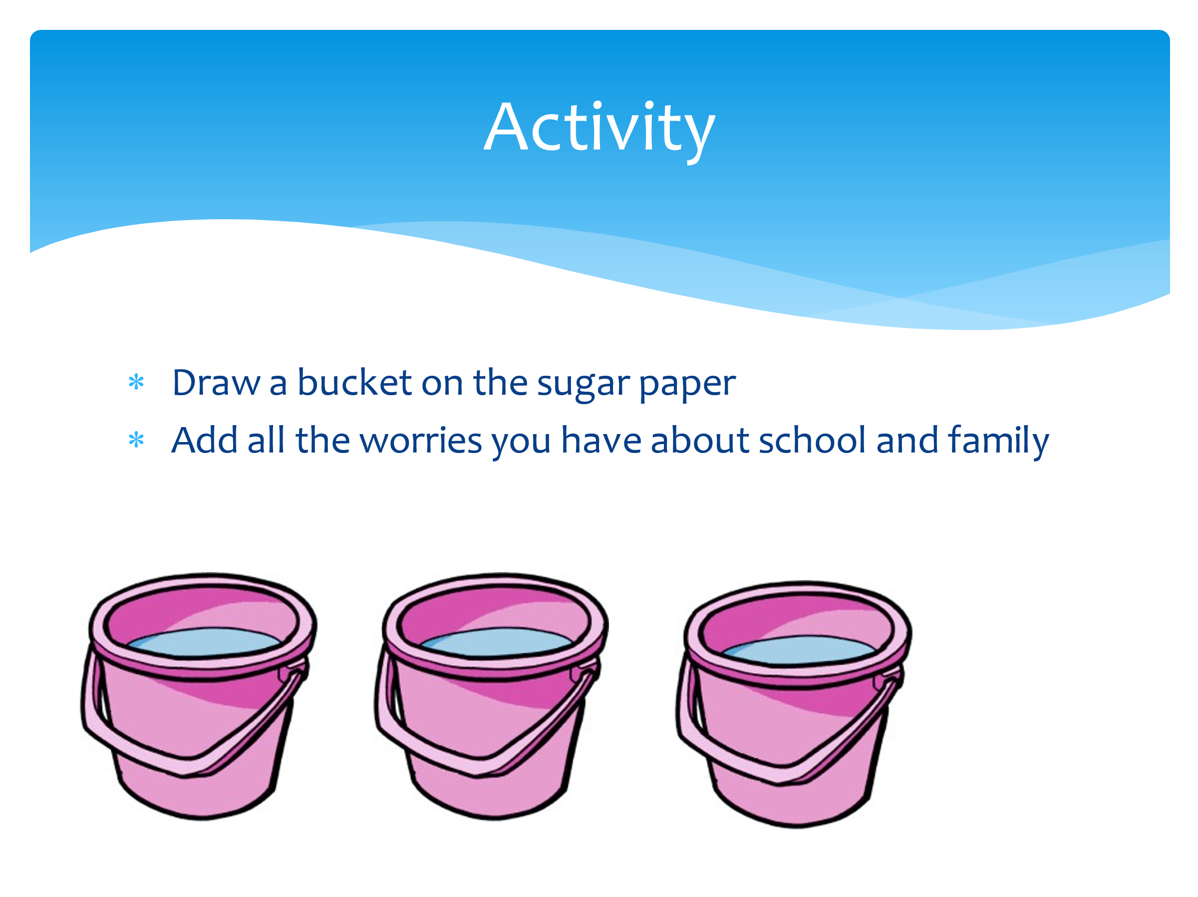 | Hand out the large paper and highlighters/bright markers.  On your large piece of paper, I’d like you to draw a bucket. It doesn’t have to be realistic – just a bucket! You’ll need to write things inside the bucket so make it large.  Now, inside your bucket, I want you to write all the worries you have about school, family, friendships and anything else we’ve discussed today, or that you feel willing to add.  Once complete, ask the following:  Are there any worries you’ve highlighted that will reduce if you get support/help/do something different?  What worries CAN’T you control? .
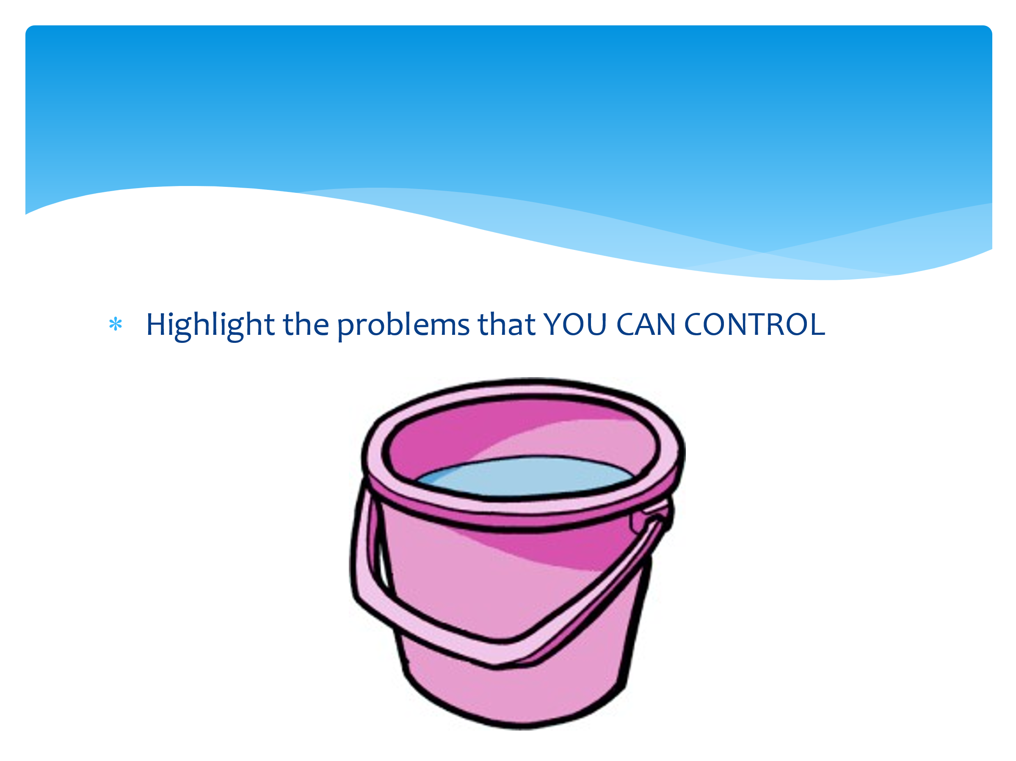 | In life there are many things we can control, and many things we can’t. For example, we can’t control the weather, but we can control what we wear in it. In order to sleep better, we can’t control our baby brother crying in the room next door, but we can control what time we go to bed, night-time use of the phone etc. When worries are out of our hands (we have no control), we need to find outlets (or regulation strategies) to cope with these worries so they don’t overwhelm us.  Now I want to you look at all the items in your bucket and highlight the problems that you CAN control.  Ask for feedback from students and share ideas. Ask others to help find ways to ease some of the issues. For example if a worry is exams, then although we can’t control exams, we can do things like revise, ask for help from friends/teachers/parents, get a good night’s sleep the night before etc.  Our brains are like buckets – if our worries build up, they overflow. Brains aren’t the same so it can come out in different ways such as sadness/anger etc. Small worries can be the last straw and cause the ‘blow up’, but it’s actually about accumulation of all the other things.
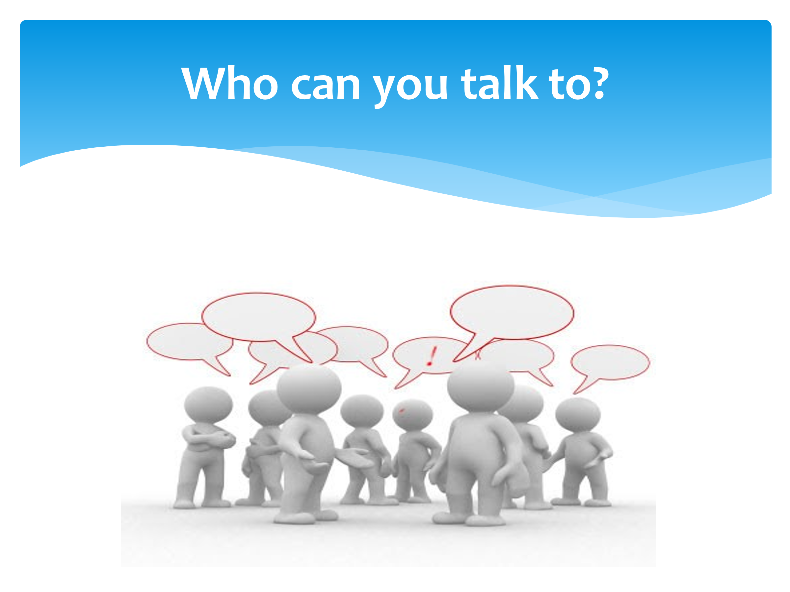 | Talking is really important – so you need to think: who can I talk to?  Now I’d like you to draw three concentric circles (three circles once inside the other – you may need to demonstrate this on the board).  In the smallest one write the names of those closest to you. In the middle circle write the names of those you can touch base with, and in the biggest circle those they don’t go to all the time but are there if needed. (You can prompt with ideas such as family, friends, peers, websites, helplines etc)  Now look again at your list of worries – particularly the ones you CAN’T control. Pick one and discuss with a partner who you could approach to help you lessen that worry? Remember this doesn’t have to be a professional such as a teacher or mentor; it could be with your friends, peers or the person who is causing you that worry.  Listen to some ideas from students regarding their worry and how/who they could talk to in order to help.
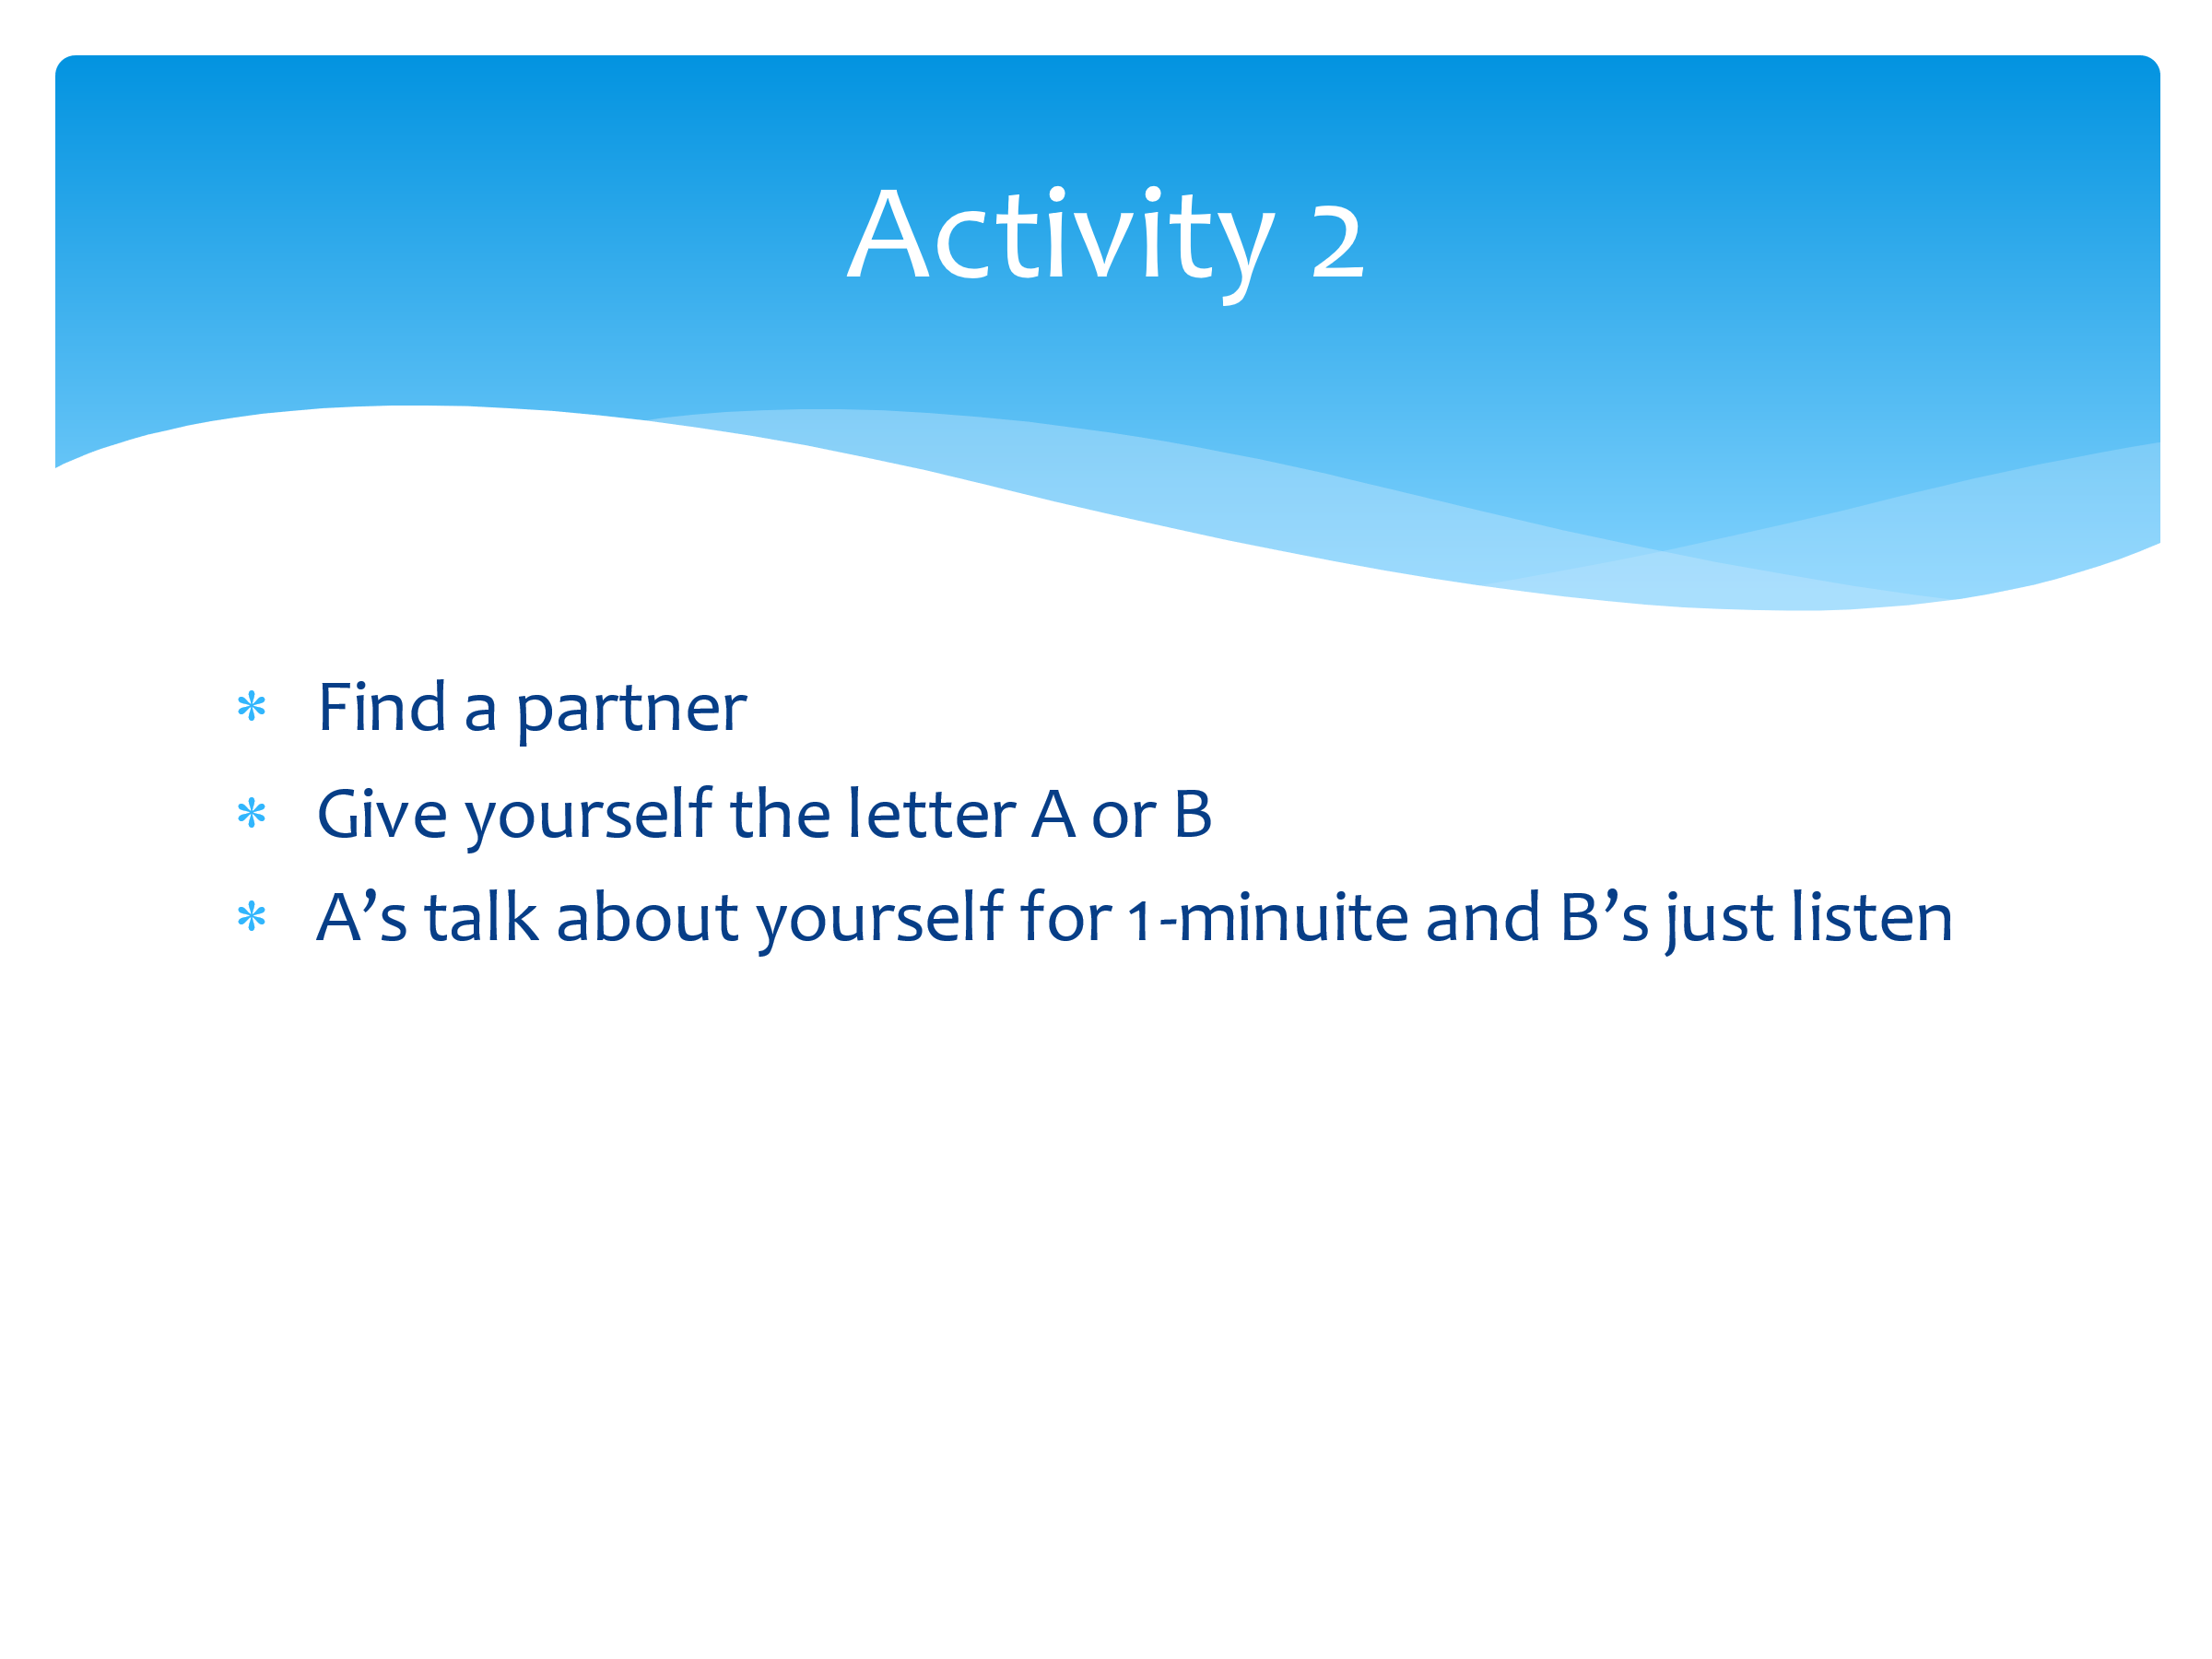 | Now we’re going to look at the importance of active listening. It’s really important to be a good listener as you may well be the person that someone comes to in order to discuss their worries.  So get into pairs and name yourself either A or B. You’ll both get a chance to take the listening and speaking parts.  Now, As you need to talk about yourself (or one of your worries if you wish) for one minute. Bs, all you have to do is just listen.
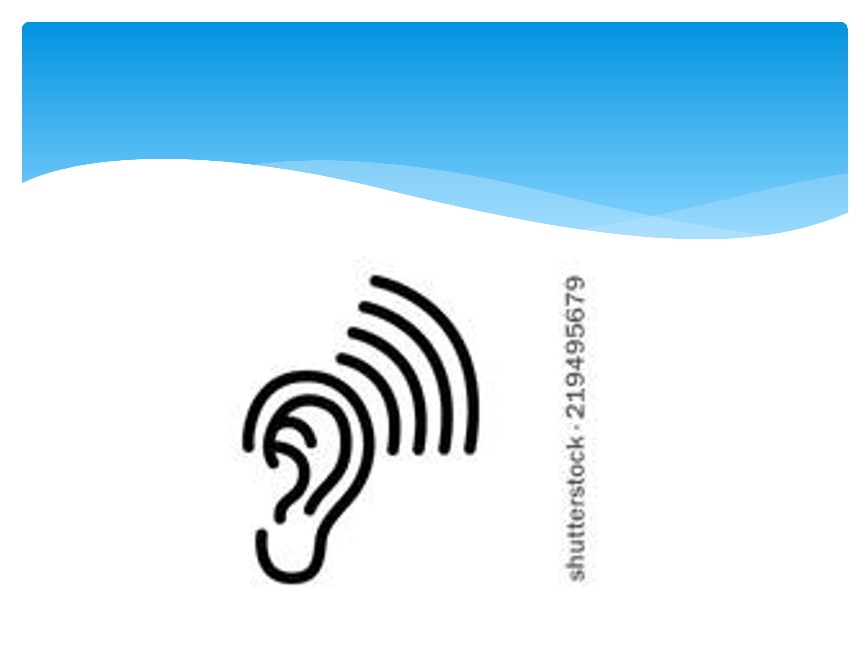 | Time one minute.
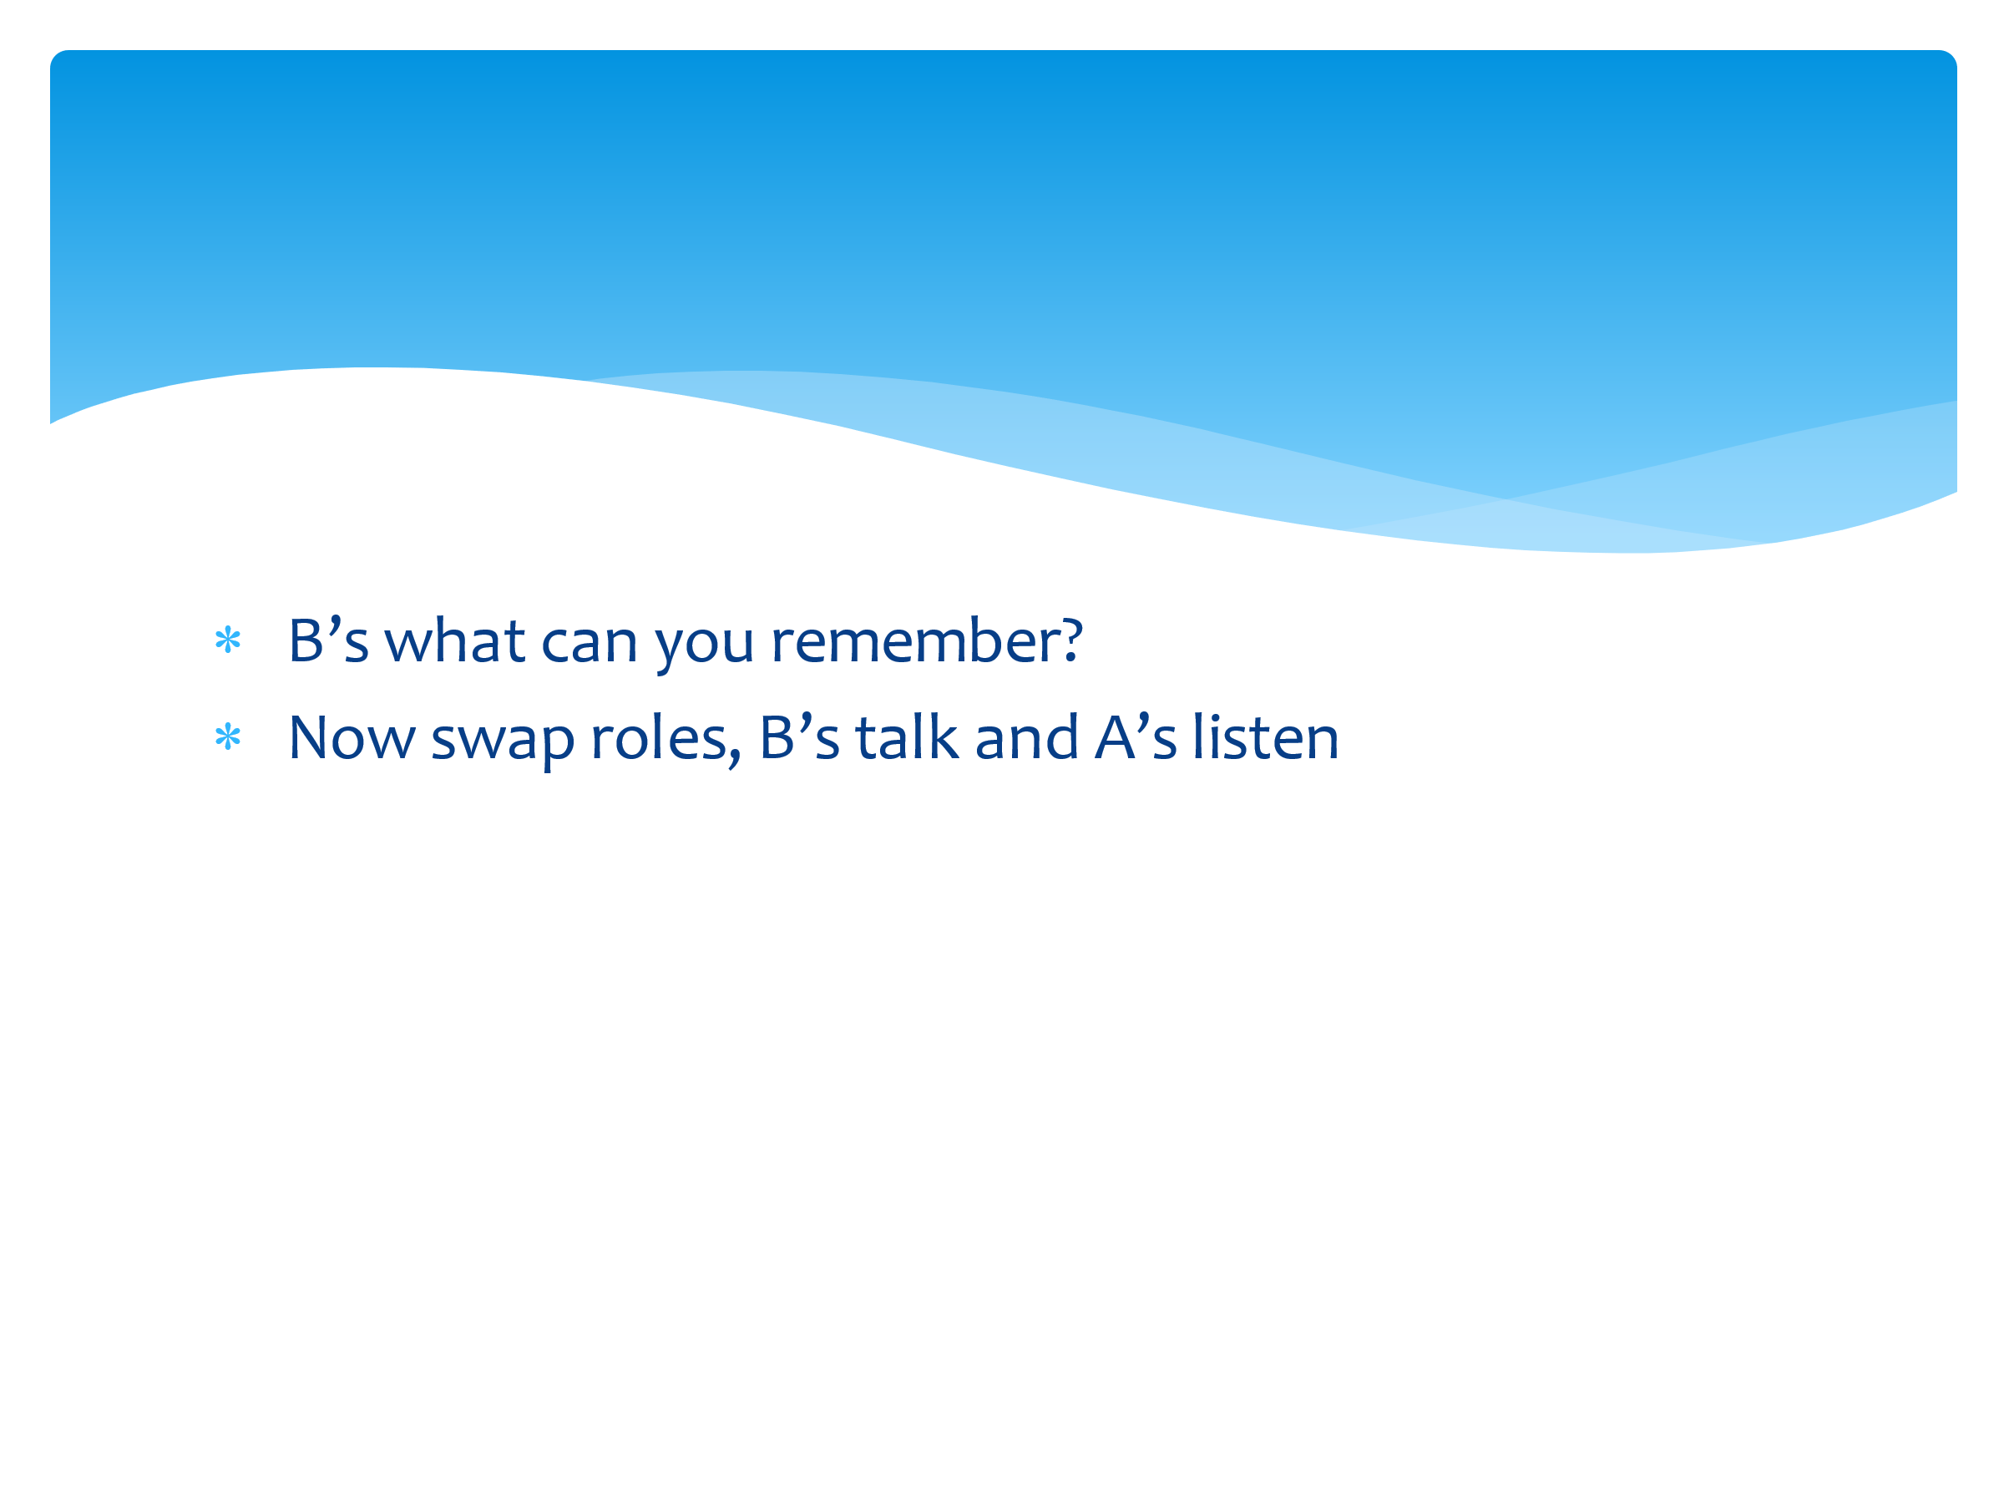 | Bs feedback to As everything that you remember them saying.  - What can you remember?  - Was there anything key that you forgot?  - As, did you feel that you were being listened to?  - How did Bs make you feel like that? (body language, eye contact, nodding….)  Now swap roles with Bs talking and As listening.
 | Time one minute.
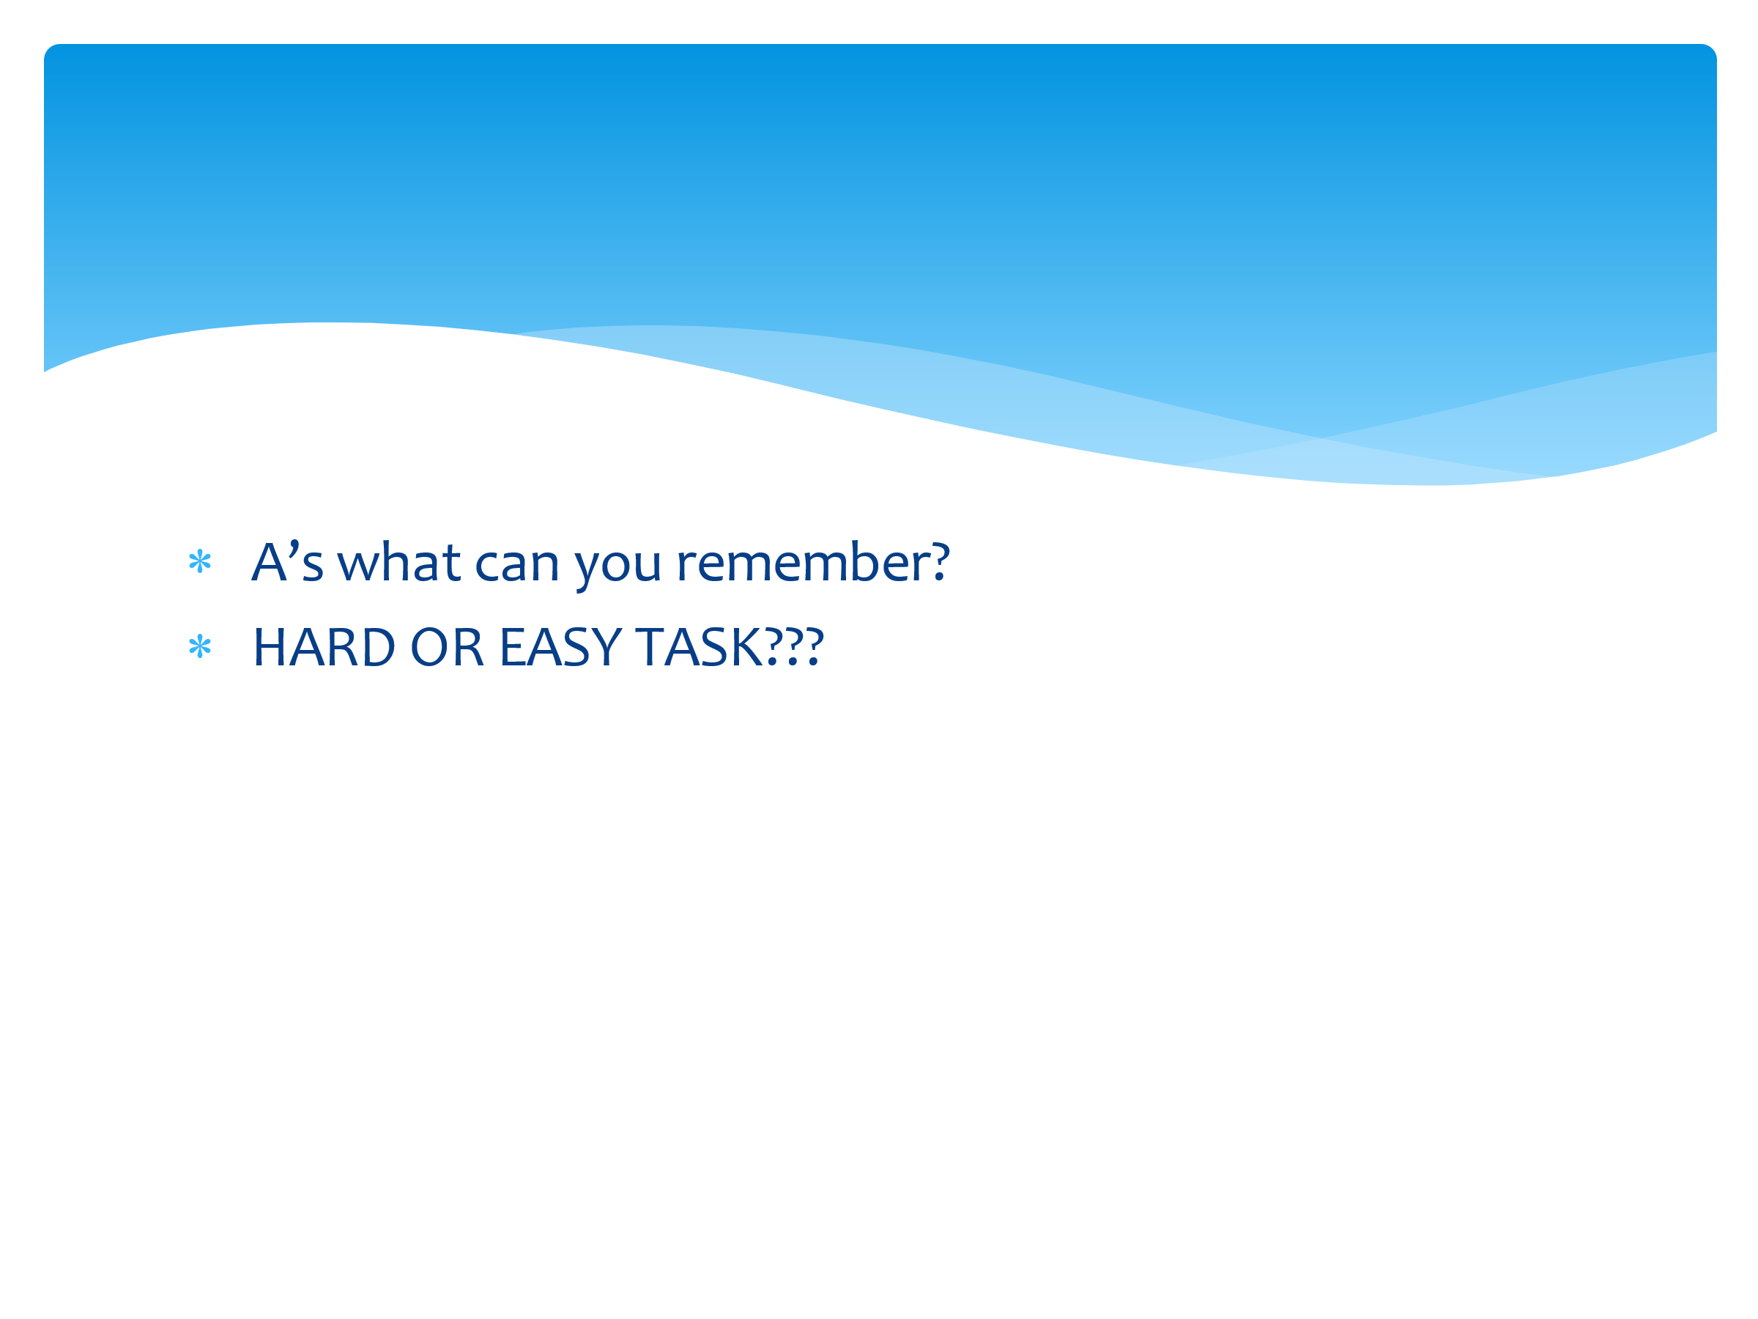 | As feedback to Bs everything that you remember them saying.  - What can you remember?  - Was there anything key that you forgot?  - Bs, did you feel that you were being listened to?  - How did As make you feel like that? (body language, eye contact, nodding….)  Overall, was this an easy or challenging task?
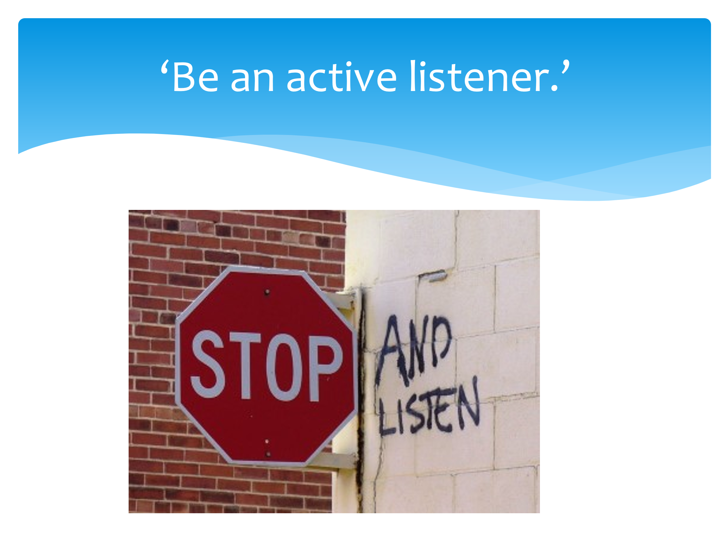 | What makes a good listener? What have we learned?  Collate answers on the board, but these should include things such as:  - No interrupting  - Not immediately trying to solve issues  - Listening to understand and not listening to respond  - Body language (eye contact, nodding, vocalisations etc)  The important point here is that life is busy, but we need to stop and listen actively. – It helps us to slow down and helps our friends. This aids our and their resilience levels.
 | Are there any questions that have arisen today as a result of this session? Anything you’d like to know more about or discuss in more detail?

Session Three – What can you do to increase your resilience?

The aim of this session is to look more at outside factors that can have a positive impact on CYP’s resilience.

You will need:
- Dry-wipe board/flip chart for collating CYP views
- Blind-folds for meditation (optional)
- Meditation script (see Appendix 2)
- Connection to YouTube and space for classroom yoga (yoga mats optional)
- Paper and pens (paper plates are optional)

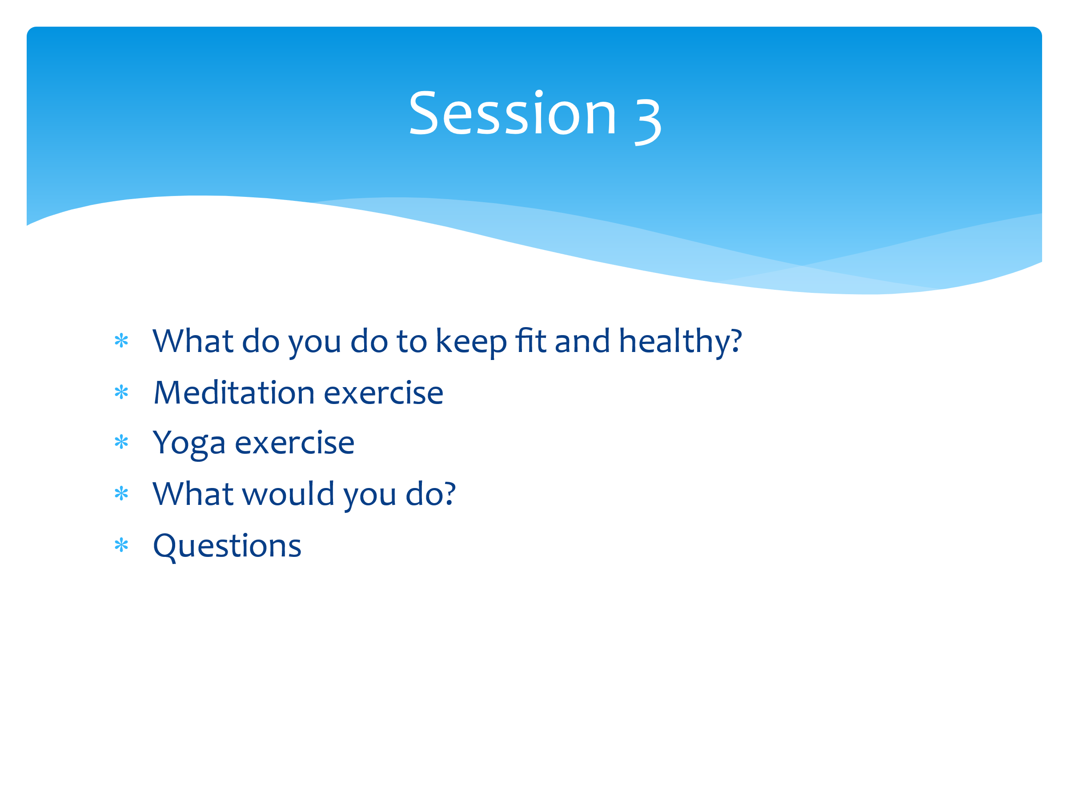 | So far in these sessions we have introduced the concept of resilience, looked at definitions (ensure the group definition is displayed somewhere in the room), looked at our own worries both inside and outside of school and looked at how we can group them into ones we can and can’t control. At the end of last session we looked at the importance of talking, and more importantly, or listening.  In today’s session we’re going to move that forward and look at ways to increase our resilience in our daily lives and routines so that when worries and challenges come our way, we’re in a better place to respond to them.  Today we’ll look at regulation strategies (ways to calm us when we feel stressed or anxious) and have a go at some meditation and yoga. We’ll also share our own regulation strategies to see what works for us as individuals, and perhaps give some ideas to others in the group.
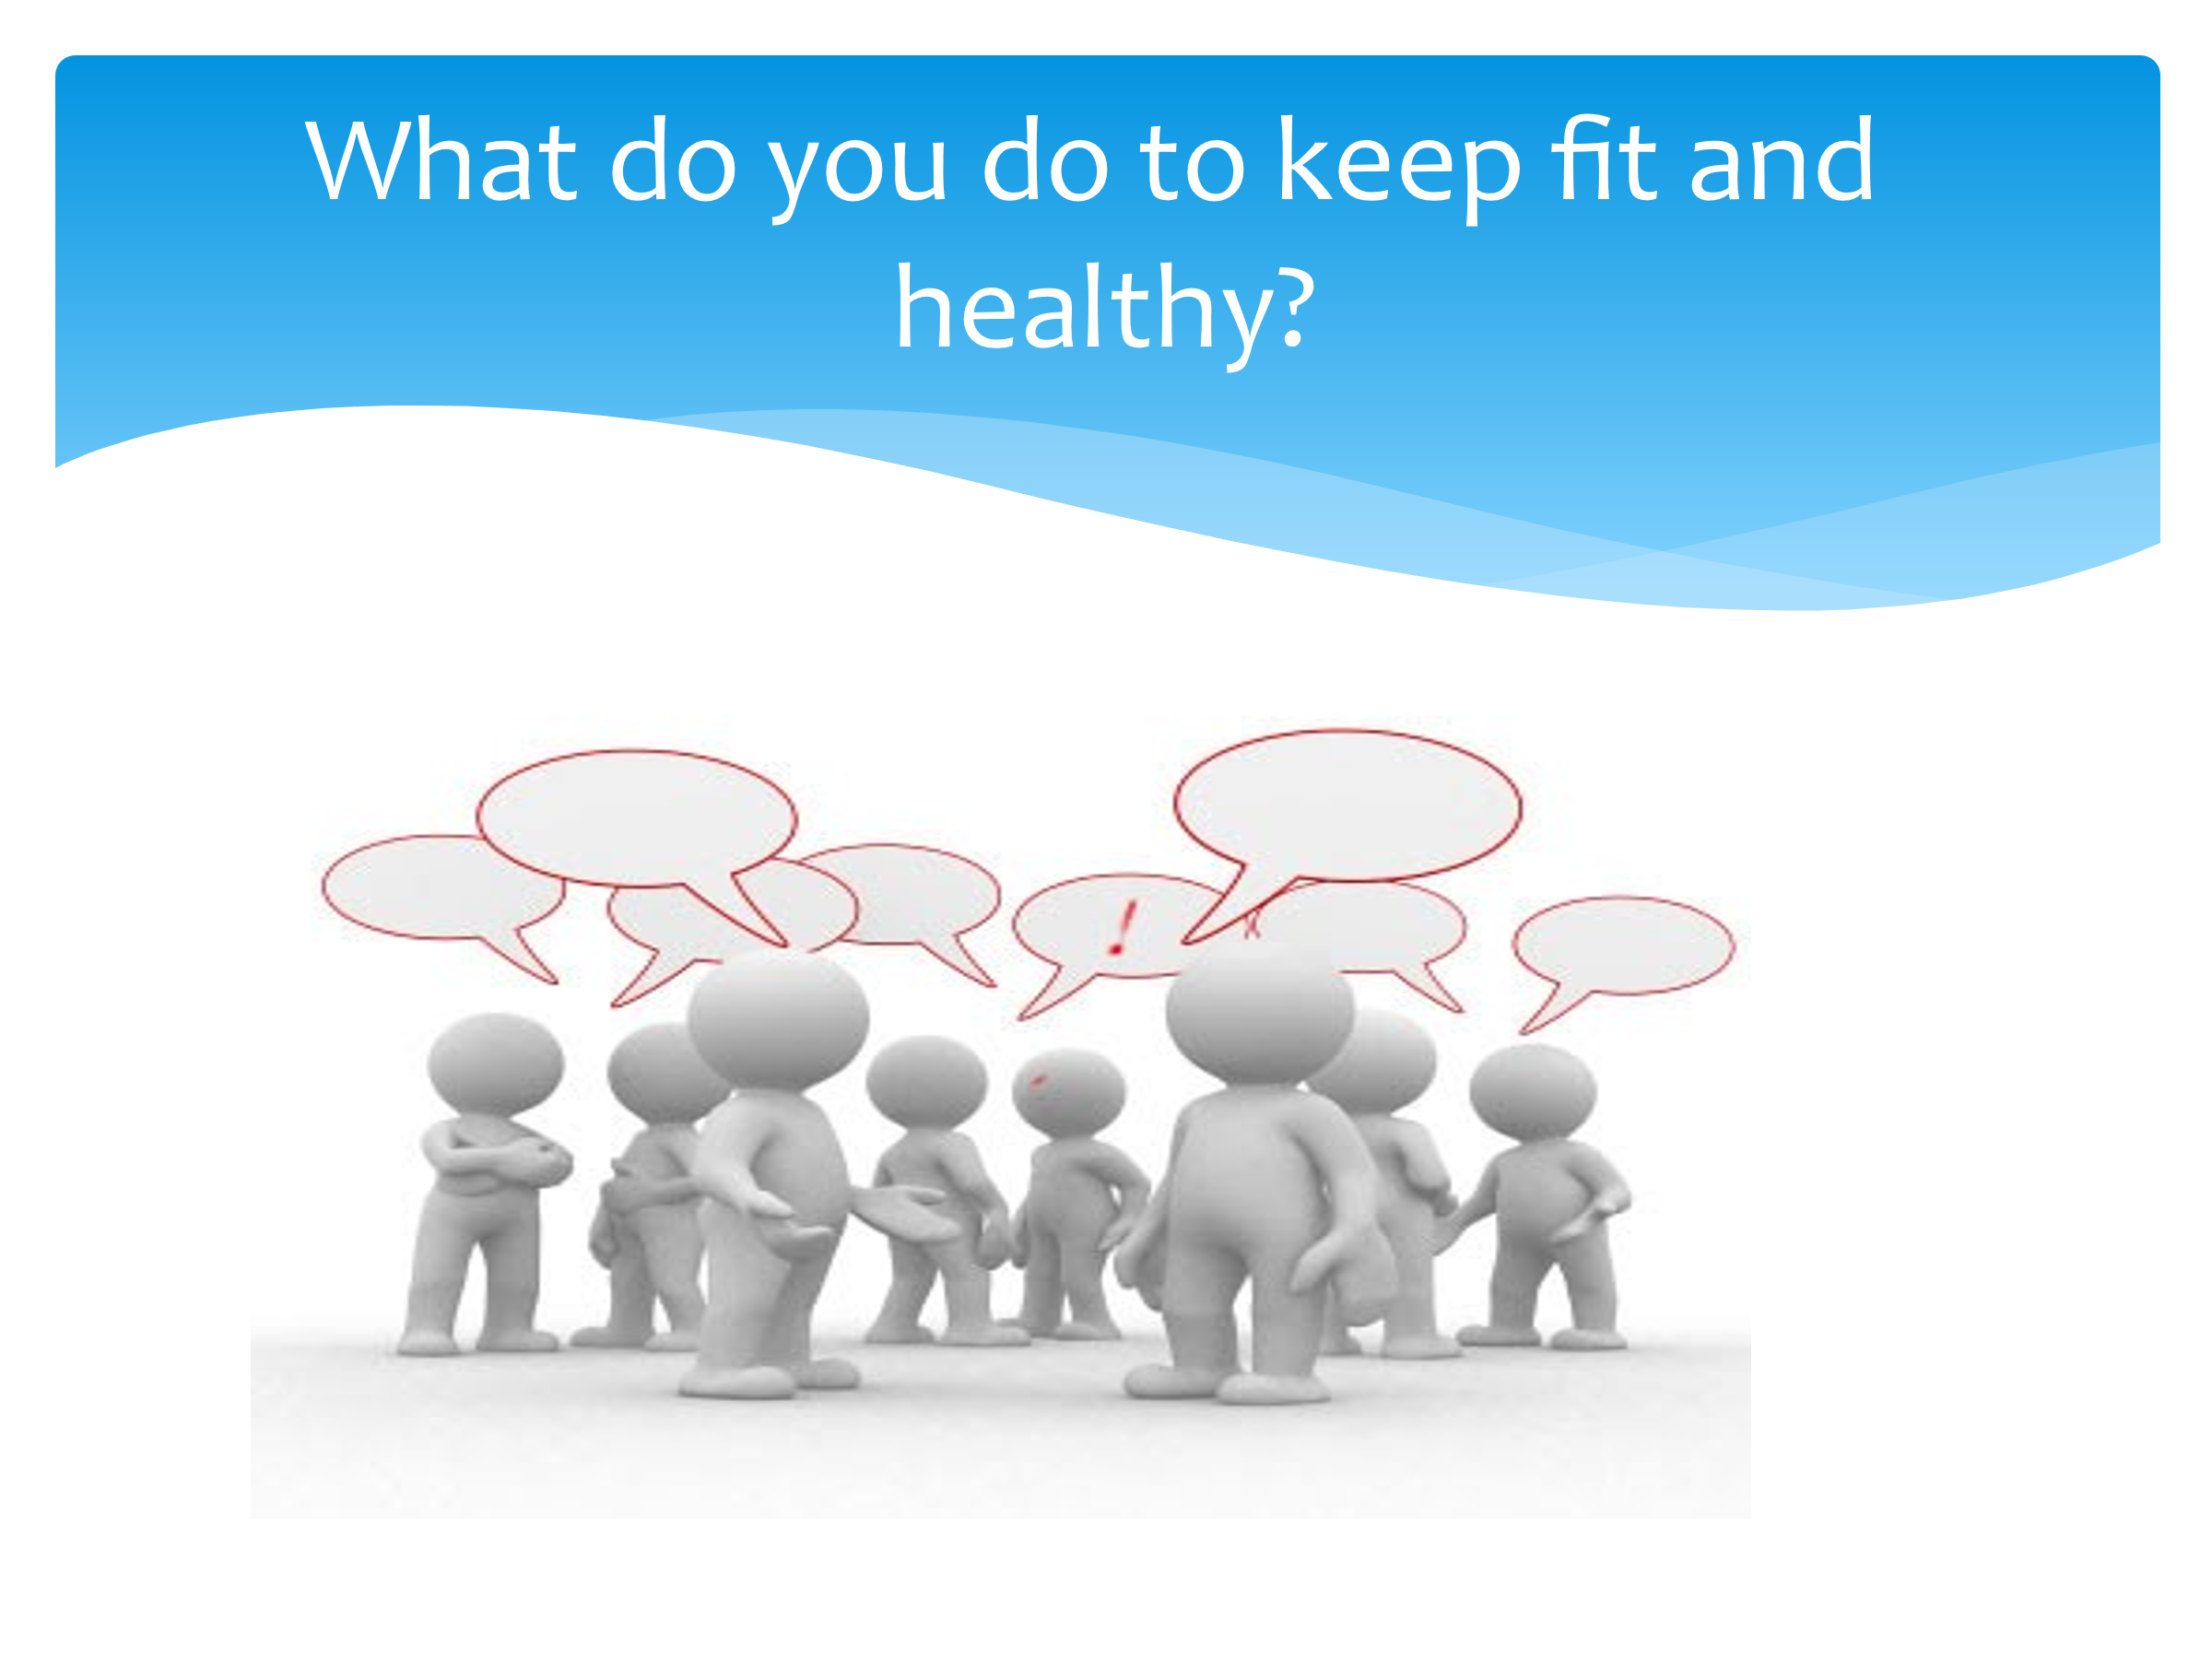 | We’ll start by looking at what YOU do daily to keep yourself feeling mentally and physically well. In your pairs, write a list of all the strategies you use to regulate yourself when feeling overwhelmed or stressed. You have five minutes, then we’ll share the answers.  Discuss in pairs/small groups. Prompts may be needed so things like walking the dog, listening to music, meeting with friends, going for a run etc… If gaming comes up, then discuss the positives of this, but also the need to have limits.  Take feedback and list some on the board.
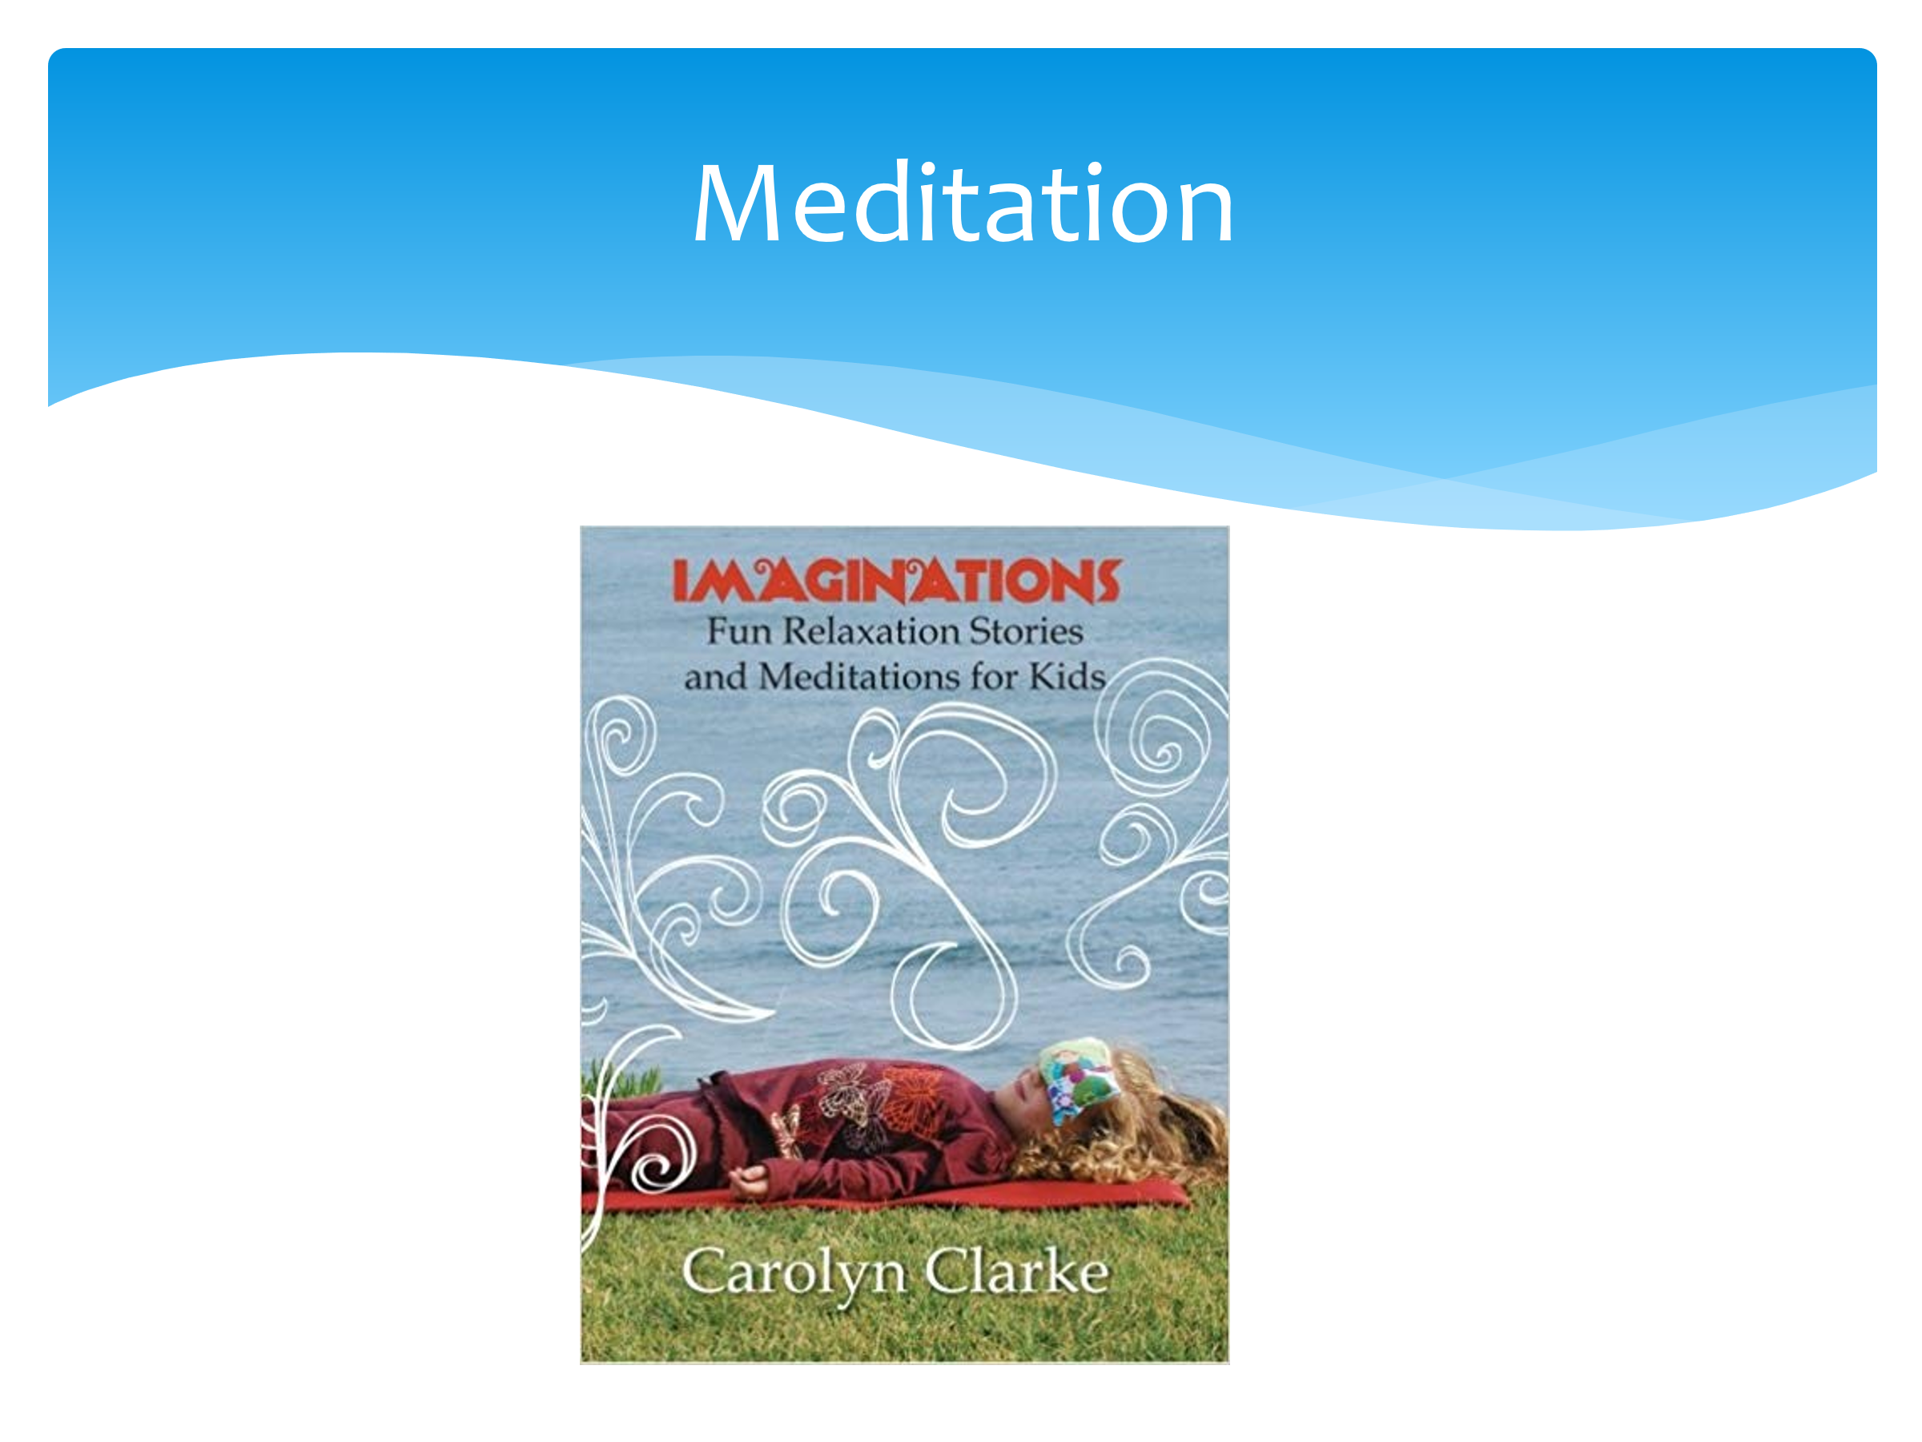 | Many of you will have heard of meditation? How many of you have tried it?  For the next few minutes I will read a meditation to you. You can relax, even put your head on your desks if you like (optional blindfolds). We’ll need silence in order to be successful. The room will be darkened and there will be no talking. This will take about ten minutes.  Adult then reads out meditation to students. (See Appendix 2 page 29)  Afterwards take feedback:  - How did it make you feel?  - Would you do this again?  - Do you do your own form of meditation in your life (although you might not have thought of it as meditation)?
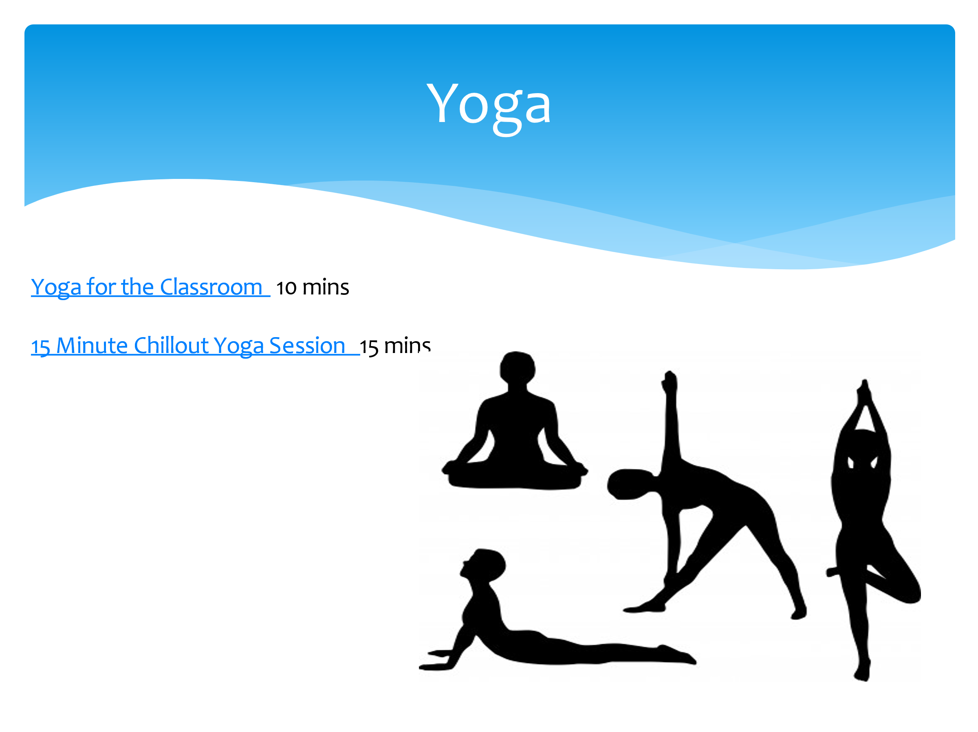 | Choose which of the videos to watch dependent on time available and space in your classroom.  Many people use yoga, and this video we’re about to watch will give us a ten/fifteen minute session of yoga.  Find yourself a space away from the tables etc (you may need to move furniture to the side of the room).  Afterwards take feedback:  - How did it make you feel?  - Would you do this again?  - What link is there to how your body feels and how your mind feels?  There are apps that you can download onto your phone that have calming strategies to help you.
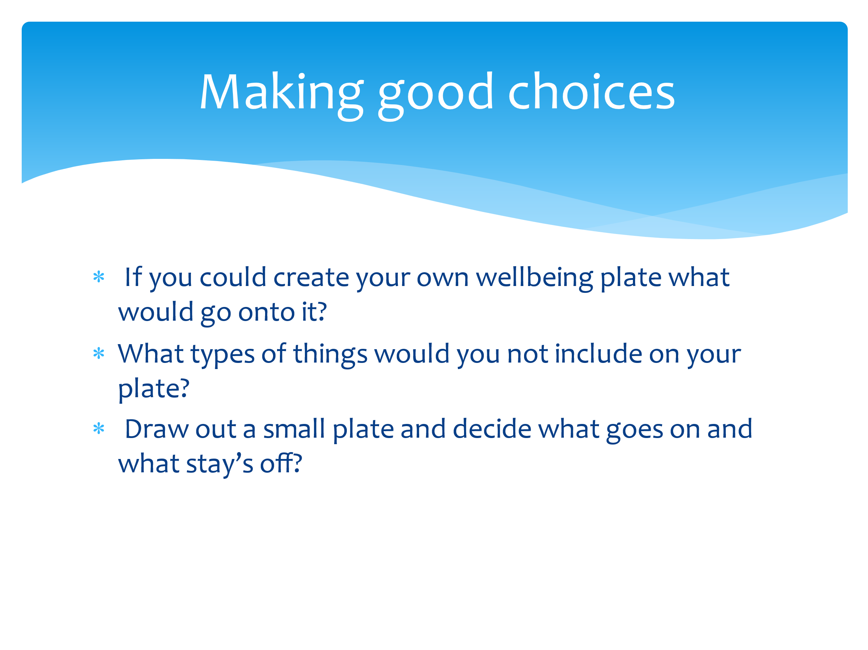 | All of these regulation strategies we’ve talked about or tried today are all things can help us to lessen our worries and increase our resilience.  We’re now going to create our own ‘wellbeing plate’. This is going to be our way of regulating ourselves when things are feeling a bit tough. Like the focus on eating well, split the plate into many areas and in each section thin k about what you need to help reduce your worries and increase your resilience. On here you’re going to put YOUR strategies for YOU.  Then you can keep it on your bedroom wall or inside your folder to remind you of these strategies when you’re experiencing challenges.  They can reflect on their plate and see if they’re doing enough of the good stuff. They can keep this and take it away to continue to refer back to. You can also check that you’re doing enough of the good things, and if not, then you need to increase them.  Hand out paper plates or pieces of paper. CYP to write on their plate their regulation strategies. This can be made visual/colourful.  If anyone wants to share their wellbeing plate, this can be done within pairs or to the whole class.
 | Are there any questions that have arisen today as a result of this session? Anything you’d like to know more about or discuss in more detail?

Session Four – What is mental health?

The aim of this session is to look at the impact of mood and to explore in more detail the idea of ‘mental health’.

You will need:
- Dry-wipe board/flip chart for collating CYP views
- A4 plain paper
- Large sheets of paper Flip chart/Sugar paper
- Old bed sheets and spray cans for graffiti art (you could use paint, brushes and large sheets of paper, or chalk on a playground instead). Colours required – red and green!

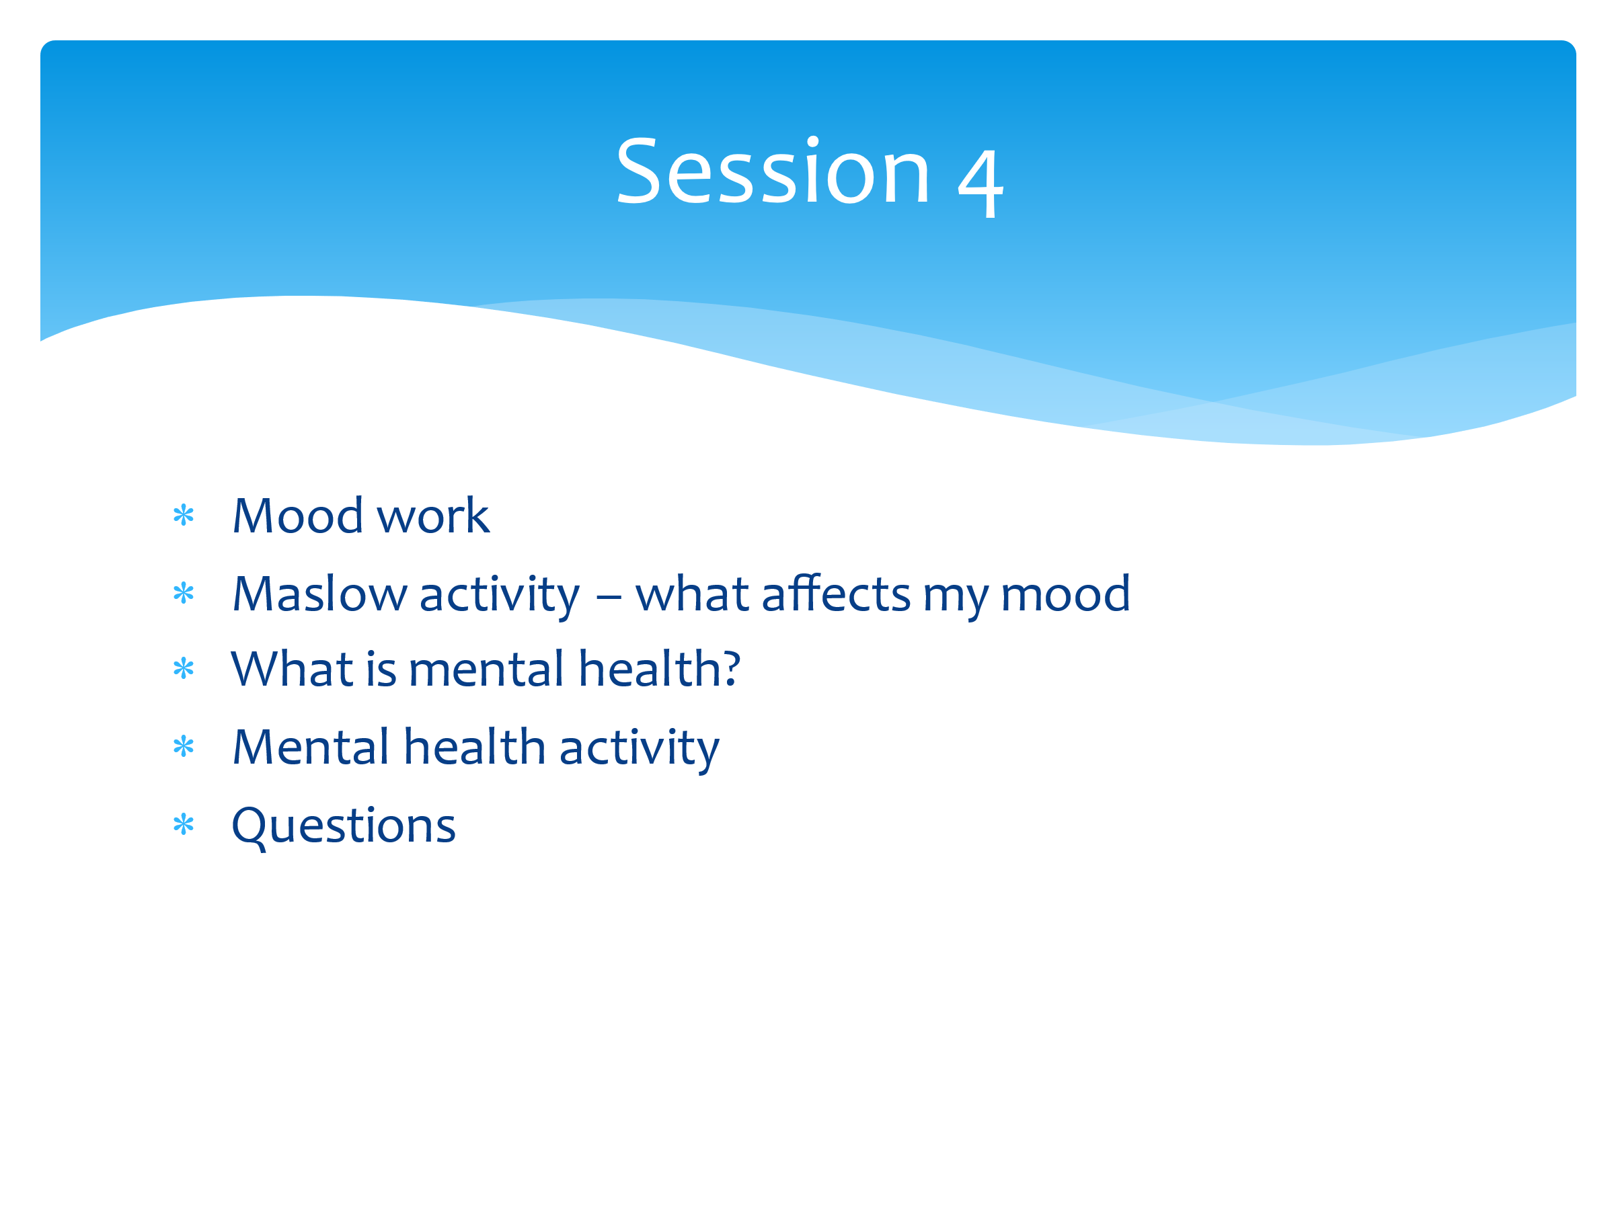 | So far in these sessions we have introduced the concept of resilience, looked at definitions (ensure the group definition is displayed somewhere in the room), looked at our own worries both inside and outside of school and looked at how we can group them into ones we can and can’t control.  In the last session we looked at regulation strategies and created our own wellbeing plates to refer to when we’re feeling overwhelmed or stressed.  In today’s session we’re going to move that forward and look at the impact of mood can affect us, and the importance of looking after our own mental health.  We’ll also look at practical ways of turning a bad ‘mood’ into a good ‘mood’. As always, there will be a chance to ask questions at the end of the session.
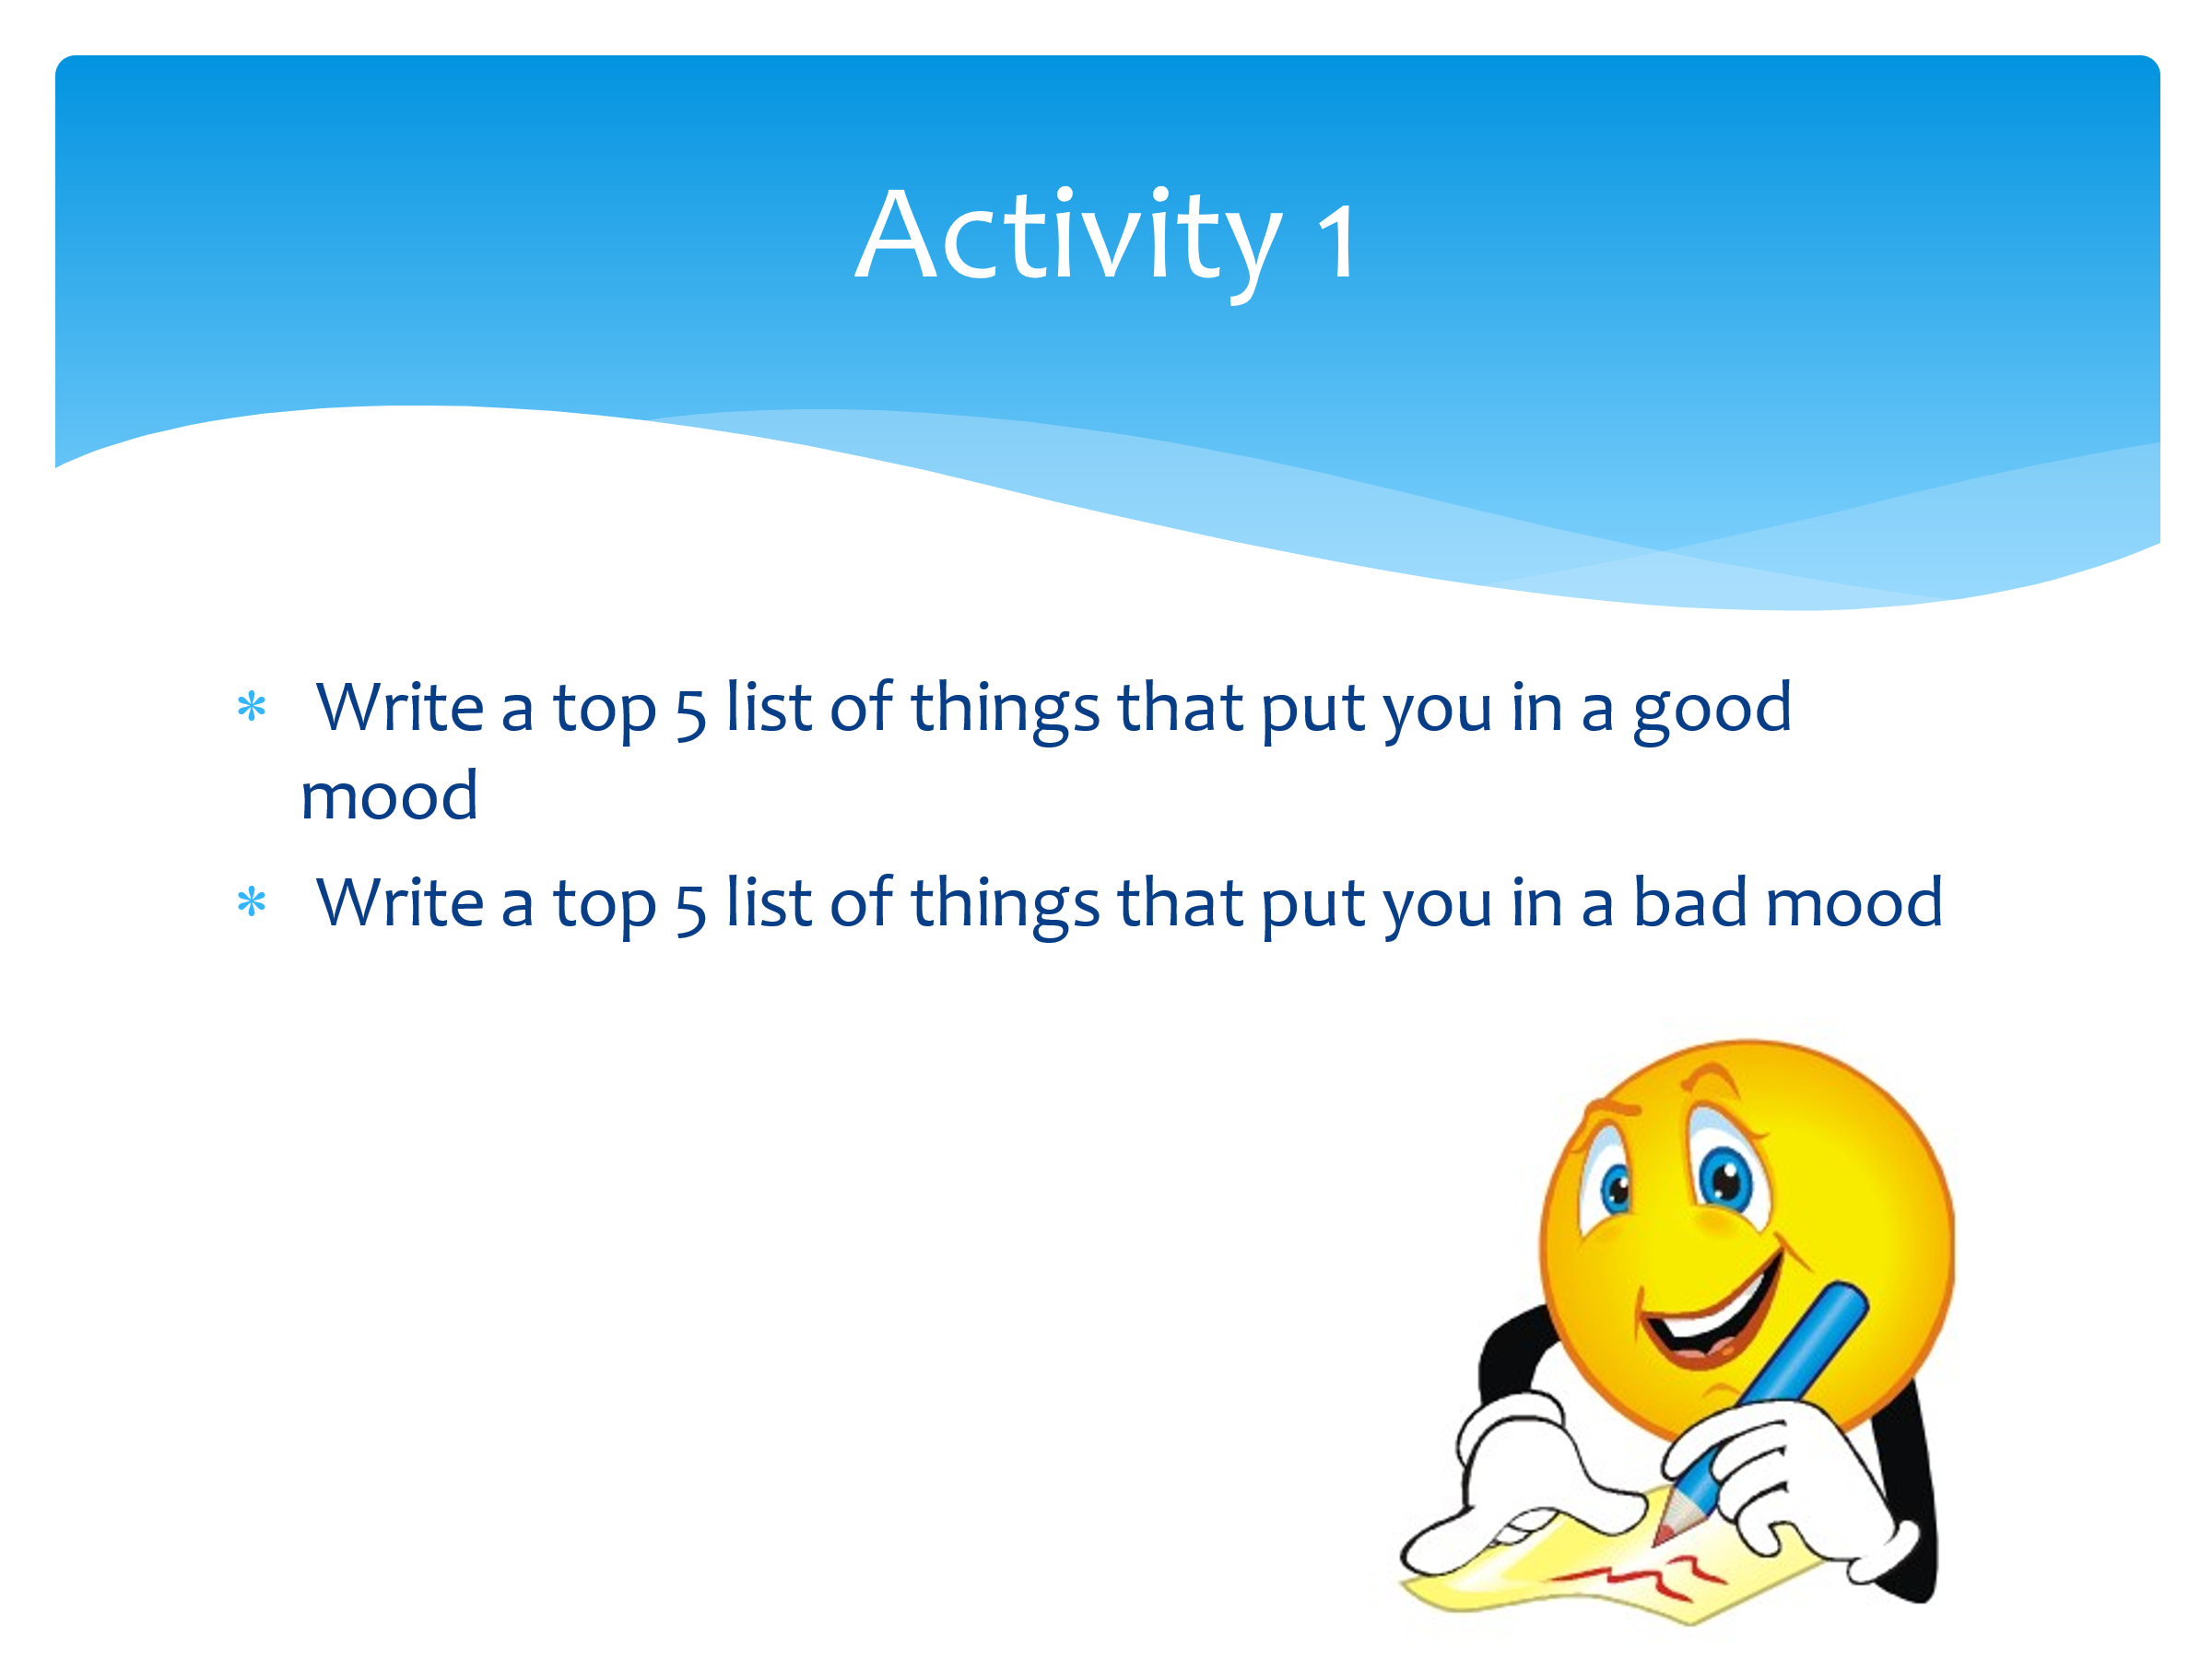 | What do we mean by mood? What is a good or a bad mood?  Take answers from the class. Then hand round plain paper – one per student.  I want you to take this piece of paper and draw a line down the middle of it. On one half, list all of the things that put you into a BAD mood. On the other half list all the things that put you in a GOOD mood.  Give 5 mins for this task.  Take feedback from the class looking at the good mood.  - What puts you in a good mood?  - How/why?  - Are these things that we have put onto our wellbeing plate? If not, can they be added now?  Now take feedback from the class looking at the bad mood.  - What type of things put you in a bad mood?  - Is it possible to change a bad mood into a good mood?  - How? (Refer back to good mood, wellbeing plate etc)  - How does this increase/improve our resilience?  It’s really important to understand that not everything can be positive all the time. That’s why we’ve undertaken this project in order to give us the strategies to build our resilience so we can better deal with challenges that come our way.
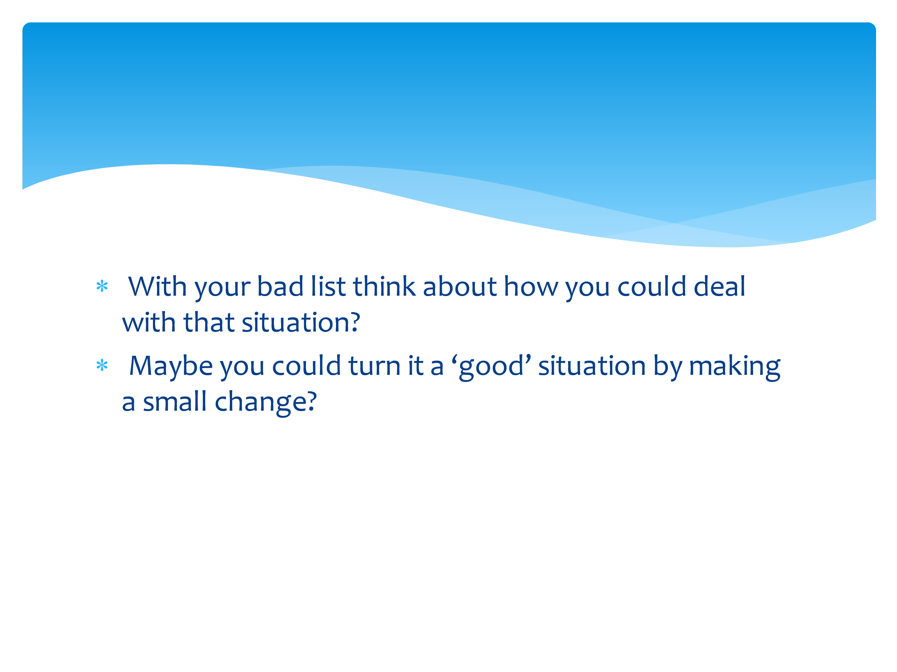 | Now, on your own, go back to your BAD list and think about how you could deal with that situation. Is it possible to turn it into a GOOD situation? What could improve your mood? What might give you a break from BAD and increase the GOOD?  Give 3 mins reflection or making notes next to their BAD list.
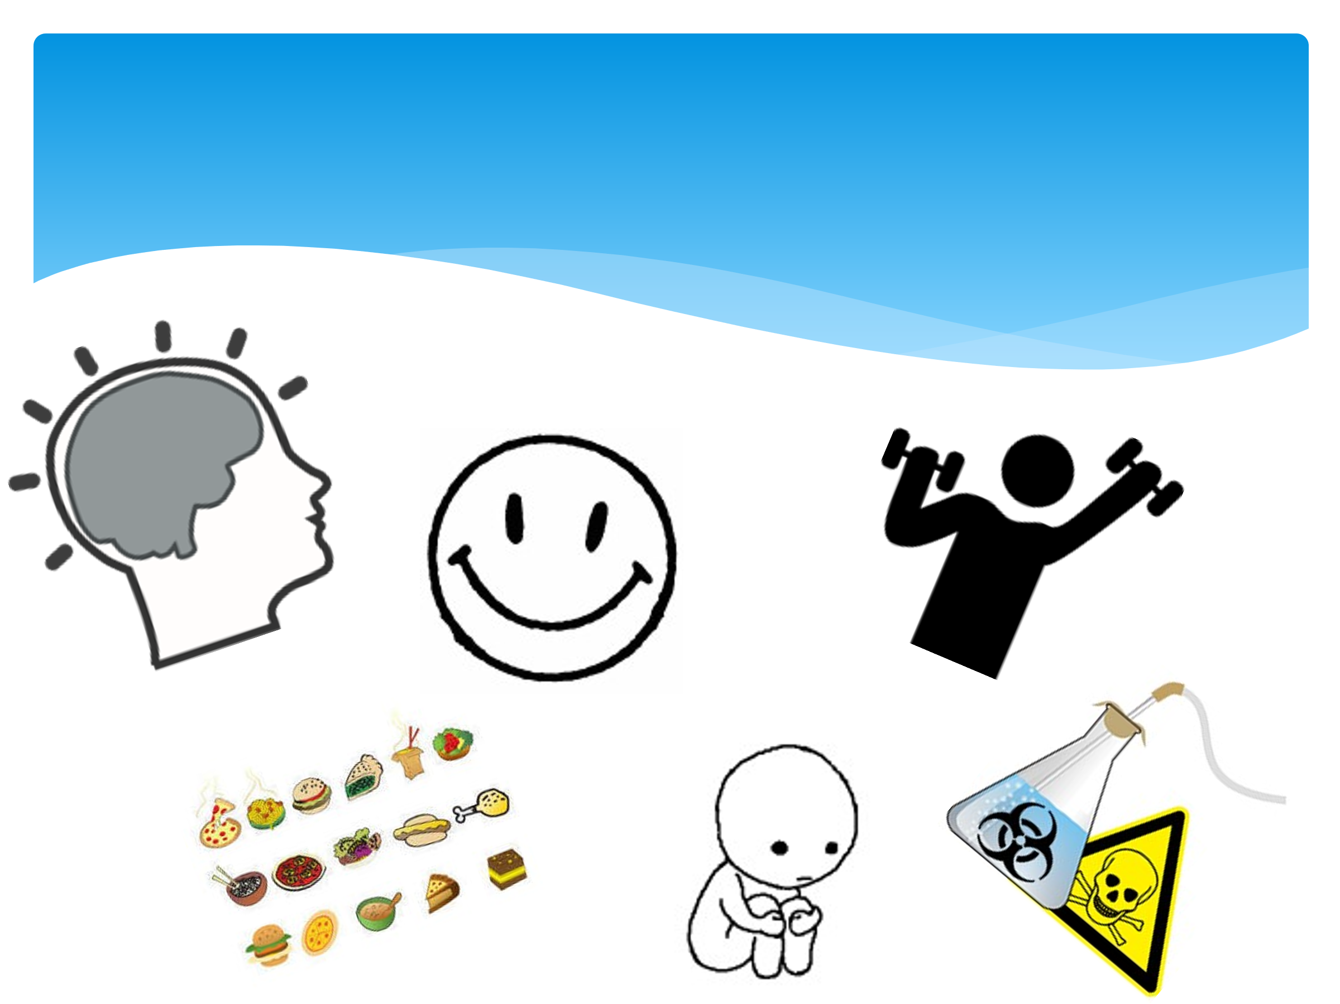 | Now, with your partner, look at images on the screen and discuss how they could link to resilience.  Give 5 mins and take feedback from the group. Ensure that the discussion draws out the following aspects:  - impact of drugs and alcohol on mood  - impact of loneliness and having the right people around us  - importance of exercise and being active mind and body  - balanced diet and the impact that can have  - the smiley face is all about whether it’s realistic to be happy ALL the time. Sometimes you WILL be down and sad – and it’s important to learn to deal with it and find positive outlets (resilience)  - brain picture is about how we look after it. We need to look after our mental health (sleep, being able to switch off, relaxation etc).
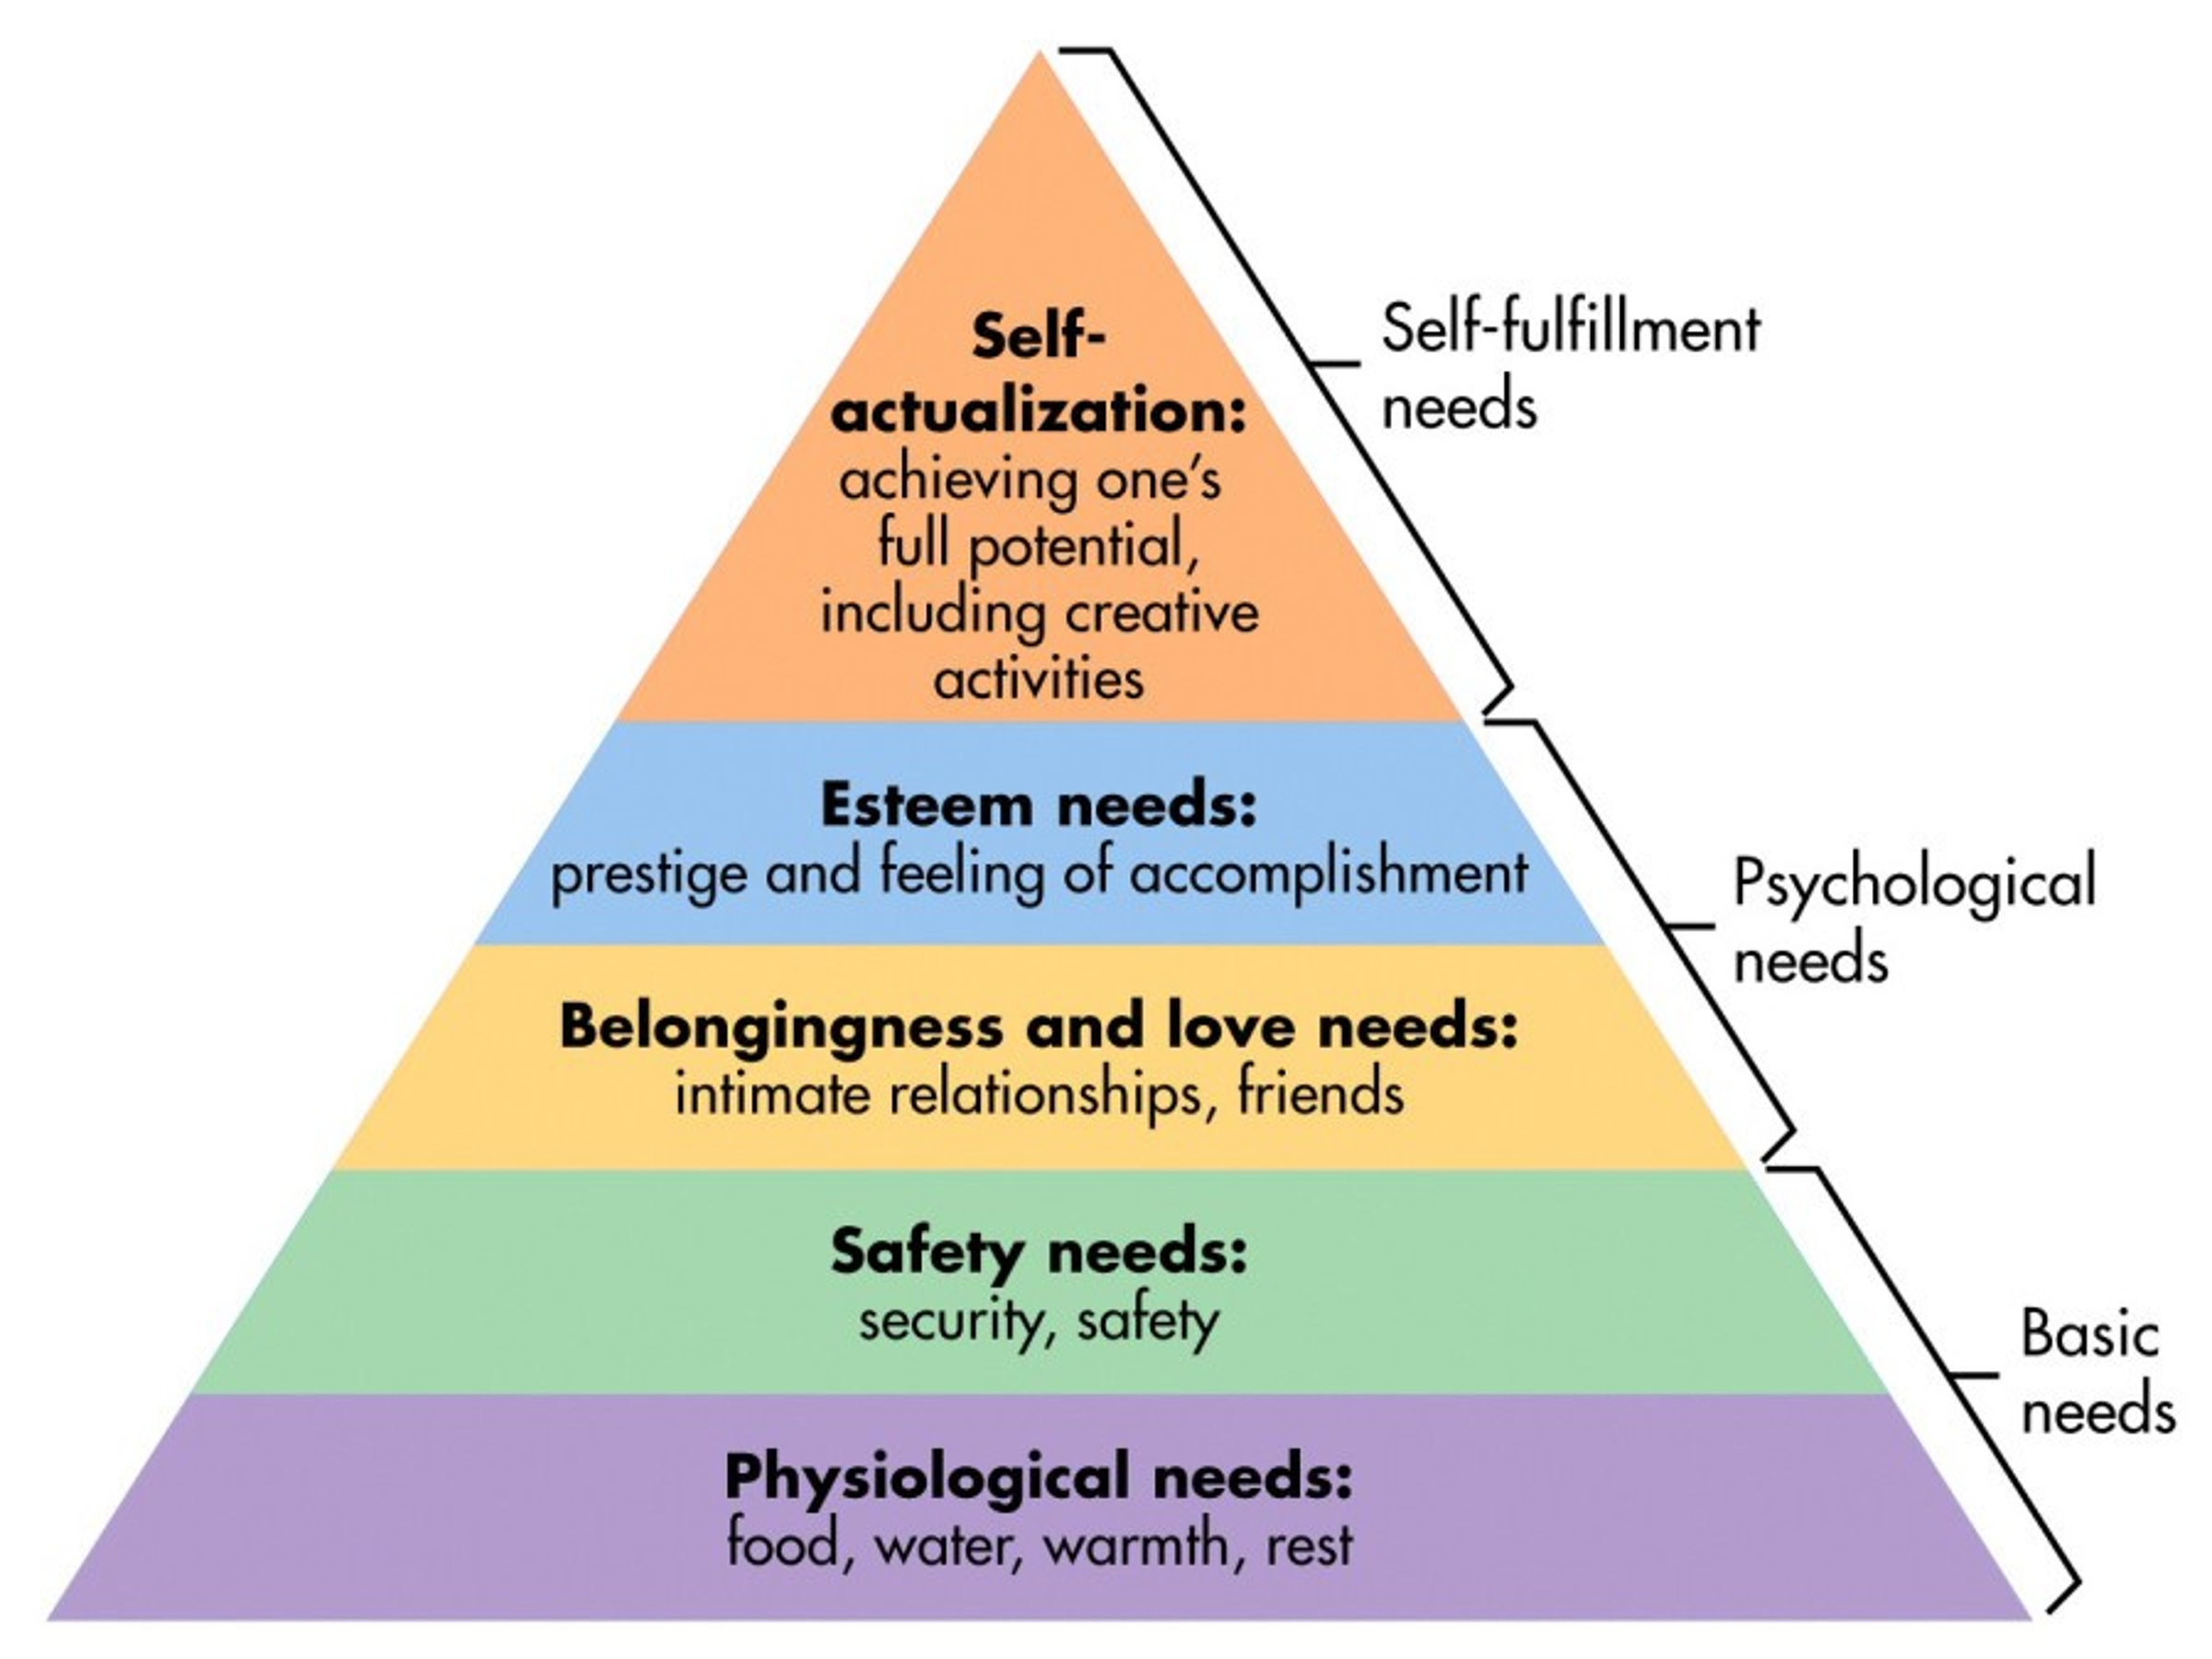 | Maslow’s hierarchy of needs is introduced. Vocab will need to be adapted depending on group and age.  This is Maslow’s hierarchy of needs. It’s a pyramid. All pyramids need strong base foundations in order for them to stand strong, just like people.  The aim for all of us is to be at the top of the pyramid, but this can only be achieved if the foundations are in place, so in order to understand it, and ourselves, we need to start at the foundations.  Firstly, as you can see, it is our physiological needs that have to be met – the things that keep us alive. Above that is the need to feel safe and secure. These are the absolute basics, and without them we can’t progress to the next level.  If those layers are in place and secure, we can then look at our psychological needs. If we have the layer of belonging, connection, friendships etc we can then move up up to the next session and see how that gives us our self-esteem and sense of self-worth. These are essential to us reaching the top of the pyramid.  And that is called ‘self-actualisation’ which is where we are achieving our goals, we’re creative, we are fulfilling our potential. But in order to be this, all the other layers need to be in place first.
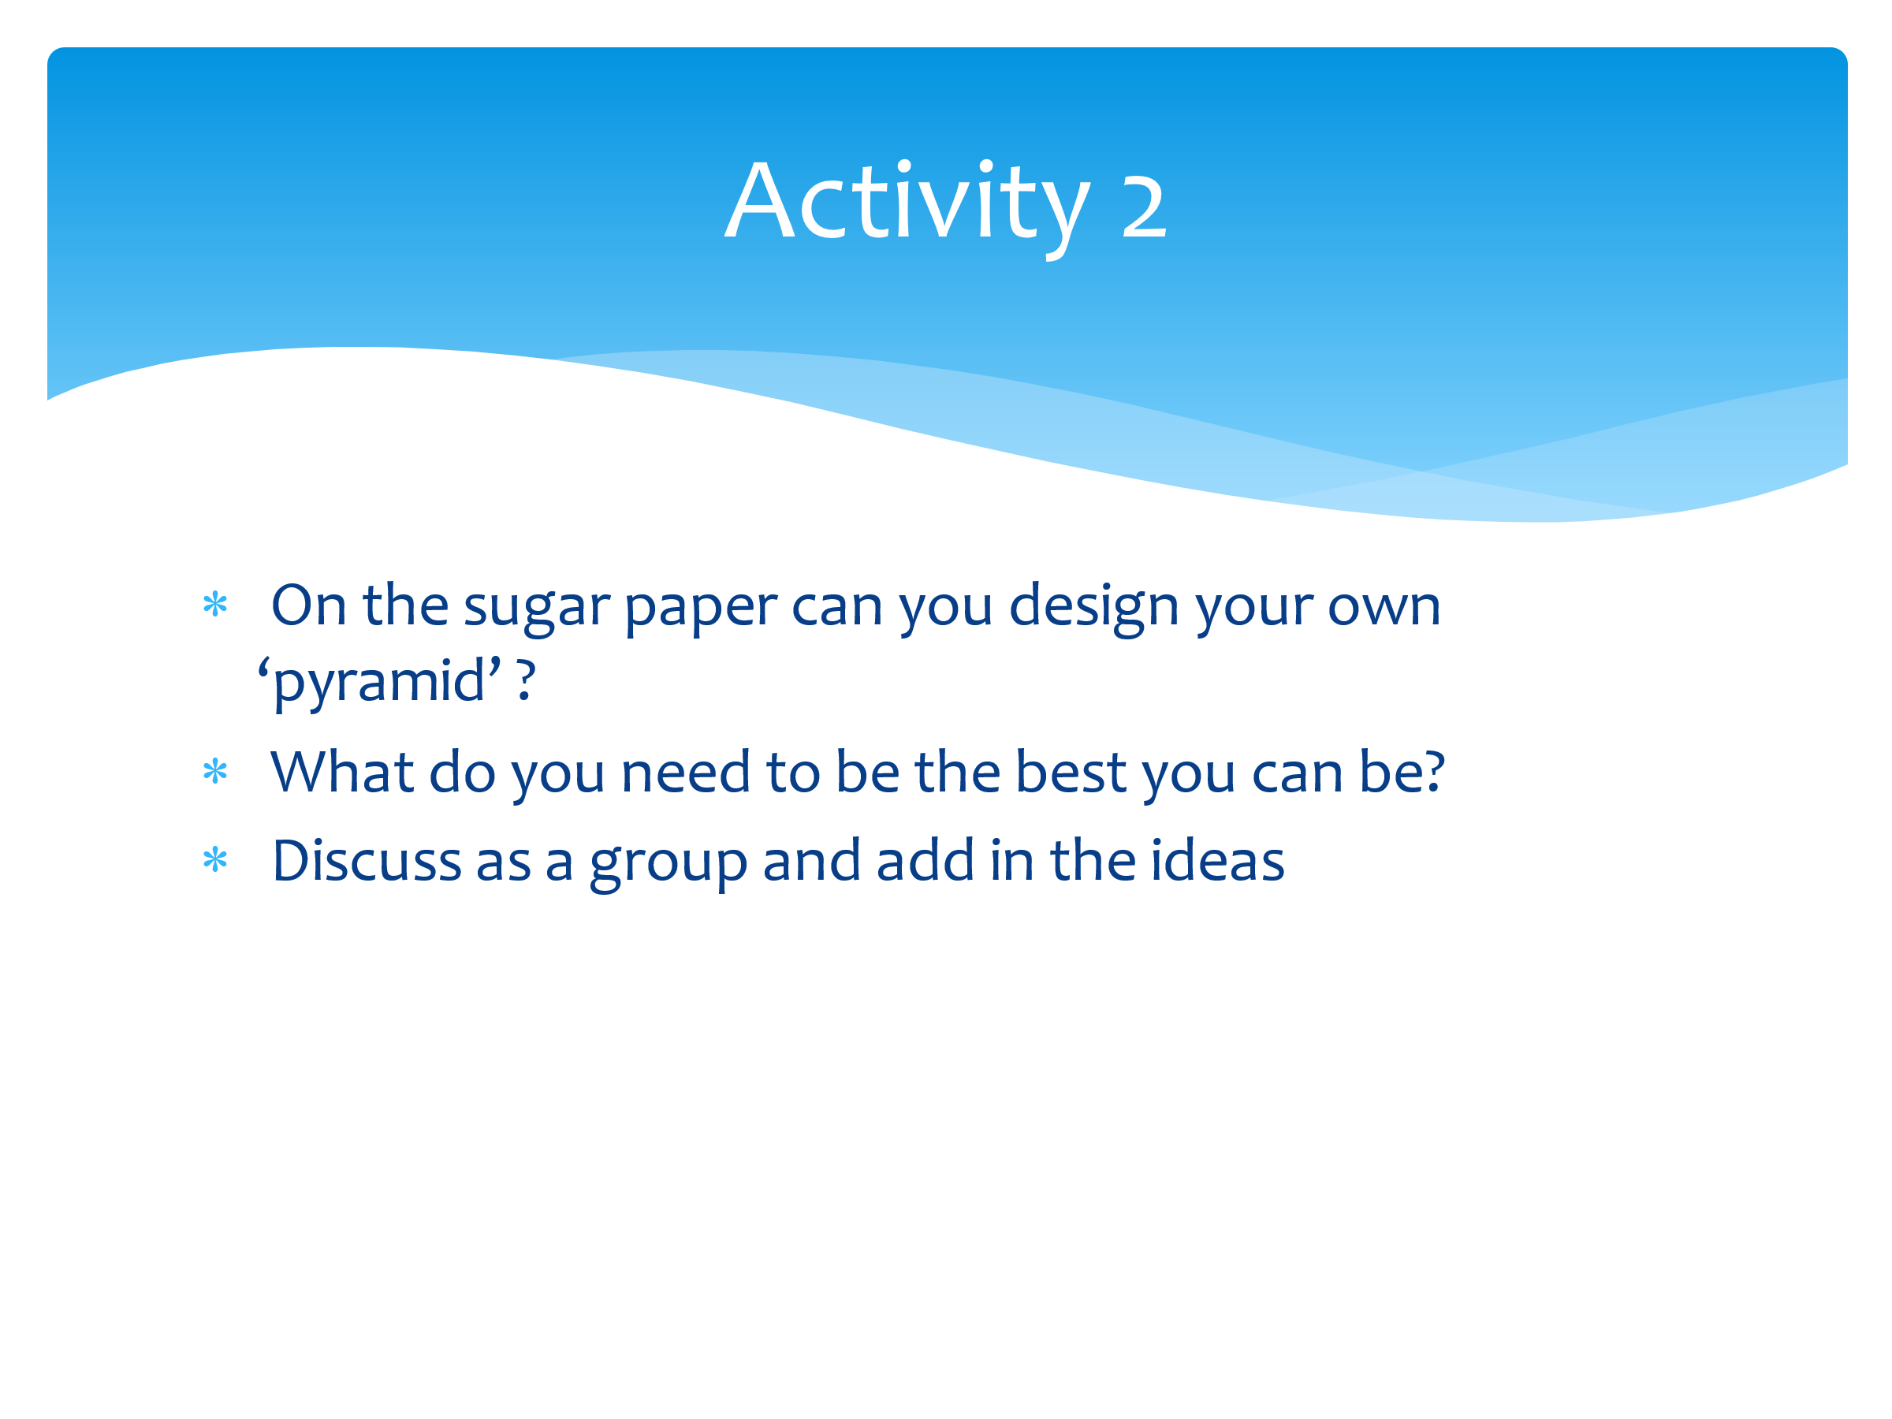 | Now you’re going to use a plain piece of paper and you’ll create your own pyramid based on Maslow’s. It will be different to everyone else’s as you’re going to populate it with YOUR OWN needs in each of the layers.  Provide pupils with paper and pens to complete this task.  Now, I want you to draw a ladder next to your pyramid. Allow time for this.  We now understand what our own needs are, and we might be able to meet these. But sometimes things happen that our out of our control. For example, we might be in a really good mood, but if someone comes along and is mean to us, it might knock our self-esteem. We’d then use the ladder to climb down one level to find something/someone to meet that need.  So in that scenario we’d need to look at belonging, connection, friendships etc…. so we’d seek out a friend or family member to restore us back up the next level so we can climb the ladder back up again.  If that isn’t available, we might need to climb down to the next level to meet our needs. The important thing to remember is that the ladder goes both ways – we may climb down sometimes when challenges come our way, but we can use the tools on that lower level to help us climb back up again. This is resilience! The ability to bounce-back and overcome.
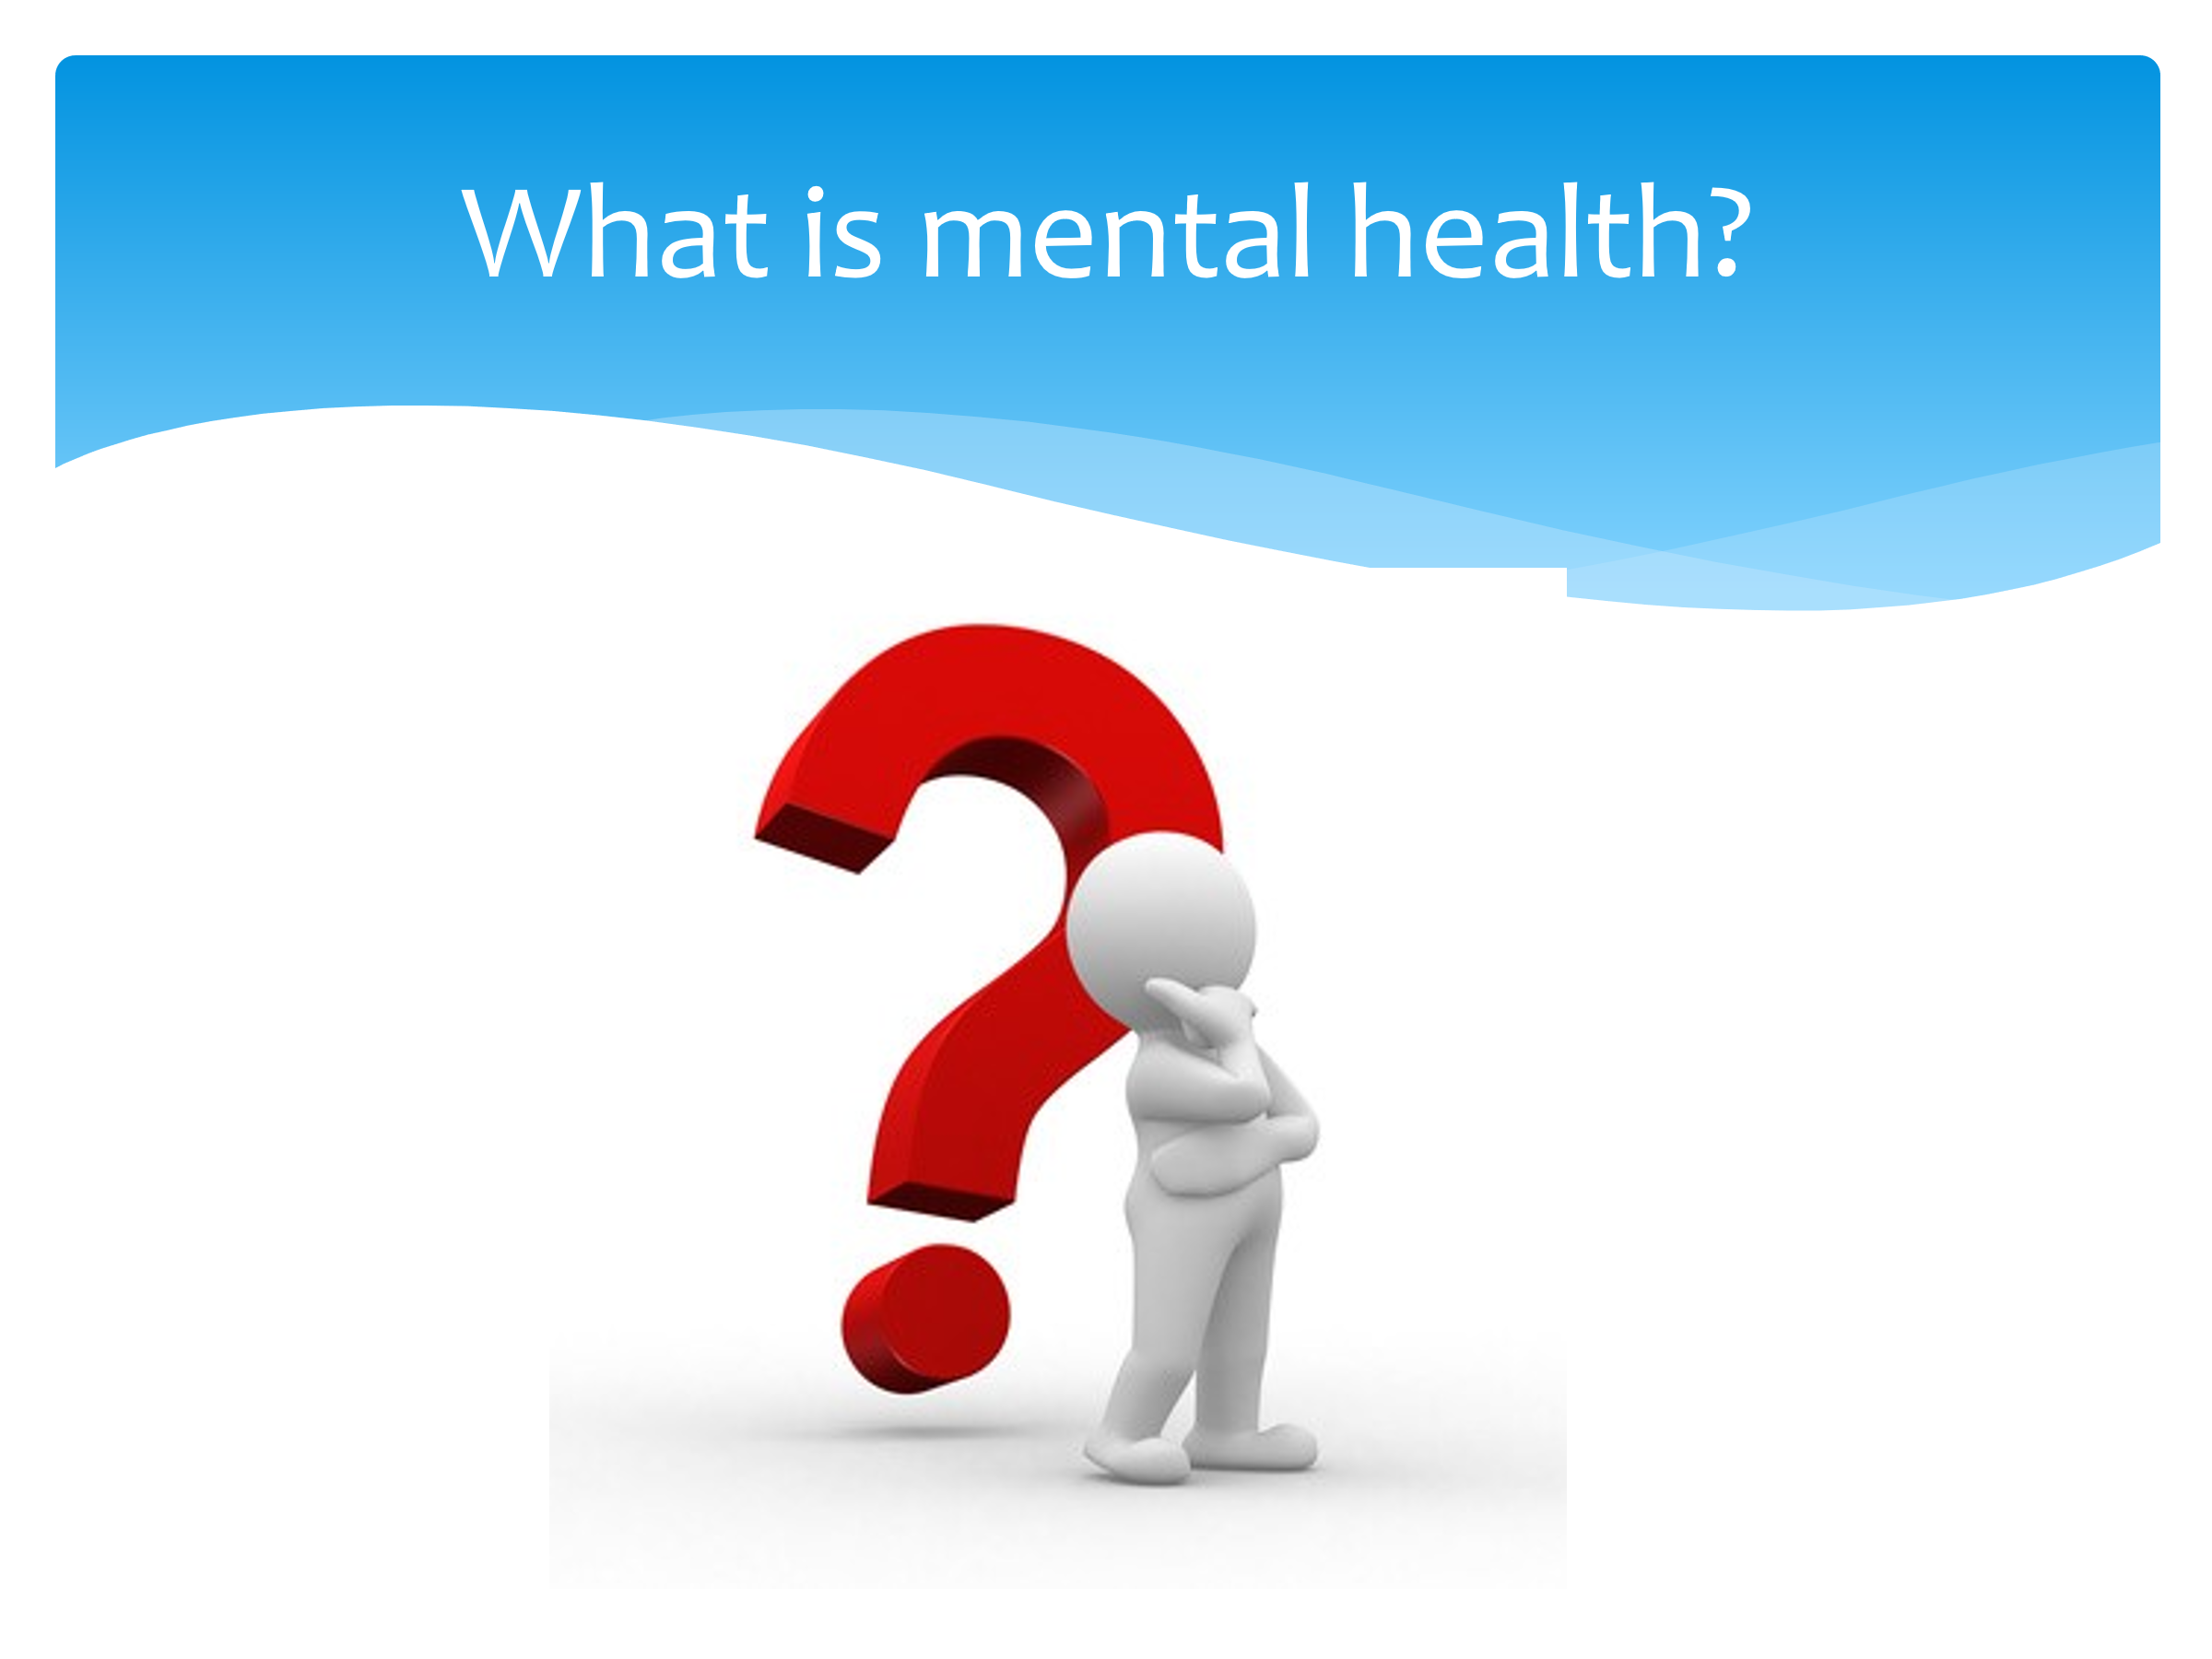 | We hear a lot about mental health. So – what IS mental health?  Take ideas from the CYP.  How does mental health link to resilience?  Take ideas from the CYP.  Is there a stigma around mental health?  Take ideas from the pupils and challenge bias/stigma if and when it arises. Liken it to physical health and the lack of stigma in comparison. Also mention the rise of poor mental health during the pandemic and the drive to make it something that people talk about more openly.
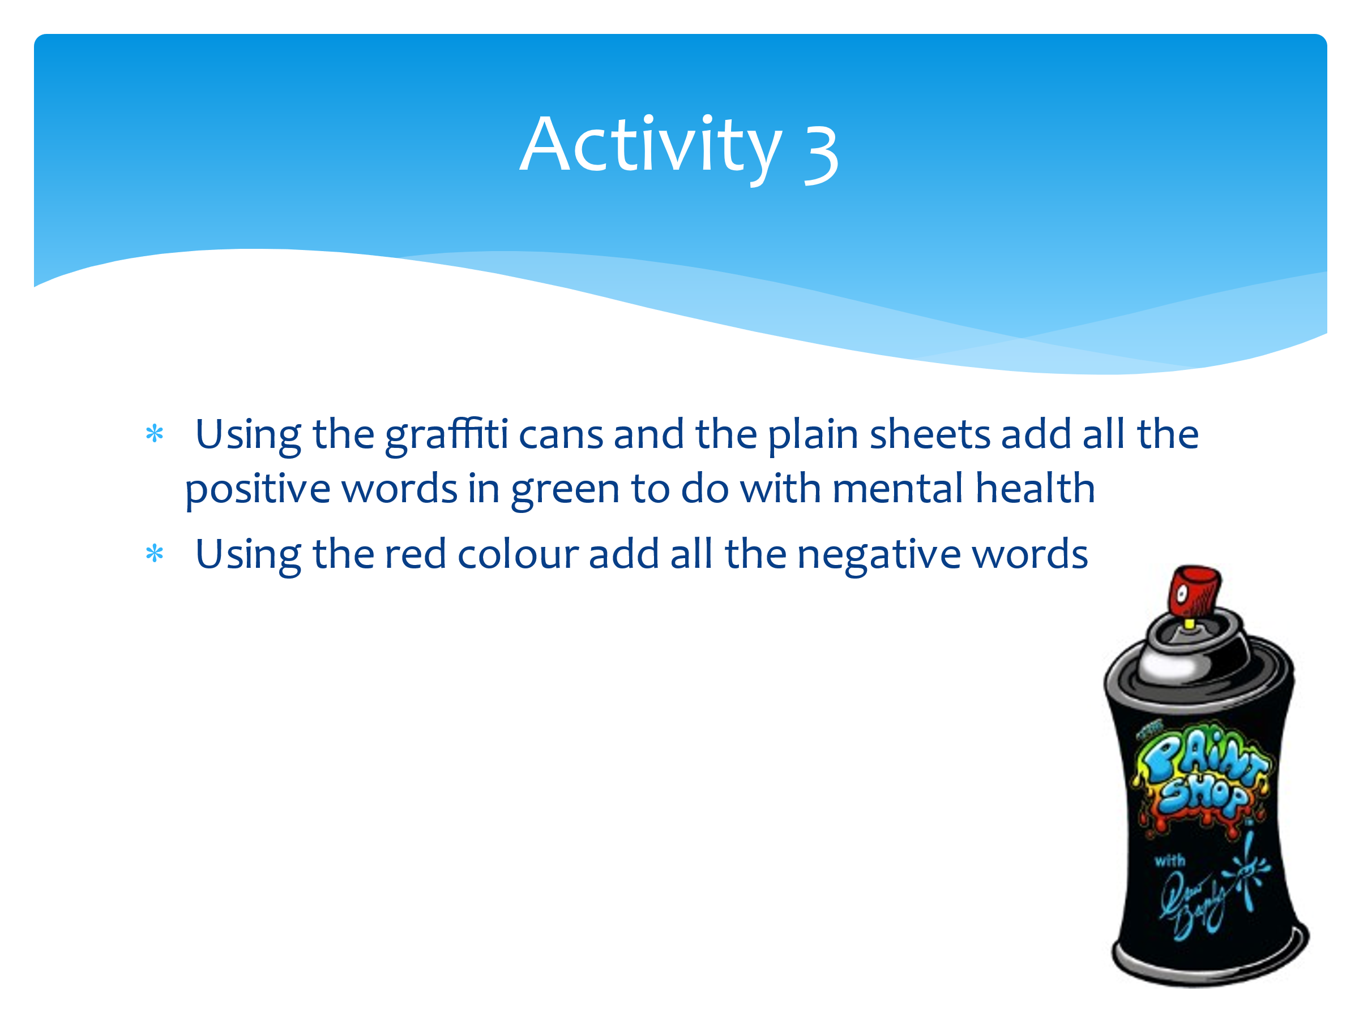 | This activity works best using the graffiti cans and bed sheets (OUTSIDE!!) but can be replicated using paint and pieces of paper, or chalk on a playground if necessary. However, it needs to be art based and preferably outside.  For this activity, we are going to use graffiti cans and old bedsheets (adapt for what you’re using) and use them to write positive and negative words/phrases to talk about mental health.  All the positive things we’re going to put in green – for example ‘it’s ok not to be ok’. Then in red we’re going to put negative or unhelpful phrases – for example – ‘they’re mental’.  Walk round the artwork and discuss the positive and negative words. Encourage pupils to reflect on this and use only the green words in future.
 | Are there any questions that have arisen today as a result of this session? Anything you’d like to know more about or discuss in more detail?

Session Five – What is self-esteem?

The aim of this session is to explore further the concept of self-esteem and how it links to resilience.

You will need:
- Dry-wipe board/flip chart for collating CYP views
- A4 plain paper
- Large sheets of paper Flip chart/Sugar paper

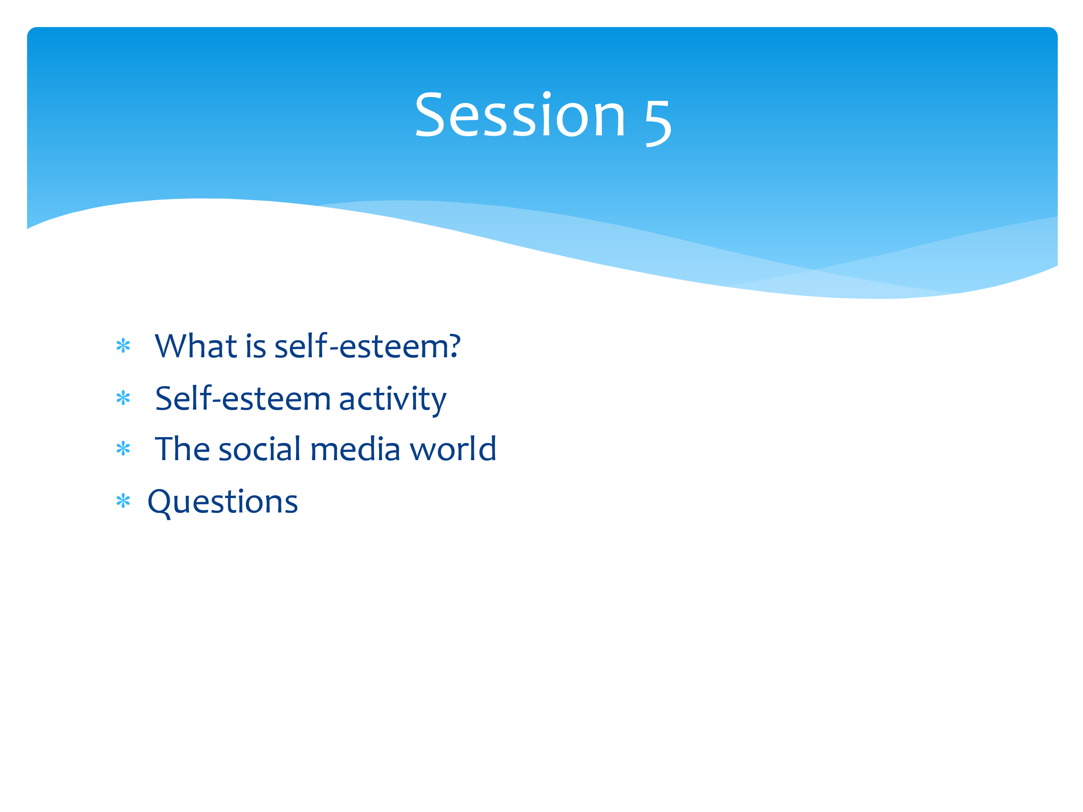 | Over the past four sessions we’ve looked at worries, stresses, the impact our mood can have, ways to regulate ourselves when we are overwhelmed and given ourselves a number of strategies to help us. We’ve created the wellbeing plate and looked at the ladder up and down our own version of Maslow’s pyramid.  Today we’re going to look at self-esteem (which you’ll remember is part of Maslow’s pyramid) and the things that can impact that – including social media.  At the end, there’ll be opportunities for questions.
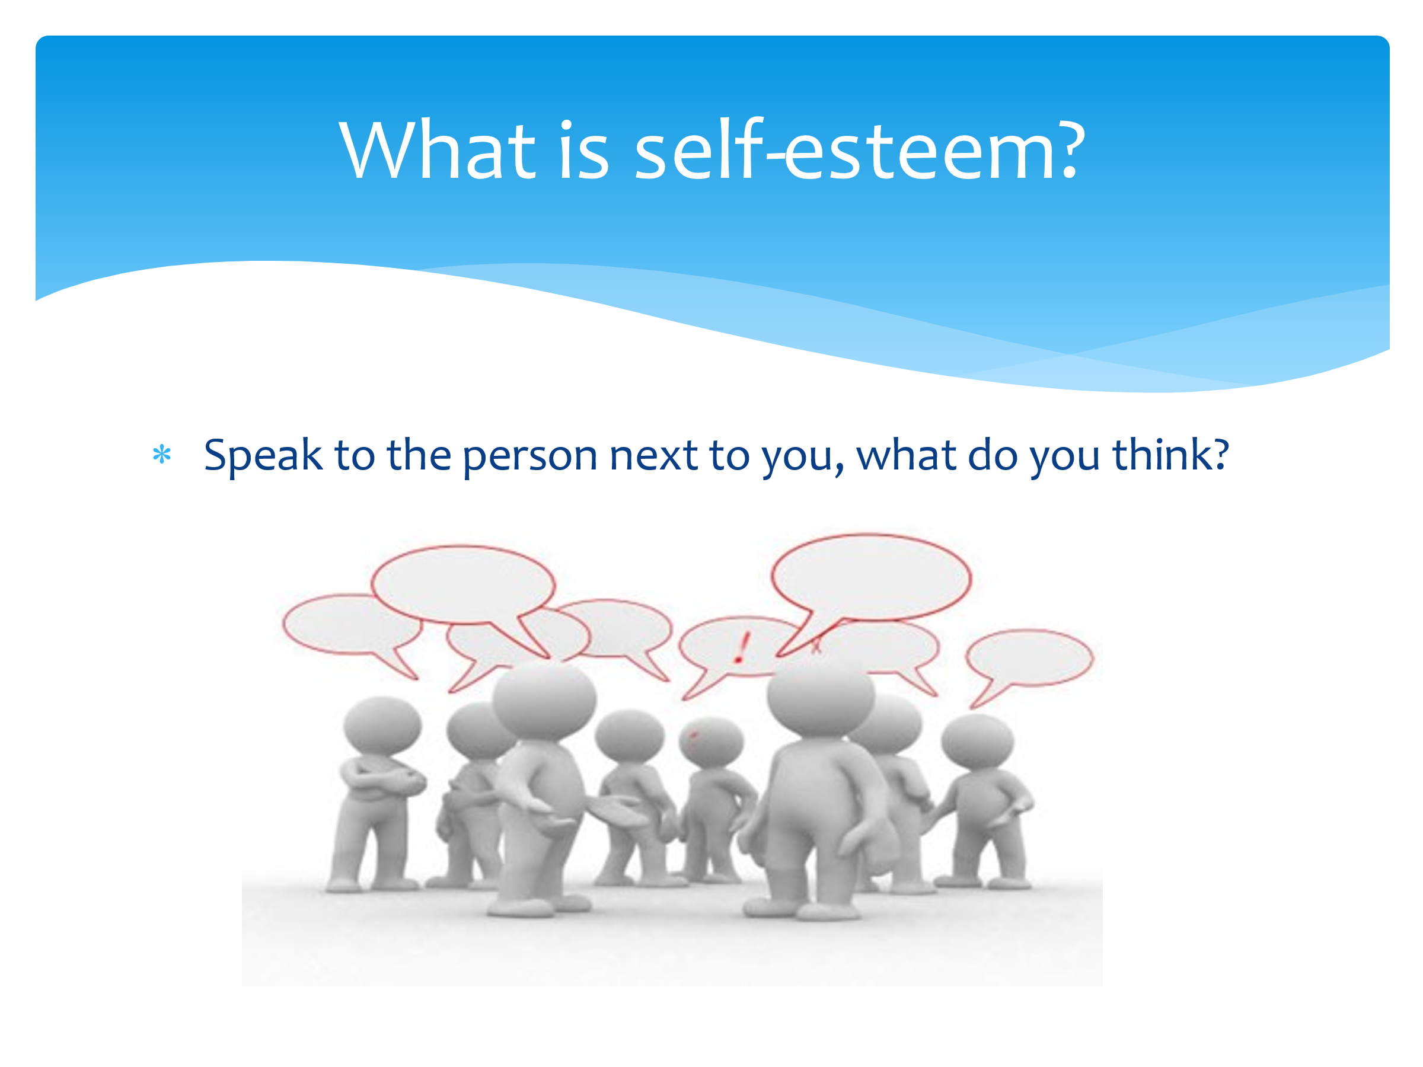 | Speak to the person next to you – what is self-esteem to you? Your friends etc?  Take some feedback from round the room and try to come up with a group definition which can be written on the board.
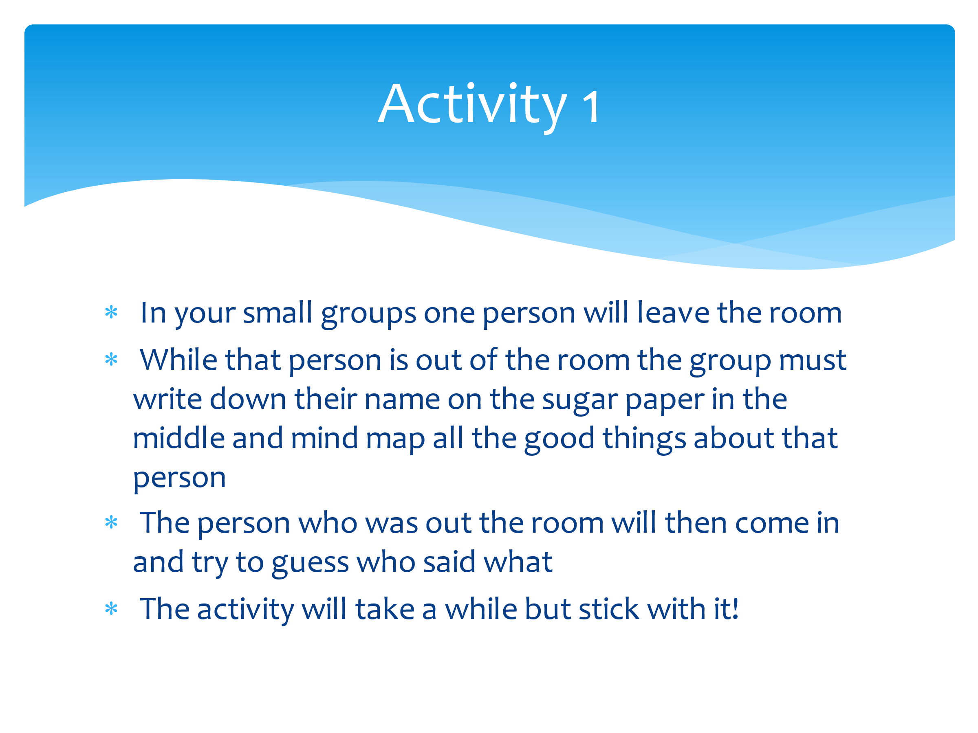 | Now we’ll have a go at the main activity of this session. Firstly, get yourselves into small groups of 4-5 people.  In a minutes I’m going to ask one person to leave your group and stand outside the door (or other safe area where they can’t see/hear the activity).  The rest of the group, write that person’s name in middle of your sheet of paper, and everyone in the group has to write positive things about that person. This can be things like: friendly, good at football, kind, artistic etc. Write as many things as you can.  Then we’ll invite the person back into your group and they will choose try to guess who has made the comment about them, and that person can explain why they chose that word/phrase. The person will get to keep the sheet of paper about them.  We’ll keep doing this activity until everyone has had a turn. I appreciate that some people will find this uncomfortable as we’re not always very good about accepting praise, but we will be keeping these sheets in order to build our resilience and remind ourselves, in the bad times, of all the things people admire about us.  Over time, as our self-esteem increases, it builds our resilience.  Repeat activity until every CYP has had a turn. These sheets can be kept with their wellbeing plates and pyramids.
What are these logos of?

Pupils respond. Ask if there are any more they use that are not on here (ie TikTok).

Split pupils into groups or pairs (dependent on numbers).

In your group/pair I want you to consider the app you’ve been given. You need to create a list of they ways in which the app can IMPROVE your self-esteem and a list of the ways the app can DAMAGE your self-esteem. You may also want to consider the dangers of the app in terms of your personal security/safeguarding.

Allow five minutes for this activity and ask groups to feedback to the rest of the class. Draw out the positives and negatives of social media in relation to self-esteem and resilience.

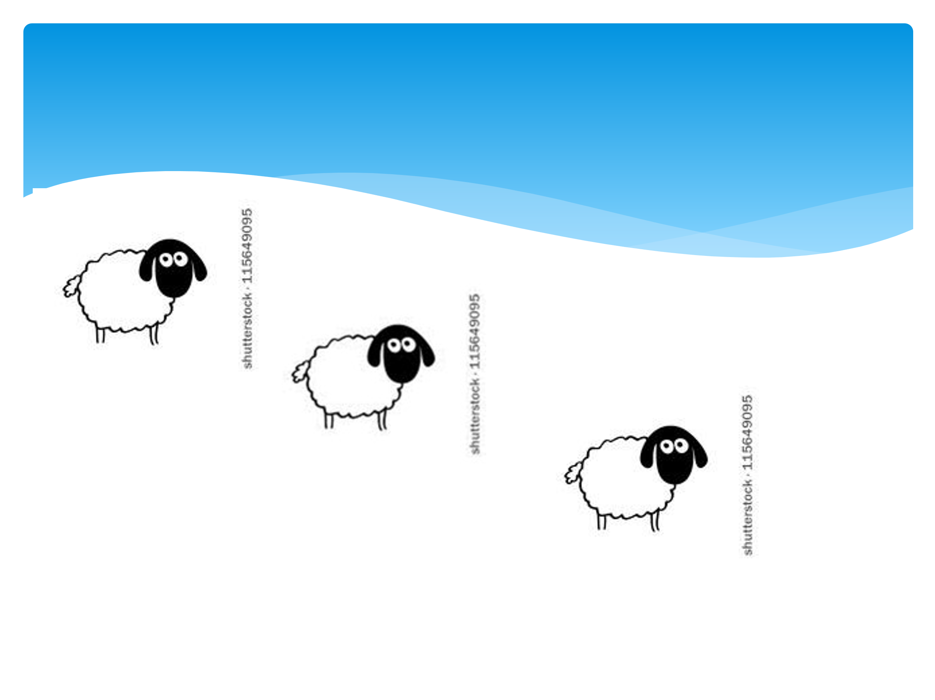 | How does this image link to the conversation we’re having today about self-esteem, and also the influence of social media?  Take feedback from the group. Draw out the following:  - Just because that you follow people in life as humans, we shouldn’t feel under pressure to follow anyone on social media.  - People ‘liking’ your photo isn’t people ‘liking’ you in real life, and the opposite.  - Don’t allow the number of likes or followers to influence your self-esteem.  - Anything you post can be viewed in a different way to how we want it to be seen.  - Things posted online can stay there forever (link to job-seeking in the future and the impact of previous comments/posts.  - Everything may not be what it seems – people tend to only post the good things  Remember, if there are any concerns, issues, worries or any bullying, you can always seek help here in school or through online support groups.
What do you think of this quote? What is he trying to say?

Take feedback from CYP and relate it to the last ‘sheep’ slide.
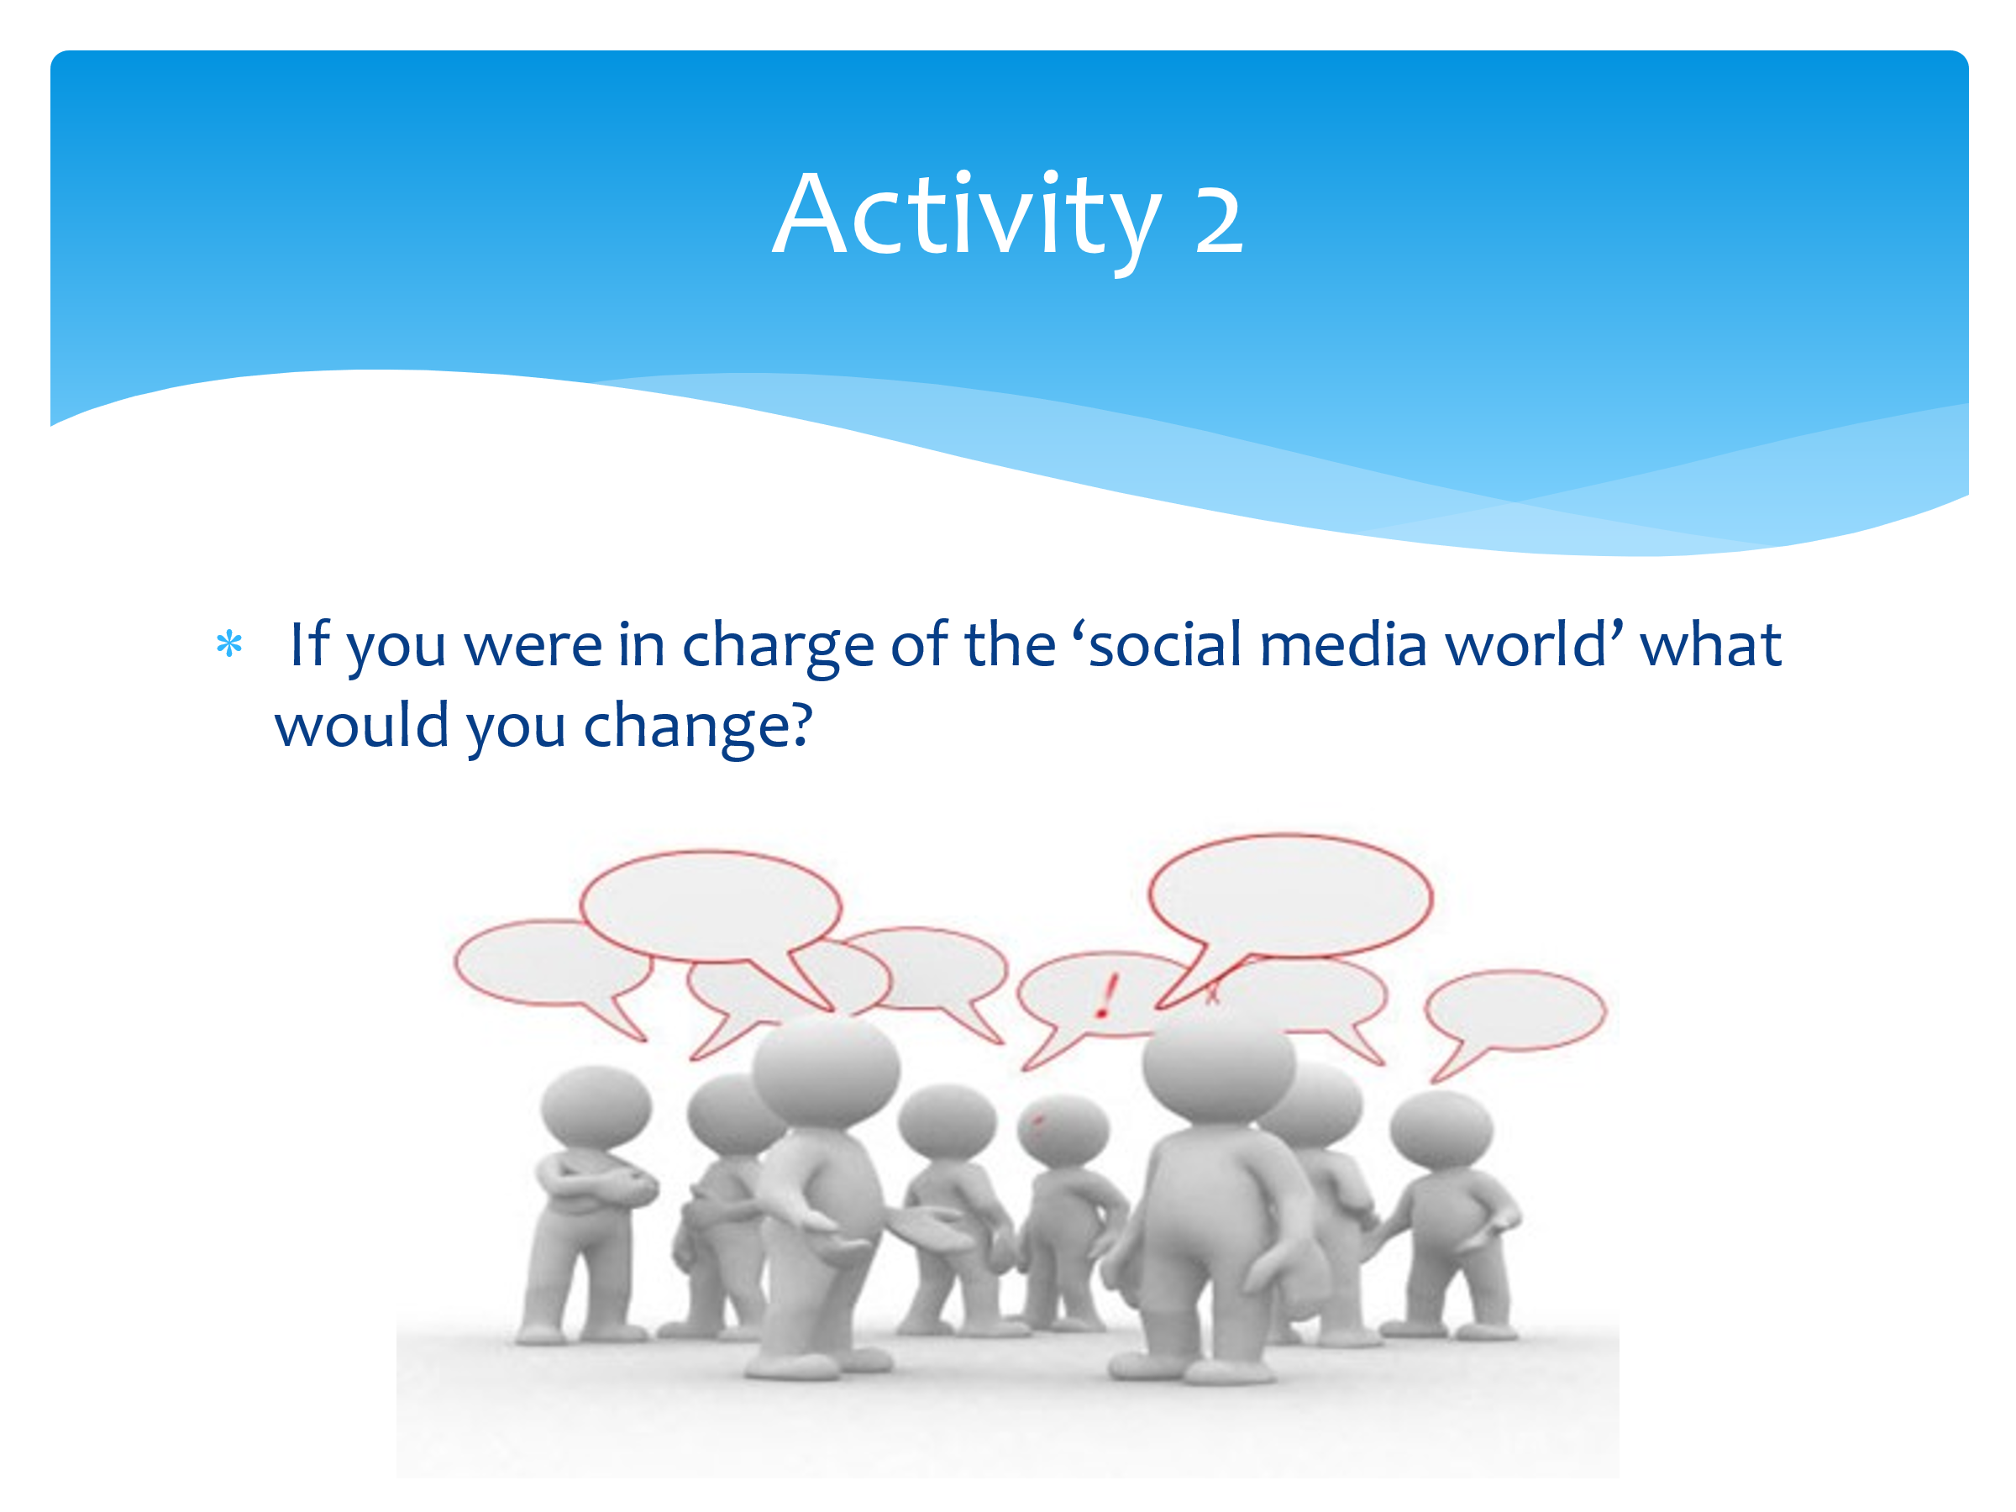 | For the final part of this session, discuss in your pair or groups the following: if YOU were in charge of social media, what would you do differently in order to protect people?  Draw out answers such as screentime, age limits, need for more regulation, a way to battle the trolls and anything else they come up with.
 | Are there any questions that have arisen today as a result of this session? Anything you’d like to know more about or discuss in more detail?

Session 6 – How can resilience help me achieve my goals?

The aim of this session is to bring together all the other sessions in order for CYP to understand how their increased resilience will help them achieve their goals.

You will need:
- Dry-wipe board/flip chart for collating CYP views
- A4 plain paper
- Large sheets of paper Flip chart/Sugar paper

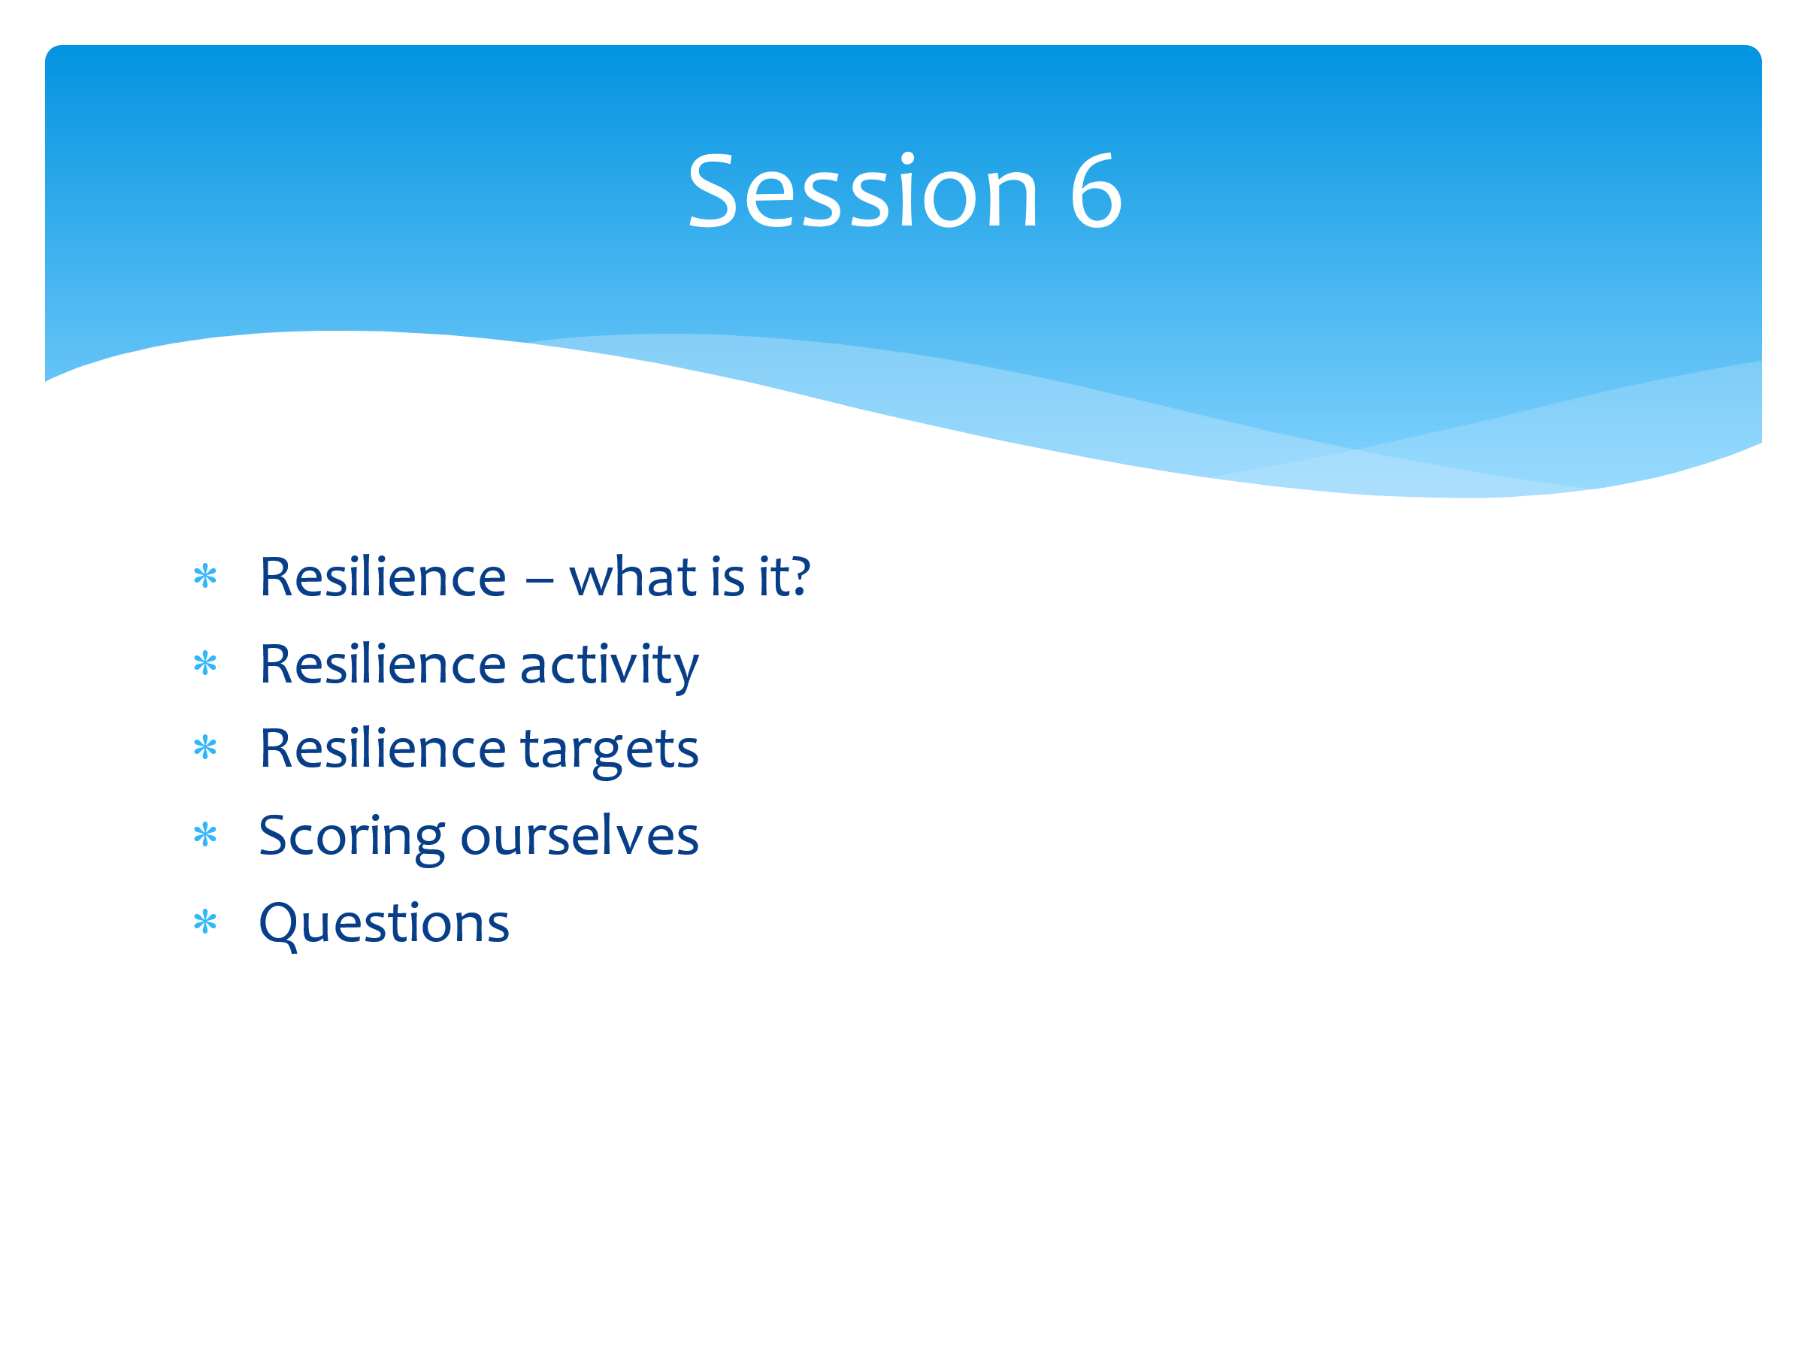 | We’ve worked hard over the last five sessions to understand what resilience is, how it can help us manage the challenges in our lives, and how we can build it up. We’ve also learned regulation strategies to help us when the challenges just seem too big to manage. Finally, we’ve learned how important it is to look after ourselves mentally as well as physically.  So today we’re going to bring together everything we have learned in order to help us to reach our targets and goals. We’ll also re-score ourselves to see how much our resilience has increased from when we did the baseline score back in session 1.
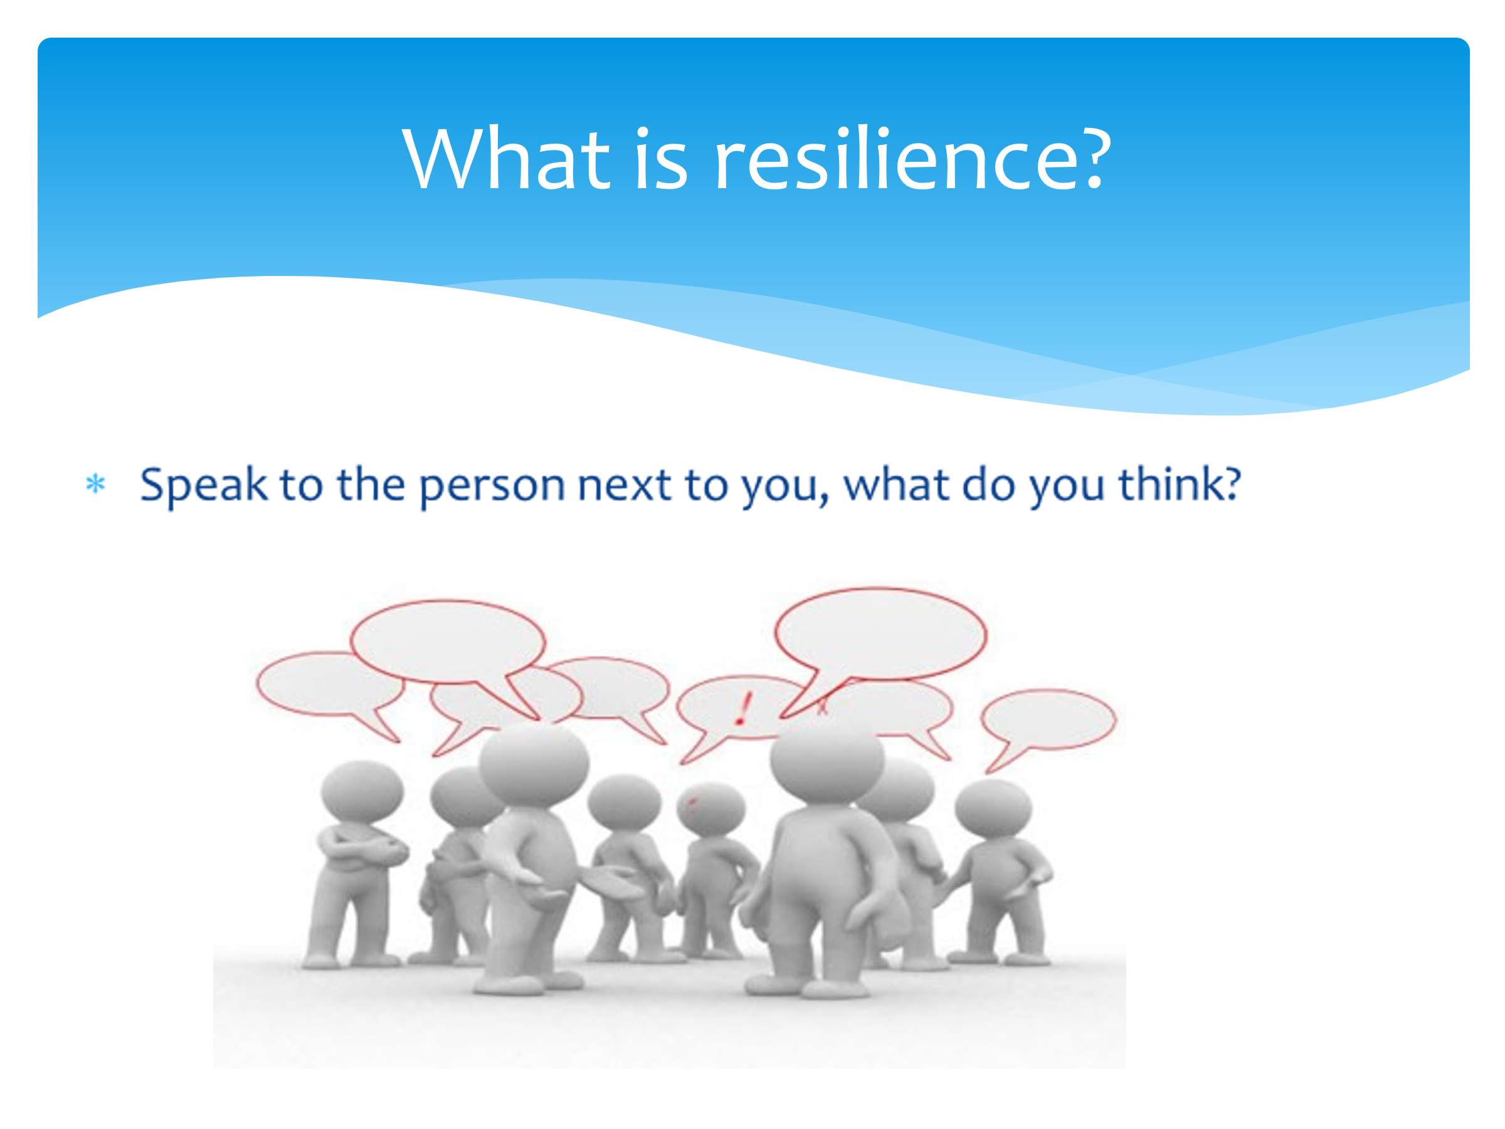 | In session one we created this definition of resilience (show group definition from week one). Are we still happy with this? Do we want to change it? Add to it? Provide more detail? Work with a partner to see what changes you can suggest.  Use CYP feedback to create a better version of the original definition with more detail. Acknowledge how much progress the group has made with their understanding.
Here’s a short clip which really sums up what we have been working on in this project.

After watching the video, take any feedback or questions from CYP as required).
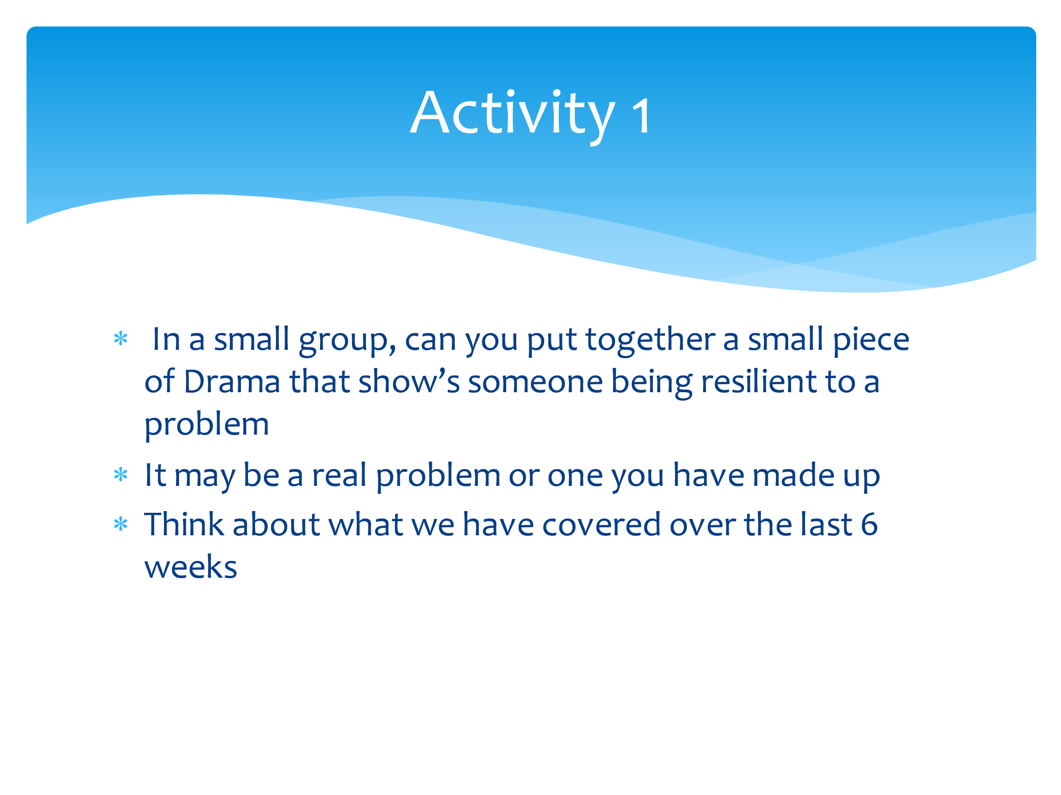 | One thing the video showed us was that it’s important to practice resilience skills on the small stuff so we are better equipped to deal with the big stuff.  We’re going to have a practice now with a small piece of drama (any pupils who can’t take part can write a script instead).  For this drama activity, you need to be in small groups of up to 4 people. Decide on a challenge or difficulty that young people might face (you can look at your ‘worries’ list for ideas) and show as a group how that person can become more resilient to those challenges.
Watch each performance in turn (and reading of scripts if required).

Ask the audience to comment on what the issue or challenge is, and then say how resilient the person was to it, or how they coped with it and can therefore improve their resilience in the future.
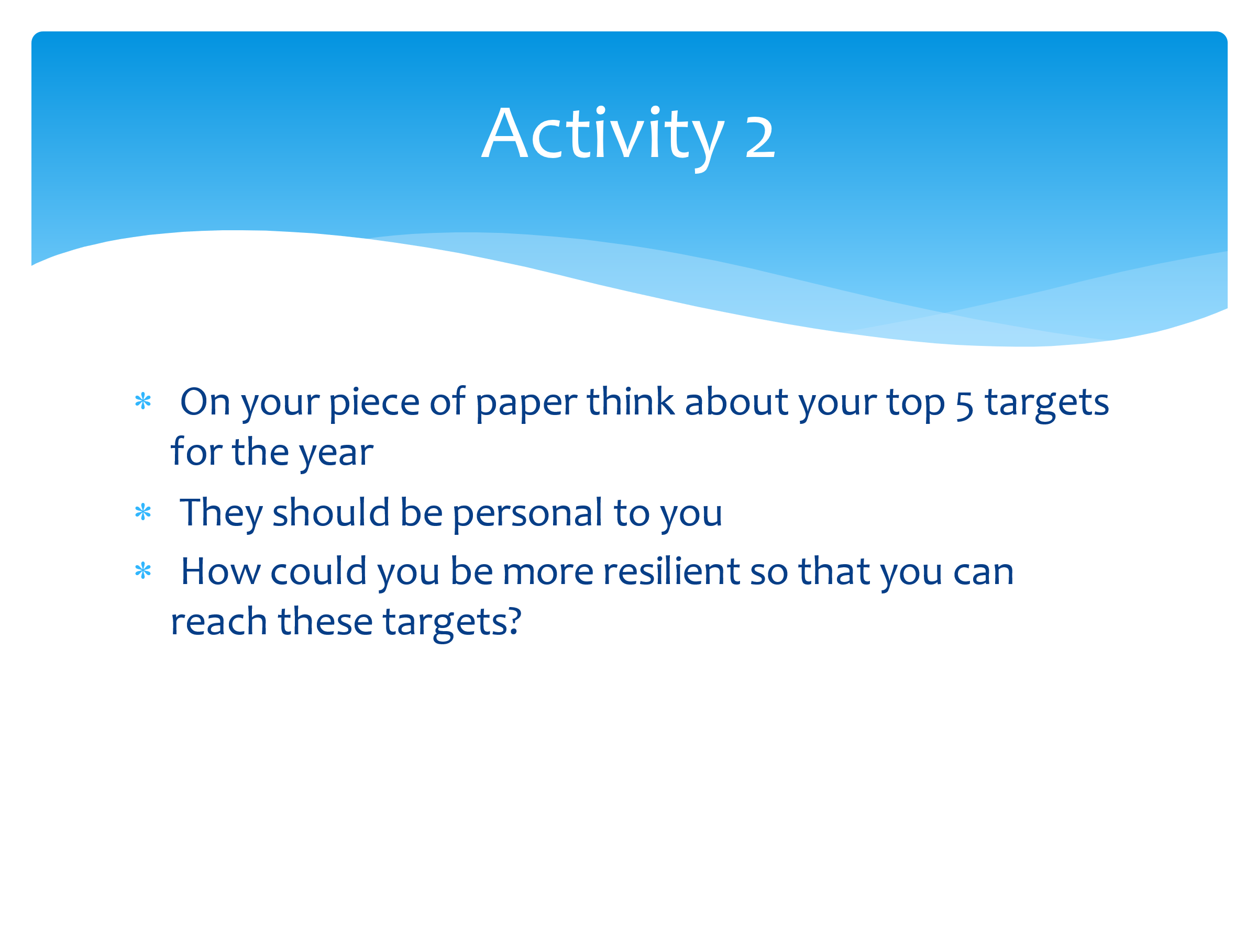 | Now we’re going to look at your personal targets. So have a think and write down your top FIVE targets for this year. They should be personal to you, and they don’t have to be school-related. They can be things that you want to improve in yourself. They can be short or long term targets.  Give pupils paper and 5 mins to do this task.  Now, have a look at those targets. Share them with your partner. Look at what each other has written. How can you be more resilient when working towards these targets? Do you need to give yourself a longer timescale? Do you need to involve someone else in it/ask for help? Do you need to be adaptable to changes in the target and expectations? Do you need allow yourself some more good time from your wellbeing plate?  Ask CYP to share one of their targets and how they can be more resilient in terms of meeting the target.
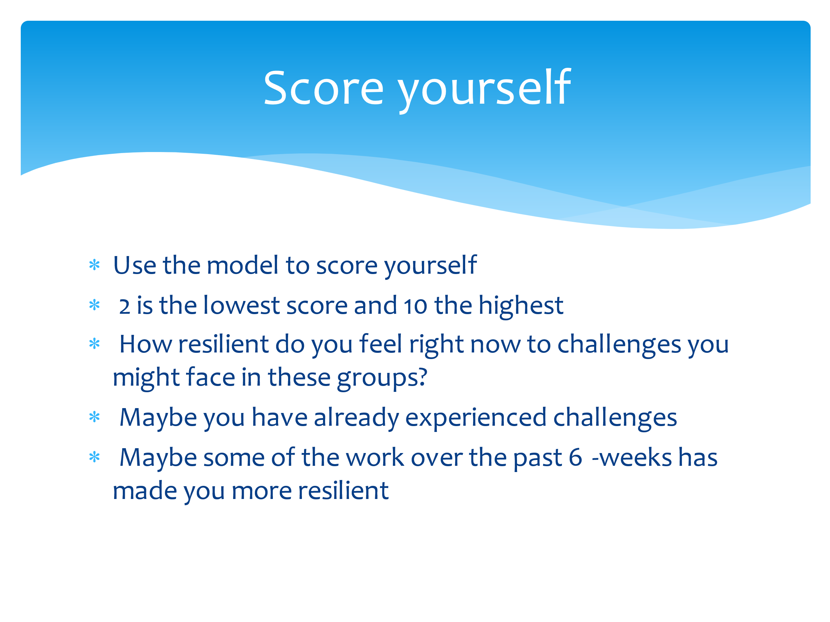 | Now let’s go back to when we scored our resilience back in Session 1. Re-score yourself now based on what you’ve learned.  How resilient do you feel right now to challenges that you might face? Maybe some of the work we’ve done over the last five weeks has increased your resilience.  Allow time for this activity.  Now I’d like you to speak with a partner and show them where you have really improved your resilience in comparison to before this project. Are there any areas where you are ‘stuck’? If so, what can you do about it? Think about the wellbeing plate, Maslow’s pyramid (and the ladder) and your good mood list!  Allow time for this and ask CYP to report back on their progress.
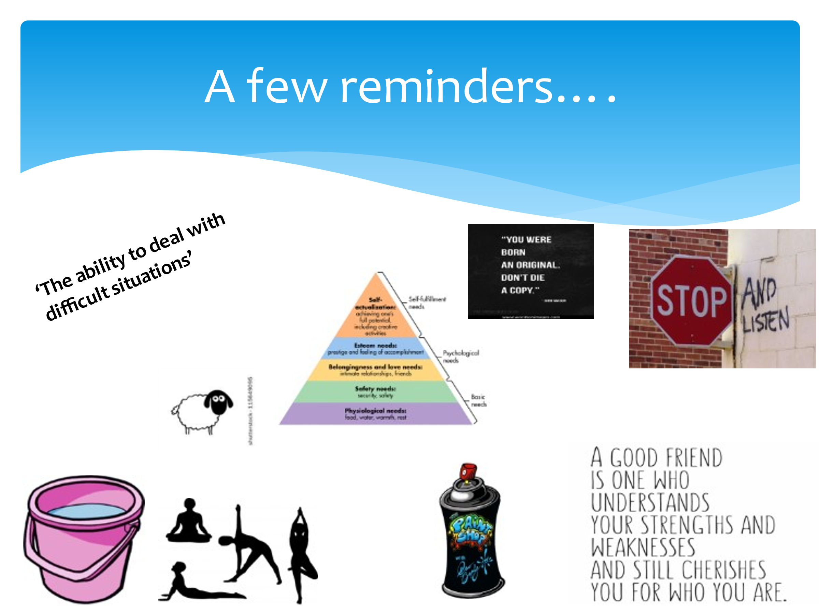 | Share visuals to link back to the activities of the programme. Take feedback from the group regarding the following:  - What did you enjoy?  - What did you find really helpful?  - Will you use any of the tools or strategies you’ve learned during this project? If so, which ones?  - What would you like to know more about?  - What would you like to do again?
 | Are there any questions that have arisen today as a result of this session? Anything you’d like to know more about or discuss in more detail?

Appendix 1 - CYP Resilience Score Sheet/Scale

NAME: ____________________________

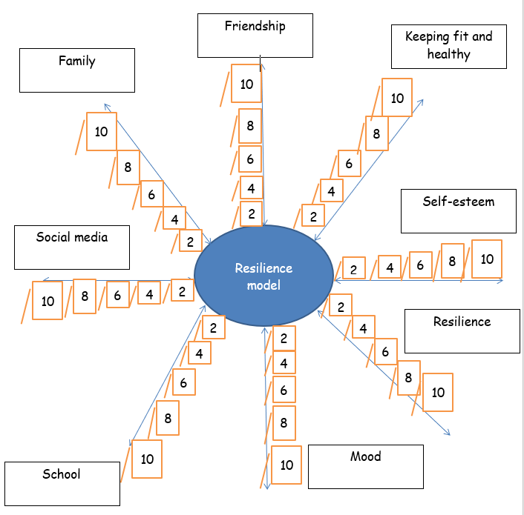

Appendix 2 – Guided Meditation Script

Alleviate Stress with Three Deep Breaths (from MindfulnessExercises.com)

This script guides the listeners to adopt a simple stress release technique – that is, taking three deep breaths. It also includes positive affirmations that can help to shift the subconscious mind.

Your voice at the beginning of the session is serious yet calm and soothing, speaking at a
slower yet comfortable speed. Words that are underlined should be emphasised and said
with conviction.

Begin by taking a deep breath and hold it for 5 seconds… (pause for 5 seconds)… exhale and
relax… (pause for 5 seconds)... take another deep breath, as deep as you can, and hold it,
count for 5 seconds… (pause for 5 seconds) and as you exhale just imagine blowing out all
of your stress… (pause for 5 seconds)... take a third deep breath and hold it… (pause for 5
seconds)... and as you exhale you blow out any stress you’ve been holding on to, saying to
yourself “relax now”.

[pause for 3 seconds, speaking now with confidence and at a normal pace of speech]

This is your new solution to stress.

Whenever you become stressed in the future, you simply take 3 fully in and deep breaths,
holding it at the top of the inhalation for 5 seconds, and when you exhale, blow out any
stresses that you feel.

And on the third breath as you exhale you simply say to yourself, relax now.

[Pause for 5 seconds] [speaking slowly with a soothing and gentle voice]

[Body Scan Induction]
Begin by slowly blinking your eyes, and with each number I say, blink once. (pause for 3
seconds in between each number) 10, 9, 8, 7, 6, 5, 4, 3, 2, 1, and 0.

Allow your eyes to gently close, and when you do this you feel a wave of relaxation sweep
over you.

[speaking even slower now]

Now I’d like for you to focus on the sensations at the top of your head. Just notice how the
very top of your head feels. [Pause for 5 seconds]

And now let your focus move down to your eyes. Just notice how your eyes feel and ask
them to relax even more. The little movement in your eyes is called rapid eye movement
and is completely normal.

These small eye movements allow for you to feel calm. Notice how the back of your head
feels against the surface that it is touching. How heavy does your head feel right now?

[Pause for 5 seconds]

Let your focus move to your nose, and feel the slight sensations of the air moving in and out
with your breath.

When you breathe in, imagine that you are being filled with calmness, and when you
breathe out, imagine your body feels heavy and deeply relaxed.

Very good. [Pause for 5 seconds]

Now focus on your ears. Notice how they feel, and what they hear around you. Try to hear
every single noise. When sounds come into your ears they act as little waves of relaxation
taking you even deeper.

Notice the sound of my voice and how soothing it is. From here forward you
can only hear my voice guiding you.

All other sounds passing though only take you deeper into a state of relaxation.

[Pause for 5 seconds]

Now focus on your mouth, how does it feel? And what do you notice?

Can you sense the flavour of something you recently tasted? Perhaps you can imagine biting
into a fresh slice of lemon, and you notice how your mouth waters.

Very good. [Pause for 5 seconds]

And move your focus down now to your neck, and if there is any tension just ask it to
release a little more.

Notice how your neck feels right now, and just feel all of the sensations in your neck.
[Pause for 5 seconds]

Now focus on your shoulders and move your attention slowly going down each arm, down
all the way to each fingertip. What are your fingertips touching right now?

Feel the sensations on your fingertips…. (pause for 3 seconds)

Nice. [Pause for 5 seconds]

Allow your focus to go to your chest, relaxing this area, as well as your upper back. And if
you notice any tension, just ask it nicely to release just a little.

Now imagine you are focusing on your heart, and feeling it beating strongly, supporting
you. Relax your heart and notice how good it feels to do so. [Pause for 5 seconds]

And now focus on your lungs. Feel them gently expanding and contracting with your
breath, delivering oxygen to your body. [Pause for 5 seconds]

Allow your focus to move down your vital organs and digestive system. Just notice your
belly and how it feels, just observe it working and digesting effortlessly for you.

Now notice your lower back and how it is pressing against the surface you are on, and if
you feel any tension just say, please relax just a little more. [Pause for 5 seconds]

Focus now on your pelvis and hips and notice any sensations you are having there. This
takes you even deeper into a state of relaxation. Allowing your focus to move down each
leg now, slowly relaxing those as well.

Your legs have been taking you so many places over the years and they deserve to fully
relax. [Pause for 5 seconds]

Notice this wonderful wave of relaxation moving down to your knees and down your lower
legs, all the way to your feet and the very tip of each toe… (pause for 3 seconds)

Good, you are doing so well. [Pause for 5 seconds]

Now that you have relaxed your body so well, I am going to count down from 10, and with
each descending number your conscious mind will relax even more so, letting go of any
beliefs that hold you back from your goal.

Imagine that you are standing at the top of a set of stairs and when I begin counting, you
will walk down the stairs.

Ok (pause 3 seconds between each number) 10, 9, 8, 7, 6, 5, 4, 3, 2, 1, and zero.

[Pause for 5 seconds]

Good, it‘s natural that your conscious mind give less and less importance to the words that I’m saying, allowing your subconscious mind to be present right now. [pause for 3 seconds]

From now on you choose to be relaxed…(pause for 3 seconds)

You choose to be calm…(pause for 3 seconds)…

You choose to be in control of all you do because your health is very important to you.
[pause for 3 seconds]

Remember that it is natural for you to be healthy and happy. It is unnatural for you to have
sickness and misery. [Pause for 5 seconds]

Now hear yourself saying: (lower the tone of voice and speak very slowly now, with great
confidence). Each day, in every way, I get better and better. [pause for 5 seconds]

In order to make change I challenge myself. [pause for 5 seconds]

Change is not comfortable, in fact it is inconvenient, so if I feel comfortable with the change
I am making, I am probably not extending myself enough. [pause for 5 seconds]

When I have a negative thought, I acknowledge that I feel this way and then I release it.
When another negative thought arises, I catch it quickly and I say with confidence, I
acknowledge that part of me feels this way, but this thought does not help me right now.
[pause for 5 seconds]

Each day, in every way I get better and better. [pause for 5 seconds]

Whenever I am presented with feelings of stress, I know my breath is there to soothe me
and guide me into relaxation. [pause for 5 seconds]

Every single day, I become more aware of all the good things going on in my community,
and in the world around me. [pause for 5 seconds]

When I feel that darkness is surrounding me, I know that the way to see light is to take 3
deep breaths, relaxing my mind and body by doing so. [pause for 5 seconds]

Each day, in every way I get better and better. [pause for 5 seconds]

In order to make great change, I challenge my thoughts. [pause for 5 seconds]

From now on I challenge every single negative and unproductive thought that arises.
[pause for 5 seconds, pace of speech returns to normal and is spoken with seriousness]

From this point forward, whenever you find yourself having negative unproductive
thoughts, you will immediately say to yourself the word STOP…..

Let me repeat that to you so that it is perfectly clear…. whenever you find yourself having
negative unproductive thoughts you will immediately say to yourself the word STOP, and
as soon as you say the word STOP you'll find that the negative thoughts you were having
will just disappear.

This gives you the opportunity to start a new positive thought process.

[pause for 5 seconds, speech is now positive and uplifting, supporting the listener]

How do you feel? Notice how you feel right now and take great note of exactly how you
feel, right now.

Good, now let’s come to conscious awareness, bringing back everything that you learned
today for the better. [speech when counting is always very slow]

1, slowly coming back to the present moment
2, (pause for 3 seconds)
3, (pause for 3 seconds)
4, feeling fresh, new energy coming in as you breathe
5, (pause for 3 seconds)
6, (pause for 3 seconds)
7, bringing back all that you have learned today
8, (pause for 3 seconds)
9, almost there
And 10. (pause for 3 seconds) Welcome back.

[pause for 5 seconds, speech is now positive and uplifting, again supporting the listener]

Good…(pause for 3 seconds)

This is the way you change your life for the better. [pause for 3 seconds]

Thank you, and well done.

Appendix 3 - Further Reading and Helpful Links

https://www.multischoolscouncil.org.uk/
https://www.mind.org.uk/
https://www.listennotes.com/podcasts/time-out-with-connell-co-connell-scholar-lpS4y1buFGA/
https://mhfaengland.org/
https://education.gov.scot/improvement/learning-resources/compassionate-and-connected-classroom/
https://www.youngminds.org.uk/
https://www.headstogether.org.uk/
https://www.kooth.com/

