## Landlord Consent Manual

## August 2021

1. **Why do you need Landlord Consent?**
   1. Landlord consent is required where changes or adaptions are being made to the building or land dependant on ownership or lease agreements, this process must be observed and approved by ECC to ensure that the ‘tenant’ is undertaking the necessary tasks under the current UK construction guidance and legislations. ECC will not only review the above requirements relating to ownership but consider the environmental impact of the proposals, their educational suitability and DfE compliance.
   2. ECC will not provide technical feedback or approve designs or planning, therefore we need evidence that this is in hand and being acted upon appropriately by the tenant.
   3. ECC, as Landlord needs to ensure that their assets are not compromised or damaged where the tenant needs to undertake a change to the property to aid with the education of their students, ECC will endeavour to be as flexible and openminded as possible, however it must be acknowledged that constraints are in place.
2. **Consequences of undertaking works without review/approval:**
   1. If construction works are undertaken outside of UK legislation and regulations, there is a serious risk of non-compliance to Health and Safety, planning, building control, construction design, building and environmental protections as well as other unlisted factors.
   2. These legislations are in place to protect Landlords, tenants, users of the building and grounds from poor design and planning, low quality materials, poor installation, and irreversible damage.
   3. If it is discovered or reported that any of the above laws are skipped or ignored there are several enforcements and powers the governing agencies can pursue, these are and not limited to:

* Criminal charges.
* Insistence on reversing all or part of works already undertaken.
* Fines
* Investigative costs incurred
  1. The above points can be acted upon at any time during construction or post-construction.
  2. You must remain aware that enforcement agencies do not accept ignorance as an acceptable excuse, investigations and fines can be excessive and extremely intrusive. It is up to you to ensure you understand and provide the correct information to ECC, if unsure you must employ a professional service to take on these responsibilities on your behalf.
  3. A school following the correct construction procedures will result in the construction and post construction phases of a project running smoother with better budget accuracy, risk levels reduced, operational and maintenance costs better understood and overall construction time reduced. The employment of a suitable building consultant who understands and can take on Construction Design Management responsibilities will be looking at all elements of a project from design to post-handover, for example if you have tall ceiling, they will be looking at how the lights are accessible without needing to pay for expense access equipment when bulbs need to be replaced.

1. **Landlord Consent Process** This section is to be read in conjunction with the landlord consent flow chart located on Page 6 of this document.
   1. The following bullet points provide the step-by-Step detail of the process you will need to follow to achieve Landlord Consent for your works.
2. Does it relate to Works? (ref: ‘works’ are related to construction or changes to the format of the build or grounds)
3. If **NO** (NON WORKS)then move to bullet point iii, if **YES** (WORKS) move to bullet point iv. (ref: ‘Non-works’ could be changing the use of a particular space that does not involve physical alterations)
4. For **NO** NON WORKS – e.g., changing the use of a space without any physical alterations. Please refer to Property Services using the following contact details:
   * School/Nurseries and Children's services email [sue.rutter@essex.gov.uk](mailto:sue.rutter@essex.gov.uk)
   * Any other enquires: [peter.white@essex.gov.uk](mailto:peter.white@essex.gov.uk)
5. For WORKS, if you answered **YES**. You will need to assess if your WORKS need Landlord Consent is required. Please Refer to the list below.
6. Landlord Consent is required if your project includes the following associated works:

* Adventure playground, fixed apparatus, pergolas, decking etc
* Air conditioning
* Artificial grass pitch
* Asbestos removal
* Awnings
* Boilers, water tanks, oil storage
* Boundary and security fencing, walls, railings, access gates, safety barriers
* Canopies
* Car parks – creating or extending
* Ceilings – replace, lower
* Conversion to specialist use
* Cycle sheds
* Damp proof course
* Dining hall serveries
* Doors internal if several involved (not for the odd one or two)
* Double glazing
* Drainage works
* Driveway entrances – changes to
* Dust extraction
* Electrical works including cabling, heating, fire alarm systems, lighting (internal and external), lighting and distribution boards
* Extensions
* External doors
* Fans – installation
* Foundation Stage/Early Years outdoor area
* Hard play extensions
* Kitchen refurbishment
* Laminate glass roof/windows
* MUGA
* New buildings
* New disabled access toilet
* Outdoor classroom
* Partitions – fixed/permanent
* Paths, driveways, changing grass to tarmac
* Pumps and filters (Boiler/plant)
* Ramps – installing
* Re-cladding, replace cladding
* Relocatables – move, install, remove
* Remodelling of administration area
* Remodelling of teaching accommodation
* Roofs
* Security doors, firewalls – installing
* Security lighting, including car parks
* Shading (Sunshades)
* Sinks and wet areas
* Swimming pools – new, decommissioning
* Toilet refurbishment, including changing layout
* Ventilation
* Water tanks, boilers and oil storage
* Windows (and door) replacement
* Wiring
* Strip out and replace units where drilling is required

1. Landlord Consent is NOT required if your project includes the following works **(if disturbing any part of the building fabric is required to any of the points listed below (e.g. drilling) and the building was constructed before 2000, this will require Landlord consent, ECC must be aware and monitor any activities that could release Asbestos from the building)**

* CCTV and security systems – installing
* Doors internal, consent not required for odd door, but if replacing several then it is required.
* Fascia’s
* Filters, pumps (e.g., Sump pumps)
* Flooring – all i.e. coverings and the actual floor if overlaying. If stripping of old floor this will need LLC due to the risk of ACM disturbance.
* Humidification
* Partition doors, folding doors, installing or removing (but consider if it will affect net capacity)
* Plumbing works
* Replastering walls and new skirting
* Shutters including security and kitchen roller shutters
* Signs
* Soffits
* Solar film to roof/windows
* Storage cupboards

1. If you have reviewed the list above and remain unclear on the Landlords Consent Requirements, please contact

infrastructure.delivery@essex.gov.uk

1. If you have assessed that your Project does not require Landlord Consent this process ends.
2. If you have assessed that your Project if Works and does require Landlord Consent progress with stages A to K below:

* A, Tenant completes LLC1 Stage 1 Project Concept form and submits to infrastructure.delivery@essex.gov.uk
* B, Landlord review’s completed LLC1 Stage 1 Project Concept Submission, Stage B may require additional feedback between landlord and tenant.
* C, Landlord then either completes LLC2 Form and issues back to Tenant If LLC Form 2 is required progress to Stage D
* D, Tenant reviews the LLC2 Project Detail Checklist and Tenant submits to the landlord all information requested by ECC on LLC2.
* E, Landlord reviews LLC2 Project Detail Checklist submission. ECC provides technical review and feedback to the Tenant. Stage E may require additional feedback between landlord and tenant.
* F, Landlord Consent decision issued to the tenant
* G, Landlord advises Tenant that project can proceed and issues LLC3 Project Completion Checklist this is to ensure Tenant is aware of the requirements at Project Completion.
* H, Tenant the proceeds with the approved project
* I, On Completion of all the WORKS, Tenant issues to Landlord all the required LLC3 Project Completion documentation.
* J, Landlord reviews submitted LLC3 Project Completion Documentation, Stage J may require additional feedback between Landlord and Tenant.
* K, Landlord confirms to Tenant that the Consent Process is Complete.

1. Landlord Consent Process Ends.
   1. Alternatively, the pictogram below provides a step-by-Step Flow Chart of the process you will need to follow to achieve Landlord Consent for your works.

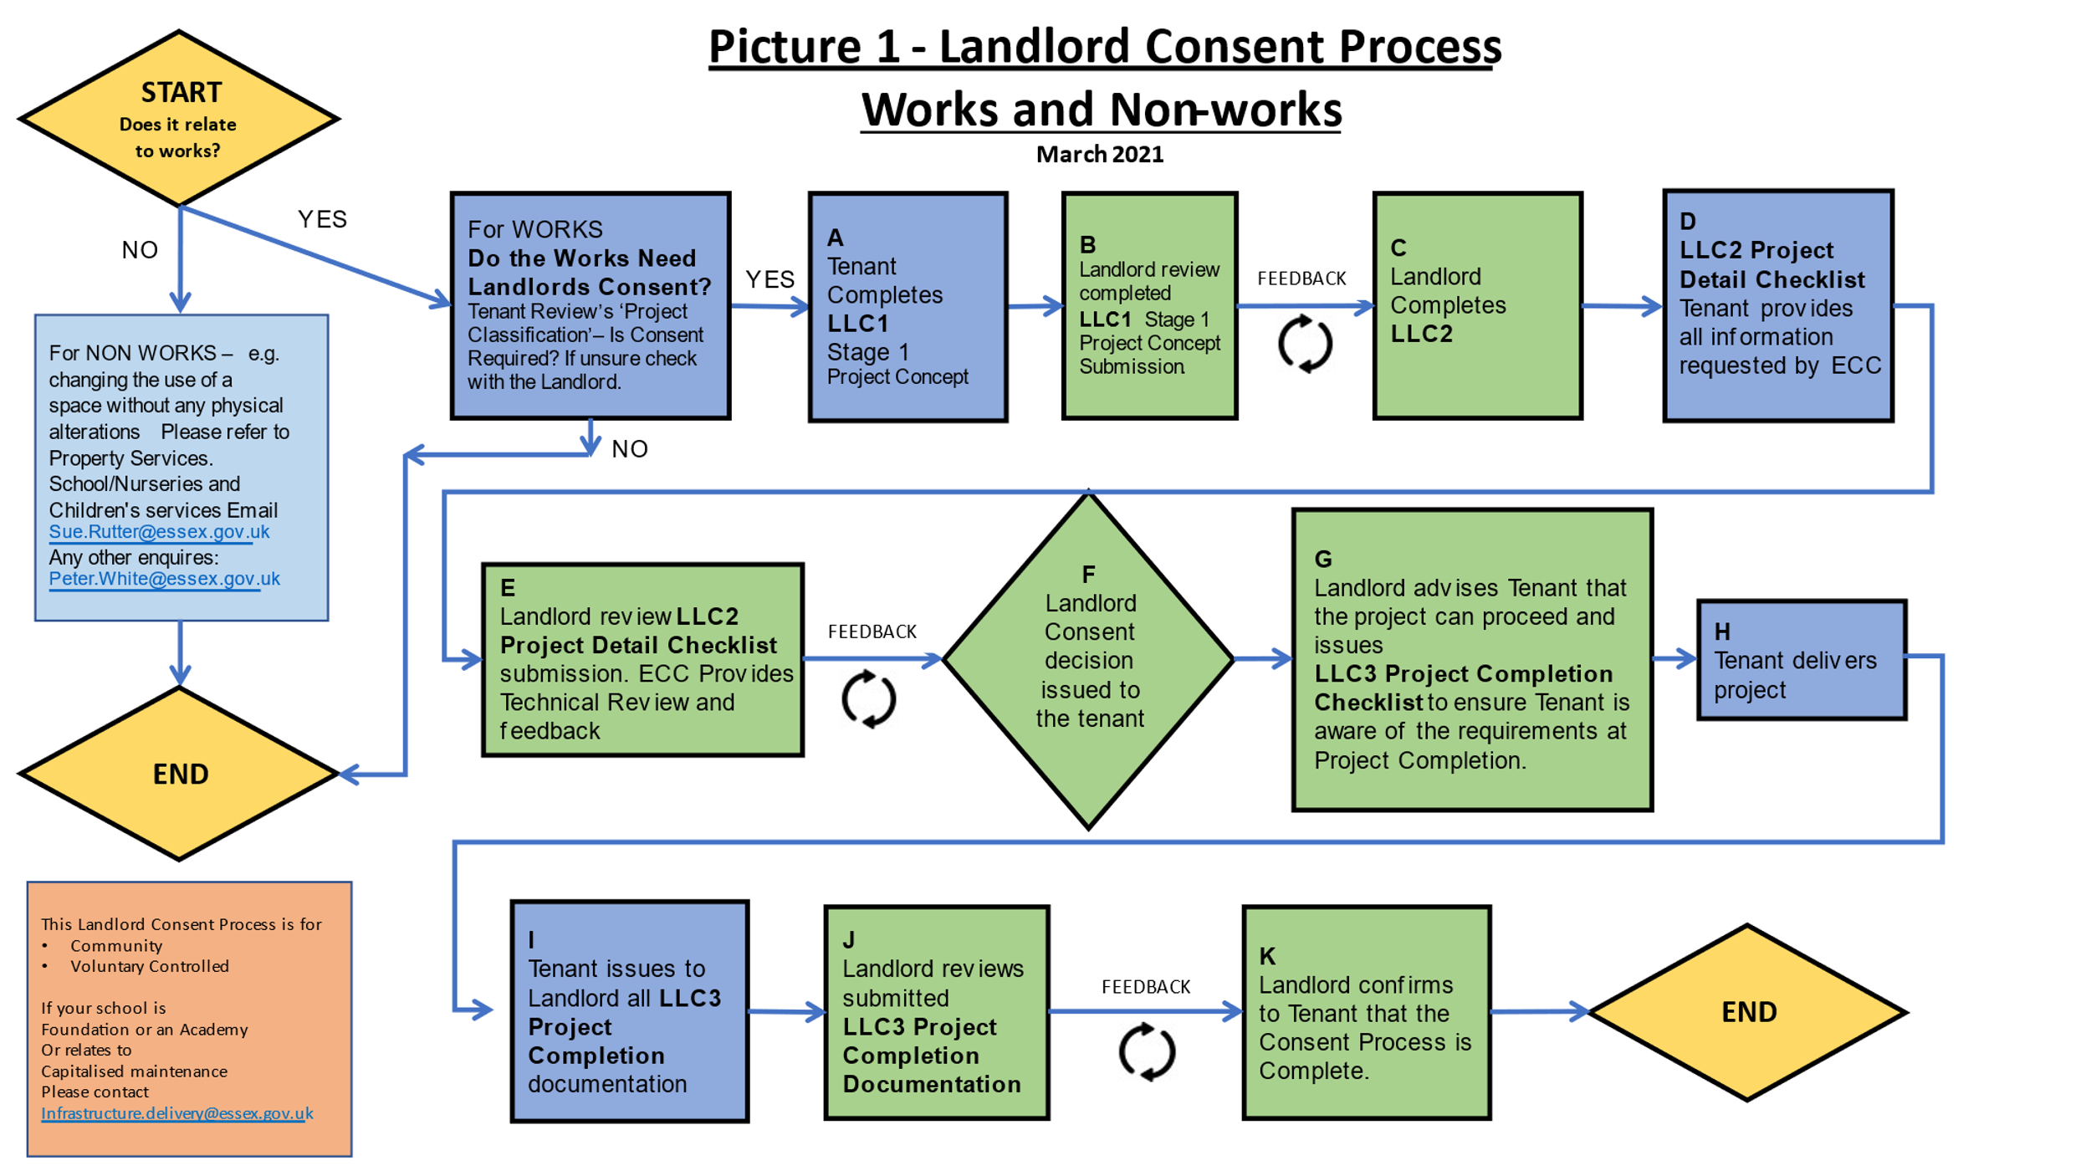

* 1. **Examples of projects that would require Landlord consent:**
     1. Change to school capacity – i.e. number of available places.
  + ECC need to be made aware, if a school intend to extend the buildings footprint of the existing floor plan, where changes are made to the format of the existing floor plan, for example removal of internal walls, both load bearing and non-load bearing.  External infill spaces converted to habitable rooms, offices, or corridors.
  + ECC do not need to be made aware, if a school intend to divide an open space using non-permanent divisions or screens, and where no alterations are made to the existing building fabric or services.
    1. Impact the ability of the school to be expanded in the future
  + ECC need to be made aware, As the ECC estate is constantly under review and where town/districts are growing in size there is likely to be a strategic plan to increase the capacity of a school, where a school wish to increase the foot of the existing building a formal review will need to be undertaken by ECC to ensure that such proposals do not hinder future expansion schemes.  This might be in the form a physical building or where access is changed.  Examples of this could be where a school want to install a canopy, this can cause access issues for plant and equipment at a later date, access to an elevation intending to be built against or restrictions where a canopy might restrict access to a roof needing repair or maintenance works.
  + ECC do not need to be made aware:  If the school need to install a shed for storage without service connections like gas or electric, ECC would not need to know as temporary structures can be moved temporarily or re-located if access or land is required for a future expansion Project.
    1. Impact the value of the building
  + ECC need to be made aware, if a building has a protected status or contains an artefact of considerable interest, changes, removal, or damage can have a significant effect of the value of the building.  For example, if a decorative brick/tile façade is rendered over without consent from ECC, local planning and heritage departments can stipulate that the building is put back to its original condition.  This will incur sizeable remediation works, heritage input and planning approval all at cost to ECC.  This is assuming damage is reversable.
  + ECC do not need to be made aware, where routine maintenance is undertaken to retain the character of a building element ECC do not need to be made aware.  For example, the like for like painting of a Cupola or bell house.
    1. Impact utilities – Gas, Electricity, Water, Oil.
  + ECC need to be made aware, where excavation works are being undertaken it is very easy for a contractor to miscalculate the location of a main service into a building, for example if a gas, water electrical main is struck this can not only cause immediate danger to the contractor and site users it can also disrupt surrounding building should the main supply need to be shut off and repaired.  A competent consultant and contractor can manage the correct investigation techniques to plot services prior to works commencing as part of a well planned and executed project.
  + ECC do not need to be made aware, if a school have a number of Thermostatic radiator valves that are damaged and need to be replaced, we would not need to know that these need to be replaced, it would be the responsibility of the school to ensure that the valves are replaced like for like by a suitably qualified and experienced contractor.
    1. Window replacement:
  + ECC need to be made aware, a window is set to be replaced through age or defect, ECC would need to be made aware so that it can be checked that all requirements are in place.  Planning can be a governing factor when replacing windows along with the necessary regulatory requirements, building regulations, Construction Design Management (CDM) and Asbestos.  A good, suitably qualified building consultant will need to manage such Projects to ensure the regulations above are met and structural factors are considered and designed out accordingly.
  + ECC do not need to be made aware, if a windowpane has failed, for example if it has misted between the two sheets of glass, a reputable window company will advise the change of glass only and not the frames.  This is a simple and unobtrusive exercise.
    1. Door replacement:
  + Examples where ECC need to be made aware:   As above, if a door is set to be replaced through age or defect, ECC would need to be made aware so that it can be checked that all requirements are in place.  Planning can be a governing factor when replacing doors along with the necessary regulatory requirements, building regulations, Construction Design Management and Asbestos.  Old fire doors can be lined with Asbestos and without the correct management in place contractors and site users can be at risk if such material is damaged in the removal/adaption of the doors.
  + Examples where ECC do not need to be made aware:  If a door has become difficult to operate a good door/window contractor would be able to ease and adjust the door on its integral adjustment controls, if it is UPVC, composite or aluminium.

* + 1. Structural works
  + ECC need to be made aware:  If the school has suffered from cracking to the building or a proposed extension needs part of the existing building to be changed or moved, we would need to be aware.  Firstly, from the regularity perspective (Planning, Building Control, CDM and Asbestos) are being correctly controlled but also to ensure the correct level of input is being applied from an external and appropriately qualified and experienced building consultant.  If a building is cracking as mentioned, this could be an insurance claim which ECC manage internally so we need to be aware of such instances to monitor the process.
  + ECC do not need to be made aware:  If a school has a wall or room that has a poor wall finish and a plaster skim over is required, as long as the existing walls are not disturbed through racking, scraping or hacking ECC would not need to be made aware, however if there was a stippled finish that needed to be scrapped back prior to the skim ECC would need to be informed.

* + 1. Roofing works
  + ECC need to be made aware, where a school propose to fix or repair a leaking roof, ECC need to be informed for the following reasons.  Existing warranties can be voided by the cutting or patching of an existing roofing system, we can advise if such warranties are in place and if this can be covered by the manufacturer of the system.  Asbestos can be present in older felt materials and ECC need to aware of any works to ensure CDM, Asbestos, building and planning regulations are adhered to.  In some instances, roof structures are designed with limited tolerances and additional layering where an overlay might be proposed might exceed roof overall loading capabilities.
  + ECC do not need to be made aware, where roofing tiles have slipped or fallen and need to be replaced or guttering needs to be adjusted or replaced outside of known warranties, ECC would not need to be made aware, it would be for the school to ensure a suitable contractor undertakes the works and meets Health and Safety, Asbestos and CDM regulations.