**PNI Specialist Teaching Team – who we are and what we do**

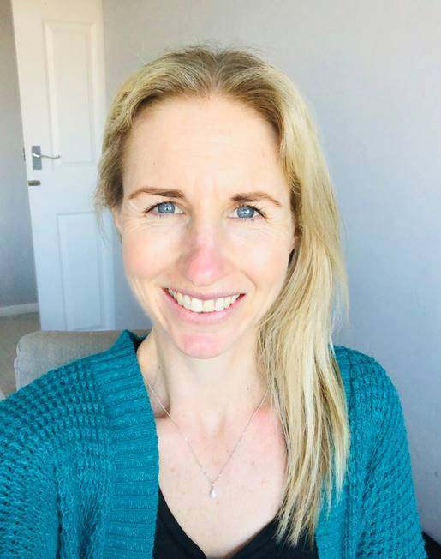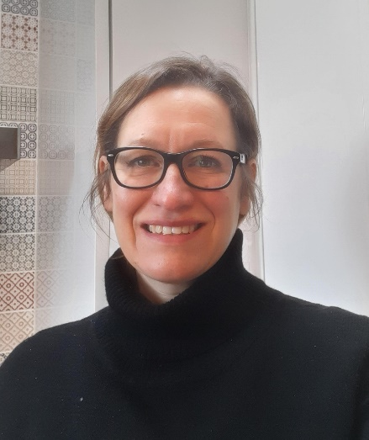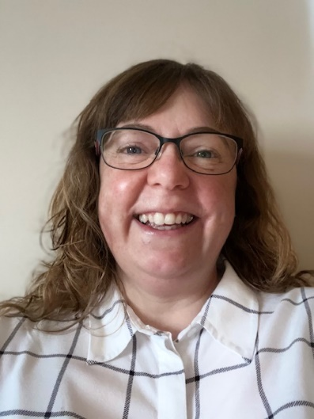

Jennie Hipkin Catherine Hills Nicola Welham

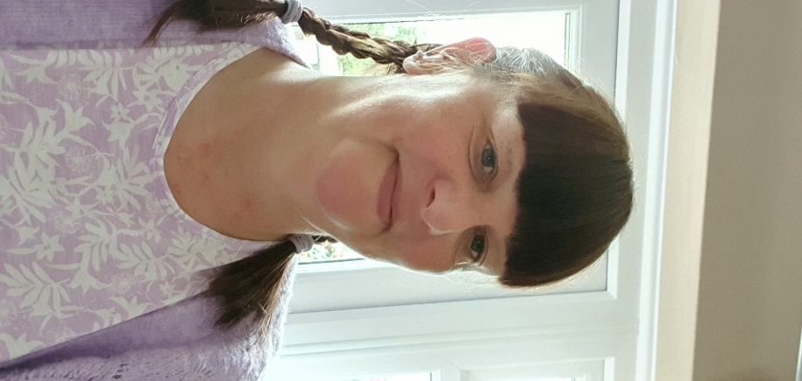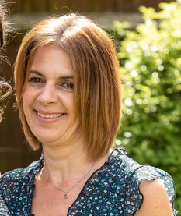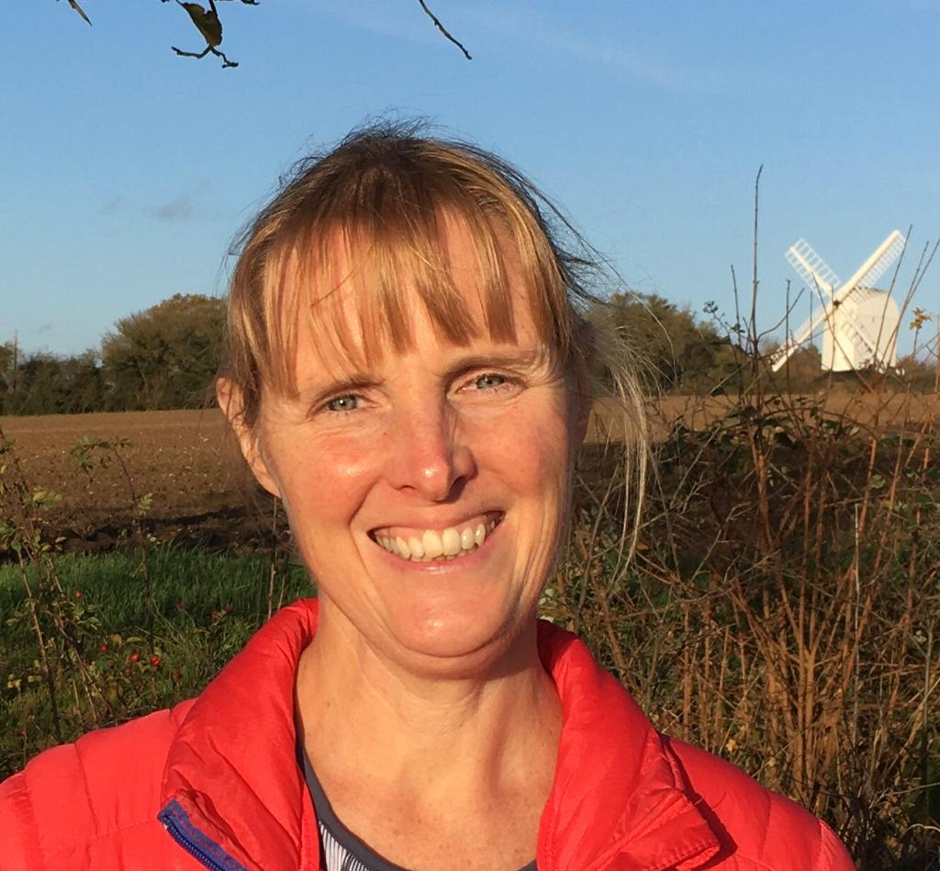

K-J Dalley Nicky Rollinson Katie Howard

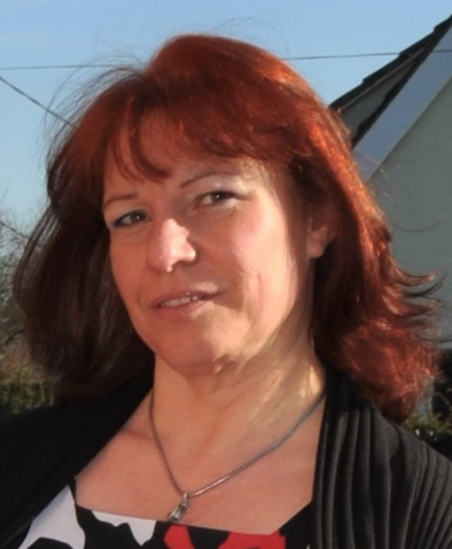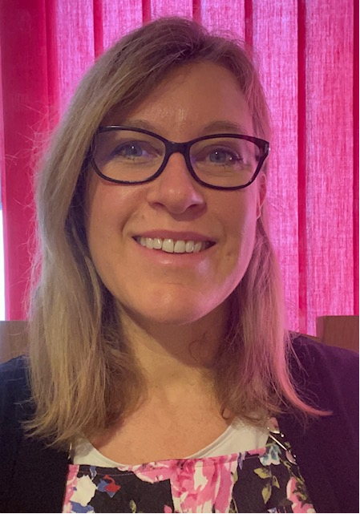

Jo Lambert Mary Osborne Jess Fairman

The Specialist Teaching Team for Physical and Neurological Impairment (PNI) aims to ensure that children and young people (CYP) with physical difficulties and/or medical needs can attend mainstream settings; be safe, learn, make progress, socialise and join in with all aspects of school life**.** We work with CYPwho meet our criteria for support from the ages of 0-25**.** PNI Specialist Teacher support can vary from setting to setting and can be tailored to the unique needs of the CYP and the staff working with them. This support can include some or all of the following, depending on the level of need:

* Advice giving in the form of telephone calls, emails, face to face meetings, visit notes or signposting to useful websites or organisations.
* Assessment of the physical environment of a setting and advice on adjustments to this if necessary.
* Close liaison with other professionals involved in the care of the CYP, including, Occupational Therapists, Speech and Language Therapists, Physiotherapists and Social Workers.
* Information giving and sourcing of specialist equipment, including technology, where necessary. Direct teaching in the use of certain equipment where appropriate.
* Support for school staff in differentiating the curriculum to meet the CYP’s learning and physical/medical needs. Assessment of the CYP’s learning with a view to informing next steps and maximising progress.
* Advice giving regarding accessing off-site visits and extracurricular activities.
* Provision of training to staff in order that they understand the nature of a CYP’s condition or disability, and the implication of these for their education, thus enabling them to support the CYP effectively and sensitively.
* Support for the CYP and staff in terms of developing self-help and independence skills, as well as confidence, self-esteem and self-advocacy (helping the CYP to express their views and communicate their needs).
* Support for the CYP and settings at times of transition, such as moving to another setting.
* Provision of strategies and advice around Preparing for Adulthood.

**Criteria for possible PNI Specialist Teacher support:**

1. Evidence of a physical difficulty and/or medical need, which is creating a significant barrier to a CYP’s access to their setting and/or their learning.
2. Evidence that a setting will need to make reasonable adjustments above and beyond that needed for any other CYP in the setting.
3. Evidence of a significant need for specialist equipment and/or adaptations to the physical environment.

**How to request PNI Specialist Teacher support:**

Please complete the online form, which is available on the Infolink, attaching any supporting documents. If you have any difficulties with this or have any questions, please contact [education.psi@essex.gov.uk](mailto:education.psi@essex.gov.uk) , with PNI in the subject line.