

**Early Years Foundation Stage Profile**

**Summer 2023 data collection**

**Guidance Notes for Schools**

**Contents**

1. Reporting EYFSP levels to the LA 2-3

2. Key dates 4

3. Children who move to a new school during the year 4

4. Creating your return 4

5. Data checking reports 4

6. Reporting results to parents 4

7. Returning data to the LA using s2s 5-10

8. Contact us. 11

**1. Reporting EYFSP levels to the LA**

**School or Setting data**

The following School or Setting data is required:

* local authority number: For Essex this is 881.
* establishment number of the school: for local authority maintained schools, academies and nursery schools. This is a 4-digit number.
* early years unique reference number (URN) of the setting: for all other funded settings, including independent schools and private and voluntary settings. It is a 6-digit number (starting with a 5, 6 or 7) as used for early years census 2023 return.
* academic year: This year will be 2022 to 2023

**Pupil data**

The following pupil level data should be provided for each child:

* Surname (i.e. legal surname)
* First forename (full forename, not shortened or familiar versions)
* Unique Pupil Number (schools only)
* Gender
* Date of Birth
* Home Postcode

**EYFSP data**

Each child is awarded an assessment rating of 1 (‘emerging’ level at the end of EYFS) or an assessment rating of 2 (‘expected’ level at the end of EYFS) in each of 17 early learning goals (ELG).

Code ‘A’ should be used to indicate a child who has an exemption. This code should only be used in the following circumstances:

* The secretary of state has granted an exemption from the profile
* The child is continuing in early years foundation stage provision beyond the year in which they turn 5

If the secretary of state grants an exemption from the profile, use code ‘A’ from every learning goal.

Where a child has a special educational need or disability (SEND), you should:

* Make sure the child is able to demonstrate their development and attainment
* Not assign an exemption to the child unless one has previously been obtained

The goals are grouped into areas of learning, such as communication and language and physical development. These areas of learning are themselves grouped into prime and specific areas..

A child is considered to have made a good level of development if they have been awarded an expected (2) in all of the prime areas of learning, as well as the literacy and mathematics goals, 12 goals in total.

Tables 1 and 2 below show the EYFSP data items and data values collected for each child.

Table 1. Data items collected for each child

|  |  |  |  |  |
| --- | --- | --- | --- | --- |
|  | Areas of Learning | GLD | Early Learning Goals | Valid Data Values |
| Prime Areas | **Communication and Language** | **✓** | **E01 - Listening, Attention and Understanding** | **2, 1, A** *(see table 2)* |
|  |  | **✓** | **E02 - Speaking** |  |
|  | **Personal, Social and Emotional Development** | **✓** | **E03 - Self-regulation** |  |
|  |  | **✓** | **E04 - Managing Self** |  |
|  |  | **✓** | **E05 - Building Relationships** |  |
|  | **Physical Development** | **✓** | **E06 - Gross Motor Skills** |  |
|  |  | **✓** | **E07 - Fine Motor Skills** |  |
| Specific Areas | **Literacy** | **✓** | **E08 - Comprehension** |  |
|  |  | **✓** | **E09 - Word Reading** |  |
|  |  | **✓** | **E10 - Writing** |  |
|  | **Mathematics** | **✓** | **E11 - Number** |  |
|  |  | **✓** | **E12 - Numerical patterns** |  |
|  | **Understanding the world** |  | **E13 - Past and Present** |  |
|  |  |  | **E14 - People, Culture and Communities** |  |
|  |  |  | **E15 - The Natural World** |  |
|  | **Expressive Arts and Design** |  | **E16 - Creating with Materials** |  |
|  |  |  | **E17 - Being Imaginative and Expressive** |  |

|  |  |
| --- | --- |
| Assessment rating | EYFS judgement |
| 1 | Indicates a child who is at the ‘emerging’ level at the end of the EYFS |
| 2 | Indicates a child who is at the ‘expected’ level at the end of the EYFS |
| A | Indicates a child who has an exemption |

Table 2. Note - **If any item: E01 to E17 is indicated ‘A’ then all items must be indicated ‘A’**

**2. Key dates**

The deadline for data submission to LAs is **Friday 30 June 2023**.

To ensure all data cleansing and checking can be completed we would request that you submit your data to us from the beginning of Juneif at all possible. This will also allow us to monitor data quality and assist you with any queries.

**3. Children who move to a new school during the year**

If a child moves to a new school or provider during the academic year, the original school must send their assessment of the child’s development against the ELGs to the new school or provider.

If a child starts a new school or provider on the first day of the second half of the summer term (or any time after that), then the previous school should submit the data. If a child moves school or provider any time before the half term, then the new school should submit the data. Where half term dates differ between LA areas, it is the school or provider where a child attends (or will attend) for the longest period of time that submits the data.

**4. Creating your return**

Schools should record their EYFSP data for each child on their assessment software e.g. Target Tracker, SIMS Assessment Manager, etc. Your software will allow you to create an export file to send to the LA. **Please note we cannot accept results as paper returns.**

Any queries regarding the creation of the export file should be referred to your software provider, but please contact us if you require assistance in using the s2s website to send us your data.

**5. Data checking reports**

Once we have received and processed your EYFSP data, we will send you details of the results we hold prior to submitting them to the DfE. This will give schools a final opportunity to check their data and to notify us of any amendments.

**6. Reporting results to parents**

Once the EYFSP data has been stored in your assessment software and has been verified you will be able to produce the child and school level reports for parents.

**7. Returning data to the LA using s2s**

Schools should use the **school to school (s2s)** data transfer website to send their FSP data to the LA. Schools are reminded that s2s is now via DFE Sign-in.

Log in to **DfE Sign-in**

The **DfE Sign-in** screen looks like this:

**Screen 1**

Enter your email address and password and click **‘Sign in’.** The My Services (like Screen 2 below) will now appear.

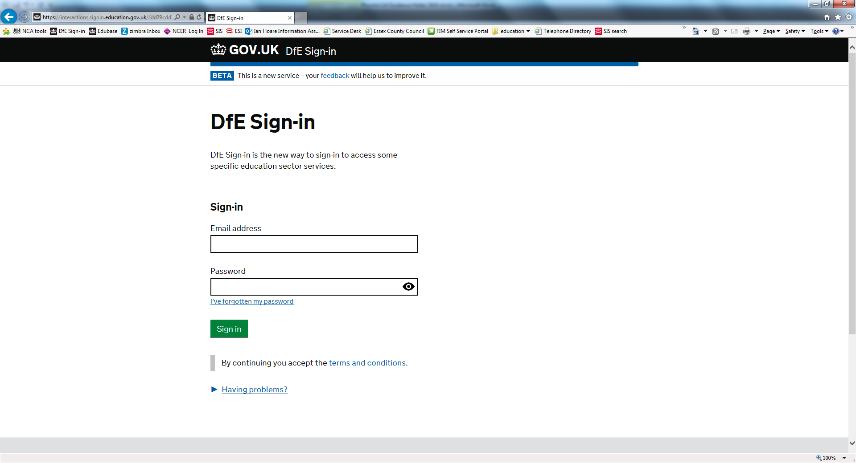

**Screen 2**

Select **‘School to School’** to access the school to school (s2s) data transfer website. (other services such as Collect may be on this screen if your approver has selected them for you. If School to School is not showing, click the My Approvers link and find your approver and request access to s2s).

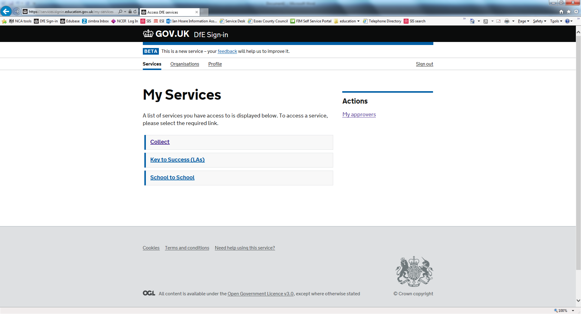

Screen 3 should now appear. (Other DFE Sign-in screens may intervene.)

**Screen 3**

From the Upload menu on the left-hand side of the screen, select **‘Upload CTF File’.** Screen 4 will now appear.

s2s upload choices screen

**Screen 4**

Schools must use the **‘Browse’** function to find their file. If you type in the file path this results in an empty file being returned.

s2s file upload page

Use the Browse function to find the FSP XML file stored on your computer in your chosen location. The file name will be in one of the following formats:

**881SSSS_FSP_881LLLL_NUM.XML or**

**881SSSS_CTF_881LLLL_NUM.XML**

where:  
**SSSS** is the school DfE number.  
**NUM** is a file extension number (such as 001, 002 or 100, 101), which increases each time a phonics file is created.

To check that you have located the most recent version, hover over the file name with your cursor to see ‘date modified’.

Once the file has been located, double click on the file name and the box **Select Folder & File Name** will be populated with the file. Screen 5 will now appear.

**Screen 5**

Click ‘**Upload file’**. A warning box will appear to say this could take up to five minutes to upload. Click **‘OK’**.

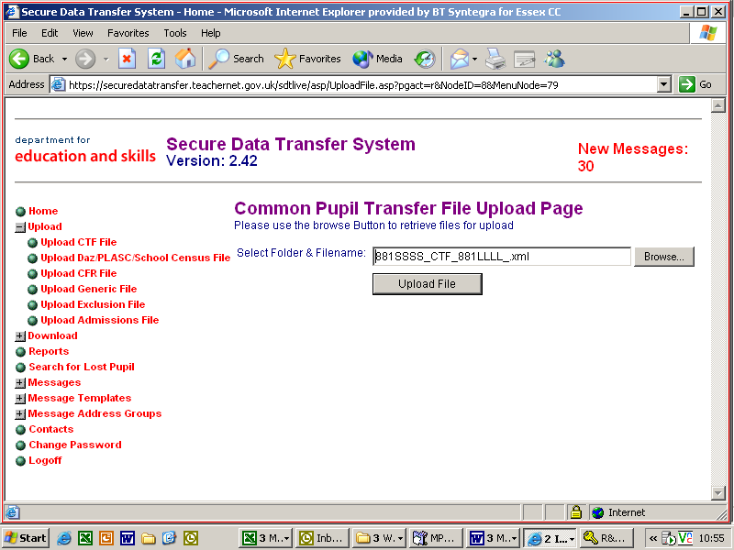

Once the upload is complete a message similar to the one in Screen 6 will appear to say that the file has been transferred to the web site. It is important that you wait for this message, because if you exit the screen before it appears no data will be transferred.

**Screen 6**

**PLEASE NOTE:** The wording will vary slightly depending on the type of file transferred.

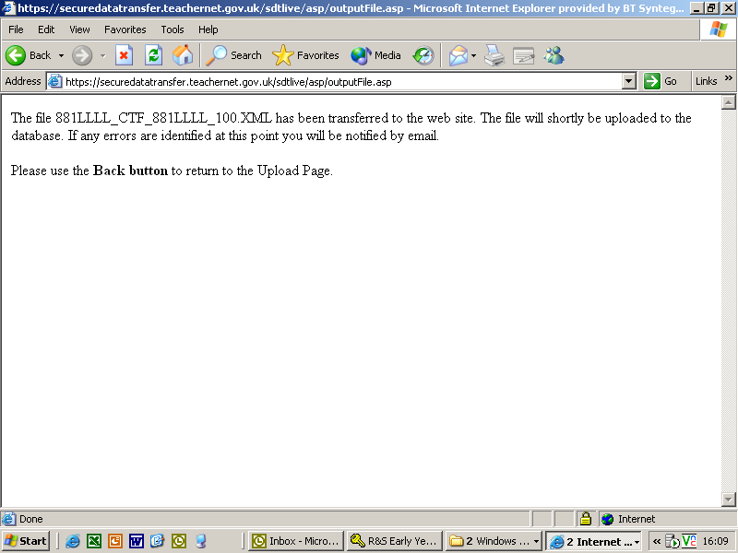

When the file has been successfully transferred to the website, use the ‘Back’ button on your toolbar to return to the previous page and choose logoff from the s2s menu on the left and then click the ‘Sign Out’ button to exit DFE Sign-in.

**8. Contact us**

Please submit all enquiries by email to: EYFSP Data Collections team

Email: [eyfsp.data@essex.gov.uk](mailto:schooldata@essex.gov.uk)