

**Let’s Talk:**

**Reducing the Risk of Suicide**

**Promoting positive emotional wellbeing and reducing the risk of suicidal thoughts and actions in Children and Young People**

Guidance for Educational Settings

February 2021

**Resources and Appendices**

*(This resource may also be used by any professional working with Children and Young People)*

**If you are responding to an emergency**

**If you are looking for urgent assistance with a critical incident (e.g. completed suicide or sudden death) please go to: Please go to** [**Essex Schools InfoLink Critical Incidents page**](https://schools.essex.gov.uk/admin/Critical_Incidents/Pages/Critical%20Incidents%20and%20School%20Closures.aspx)

**Response to a serious incident**

If a child or young person (CYP) needs urgent medical attention, please call 999 or take them to the closest A&E department.

Settings may contact EWMHS through the [Single Point of Access](https://www.escb.co.uk/media/1507/updated-ewmhs-booklet-2017.pdf) and there is a duty clinician available between 9.00am – 5.00pm on 0300 300 1600 or Crisis Support and Out of Hours Switchboard on 0300 555 1201 (this is accessible 24/7, 365 days a year). If a CYP is already open to EWMHS, the professional can be directed to the CYP’s care co-ordinator. When contacting EWMHS, please ensure you have relevant and appropriate information to hand, as they cannot respond effectively without this.

Where there are significant concerns about a CYP or where serious incidents have already occurred, it would be helpful to compile a Risk Management Plan (see Appendix A).

**Response to a sudden death / completed suicide**

In the very sad event that a CYP (or other member of the setting community) dies from suicide, the setting should implement its Critical Incident Management Plan (CIMP). You should also contact the Schools Communications Team on either 033301 39880 (available 9am-4pm).

If you require media / press office support, the Press Office out of hours number is available, but should only be used for urgent media enquiries: 07717 867525.

* ​[Guidance for Schools informing ECC in the event of a critical incident (.pdf)​](https://schools.essex.gov.uk/admin/Critical_Incidents/Documents/Guidance%20for%20Schools%20Reporting%20CI%20January%202019.pdf)
* [Schools process to report an Incident​​​](https://schools.essex.gov.uk/admin/Critical_Incidents/Documents/Guidance%20for%20Schools%20Reporting%20CI%20January%202019.pdf)

**Resources**

|  |  |
| --- | --- |
| Emotional well-being and mental health portal for schools (Essex School Infolink) | [Emotional well-being and mental health for schools](https://schools-secure.essex.gov.uk/pupils/Emotional_Wellbeing_and_Mental_Health_Information_Portal_for_Schools/Pages/default.aspx)  [EWMHS - information](https://www.nelft.nhs.uk/download.cfm?doc=docm93jijm4n1223.pdf&ver=4227)  [EWMHS referral form](https://www.nelft.nhs.uk/download.cfm?doc=docm93jijm4n2137.docx&ver=4127) |
| EWMHS Single point of Access | [EWMHS - Essex](https://www.nelft.nhs.uk/services-ewmhs) |
| Samaritans | [Samaritans](http://www.samaritans.org/sites/default/files/kcfinder/files/HWWNIM_Feb17_Final_web.pdf) |
| Child Bereavement UK | <http://www.childbereavementuk.org/> |
| CYP’s feedback on the Essex Emotional Wellbeing Mental Health Service Model (April 2014) |  |
| Cruse Bereavement Care | <http://www.cruse-essex.org.uk/> |
| Effective Support for CYP and Families in Essex (ESCB, 2017) | [Effective Support ​for ​C​h​ildren and Families in Essex](http://www.escb.co.uk/Portals/67/Documents/professionals/EffectiveSupportBooklet2017v5-FINAL.pdf)​​ ​ (ESCB, 2017) |
| Guidance to Schools on Critical Incidents (Essex Schools Infolink) | [ESI/critical incidents](https://schools-secure.essex.gov.uk/admin/Critical_Incidents/Pages/Critical%20Incidents%20and%20School%20Closures.aspx) |
| Essex One Planning Environment (Essex Schools Infolink) | [Essex One Planning Environment](https://schools-secure.essex.gov.uk/pupils/sen/the%20one%20plan%20environment/Pages/The%20One%20Plan%20Environment.aspx) |
| Essex Provision Guidance (Essex Schools Infolink) | [Essex Provision Guidance](https://schools-secure.essex.gov.uk/pupils/sen/Provision%20Guidance/Pages/default.aspx) |
| Essex Educational Psychology Service (Essex Schools Infolink) | [Essex Educational Psychology Service](https://schools-secure.essex.gov.uk/pupils/Educational%20Psychology%20Service/Pages/Educational-Pyschology-Service.aspx) |
| Essex Safeguarding CYP Board (ESCB) | <http://www.escb.co.uk/> |
| Essex Safeguarding for Schools (Essex School Infolink) | [Essex Safeguarding for Schools/ESI](https://schools-secure.essex.gov.uk/pupils/Safeguarding/Pages/Safeguarding.aspx) |
| Help is at Hand (NHS, 2010) - document to support those bereaved by suicide |  |
| Kidscape | www.kidscape.org.uk |
| Kooth | <https://kooth.com/> |
| Managing self-harm in young people (Royal College of Psychiatrists, 2014) | <http://www.rcpsych.ac.uk/files/pdfversion/CR192.pdf> |
| Mental Health and Behaviour in Schools (DfE, 2016) | [Mental Health and Behaviour in Schools (DfE, 2016)](https://www.gov.uk/government/uploads/system/uploads/attachment_data/file/508847/Mental_Health_and_Behaviour_-_advice_for_Schools_160316.pdf) |
| Mental Health First Aid (MHFA) -  *people how to identify, understand and help a person who may be developing a mental health problem* | <http://mhfaengland.org/> |
| Mentally Healthy Schools | [Mentally Healthy Schools](https://www.mentallyhealthyschools.org.uk/?mc_cid=f49c132db5&mc_eid=c306408d2b) |
| MindED – m*ental health and emotional wellbeing online training portal for professionals working with CYP* | <https://www.minded.org.uk/> |
| NSPCC | [NSPCC](https://www.nspcc.org.uk/preventing-abuse/keeping-children-safe/mental-health-suicidal-thoughts-children/) |
| Nurture Dogs | <http://www.nurture-dogs.co.uk/> |
| Papyrus | <https://www.papyrus-uk.org/> |
| Samaritans | www.samaritans.org |
| SET procedures (ESCB, 2018) | [SET Procedures (ESCB, 2018)](http://www.escb.co.uk/Portals/67/Documents/Local%20Practices/SET%20Procedures-Jan2018-updated.pdf) |
| Trauma Perceptive Practice (TPP) | Contact [tpp@essex.gov.uk](mailto:tpp@essex.gov.uk) for information |

**Appendix A: Risk Assessment**

Information in this plan could be gathered using person centred tools as part of a One Planning Environment). [One planning Environment](http://schools.essex.gov.uk/pupils/sen/The%20One%20Plan%20Environment/Pages/The%20One%20Plan%20Environment.aspx)

|  |  |
| --- | --- |
| **Date plan completed:** |  |
| **Date updated:** |  |
| **Date to be reviewed:** |  |
| **Is this part of a One Plan / SEN support?** |  |

|  |  |  |
| --- | --- | --- |
| **What is the self- harm behaviour? *(Please tick / add in other relevant information)*** | | |
| * Drug or alcohol use | |  |
| * Restricted eating | |  |
| * Cutting, scratching, burning or other | |  |
| * Absconding | |  |
| * Exposing self to risks | |  |
|  | | |
| **Are the parents / carers aware and involved in the management plan?** | | |
| Name of parents / carers: |  | |
| Contact details: |  | |
| How frequently are your setting’s staff in contact with parents / carers to liaise in relation to support? | | |
| Views of parents / carers: | | |

**It is essential that the young person has a support network within your educational setting and that staff allocated to offer this can do so reliably. Consideration therefore needs to be given to who is available to offer this and how this person will receive their support. It would be preferable if this member of staff has some training in supporting CYP who self-harm.**

|  |  |
| --- | --- |
| **Does the young person have a support person within your educational setting who he/she is able to communicate with? *(this should be an adult not peer or prefect)*** | |
| * Name of support person: |  |
| * How often is the contact? |  |
| * Who will provide this is support person not available? |  |
| * Any notes of what support is most helpful and any special arrangements (e.g. time out card, daily check-ins) |  |
| **Does the young person have friends who are aware of the self-harm and are supportive?** | |
| * Are these relationships consistent? |  |
| * How are the friends managing this supportive role? |  |
|  | |
| **Is the young person’s GP aware and is the young person receiving any treatment or medical support?** |  |
| * Name of GP and contact details: |  |
| **Is the young person known to EWMHs?** |  |
| * Name of care co-ordinator and contact details: |  |
| **Is the young person receiving counselling?** | |
| * Name of organisation providing counselling: |  |
| * Name of counsellor and contact details: |  |
| **Are any other agencies involved in supporting this young person and/or their family?** | |
| Name of organisation and key worker: |  |
| **Is the young person in Care or subject to a ‘Child Protection’ or ‘Child in Need’ plan?** |  |
|  | |
| **Any notes made between supporting agencies and young person and family in relation to management of the self- harming behaviour:** |  |
| **Any changes of behaviour that may need to be monitored and communicated to those involved in supporting the young person:** |  |
| **Any activities within your setting which will need additional support, should be avoided or may act as a trigger of self- harm behaviour (consideration needs to be given to sensory needs when a young person has special educational needs):** |  |
| **Any known specific dates that may trigger distress for the young person (e.g. anniversary of a significant loss):** |  |

*This information should be treated confidentially. However, the young person’s safety is paramount and therefore it is necessary to liaise with those involved with the care of the young person as appropriate to ensure his/her safety.

**Monitoring and review arrangements**

How to hold Person Centred Review Meetings: [Person Centred Reviews](http://schools.essex.gov.uk/pupils/sen/The%20One%20Plan%20Environment/Documents/One%20Plan%20-%20person-centred%20reviews.pdf)

|  |  |  |  |
| --- | --- | --- | --- |
| **Dates plan updated/ Reviewed** | **Key person/ co-ordinator** | **Those involved in development of plan** | **Agreed actions** |
|  |  |  |  |
|  |  |  |  |
|  |  |  |  |
|  |  |  |  |
|  |  |  |  |
|  |  |  |  |
|  |  |  |  |

**Appendix B: Risk and Protective Factors**

|  |  |  |
| --- | --- | --- |
|  | **Risk Factors** | **Protective Factors** |
| **In the child** | * Genetic influences * Genetic disposition * Prenatal alcohol exposure * Low IQ * Learning disabilities * Specific development delay or neuro-diversity * Communication difficulties * Difficult temperament * Physical illness * Academic ‘failure/disappointment’ * Low self-esteem * Feelings of isolation * Difficulties with impulse control * Underdeveloped executive functioning skills * Low harm avoidance * Sensation seeking * Difficulties with self-control/regulation * Aggressiveness * Anxiety * Depression * Hyperactivity/ADHD * Early persistent social, emotional and mental health needs * Early substance use * Social disengagement / Retreating coping strategy * Conduct disorder * Favourable attitudes toward drugs * Rebelliousness * Early substance use * Antisocial behaviour * Self-injury * Risk taking behaviours * Risk of knowing or knowing of someone who has completed suicide. | * Secure attachment(s) experience * Outgoing temperament as an infant * Good communication skills, sociability * Being a planner and having a belief in control * Humour * Confident * A positive attitude, optimistic approach to life * Experiences of success and achievement * Faith or spirituality * Capacity to reflect * Ability to self-regulate/self-soothe * Ability to make friends and get along with others * Positive physical development * Good self-esteem * Good coping skills and problem-solving skills * Engagement and connections in two or more of the following contexts: at school/setting, with peers, in athletics, employment, religion, culture * Identity exploration in love, work, and world view * Subjective sense of self-sufficiency, making independent decisions, becoming financially independent * Future orientation * Achievement motivation * Feeling valued |
| **In the family** | * Overt parental conflict including domestic violence * Family breakdown (including where children are taken into care or adopted) * Inconsistent or unclear boundaries and limitations * Hostile and rejecting relationships * Failure to adapt to a child’s changing needs * Physical, sexual, emotional abuse, or neglect, maltreatment * Parental or sibling psychiatric illness * Parental or sibling criminality, Substance e.g. drugs & alcoholism or personality disorder * Death and loss – including loss of friendship & pets * Permissive parenting * Parent–child conflict * Inadequate supervision and monitoring * Low parental warmth * Parental hostility * Harsh discipline * Low/high parental aspirations for child where the child is experiencing extreme pressure or feel unsupported * Fragile attachments with parents * Leaving home as a result of conflict * Homelessness * Family distress * Leaving institutional/government care (hospital, foster care, correctional facility, etc.) | * At least one good parent-child relationship (or one supportive adult) * Affection * Clear, consistent discipline * Support for education * Supportive long-term relationship or the absence of severe discord * Responsiveness * Protection from harm and fear * Opportunities to resolve conflict * Adequate socioeconomic resources for the family * Consistent and clear boundaries and limitations implemented and maintained including family that provides structure, limits, rules, monitoring, and predictability * Language-based, rather than physical, discipline * Extended family support * Supportive relationships with family members * Clear expectations for behaviour and values * Balance of autonomy and relatedness to family * Behavioural and emotional autonomy * Healthy prenatal and early childhood development * Connectedness to adults in the extended family / family support network |
| **In the setting** | * Bullying / abuse including online (cyber) * Discrimination e.g. Racism * Breakdown in or lack of positive friendships * Peer influences towards risk taking e.g. associating/partaking with drug-using peers * Peer pressure * Fragile pupil to teacher/setting staff relationships * Experience of educational setting ‘failures’ * Low motivation around education setting * Accessibility/ availability * Peer rejection / lack of a sense of belonging/ Interpersonal alienation * Exclusion / Non-attendance * Aggression toward peers * Accessibility/ availability * Lack of positive role models * Low ratio of caregivers to children | * Inclusive practice * Personalised/ tailored curriculum if required * Clear policies on behaviour and bullying * Staff behaviour policy (also known as code of conduct) * ‘Open door’ policy for children to raise problems * A whole-setting approach to promoting good mental health * Good pupil to teacher/setting staff relationships * Positive classroom management * A sense of belonging * Positive peer influences/ friendships * Effective safeguarding and Child Protection policies. * An effective early help process * Understand their role in and be part of effective multi-agency working * Appropriate procedures to ensure staff are confident to can raise concerns about policies and processes, and know they will be dealt with fairly and effectively including risk assessments * Support for early learning * Access to supplementary services to support the child’s needs * Stable, secure attachment to childcare provider * Regulatory systems that support high quality of care * Healthy peer groups * Pupil educational setting engagement/ motivation * Positive teacher expectations * Effective classroom management * Positive partnering between educational setting and family * High academic standards * Presence of mentors and support for development of skills and interests * Opportunities for engagement within educational setting and community * Positive norms * Physical and psychological safety * Opportunities for exploration in work and setting * Positive adult role models, coaches, mentors |
| **In the community** | * Socio-economic disadvantage * Homelessness * Disaster, accidents, war or other overwhelming events * Discrimination * Exploitation, including by criminal gangs and organised crime groups, trafficking, online abuse, sexual exploitation and the influences of extremism leading to radicalisation * Other significant life events * Presence of neighbourhood crime * Negative Social Media | * Wider supportive network * Good/stable housing * High standard of living * Opportunities for valued social roles * Range of sport/leisure activities available * Steady employment * Availability of services (social, recreational, cultural, etc) * Access to Technology |

**Appendix C: Model template for a planning meeting**

|  |  |
| --- | --- |
| **Agenda Item** | **Notes** |
| Introductions |  |
| Purpose of meeting:   * What has happened / why are we here? |  |
| Discussion points:   * What’s working? * What’s not working? * Views of CYP * Views of Parents / Carers * Views of Education * Views of others involved * Identifying risk and protective factors * Any other support required for the CYP and/or family * Any other support required for the setting (eg. training, consultation) |  |
| Outcomes / Actions agreed:   * Roles and responsibilities of everyone involved. * Key member of staff (trusted adult) identified to act as the lead. * Risk assessment & plan reflects discussion and addresses identified needs. * Any additional support / intervention required has been identified and is included in the support plan. |  |
| Review date agreed: |  |

**Appendix D: High-five to stay alive**

Developed during critical incident response work in settings following sudden and unexpected deaths within setting communities.

In times of crisis and shock, the vulnerability of other students can sometimes increase and the EPs and EWMHS teams work together with settings to support students, their families and setting staff.

During conversations with young people, the following themes emerged and having 5 elements one of each thumb/finger became memorable at a time when thinking is hard.

High 5 to Stay Alive can be used to:

* Assess what is happening for a young person
* Highlight what is currently important and areas to support (what’s working well)
* Make a plan of what is needed to be put in place/arranged (intervention)
* Consider what things get in the way of the YP feeling connected / smiling etc.

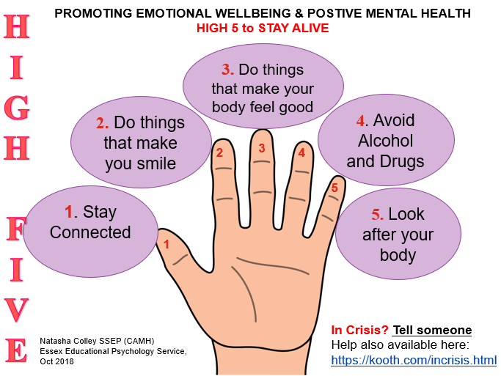

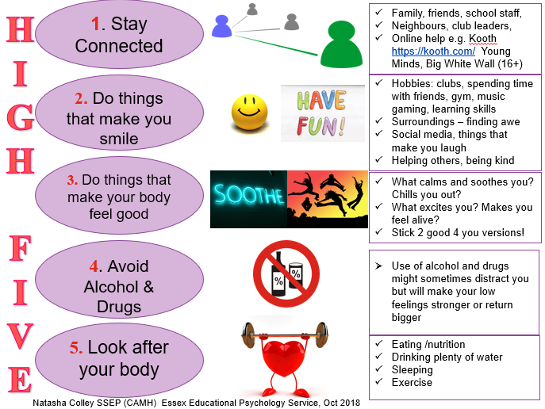

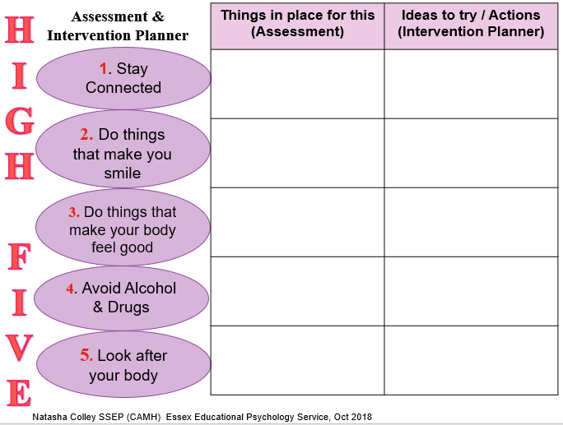

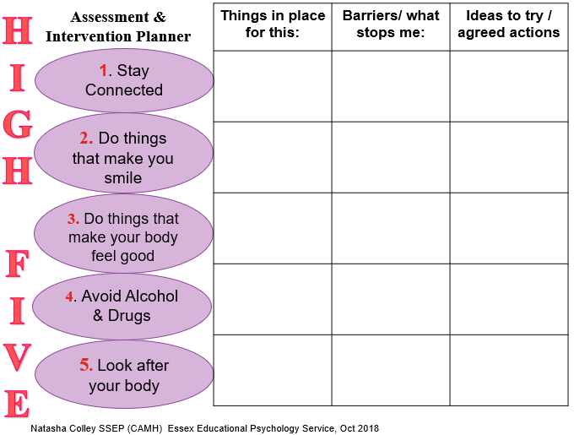

**Acknowledgements:**

This guidance has been produced by a multi-agency group involving the Emotional Well-being and Mental Health Service (EWMHs provided by NELFT), Commissioning Support Service, Essex Educational Psychology Service and SEND Social, Emotional and Mental Health (SEMH) Team and the School Effectiveness Service (Education). In addition, educational settings and other partners have been consulted and have contributed to this guidance.