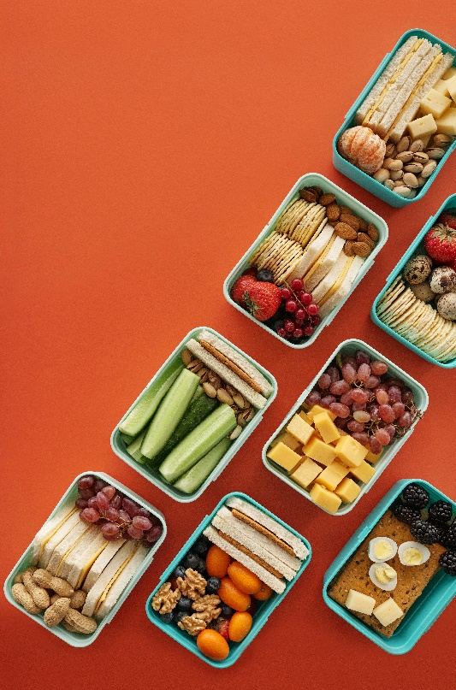
Let’s Talk: Healthy Eating
Secondary

This resource is part of our self-care suite of resources and has been co-produced with children and young people living in Essex, for children and young people. They have also been developed and quality assured by the following stakeholders:
- Essex Educational Psychology Service
- Essex Health Watch
- Essex Mental Health Support Teams (MHSTs) NELFT NHS Foundation Trust
- Essex Multi-schools Council
- Essex Social, Emotional and Mental Health (SEMH) strategy team
- HCRG care group Child and Family Wellbeing Service
- NELFT NHS Trust Southend, Essex, and Thurrock (SET) Child, Adolescent and Mental Health Service (CAMHS)
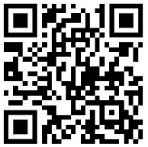
- Professionals in schools and settings can access all these resources via the Essex info link SEMH portal. Children and young people (CYP), parents/carers and professionals can also access these resources via the SET CAMHS website. Our self-care content can also be accessed via SET CAMHS Instagram account:

The resources are intended to be accessed by CYP independently or trusted adults use these resources with CYP through 1:1 conversation, whole school/group discussion and assemblies.
Please note: some of the content within our self-care resources may be emotive for CYP. We recommend that you make use of the ‘signposting to support’ section of this document should any of the content be triggering.
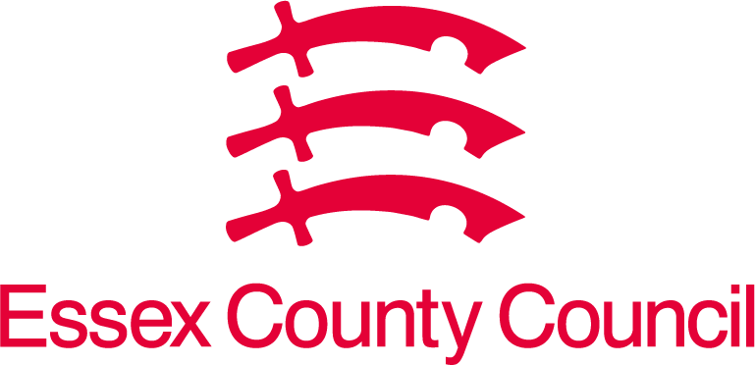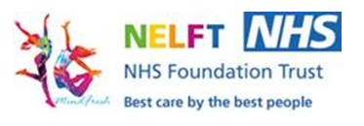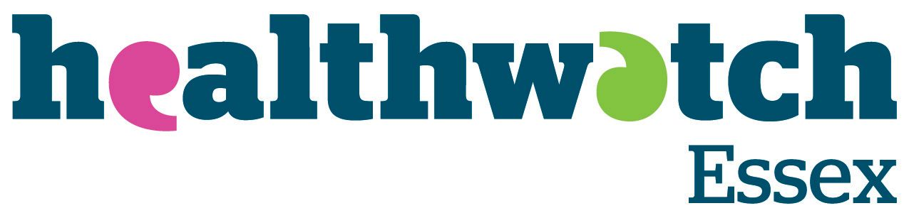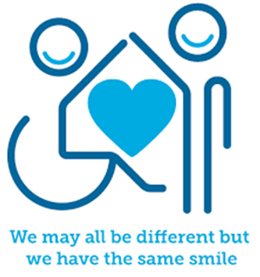
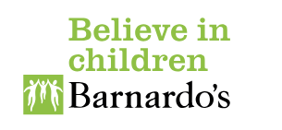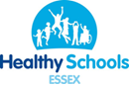

Introduction
Eating a healthy, balanced diet is an important part of maintaining good health and can help you feel your best. It provides the energy you need to keep active, learn and interact with others throughout the day.

Facts
- A healthy diet helps to protect against malnutrition in all its forms, as well as some diseases including diabetes, heart disease, stroke, and cancer.
- Fibre helps your body to digest food and is found in vegetables, wholegrains, and fruit.
- Avocado is a fruit with the highest protein content of any fruit.
- The slower you eat the more time your stomach has to tell your brain that it is full.
- Children over 11yrs old should limit their salt intake to 6grams per day.
- By eating wholegrains and other forms of fibre regularly you are cleansing your system and limiting your risks to diseases such as high blood pressure, diabetes and heart disease.
- A healthy diet requires a balance of different foods. These different foods help your body in different ways:
  - Proteins (meat, fish, nuts, and eggs) help your muscles to grow.
  - Vitamins and minerals (fruits and vegetables) help keep your skin strong and grow as you grow. They also help to keep your organs going.
  - Dairy (milk and cheese) helps you as you grow and helps give you strong teeth, bones, and nails.
  - Sugar (chocolate, sweets and cakes) give you energy quickly, but you only need a small amount of it.
  - Carbohydrates (bread, pasta and potatoes) give you energy but release more slowly than sugar, keeping your energy levels going throughout the day.
  - Fats (butter and oil) keep you warm but you don’t need to eat a lot of these.
- You should drink about 6 cups of water everyday too, not sugary fizzy drinks.
- Everyone should have 5 fruit and vegetables a day.

Myth Buster
- Eating all types of fats will make you fat X
- Salads are always the heathier choice X
- Fat free and low-fat foods are always better that full fat versions X
- Healthier foods are more expensive X
- Raw carrots are more nutritious than cooked X
- Nuts are as bad as junk food X
- Frozen and canned fruits and vegetables are less nutritious than fresh ones X
- Eating carrots will improve your eyesight X

Video clips
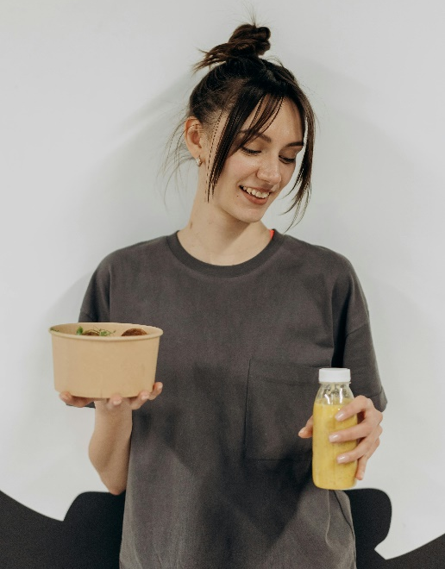
Check out these videos about healthy eating:
- Healthy diet - Nutrition, digestion and excretion - KS3 Biology - BBC Bitesize - BBC Bitesize
Healthy plate video and supporting questions.

- Essential Nutrients - YouTube
A video explaining essential nutrients and how to get them into our diets.

- Gastro Lab – BBC Teach
A series of short films about foods that support our bodies and those that aid sports.

- Healthy Eating and Nutrition - Food A Fact Of Life
A series of webinars that explain processed food and gut health.

Resources
- Healthy diet - Nutrition, digestion and excretion - KS3 Biology - BBC Bitesize - BBC Bitesize
Information about balanced diet, nutrients and follow up quiz.

- Food facts - Healthier Families - NHS (www.nhs.uk)
Information on healthy snacks, sugar, salt, 5 a day, healthier food swaps and fat.

- Recipes - Healthier Families - NHS (www.nhs.uk)
A selection of healthy recipes to try.

- The Secret Life of Our Favourite Dishes - BBC Teach
Cooking demonstrations and explanations of ingredients and where they come form for some popular dishes

- Healthy eating (11-14 Years) - Food A Fact Of Life
- Healthy eating (14-16 Years) - Food A Fact Of Life
Activity ideas and resources to strengthen learning around eating well, energy and nutrients, diet and health, nutrition labelling, digestion and activity.
Reflective questions
(Try exploring these reflective questions with a CYP)
- How many portions of oily fish are we recommended to consume per week?
- Give 2 examples of a type of fat?
- Name the 3 macronutrients?
- Which food group helps with muscle growth and repair?
- Which food group provides us with our main source of energy?
- How much water is recommended per day?
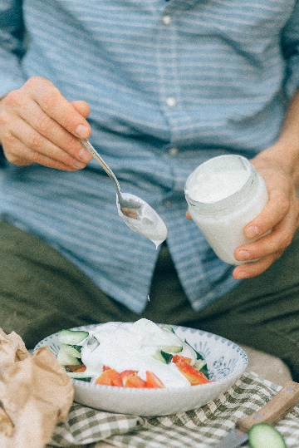

Quiz of 5 questions per theme
Once you’ve gone through this resource with a CYP try this quiz questions with them:

- Which food group is not essential for health?
- Which of the following counts as 1 of your 5-A-DAY?
  - Strawberry Jam
  - Fruit/vegetable juice or smoothies (150ml)
  - Potatoes
  - All of the above
- Why is it not recommended to consume over 150ml of fruit/vegetable juice or smoothies per day?
  - As they are high in free sugars
  - As they are high in vitamin C
  - Because only water counts towards your fluid intake
  - As they never count towards your 5-A-DAY
- True or False? Fat provides the most energy per gram of ALL the macronutrients.
- What does a healthy diet protect you from?
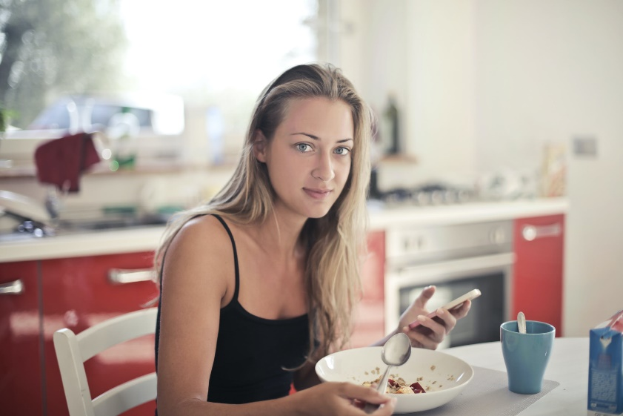

Signposting to Support
- The UK's Eating Disorder Charity - Beat (beateatingdisorders.org.uk)
This is the UK’s eating disorder charity. Founded in 1989 as the Eating Disorders Association, our mission is to end the pain and suffering caused by eating disorders.

- The Eatwell Guide and Resources | Food Standards Agency
The Eatwell Guide makes healthy eating easier to understand by giving a visual representation of the types of foods and drinks we should consume and in what proportions to have a healthy, balanced diet. The Eatwell Guide Booklet

- Eating Disorders and Problems | Parent Guide | YoungMinds
If you are concerned about your child’s behaviour around food, or they have been diagnosed with an eating disorder, you are not alone. On this page, you can find information about eating disorders, and advice about getting the right help for your child.

- Getting help for your child: where to start
- Childline 0800 1111 when contacting ChildLine what to expect?
- Hopeline 0800 068 41 41 offering confidential support and practical advice
- Text ‘SHOUT’ to 85258 for free, confidential, anonymous text support service
- NHS 111
- Southend, Essex & Thurrock Children and Adolescent Mental Health Service (SET CAMHS)
- Explore counselling/therapy
- Where to get urgent mental health support from: Advice from NHS

- SET CAMHS Instagram account

How to help a friend
- Talk with your friends about your favourite meals (breakfast, lunch and dinner)
- Discuss what a balanced diet it and why it’s important.
- Find out what their favourite balanced diet meals, and share yours.
- Talk about what your favourite snacks are. How healthy do you think they are?
- Have a conversation about how much water and other drinks you have a day to keep your body hydrated.
- Suggest they look at this resource for ideas and support.
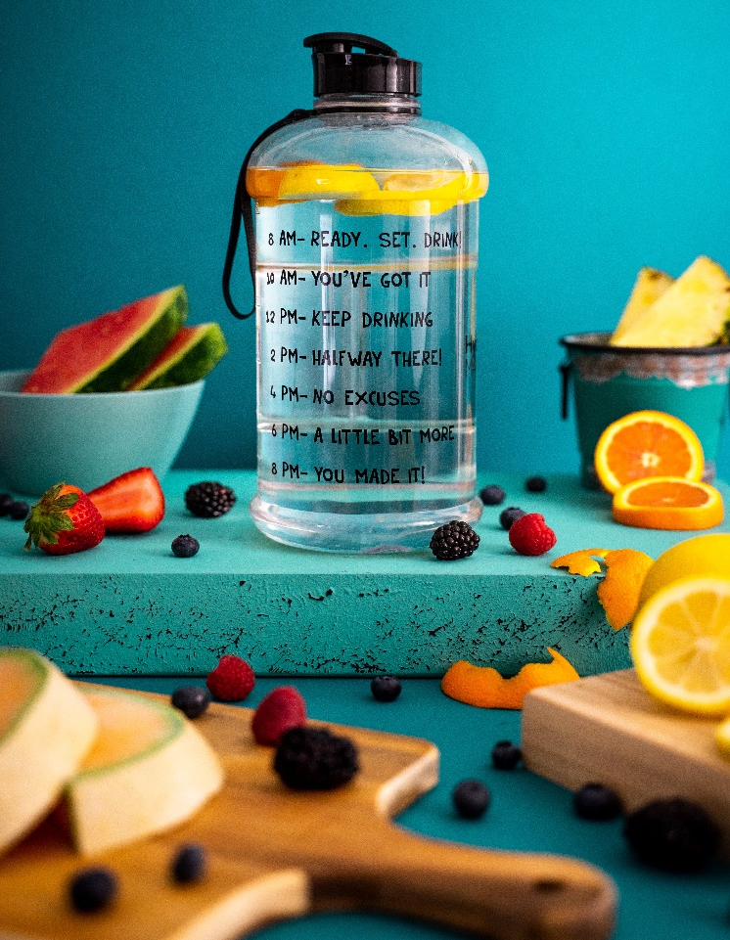
- Recommend that they follow the SET CAMHS Instagram account: set_camhs_nhs
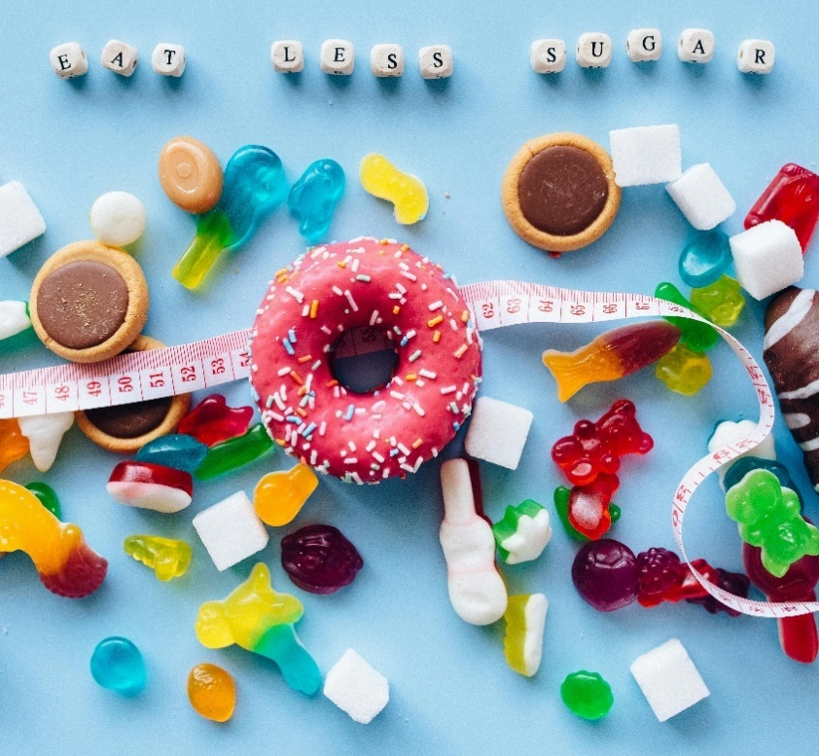

The adult box (for professionals and parent/carers to read)
- Schemes of Work (11-14 Years) - Food A Fact Of Life
Sources to support the teaching and learning of food with young people.

- Quiz worksheets - Food A Fact Of Life
Healthy eating quizzes

- Eatwell guide and food guidelines
A resource that shows how much of what we eat overall should come from each food group to achieve a healthy, balanced diet.

- Healthy eating for children | British Dietetic Association (BDA)
A fact sheet for parents to help you ensure your child is eating the right food.

