

# How It Works

Once you sign up, an age appropriate book will be delivered to your child every month until their fifth birthday. The books are free for families and yours to keep forever! All titles in the Imagination Library are published by Penguin Random House and carefully selected by a panel of experts in early childhood literacy and reading.

# Eligibility

##### This Programme is for Essex Children in Care, Previously Looked After Children, children known to social care, those in Kinship care and the children of care experienced adults that live in Essex.

**Contact Us**

If you have any questions or comments regarding this scheme please do not hesitate to contact:

[virtual.school@essex.gov.uk](mailto:virtual.school@essex.gov.uk) We hope the children in your care

### enjoy the books!



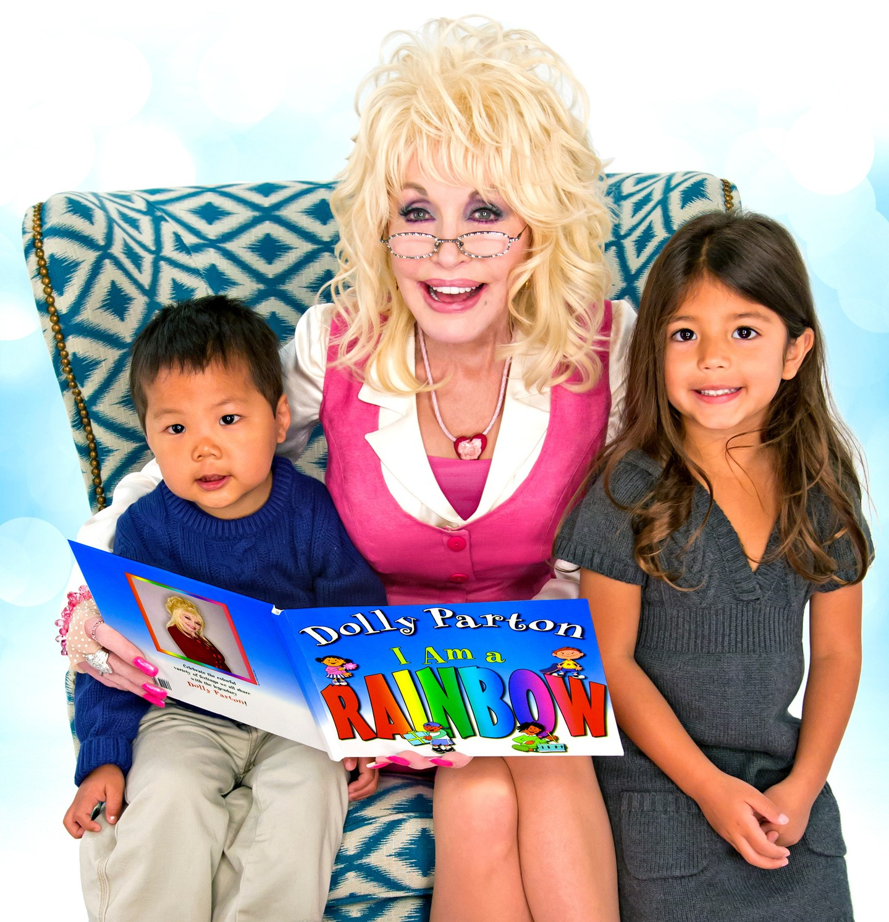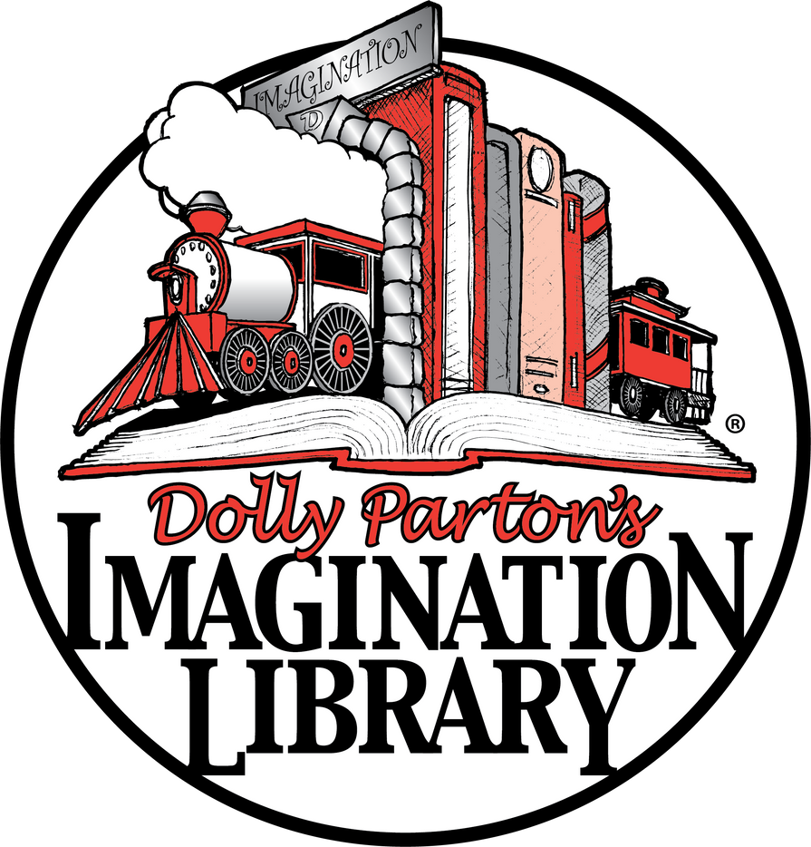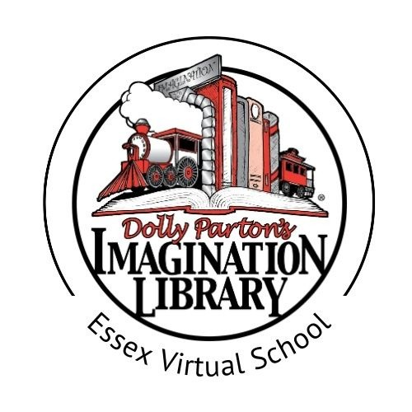

England and Wales Registered Charity Number 1121917 The Dollywood Foundation UK, 167 - 169 Great Portland Street,

5th Floor, London W1W 5PF.

General Enquiries: [info@imaginationlibrary.co.uk](mailto:info@imaginationlibrary.co.uk)

of Reading

**Dolly Parton’s Imagination Library inspires a lifelong love of books and reading.**

**We gift a brand new book every month to children from birth until their fifth birthday.**

#### Reading and encouraging a love of books is one of the best things we can do for our children. Book sharing with a child encourages bonding and development of language, communication and cognitive skills.

Children find snuggling up with a grown up and a book very comforting. Books are a fuel for a child’s imagination!

## How the programme is funded

#### The Dollywood Foundation UK works with national and local funders and other charities to fund this programme. Dolly, through her Foundation, contributes as well. Here in Essex, this is supported by the charity Make My Day Better, plus other donors. This means it is free for the children receiving the books.

**SIGN UP FOR FREE**

Child’s Full Name:

.................................................................................................................................... Child’s Date of Birth: ...............................................................................

Phone: .................................................................................................................

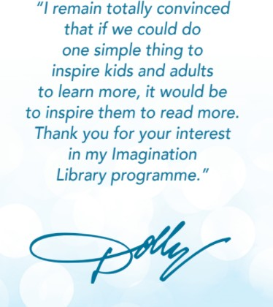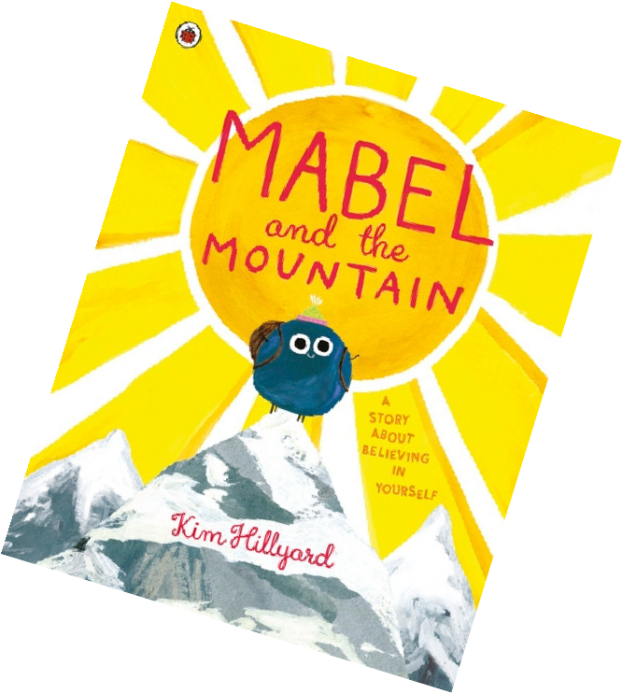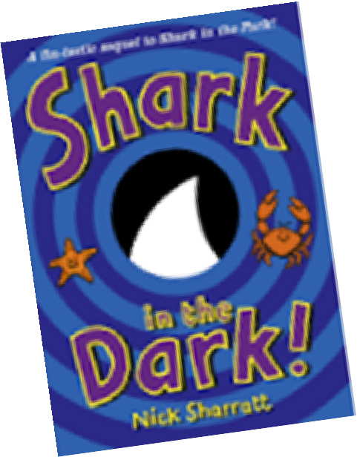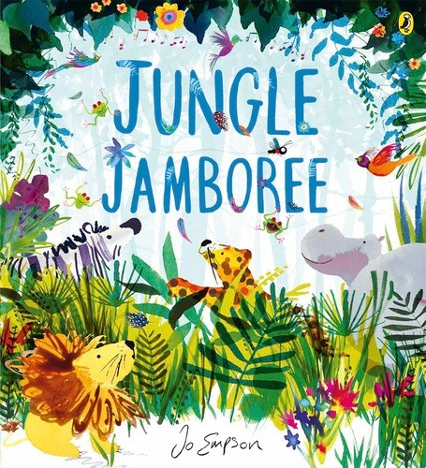

Parent/Guardian/Carer’s Name:

................................................................................................................................... Child’s Home Mailing Address: ......................................................

....................................................................................................................................

.......................................................................Postcode:....................................

Email: ...................................................................................................................

*This child is known to Essex Virtual School*

..............................................................................................................................

Signature of parent/guardian/carer



I hereby explicitly consent to allow the Dollywood Foundation, Inc. to use the information provided herein for the purposes of participating in Dolly Parton’s Imagination Library book-gifting programme. To measure the benefits of this programme we may create data sets with the information provided herein and share them with research and educational advancement partners. You agree to review our full Terms & Conditions and Privacy Policy by visiting imaginationlibrary.com. By signing and submitting this form you expressly consent to the terms set forth herein.

Please return to:

[**virtual.school@essex.gov.uk**](mailto:virtual.school@essex.gov.uk)