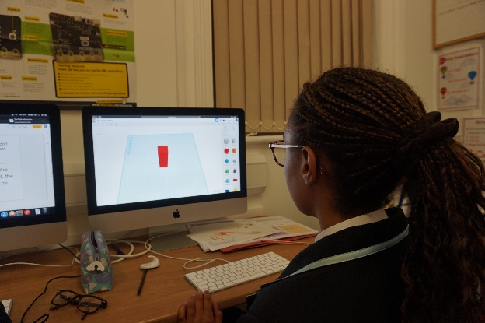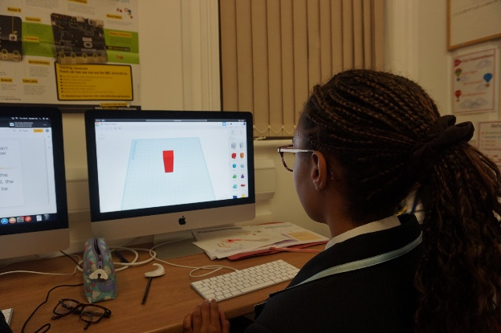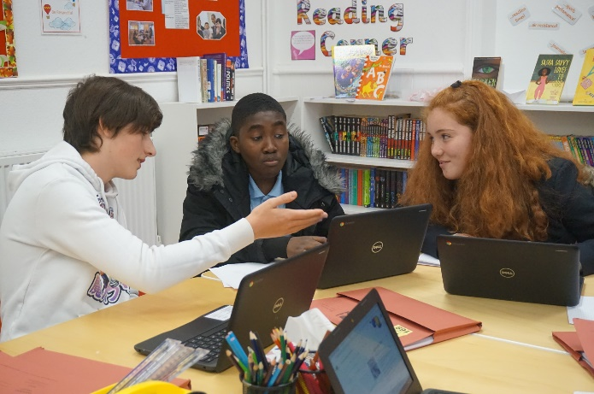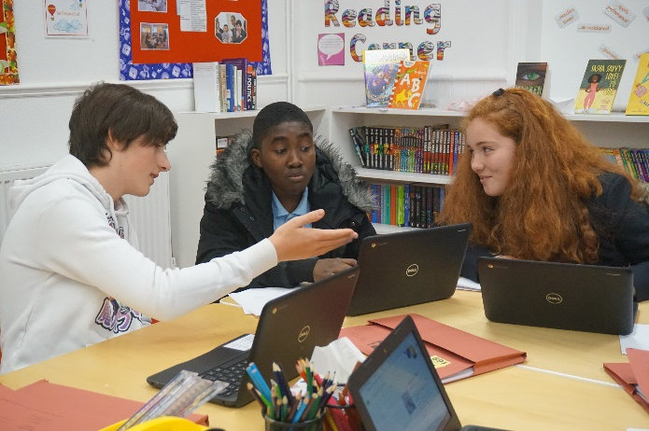

**Want some extra support after school?**



We have trained and friendly tutors

with a range of subject knowledge who

can support you in your studies.

We’ll work with you through

homework, revision, past papers and

more.

Our classroom has lots of resources to

support your coursework, including

Chromebooks and an Apple Mac suite.

Students have internet access and

can print work for free!

Need a quiet place to get your coursework done?



**Looking for exciting and exclusive opportunities?**

Into

University students can access work experience and other enrichment

opportunities through our programme.

**Contact us now for information**

Into

University Clacton

Imperial House, 20

**-**

22

Rosemary Road, Clacton on Sea, CO15 1NZ

**01255 446857**

**clacton@intouniversity.org**

**Want some extra support after school?**



We have trained and friendly tutors

with a range of subject knowledge who

can support you in your studies.

We’ll work with you through

homework, revision, past papers and

more.

Our classroom has lots of resources to

support your coursework, including

Chromebooks and an Apple Mac suite.

Students have internet access and

can print work for free!

Need a quiet place to get your coursework done?

?



**Looking for exciting and exclusive opportunities?**

**Into**

**University students can access work experience and other enrichment**

**opportunities through our programme.**

**Contact us now for information**

Into

UniversityClacton

Imperial House, 20

**-**

22

Rosemary Road, Clacton on Sea, CO15 1NZ

**01255 446857**

**clacton@intouniversity.org**

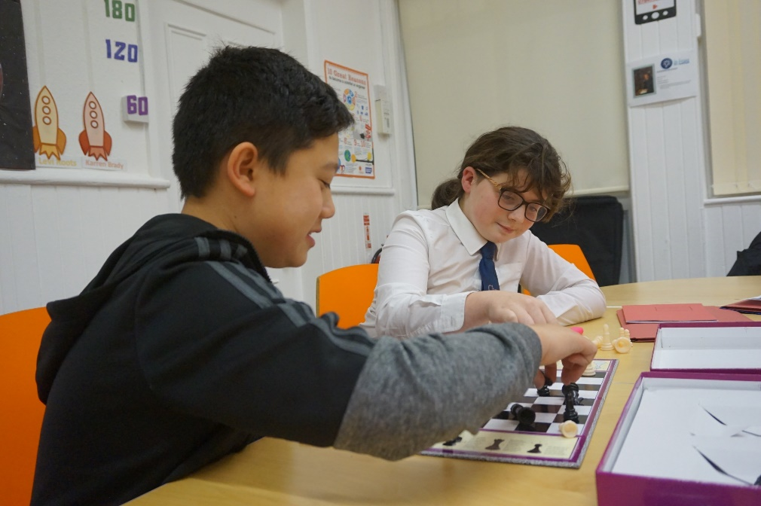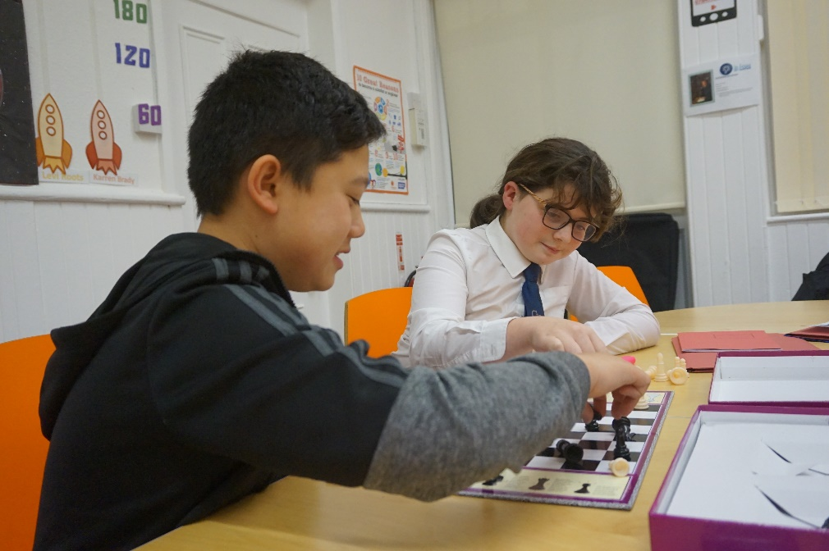

**Thursday: 4:00 – 5:30pm**

**Monday: 4:00 – 5:30pm**

**Monday: 4:00 – 5:30pm**

We’re in the centre of

town, at the Community

and Voluntary Services

Tendring building!

**Find Us**



**Secondary Academic Support**

We run free support twice a week for

secondary students. Come to us with

homework, coursework or applications!

!

**Contact us now for information**

Into

University Clacton

Imperial House, 20

**-**

Rosemary Road, Clacton on Sea, CO15 1NZ

22

**01255 446857**

**clacton@intouniversity.org**

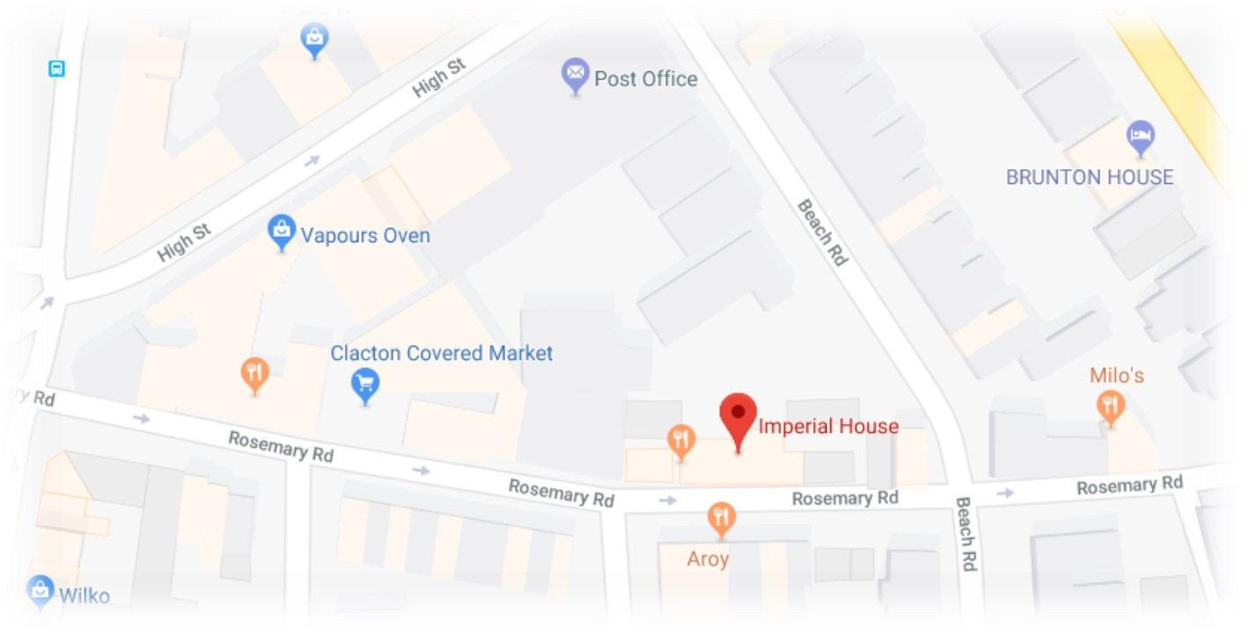

**Thursday: 4:00 – 5:30pm**

We’re in the centre of

town, at the Community

and Voluntary Services

Tendring building!

**Find Us**



**Secondary Academic Support**

We run free support twice a week for

secondary students. Come to us with

homework, coursework or applications!

**Contact us now for information**

Into

University Clacton

Imperial House, 20

**-**

22

Rosemary Road, Clacton on Sea, CO15 1NZ

**01255 446857**

**clacton@intouniversity.org**

