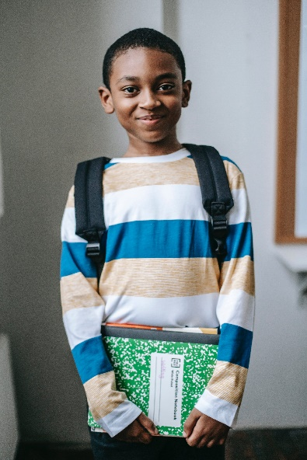
Let’s Talk: Self-esteem
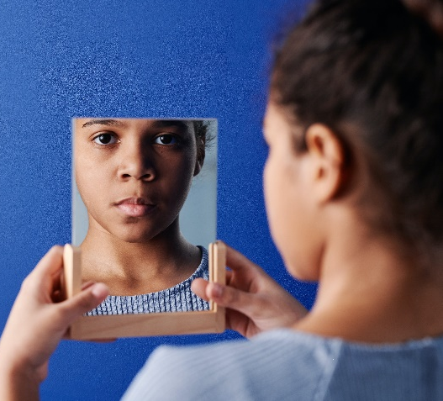
Primary

This resource is part of our self-care suite of resources and has been co-produced with children and young people living in Essex, for children and young people. They have also been developed and quality assured by the following stakeholders:
- Essex Educational Psychology Service
- Health Watch Essex
- Essex Mental Health Support Teams (MHSTs) NELFT NHS Foundation Trust
- Essex Multi-schools Council
- Essex Social, Emotional and Mental Health (SEMH) strategy team
- Essex Child and Family Wellbeing Service, HCRG Care Group in partnership with Barnardos
- NELFT NHS Trust Southend, Essex, and Thurrock (SET) Child, Adolescent and Mental Health Service (CAMHS)

- Professionals in schools and settings can access all these resources via the Essex info link SEMH portal. Children and young people (CYP), parents/carers and professionals can also access these resources via the SET CAMHS website. Our self-care content can also be accessed via SET CAMHS Instagram account:

The resources are intended to be accessed by CYP independently or trusted adults use these resources with CYP through 1:1 conversation, whole school/group discussion and assemblies.
Please note: some of the content within our self-care resources may be emotive for CYP. We recommend that you make use of the ‘signposting to support’ section of this document should any of the content be triggering.
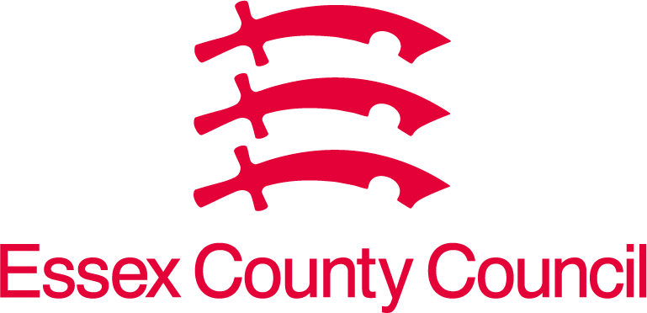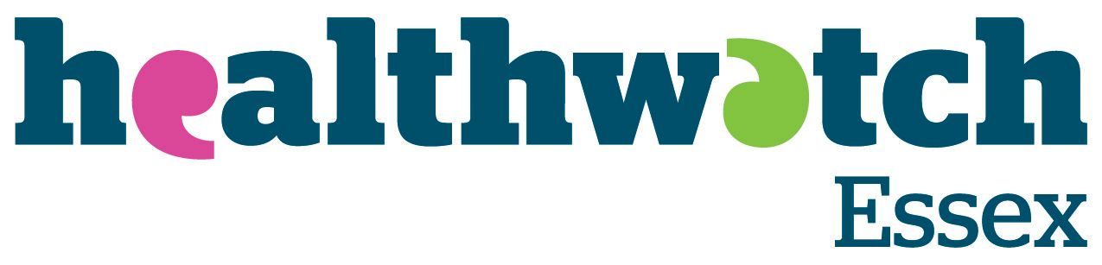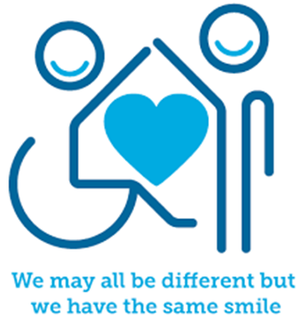
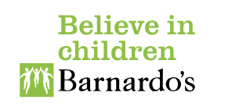

Introduction
Self-Esteem is also known as confidence. It is what we think and feel about ourselves, and how much we believe in ourselves. When we feel good about ourselves, we are more likely to have a higher self-esteem. If we have high self-esteem, then we may be aware of what we are good at, we may feel confident trying new things, we may believe we are worthy of good things.
If you have a high self-esteem, you are able to manage better when you face adversity (difficult times). This means, that when you are experiencing a challenge, you are able to believe in yourself and try your hardest to overcome this challenge. If you have a low self-esteem, you may find it difficult to try your best and you might try to avoid the challenge.
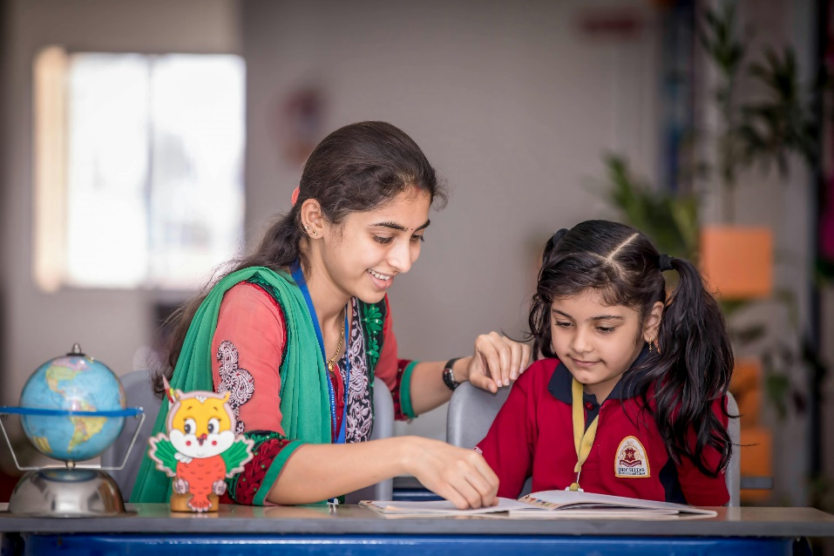

Facts
- Self-esteem has many different forms. It can be how we think and feel about: ourselves as a person, how clever we are, how we look, how good we at sport, how good we are at art, etc.
- How good you are at things can change. Every person is able to learn new things. Sometimes it takes longer, sometimes it needs more effort, sometimes others learn it quicker, but everyone can learn new things if they focus on trying hard rather than getting it right. If you try your best, and focus on trying your best, you are more likely to do something. If you believe this, then you have a Growth Mindset, you focus on learning and improving, not getting this right. If you believe that getting something wrong is bad, and you’re not clever if you get something wrong, then it is likely you have a fixed mindset. Someone with a fixed mindset believes that people cannot get better at things they are not good at, and therefore if you get something wrong, it shows you cannot do that thing. Someone with a growth mindset will see this as an opportunity to learn a new thing if they try.
- There’s a magic word that helps boost self-esteem. Do you know what it is? YET. Instead of saying “I can’t do this”, if you say “I can’t do this yet” then you are saying that one day you will be able to do this. This is the power of yet.
- It is ok to get something wrong when you learn. If you get everything right, all the time, you’re not learning as much as you could be. Remember, if you FAIL, you have made the First Attempt In Learning. When you know what you find difficult, you and others can focus on this to help you.
- It is helpful to focus on what’s going well, rather than what’s going wrong.

Myth Buster
- If you have lots of self-esteem, you feel happy or confident all the time. X
Things happen that can impact our happiness or confidence, however having a high self-esteem means you can bounce back quicker. In other words, you will be able to move on from things that impact your confidence by being kind to yourself and realising your strengths.
- If you have low self-esteem, you will always have low self-esteem. X
Your self-esteem will go up and down as you experience different things. It is important to know that, just because you feel bad about yourself at any point, it does not mean you will forever feel bad about yourself.
- If you have low self-esteem, it just means that you are not confident. X
If someone has a low self-esteem, it might mean that: they experience low mood (feeling a bit rubbish), they might be overly critical of themselves, they might avoid things they usually like doing.
- If you have low self-esteem, just do things you are good at and you will feel better. X
While this may make us feel a bit better, it will not improve your self-esteem. Our self-esteem will grow more if we see ourselves overcoming challenges. Sometimes we might need help to do this at first, and that’s ok. When you overcome challenges, you will feel better about yourself, and feel more confident about the next challenge you face.
- If you ask for help, you are admitting you are not clever enough. X
Everybody needs help, and if you can get help from a friend or an adult, this might help you overcome the challenge and still learn. You should work with the person, rather than let them do it for you though! Asking for help is a sign of strength, not weakness.
- You either have a fixed mindset, or a growth mindset. X
This is not true because mindsets can change overtime. People may also have a growth mindset for some skills, and a fixed mindset for other things. For example, someone may love challenges in maths and tries really hard because they know they can get better, but they may have a fixed mindset when they play football and think they will never get better.
Video clips
Check out these videos about self-care:
- The Power of Yet – Sesame Street with Janelle Monae
When something doesn't work out right now, follow Janelle Monae's advice and don't give up because you'll learn how! Keep trying and you'll reach your goal because that's the Power of Yet (Ks1)

- Don’t Give Up – Sesame Street with Bruno Mars
When you want to do something new that seems hard to do, listen to Bruno Mars and don't give up! (Ks1)

- The Superpower of Yet: Growth Mindset
Discover the incredible "Superpower of Yet" with our engaging superhero-themed video for kids. Learn how saying "I can't do it YET" empowers young learners to conquer challenges and embrace a growth mindset! (Ks1)

- How to develop a positive mindset
This is a simple description of growth mindset for young people. Be aware that it oversimplifies changing from a fixed to growth as it suggests it’s ‘just’ a choice. (KS2)

- What is Self-Esteem: How To Feel Awesome About You
RocketKids explore self-esteem and how to feel awesome about yourself (KS1 & Ks2)

- Growth Mindset – Get What You Want
RocketKids 4 simple steps to get our mindset in shape and get the most out of life (Ks2)

- Boost Your Self-esteem
RocketKids 5 ways to improve your self-esteem (KS2)

- Self-Esteem for Kids
Mental Health Centre Kids shares 10 ways to build self-esteem and self-confidence (ks2)

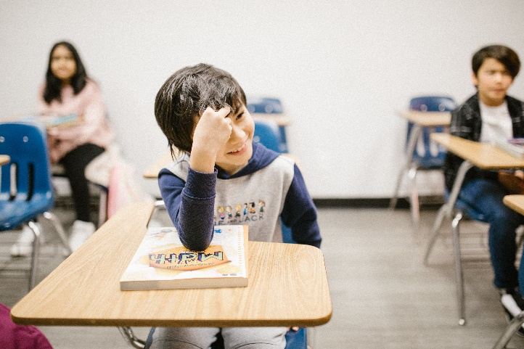

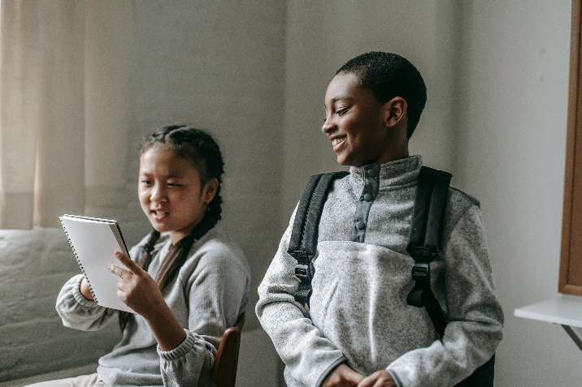

Resources
We have indicated whether the resources is accessible for Ks1 or Ks2. Please note that some of the ks2 content could be adapted and differentiated to support pupils in Ks1.

- Growth Mindset Questions and Action Plan
A list of questions to ask yourself/young people when discussing learning and an action plan to help with future tasks (KS2)

- Letter to your future self (example)
Try writing a letter to yourself about where you would like to be in a years time! You can set yourself some goals that you can achieve and then keep reading it and think with an adult how you can achieve it. Also write what you like about yourself! (KS2)

- Self-esteem printable resources
Twinkl have developed a range of self-esteem activities for Ks1 and Ks2

Reflective questions
(Try exploring these reflective questions with a CYP)
- What things are you good at?
- What makes you good at these things?
- How can these skills help you with other things?
- What makes you feel good about yourself? Why does it?
- Can you tell me the last time you felt proud of yourself? What happened to make you feel proud? (Try to draw focus to a time they faced a challenge)
- What would you say to a friend who said something horrible about themself?

Quiz of 5 questions per theme
Once you’ve gone through this resource with a CYP try this quiz questions with them:
- What is self-esteem?
- What things help you feel better about yourself?
- What should you say instead of “I can’t do this?”
- What is a fixed mindset, and what is a growth mindset?
- If you have a high self-esteem, will you always feel happy?


Additional ideas
Other things to try:
- Praise effort, rather than attainment (what mark you get on a test). If someone experiences a setback, work with them to understand what they have learnt from this and how to avoid it in the future.

- Try keeping a diary of successes! You should write down something you were proud of, every day. These can be tiny things, it may be something you learnt, it may be a challenge you overcame, or it may be something you were grateful for rather than a success.

Signposting to Support
For additional support we recommend you:
- Getting help for your child: where to start
- Childline 0800 1111 when contacting ChildLine what to expect?
- Hopeline 0800 068 41 41 offering confidential support and practical advice
- Text ‘SHOUT’ to 85258 for free, confidential, anonymous text support service
- NHS 111
- Southend, Essex & Thurrock Children and Adolescent Mental Health Service (SET CAMHS)
- Explore counselling/therapy
- Where to get urgent mental health support from: Advice from NHS

- SET CAMHS Instagram account

How to help a friend
- Share this resource with them
- Tell them about the SET CAMHS Instagram account
- Remember, with great power, comes great responsibility! Tell them about the Power of Yet!

The adult box (for professionals and parent/carers to read)
- Young Minds – Self-esteem
This is a guide to self-esteem in children and young people

- Carol Dweck – Mindset
Leading researcher describing what growth mindset is and why it’s so important
- Growth Mindset Vs Fixed Mindset
Describes growth and fixed mindset
- Self-care – Year 6 Short Activities
Public Health’s downloadable resources for teachers and families.
- Raising children’s self-esteem between ages 1-8 years
Explores self-esteem in the early years


