Let’s Talk: Managing Emotions

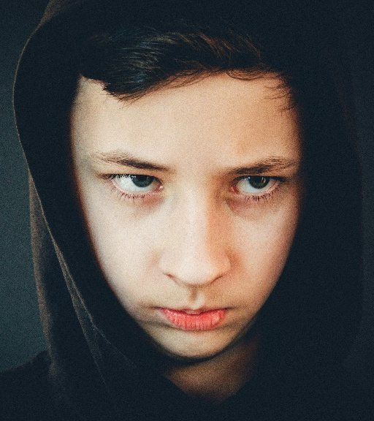
(Co-regulation & Self-regulation)
Primary

This resource is part of our self-care suite of resources and has been co-produced with children and young people living in Essex, for children and young people. They have also been developed and quality assured by the following stakeholders:
- Essex Educational Psychology Service
- Health Watch
- Essex Mental Health Support Teams (MHSTs) NELFT NHS Foundation Trust
- Essex Multi-schools Council
- Essex Social, Emotional and Mental Health (SEMH) strategy team
- Essex Child and Family Wellbeing Service, HCRG Care Group in partnership with Barnardos
- NELFT NHS Trust Southend, Essex, and Thurrock (SET) Child, Adolescent and Mental Health Service (CAMHS)

- Professionals in schools and settings can access all these resources via the Essex info link SEMH portal. Children and young people (CYP), parents/carers and professionals can also access these resources via the SET CAMHS website. Our self-care content can also be accessed via SET CAMHS Instagram account:

The resources are intended to be accessed by CYP independently or trusted adults use these resources with CYP through 1:1 conversation, whole school/group discussion and assemblies.
Please note: some of the content within our self-care resources may be emotive for CYP. We recommend that you make use of the ‘signposting to support’ section of this document should any of the content be triggering.
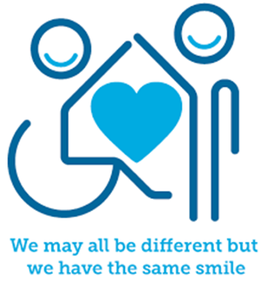


Introduction
Emotions are a normal part of everyday life. Throughout the day we might at times feel all sorts of emotions - happy, sad, frustrated or angry for example. We need to be able to understand these feelings and how they affect us so that we are able to manage our own emotions.
Emotional Regulation is how we manage and respond to an emotional experience and is also known as emotional self-regulation. This may be achieved by processing feelings and perhaps expressing themselves by crying, listening to music, napping, having a break or doing something active like going for a walk.
Children and young people (and adults) who struggle to make sense of and/or manage their emotions on their own, can get help to feel better with the support of another/others (including your pets). We call this Co-Regulation. This could be having a cuddle, talking, or kicking a ball with someone.

Facts
- Every day we experience different emotions based on our experiences. Our thoughts and feelings about the things that happen throughout the day will connect to our emotions (positive and negative)
- People respond differently to different situations, so the same event could leave one person feeling happy and another feeling worried, for example
- Regulating our emotions is a skill. Some people find it easier than others to regulate their emotions.
- At times everyone struggles to manage their emotions
- Other people can help us to manage our emotions
- We can learn and use different tools to help us manage our emotions

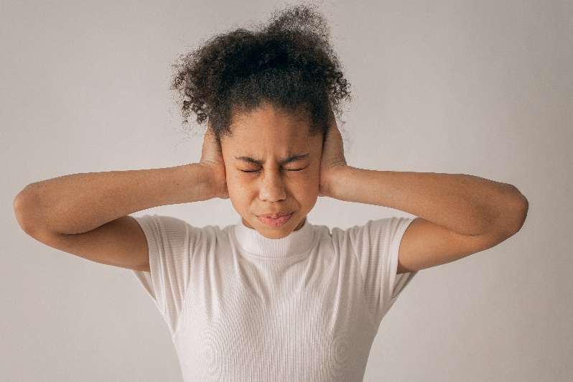


Myth Buster
- The older you are, the better you are at managing emotions X
- Having strong emotions means you are out of control X
- Emotions are unhelpful X
- It’s better/easier to just ignore negative emotions X
- Emotion should not be talked about with other people X
Video clips
Check out these videos about Managing Emotions:
- Coping Skills For Kids - Managing Feelings & Emotions For Elementary-Middle School | Self-Regulation - YouTube
Strategies young people can use to manage emotions (KS2)

- Feelings and emotions – BBC Bitesize Key Stage 2 Personal Development and Mutual Understanding - YouTube
Fun video about feelings and emotions (KS2)

- Dealing with feelings - BBC Bitesize Foundation Personal Development and Mutual Understanding - YouTube
Fun video to help understand emotions and give basic strategies (KS1)

- The Feelings Song | Emotions Song | Scratch Garden - YouTube
Song for KS1 and KS2




Resources
We have indicated whether the resources is accessible for Ks1 or Ks2. Please note that some of the ks2 content could be adapted and differentiated to support pupils in Ks1.

- feelings-activities.pdf (mentallyhealthyschools.org.uk)
Resources for KS1 and 2 including activity sheets on feelings
- Yr-1-2-Lesson-1-We-all-have-Feelings.pdf (healthyschoolscp.org.uk)
Activities focused on mental health and wellbeing (KS1)

- Yr-3-4-Lesson-1-Everyday-Feelings.pdf (healthyschoolscp.org.uk)
- Yr-3-4-Lesson-2-Expressing-Feelings.pdf (healthyschoolscp.org.uk)
Activities focused on mental health and wellbeing (KS2)

- 7-Minute Emotional Regulating Activity to Help Kids Calm Down
BrightenUp! Kids have developed a 7-minute activity to help CYP regulate (Ks1)

Reflective questions
(Try exploring these reflective questions with a CYP)
- Name 5 feelings you might have during the school day
- Name 3 things you can do to help your body feel calm
- Who helps you when you have big feelings?
- How does your body feel when you’re scared or angry?
- What activities do you do that help you to feel better?

Quiz
Once you’ve gone through this resource with a CYP try this quiz questions with them:
- Why do we need to manage our feelings?
- What might happen if we can’t manage our feelings?
- What is mindfulness?
- What can you do if you need help to manage your emotions?
- How might you help a friend who is struggling with their feelings?

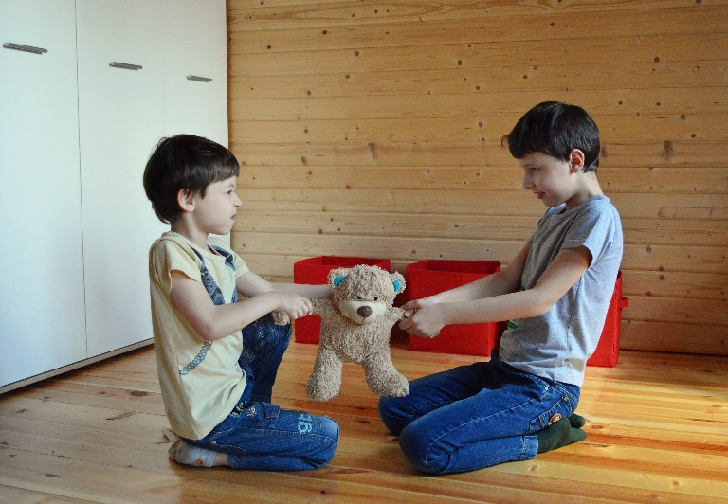
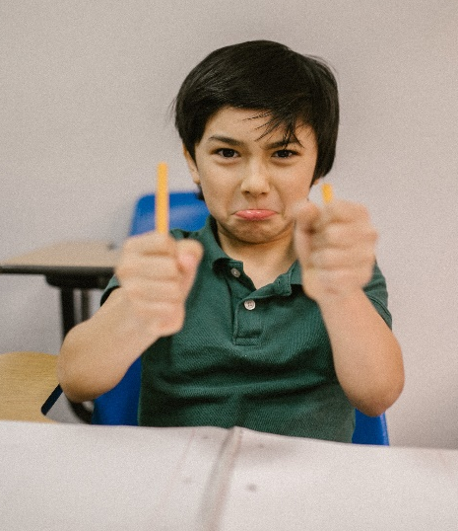

Additional ideas
Other things to try:
- I Am Cloud | Mindfulness Story for Kids | Acceptance of changing feelings. - YouTube
Video story explaining mindfulness

- Cosmic Kids Yoga - YouTube
Free yoga sessions for children based on stories / songs

Signposting to Support
For additional support we recommend that trusted adults use these resources to support children and young people access support when required:
- Getting help for your child: where to start
- Childline 0800 1111 when contacting ChildLine what to expect?
- Hopeline 0800 068 41 41 offering confidential support and practical advice
- Text ‘SHOUT’ to 85258 for free, confidential, anonymous text support service
- NHS 111
- Southend, Essex & Thurrock Children and Adolescent Mental Health Service (SET CAMHS)
- Explore counselling/therapy
- Where to get urgent mental health support from: Advice from NHS

- SET CAMHS Instagram account

How to help a friend
- Listen to them
- Encourage them to talk to an adult
- Tell an adult that your friend might need some support
- Tell your friend some things that you do to manage big feelings

The adult box (for professionals and parent/carers to read)
- 5 Incredibly Fun GAMES to Teach Self-Regulation (Self-Control) | Social Emotional Learning - YouTube
Evidence based activities to use with children and young people to help teach self-regulation
Please note: In Essex we use the terms ‘dysregulation’ or ‘dysregulated’ to describe some of the terms used within this video, such as ‘meltdowns’, ‘tantrums’ and ‘overly silly’.

- when-emotions-explode-indesign_pdf.pdf (youngminds.org.uk)
A poster to remind adults how to help when a child is dysregulated. (KS1 and KS2)

- The 3 R’s
Beacon House explain how adults can support regulate children and young people using the 3R’s (regulate, relate and reason)

- Talking to your child about feelings - NHS (www.nhs.uk)
NHS advice about different ways of talking to your child about feelings.

- Mindfulness Activities | Mental Health Resources | YoungMinds
Ideas for mindfulness activities to use with children and young people. (KS1 and KS2)



