**Let’s Talk: Managing Emotions**

**(Co-regulation & Self-regulation)**

**Primary**

This resource is part of our self-care suite of resources and has been co-produced with children and young people living in Essex, for children and young people. They have also been developed and quality assured by the following stakeholders:

* Essex Educational Psychology Service
* Health Watch
* Essex Mental Health Support Teams (MHSTs) NELFT NHS Foundation Trust
* Essex Multi-schools Council
* Essex Social, Emotional and Mental Health (SEMH) strategy team
* Essex Child and Family Wellbeing Service, HCRG Care Group in partnership with Barnardos
* NELFT NHS Trust Southend, Essex, and Thurrock (SET) Child, Adolescent and Mental Health Service (CAMHS)
* Professionals in schools and settings can access all these resources via the [Essex info link SEMH portal](https://schools.essex.gov.uk/pupils/social_emotional_mental_health_portal_for_schools/Pages/Self-care-for-CYP-Library.aspx). Children and young people (CYP), parents/carers and professionals can also access these resources via the SET CAMHS website. Our self-care content can also be accessed via SET CAMHS Instagram account:

The resources are intended to be accessed by CYP independently or trusted adults use these resources with CYP through 1:1 conversation, whole school/group discussion and assemblies.

Please note: some of the content within our self-care resources may be emotive for CYP. We recommend that you make use of the ‘signposting to support’ section of this document should any of the content be triggering.

   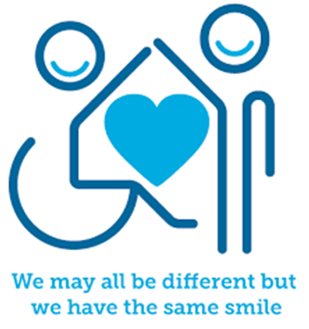

 

**Introduction**

Emotions are a normal part of everyday life. Throughout the day we might at times feel all sorts of emotions - happy, sad, frustrated or angry for example. We need to be able to understand these feelings and how they affect us so that we are able to manage our own emotions.

**Emotional Regulation** is how we manage and respond to an emotional experience and is also known as **emotional self-regulation**. This may be achieved by processing feelings and perhaps expressing themselves by crying, listening to music, napping, having a break or doing something active like going for a walk.

Children and young people (and adults) who struggle to make sense of and/or manage their emotions on their own, can get help to feel better with the support of another/others (including your pets). We call this **Co-Regulation.** This could be having a cuddle, talking, or kicking a ball with someone.

**Facts**

* Every day we experience different emotions based on our experiences. Our thoughts and feelings about the things that happen throughout the day will connect to our emotions (positive and negative)
* People respond differently to different situations, so the same event could leave one person feeling happy and another feeling worried, for example
* Regulating our emotions is a skill. Some people find it easier than others to regulate their emotions.
* At times everyone struggles to manage their emotions
* Other people can help us to manage our emotions
* We can learn and use different tools to help us manage our emotions

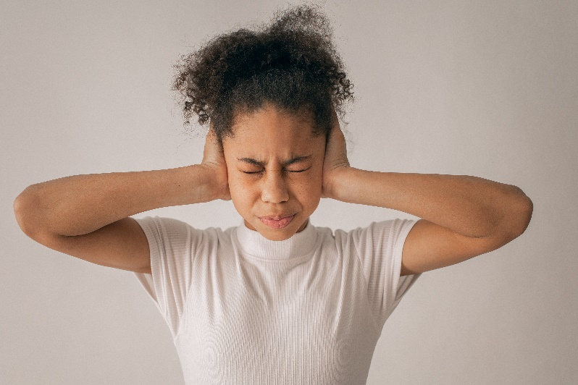

**Myth Buster**

* The older you are, the better you are at managing emotions X
* Having strong emotions means you are out of control X
* Emotions are unhelpful X
* It’s better/easier to just ignore negative emotions X
* Emotion should not be talked about with other people X

**Video clips**

Check out these videos about Managing Emotions:

|  |
| --- |
| * [Coping Skills For Kids - Managing Feelings & Emotions For Elementary-Middle School | Self-Regulation - YouTube](https://www.youtube.com/watch?v=Vs-MyQgfH3A)   Strategies young people can use to manage emotions (KS2) |
| * [Feelings and emotions – BBC Bitesize Key Stage 2 Personal Development and Mutual Understanding - YouTube](https://www.youtube.com/watch?v=_RqoU-m8kaw)   Fun video about feelings and emotions (KS2) |
| * [Dealing with feelings - BBC Bitesize Foundation Personal Development and Mutual Understanding - YouTube](https://www.youtube.com/watch?v=07hjPeyWVCU)   Fun video to help understand emotions and give basic strategies (KS1) |
| * [The Feelings Song | Emotions Song | Scratch Garden - YouTube](https://www.youtube.com/watch?v=uos7eDRUokE)   Song for KS1 and KS2 |



**Resources**

|  |
| --- |
| We have indicated whether the resources is accessible for Ks1 or Ks2. Please note that some of the ks2 content could be adapted and differentiated to support pupils in Ks1. |
| * [feelings-activities.pdf (mentallyhealthyschools.org.uk)](https://mentallyhealthyschools.org.uk/media/2065/feelings-activities.pdf)   Resources for KS1 and 2 including activity sheets on feelings |
| * [Yr-1-2-Lesson-1-We-all-have-Feelings.pdf (healthyschoolscp.org.uk)](https://healthyschoolscp.org.uk/wp-content/uploads/2020/04/Yr-1-2-Lesson-1-We-all-have-Feelings.pdf)   Activities focused on mental health and wellbeing (KS1) |
| * [Yr-3-4-Lesson-1-Everyday-Feelings.pdf (healthyschoolscp.org.uk)](https://healthyschoolscp.org.uk/wp-content/uploads/2020/04/Yr-3-4-Lesson-1-Everyday-Feelings.pdf) * [Yr-3-4-Lesson-2-Expressing-Feelings.pdf (healthyschoolscp.org.uk)](https://healthyschoolscp.org.uk/wp-content/uploads/2020/04/Yr-3-4-Lesson-2-Expressing-Feelings.pdf)   Activities focused on mental health and wellbeing (KS2) |
| * [7-Minute Emotional Regulating Activity to Help Kids Calm Down](https://www.youtube.com/watch?v=ORRdf_nLc_I)   BrightenUp! Kids have developed a 7-minute activity to help CYP regulate (Ks1) |

**Reflective questions**

(Try exploring these reflective questions with a CYP)

* Name 5 feelings you might have during the school day
* Name 3 things you can do to help your body feel calm
* Who helps you when you have big feelings?
* How does your body feel when you’re scared or angry?
* What activities do you do that help you to feel better?

**Quiz**

Once you’ve gone through this resource with a CYP try this quiz questions with them:

* Why do we need to manage our feelings?
* What might happen if we can’t manage our feelings?
* What is mindfulness?
* What can you do if you need help to manage your emotions?
* How might you help a friend who is struggling with their feelings?

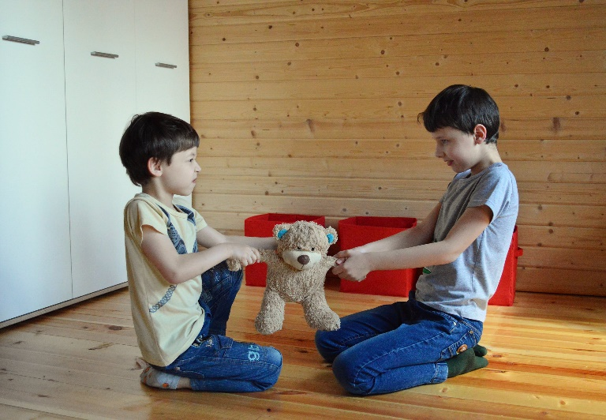

**Additional ideas**

Other things to try:

|  |
| --- |
| * [I Am Cloud | Mindfulness Story for Kids | Acceptance of changing feelings. - YouTube](https://www.youtube.com/watch?v=1us7DmXAuaU)   Video story explaining mindfulness |
| * [Cosmic Kids Yoga - YouTube](https://www.youtube.com/user/cosmickidsyoga)   Free yoga sessions for children based on stories / songs |

**Signposting to Support**

For additional support we recommend that trusted adults use these resources to support children and young people access support when required:

* [Getting help for your child: where to start](https://www.youngminds.org.uk/parent/parents-a-z-mental-health-guide/getting-help-for-your-child/)
* [Childline](https://www.childline.org.uk/info-advice/your-feelings/mental-health/?&&&&gclsrc=aw.ds&&gclid=EAIaIQobChMIqryktIeP_wIVicPtCh3QZQs6EAAYASAAEgJr5vD_BwE&gclsrc=aw.ds) 0800 1111 when [contacting ChildLine what to expect](https://www.youtube.com/watch?v=_KNtMOKwTco)?
* [Hopeline 0800 068 41 41](https://www.papyrus-uk.org/papyrus-HOPELINE247/) offering confidential support and practical advice
* [Text ‘SHOUT’ to 85258](https://giveusashout.org/get-help/?gclid=Cj0KCQiA6vaqBhCbARIsACF9M6nG--bxZCnflhd5C3jT-d9dS48o5t6XTTTidI0MLTgwjjRAlxszRT8aAnvvEALw_wcB) for free, confidential, anonymous text support service
* [NHS 111](https://www.nhs.uk/nhs-services/mental-health-services/)
* [Southend, Essex & Thurrock Children and Adolescent Mental Health Service (SET CAMHS)](https://www.nelft.nhs.uk/set-camhs/)
* [Explore counselling/therapy](https://www.nhs.uk/mental-health/talking-therapies-medicine-treatments/talking-therapies-and-counselling/counselling/)
* [Where to get urgent mental health support from: Advice from NHS](https://www.nhs.uk/nhs-services/mental-health-services/where-to-get-urgent-help-for-mental-health/)



* SET CAMHS Instagram account

**How to help a friend**

* Listen to them
* Encourage them to talk to an adult
* Tell an adult that your friend might need some support
* Tell your friend some things that you do to manage big feelings

**The adult box** (for professionals and parent/carers to read)

|  |
| --- |
| * [5 Incredibly Fun GAMES to Teach Self-Regulation (Self-Control) | Social Emotional Learning - YouTube](https://www.youtube.com/watch?v=H_O1brYwdSY)   Evidence based activities to use with children and young people to help teach self-regulation  *Please note: In Essex we use the terms ‘dysregulation’ or ‘dysregulated’ to describe some of the terms used within this video, such as ‘meltdowns’, ‘tantrums’ and ‘overly silly’.* |
| * [when-emotions-explode-indesign_pdf.pdf (youngminds.org.uk)](https://www.youngminds.org.uk/media/g3cpojk3/when-emotions-explode-indesign_pdf.pdf)   A poster to remind adults how to help when a child is dysregulated. (KS1 and KS2) |
| * [The 3 R’s](https://beaconhouse.org.uk/wp-content/uploads/2019/09/The-Three-Rs.pdf)   Beacon House explain how adults can support regulate children and young people using the 3R’s (regulate, relate and reason) |
| * [Talking to your child about feelings - NHS (www.nhs.uk)](https://www.nhs.uk/mental-health/children-and-young-adults/advice-for-parents/talk-to-children-about-feelings/)   NHS advice about different ways of talking to your child about feelings. |
| * [Mindfulness Activities | Mental Health Resources | YoungMinds](https://www.youngminds.org.uk/professional/resources/mindfulness-activities/)   Ideas for mindfulness activities to use with children and young people. (KS1 and KS2) |

   

 