**Let’s Talk: Sex**

**Secondary**

This resource is part of our self-care suite of resources and has been co-produced, with children and young people living in Essex, for children and young people. They have also been developed and quality assured by the following stakeholders:

* Essex Educational Psychology Service
* Health Watch Essex
* Essex Mental Health Support Teams (MHSTs) NELFT NHS Foundation Trust
* Essex Multi-schools Council
* Essex Social, Emotional and Mental Health (SEMH) strategy team
* Essex Child and Family Wellbeing Service, HCRG Care Group in partnership with Barnardos
* NELFT NHS Trust Southend, Essex, and Thurrock (SET) Child, Adolescent and Mental Health Service (CAMHS)
* Professionals in schools and settings can access all these resources via the [Essex info link SEMH portal](https://schools.essex.gov.uk/pupils/social_emotional_mental_health_portal_for_schools/Pages/Self-care-for-CYP-Library.aspx). Children and young people (CYP), parents/carers and professionals can also access these resources via the SET CAMHS website. Our self-care content can also be accessed via SET CAMHS Instagram account:

The resources are intended to be accessed by CYP independently or trusted adults use these resources with CYP through 1:1 conversation, whole school/group discussion and assemblies.

Please note: some of the content within our self-care resources may be emotive for CYP. We recommend that you make use of the ‘signposting to support’ section of this document should any of the content be triggering.

   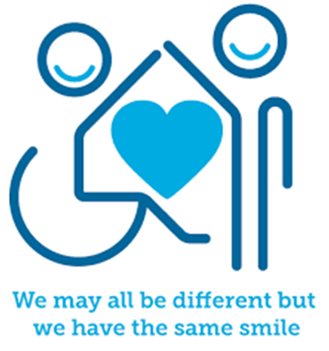

 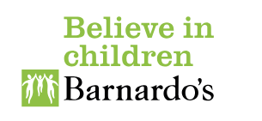

**Introduction**

The age of consent is 16. This is the age when young people of any sex, gender or sexual orientation can legally consent to taking part in sexual activity.

Sex can mean lots of different things. People who mention ‘having sex’ are often talking about having sexual intercourse, but not always.

Having sex is not the only way people are intimate or sexual with each other. There are lots of things that someone might find intimate, like hugging, kissing or watching something sexual with someone else.

Sex should be something that you enjoy and can have safely. If you are thinking about having sex, then it is important that you are ready, can enjoy it, and can take responsibility for it. It is also important to make sure that you get contraceptive advice to protect yourself from unplanned [pregnancy](https://www.brook.org.uk/topics/pregnancy) and [Sexually Transmitted Infections (STIs](https://www.brook.org.uk/topics/stis/)).

**Facts**

* Consent is when a person freely agrees to something. When it comes to sex, consent is mandatory, every time.
* Having sex under the age of 16 is illegal.
* Trust and respect are important parts of a sexual relationship.
* Chlamydia often doesn't have any symptoms. This means that people can be infected without knowing it.
* Condoms help stop infections being spread during sex.

**Myth Buster**

* Only girls can use contraception X
* Sex education encourages young people to have sex X
* Sex will hurt X
* ‘Everyone’ is having sex at school X
* Having an STI means you are unclean X

**Video clips**

Check out these videos about sex and consent:

|  |
| --- |
| * <https://youtu.be/jM_2hiSikAQ>   Childline video explaining consent |
| * <https://youtu.be/MiucLWKCOsU>   Childline sex and relationships |
| * <https://youtu.be/XQw5Ee7nunY>   Childline sex and contraception |

**Resources**

|  |
| --- |
| We have indicated whether the resources are accessible for Ks3, Ks4 or Ks5+. However, some of the content may be able to be differentiated to suit other age groups of children and young people using these resources. |
| * [Sexual Health & Wellbeing - Brook – Fighting for healthy lives](https://www.brook.org.uk/)   Your free and confidential sexual health and wellbeing experts (Ks3+) |
| * [Welcome to Essex Sexual Health Services (askingforafriend.org.uk)](https://askingforafriend.org.uk/)   Essex sexual health providing you with free confidential advice and support |

**Reflective questions**

(Try exploring these reflective questions with a CYP)

* What does sex mean?
* What are some important things to consider when you are thinking about having sex?
* Where can you go to access advice and support before or after having sex?
* What does consent mean and how do you know it’s given?



**Quiz**

Once you’ve gone through this resource with a CYP try these quiz questions with them:

* Can you name three types of STI?
* What is the legal age to have sex in the UK?
* What is consent?
* Can you name three types of contraception?
* What can you do if you think you have an STI?

**Signposting to Support**

For additional support we recommend that trusted adults use these resources to support children and young people access support when required:

* [Anna Freud Centre – On My Mind](https://www.annafreud.org/on-my-mind/)
* [Kooth.com](https://www.kooth.com/) (Age 11-25)
* [Togetherall](https://togetherall.com/en-gb/faqs/becoming-a-member-and-managing-your-profile/#:~:text=Togetherall%20is%20only%20for%20adults,is%20only%20available%20to%2018%2B.) (Age 16+)
* [Explore counselling/therapy](https://www.nhs.uk/mental-health/talking-therapies-medicine-treatments/talking-therapies-and-counselling/counselling/)
* [Childline](https://www.childline.org.uk/info-advice/your-feelings/mental-health/?&&&&gclsrc=aw.ds&&gclid=EAIaIQobChMIqryktIeP_wIVicPtCh3QZQs6EAAYASAAEgJr5vD_BwE&gclsrc=aw.ds) - 0800 1111 – [when contacting ChildLine what to expect](https://www.youtube.com/watch?v=_KNtMOKwTco)?
* [Hopeline 0800 068 41 41](https://www.papyrus-uk.org/papyrus-HOPELINE247/) offering confidential support and practical advice
* [Text ‘SHOUT’ to 85258](https://giveusashout.org/get-help/?gclid=Cj0KCQiA6vaqBhCbARIsACF9M6nG--bxZCnflhd5C3jT-d9dS48o5t6XTTTidI0MLTgwjjRAlxszRT8aAnvvEALw_wcB) for free, confidential, anonymous text support service.
* [Share any concerns about your mental health with your GP](https://www.mind.org.uk/information-support/guides-to-support-and-services/seeking-help-for-a-mental-health-problem/talking-to-your-gp/) and [Understanding Confidentiality](https://www.mind.org.uk/for-young-people/your-rights/understanding-confidentiality/)
* [NHS 111](https://www.nhs.uk/nhs-services/mental-health-services/)
* [Southend, Essex & Thurrock Children and Adolescent Mental Health Service (SET CAMHS)](https://www.nelft.nhs.uk/set-camhs/)
* [Where to get urgent mental health support from: Advice from NHS](https://www.nhs.uk/nhs-services/mental-health-services/where-to-get-urgent-help-for-mental-health/)
* 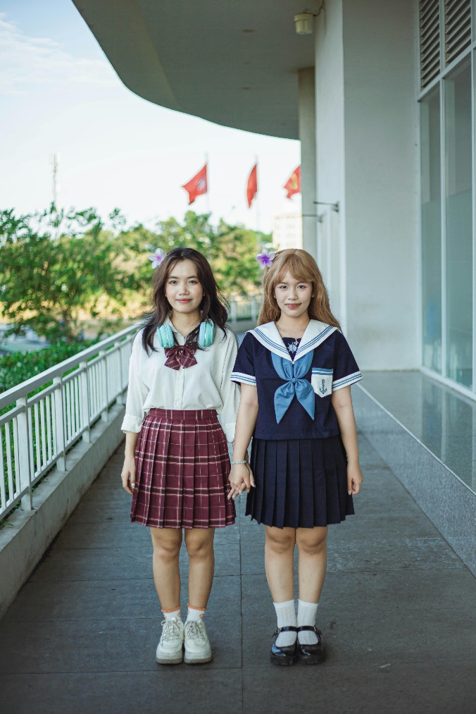SET CAMHS Instagram account 

**How to help a friend**

* Share this resource with them.
* Tell them about the SET CAMHS Instagram account.
* Signpost them to [www.askingforafriend.org.uk](http://www.askingforafriend.org.uk)
* Listen to them and reassure them, encouraging them to seek help from a trusted adult if you or they are worried.



**The adult box** (for professionals and parent/carers to read)

|  |
| --- |
| * [Healthy relationships | NSPCC](https://www.nspcc.org.uk/keeping-children-safe/sex-relationships/healthy-relationships/)   How to talk to your child about relationships |
| * [Family Planning Association (fpa.org.uk)](https://www.fpa.org.uk/)   Family Planning Association resources |
| * [How to have difficult conversations with children | NSPCC Learning](https://learning.nspcc.org.uk/safeguarding-child-protection/how-to-have-difficult-conversations-with-children)   Advice on how to approach difficult conversations with your child |
| * [Search (pshe-association.org.uk)](https://pshe-association.org.uk/search?queryTerm=sex)   PSHE association’s sex education resources |
| * [sexeducationforum.org.uk | Working together for quality relationships and sex education](https://www.sexeducationforum.org.uk/)   Offering a voice for sex education and relationships |
| * [Relationships and sex education (RSE) resources for schools | NSPCC Learning](https://learning.nspcc.org.uk/safeguarding-child-protection-schools/relationships-health-and-sex-education-resources)   Relationships and sex education (RSE) resources for schools, preparing health, relationships, and sex education lessons with our RSE resources |



   

 