**Maximising school attendance bulletiN**

**November 2024 – Half term 2**

**Welcome back, we hope you had a restful October half term. This bulletin is a brief update, please remember to check ESI (Essex Schools Infolink) for supporting forms and documents you may find useful.**

**In this issue:**

* **Data**
* **Improving attendance – half-term 2**
* **Moments Matter**
* **Monitor your school attendance – October update:**
* **Other useful webinars**
* **Supporting improved attendance campaign materials**
* **Updated attendance resources and ESI**
* **Other Education Services**
* **Targeting Support Meetings (TSM’s)**
* **Coding**
* **Team Contacts**

**Data:**

|  |  |  |  |  |  |  |  |  |  |  |  |  |
| --- | --- | --- | --- | --- | --- | --- | --- | --- | --- | --- | --- | --- |
| **Date** | **PRIMARY** | | | | **SECONDARY** | | | | **SPECIAL** | | | |
| **ATTENDANCE** | | **PA** | | **ATTENDANCE** | | **PA** | | **ATTENDANCE** | | **PA** | |
|  | **ESX** | **NAT** | **ESX** | **NAT** | **ESX** | **NAT** | **ESX** | **NAT** | **ESX** | **NAT** | **ESX** | **NAT** |
| **13.9.24** | 96.5 | 96.2 | n/a | n/a | 94.3 | 94.3 | n/a | n/a | 91.4 | 89.9 | n/a | n/a |
|  | ***+0.3*** |  | n/a | n/a | ***=*** |  | n/a | n/a | ***+1.5*** |  | n/a | n/a |
| **27.9.24** | 95.8 | 95.8 | n/a | n/a | 93.1 | 93.2 | n/a | n/a | 90.1 | 88.6 | n/a | n/a |
|  | ***=*** |  | n/a | n/a | ***0.1*** |  | n/a | n/a | ***+1.5*** |  | n/a | n/a |
| **11.10.24** | 95.7 | 95.7 | n/a | n/a | 92.7 | 93.0 | n/a | n/a | 89.7 | 88.3 | n/a | n/a |
|  | ***=*** |  | n/a | n/a | ***0.3*** |  | n/a | n/a | ***+1.4*** |  | n/a | n/a |

The above table shows data from the beginning of this term, published fortnightly via the [DfE data dashboard](https://department-for-education.shinyapps.io/pupil-attendance-in-schools/).

As you can see, Essex is on par with National for primary phase, but slightly below National for secondary phases. Similar to the previous academic year our special schools remain above National average for their phase.

When compared to the same period for last Academic year for all phases, both nationally and across Essex, attendance levels are down. This is to be expected given the changes in coding and impact of the introduction of the C2 code.

**Improving attendance – half-term 2**

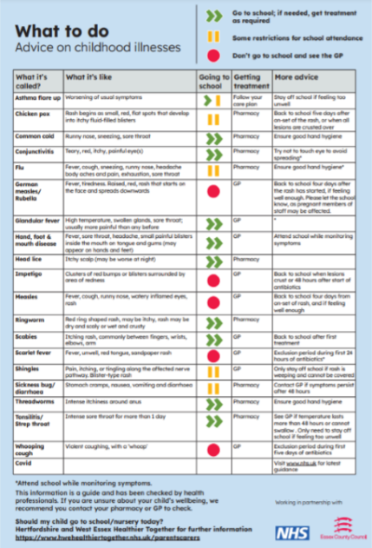Attendance in schools may experience a decline following the October half-term break and, the lead-up to Christmas. The increased absence is often due to illness. To encourage improved attendance schools are advised to communicate expectations regularly and clearly in terms of illness absence, using the NHS/ECC Guide to Childhood illness as mentioned in previous Maximising Attendance Bulletins.

It is important all staff who speak with pupils and their families are familiar with the school’s expectations and can communicate these with confidence. Another strategy to minimise absence through illness in school is to consider and re-emphasise a healthy hygiene programme around hand washing etc. The UK Health Security Agency has developed a health education programme called e-Bug which aims to promote positive infection prevention and control efforts for children and young people. The programme provides resources and training aimed at each key stage, which includes lesson plans on topics like hand hygiene, coughs, and sneezes spreading illness etc.

Check it out here: [e-Bug resource](https://www.e-bug.eu/)

**Moments Matter:**

Improving school attendance is everyone’s business, and back in January 2024, the Department for Education launched an attendance campaign to support this challenge, “Moments Matter, Attendance Counts”.

Now is a good time to remind parents/carers of the following three major points of that campaign:

1. **The link between regular attendance to school and attainment is clear:**

**Data analysis clearly shows that students attendance over 90% are three times more likely to achieve grade 4 and above at GCSE.**

1. **It is never too late to benefit from good attendance to school:**

**Over half of students whose attendance was below 90% in year 10 and were rarely absent in year 11, went on the achieve at least 5 GCSE’s. Compared to only one-third who had persistent absence in years 10 & 11.**

1. **Regular attendance to school is important for more than just attainment:**

Attending school regularly (attendance above 90%) can facilitate positive peer relationships, which is a protective factor for mental health and wellbeing.

We know and appreciate that a small number of children face greater barriers to attendance, such as those with long term medical needs or special educational needs and disabilities and we will continue to work with these individual children and families to overcome these barriers.

**Monitor your school attendance – October update:**

This is the October update on the monitor your school attendance tool which gives schools, trusts and local authorities access to up- to- date attendance data.

Please use link: [Monitor your school attendance - October update](https://www.youtube.com/watch?v=U6lwhkuZdn0&list=PLXjcCX3hH9LV-atDG7rxT8IzI2AurN3XX&index=1)

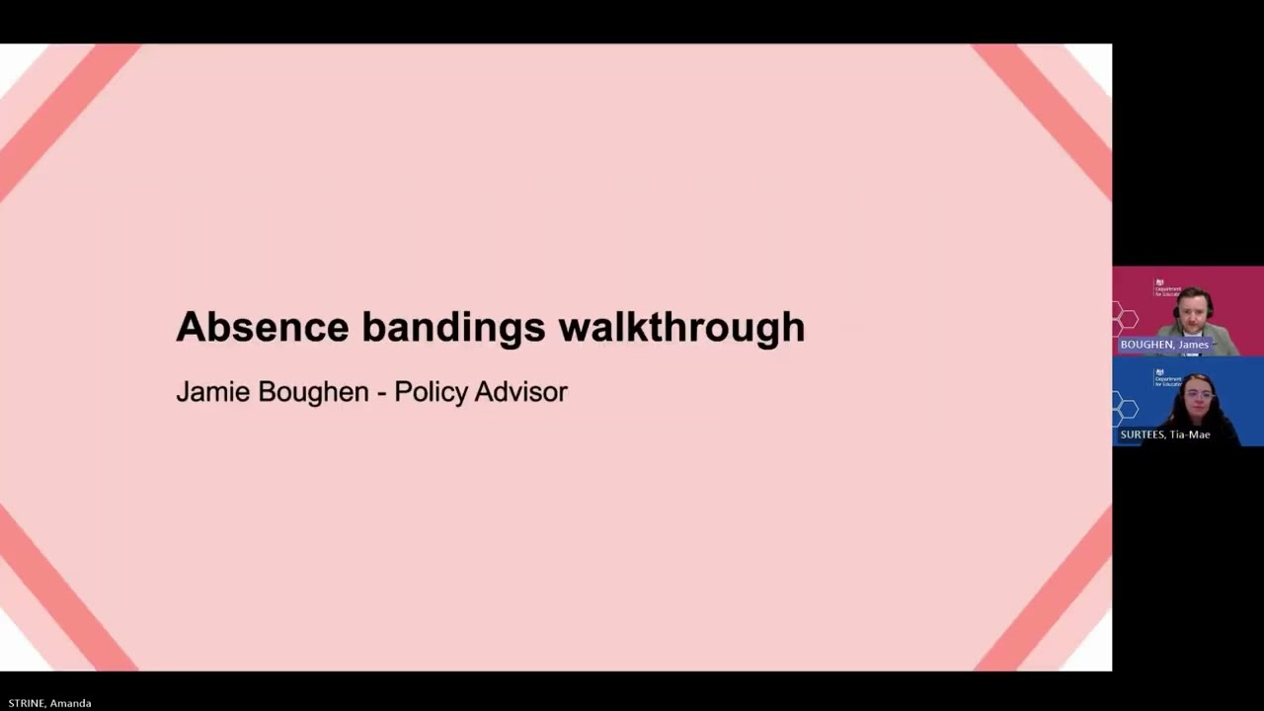

**Other useful webinars**

* [DfE - Monitor your school attendance webinar for schools, trusts and LAs Tickets, Tue, Nov 19, 2024 at 9:45 AM | Eventbrite](https://www.eventbrite.com/e/dfe-monitor-your-school-attendance-webinar-for-schools-trusts-and-las-tickets-1053290894419?aff=ebemoffollowpublishemail&ref=eemail&utm_campaign=following_published_event&utm_content=follow_notification&utm_medium=email&utm_source=eventbrite)

|  |
| --- |
| * [How to create an effective early help plan](https://eur02.safelinks.protection.outlook.com/?url=https%3A%2F%2Fnews.news.essex.gov.uk%2FBE2082DEF861614C3066250A5A7E771323DC4D263F5A6BDB2157EABFF40FE728%2F422B71D0095599206E1F734B61FCF84B%2FLE35&data=05%7C02%7Cdaisy.alexander%40essex.gov.uk%7C873035c7a6754a3f59ee08dcf338c780%7Ca8b4324f155c4215a0f17ed8cc9a992f%7C0%7C0%7C638652672432311131%7CUnknown%7CTWFpbGZsb3d8eyJWIjoiMC4wLjAwMDAiLCJQIjoiV2luMzIiLCJBTiI6Ik1haWwiLCJXVCI6Mn0%3D%7C0%7C%7C%7C&sdata=uLnPyXeEKZTNv5n2j2nbBGqg9Z%2ByjoK2kHH4XDSCowA%3D&reserved=0) |

**Supporting improved attendance campaign materials:**

Additional, supporting improved attendance campaign resources remain available on ESI:

Supporting Improved Attendance – campaign materials including posters, bookmarks, and more – link below.

[**Supporting Improved Attendance – campaign materials including posters, bookmarks, and more**](https://schools.essex.gov.uk/pupils/attendance_specialist_teams/Pages/Supporting-Improved-Attendance-campaign-materials.aspx)

**Updated attendance resources and ESI:**

Please be advised, all template letters have been revised to reflect the ‘support first’ notion of the [WTTISA guidance](https://assets.publishing.service.gov.uk/media/66bf300da44f1c4c23e5bd1b/Working_together_to_improve_school_attendance_-_August_2024.pdf). Supporting resources and templates can be found here: NEW – Attendance template letters and forms and model policy – Effective September 2024 | Essex Schools Infolink; [Essex Support First Toolkit](https://schools.essex.gov.uk/essex-schools-infolink/attendance/attendance-support-first/essex-support-first-toolkit)

We suggest that this page is checked frequently for live updates as additional resources will continue to be made available.

**Other Education Services:**

Please see below, links to other education services which you may find useful:

<https://schools.essex.gov.uk/admissions-and-attendance/admissions>

<https://schools.essex.gov.uk/admissions-and-attendance/roll-notifications>

[Education access | Essex Schools Infolink](https://schools.essex.gov.uk/admissions-and-attendance/education-access)

[Home to school transport | Essex Schools Infolink](https://schools.essex.gov.uk/pupil-support-and-wellbeing/home-school-transport)

[Safeguarding | Essex Schools Infolink](https://schools.essex.gov.uk/safeguarding)

[Safeguarding contacts | Essex Schools Infolink](https://schools.essex.gov.uk/safeguarding/safeguarding-contacts)

[Social, emotional and mental health (SEMH) | Essex Schools Infolink](https://schools.essex.gov.uk/pupil-support-and-wellbeing/social-emotional-and-mental-health-semh)

[SEMH strategy, policies and frameworks | Essex Schools Infolink](https://schools.essex.gov.uk/pupil-support-and-wellbeing/social-emotional-and-mental-health-semh/semh-strategy-policies-and)

<https://youth.essex.gov.uk/schools/>

**TSM’s:**

During half term 1, the Attendance Specialist Team have been undertaking Targeting Support Meetings with schools across the County. The meetings have been an opportunity to review those pupils whose attendance has fallen within the severely absent cohort and where time allows, discussion around persistently absent pupils. The discussion facilitates the opportunity to review the support and intervention allocated and additional consideration to appropriate signposting or support that may be available to ensure a multi-agency approach.

Please be advised that the Senior Attendance Champion is expected to be present at the scheduled meeting alongside other relevant attendance staff e.g. Attendance Officer/pastoral support officer. Other colleagues are also welcome to join where they have availability to do so, e.g. Senco/DSL.

The Attendance specialist Team will continue to contact you where it is felt a TSM would be beneficial in line with the statutory guidance. Additional information relating to TSM’s can be found on pg34 of the [WTTISA guidance](https://assets.publishing.service.gov.uk/media/66bf300da44f1c4c23e5bd1b/Working_together_to_improve_school_attendance_-_August_2024.pdf) and also on Essex schools info link: [Targeting Support Meetings (TSMs): Overview | Essex Schools Infolink](https://schools.essex.gov.uk/essex-schools-infolink/attendance/attendance-support-first/targeting-support-meetings-tsms)

**Coding:**

Please be advised that as of Sept 2024 absence codes have been updated in line with the Pupil (registration) (England) regulations 2024, please review pages 76-93 of the WTTISA guidance for greater clarity around these codes.

The following DfE webinars also give greater insight into amended codes: School Attendance Register: Attendance and Absence Codes and an additional Q&A session:

[School Attendance Register: Attendance and Absence Codes - YouTube](https://www.youtube.com/watch?v=zonE7wTKIiE)

[Q & A - School attendance register: attendance and absence codes](https://www.youtube.com/watch?v=hl6QzPPr1Zg)

**Team Contacts:**

 The way schools contact the AST has also changed this term - Due to the AST being timetabled to complete TSMs, schools are requested to contact the AST via the relevant quadrant email address, allowing the voice mail linked to the phone line to be used by

parents only.

**Attendance Specialist Teams quadrant email addresses:**

North East: [neattendanceteam@essex.gov.uk](mailto:neattendanceteam@essex.gov.uk)

Mid: [midattendanceteam@essex.gov.uk](mailto:midattendanceteam@essex.gov.uk)

West: [westattendanceteam@essex.gov.uk](mailto:westattendanceteam@essex.gov.uk)

South: [southattendanceteam@essex.gov.uk](mailto:southattendanceteam@essex.gov.uk)



**Early Help Drop-In**

**Below is an image of the poster, to go direct to the poster:** **ECC Early Help Drop-in Poster 022.pdf**