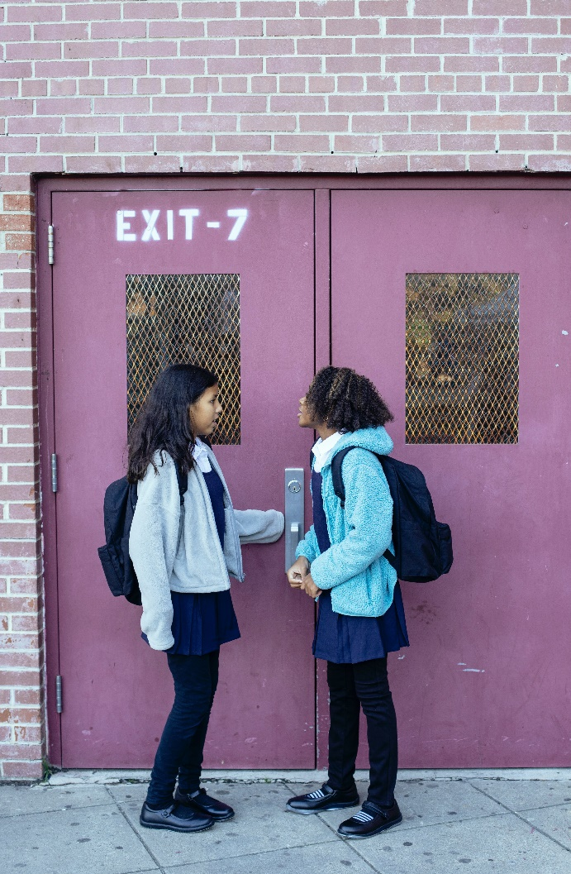**Let’s Talk: Transitions**

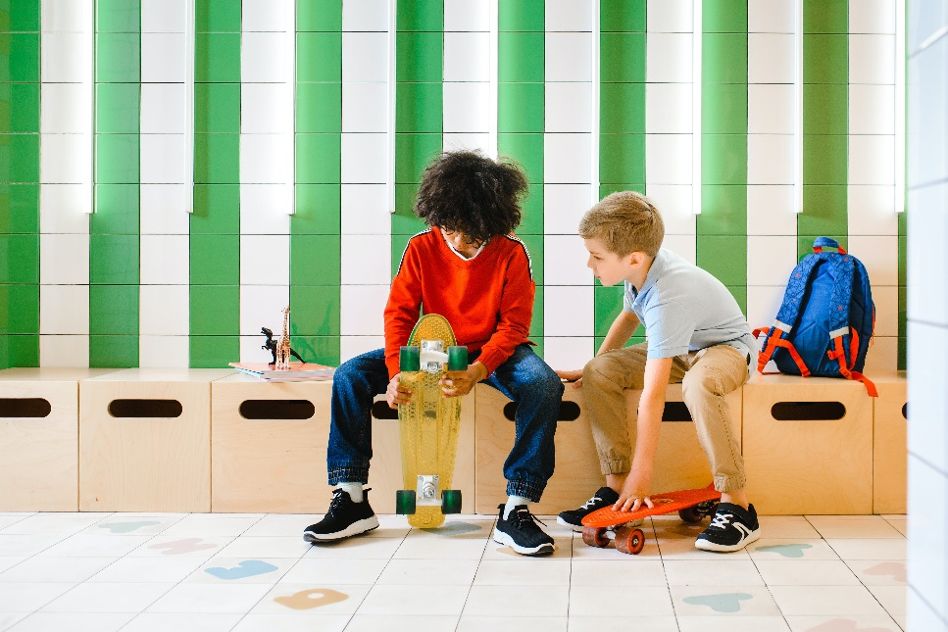**Primary**

This resource is part of our self-care suite of resources and has been co-produced, with children and young people living in Essex, for children and young people. They have also been developed and quality assured by the following stakeholders:

* Essex Educational Psychology Service
* Health Watch Essex
* Essex Mental Health Support Teams (MHSTs) NELFT NHS Foundation Trust
* Essex Multi-schools Council
* Essex Social, Emotional and Mental Health (SEMH) strategy team
* Essex Child and Family Wellbeing Service, HCRG Care Group in partnership with Barnardos
* NELFT NHS Trust Southend, Essex, and Thurrock (SET) Child, Adolescent and Mental Health Service (CAMHS)
* Professionals in schools and settings can access all these resources via the [Essex info link SEMH portal](https://schools.essex.gov.uk/pupils/social_emotional_mental_health_portal_for_schools/Pages/Self-care-for-CYP-Library.aspx). Children and young people (CYP), parents/carers and professionals can also access these resources via the SET CAMHS website. Our self-care content can also be accessed via SET CAMHS Instagram account:

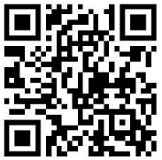

The resources are intended to be accessed by CYP independently or trusted adults use these resources with CYP through 1:1 conversation, whole school/group discussion and assemblies.

Please note: some of the content within our self-care resources may be emotive for CYP. We recommend that you make use of the ‘signposting to support’ section of this document should any of the content be triggering.

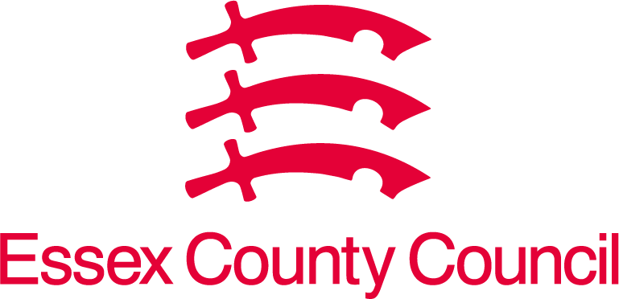   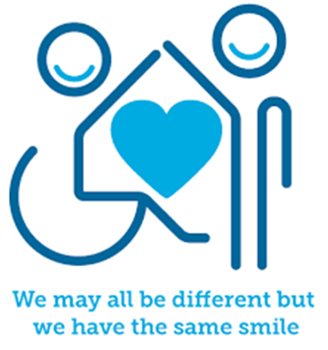

 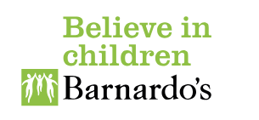

**Introduction**

A transition is a change that happens when you move between two stages of something. There can be small everyday transitions such as moving from one lesson to another, from lesson to a break/lunch time, or coming into/leaving your school/setting. There can also be bigger transitions such as moving year groups or schools, from primary to secondary school, or secondary school to college, work, or university. Some people find transitions okay to manage, whilst other people can find transitions difficult for many reasons. These include feeling emotional about leaving the comfort they know or feeling anxious about what is coming next. It can be helpful to prepare for transitions so you feel more in control over managing the changes and it can be important to recognise when you need help from others to support you. Why not talk to a trusted adult and ask for their help to support you to plan and manage transitions.

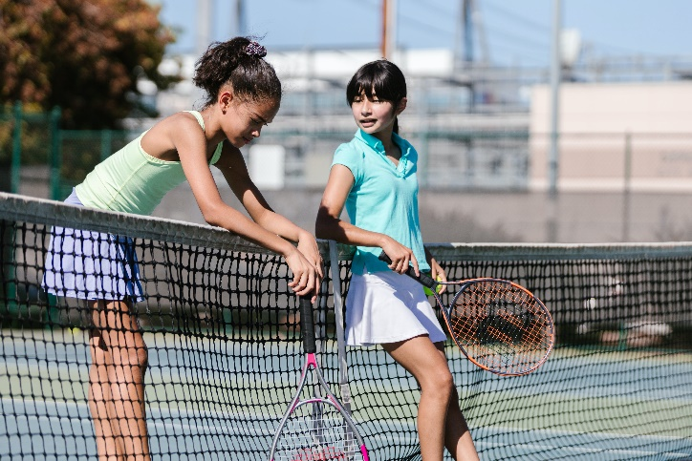

**Facts**

Transition facts:

* A transition is when a change happens.
* Some transitions can be big whilst other transitions can be smaller everyday transitions through the day.
* 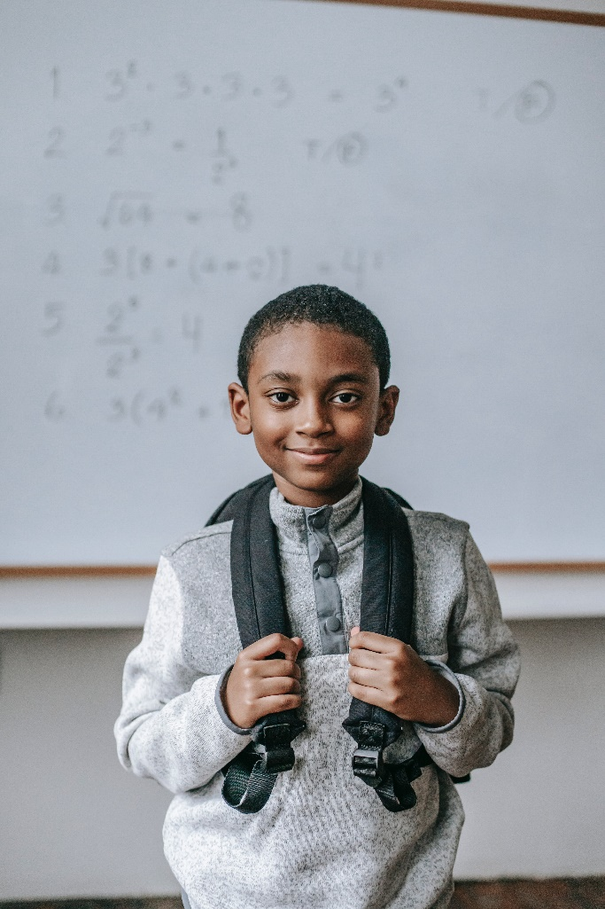Some transitions may be planned for such as the school day routines whilst other transitions can be unplanned, such as the school fire alarm going off or a teacher being absent from school because they are unwell.

**Myth Buster**

Transition myths:

* Everyone should just be okay with transitions. X
* You shouldn’t need help to manage transitions. X
* You always lose friendships during transitions. X
* Transitions are difficult for everyone. X

**Video clips**

Check out these videos about disability:

## [Moving Up! The transition to secondary school (youtube.com)](https://www.youtube.com/watch?v=kFpVOIpeksk)

## Anna Freud video to support transition from primary to secondary school (KS2)

* [Dealing with Changes and Transitions - Social Story - YouTube](https://www.youtube.com/watch?v=kEO29ckgNBw)

All special needs now have created a video to help students prepare for transitions (KS2)

* [How to Prepare for Secondary School or High School | Year 6 Transition to Secondary School (youtube.com)](https://www.youtube.com/watch?v=mhQpKizLC4s)

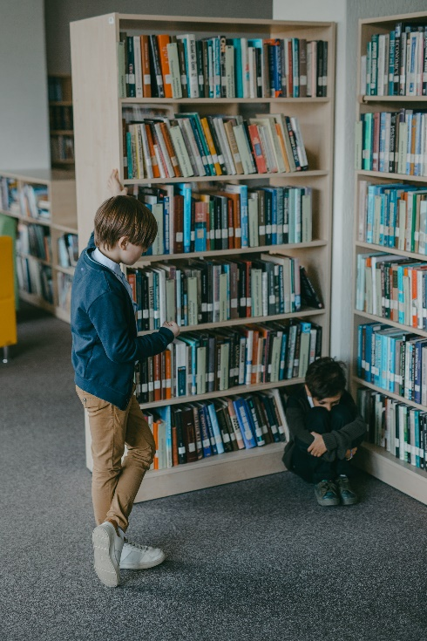Twinkl Education video about preparing for secondary school (KS2)

* [Coping with Change - YouTube](https://www.youtube.com/watch?v=o4yE6BidJCM)

Pepperdine Teacher Education shares top tips for managing change (Ks2)

**Resources**

* [Children’s Books About Transitions - Trying Together](https://tryingtogether.org/dap/books-transitions/)

Books to support children and young people explore different types of transitions

**Reflective questions**

(Try exploring these reflective questions with a CYP)

* What is a transition?
* Which transitions do you find easy and which do you find more difficult?

**Quiz**

Once you have gone through this resource with a CYP try this quiz questions with them:

* Describe 3 big transitions in life?
* Describe 3 smaller everyday transitions?
* What strategies can help to cope with transitions/change?

**Signposting to Support**

For additional support we recommend you take a look at the following links:

* [Getting help for your child: where to start](https://www.youngminds.org.uk/parent/parents-a-z-mental-health-guide/getting-help-for-your-child/)
* [Childline](https://www.childline.org.uk/info-advice/your-feelings/mental-health/?&&&&gclsrc=aw.ds&&gclid=EAIaIQobChMIqryktIeP_wIVicPtCh3QZQs6EAAYASAAEgJr5vD_BwE&gclsrc=aw.ds) - 0800 1111 – [when contacting ChildLine what to expect](https://www.youtube.com/watch?v=_KNtMOKwTco)
* [Hopeline 0800 068 41 41](https://www.papyrus-uk.org/papyrus-HOPELINE247/) offering confidential support and practical advice
* [Text ‘SHOUT’ to 85258](https://giveusashout.org/get-help/?gclid=Cj0KCQiA6vaqBhCbARIsACF9M6nG--bxZCnflhd5C3jT-d9dS48o5t6XTTTidI0MLTgwjjRAlxszRT8aAnvvEALw_wcB) for free, confidential, anonymous text support service
* [NHS 111](https://www.nhs.uk/nhs-services/mental-health-services/)
* [Southend, Essex & Thurrock Children and Adolescent Mental Health Service (SET CAMHS)](https://www.nelft.nhs.uk/set-camhs/)
* [Explore counselling/therapy](https://www.nhs.uk/mental-health/talking-therapies-medicine-treatments/talking-therapies-and-counselling/counselling/)
* [Where to get urgent mental health support from: Advice from NHS](https://www.nhs.uk/nhs-services/mental-health-services/where-to-get-urgent-help-for-mental-health/)



* SET CAMHS Instagram account

**How to help a friend**

* Start a conversation about transitions/change.
* Explore how your friends feel about and manage change.
* What strategies do you and your friends use to manage change?

**The adult box** (for professionals and parent/carers to read)



* [dealing with change and transitions secondary toolkit](https://www.mentallyhealthyschools.org.uk/resources/dealing-with-change-and-transitions-toolkit/?searchTerm=end+of+term+toolkit)

Mentally Healthy Schools toolbox

* [Transitioning to secondary school](https://www.bbc.co.uk/teach/teach/transitioning-to-secondary-school/zkc9pg8)

BBC Bitesize resources

* [Moving up! Transition to secondary school](https://www.annafreud.org/resources/schools-and-colleges/moving-up-the-transition-to-secondary-school/)

Anna Freud resources to support transition from primary school to secondary school

* [transition tips for parents](https://www.youngminds.org.uk/professional/resources/supporting-school-transitions/) and [find your feet: parent webinar](https://www.youngminds.org.uk/professional/resources/supporting-school-transitions/)

Young minds resource for parents/carers

* [Supporting your child's transition to secondary school - Spurgeons](https://spurgeons.org/resources-for-parents/top-tips-for-school/)

Spurgeons Children’s Charity resource for transitions to secondary school

* [Transition to secondary school](https://www.place2be.org.uk/our-services/parents-and-carers/getting-ready-to-start-secondary-or-high-school/)

Place2Be resource to support CYP transition to secondary school

* [Transition Ideas KS2 - Activities and Resources - Twinkl](https://www.twinkl.co.uk/resource/t-c-1390-ks2-transition-pack)

Twinkl resources to support KS2 transitions

* [Transition Activities KS1 - Transition to School Resources (twinkl.co.uk)](https://www.twinkl.co.uk/resources/class-management/transition)

Twinkl resources to support KS1 transitions

* [Transition EYFS | Transitions in Early Years - Twinkl](https://www.twinkl.co.uk/resources/home-early-years/teacher-organisation-eyfs-early-years/early-years-transition)

Twinkl early years resource to support transition to KS1

   

 