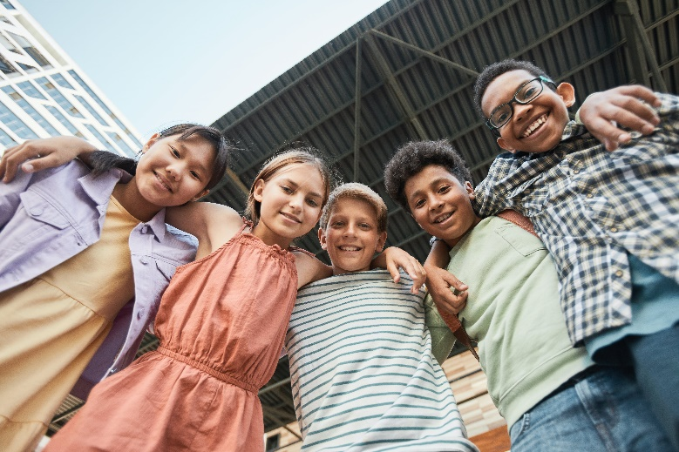**Let’s Talk: Belonging & being a part of a healthy group**

**Primary**

This resource is part of our self-care suite of resources and has been co-produced, with children and young people living in Essex, for children and young people. They have also been developed and quality assured by the following stakeholders:

* Essex Educational Psychology Service
* Health Watch Essex
* Essex Mental Health Support Teams (MHSTs) NELFT NHS Foundation Trust
* Essex Multi-schools Council
* Essex Social, Emotional and Mental Health (SEMH) strategy team
* Essex Child and Family Wellbeing Service, HCRG Care Group in partnership with Barnardos
* NELFT NHS Trust Southend, Essex, and Thurrock (SET) Child, Adolescent and Mental Health Service (CAMHS)
* Professionals in schools and settings can access all these resources via the [Essex info link SEMH portal](https://schools.essex.gov.uk/pupils/social_emotional_mental_health_portal_for_schools/Pages/Self-care-for-CYP-Library.aspx). Children and young people (CYP), parents/carers and professionals can also access these resources via the SET CAMHS website. Our self-care content can also be accessed via SET CAMHS Instagram account:

The resources are intended to be accessed by CYP independently or trusted adults use these resources with CYP through 1:1 conversation, whole school/group discussion and assemblies.

Please note: some of the content within our self-care resources may be emotive for CYP. We recommend that you make use of the ‘signposting to support’ section of this document should any of the content be triggering.

   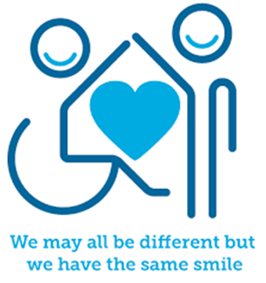

 

**Introduction**

Feeling a sense of belonging is when you feel a part of a group of people, and this is essential for our wellbeing. Surrounding yourself with people that are like minded and who share common interests is considered one of the most important things you can do to look after your mental health. Children and young people who have difficult or unhealthy peer relationships are more vulnerable to feeling left out, lonely, and isolated. Many children and young people agree that activities and hobbies are more enjoyable when they are shared with other people because it strengthens that sense of belonging.

**Facts**

Belonging is:

* Something everyone needs
* Feeling part of a group
* Feeling happy and comfortable with other people
* Feeling like I have friends around me who like me
* Feeling I can be myself when I am with other people

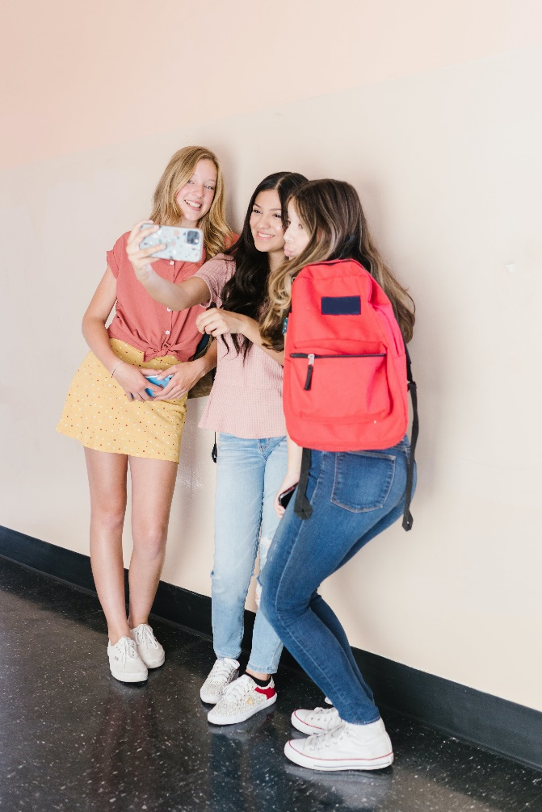

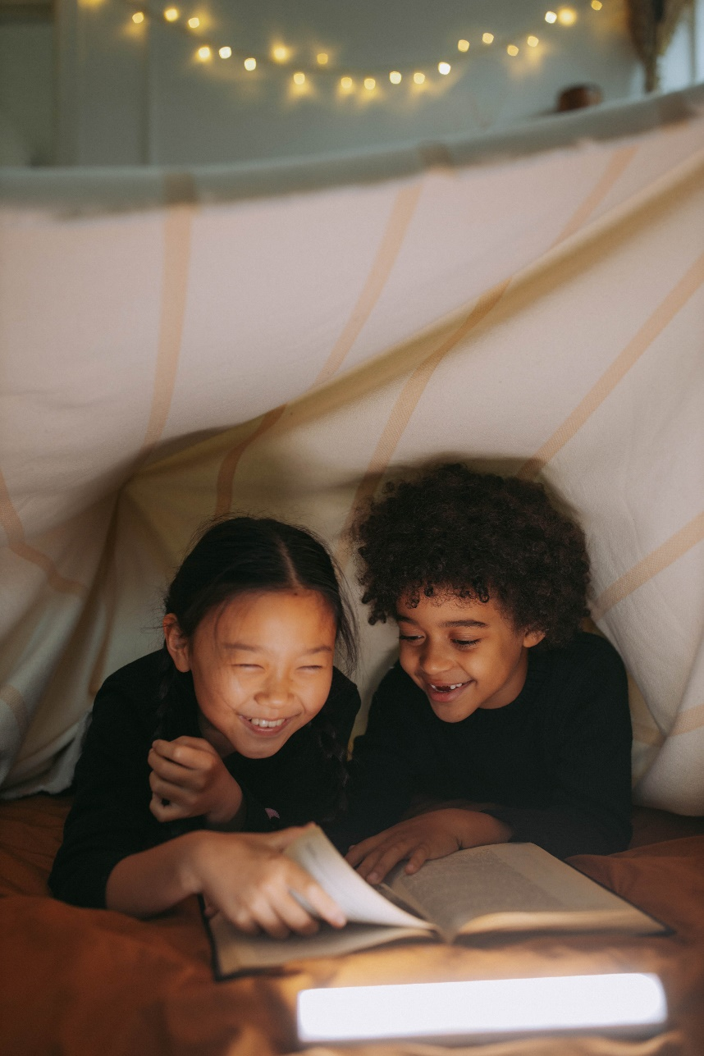

Being a part of a healthy group means:

* People can be friends with one another even if they have different interests and hobbies to each other.
* People within the group can trust one another enough to share their own ideas and feelings.
* You feel safe, equal, and respected.
* People within the group show each other kindness and look after one another when they are feeling angry or upset.

**Myth Buster**

Belonging and being a part of a healthy group:

* Can only be achieved in school X
* Is only important for girls X
* Others in the group always have to come first X
* Everyone in the group must like me X
* Group members must have the same interests and hobbies X
* You must agree with the views and opinions of others X
* You cannot be your true self X
* Online groups and communities and always safer X

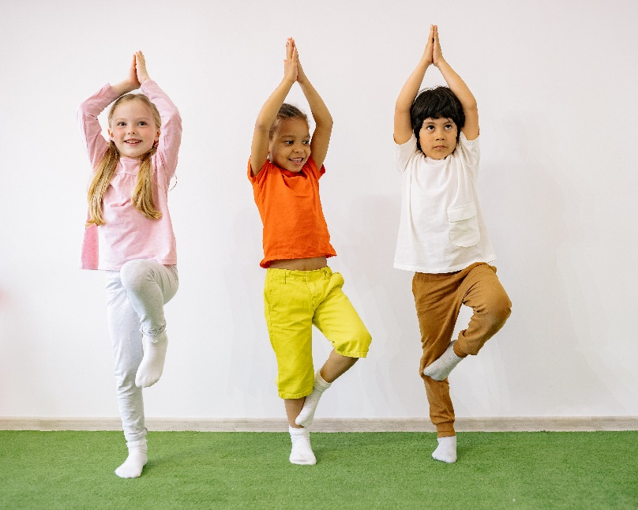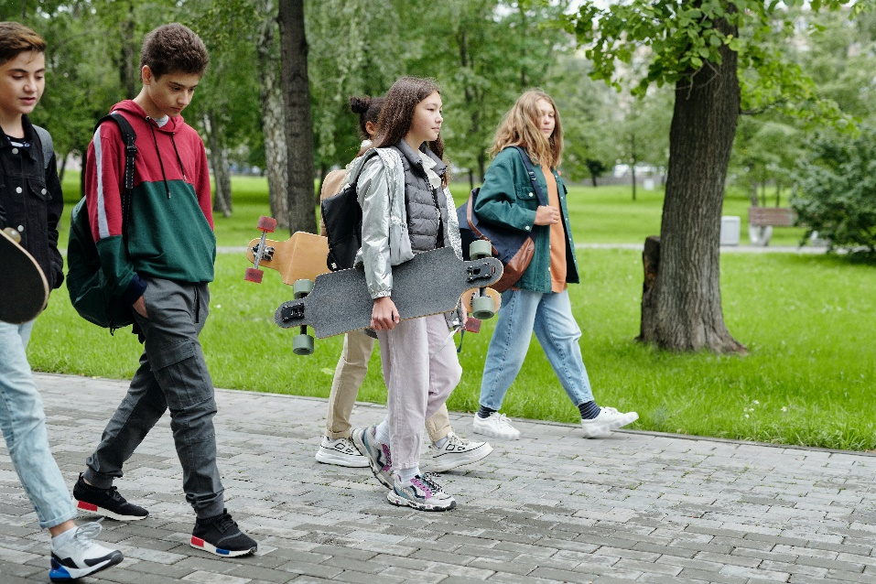

**Video clips**

Check out these videos about belonging and being a part of a healthy group:

[Spending time with friends | Anna Freud](https://www.annafreud.org/resources/children-and-young-peoples-wellbeing/self-care/spending-time-with-friends/)

Information for young people on why spending time with friends can have a positive impact on our mental health and emotional wellbeing (KS2)

[Making new friends - BBC Bitesize](https://www.bbc.co.uk/bitesize/articles/znhf7nb)

For those worried about the transition to secondary school and making new friends (Ks2)

[Scouts made me - YouTube](https://www.youtube.com/watch?v=Jlrimx5fjTQ)

Feel a sense of belonging through joining your local scout group (Ks2)

[We all belong](https://www.youtube.com/watch?v=ffX3GeRuoJE)

Highlighting the differences between people and the importance of belonging (Ks1)

[You really do belong!](https://www.youtube.com/watch?v=NXCi_p_AQdk)

An inspiring children's audio book about self-worth and belonging (Ks1)

**Resources**

* [Spending time with friends | Anna Freud](https://www.annafreud.org/resources/children-and-young-peoples-wellbeing/self-care/spending-time-with-friends/)

Information for young people on why spending time with friends can have a positive impact on our mental health and emotional wellbeing

* [Youth Service](https://youth.essex.gov.uk/)

Essex Youth Service Essex – helping young people in Essex to get the most out of school, work and life through community groups

* [Essex Outdoors](https://www.essexoutdoors.com/groups/youth-groups/)

Bringing the out the best in young people through the great outdoors through a number of community groups

* [Scouts](https://www.scouts.org.uk/)

Why not take a look at the Scouts Association and join one of their local groups?

* [Youth Sport Trust - Youth Sport Trust](https://www.youthsporttrust.org/)

The Youth Sport Trust Sport gives young people a platform to have their voice heard and a place to feel they belong.

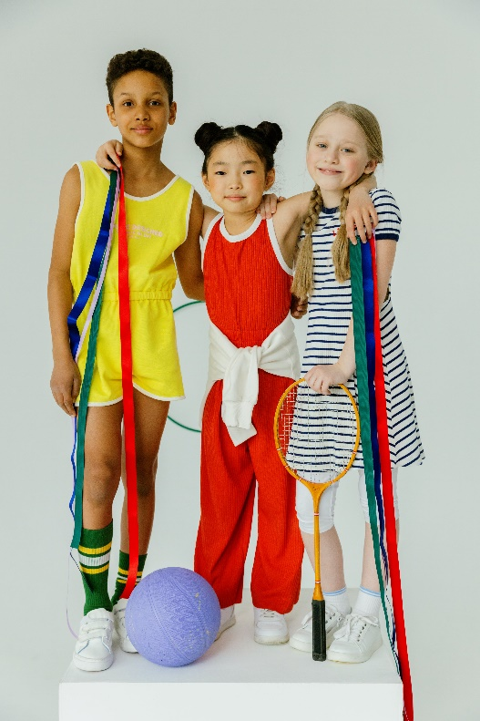

**Reflective questions**

(Try exploring these reflective questions with a CYP)

1. What does belonging mean to you?
2. What groups do you belong to?
3. Where do you feel like you belong?
4. Are there any parts of your identity you wish you could know more about?
5. Do you ever feel lonely? If so, when?

**Quiz**

Once you’ve gone through this resource with a CYP try these quiz questions with them:

1. What does belonging mean?
2. Why is it important to feel a sense of belonging?
3. With whom can you feel like you belong?
4. Can everyone belong?
5. Is it important to be yourself around other people?

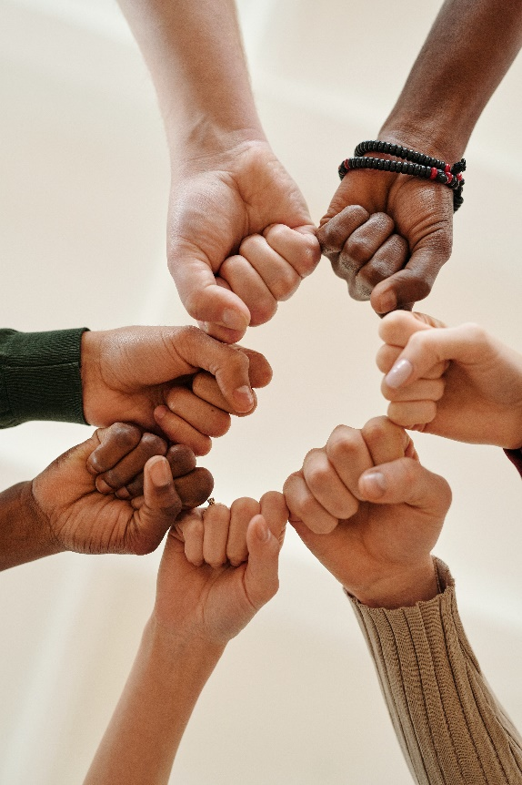

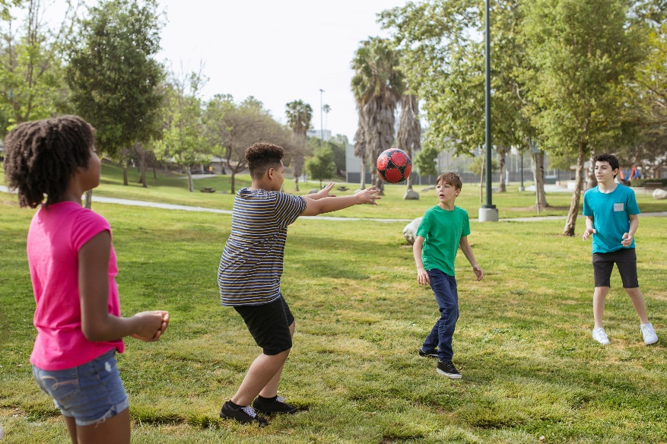

**Signposting to Support**

For additional support we recommend you take a look at the following links:

* [Anna Freud Centre – On My Mind](https://www.annafreud.org/on-my-mind/)
* [Kooth.com](https://www.kooth.com/)
* [Explore counselling/therapy](https://www.nhs.uk/mental-health/talking-therapies-medicine-treatments/talking-therapies-and-counselling/counselling/)
* [Childline](https://www.childline.org.uk/info-advice/your-feelings/mental-health/?&&&&gclsrc=aw.ds&&gclid=EAIaIQobChMIqryktIeP_wIVicPtCh3QZQs6EAAYASAAEgJr5vD_BwE&gclsrc=aw.ds) 0800 1111
* [Text ‘SHOUT’ to 85258 for access to their 24/7 textline](https://giveusashout.org/)
* [Share any concerns about your mental health with your GP](https://www.mind.org.uk/information-support/guides-to-support-and-services/seeking-help-for-a-mental-health-problem/talking-to-your-gp/) and [Understanding Confidentiality](https://www.mind.org.uk/for-young-people/your-rights/understanding-confidentiality/)
* [NHS 111](https://www.nhs.uk/nhs-services/mental-health-services/)
* [Southend, Essex & Thurrock Children and Adolescent Mental Health Service (SET CAMHS)](https://www.nelft.nhs.uk/set-camhs/)
* [Where to get urgent mental health support from: Advice from NHS](https://www.nhs.uk/nhs-services/mental-health-services/where-to-get-urgent-help-for-mental-health/)
* [SouthEast and East Asian Centre](https://www.seeac.org.uk/mental-health-support) A community group for migrants, refugees and anyone of southeast and east Asian heritage in the UK.
* [African families in the UK](https://africanfamiliesuk.wixsite.com/afiuk) A community interest charity for British African children and their families.
* [The Outhouse](https://theouthouse.org.uk/)  A place for the Essex LGBTQ+ community to find support and friendship.

**The adult box** (for professionals and parent/carers to read)

* [Place2Be: Parenting Smart: Understanding shyness in children](https://parentingsmart.place2be.org.uk/article/understanding-shyness-in-children)

Advice on how to encourage shy children to build positive friendships.

* [Research shows 'a sense of belonging' is important for pupils’ learning and behaviour | IOE - Faculty of Education and Society - UCL – University College London](https://www.ucl.ac.uk/ioe/news/2020/nov/research-shows-sense-belonging-important-pupils-learning-and-behaviour)

Research article detailing the importance of a ‘sense of belonging’ in school for student learning and behaviour.

* [Parents' Guide to Looking After Your Mental Health | YoungMinds](https://www.youngminds.org.uk/parent/parents-guide-to-looking-after-yourself/)

A-Z mental health guide for parents: how to talk to your child about mental health, getting help for your child, parent support groups, parent helplines, webchats and blogs.

* [What do Scouts do? | Scouts](https://www.scouts.org.uk/information-for-parents/what-do-scouts-do/)

A guide for parents of the various groups the scouting association offer to children and young people, including Squirrels (4-6 years), Beavers (6-8 years) and cubs (8-10 years).

* [How sport can create a sense of belonging and inclusion - Youth Sport Trust](https://www.youthsporttrust.org/news-insight/blogs/how-sport-can-create-a-sense-of-belonging-and-inclusion)

Read about the importance of sport for building a sense of belonging.

* [Supporting others - Every Mind Matters - NHS (www.nhs.uk)](https://www.nhs.uk/every-mind-matters/supporting-others/)

Advice on how best to support children and young people with their mental health

* [National education union](https://neu.org.uk/advice/classroom/behaviour/creating-sense-place-and-belonging-schools" \t "_blank)

How to create a sense of space and belonging in schools – teaching staff resources

* [UNICEF – How to connect with your child](https://www.unicef.org/parenting/child-care/9-tips-for-better-communication)

Parenting advice on how to listen, connect and bond with your child.

* [On our sleeves – how to boost belonging](https://www.onoursleeves.org/mental-wellness-tools-guides/belonging/belonging-boosts-kids-mental-health)

Guidance on how to help children and young people feel a sense of belonging to boost their mental health.

* [Anna Freud – Mentally Healthy Schools](https://mentallyhealthyschools.org.uk/factors-that-impact-mental-health/school-based-risk-factors/relationships-and-belonging/)

Importance of maintaining healthy relationships.

* [Sport England](https://www.sportengland.org/research-and-data/research/children-and-young-people" \t "_blank)

An article on how sports can help children and young people to feel a sense of belonging.

   

 