**Let’s Talk: Neurodiversity**

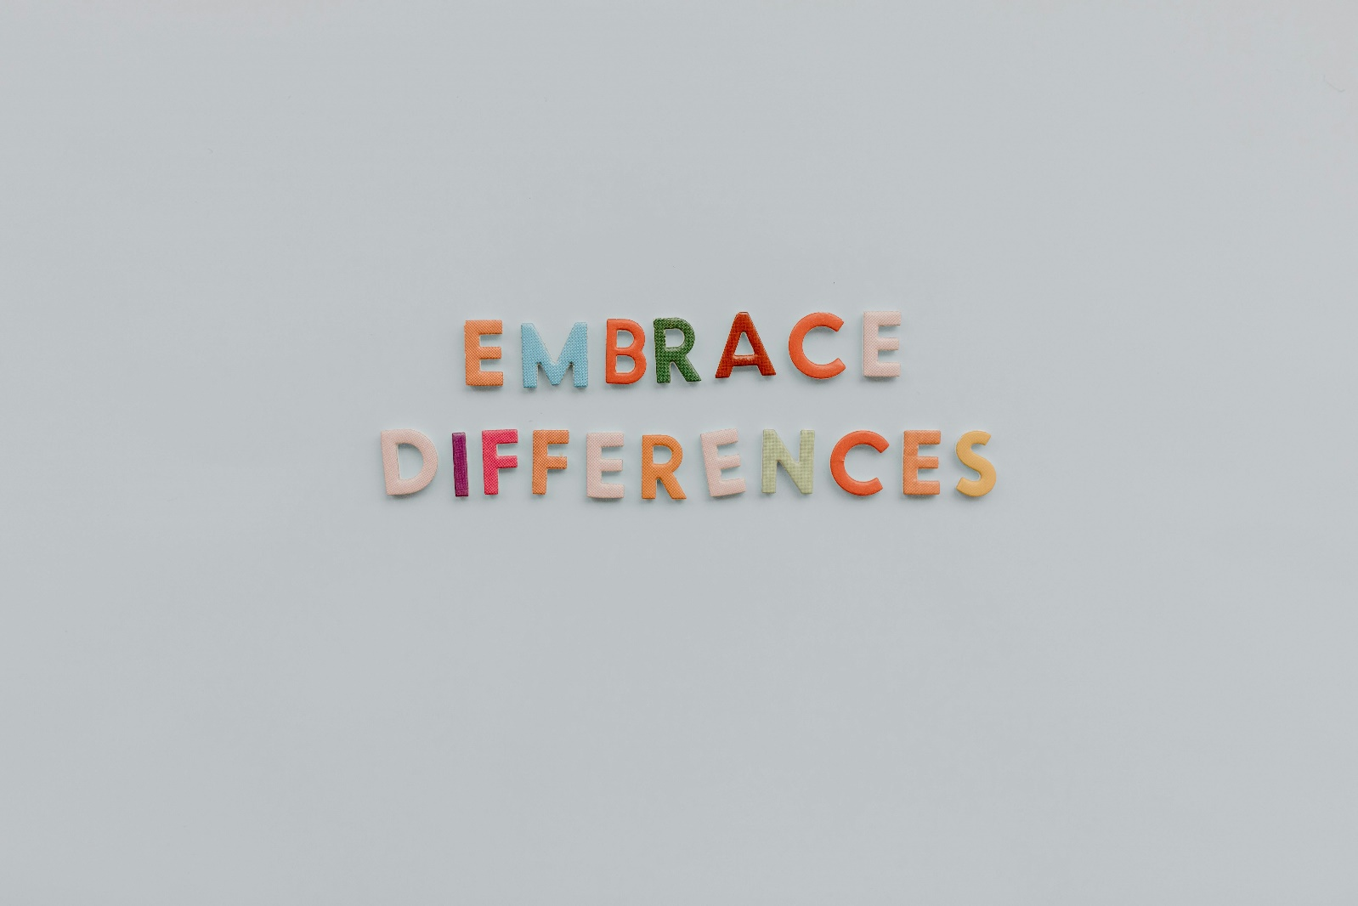**Secondary**

This resource is part of our self-care suite of resources and has been co-produced, with children and young people living in Essex, for children and young people. They have also been developed and quality assured by the following stakeholders:

* Essex Educational Psychology Service
* Health Watch Essex
* Essex Mental Health Support Teams (MHSTs) NELFT NHS Foundation Trust
* Essex Multi-schools Council
* Essex Social, Emotional and Mental Health (SEMH) strategy team
* Essex Child and Family Wellbeing Service, HCRG Care Group in partnership with Barnardos
* NELFT NHS Trust Southend, Essex, and Thurrock (SET) Child, Adolescent and Mental Health Service (CAMHS)
* Professionals in schools and settings can access all these resources via the [Essex info link SEMH portal](https://schools.essex.gov.uk/pupils/social_emotional_mental_health_portal_for_schools/Pages/Self-care-for-CYP-Library.aspx). Children and young people (CYP), parents/carers and professionals can also access these resources via the SET CAMHS website. Our self-care content can also be accessed via SET CAMHS Instagram account:

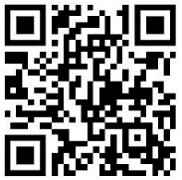

The resources are intended to be accessed by CYP independently or trusted adults use these resources with CYP through 1:1 conversation, whole school/group discussion and assemblies.

Please note: some of the content within our self-care resources may be emotive for CYP. We recommend that you make use of the ‘signposting to support’ section of this document should any of the content be triggering.

   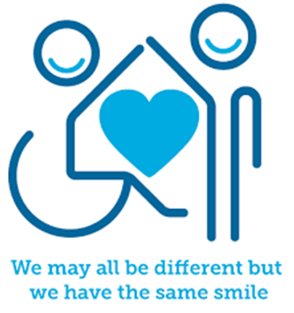

 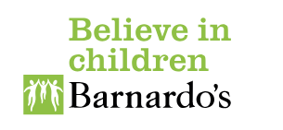

# **Introduction**

Everyone has a unique way that their brain works. While everyone's brain develops similarly, no two brains function just alike. Many people are classed as being Neurotypical. This is defined as a person whose brain functions are considered usual or expected by society. Some people’s brains work differently, and they are classed as Neurodiverse. This means having a brain that works differently from the average or “neurotypical” person. It includes a wide range of differences, such Autism, ADHD, Dyspraxia, OCD, Tourette’s Syndrome, Dyslexia, Global Development Delay.

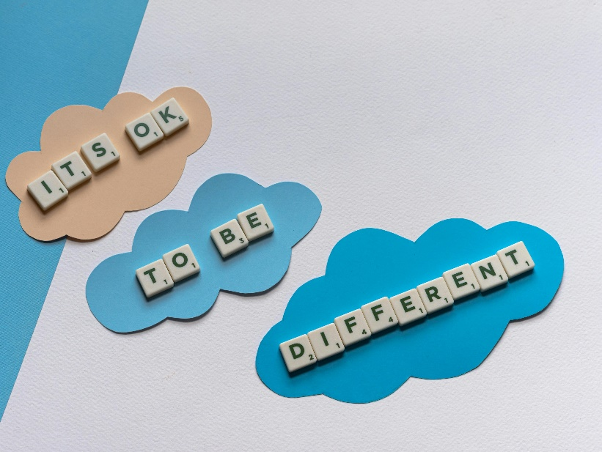

**Facts**

* All neurodiverse children will experience the world differently from one another.
* Autistic people can experience, interact with, and interpret the world in unique ways differently from neurotypical people.
* There can also be many positives to ADHD such as creativity, curiosity and the ability to think outside the box.

**Did you know?**

Did you know the following list of iconic, successful and celebrated people have autism?

* Albert Einstein - Scientist
* Lionel Messi - Footballer
* Greta Thunberg - Activist
* Eminem - Musician
* Sir Isaac Newton – Mathematician and scientist
* Vincent Van Gogh - Artist
* Wolfgang Mozart - Composer
* Thomas Edison – Inventor

**Myth Buster**

Here are some myths busters surrounding neurodiversity:

* You can grow out of being neurodiverse X You do not grow out neurodiversity, however, it can be supported with the right help.
* Boys are more likely to be neurodiverse X Whilst more boys are diagnosed with neurodiversity, girls are more likely to mask and are often diagnosed at an older age.
* Neurodiverse people don’t worry about things X Some neurodiverse children may suffer from anxiety also.

**Video clips**

Check out these videos about neurodiversity:

[BBC - My Autism and Me (youtube.com)](https://www.youtube.com/watch?v=ejpWWP1HNGQ)

13 year old Rosie takes us into her world to explain what it is like to grow up with autism.

[what is ADHD? (youtube.com)](https://www.youtube.com/watch?v=1t9UHQgtDfU)

Short animation explains ADHD through the eyes of Molly.

[Living with “High Functioning” Autism (Connor's Experience) (youtube.com)](https://www.youtube.com/watch?v=WVnSIExQ5WY)

Connor talks about his experience of living with high functioning autism.

[Amazing Things Happen! (youtube.com)](https://www.youtube.com/watch?v=Ezv85LMFx2E)

Introduction to autism that aims to raise awareness among young non-autistic audiences, to stimulate understanding and acceptance in future generations.

[Me, My Autism & I | Vanish & Ambitious about Autism | Hero Film (youtube.com)](https://www.youtube.com/watch?v=4Xtog_zRRJg)

Short film about teenager Ash who needs help with sensory regulation.

[Brain & amygdala hand model explains how thoughts & emotions fuel anxiety https://empoweru.education (youtube.com)](https://www.youtube.com/watch?v=2xeDcPBD5Fk)

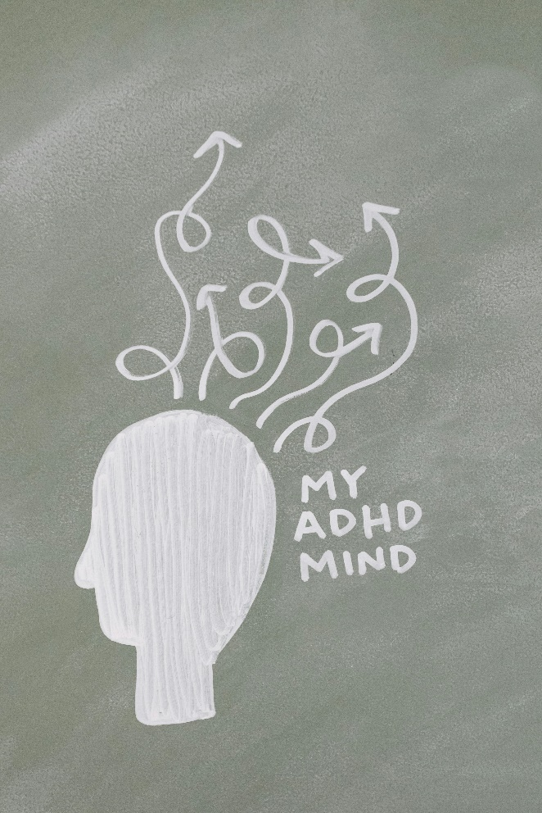To learn how to calm down from your big emotions triggered by fear and get your logical brain back in action.

**Resources**

[A young person’s guide to thriving with ADHD : Mentally Healthy Schools](https://www.mentallyhealthyschools.org.uk/resources/a-young-person-s-guide-to-thriving-with-adhd/)

This booklet is about living with ADHD, with tips to help young people and advice about getting support.

[Stories that never stand still: a young person’s guide to ADHD : Mentally Healthy Schools](https://www.mentallyhealthyschools.org.uk/resources/stories-that-never-stand-still-a-young-person-s-guide-to-adhd/)

This free information booklet shares the stories, struggles and achievements of those with ADHD.

The Reason I Jump: The Inner Voice of a Thirteen Year-Old Boy with Autism (Book)

Author Naoki Higashida provides an insight into the mind of a non-verbal autistic child. The film adaptation of this book was released in cinemas in June 2021

[Starting college or university: advice for autistic young people : Mentally Healthy Schools](https://www.mentallyhealthyschools.org.uk/resources/starting-college-or-university-advice-for-autistic-young-people/)

A webpage offering guidance and support to autistic children and young people, or their families, who are in the position of transitioning to college or university.

**Local groups and communities**

[Neurodiversity | Essex Family Forum](https://essexfamilyforum.org/resources/nd-pack)

Essex Family Forum, SEND the Right Message (STRM) Support Services and MyOTAS (My Own Time And Space) Charity are proud to have written and produced a pack which is full of useful information for families with a neurodivergent child.

[MyOTAS | Essex SEND IASS](https://www.essexsendiass.co.uk/news-and-events/m/)

This parent and carer support group have a number of activities running throughout the year.

[360 Play Basildon | Essex SEND IASS](https://www.essexsendiass.co.uk/news-and-events/360-play-basildon/)

This soft play centre has a SEND specific session.

**Reflective questions**

(Try exploring these reflective questions with a CYP)

* What does neurodiversity mean to you?
* How does being neurodiverse make you different from neurotypical people?
* As you look through the resources have you learnt anything new that you didn’t know about neurodiversity before?

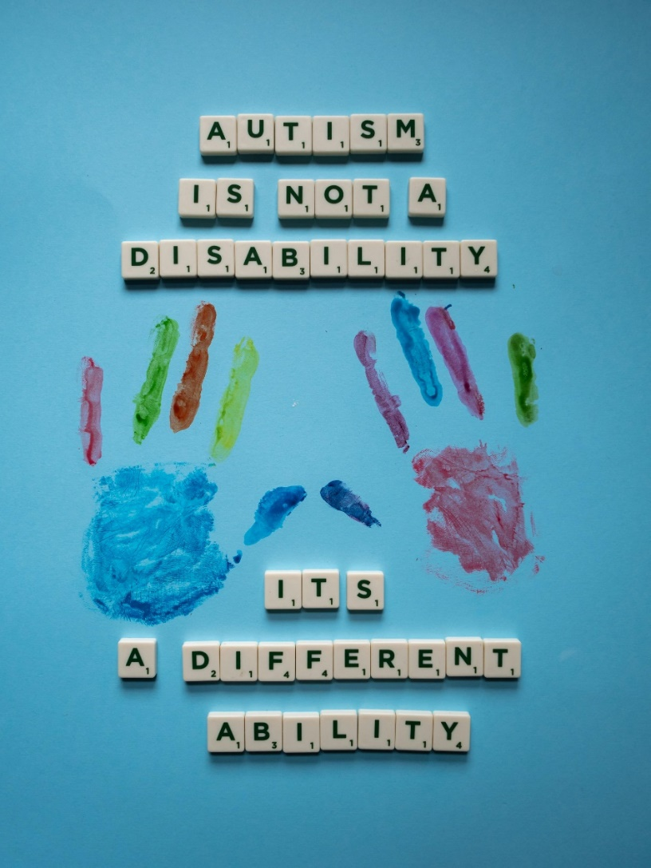

**Quiz**

Once you’ve gone through this resource with a CYP try this quiz questions with them:

* Which of the following differences are regarded as neurodiverse?
* Autism
* ADHD
* Dyspraxia
* OCD
* Tourette’s Syndrome
* Dyslexia
* Global Development Delay
* ALL OF THE ABOVE
* Can you name one iconic, successful and celebrated person who is autistic?
* What are some of the positive aspects to ADHD?
* Can neurodiverse people also suffer with anxiety?
* What is a neurotypical brain?

**Signposting to Support**

For additional support we recommend you look at the following links:

* [Young people - Essex Special Educational Needs & Disability (essexsendiass.co.uk)](https://www.essexsendiass.co.uk/young-people/)

Free, confidential and impartial advice, guidance and support for young people who have special educational needs and disabilities (SEND).

* [Resources - Essex Special Educational Needs & Disability (essexsendiass.co.uk)](https://www.essexsendiass.co.uk/resources/support-groups-and-organisations/)

Signposting to support groups and organisations for young people and their families.

* [Resource hub : Mentally Healthy Schools](https://www.mentallyhealthyschools.org.uk/resources/?Theme=Neurodiversity&Audience=Pupils_)

Resources to support children and young people with neurodiversity.

* [Kooth.com](https://www.kooth.com/) (Age 11-25)
* [Togetherall](https://togetherall.com/en-gb/faqs/becoming-a-member-and-managing-your-profile/#:~:text=Togetherall%20is%20only%20for%20adults,is%20only%20available%20to%2018%2B.) (age 16+)
* [Explore counselling/therapy](https://www.nhs.uk/mental-health/talking-therapies-medicine-treatments/talking-therapies-and-counselling/counselling/)
* [Childline](https://www.childline.org.uk/info-advice/your-feelings/mental-health/?&&&&gclsrc=aw.ds&&gclid=EAIaIQobChMIqryktIeP_wIVicPtCh3QZQs6EAAYASAAEgJr5vD_BwE&gclsrc=aw.ds) 0800 1111 when [contacting ChildLine what to expect](https://www.youtube.com/watch?v=_KNtMOKwTco)?
* [Hopeline 0800 068 41 41](https://www.papyrus-uk.org/papyrus-HOPELINE247/) offering confidential support and practical advice
* [Text ‘SHOUT’ to 85258](https://giveusashout.org/get-help/?gclid=Cj0KCQiA6vaqBhCbARIsACF9M6nG--bxZCnflhd5C3jT-d9dS48o5t6XTTTidI0MLTgwjjRAlxszRT8aAnvvEALw_wcB) for free, confidential, anonymous text support service.
* [Share any concerns about your mental health with your GP](https://www.mind.org.uk/information-support/guides-to-support-and-services/seeking-help-for-a-mental-health-problem/talking-to-your-gp/) and [Understanding Confidentiality](https://www.mind.org.uk/for-young-people/your-rights/understanding-confidentiality/)
* [NHS 111](https://www.nhs.uk/nhs-services/mental-health-services/)
* [Southend, Essex & Thurrock Children and Adolescent Mental Health Service (SET CAMHS)](https://www.nelft.nhs.uk/set-camhs/)
* [Where to get urgent mental health support from: Advice from NHS](https://www.nhs.uk/nhs-services/mental-health-services/where-to-get-urgent-help-for-mental-health/)
* 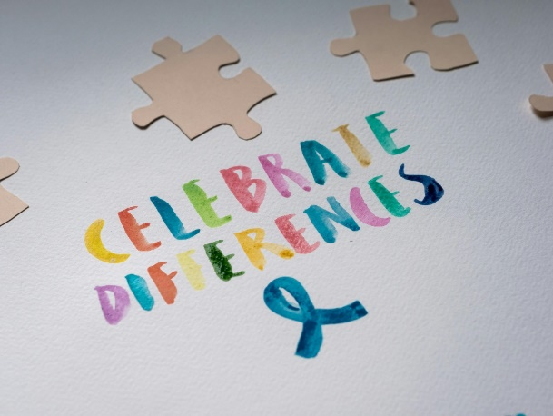SET CAMHS Instagram account 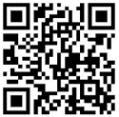

**How to help a friend**

* Share this resource with a friend.
* Be open and invite a friend to talk about their neurodiversity with you.
* Find out what your friends likes and strengths are.

**The adult box** (for professionals and parent/carers to read)

[Supporting Your Neurodiverse Child (essexfamilyforum.org)](https://essexfamilyforum.org/wp-content/uploads/2024/04/ECC-Supporting-Your-Neurodiverse-Child-Spring-2024-V4-Accessible.pdf)

eBook written my parents for parents.

[About | Essex Family Forum](https://essexfamilyforum.org/about)

A Parent Carer Forum (PCF) is a group of parents and carers of children with additional needs and disabilities.

[Girls and Autism: Flying under the radar | Nasen](https://nasen.org.uk/resources/girls-and-autism-flying-under-radar)

Discusses key issues for girls with autism spectrum conditions.

[Girls and Women and Autism: What’s the difference? - Sarah Hendrickx (youtube.com)](https://www.youtube.com/watch?v=yKzWbDPisNk)

Video presentation delivered by Sarah Hendrickx discusses autism in women and girls.

[Tony Attwood - Aspergers in Girls (Asperger Syndrome) (youtube.com)](https://www.youtube.com/watch?v=wfOHnt4PMFo)

Video presentation delivered by Tony Attwood discusses autism in girls.

[Supporting your Neurodiverse Child | Essex SEND IASS](https://www.essexsendiass.co.uk/parents-and-carers/sen-support/supporting-your-neurodiverse-child/)

Essex Family Forum, SEND the right message (STRM) Support Services and MyQTAS (My Own Time and Space) charity have written and produced an information pack for families with a neurodiverse child.

[Why Autism is a Difference, not a Deficit (youtube.com)](https://www.youtube.com/watch?v=We2fJz866NU)

Created for the Autism Education Trust. It is aimed at education professionals and leaders, parent/carers, AET network of trainers and the public more generally.

[Dyslexia - NHS (www.nhs.uk)](https://www.nhs.uk/conditions/dyslexia/)

The NHS provides a link to the British Dyslexia Association

[Neurodiversity Celebration Week: secondary presentation : Mentally Healthy Schools](https://www.mentallyhealthyschools.org.uk/resources/neurodiversity-celebration-week-secondary-presentation/)

A presentation for a secondary school assembly introducing the topic of neurodiversity and looking at different types of neurodivergence.

   

 