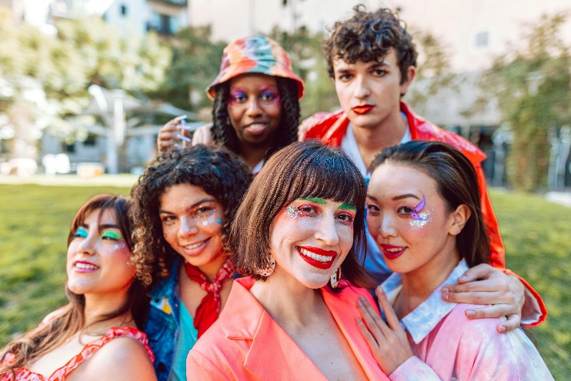**Let’s Talk: Diversity, Equity & Inclusion**

**Secondary**

This resource is part of our self-care suite of resources and has been co-produced, with children and young people living in Essex, for children and young people. They have also been developed and quality assured by the following stakeholders:

* Essex Educational Psychology Service
* Health Watch Essex
* Essex Mental Health Support Teams (MHSTs) NELFT NHS Foundation Trust
* Essex Multi-schools Council
* Essex Social, Emotional and Mental Health (SEMH) strategy team
* Essex Child and Family Wellbeing Service, HCRG Care Group in partnership with Barnardos
* NELFT NHS Trust Southend, Essex, and Thurrock (SET) Child, Adolescent and Mental Health Service (CAMHS)
* Professionals in schools and settings can access all these resources via the [Essex info link SEMH portal](https://schools.essex.gov.uk/pupils/social_emotional_mental_health_portal_for_schools/Pages/Self-care-for-CYP-Library.aspx). Children and young people (CYP), parents/carers and professionals can also access these resources via the SET CAMHS website. Our self-care content can also be accessed via SET CAMHS Instagram account:

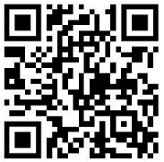

The resources are intended to be accessed by CYP independently or trusted adults use these resources with CYP through 1:1 conversation, whole school/group discussion and assemblies.

Please note: some of the content within our self-care resources may be emotive for CYP. We recommend that you make use of the ‘signposting to support’ section of this document should any of the content be triggering.

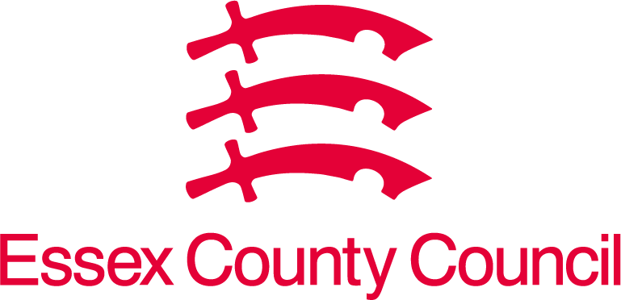 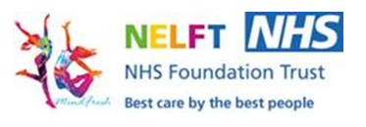 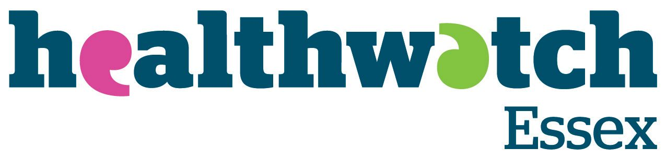 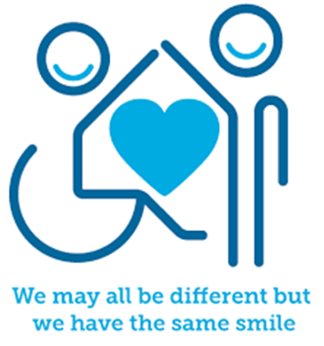

 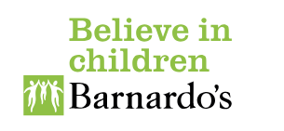

**Introduction**

Diversity simply means differences between humans. This includes but is not limited to differences such as race, ethnicity, gender, gender identity, sexual orientation, age, social class, physical ability, or attributes, religious or ethical values, national origin, and political beliefs. Our diversity can make us feel the same as others or different from others, which affects our sense of belonging, confidence, self-esteem, and self-worth etc. Being different from others can feel difficult sometimes but it is important that our differences are understood, accepted, and celebrated by others. Every person has the right to be their true self, included, and to live a full life without prejudice, fear, or barriers.

Equality where all members of a society or group have the same status, rights, and opportunities as each other. For instance, racial equality ensures that people of different races receive equal treatment and opportunities. Gender equality aims to eliminate inequalities between male and female rights and opportunities.

Inclusion refers to the act of including someone or something as part of a group and fosters an environment where people feel valued and included. At school for instance, Inclusion emphasises that everyone should have equal access to facilities, activities, and experiences. This includes people with disabilities for instance or those who experience other disadvantages.

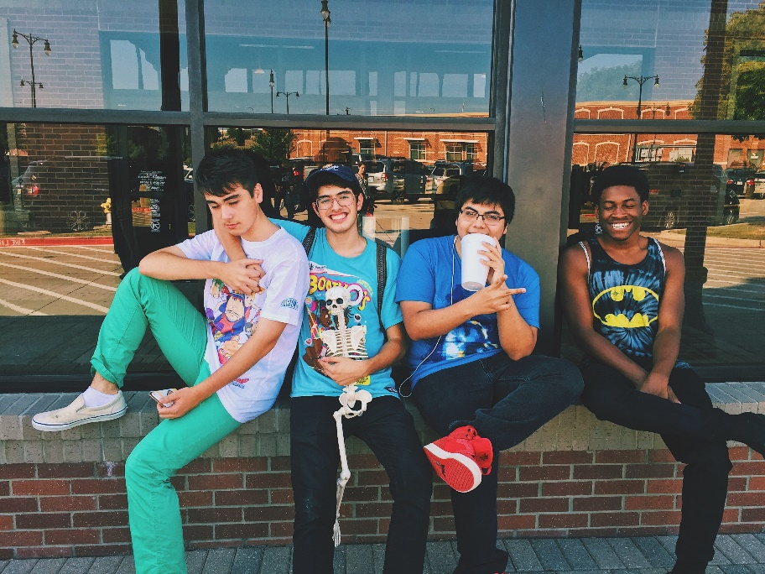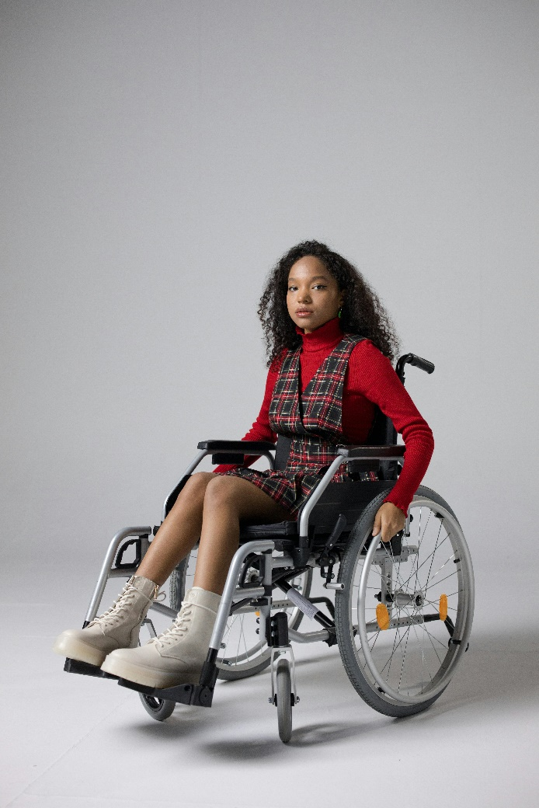

**Facts**

Diversity, equality, and inclusion:

* We are all diverse.
* Everyone has the right to experience equality.
* Everyone has the right to feel included in different aspects of their life e.g. education, friendships, and family.

**Myth Buster**

Diversity, equality, and inclusion:

* Diversity is just about gender and race. X
* Diversity, equality, and inclusion describe the same things. X
* You have to treat everyone the same all of the time. X Sometimes we may need to make changes so everyone is included and gains an equal outcome.
* Inclusion is something that only schools are responsible for. X

**Video clips**

Check out these videos about diversity, equality, and inclusion:

## [Cultural Identity & Mental Health | Family Pressures | YoungMinds](https://www.youngminds.org.uk/young-person/coping-with-life/cultural-identity-and-mental-health/)

## Young minds guide to cultural identity.

* [Gender Identity & Mental Health | Guide for Parents | YoungMinds](https://www.youngminds.org.uk/parent/parents-a-z-mental-health-guide/gender-identity/)

Young minds guide to gender identity.

* [What is diversity? [Diversity for kids] (youtube.com)](https://www.youtube.com/watch?v=SyaLcfMeeEM)

Muse wellbeing explains what Diversity means.

* [Is there a lack diversity in books for young people? - BBC Young Reporter (youtube.com)](https://www.youtube.com/watch?v=E7fg8nAin90)

BBC young reporter discussing the lack of diverse books for children and young people to read.

* [That Little Voice (youtube.com)](https://www.youtube.com/watch?v=Ll56imVATLk)

RBC video explores the need for us to all speak up to foster equality and inclusion for ourselves and others.

* [Who We Are Music Video (youtube.com)](https://www.youtube.com/watch?v=x5BxqkoSBoY)

The Diversity Movement song about diversity, equality, and inclusion.

* [HELLO - a short film about tolerance & diversity (1ST PLACE in the Nikon Cinema Z Film Fest 2019) (youtube.com)](https://www.youtube.com/watch?v=3AQ7yC5jQ28)

Charles story about diversity and inclusion.

* [Teaching diversity more than one day at a time | Grace Darrow | TEDxStowe (youtube.com)](https://www.youtube.com/watch?v=6iq2QI5GfmQ)

Grace Durrow’s TED Talk about teaching others about diversity

* [When More People Speak Up, More People Listen (youtube.com)](https://www.youtube.com/watch?v=b1nJqpqgzR0)

How assumptions about people’s diversities affect how we see the world and how others experience us and the world around them.

* [Unconscious Bias Test - Diversity and Inclusion in the Workplace Training Clip (youtube.com)](https://www.youtube.com/watch?v=0veDFGo666s)

Being aware of your unconscious bias’s and how this affects diversity, equality, and inclusion.

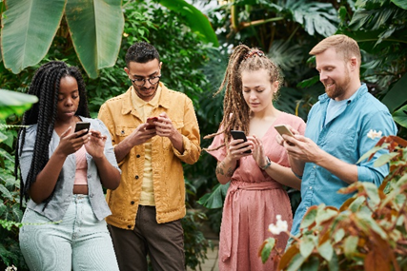

**Resources**

* [Equality Diversity & Inclusion in 2021 - WHAT'S IT ALL ABOUT? (youtube.com)](https://www.youtube.com/watch?v=maw6hmlNh44)

Exploring equality, diversity, and inclusion in the workplace.

* [What is diversity? - BBC Bitesize](https://www.bbc.co.uk/bitesize/articles/zk79t39)

BBC bitesize explores Diversity for KS3

* [Books that promote diversity and inclusion for KS3 and KS4 | Bedrock Learning](https://bedrocklearning.org/literacy-blogs/books-that-promote-diversity-and-inclusion-for-ks3-ks4/)

12 inspiring books that promote diversity and inclusion for KS3 & KS4

* [Promoting inclusion - BBC Bitesize](https://www.bbc.co.uk/bitesize/articles/zjtwbdm)

BBC Bitesize explores inclusion for KS3

* 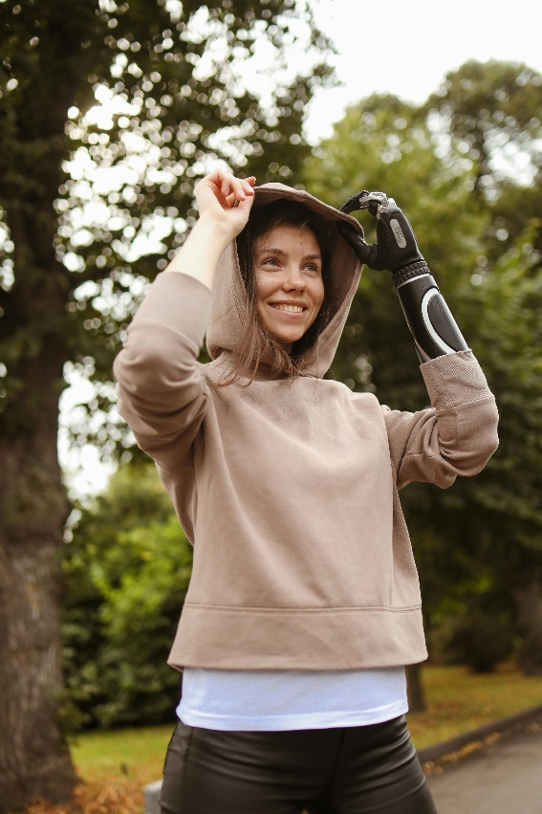[Introduction - Diversity and inclusion - GCSE Learning for Life and Work (CCEA) Revision - BBC Bitesize](https://www.bbc.co.uk/bitesize/guides/zt4m6fr/revision/1)

BBC bitesize GCSE diversity and inclusion introduction

**Reflective questions**

(Try exploring these reflective questions with a CYP)

* Can you describe what diversity means?
* Can you describe what equality means?
* Can you describe what inclusion means?
* How can schools be inclusive?
* What diversity can be found in your friendship group(s)?
* How do you promote inclusion?

**Quiz**

Once you have gone through this resource with a CYP try this quiz questions with them:

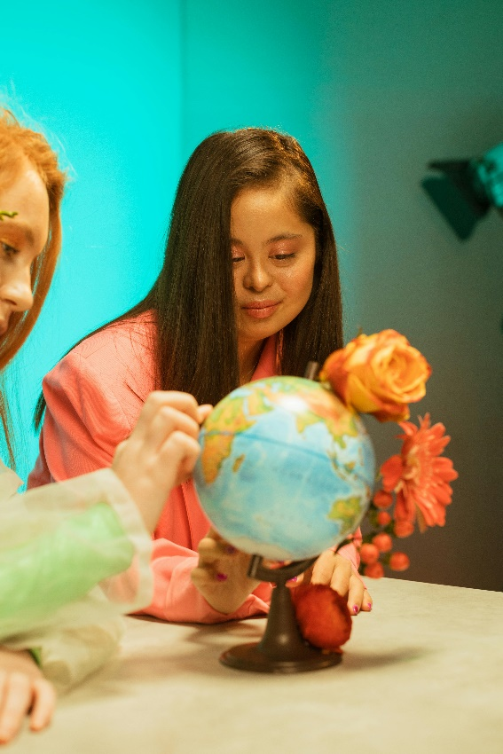

* What is the difference between diversity, equality, and inclusion?
* Name six different characteristics that make people diverse?
* What is a myth about diversity, equality, and inclusion?
* Describe three ways of promoting inclusion?
* What is unconscious bias?

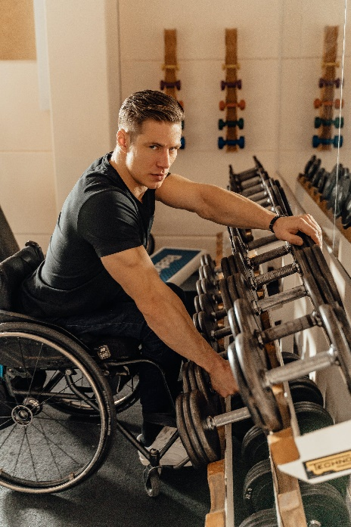

**Signposting to Support**

For additional support we recommend you take a look at the following links:

* [Anna Freud Centre – On My Mind](https://www.annafreud.org/on-my-mind/)
* [Kooth.com](https://www.kooth.com/) (Age 11-25)
* [Togetherall](https://togetherall.com/en-gb/faqs/becoming-a-member-and-managing-your-profile/#:~:text=Togetherall%20is%20only%20for%20adults,is%20only%20available%20to%2018%2B.) (age 16+)
* [Explore counselling/therapy](https://www.nhs.uk/mental-health/talking-therapies-medicine-treatments/talking-therapies-and-counselling/counselling/)
* [Childline](https://www.childline.org.uk/info-advice/your-feelings/mental-health/?&&&&gclsrc=aw.ds&&gclid=EAIaIQobChMIqryktIeP_wIVicPtCh3QZQs6EAAYASAAEgJr5vD_BwE&gclsrc=aw.ds) 0800 1111 when [contacting ChildLine what to expect](https://www.youtube.com/watch?v=_KNtMOKwTco)?
* [Hopeline 0800 068 41 41](https://www.papyrus-uk.org/papyrus-HOPELINE247/) offering confidential support and practical advice
* [Text ‘SHOUT’ to 85258](https://giveusashout.org/get-help/?gclid=Cj0KCQiA6vaqBhCbARIsACF9M6nG--bxZCnflhd5C3jT-d9dS48o5t6XTTTidI0MLTgwjjRAlxszRT8aAnvvEALw_wcB) for free, confidential, anonymous text support service.
* [Share any concerns about your mental health with your GP](https://www.mind.org.uk/information-support/guides-to-support-and-services/seeking-help-for-a-mental-health-problem/talking-to-your-gp/) and [Understanding Confidentiality](https://www.mind.org.uk/for-young-people/your-rights/understanding-confidentiality/)
* [NHS 111](https://www.nhs.uk/nhs-services/mental-health-services/)
* [Southend, Essex & Thurrock Children and Adolescent Mental Health Service (SET CAMHS)](https://www.nelft.nhs.uk/set-camhs/)
* [Where to get urgent mental health support from: Advice from NHS](https://www.nhs.uk/nhs-services/mental-health-services/where-to-get-urgent-help-for-mental-health/)
* SET CAMHS Instagram account 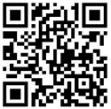

**How to help a friend**

* Start a conversation about diversity, equality, and inclusion.
* Explore how your friendship group is aware of diversity and promotes equality and inclusion for each other.
* Share this resource with your friend.

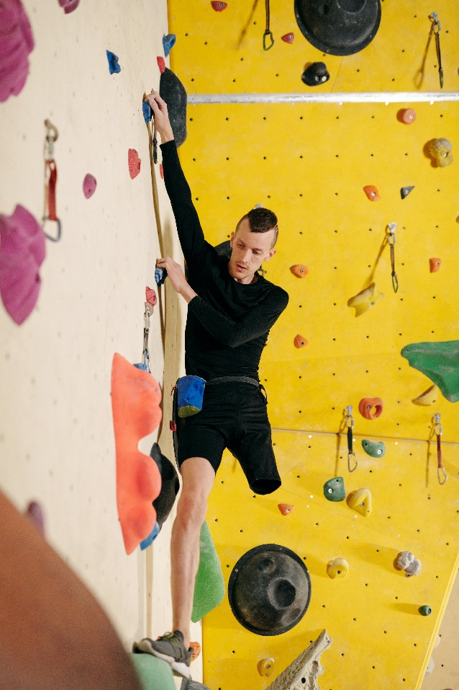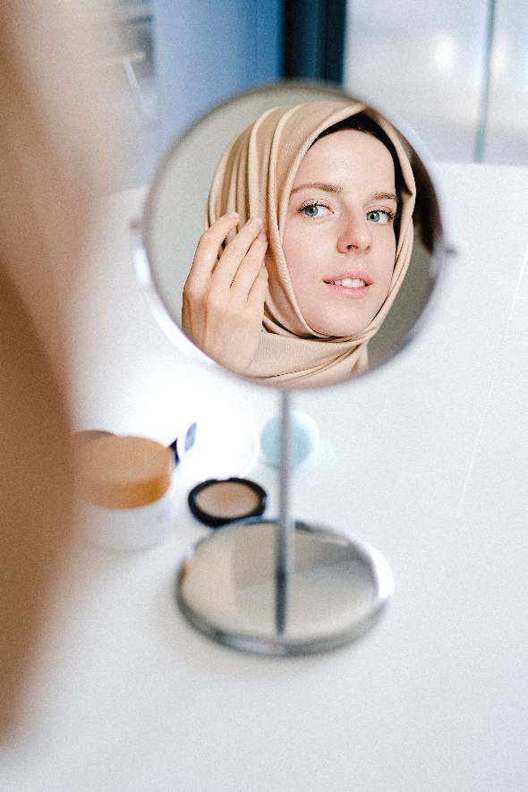

**The adult box** (for professionals and parent/carers to read)

* [Diversity lesson plan for 11-14 year olds: Mentally Healthy Schools](https://www.mentallyhealthyschools.org.uk/resources/diversity-lesson-plan-for-11-14-year-olds/)

This lesson plan from the Equality and Human Rights Commission will help students understand the diversity of the UK population, and celebrate the benefits diversity brings to their lives.

* [Primary Resources - KS2, KS1, Early Years (EYFS) KS3, KS4, Twinkl](https://www.twinkl.co.uk/equality-diversity-inclusion-hub)

Twinkl resources from the equality, diversity, and inclusion teaching hub

* [Diversifying the curriculum to increase representation | Anna Freud](https://www.annafreud.org/resources/schools-and-colleges/diversifying-the-curriculum-to-increase-representation/)

Anna Freuds guide to diversifying the curriculum to increase representation

* [Working with families from diverse cultures (youtube.com)](https://www.youtube.com/watch?v=ENL2aPff2-I)

Anna Freud video on working with families from diverse backgrounds

* [Supporting children and young people who identify as gender diverse | Emerging Minds Families (youtube.com)](https://www.youtube.com/watch?v=wiSzRXs5_YA)

Emerging Minds Families podcast exploring how to support children and young people who identify as gender diverse.

* [Taking Action Against Racism: Helping Kids Embrace Diversity (youtube.com)](https://www.youtube.com/watch?v=dYnkJl3HDxM)

Nemours KidsHealth explores how to take action against racism and how this starts at home.

* [7 Ways to Teach Your Children about Diversity and Inclusion | Macaroni KID Mt Airy-Damascus-Urbana](https://mtairy.macaronikid.com/articles/645a8f6f69ea3f40944fe0fd/7-ways-to-teach-your-children-about-diversity-and-inclusion)

Ways of teaching and promoting diversity and inclusion in your family.

* [How to Promote Diversity and Inclusion in Your Child’s Life - CHC Resource Library | CHC | Services for Mental Health and Learning Differences for Young Children, Teens, and Young Adults](https://www.chconline.org/resourcelibrary/how-to-promote-diversity-and-inclusion-in-your-childs-life/)

Children’s Health Council article exploring how to promote diversity and inclusion in your child’s life.

   

 