**Let’s Talk: Taking Healthy Risks**

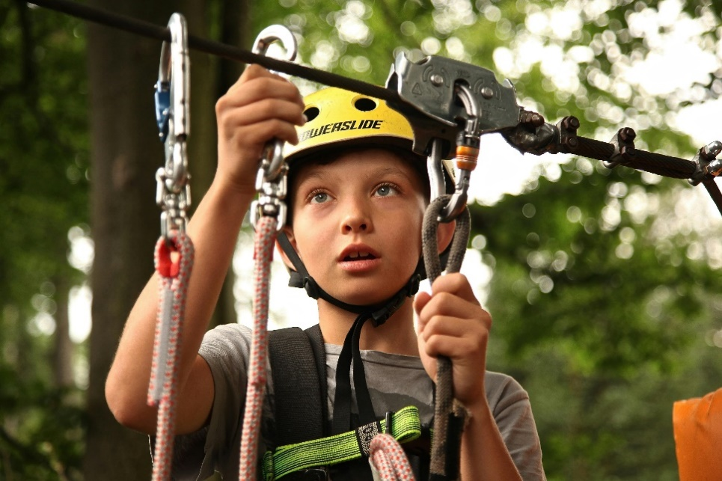**Primary**

This resource is part of our self-care suite of resources and has been co-produced with children and young people living in Essex, for children and young people. They have also been developed and quality assured by the following stakeholders:

* Essex Educational Psychology Service
* Health Watch Essex
* Essex Mental Health Support Teams (MHSTs) NELFT NHS Foundation Trust
* Essex Multi-schools Council
* Essex Social, Emotional and Mental Health (SEMH) strategy team
* Essex Child and Family Wellbeing Service, HCRG Care Group in partnership with Barnardo’s
* NELFT NHS Trust Southend, Essex, and Thurrock (SET) Child, Adolescent and Mental Health Service (CAMHS)
* Professionals in schools and settings can access all these resources via the [Essex info link SEMH portal](https://schools.essex.gov.uk/pupils/social_emotional_mental_health_portal_for_schools/Pages/Self-care-for-CYP-Library.aspx). Children and young people (CYP), parents/carers and professionals can also access these resources via the SET CAMHS website. Our self-care content can also be accessed via SET CAMHS Instagram account:

The resources are intended to be accessed by CYP independently or trusted adults use these resources with CYP through 1:1 conversation, whole school/group discussion and assemblies.

Please note: some of the content within our self-care resources may be emotive for CYP. We recommend that you make use of the ‘signposting to support’ section of this document should any of the content be triggering.

   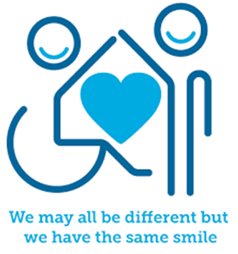

 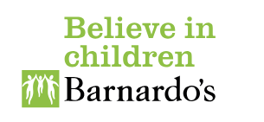

**Introduction**

Risks can often be thought about as situations or actions you take, which can lead to some sort of danger, harm, or loss. You must be very careful with risk taking especially if it compromises your safety. If it is not safe to take a risk do not do it, or seek the support of a trusted adult to make that risk safe and supervised for you. Healthy risks or responsible risks however are actions you take which benefit you and your development as a person. Healthy risks are about trying something new. It could be as simple as raising your hand to answer a question in class, trying out for a role in the school play, trying a new activity on a school trip or saying no to someone.



**Facts**

Healthy/responsible risks:

* teach us responsibility
* improve our confidence and self-esteem
* help us to develop problem-solving skills and assess risk
* become more aware of safety



**Myth Buster**

Here are some of the myths about risk taking:

* Risk taking is always bad X
* Risks are always dangerous X
* You should never take risks X
* You should always take risks X

**Video clips**

Check out these videos about risks:

|  |
| --- |
| * [Taking Responsible Risks | Habits of Mind](https://www.youtube.com/watch?v=6rravJ7RVsY)   This video describes what responsible risks are (Ks2) |
| * [Habits of Mind Animations: Taking Responsible Risks](https://www.youtube.com/watch?v=WCTGJGjzay8)   Highlights the benefits of taking responsible risks (Ks1) |
|  |

**Resources**

|  |
| --- |
| We have indicated whether the resources are accessible for Ks1 or Ks2. Please note that some of the Ks2 content could be adapted and differentiated to support pupils in Ks1. |
| * [Taking Risks PowerPoint (teacher made) - Twinkl](https://www.twinkl.co.uk/resource/taking-risks-powerpoint-cfe2-p-287)   Twinkl resources to explore risk taking with primary age pupils (Ks2) |

**Reflective questions**

(Try exploring these reflective questions with a CYP)

* What is a risk?
* What is a healthy/responsible risk?
* Can you name three unsafe risks?
* What risks have you taken that have been beneficial to you?
* Name three risks you would not take?

**Quiz**

Once you have gone through this resource with a CYP try these quiz questions with them:

* What do taking safe and responsible risks help you to develop?
* Why might you take a risk?
* When would you not take a risk?
* Name three safe risks
* Name three unsafe risks

**Signposting to Support**

For additional support we recommend you access:

* [Getting help for your child: where to start](https://www.youngminds.org.uk/parent/parents-a-z-mental-health-guide/getting-help-for-your-child/)
* [Childline](https://www.childline.org.uk/info-advice/your-feelings/mental-health/?&&&&gclsrc=aw.ds&&gclid=EAIaIQobChMIqryktIeP_wIVicPtCh3QZQs6EAAYASAAEgJr5vD_BwE&gclsrc=aw.ds) - 0800 1111 – [when contacting ChildLine what to expect](https://www.youtube.com/watch?v=_KNtMOKwTco)
* [Hopeline 0800 068 41 41](https://www.papyrus-uk.org/papyrus-HOPELINE247/) offering confidential support and practical advice
* [Text ‘SHOUT’ to 85258](https://giveusashout.org/get-help/?gclid=Cj0KCQiA6vaqBhCbARIsACF9M6nG--bxZCnflhd5C3jT-d9dS48o5t6XTTTidI0MLTgwjjRAlxszRT8aAnvvEALw_wcB) for free, confidential, anonymous text support service
* [NHS 111](https://www.nhs.uk/nhs-services/mental-health-services/)
* [Southend, Essex & Thurrock Children and Adolescent Mental Health Service (SET CAMHS)](https://www.nelft.nhs.uk/set-camhs/)
* [Explore counselling/therapy](https://www.nhs.uk/mental-health/talking-therapies-medicine-treatments/talking-therapies-and-counselling/counselling/)
* [Where to get urgent mental health support from: Advice from NHS](https://www.nhs.uk/nhs-services/mental-health-services/where-to-get-urgent-help-for-mental-health/)



* SET CAMHS Instagram account

**How to help a friend**

* Start a conversation with a friend about taking risks (both safe, healthy, and responsible risks as well as unsafe risks).
* Suggest a friend seeks help from a trusted adult if they are going to take a risk that they need help with.
* Speak to a trusted adult if you are concerned a friend is taking unsafe risks.

**The adult box** (for professionals and parent/carers to read)

|  |
| --- |
| * [Risk in play: how it helps child development](https://www.youtube.com/watch?v=FeJPLOHJNMA)   Video describe the importance of children taking responsible risks in play. |
| * [Encouraging Healthy Risk-Taking](https://www.teamkids.com.au/encouraging-healthy-risk-taking/)   Team Kids article on the benefits of encouraging healthy risk taking |
| * [Bright Horizons | Risk taking in early childhood: When is it appropriate?](https://www.brighthorizons.com/resources/article/risk-taking-benefits-children#:~:text=As%20parents%2C%20your%20best%20strategy,they%27ll%20need%20for%20adulthood.)   Bright Horizons discuss how parents can support children to take healthy risks |
| * [Home of Early Years Foundation Stage](https://eyfs.info/articles.html/teaching-and-learning/supporting-parents-to-understand-the-benefits-of-%E2%80%98risky%E2%80%99-play-r250/)   Foundation stage forum shares with practitioners the reasons why they need to develop parents/carers confidence in allowing their children to take healthy risks |
| * [Risky Play and Children’s Safety: Balancing Priorities for Optimal Child Development](https://www.ncbi.nlm.nih.gov/pmc/articles/PMC3499858/)   National Library of Medicine research article about play and risk taking |
|  |

   

 