**Early planning for year 7 transition is vital in the PNI team**

In preparation for transition to secondary school the PNI specialist teaching team begins planning during year 5. This is imperative to ensure that access to the secondary school of choice is possible and not a barrier to inclusion. While the team is unable to advise parents on their choice of school, they can share their knowledge of access facilities and highlight any difficulties with the school buildings that may arise.

An example of this early planning can be demonstrated with the following case study:

During the summer term, of a year 5 pupil, it was discussed at a review meeting that the pupil and parent were very keen for the pupil to attend a secondary school that was out of catchment and needed some building adaptations to make it fully accessible for the pupil. The PNI teacher had knowledge of all the surrounding secondary schools and was aware the catchment school was already adapted. Nationally, when the catchment school is accessible and can meet the needs of a pupil, funding for adaptations may not be agreed. The Essex Local Educational Authority prides itself on continuing to improve access facilities in its schools and has Access Funding available to ensure this. However, it was not clear, in this instance, whether or not funding would be allocated, so it was agreed that the Specialist Teacher would assess the adaptations needed and report to the funding panel.

In order to ensure that all aspects of the pupil’s needs were not overlooked, both the Occupational Therapist and Physiotherapist were consulted to ensure that every contingency was planned for. It was the role of the PNI teacher to ensure that health and school information was gathered and presented in a report to the panel and many visits to the secondary school were undertaken. The secondary school was keen to be open to suggestions for adaptation and understood why the pupil wanted to come to their school. They had attended an inclusive debate earlier in the year as part of the secondary school’s extended reach in the local community programme. While the school already had ramped access, lifts and accessible bathrooms, it did not have the specific, specialist equipment installed that the prospective pupil would need.

A report was submitted to the Access Initiative Meeting (AIM) panel, requesting that a surveyor undergo a joint visit with the PNI specialist teacher, Occupational Therapist and Physiotherapist to the secondary school. This action was agreed and two separate visits were made to the school in order to find a bathroom space that could be made into an accessible toilet and changing space for the pupil.

Once the surveyor had submitted projected costs back to the Access Funding panel, it was noted that this was not the catchment school and therefore questions were raised about the need for the identified works to be carried out as the catchment school already had the appropriate adaptations. It was at this point that the PNI specialist teacher’s report was referred to where the wider picture had been explained and the funding was agreed.

The impact of the PNI specialist teacher’s report, demonstrating knowledge of the local area, the pupil’s health needs, intimate care needs and wider, social community needs, attributed to the agreement of this funding. Without this report, the secondary school would not have received funding to improve their accessible toilet and the pupil would have been directed to their catchment school.

Below are photos of a wonderfully accessible bathroom that is used on a daily by the pupil, who is thoroughly enjoying their time in year 7. This bathroom was constructed in the summer holidays proceeding transition from junior to secondary school. Funding was agreed in the Autumn term of year 6 and contractors assigned during the Spring term of year 6. Without this early planning for transition there would have been insufficient time to have the bathroom ready for secondary transition.

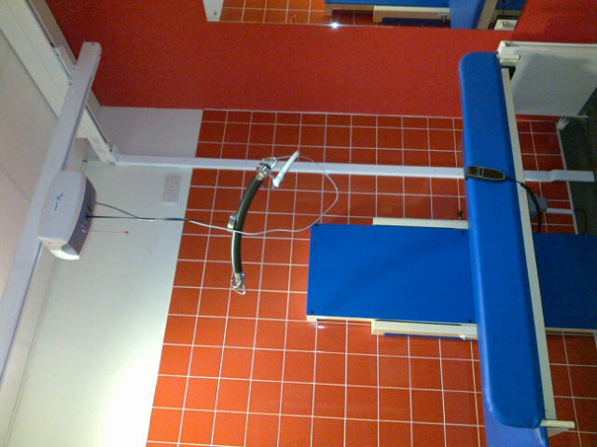 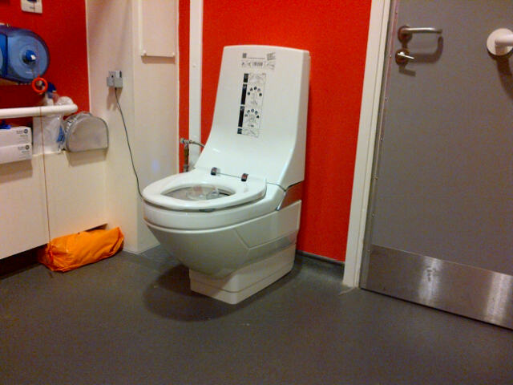

Ceiling track hoist plus height Clos-o-Mat toilet

adjustable changing bench