## What is VIG?

VIG is a strengths-based, effective, brief intervention for professionals and parents/carers of children across all ages. VIG aims to promote enhanced sensitivity, and capacity to mentalise, in both client and practitioner.

VIG has a strong theoretical base: attachment, co-operative intersubjectivity, mediated learning, mentalization, and positive psychology. VIG is client-centred – moving at the client’s pace, with their goals in mind.

The evidence base for Video Interaction Guidance is an international one. VIG is recommended as an evidence-based intervention in the **NICE guidelines**: high level studies (RCT or QED) show that parents receiving VIG score significantly higher on sensitivity, warmth, and parent-infant bonding, are less anxious and depressed, and have increased confidence.

**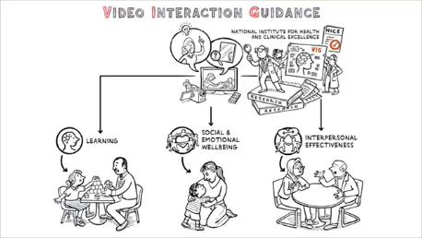***Children’s Attachment: attachment in children and young people who are adopted from care, in care, or at high risk of going into care*(NICE 2015)

*Children with Autism* (NICE 2013)

*Social and Emotional Wellbeing – Early Years* (NICE 2012)

## VIG highlights and builds on attuned moments in parent-child / professional-child interaction

Adults are supported by a VIG Practitioner to view and reflect together on strengths-based micro-moments of video. They are asked: **‘What is it that you are doing that is making a difference?’** Through this process of active engagement and reflection, they become aware of, and build on, their skills in attunement.

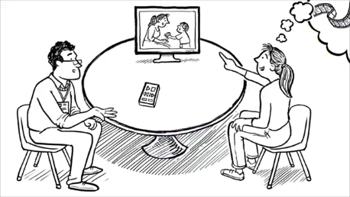

VIG is **powerful and emotionally moving**: clients voice their surprise and pleasure in what they see.

The VIG practitioner and client together notice and build on the **client’s strengths**.

VIG relationships are built on respect, trust, hope, compassion, co-operation and appreciation.

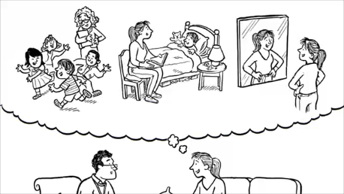

VIG is effective in helping adultsmove to a **new narrative** aboutthemselves as a parent, carer or professional, about the child, and their relationship with the child.

This is key to **secure attachment** in the child.

## How VIG is used

VIG is used in a variety of contexts. VIG is adaptable with any client group, any helping professional, and can be applied to the system around the client.

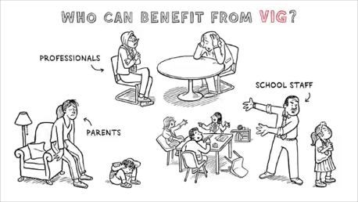**Health**: perinatal mental health, parent-infant services, CAMHS (all ages), adult mental health, hospital settings, learning difficulties services, elderly and dementia services

**Schools**: to promote staff attunement to pupils, or for staff teams

**Social care**: therapeutic work with families on the edge of care, parenting assessments, fostering and adoption services

**Drug and alcohol services, domestic violence, courts** (assessments of families going through legal proceedings, or via CAFCASS), and third sector services, eg NSPCC, Parents 1st, Babies1st.net, Stefanou Foundation.

## Training in VIG

VIG has an established UK training and accreditation programme which includes on-going video-reflective supervision, and rigorous accreditation criteria.

AVIGuk is an association of accredited practitioners of VIG, and those in training.  AVIGuk regulates training in the UK, and facilitates communication between those interested in training and available training opportunities.

The training to become a VIG Accredited Practitioner usually takes between 15-18 months, depending on the trainee’s client caseload and access to regular VIG supervision.

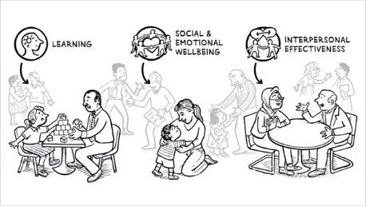

The training and supervision process of VIG mirrors the core attuned principles and beliefs, in which the supervisor scaffolds each trainee’s learning, building on their unique strengths.

Trainees benefit from professional development which increases their attunement to clients, and their interpersonal effectiveness.

## VIG in Essex

Essex Virtual School has commissioned training for practitioners across social care and education to deliver VIG. The aim is ultimately to improve children’s outcomes by enabling adults around them to support children into school, and to settle to learn. We believe having secure relationships at home and at school will help to achieve this.

We recommend considering VIG when situations feel a little ‘stuck’; narratives around children have become problematised; there is the need for more attunement in an adult-child relationship and when there is a particular difficulty (for example, a child feeling dysregulated often at school). It can be used to inform an assessment or as an intervention. We are trained to help all involved adults understand what VIG is being used for and how their data is stored. The main thing to know is that the video is not used as evidence in any way.

We offer a referral pathway where children known to social care can be suggested, and the most appropriate practitioner can be allocated.

We also aim to collect anonymised educational and relationship measures to evaluate the effectiveness of the intervention.

**Some further reading:**

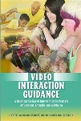Kennedy, H., Landor, M. & Todd, L. (eds) (2011*) Video Interaction Guidance: A Relationship-based Intervention to Promote Attunement, Empathy and Wellbeing.* London: Jessica Kingsley Publishers.



[Kennedy, H. and Underdown, A. (2017) Video Interaction Guidance: promoting secure attachment and optimal development for children, parents and professionals, in Leach, P. Innovative Research in Infant Wellbeing. London: Routledge.](https://www.videointeractionguidance.net/resources/Documents/2016-18%20Research%20IMH/Kennedy,%20Underdown(1).pdf)