# **Let’s Talk: LGBTQIA+**

**Secondary**

This resource is part of our self-care suite of resources and has been co-produced, with children and young people living in Essex, for children and young people. They have also been developed and quality assured by the following stakeholders:

* Essex Educational Psychology Service
* Health Watch Essex
* Essex Mental Health Support Teams (MHSTs) NELFT NHS Foundation Trust
* Essex Multi-schools Council
* Essex Social, Emotional and Mental Health (SEMH) strategy team
* Essex Child and Family Wellbeing Service, HCRG Care Group in partnership with Barnardos
* NELFT NHS Trust Southend, Essex, and Thurrock (SET) Child, Adolescent and Mental Health Service (CAMHS)
* Professionals in schools and settings can access all these resources via the [Essex info link SEMH portal](https://schools.essex.gov.uk/pupils/social_emotional_mental_health_portal_for_schools/Pages/Self-care-for-CYP-Library.aspx). Children and young people (CYP), parents/carers and professionals can also access these resources via the SET CAMHS website. Our self-care content can also be accessed via SET CAMHS Instagram account:

The resources are intended to be accessed by CYP independently or trusted adults use these resources with CYP through 1:1 conversation, whole school/group discussion and assemblies.

Please note: some of the content within our self-care resources may be emotive for CYP. We recommend that you make use of the ‘signposting to support’ section of this document should any of the content be triggering.

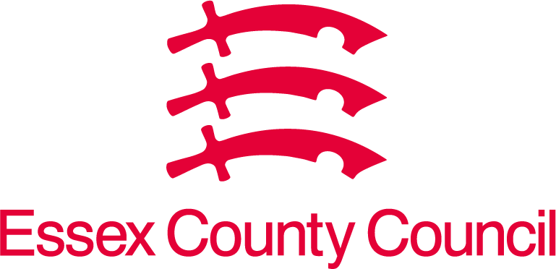   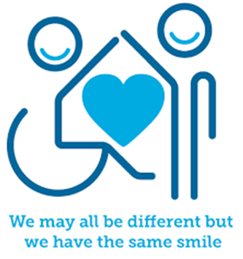

 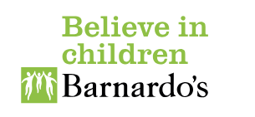

**Introduction**

Some people identify as LGBTQIA+. This means they may be lesbian, gay, bisexual, transgender, queer, intersex, questioning or asexual.

Definitions of these terms:

*Lesbian:* A woman who is attracted to other women.

*Gay:* Traditionally this word has meant a man who is attracted to other men. Today, people of other genders use this word too, so the word gay describes a person who is attracted to other people of the same gender.

*Queer:* Historically this word was used as a negative insult, however many people feel they have reclaimed the word to have a positive meaning. Some people use it as a collective term for LGBT+ people, and some use it to explain their gender, sexual or political identity. Some people still use this word as an insult – this is LGBT phobia and should be challenged.

*Bisexual:* A person of any gender who experiences attraction to people of their own gender as well as other genders.

*Trans/transgender*: A person whose gender identity is in some way different to the gender they were assigned at birth.

*Intersex:* There are many different ways someone can be intersex. Some intersex people have genitals or internal sex organs that fall outside the male/female categories — such as a person with both male and female organs. Other intersex people have combinations of chromosomes that are different than the usual ones associated with male and female. Some people are born with external genitals that fall into the typical male/female categories, but their internal organs or hormones do not.

*Questioning:* A person who is uncertain about and/or exploring their own sexual orientation (and/or gender identity).

*Asexual* : A person of any gender or sexual orientation who experiences little, or no, sexual attraction to another person. Asexual people may still experience other types of attraction, such as physical or romantic attraction.

We're using 'LGBTQIA+' as an umbrella term, but we know that LGBTQIA+ people do not exist as one group. Everyone is different. Identities are a complicated mix of factors, including:

* age
* ethnicity
* religion
* cultural background
* socio-economic background
* gender identity and gender expression
* sexuality
* physical ability
* many other characteristics.

Gender identity and gender expression

When people think of “gender”, they often think about body parts, clothes or how a person looks and acts - but people also have a ‘gender identity’. This is the gender that you identify with, the gender that you know yourself to be and it is part of your internal sense of self.

At birth, most people are either labelled as a girl or a boy. This is called gender assignment and is usually based on your physical body parts. This can make things difficult to figure out when your gender *identity* does not match the gender you were assigned at birth.

Your gender identity can be very important to who you are as a person. Some people are men, some people are women, some people are non-binary (which means they identify as neither 100% a man nor 100% a woman). You can describe your gender however feels most comfortable to you.

Your gender identity does not mean you have to wear certain clothes or look a certain way either. Some men can present in a way traditionally seen as feminine. Some women can present in a way traditionally seen as masculine. Everyone is unique and has their own style and presentation. This is called ‘gender expression’. You do not have to fit a stereotype of what you think a man or a woman should look like.

Sexual orientation/ sexuality

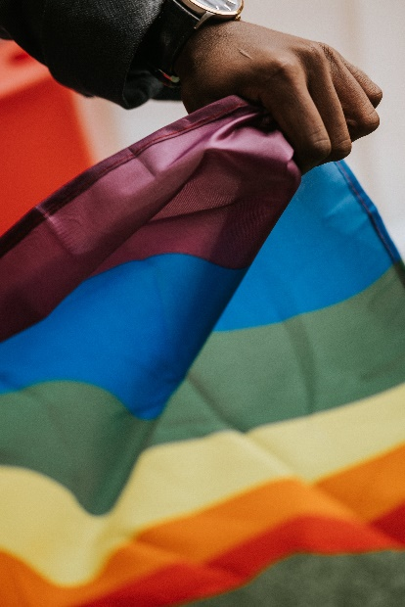A person’s ‘sexual orientation’, or sexuality, is the part of their identity that relates to who they find attractive/who they fancy. The attraction to other people does not have to be sexual, it could just be romantic. Some people are attracted to a particular gender/genders, some people are attracted to who the person is (their morals, values, humour, intelligence, etc.), and for some it’s a combination of the two. Attraction can feel different for different people; it can involve wanting to be around a person more, thinking about them when you are not with them, “butterflies” in your stomach, feeling giddy or nervous when you are together and more.

**Facts**

* All aspects of LGBTQ+ are part of the beautiful human variation and diversity. People differ from each other in all kinds of ways and gender and sexuality are no exception.
* It is estimated that around 6% of the UK’s population does not identify as straight/heterosexual. So, although there are fewer LGBTQ+ people than non-LGBTQ+ people, there are still lots of LGBTQ+ people, with an estimated three to four million in the UK alone.
* Approximately 1% of the population is trans. In the UK that would make over 600,000 trans and non-binary people. That’s about the same percentage as people who have red hair!
* Being LGBTQ+ is not an illness. LGBTQ+ people live happy and healthy lives just like anyone else.
* Some trans people might experience ‘gender dysphoria’. This is a feeling of discomfort associated with the gender they were assigned at birth. Some trans people will transition (make certain changes to their lives, such as changing their name or parts of their body) to make themselves feel more comfortable. This is just part of becoming who you are.
* Nothing has “caused” you to feel this way and there is nothing wrong or weird about the way you are feeling. What you are feeling is completely valid and you should not put yourself under pressure to figure out your gender identity or sexuality immediately. Take the time to explore your feelings and reflect on how you are feeling – it will be difficult to understand them if you ignore them.
* You might find it helpful to talk to other people who have gone through or are going through the process of questioning their sexuality or gender. There are lots of online groups which can help with this (see below).

**Myth Buster**

* LGBTQ+ is a modern term and being in this category is a very new concept. X

(FALSE! A lot of the language we have to describe a person’s sexuality is fairly modern, but attraction between two people of the same gender has existed throughout history).

* It isn’t ‘normal’ X

(FALSE! There is no such thing as normal, everyone is different and in different ways! When people ask, “Am I normal?” they usually want to know, “Are other people like me?”.)

* It is important to label your sexuality and gender X

(FALSE! No, you do not have to label your sexuality. Some people like to have a word that describes their feelings, but there are many others who find labels restrictive. If you would like an umbrella term that lets others know you are not straight, you could use terms like “queer” or “LGBT+”. Or, if others ask, you can just let them know that you do not, and that you do not wish to, label your sexuality.)

* These ideas and feelings are ‘contagious’ X

(FALSE! Being LGBT+ is not contagious. You cannot become LGBT+ by being around or learning about LGBT+ people. Sometimes schools and colleges make an effort to be more LGBT+ inclusive places and people you did not realise were LGBT+ come out and share their identity. They have not become LGBT+ because of the changes the school has made or because other people have come out. They have probably come out because they feel safe and their identity is respected, so they no longer feel like they have to hide it. Or sometimes, because people have been talking about LGBT+ identities they now have the language to describe how they are feeling.)



**Video clips**

*Check out these videos about LGBTQIA+*

|  |
| --- |
| * <https://www.youtube.com/watch?v=GfycJj4jFp8>   Pop’n’Olly explaining Sexual Orientation (Ks3+) |
| * [The Gender Unicorn | Pop'n'Olly | Olly Pike (youtube.com)](https://www.youtube.com/watch?v=YPNCzXYy2CE)   Pop’n’Olly explores gender identity (Ks3+) |
| * [Gender Explained for Kids - Part 1 | Assigned Sex & Gender | Pop'n'Olly (youtube.com)](https://www.youtube.com/watch?v=Zm9vssgYcHU)   Pop’n’Olly explains sex and gender (Ks3+) |
| * <https://www.youtube.com/watch?v=UZ28idcSP9g>   Pop’n’Olly explains transgender and non-binary |
| * <https://www.youtube.com/watch?v=BoTxytQJ3z4>   Pop’n’Olly explains gender expression |

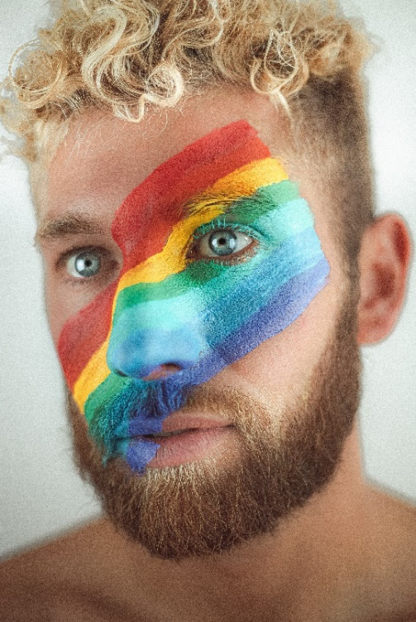**Resources**

|  |
| --- |
| *We have indicated whether the resources are accessible for Ks3, Ks4 or Ks5+. However, some of the content may be able to be differentiated to suit other age groups of children and young people using these resources.* |
| * <https://www.theproudtrust.org/young-people/?gad_source=1&gclid=EAIaIQobChMIp63bhdbrggMVsYdQBh3MDwPPEAAYASAAEgKSQPD_BwE>   The Proud Trust is an LGBT+ youth charity empowering young people to be proud of who they are (KS3+) |
| * [lgbtqi-booklet-final-021122 (595x841) - Frontify (annafreud.org)](https://brandplatform.annafreud.org/share/GyrEQyNYEvDME2zyUkrt)   Anna Freuds LGBTQI+ mental health resource to support the mental health of lesbian, gay, bisexual, trans and intersex young people (Ks3+) |
| * <https://uploads-ssl.webflow.com/5888a640d61795123f8192db/5ee0c0b33d94975252043774_AllsortsYouthProject%20-%20HealthyHeadsandHearts-.pdf>   Healthy heads and hearts resources booklet for young people who are lesbian, gay, bisexual, transgender or unsure. (Ks4+) |
| * <https://www.thetrevorproject.org/wp-content/uploads/2019/10/Coming-Out-Handbook.pdf>   A ‘coming out guide’ for LGBTQ young people (Ks3+) |
| * <https://www.mosaictrust.org.uk/young-persons?gclid=EAIaIQobChMIte6j6eDrggMVgu7tCh1RaAgGEAAYAiAAEgKdtPD_BwE>   Mosaic LGBT+ young persons’ trust – find out about who we are and how to get involved (KS3+) |
| * [Genderbread Person v4 ALL (itspronouncedmetrosexual.com)](https://eur02.safelinks.protection.outlook.com/?url=https%3A%2F%2Fwww.itspronouncedmetrosexual.com%2Fdownloads%2FGenderbread%2520Person%2520v4%2520ALL.pdf&data=05%7C01%7CJane.Tyndale-Biscoe%40essex.gov.uk%7C2ce8daae197841dd372d08dbf006b864%7Ca8b4324f155c4215a0f17ed8cc9a992f%7C0%7C0%7C638367684051877761%7CUnknown%7CTWFpbGZsb3d8eyJWIjoiMC4wLjAwMDAiLCJQIjoiV2luMzIiLCJBTiI6Ik1haWwiLCJXVCI6Mn0%3D%7C3000%7C%7C%7C&sdata=eVSylG38tDXrrvsU0P33qYujLf%2BqZtNApPViI7ZcT3U%3D&reserved=0)   This resource explores and explains a range of different aspects of identity (KS3+) |
| * <https://www.youtube.com/shorts/nvMPxuHetvg>   Pop’n’Olly quiz |

**Reflective questions**

(Try exploring these reflective questions with a CYP)

* What do you think being LGBTQIA+ might mean?
* What kind of thoughts and feelings have you been having about this?
* How do you feel about things at the moment?
* What can you do to feel better about it?
* Who have you spoken to?
* Who else can you talk to?
* What advice would you give to a friend if they were having these thoughts and feelings?

**Quiz**

Once you’ve gone through this resource with a CYP try these quiz questions with them:

* What does being LGBTQIA+ mean?
* What things are true and not true about this?
* What are some things you can do to feel ok about yourself?
* 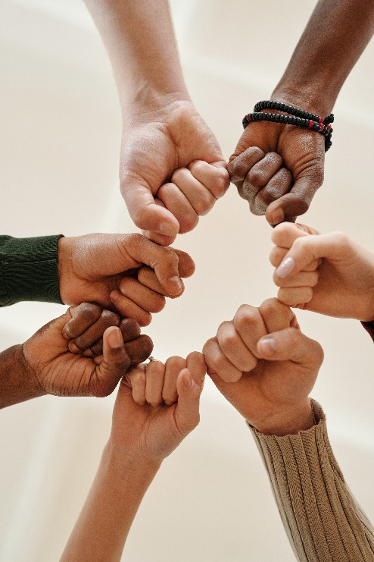Who can you talk to about this?
* How can someone else help you?

**Signposting to Support**

For additional support we recommend that trusted adults use these resources to support children and young people access support when required:

(*See resources for pupils and schools above and below*)

* <https://giveusashout.org/get-help/resources/lgbtq-support/?gclid=EAIaIQobChMI2LOZrNz4ggMVn4tQBh3Pzw2REAAYBCAAEgKcBfD_BwE>

LGBTQ+ support signposting

* [The Mix](https://www.themix.org.uk/about-us)
* [Togetherall](https://togetherall.com/en-gb/) 16+
* [Anna Freud Centre – On My Mind](https://www.annafreud.org/on-my-mind/)
* [Kooth.com](https://www.kooth.com/)
* [Explore counselling/therapy](https://www.nhs.uk/mental-health/talking-therapies-medicine-treatments/talking-therapies-and-counselling/counselling/)
* [Childline](https://www.childline.org.uk/info-advice/your-feelings/mental-health/?&&&&gclsrc=aw.ds&&gclid=EAIaIQobChMIqryktIeP_wIVicPtCh3QZQs6EAAYASAAEgJr5vD_BwE&gclsrc=aw.ds) - 0800 1111 – [when contacting ChildLine what to expect](https://www.youtube.com/watch?v=_KNtMOKwTco)
* [Hopeline 0800 068 41 41](https://www.papyrus-uk.org/papyrus-HOPELINE247/) offering confidential support and practical advice
* [Text ‘SHOUT’ to 85258](https://giveusashout.org/get-help/?gclid=Cj0KCQiA6vaqBhCbARIsACF9M6nG--bxZCnflhd5C3jT-d9dS48o5t6XTTTidI0MLTgwjjRAlxszRT8aAnvvEALw_wcB) for free, confidential, anonymous text support service.
* [Share any concerns about your mental health with your GP](https://www.mind.org.uk/information-support/guides-to-support-and-services/seeking-help-for-a-mental-health-problem/talking-to-your-gp/) and [Understanding Confidentiality](https://www.mind.org.uk/for-young-people/your-rights/understanding-confidentiality/)
* [NHS 111](https://www.nhs.uk/nhs-services/mental-health-services/)
* [Southend, Essex & Thurrock Children and Adolescent Mental Health Service (SET CAMHS)](https://www.nelft.nhs.uk/set-camhs/)
* [Where to get urgent mental health support from: Advice from NHS](https://www.nhs.uk/nhs-services/mental-health-services/where-to-get-urgent-help-for-mental-health/)
* SET CAMHS Instagram account 

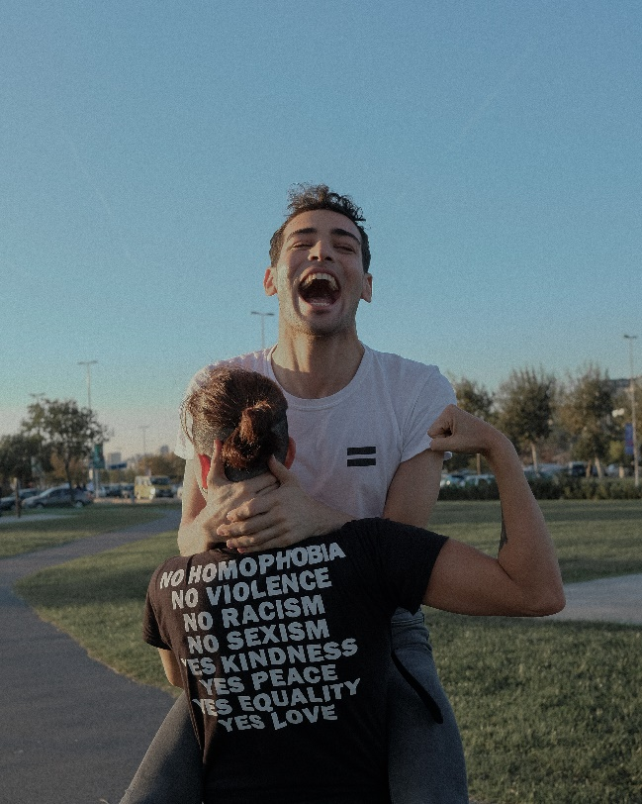

**How to help a friend**

* Share this resource with them.
* Talk to them about the resources, links and apps above.
* Listen to them and help them to find positive ways forward.
* Show them acceptance for who they are.
* Talk about who can help them and who they can talk to (an adult at home or at school) about their feelings.
* If you are really concerned about someone, find a trusted adult you can speak to for advice.

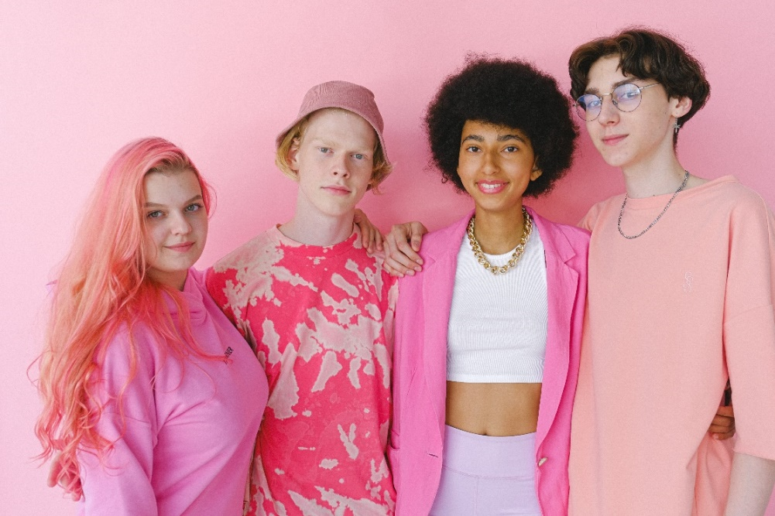

**The adult box** (for professionals and parent/carers to read)

|  |
| --- |
| * [WEBSITES | CAMHS Resources (camhs-resources.co.uk)](https://www.camhs-resources.co.uk/websites)   CAMHS resources page |
| * <https://uploads-ssl.webflow.com/5888a640d61795123f8192db/5ee0c11822791576d62f98c4_AllsortsYouthProject%20-%20Top%20Tips%20Booklet%20v2.pdf>   Transformers Trans Youth Group top tips for working with trans and gender questioning young people |
| * <https://www.stonewall.org.uk/system/files/secondary_gstk_eng_singles-ap2_-_final_edited_-_march_2022.pdf>   Stonewall’s toolkit for preventing and tackling homophobic, biphobic and transphobic bullying in secondary schools |
| * <https://www.bathnes.gov.uk/sites/default/files/siteimages/allsortsyouthproject_-_trans_inclusion_schools_toolkit_aug_2017.pdf>   Brighton and Hove City Council and Allsorts Youth Group Trans Inclusion Schools Toolkit. Supporting trans, non-binary and gender questioning children and young people |
| * <https://uploads-ssl.webflow.com/5888a640d61795123f8192db/5ee0bfaf1afffb0c3dab69f2_AllsortsYouthProject%20-%20A%20Journey%20WIthout%20A%20Map.pdf>   A journey without a map: being a parent of a trans child |
| * <https://www.youtube.com/watch?v=b8Ev2QG0W9M>   5 tips for parents of LGBT kids (by The Advocate, featuring Susan Cottrell, mother of 5) |
| * [Parents-LGBTQ-v3.2-1.pdf (cara-friend.org.uk)](https://cara-friend.org.uk/wp-content/uploads/2018/08/Parents-LGBTQ-v3.2-1.pdf)   Cara-Friend A parent and carer’s resource: supporting your LGBTQ+ child |
| * [LGBT school resources - Just Like Us](https://www.justlikeus.org/lgbt-school-resources/?gclid=EAIaIQobChMIuIT_2tbrggMViZZQBh0OQQ1cEAAYAiAAEgJEZPD_BwE)   Just Like Us, provide primary and secondary schools with LGBT+ inclusive, educational resources. |
| * <https://mentallyhealthyschools.org.uk/factors-that-impact-mental-health/vulnerable-children/lgbtqiplus/>   Anna Freud Mentally Health Schools LGBTQI+ information |

   

 