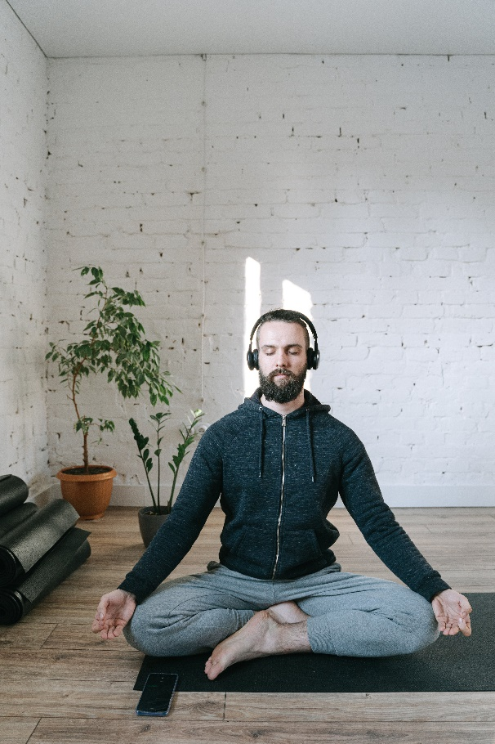**Let’s Talk: Healthy Boundaries**

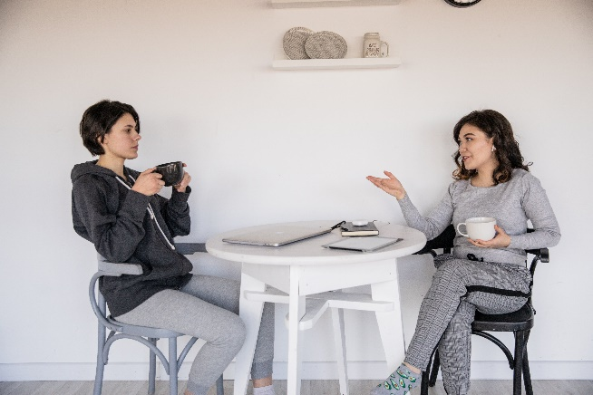**Secondary**

This resource is part of our self-care suite of resources and has been co-produced with children and young people living in Essex, for children and young people. They have also been developed and quality assured by the following stakeholders:

* Essex Educational Psychology Service
* Health Watch Essex
* Essex Mental Health Support Teams (MHSTs) NELFT NHS Foundation Trust
* Essex Multi-schools Council
* Essex Social, Emotional and Mental Health (SEMH) strategy team
* Essex Child and Family Wellbeing Service, HCRG Care Group in partnership with Barnardos
* NELFT NHS Trust Southend, Essex, and Thurrock (SET) Child, Adolescent and Mental Health Service (CAMHS)
* 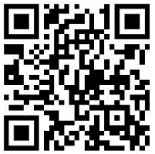Professionals in schools and settings can access all these resources via the [Essex info link SEMH portal](https://schools.essex.gov.uk/pupils/social_emotional_mental_health_portal_for_schools/Pages/Self-care-for-CYP-Library.aspx). Children and young people (CYP), parents/carers and professionals can also access these resources via the SET CAMHS website. Our self-care content can also be accessed via SET CAMHS Instagram account:

The resources are intended to be accessed by CYP independently or trusted adults use these resources with CYP through 1:1 conversation, whole school/group discussion and assemblies.

Please note: some of the content within our self-care resources may be emotive for CYP. We recommend that you make use of the ‘signposting to support’ section of this document should any of the content be triggering.

   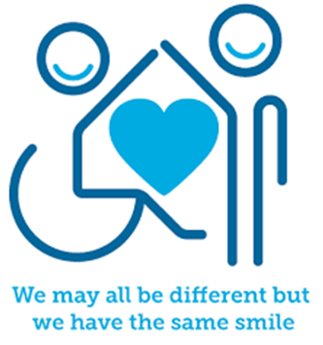

 

**Introduction**

Healthy boundaries are limits and rules we set for ourselves and others within relationships. Setting boundaries can be helpful to let others know what we feel comfortable with and what we do not feel comfortable with. They can be thought of as lines that separate us from others, in terms of our physical space and our emotions and feelings. Boundaries can be personal to us or we can share agreed boundaries with others which we all follow. A personal boundary might be saying “no thank you” or ‘thanks but that doesn’t feel right for me” when someone wants us to do something we do not want to do, whilst a shared boundary would be something we agree to do/not do, such as being a dependable friend. Boundaries are important to help keep ourselves and others safe. They affect how we treat ourselves and others as well as how others treat us. We can set boundaries with a range of things including our things (possessions), bodies, feelings, time, thoughts, and beliefs.

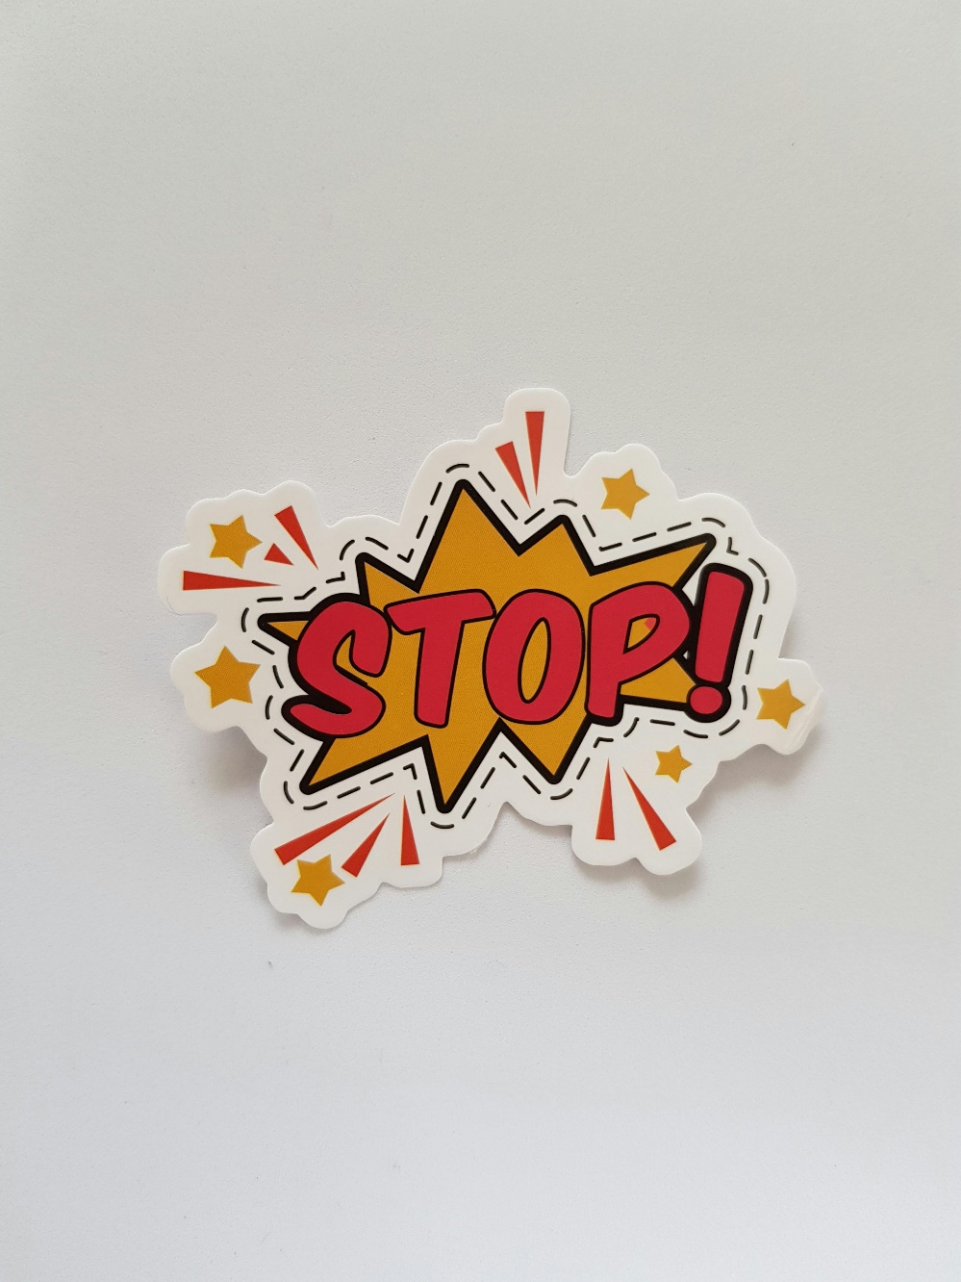

**Facts**

Boundaries:

* are a form of self-care.
* help create a clear guideline/rule/limit of how you would like to be treated.
* let others know what is and what is not okay/acceptable.
* honour our needs and wants so that we feel respected and safe.
* also help to avoid burnout, stress, and anxiety. It can also help prevent financial and emotional challenges.

**Myth Buster**

Here are some of the myths about self-care.

* Setting boundaries is selfish X
* Boundaries push people away X
* Putting boundaries in place is rude X
* Having boundaries is saying no to everything all the time X
* Putting in boundaries will upset others X
* Boundaries you set can never change X
* Setting boundaries is telling someone what to do X
* You must have the same boundaries for everyone X

**Video clips**

Check out these videos about boundaries:

|  |
| --- |
| * [Teen Voices: Friendships and Boundaries](https://www.youtube.com/watch?v=yjzGxLq1Dqs&t=1s)   A video talking about using phones to connect with friends and the challenges about put in boundaries with others. |
| * [Personal Boundaries Explained](https://www.youtube.com/watch?v=y-kqr4A5gog)   BetterHelp explain what personal boundaries are, why they are important and how to set them. |
| * [Setting Healthy Boundaries](https://www.youtube.com/watch?v=XFAEeOd3H9k)   The Prevention Connection have created a video about boundaries |
| * [Tips on How to Set Healthy Boundaries in Friendships](https://www.youtube.com/watch?v=Zb9L4XQNwPw&t=22s)   Headspace offer examples of how to set boundaries with our friends |
| * [How Can I Stop Being a Pushover](https://www.youtube.com/watch?v=OL0BFPcZl_g)   Headspace ask a teacher offers tips on putting boundaries in your life |
| * [Setting Boundaries| Mental Health Lessons | RTÉ Player Original (youtube.com)](https://www.youtube.com/watch?v=Gf4FIt5DG4g)   Irelands National Public Service Media describe how we can set boundaries |

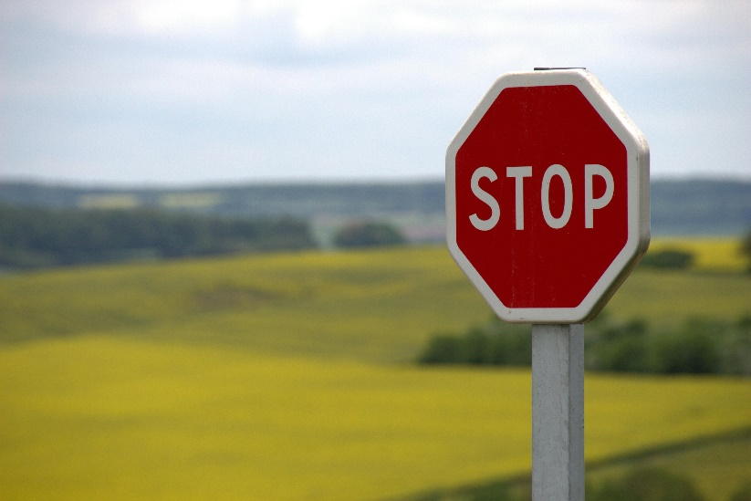

**Resources**

|  |
| --- |
| * [How I Learnt to Set Boundaries with A Friend](https://www.youngminds.org.uk/young-person/blog/how-i-learnt-to-set-boundaries-with-a-friend-for-my-mental-health/)   Young minds article about how a young person learnt to put in boundaries with a friend |
| * [Personal Boundaries: Types and How to Set Them](https://psychcentral.com/relationships/what-are-personal-boundaries-how-do-i-get-some)   An article by PsychCentral discusses different types of personal boundaries and how to set them |

**Reflective questions**

(Try exploring these reflective questions with a CYP)

* What are boundaries?
* Who needs boundaries?
* Why are boundaries so important?
* Can you name three of your own boundaries?

**Quiz**

Once you have gone through this resource with a CYP try these quiz questions with them:

* Name three boundaries that school/work set for their student/employers?
* Why are boundaries important?
* Describe two personal boundaries.
* Describe two shared boundaries.
* Who needs boundaries?

**Signposting to Support**

For additional support we recommend you access:

* [Anna Freud Centre – On My Mind](https://www.annafreud.org/on-my-mind/)
* [Kooth.com](https://www.kooth.com/) (Age 11-25)
* [Togetherall](https://togetherall.com/en-gb/faqs/becoming-a-member-and-managing-your-profile/#:~:text=Togetherall%20is%20only%20for%20adults,is%20only%20available%20to%2018%2B.) (age 16+)
* [Explore counselling/therapy](https://www.nhs.uk/mental-health/talking-therapies-medicine-treatments/talking-therapies-and-counselling/counselling/)
* [Childline](https://www.childline.org.uk/info-advice/your-feelings/mental-health/?&&&&gclsrc=aw.ds&&gclid=EAIaIQobChMIqryktIeP_wIVicPtCh3QZQs6EAAYASAAEgJr5vD_BwE&gclsrc=aw.ds) - 0800 1111 – [when contacting ChildLine what to expect](https://www.youtube.com/watch?v=_KNtMOKwTco)
* [Hopeline 0800 068 41 41](https://www.papyrus-uk.org/papyrus-HOPELINE247/) offering confidential support and practical advice
* [Text ‘SHOUT’ to 85258](https://giveusashout.org/get-help/?gclid=Cj0KCQiA6vaqBhCbARIsACF9M6nG--bxZCnflhd5C3jT-d9dS48o5t6XTTTidI0MLTgwjjRAlxszRT8aAnvvEALw_wcB) for free, confidential, anonymous text support service.
* [Share any concerns about your mental health with your GP](https://www.mind.org.uk/information-support/guides-to-support-and-services/seeking-help-for-a-mental-health-problem/talking-to-your-gp/) and [Understanding Confidentiality](https://www.mind.org.uk/for-young-people/your-rights/understanding-confidentiality/)
* [NHS 111](https://www.nhs.uk/nhs-services/mental-health-services/)
* [Southend, Essex & Thurrock Children and Adolescent Mental Health Service (SET CAMHS)](https://www.nelft.nhs.uk/set-camhs/)
* [Where to get urgent mental health support from: Advice from NHS](https://www.nhs.uk/nhs-services/mental-health-services/where-to-get-urgent-help-for-mental-health/)
* 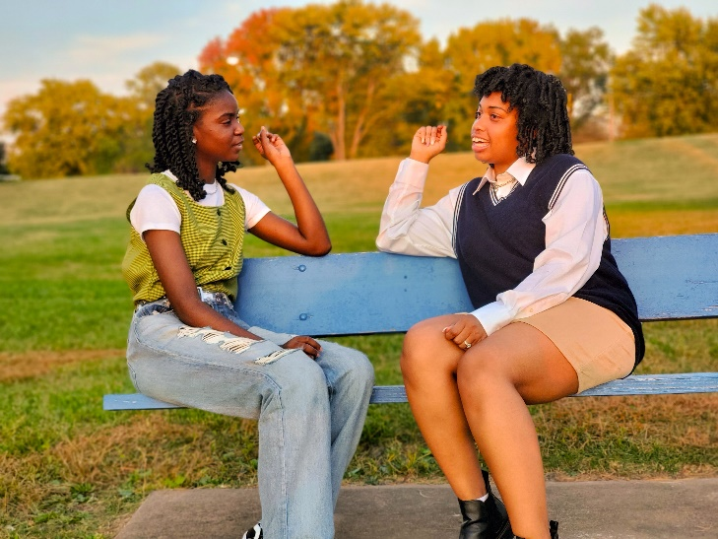SET CAMHS Instagram account 

**How to help a friend**

* Start a conversation about boundaries. Describe to them what boundaries are and why they are important.
* Review your boundaries with your friends. Tell them what you like and what you do not like, describe what makes you feel comfortable and uncomfortable.
* Ask your friends about their boundaries. What are the things they like or do not like and let them describe the things they are comfortable and uncomfortable with.

**The adult box** (for professionals and parent/carers to read)

|  |
| --- |
| * [Creating Safe Boundaries for Teens to Push Against](https://parentandteen.com/creating-safe-boundaries/)   Centre for parent and teen communication offer some advice to parents/carers about how to put in boundaries with you teenager. |
| * [Setting boundaries for teenagers](https://www.relate.org.uk/get-help/setting-boundaries-teenagers)   Relates top tips about boundary setting with your teen(s) |
| * [Teach Your Teen to Set Emotional Boundaries](https://www.psychologytoday.com/gb/blog/the-moment-youth/201904/teach-your-teen-set-emotional-boundaries)   Psychology today shares how to teach emotional boundaries with your teen |
| * [Setting boundaries](https://familytoolbox.co.uk/resource-list/setting-boundaries/)   Family toolbox video for parents about setting boundaries |
| * [Teaching About Consent and Healthy Boundaries with Learners with SEND](https://www.twinkl.co.uk/blog/teaching-about-consent-and-healthy-boundaries-with-learners-with-send)   Twinkl describe the importance of teaching about boundaries to those learners with SEND |

