**Let’s Talk: Self-care**

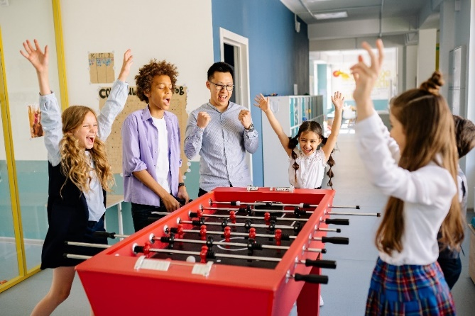**Primary**

This resource is part of our self-care suite of resources and has been co-produced with children and young people living in Essex, for children and young people. They have also been developed and quality assured by the following stakeholders:

* Essex Educational Psychology Service
* Health Watch Essex
* Essex Mental Health Support Teams (MHSTs) NELFT NHS Foundation Trust
* Essex Multi-schools Council
* Essex Social, Emotional and Mental Health (SEMH) strategy team
* Essex Child and Family Wellbeing Service, HCRG Care Group in partnership with Barnardos
* NELFT NHS Trust Southend, Essex, and Thurrock (SET) Child, Adolescent and Mental Health Service (CAMHS)
* Professionals in schools and settings can access all these resources via the [Essex info link SEMH portal](https://schools.essex.gov.uk/pupils/social_emotional_mental_health_portal_for_schools/Pages/Self-care-for-CYP-Library.aspx). Children and young people (CYP), parents/carers and professionals can also access these resources via the SET CAMHS website. Our self-care content can also be accessed via SET CAMHS Instagram account:

The resources are intended to be accessed by CYP independently or trusted adults use these resources with CYP through 1:1 conversation, whole school/group discussion and assemblies.

Please note: some of the content within our self-care resources may be emotive for CYP. We recommend that you make use of the ‘signposting to support’ section of this document should any of the content be triggering.

   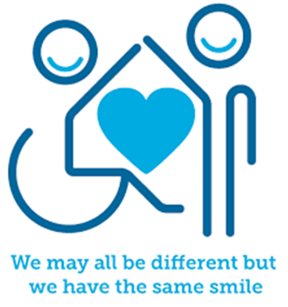

 

**Introduction**

self-care is about activities we choose to do to look after our own physical, emotional, and mental health. Self-care is personal to us and will vary from person to person. It includes trying to listen to how we are feeling and understanding what we need, even if it’s difficult, so we can take actions that support us to care for ourselves.

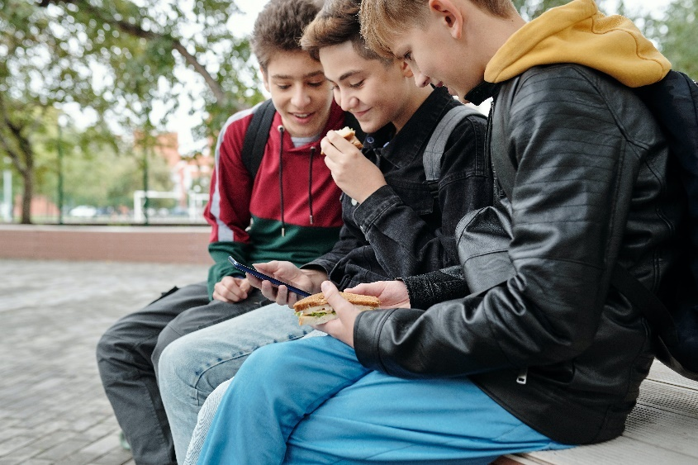

**Facts**

Self-care is:

* a need that everyone has
* personal to you​
* it’s important to make time to do things you enjoy and that make you feel good

It helps:

* Look after your mental health (mind)
* Look after your physical health (body)
* Help you to feel calm, relaxed and happy
* Helps you manage difficult emotions such as anger, upset, loneliness and sadness

**Myth Buster**

Here are some of the myths about self-care.

Self-care:

* is just doing breathing exercises and relaxation X
* is the same for everyone X
* it only helps you feel better for a little while X
* just for girls X
* it’s boring X
* it must cost you money X
* it must be done on your own X
* it must be activities you do with other X

**Video clips**

Check out these videos about self-care:

|  |
| --- |
| * [Self-care Animation](https://www.youtube.com/watch?v=mTuZiMNu7ZQ)   Video to describe self-care and offer different strategies to children (Ks2) |
| * [Self-care activities for kids](https://www.youtube.com/watch?v=_s20iNLTRwo)   Video to describe self-care to children (Ks2) |
| * [Self-care with Ted & friends](https://www.youtube.com/watch?v=DG82iIia8qs&t=57s)   Story video reading a story to describe self-care (Ks1) |
| * [I take care of myself](https://www.youtube.com/watch?v=HdzFdyPqvt8)   Story video about daily self-care routines (Ks1) |

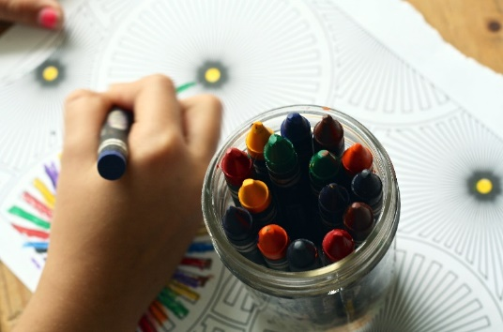

**Resources**

|  |
| --- |
| We have indicated whether the resources is accessible for Ks1 or Ks2. Please note that some of the ks2 content could be adapted and differentiated to support pupils in Ks1. |
| * [Self-care activities](https://mentallyhealthyschools.org.uk/media/2013/self-care-kit-covid-19.pdf)   Activities that promote self-care |
| * [Outdoor self-care activities](https://mentallyhealthyschools.org.uk/resources/outdoor-mindfulness-activities/)   Activities designed for children and young people aged 3-11 |
| * [Making a self-care plan](https://www.annafreud.org/schools-and-colleges/resources/my-self-care-plan-primary/#:~:text=This%20self%2Dcare%20plan%20walks,music%20and%20dance)   Create a self-care plan for primary age children (Ks2) |
| * [Self-care printable resources](https://www.twinkl.co.uk/search?q=self+care)   Twinkl provides a range of printable resources for self-care (Ks1 & Ks2) |
| * [Mindfulness calendar: daily five-minute activities](https://mentallyhealthyschools.org.uk/media/2026/mindfulness-calendar-daily-5-minute-activities.pdf)   Use this calendar to practice some self-care activities with your pupils (Ks1 & Ks2) |

**Reflective questions**

(Try exploring these reflective questions with a CYP)

* What is self-care?
* What self-care activities do you do?
* What self-care activities would you like to do more of?
* What advice would you give a friend about self-care?

**Quiz**

Once you’ve gone through this resource with a CYP try this quiz questions with them:

* What does self-care mean?
* What things are not self-care?
* Can you list 5 self-care activities?
* What can self-care activities help with?

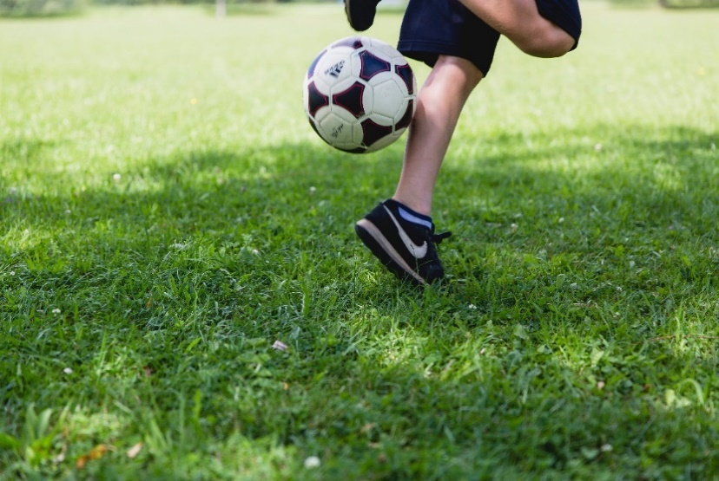

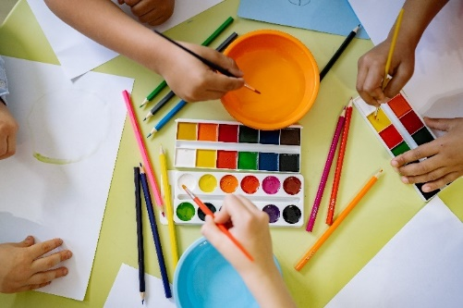

**Additional ideas**

Other things to try:

|  |
| --- |
| * [Dr Ranj’s Mindful Exercise](https://www.bbcchildreninneed.co.uk/schools/primary-school/mindfulness-hub/)   Video animation describing self-care |
| * [Calm Zone](https://www.childline.org.uk/toolbox/calm-zone/)   Online games and activities that support children and young people to regulate |
| * [Mindfulness Hubs](https://www.bbcchildreninneed.co.uk/schools/primary-school/mindfulness-hub/)   Printable mindfulness activities and videos teaching mindfulness |
| * [Relax like a cat](https://www.moodcafe.co.uk/media/26930/Relaxleaflet.pdf)   Story to help children relax |

**Signposting to Support**

For additional support we recommend you:

* [Getting help for your child: where to start](https://www.youngminds.org.uk/parent/parents-a-z-mental-health-guide/getting-help-for-your-child/)
* [Childline](https://www.childline.org.uk/info-advice/your-feelings/mental-health/?&&&&gclsrc=aw.ds&&gclid=EAIaIQobChMIqryktIeP_wIVicPtCh3QZQs6EAAYASAAEgJr5vD_BwE&gclsrc=aw.ds) 0800 1111 when [contacting ChildLine what to expect](https://www.youtube.com/watch?v=_KNtMOKwTco)?
* [Hopeline 0800 068 41 41](https://www.papyrus-uk.org/papyrus-HOPELINE247/) offering confidential support and practical advice
* [Text ‘SHOUT’ to 85258](https://giveusashout.org/get-help/?gclid=Cj0KCQiA6vaqBhCbARIsACF9M6nG--bxZCnflhd5C3jT-d9dS48o5t6XTTTidI0MLTgwjjRAlxszRT8aAnvvEALw_wcB) for free, confidential, anonymous text support service
* [NHS 111](https://www.nhs.uk/nhs-services/mental-health-services/)
* [Southend, Essex & Thurrock Children and Adolescent Mental Health Service (SET CAMHS)](https://www.nelft.nhs.uk/set-camhs/)
* [Explore counselling/therapy](https://www.nhs.uk/mental-health/talking-therapies-medicine-treatments/talking-therapies-and-counselling/counselling/)
* [Where to get urgent mental health support from: Advice from NHS](https://www.nhs.uk/nhs-services/mental-health-services/where-to-get-urgent-help-for-mental-health/)



* SET CAMHS Instagram account

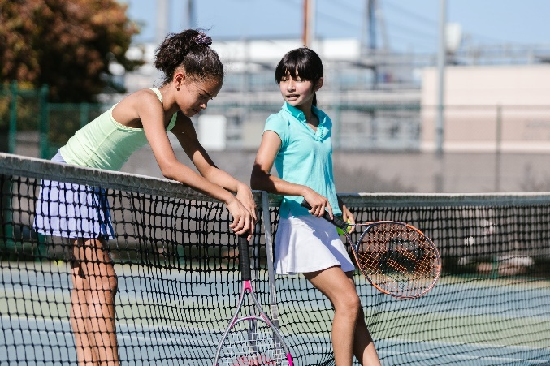

**How to help a friend**

* Start a conversation about self-care. Describe to them what it is and why it’s important for your mental health.
* Talk to your friends about what you enjoy doing.
* Find out about the things your friends like and enjoy doing.

**The adult box** (for professionals and parent/carers to read)

|  |
| --- |
| * [How to start a conversation about mental health](https://mentallyhealthyschools.org.uk/getting-started/how-to-start-a-conversation-with-children-and-young-people-about-mental-health/)   This resource provides some guidance and advice about how to talk to children and young people about mental health and introduce the importance of self-care. |
| * [Talking to parent/carers about a child/young person’s mental health](https://mentallyhealthyschools.org.uk/getting-started/how-to-start-a-conversation-with-a-parentcarer/)   This resource provides some guidance and advice about how to start conversations about children and young people’s mental health. Talking about self-care can be a supportive as part of this conversation. |
| * [Modelling self-care as a supporting adult](https://www.educationsupport.org.uk/resources/for-Individuals/guides/the-building-blocks-of-good-mental-wellbeing/?gclid=EAIaIQobChMIhcqFxImP_wIVgt_tCh13Uw4GEAAYASAAEgIEv_D_BwE)   It’s important to model self-care to young people to support your mental health. This resource is for teaching staff exploring the building blocks of good mental health and wellbeing. |

   

 